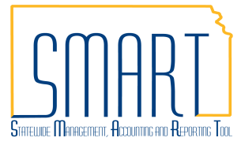
State of Kansas
Create a Journal Voucher
Statewide Management, Accounting and Reporting Tool

Date Created |  | 3/20/2018
Version |  | 2.1
Last Update |  | 04/05/2019
Purpose |  | - A journal voucher can be created to make changes to the chart fields used on a voucher that has paid. This can include the need to change the funding distribution on a voucher.  - Before creating a journal voucher, please make sure the voucher you need to correct has paid. See that the Payment Date and Reference fields are filled in on the Payments tab. If the voucher in need of correction has not paid, please make the corrections to it before it pays instead of creating a journal voucher.
Security |  | - Role Security: Only those individuals with the following roles will have access to create a journal voucher:  - Agency AP Processor (KAP_Agy_AP_Processor) with the ability to Process Journal Vouchers  - BU Security: Business Unit Security is applied. Agencies will only have access to the vouchers associated to their agency business unit.
Navigation |  | Accounts Payable Homepage > Vouchers > Add/Update > Regular Entry  or  NavBar: Navigator >Accounts Payable >Vouchers >Add/Update >Regular Entry
1. | Create a Journal Voucher in Accounts Payable  When a correction is needed for a voucher, an Accounts Payable journal voucher should be created.  - Select ‘Journal Voucher’ from the Voucher Style dropdown menu.  - Enter the supplier ID associated with the voucher in need of correction.  - Fill in the rest of the fields as necessary then click the ‘Add’ button. | 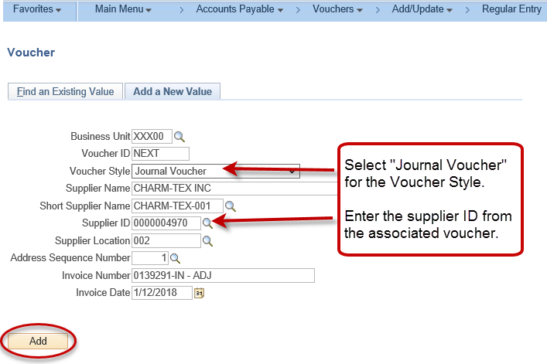

2. | Fill in the Related Voucher Field  On the Invoice Information tab, enter the Related Voucher in the field. This is the voucher that is being corrected. | 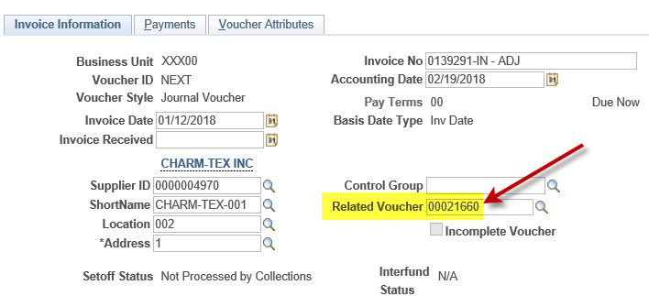
3. | Complete the Distribution Lines on the Invoice Information Tab  Line 1: Enter as a negative amount using the Chartfields that were used on the voucher including PC Chartfields. This line backs out the incorrect line from the related voucher.  Line 2: Enter as a positive amount using the correct Chartfields including PC Chartfields. This line is the correction for the related voucher.  Enter Cash Lines if there is a change in fund and/or budget unit from line 1 to line 2.  Line 3 – Cash Line: Enter a positive amount with the exact Chartfields from the incorrect line (line 1). The account code should be 110100. PC Chartfields should not be entered on cash lines.  Line 4 – Cash Line: Enter a negative amount with the exact Chartfields from the correcting line (line 2). The account code should be 110100. PC Chartfields should not be entered on cash lines.  Example: This journal voucher is being created to change the fund and budget unit for $25.00 of the expenditure on the original voucher. Cash lines are necessary for this entry because the fund and budget unit are being changed.  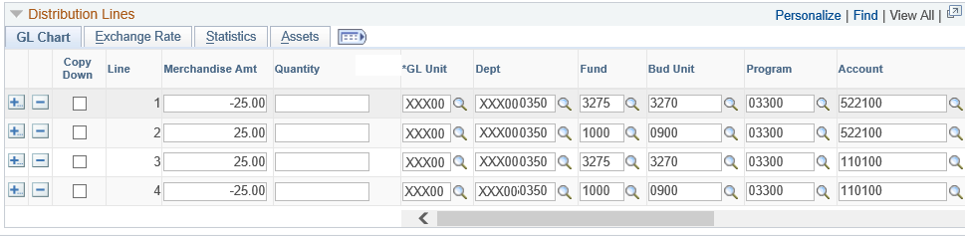  Once all fields are completed, save the journal voucher.

4. | Journal Voucher Corrections  Once a journal voucher has been approved and posted it has accrual accounting entries associated with it. Should it be determined that the journal voucher has a mistake on it, the user has the option to unpost the journal voucher to make changes to it. This allows the user to correct the journal voucher itself rather than creating an additional journal voucher to correct the issue. This is the preferred method to handle this type of situation.  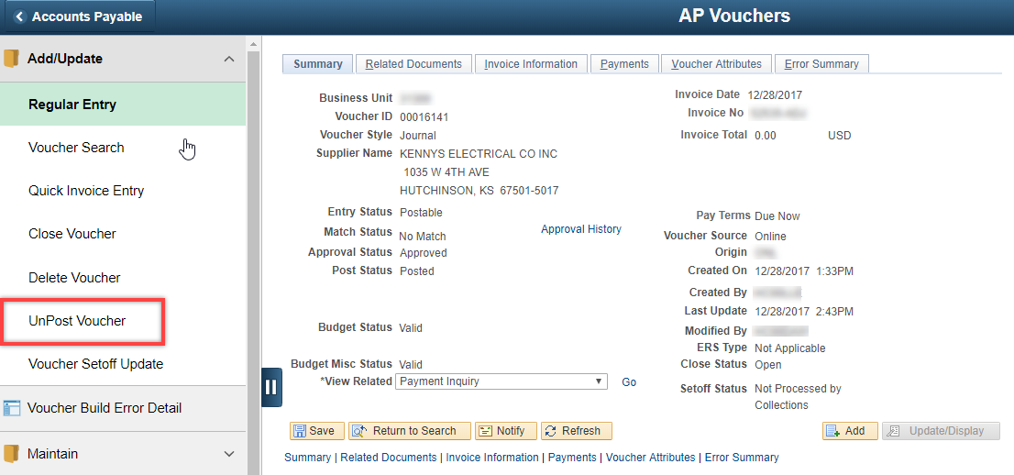  The Accounting Date for Unposting will default in as the Accounting Date on the journal voucher. It is fine to leave this date as it is. Click the Unpost button to unpost the journal voucher. Navigate back to the journal voucher once it is unposted to make the appropriate changes. Once the changes are made and it is saved, it will need to be re-approved so it can re-post with the corrections.  