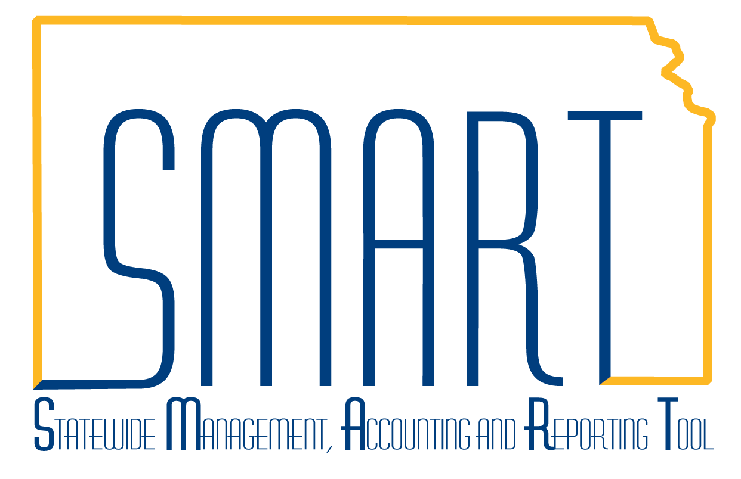
State of Kansas
Closing a Grant
Statewide Management, Accounting and Reporting Tool

Date Created: |  | 11/20/2013
Version: |  | 1.0
Last Updated: |  | 3/11/2019
Reason for Job aid: |  | This job aid describes how to close a grant in SMART. This is a multi-step process that involves coordinating inactivating data that resides in 3 separate modules in SMART: Project Costing, Customer Contracts and Grants. The process should occur in the following order:  - Close the project and activities in Project Costing to prevent any new transactions from being created.  - Set the billing/revenue plans to Completed on the customer contract so no more reimbursement processing will occur. Make sure all billable transactions have been billed. Then, set the contract status to Closed in the Customer Contracts module.  - Close the award in the Grants module.  Users must have these 3 roles in order to complete the end-to-end process: Agency Projects Manager  Agency Customer Contracts Manager  Agency Grants Manager
1. | Close the Project and associated Activities.  Navigate to: Projects and Grants Homepage > Project Costing > Project Setup > General Information or Navigator > Project Costing > Project Definitions > General Information.  Enter for the Project ID you wish to close in the Project field and click the Search button. | 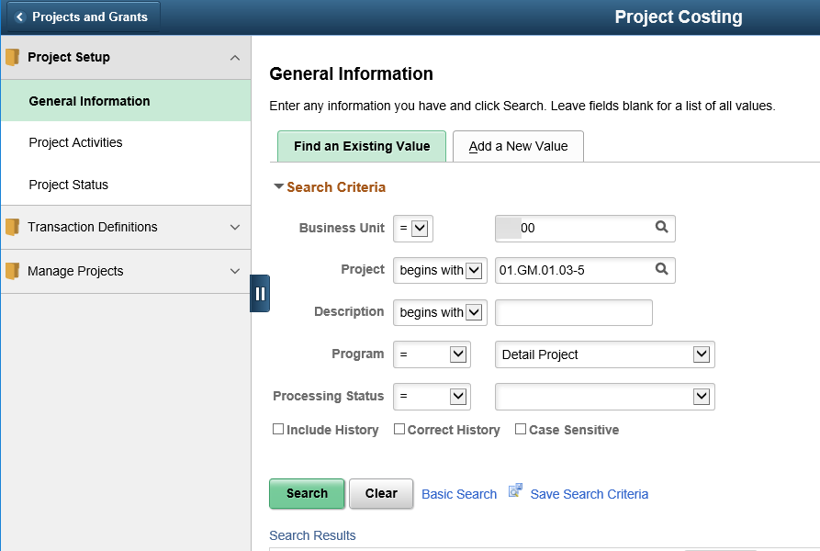

2. | From the project General Information tab, click the Project Status link to access the Status page. | 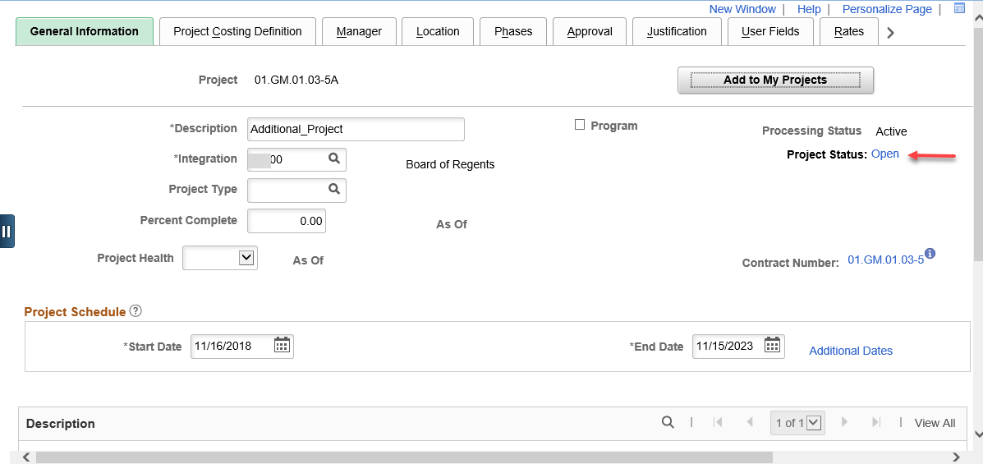
3. | On the Status page, click the + button to add a new effective-dated status row. | 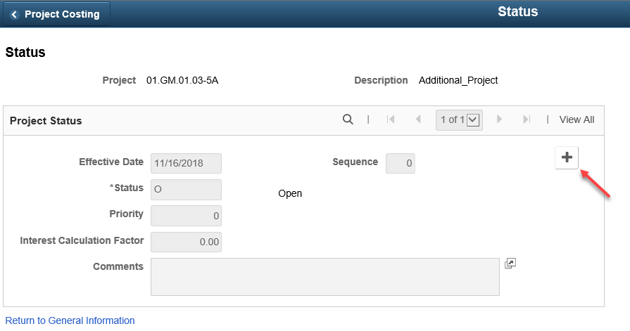
4. | Enter the following field data:  - Effective Date = date of the project closure  - Status = C (Closed)  Click Save.  Complete the above instructions for all projects related to the grant. | 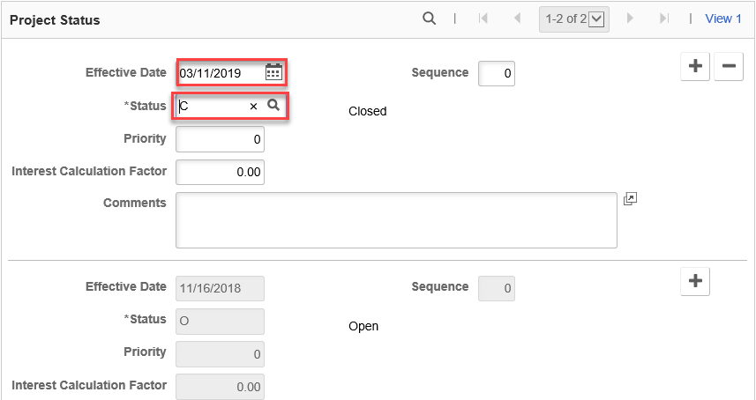

5. | Set the Billing and Revenue Plans to Completed on the Customer Contract.  Navigate to: Projects and Grants Homepage > Customer Contracts > Customer Contracts > General Information or Navigator > Customer Contracts > Create and Amend > General Information, and enter the contract number you wish to close in the Contract field and click the Search button  Or, as shown at right, click on the Rates tab while on the Project General Information page. Then, click the link to the contract number. | 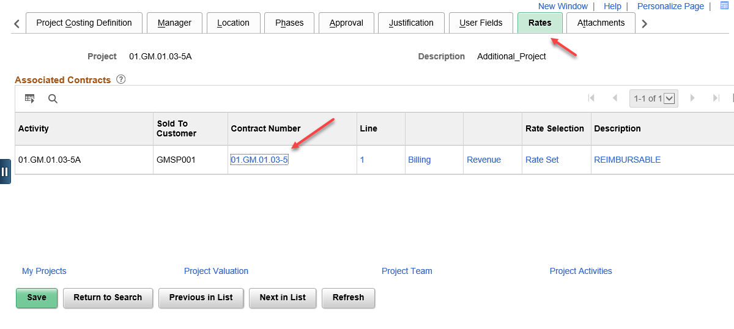
6. | Click the Lines tab on the contract. | 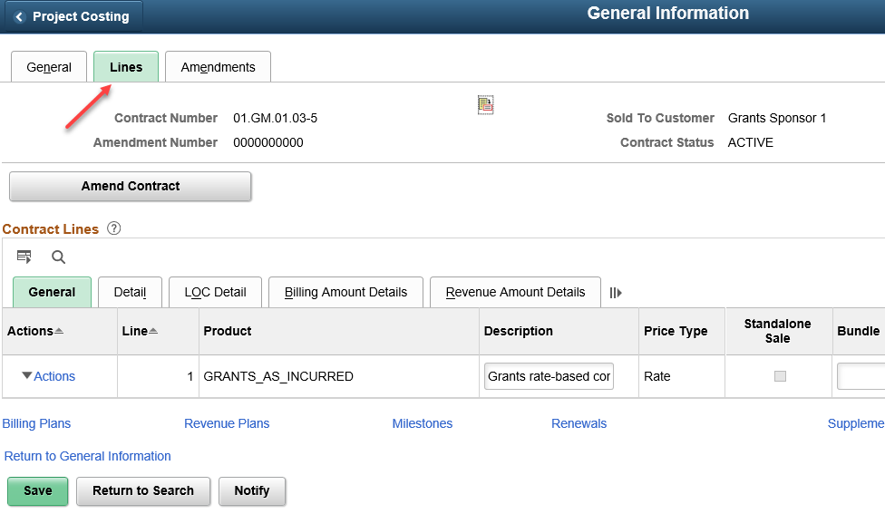
7. | Click the Detail tab from the contract Lines tab.  Click the Ready link underneath the Billing Plan heading. | 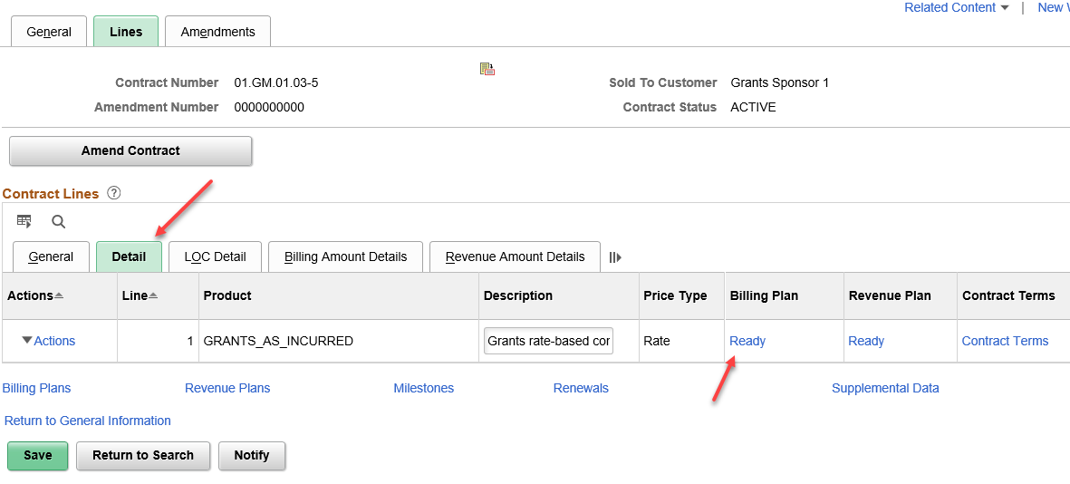

8. | From the Billing Plan General tab, change the Billing Status drop-down to Completed and click Save.  Click the Return to General Information link at the bottom of the page.  Click on the Detail tab again. Then click the In Progress link underneath the Revenue Plan heading. From the Revenue Plan page, toggle Plan Status for completed. Click Save | 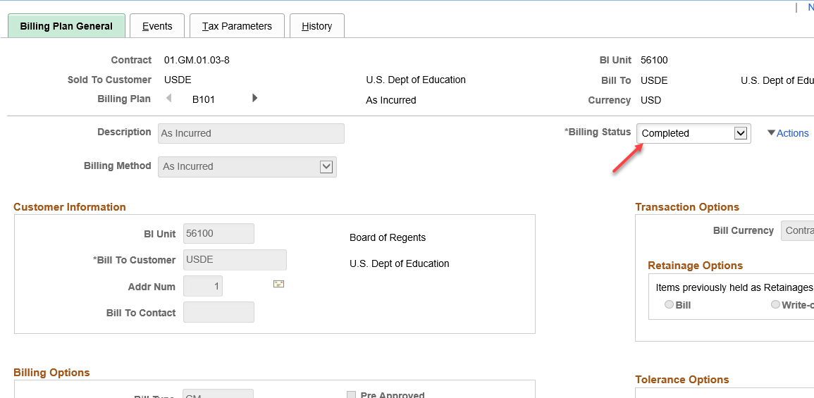
9. | Click the Return to General Information link at the bottom of the page. Click on the General tab of the Contract.  Update the Contract Status field to Closed. Click Save. | 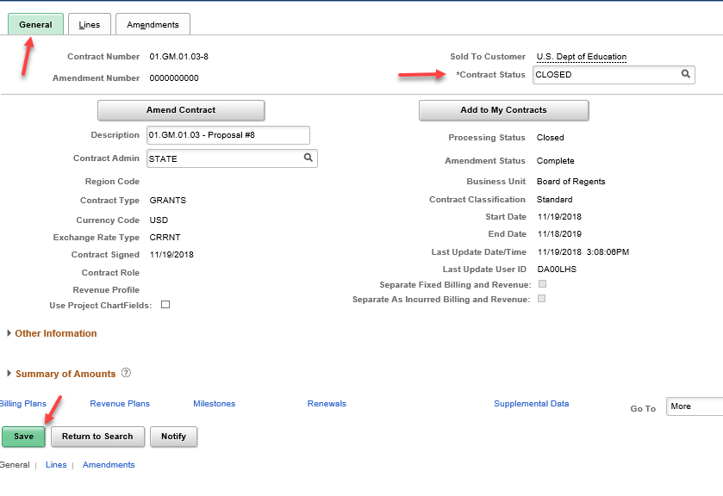
10. | You may receive a warning message that there are open projects linked to the contract. Either click Cancel and complete Steps 1-4 for all projects attached to the contract or click OK to proceed with the contract closure. | 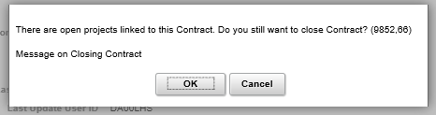
11. | Close the Grant Award.  Navigate to: Projects and Grants Homepage > Creating a Grant > Award Profile or Navigator > Awards > Award Profile, and search for the Award ID you want to close.  Or, as shown at right, expand the Other Information section on the General tab of the customer contract and click the View Award Profile link. | 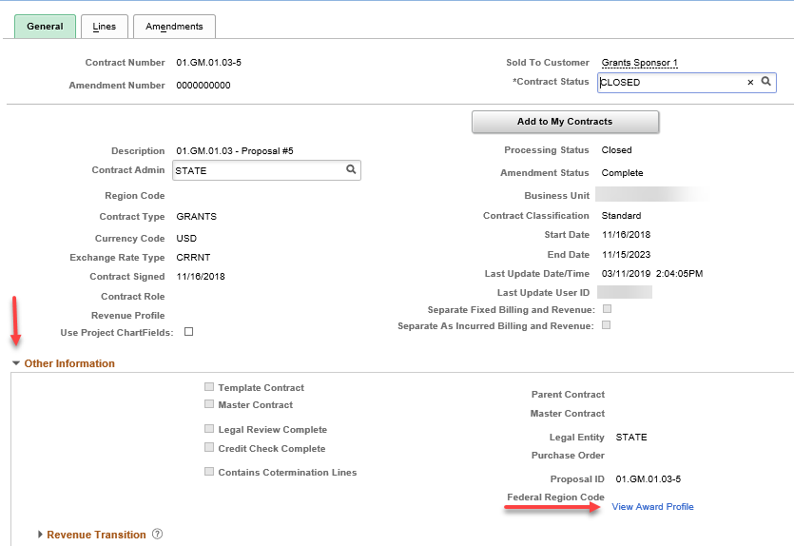
12. | On the Award tab, change the Status drop-down value to Closed and click Save. | 