State of Kansas
Billing WorkCenter
Statewide Management, Accounting and Reporting Tool

Date Created: | 3/6/2019
Version: | 1.0
Last Updated Date: | 3/6/2019
Process: | FLUID is the new architecture behind the pages of SMART. The Billing WorkCenter is the new FLUID version. There are differences in the look and feel, but essentially functions the same as the prior version, with some modifications.
Navigation: Billing Homepage > WorkCenters > Billing WorkCenter. | 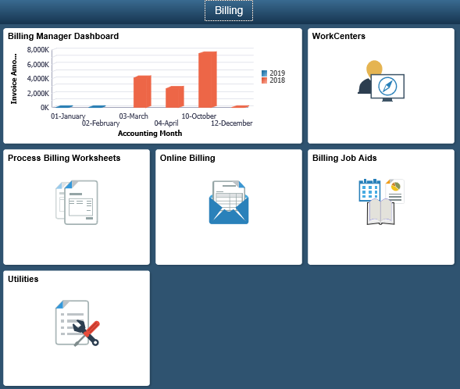
The primary difference is now all sections of My Work, Links, Queries, and Reports/Processes are displayed in the left pane without the necessity of moving between tabs of the older version. The new version also does not have the refresh icon. | 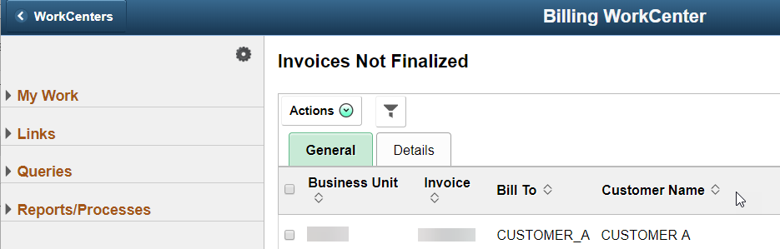
Another difference is the gear icon on the left pane now contains the Edit Filters and Personalize features. | 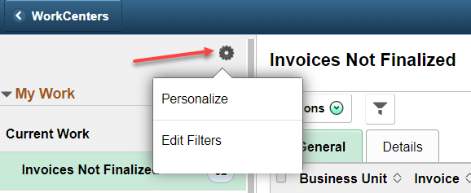
A user can now Edit Filters by clicking on the Link Label, Filter ID, or Description links.  Click the Done button on Configure Filter Values and Edit Filters Personalize to navigate back to the WorkCenter. | 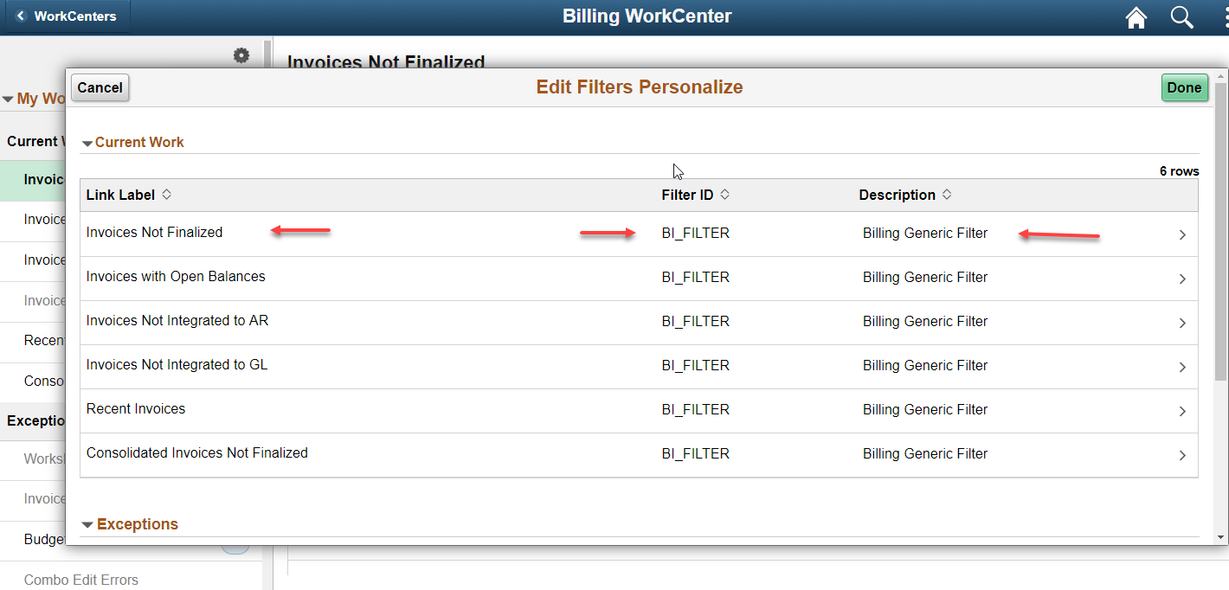  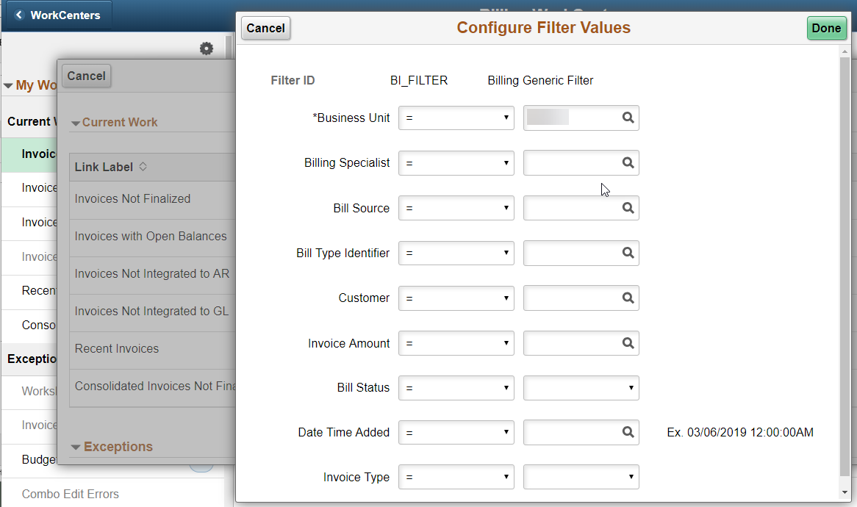
My Work  The My Work section provides delivered queries that are standard processing issues. The number to the right provides the amount of query results. | 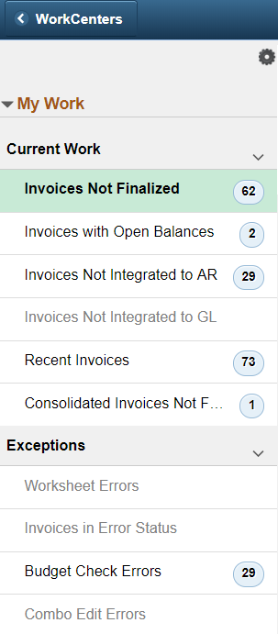
Clicking on any of the links with results in the My Work section will display the query results in the right modal window. | 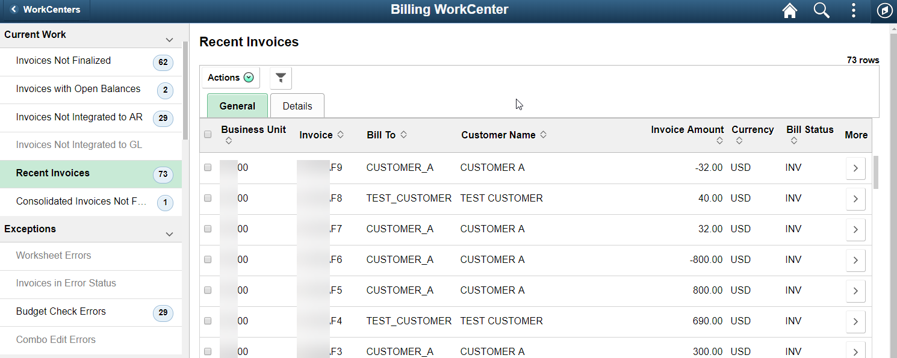
In the right pane, selecting the checkbox next to Business Unit will select all rows.  Selecting the Actions down arrow provides a list of options for taking action on a single, multiple, or all invoices in the list. | 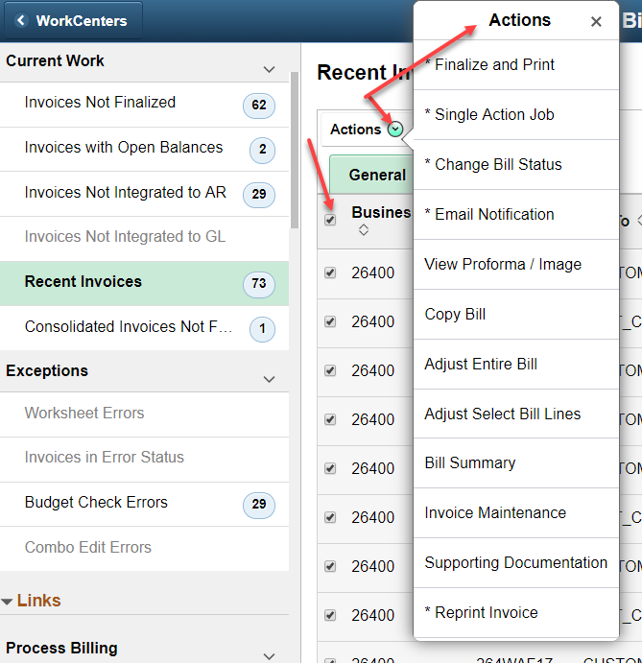
When working in the right pane, after selecting an Action, the right pane will not update, but clicking the Refine Filter Criteria, then Done, will update the page. | 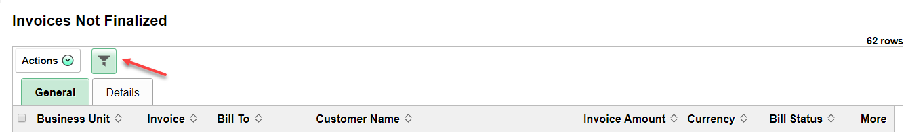
Links  The current Links Section provides links to pages used in processing Billing Worksheets. | 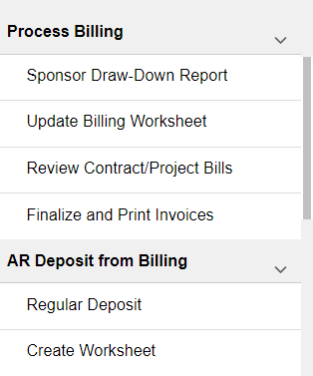
The section also contains links to job aids and training guides, which open in a new window, and other pages that may be useful.  See the topic on Personalization at the end of the job aid for instructions on how to add links, pages, and groups. | 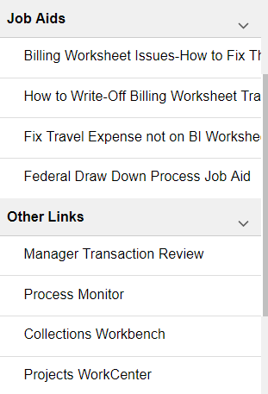
Queries  This section provides the most commonly used queries and allows the queries to display in the right pane when selected.  See the topic on Personalization at the end of the job aid for instructions on how to add links, pages, and groups.  Note: The pivot grids have not been tested for accuracy and may or may not be useful. | 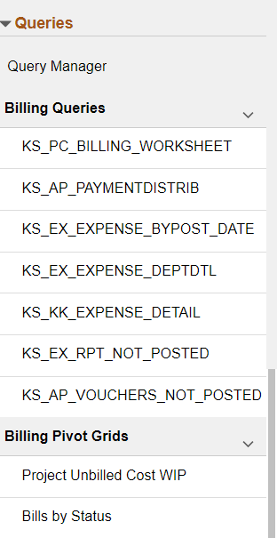
Reports/Processes  This section provides quick links to Report Manager, Process Monitor, Reports, and Reports and Inquiry pages.  See the topic on Personalization at the end of the job aid for instructions on how to add links, pages, and groups. | 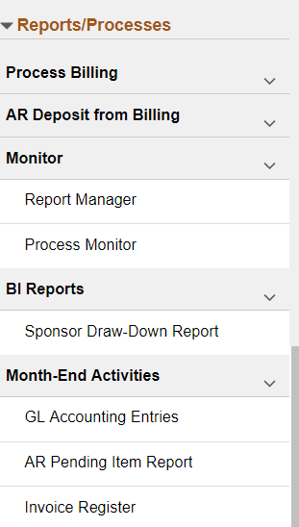
Personalization  By selecting the gear icon at the top right of the left pane and then Personalize, a user may add pages to existing groups, add additional groups, such as pages for processing online bills, and pages for Links, Queries, and Reports/Processes.  There are options to start a group collasped, to show, or remove the checkbox so a link will not show in a group. | 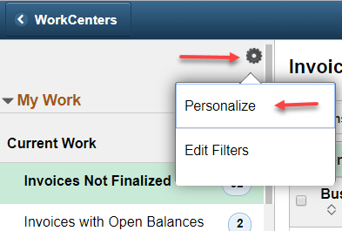  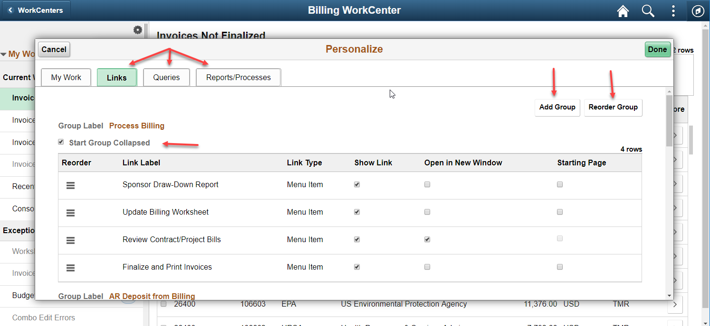
Reorder a Group or Links  One way to reorder a link is to grab the “hamburger” icon and drag/drop in the location desired within that group.  A user can also reorder a group by clicking the Reorder Group button, as shown, then use the drag and drop. | 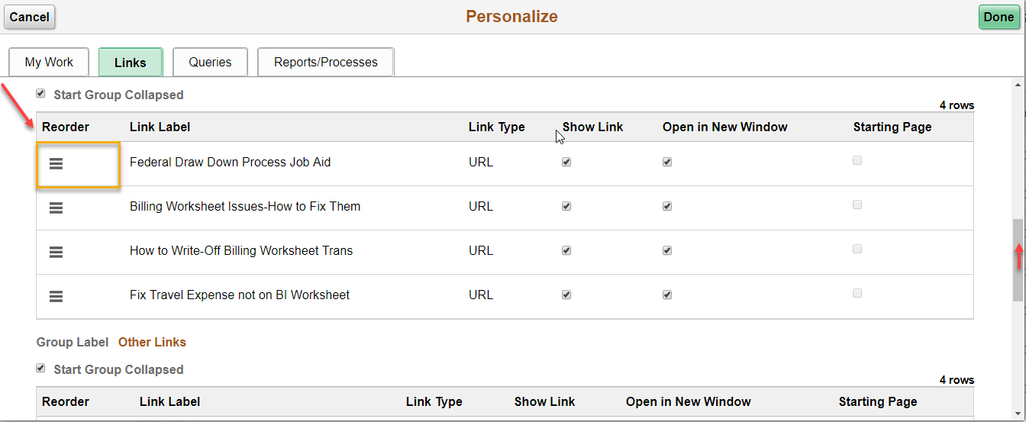  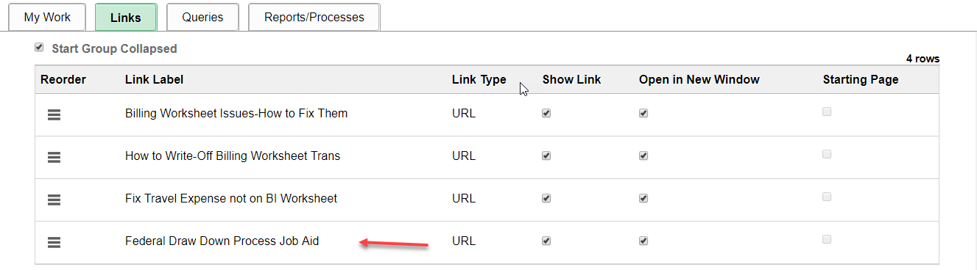  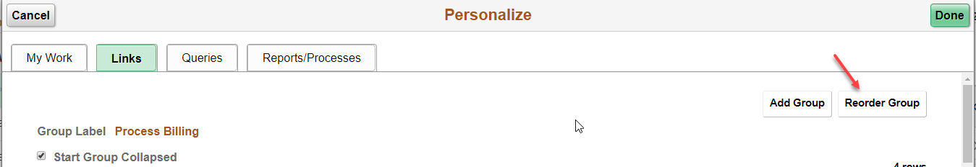
Links  Adding a Group  To add a group, select the Add Group button. Enter the Group Label, then select the Define Group hyperlink. | 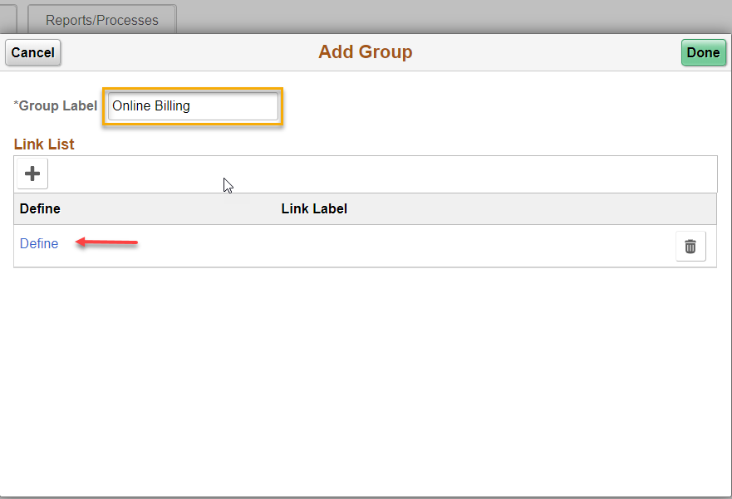
Click the Select Menu Items hyperlink. | 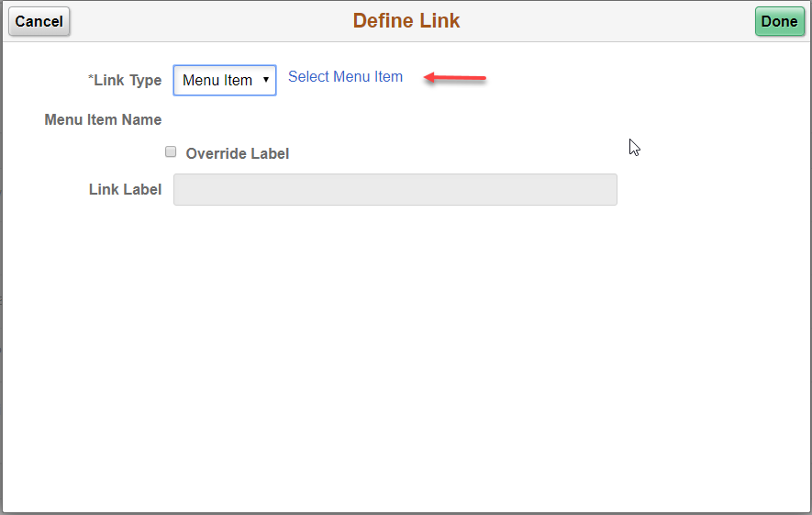
Select the Menu Item. | 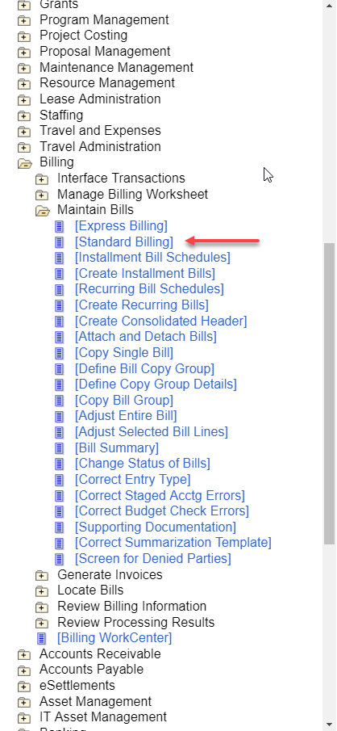
The Item name now displays in the Link Label field. Click Done.  The user has the option of using the Override Label checkbox to enter a different label. | 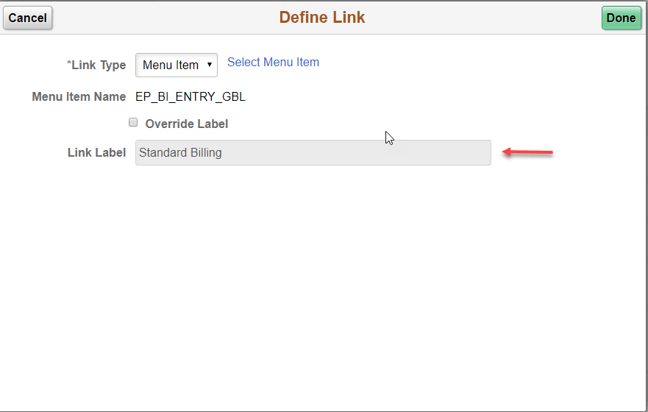
The user can continue to add Menu Items by clicking the + icon and then repeating the process. Once all Menu Items have been added, click Done. | 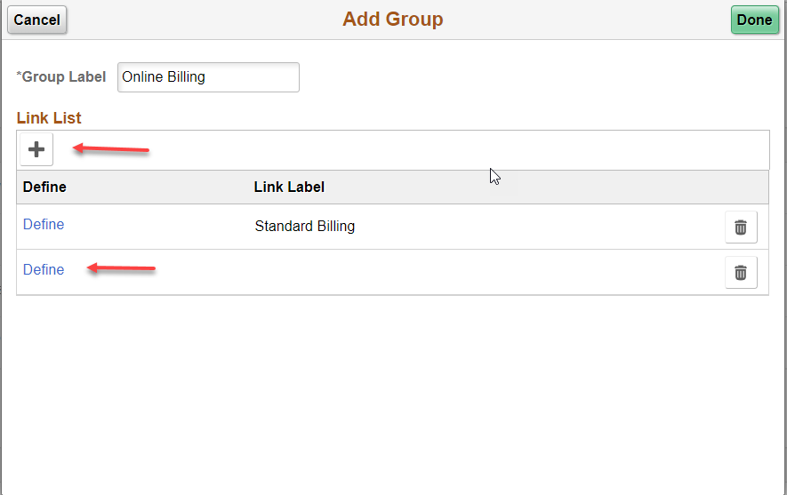  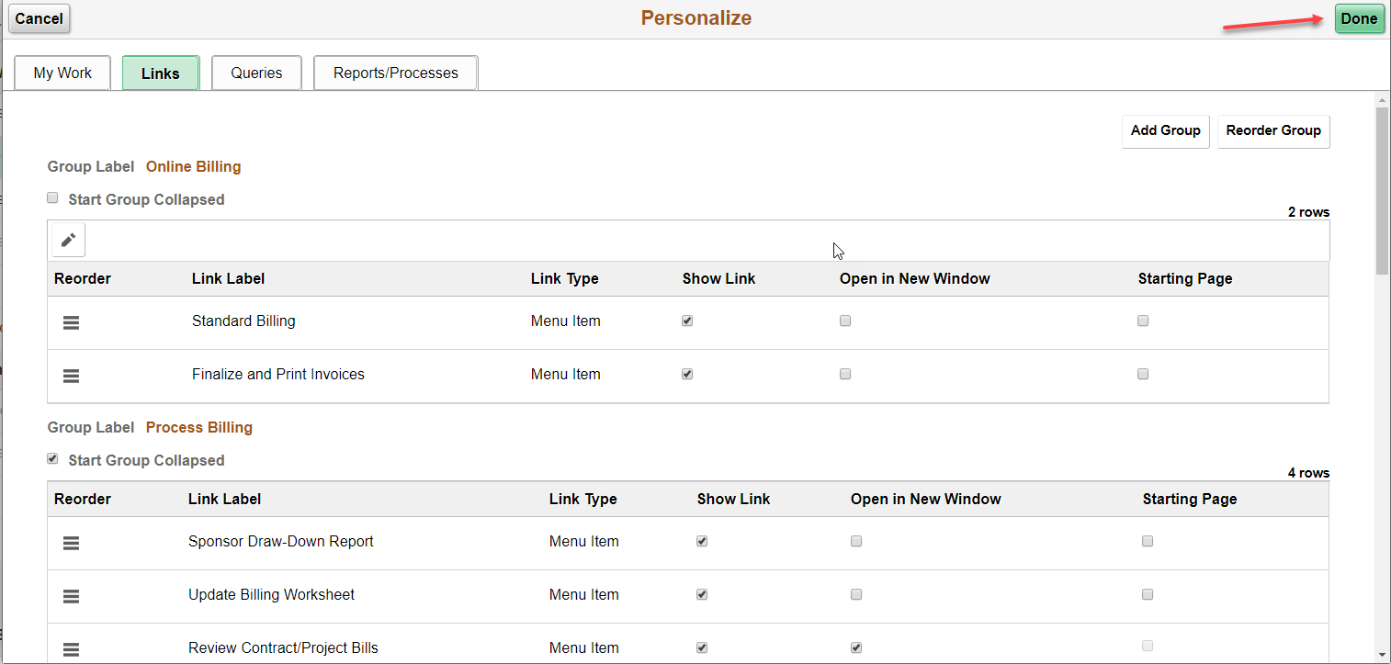
Adding a Query Group  With Personalization selected, select the Queries tab, then select Add Group. | 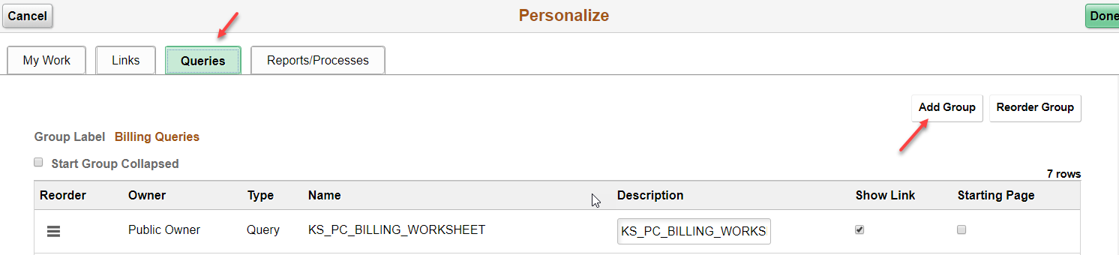
Enter the Group Label, then select the lookup under Name. | 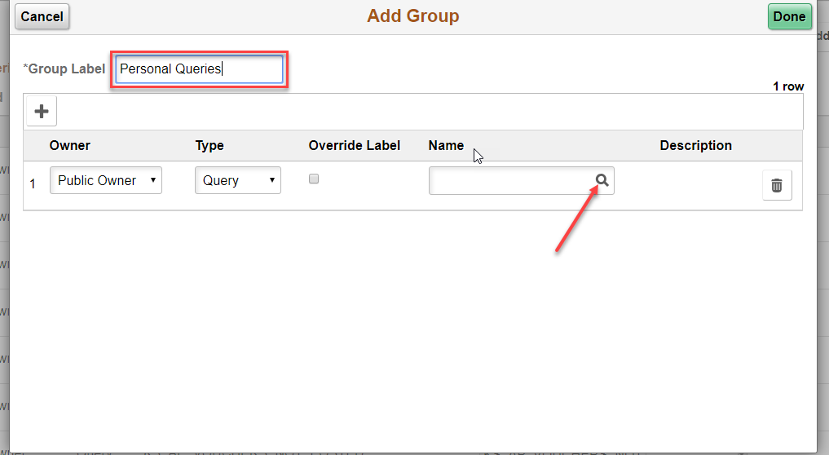
Expand the Search Criteria arrow, then enter search criteria. Click Search. | 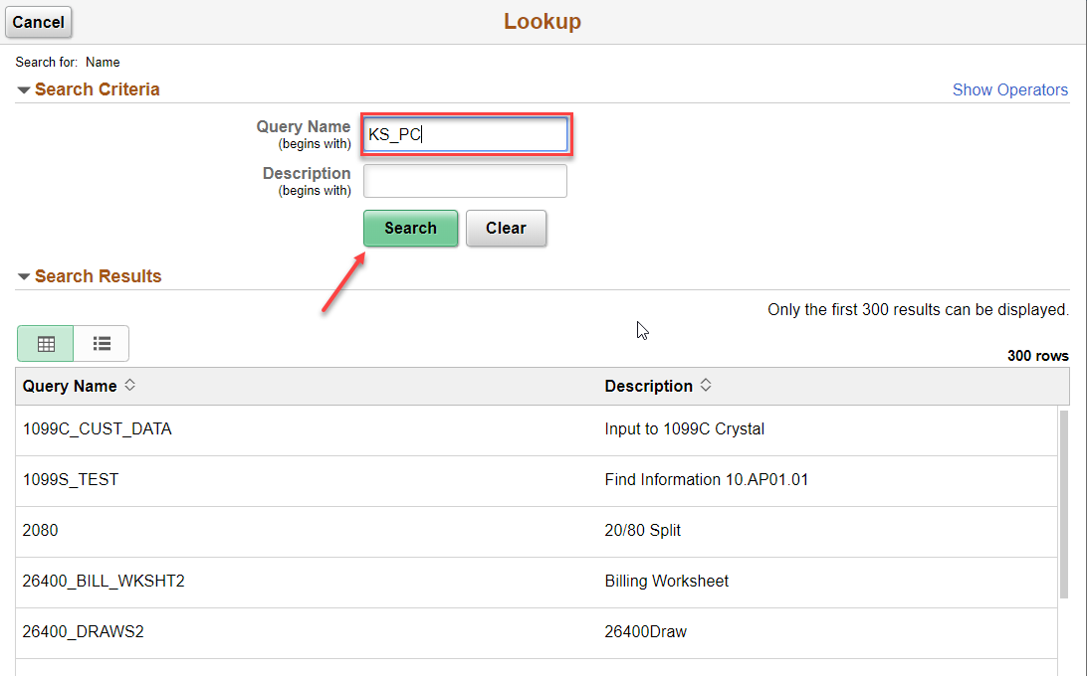
Select the desired query. Use the + icon to add additional queries. Click Done.  To have the query name display, the Override Label checkbox must be checked. The Description field will be available to copy and paste the query name into the field. | 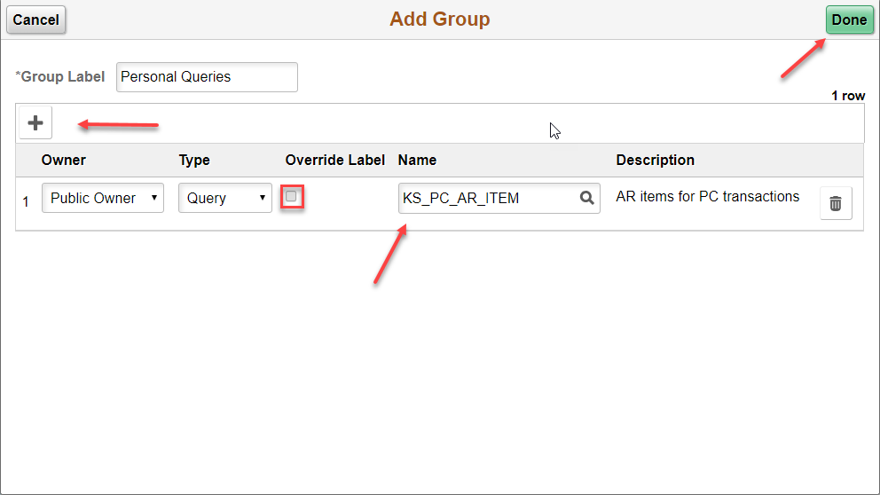  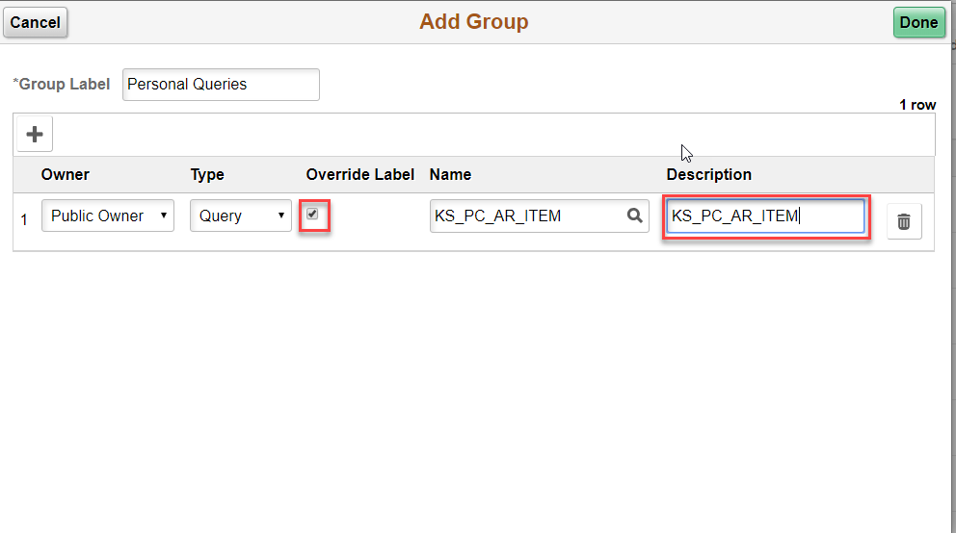
Reports/Processes  The same instruction for adding Links, Adding a Group may be followed to add Reports/Processes. | 