State of Kansas
High-Level Changes from 9.0 to 9.2 in Asset Management:
Attachments
Statewide Management, Accounting and Reporting Tool
Date Created: | 10/28/2015
Version: | 1.0
Last Updated Date:
Purpose: | This document highlights one of the changes between 9.0 and 9.2 in the Asset Management module.
Security: | - Role Security: The following roles are applicable:  Agency Asset Processor  KS Assets Viewer  BU Security: Business Unit Security is applied. Agencies will only have access to the assets in their Business Unit.
Procedure

In 9.2, you have the option of adding attachments to assets. There are some considerations to take regarding attachment use:

– The recommended size limit for a file being attached is 1 MB.

– Agencies should not attach CAD (Computer Aided Design) files or picture files (examples- .jpg, .tif, .png, or .gif).

– Excel, Word, PDF, or similar files are appropriate.

– Multiple attachments are allowed.

– Avoid attaching documents that do not add value to the transaction.

– System retention for attachment files is expected to be 3 years. This period may be reduced if storage space becomes an issue.

– Agencies should not rely on SMART as the method for meeting record retention policies.

Step | Action
 | Click the object.
 | Click the Asset Management menu.
 | Click the Asset Transactions menu.
 | Click the Owned Assets menu.

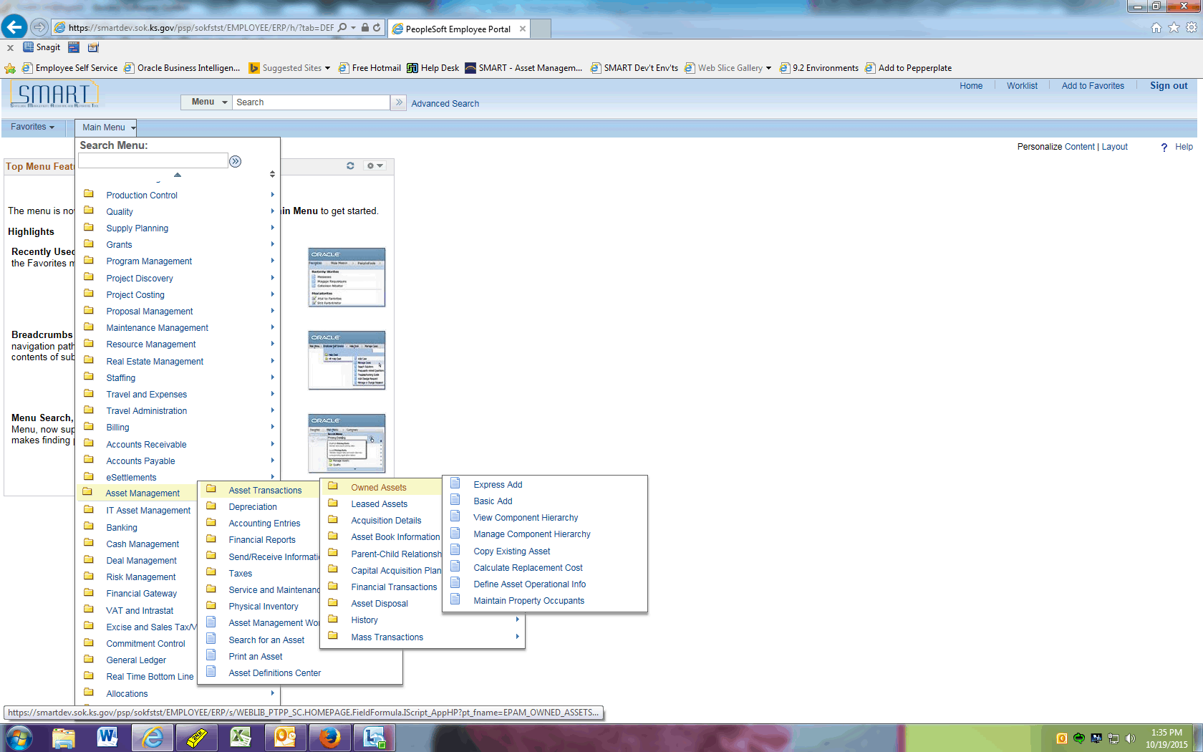

Step | Action
 | Click the Basic Add menu.
 | Click the Search button.
 | Select the asset you wish to open.

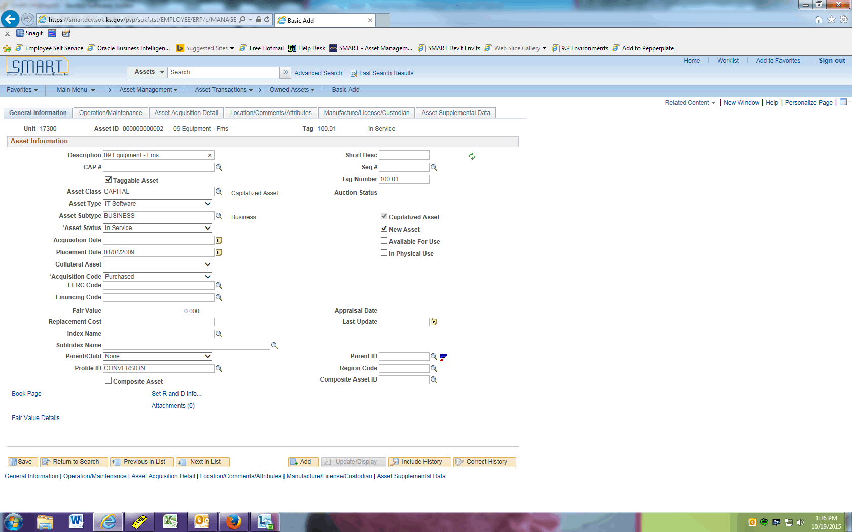

Step | Action
 | Click the Attachments (0) link.

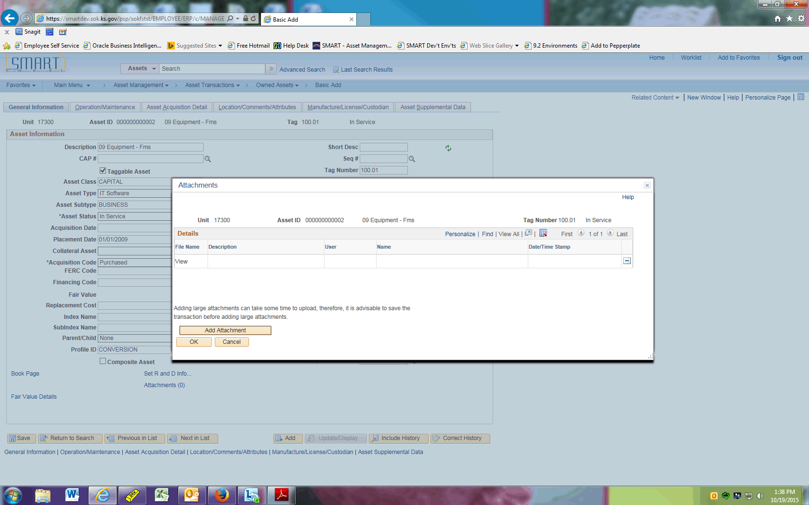

Step | Action
 | Click the Add Attachment button.

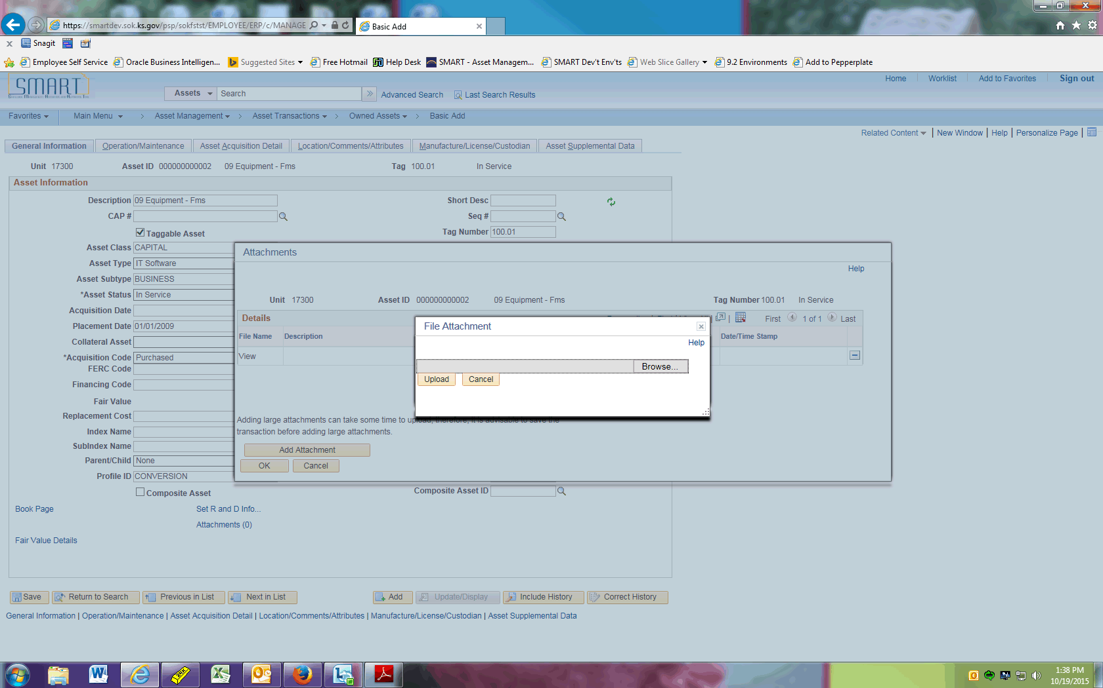

Step | Action
 | Click the Browse button.

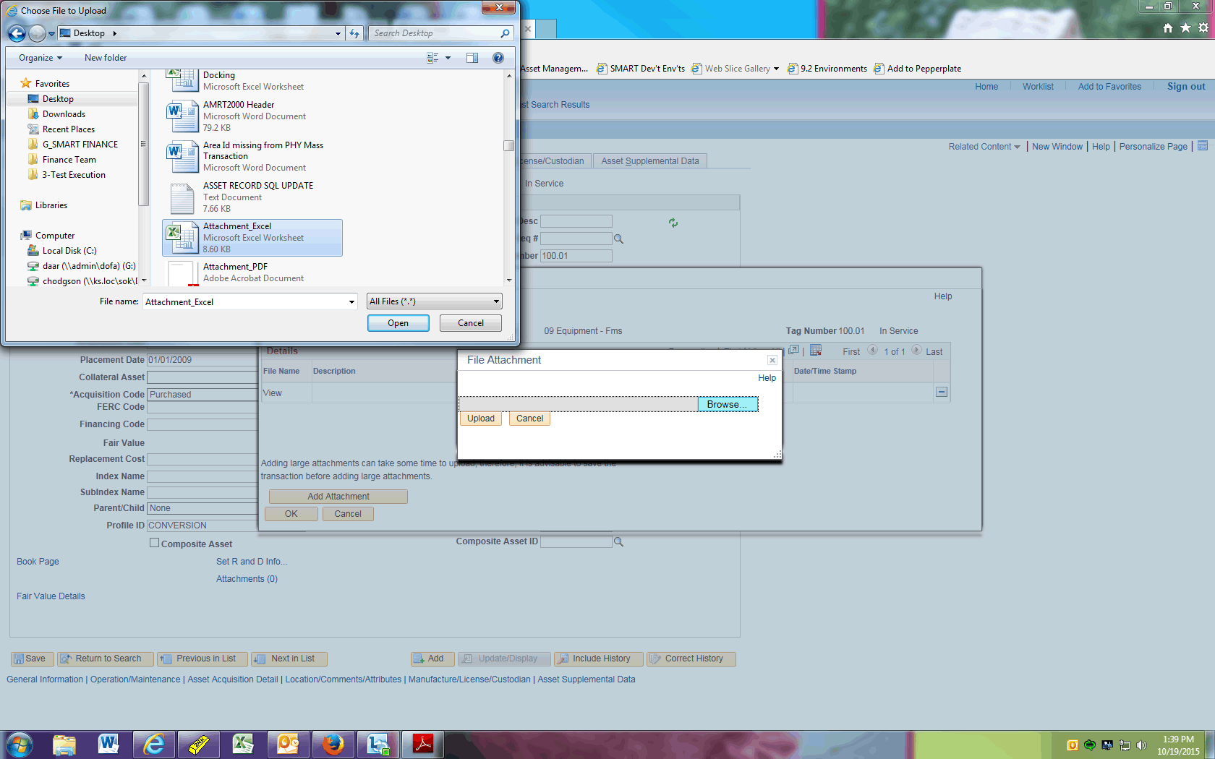

Step | Action
 | Select the file you wish to attach, then click the Open button.

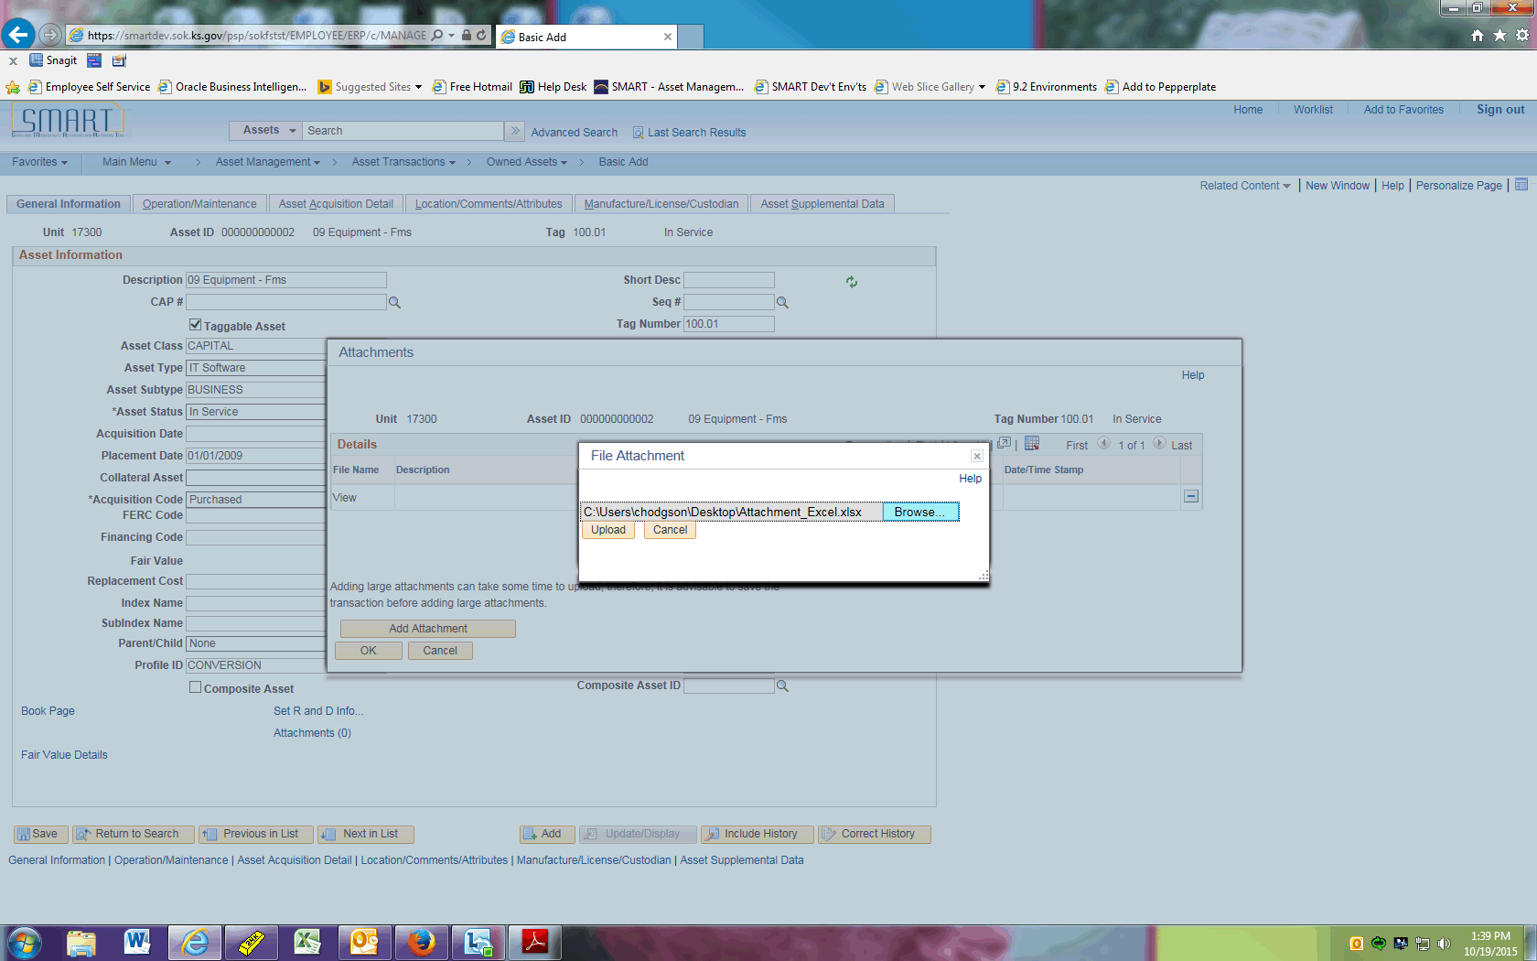

Step | Action
 | Click the Upload button.

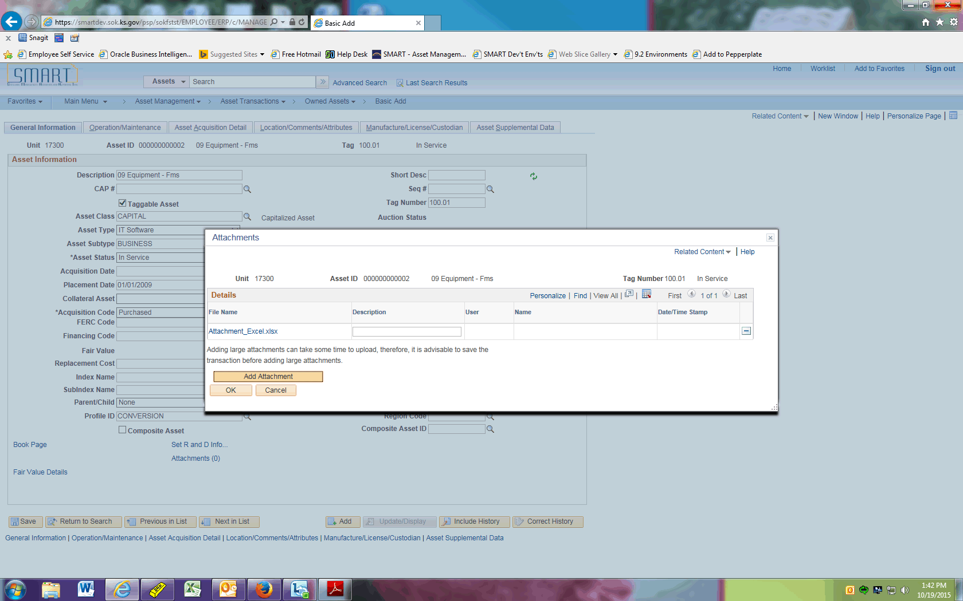

Step | Action
 | Click the Add Attachment button to add another attachment.

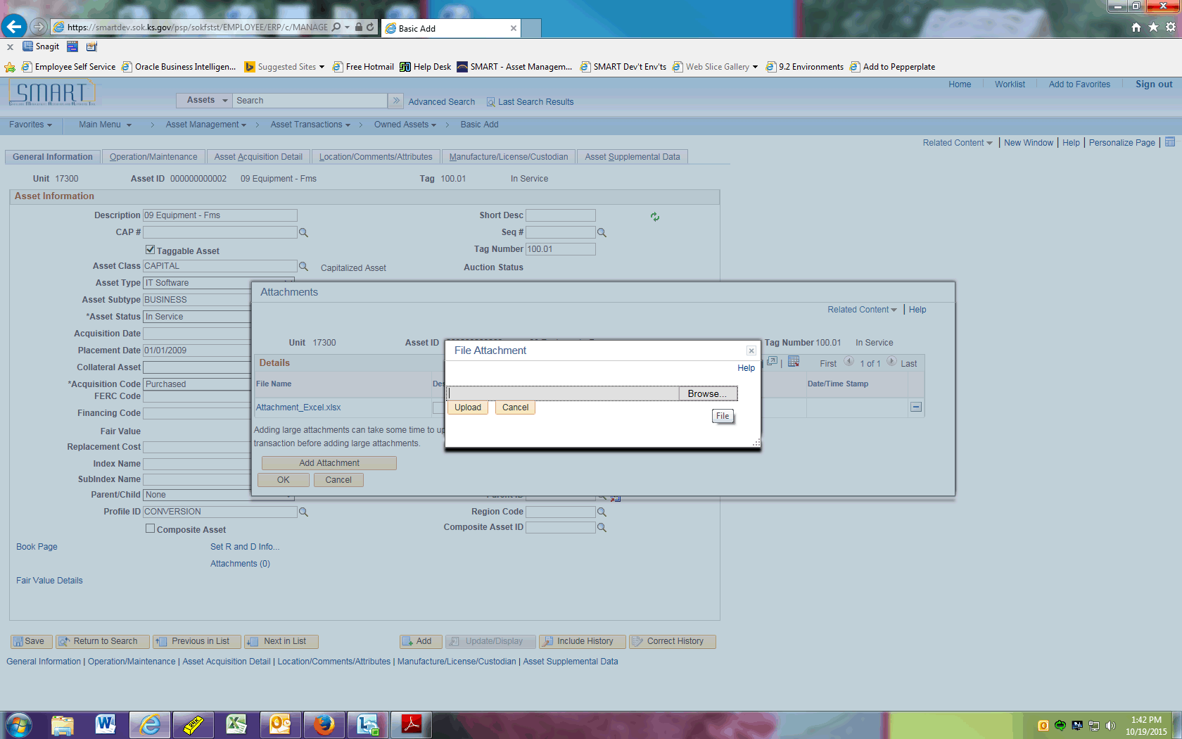

Step | Action
 | Click the Browse button.

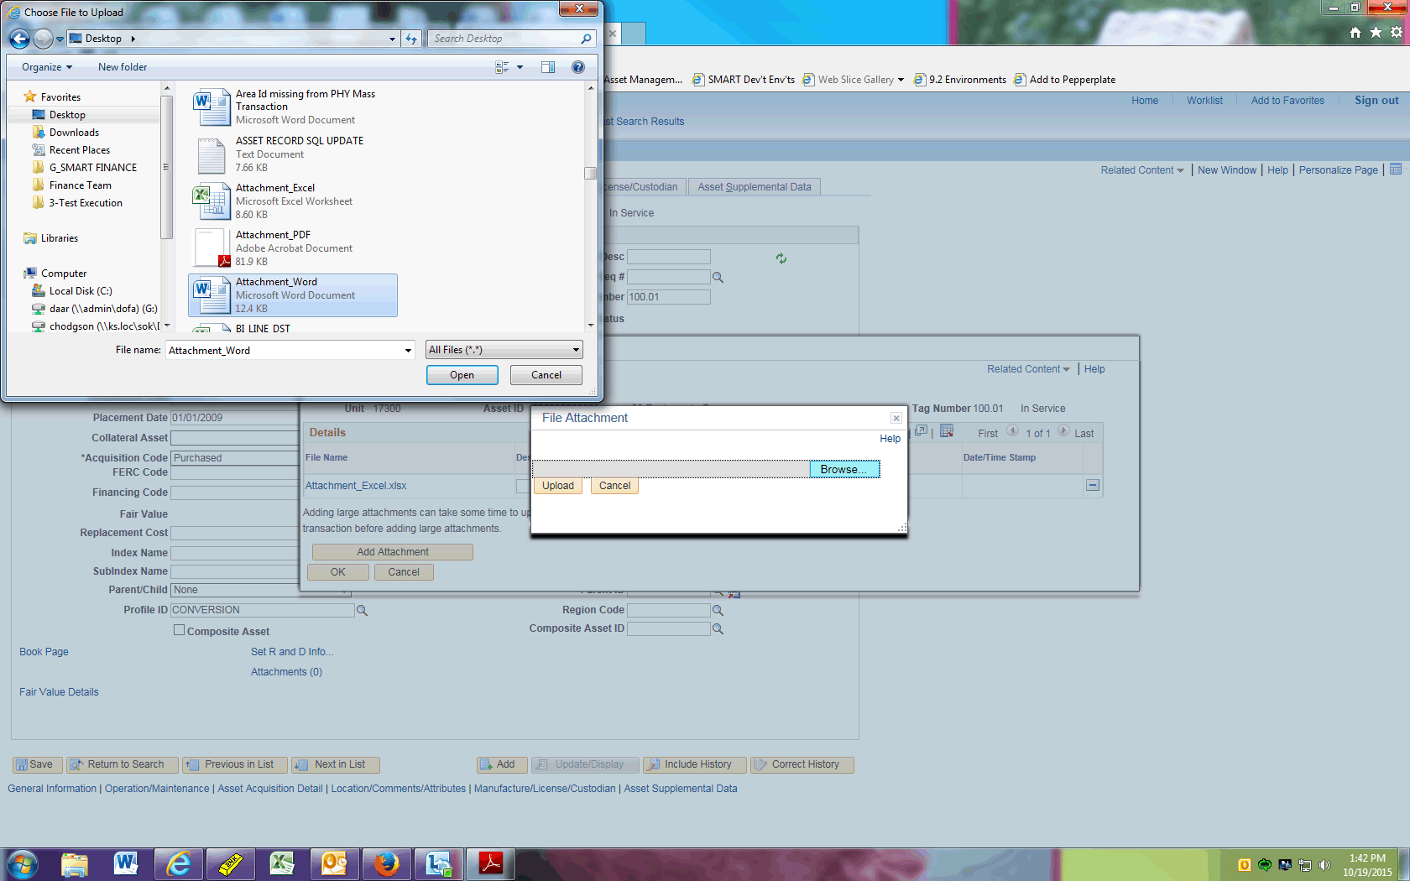

Step | Action
 | Select the file you wish to attach, then click the Open button.

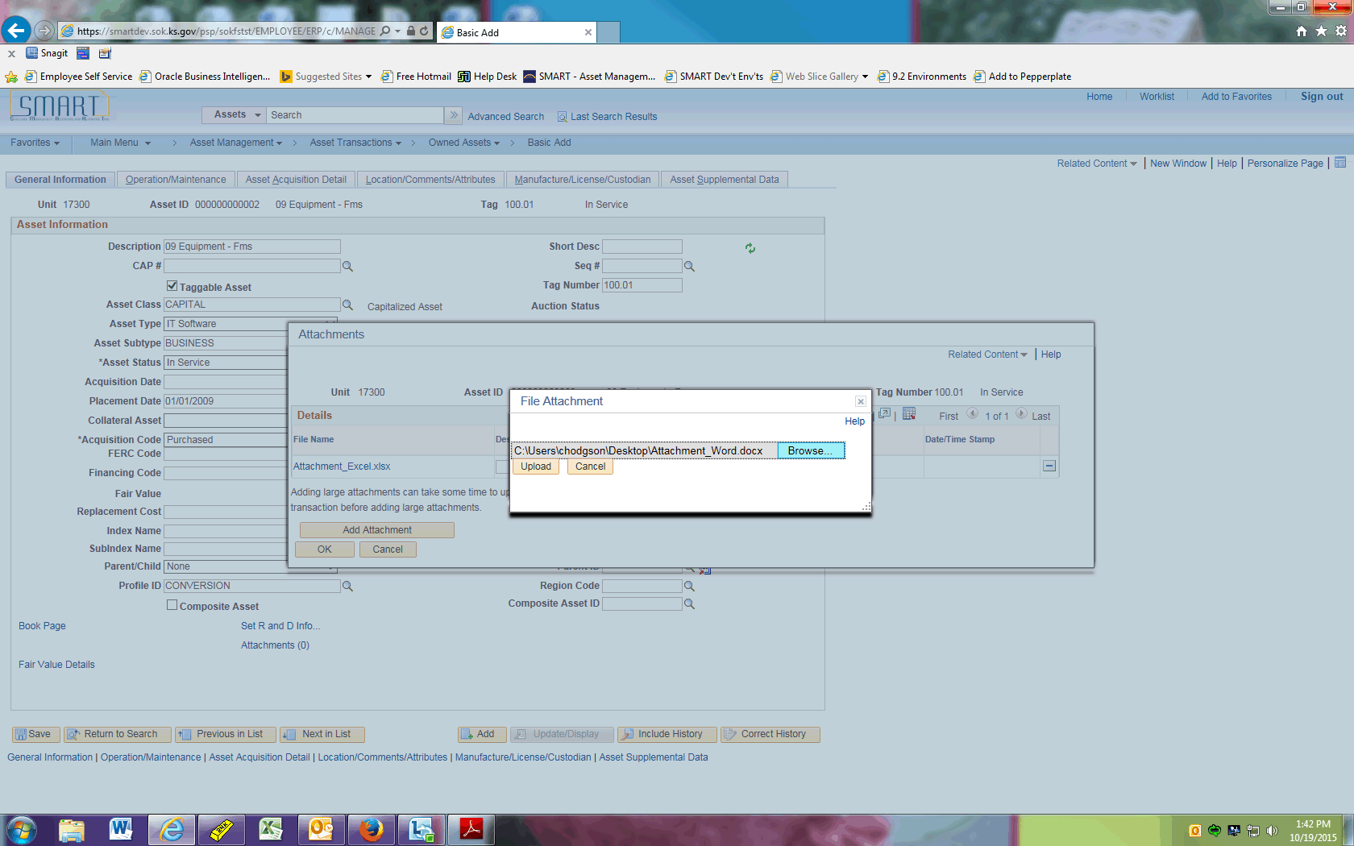

Step | Action
 | Click the Upload button.

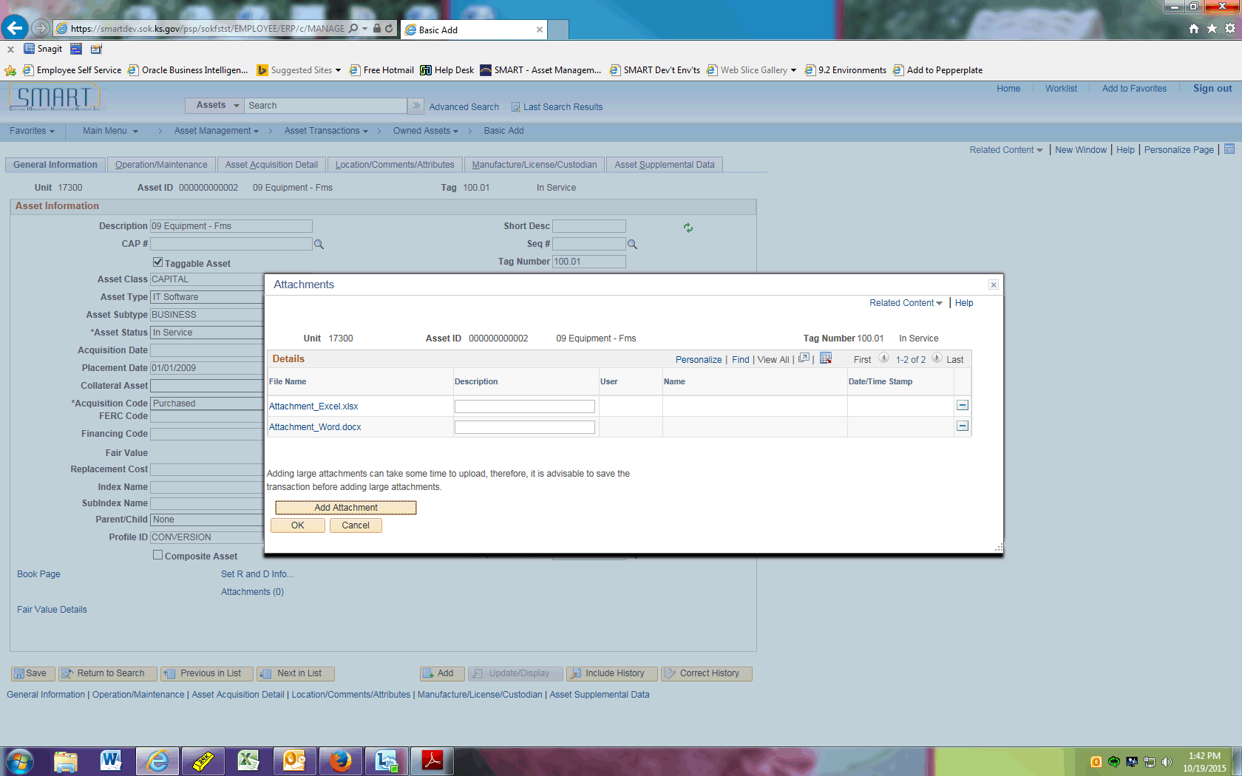

Step | Action
 | Simply click the hyperlink to open the attachment you wish to view.
 | Click the OK button.
This concludes the 'AM - Attachments' topic. Thank you for taking this course.
End of Procedure.

