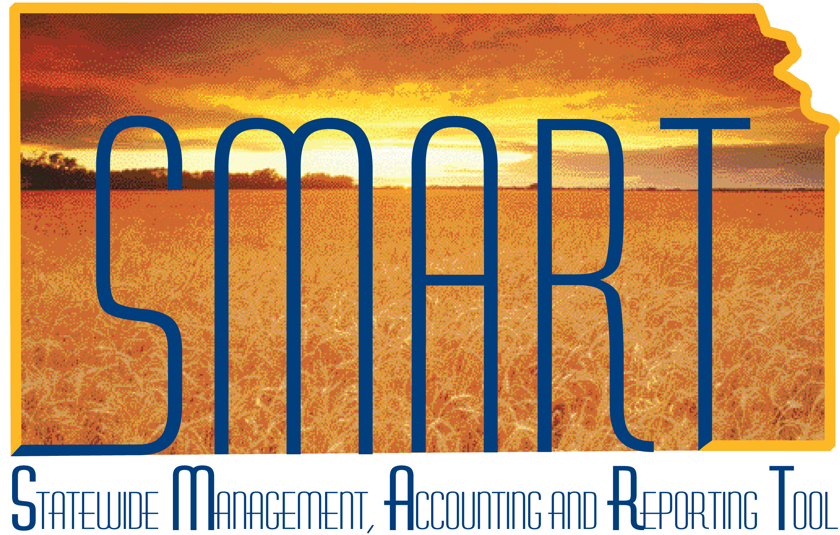

Training Guide – Asset Management
Asset Reporting

State of Kansas

Applicable Role(s):

KS Assets Viewer
Table of Contents
Search for an Asset 3
Asset Reports 6

Asset Reporting

Search for an Asset

- The Search for an Asset page allows users to quickly and easily search for assets using a variety of search criteria.
- This page has a limit of 300 search results. If your search will result in 300+ assets, you should use a report, which has no limitation on the number of assets retrieved, or refine your search parameters.
Page Name | Navigation
Search for an Asset | Asset Management>Search for an Asset

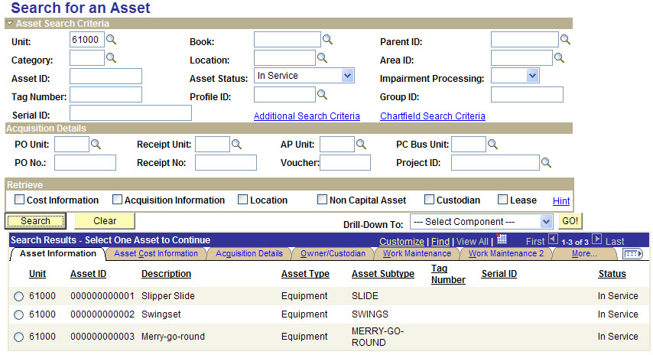
Search for an Asset Page
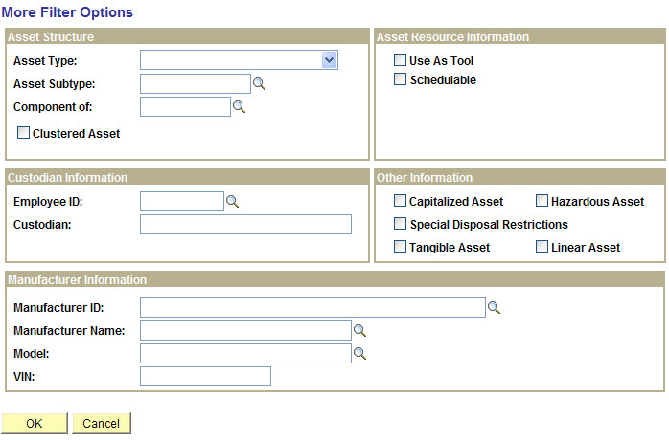
Additional Search Criteria hyperlink

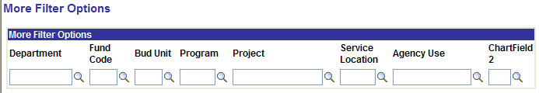
Chartfield Search Criteria hyperlink

Fields | Description
Asset Search Criteria section | Provides asset-related search fields to locate the assets that you wish to review. Enter criteria in the selected fields to limit your search results.  Note: If no Book is specified, the system will assume you want to view the CAFR book, which has capital assets. If all assets, capital and noncapital, are desired, select STATE.
Additional Search Criteria hyperlink | Provides the ability to search by Asset Type/Subtype, Custodian Information, and Manufacturer Information
Chartfield Search Criteria hyperlink | Allows you to enter specific ChartFields or a combination of ChartFields as search criteria
Acquisition Details section | Provides the ability to locate the assets that you wish to review by entering information related to the purchase order, receipt, voucher, or project ID.
Retrieve section | Use the checkboxes to indicate what information should be displayed in the search results  Typically, you should select Cost Information, Acquisition Information, Location, and Custodian.
Asset Search Utility Fields
- After performing your search, you can drill down to other asset pages for a specific asset in your search results. Click the radio button next to the asset you want to view, then select what page you want to navigate to from the “Drill Down To” dropdown box. Then click GO! and a new window will open.
  - Examples of other pages you can navigate to are:
    - Review Financial Accounting Entries
    - Basic Add
    - Cost Adjust/Transfer Asset
    - Cost History
    - Depreciation
    - Retirement
    - Copy an Asset
- The search results can be downloaded to Excel by using the button.

Asset Reports
- Use the “AM Reports and the Information They Provide” job aid to assist you with asset reporting. It lists the available reports for Asset Management, a brief description for each, and the navigation.
  - For reports with Template options (marked with *), see Knowledge Base Article #596 in the Service Desk.
- The most commonly used report is the “Asset Inventory List.” If you’re not sure where to start on asset reporting, run this one.
- Utilize the Reporting section of the SMART website for additional tips on how to run reports, downloading report results, and converting a .dat file to Excel.

