State of Kansas
High-Level Changes from 9.0 to 9.2 in Asset Management:
Asset Management WorkCenter
Statewide Management, Accounting and Reporting Tool
Date Created: | 10/28/2015
Version: | 1.0
Last Updated Date:
Purpose: | This document highlights one of the changes between 9.0 and 9.2 in the Asset Management module.
Security: | - Role Security: The following roles are applicable:  Agency Asset Processor  KS Assets Viewer  BU Security: Business Unit Security is applied. Agencies will only have access to the assets in their Business Unit.
Procedure

The Asset Management WorkCenter is a one-stop-shop for transaction processing, reporting, error identification, and links to commonly used pages.

Note additional UPKs exist for how to personalize your WorkCenter. This training simply illustrates the features of the Asset Management WorkCenter.

Step | Action
 | Click the Main Menu button.
 | Click the Asset Management menu.

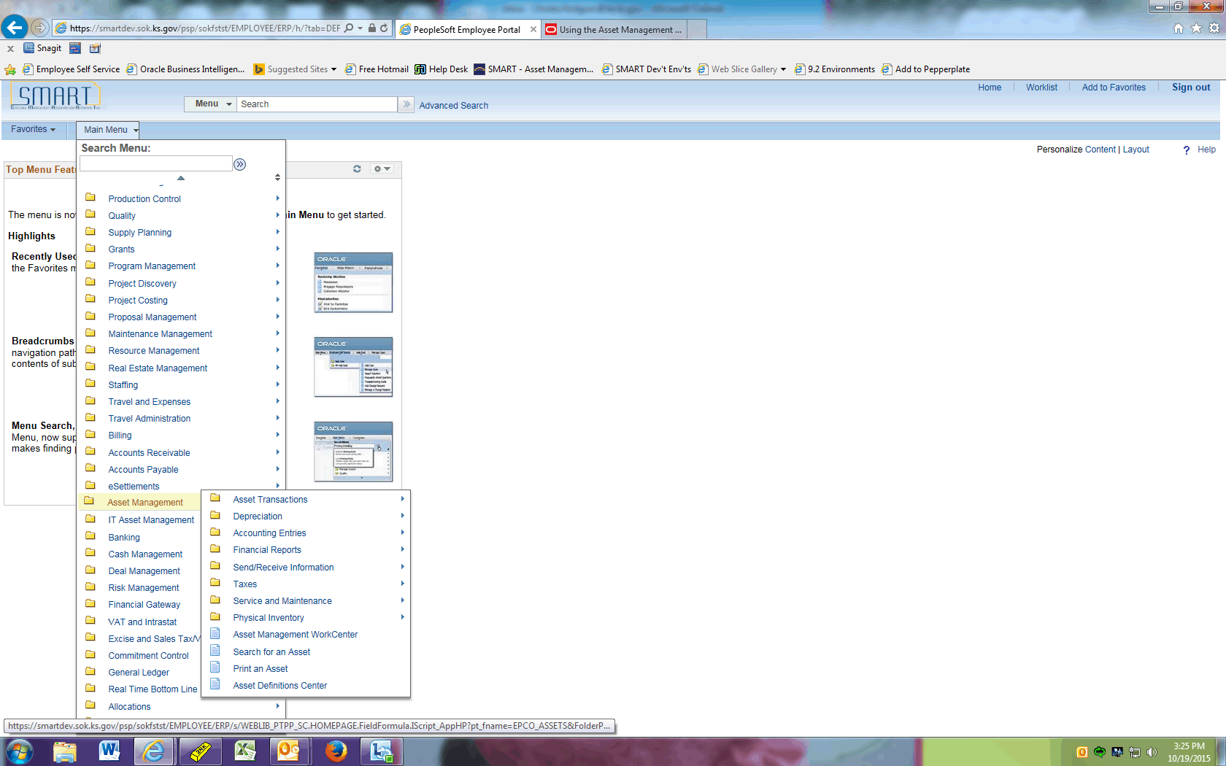

Step | Action
 | Click the Asset Management WorkCenter menu.

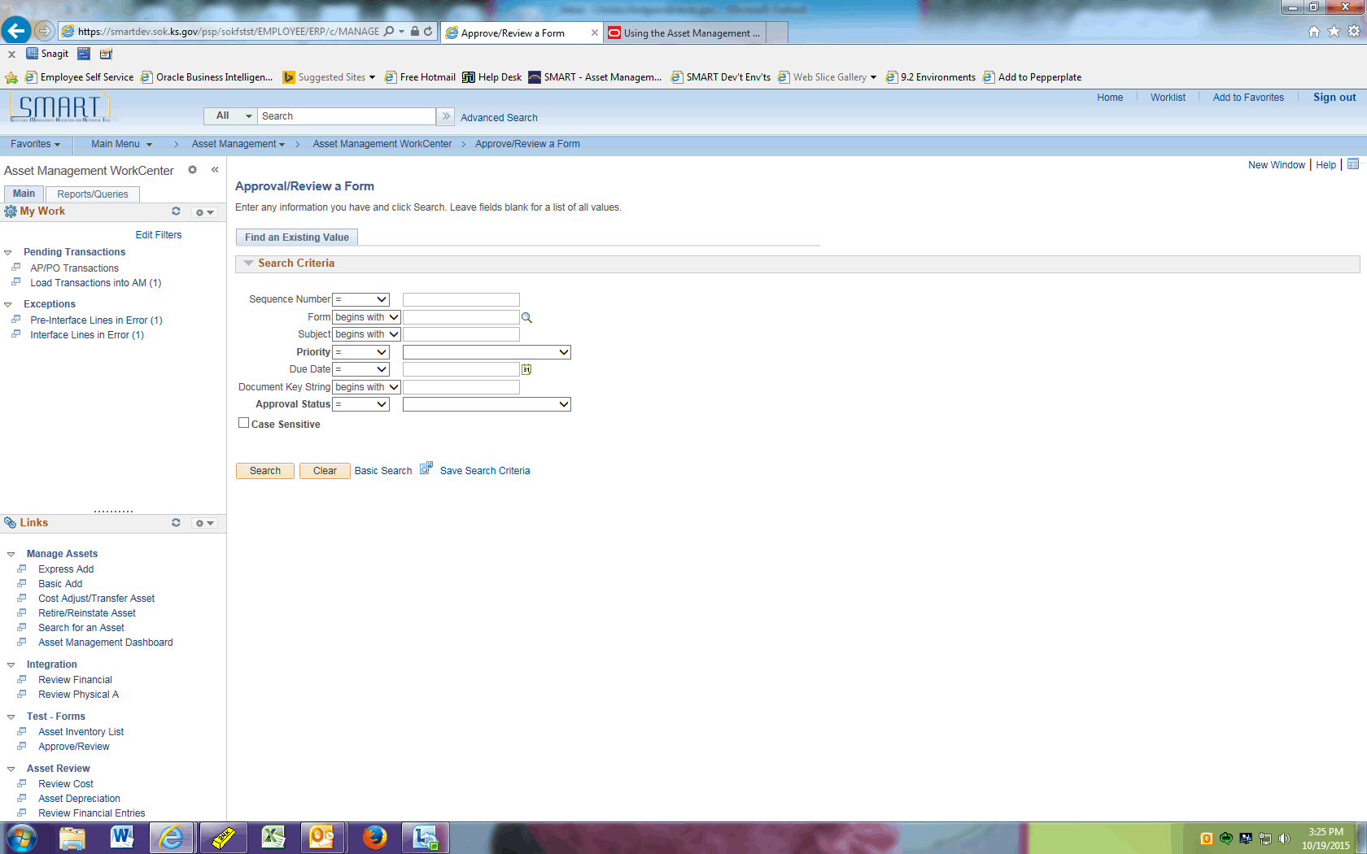

Step | Action
The My Work pagelet allows you to view and edit your most commonly used components. It can also alert you to items that require your attention.

The Pending Transactions group level displays asset transactions with a processing status of Pending and includes these links to transaction areas:

--AP/PO Transactions: Review and act upon pending AP or PO transactions

--Load Transactions into AM: Review and run the Transaction Loader process (AMIF1000)

The Exceptions group level includes links to these transaction areas:

--Pre-Interface Lines in Error: Displays pre-interface lines in error and a link to reset transactions to Pending. This type of error will require Central assistance.

--Interface Lines in Error: Displays interface lines in error and a link to reset transactions to Pending. This type of error may require Central assistance.

 | Click the Load Transactions into AM link.

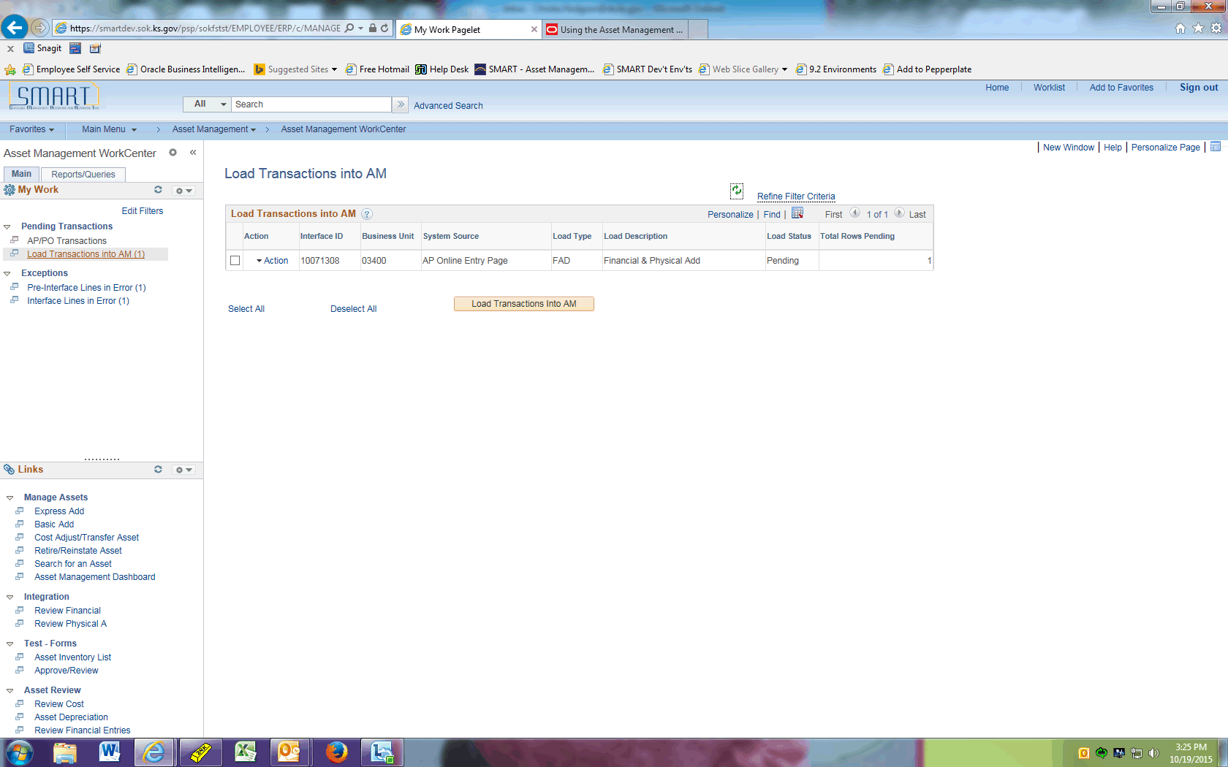

Step | Action
 | Click the Action link.

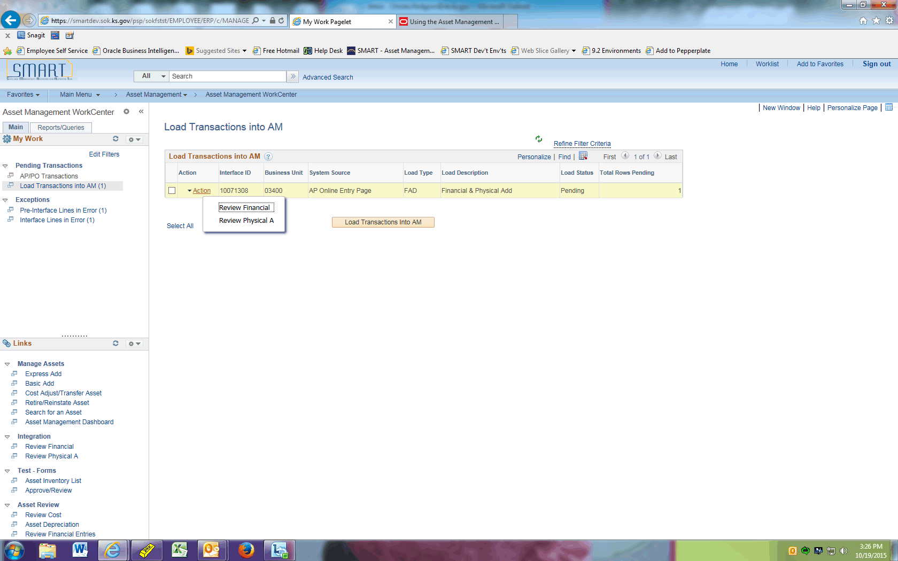

Step | Action
 | Click the Review Financial menu.

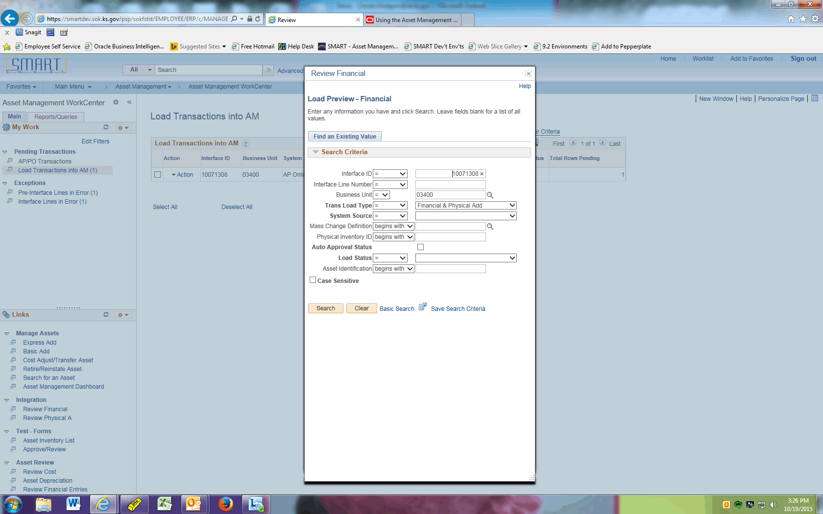

Step | Action
 | Click the Search button.

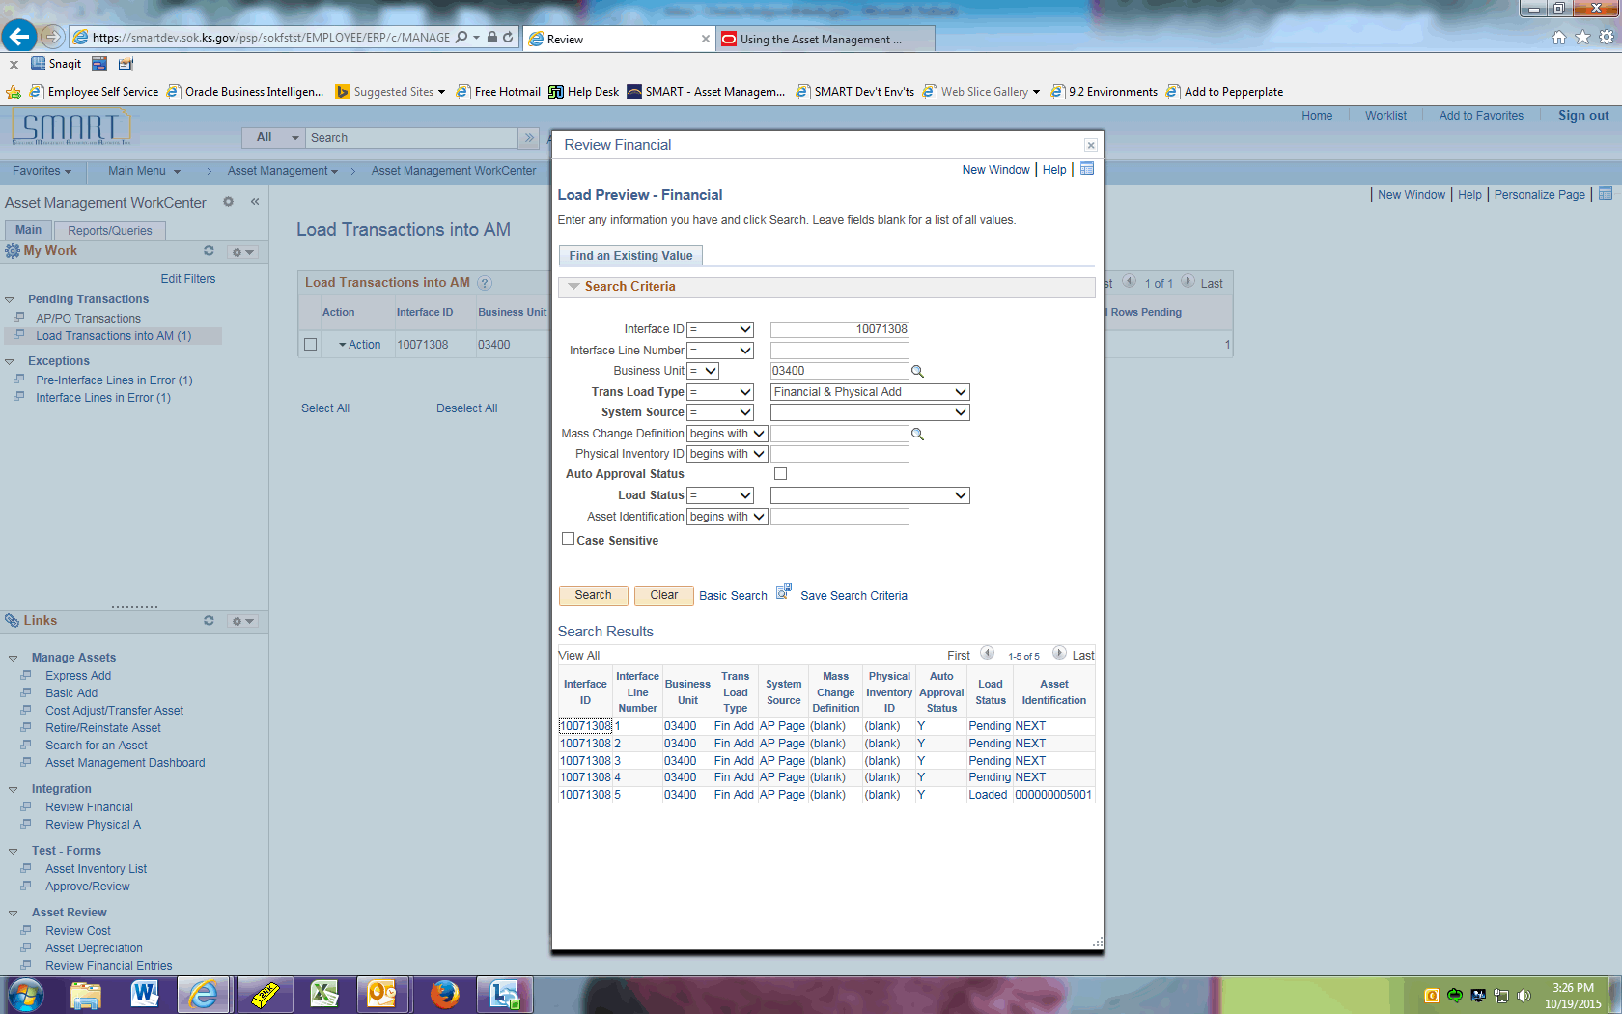

Step | Action
 | For this example, click the first 10071308 link. This allows you to view detailed information about this interface line. This will help you determine whether or not this Interface ID should load.

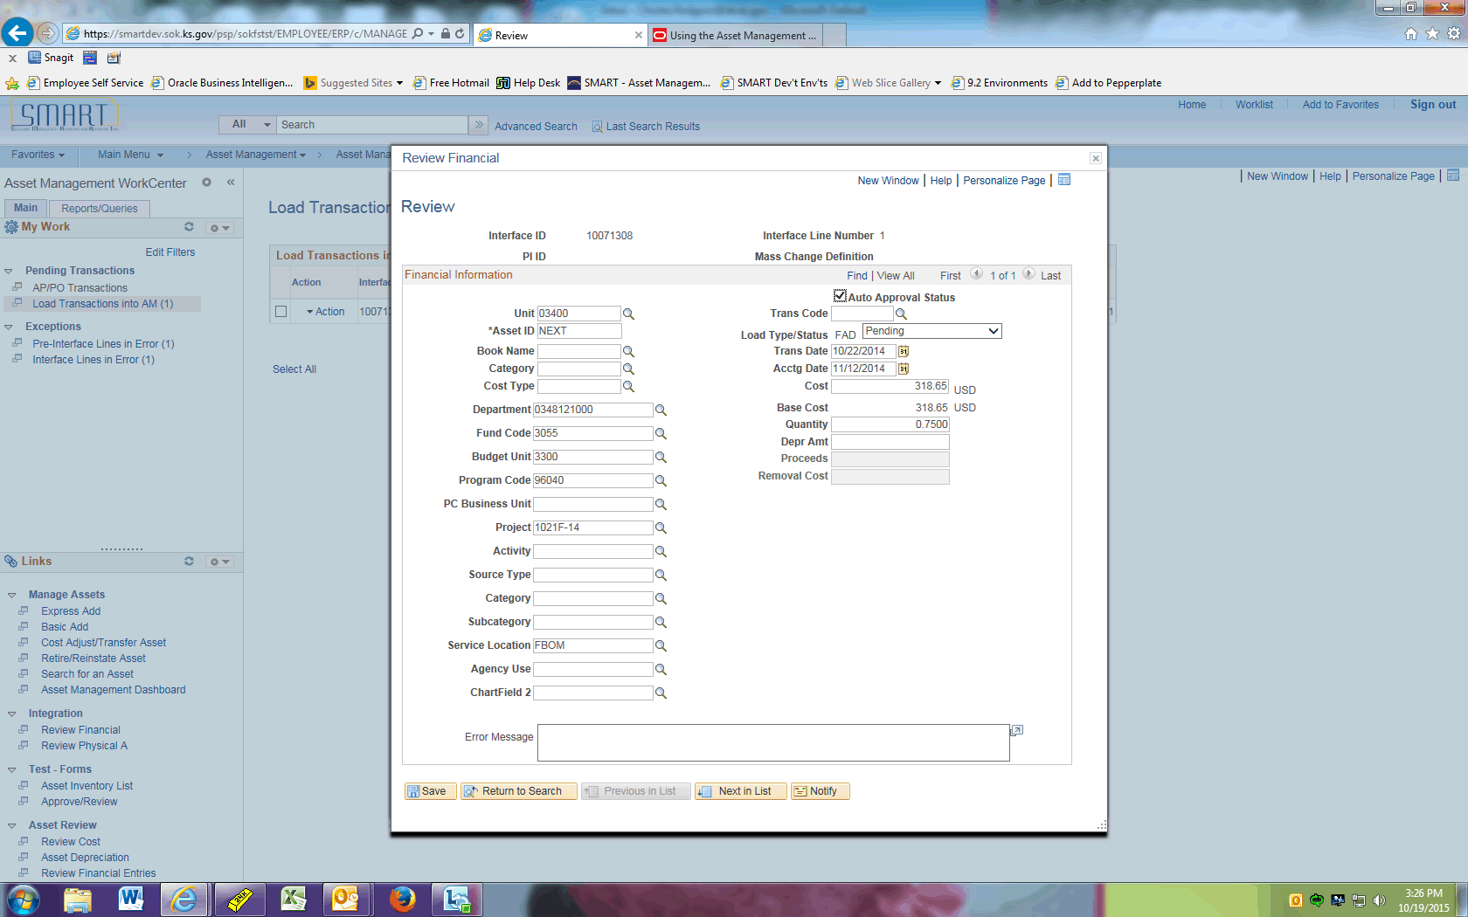

Step | Action
Review the data for accuracy.

Click the Close link.

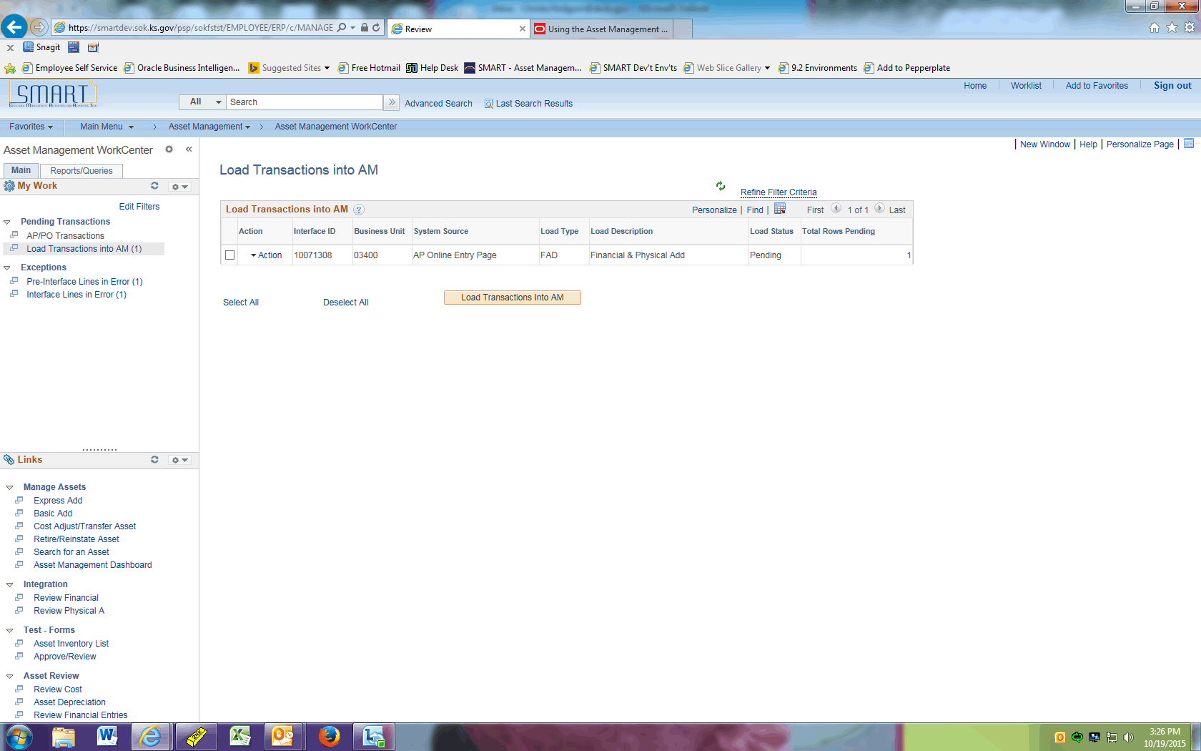

Step | Action
 | Click the option to select this Interface ID to load.
 | Click the Load Transactions Into AM button.

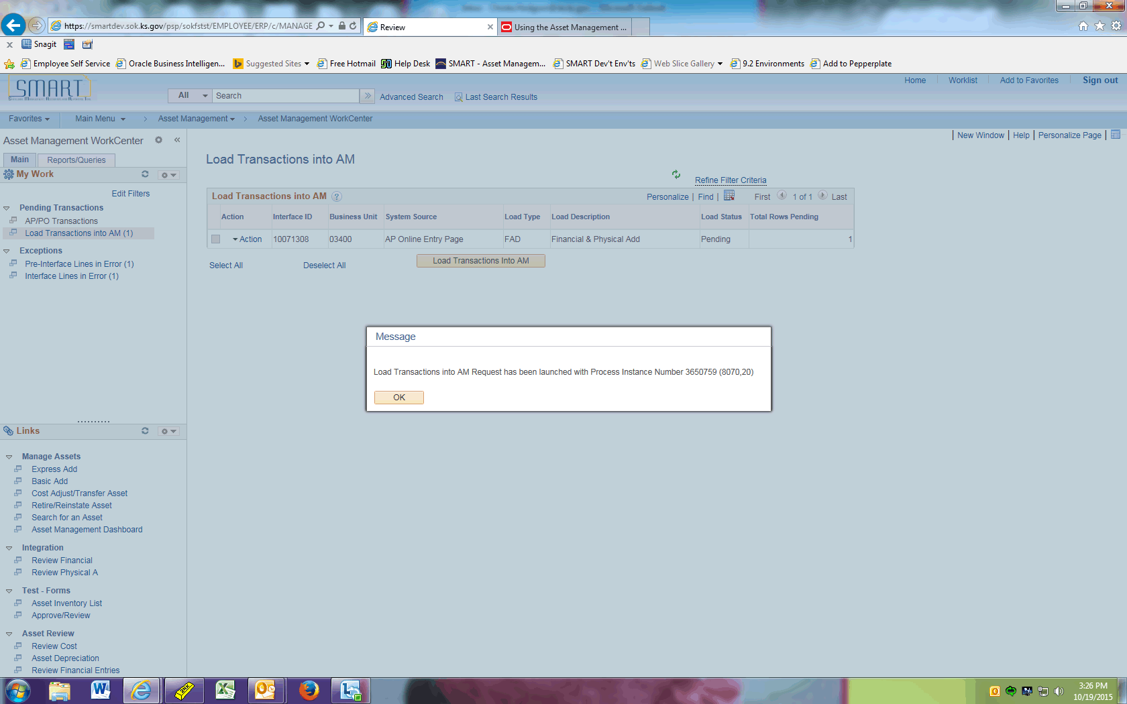

Step | Action
 | Click the button. You have successfully kicked off the Transaction Loader process.
 | Click the Pre-Interface Lines in Error (1) link.

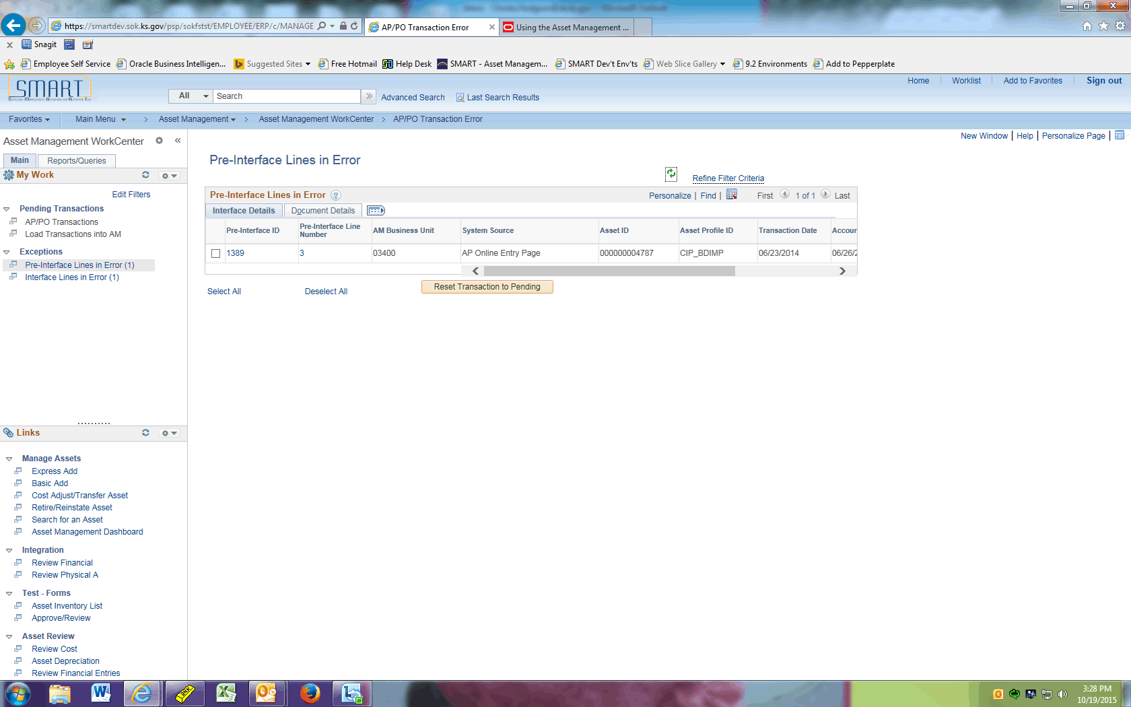

Step | Action
 | This page displays any Pre-Interface Lines in Error. This typically occurs when an Interface ID has not been loaded yet and has the same Purchase Order/Voucher as the Pre-Interface ID. That Interface ID must be loaded first before the stuck Pre-Interface ID can be pushed forward. Log a ManageEngine Service Desk ticket for assistance if there are transactions that cannot process further on this page. Central also monitors this on a monthly basis.
 | Click the Interface Lines in Error (1) link.

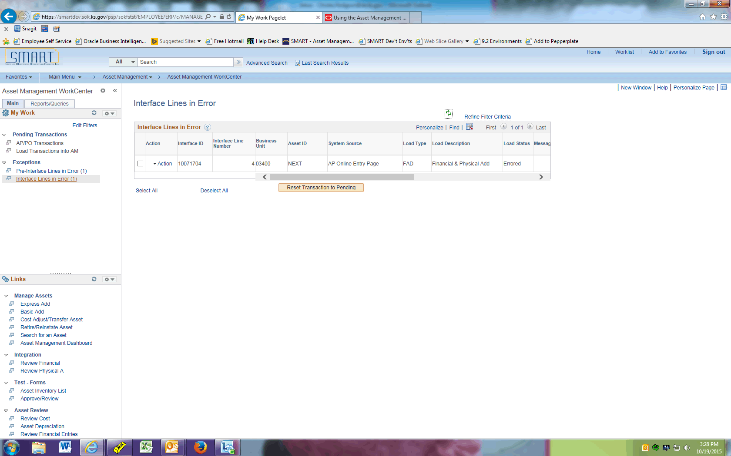

Step | Action
 | The Interface Lines in Error page displays any Interface Lines that cannot load due to an error. If you cannot identify the error, please log a Service Desk ticket for assistance.

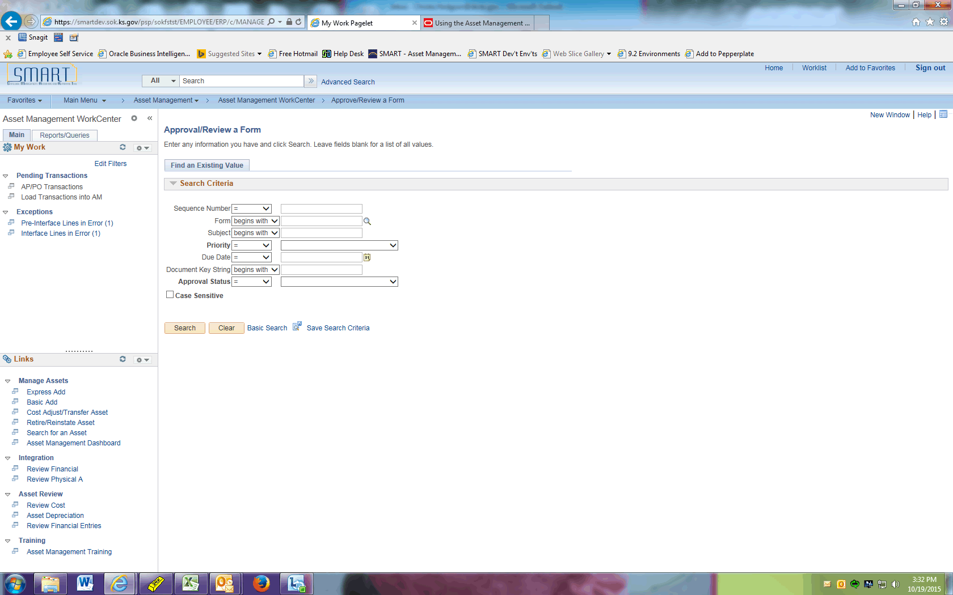

Step | Action
 | The Links pagelet displays links to commonly used AM pages as well as training material.
 | Click the Reports/Queries tab.

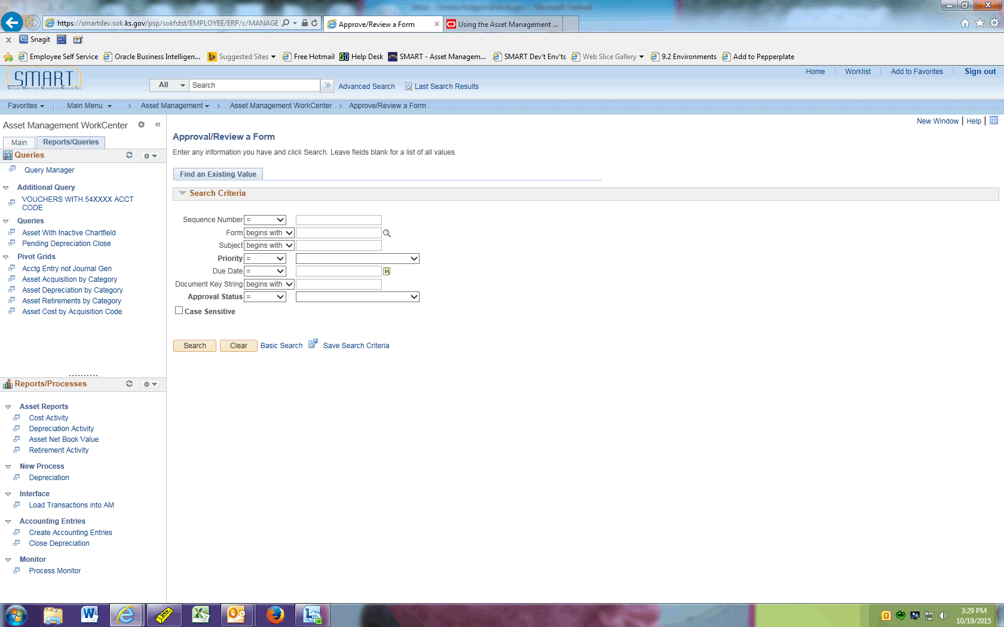

Step | Action
The Queries pagelet displays queries and Pivot Grids.

Note that the Pivot Grids are delivered functionality and have NOT been tested for data accuracy.
 | Click the VOUCHERS WITH 54XXXX ACCT CODE link.

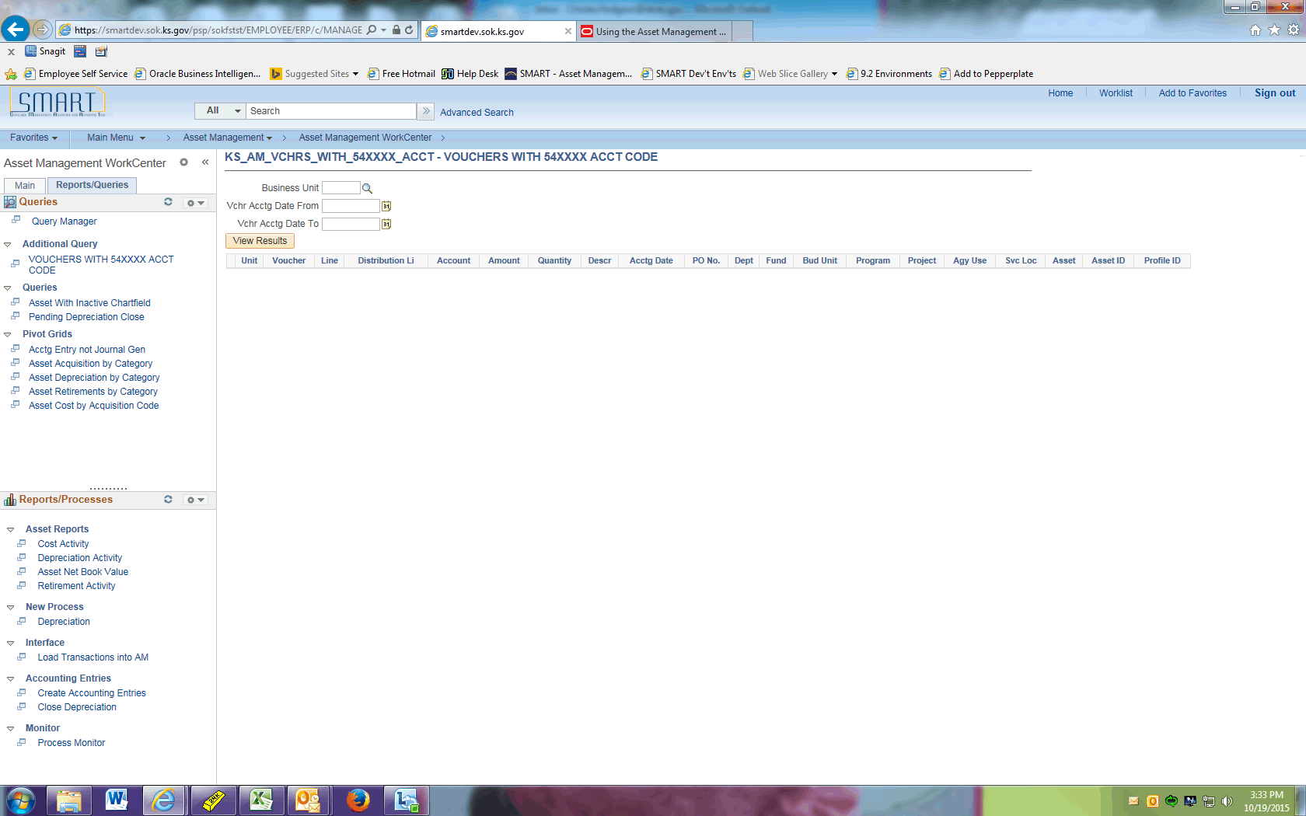

Step | Action
You are able to populate the parameters and run this query directly on this page.

Next we will review how several Pivot Grids function.
 | Click the Asset Acquisition by Category link.
 | Click the Options Menu button.

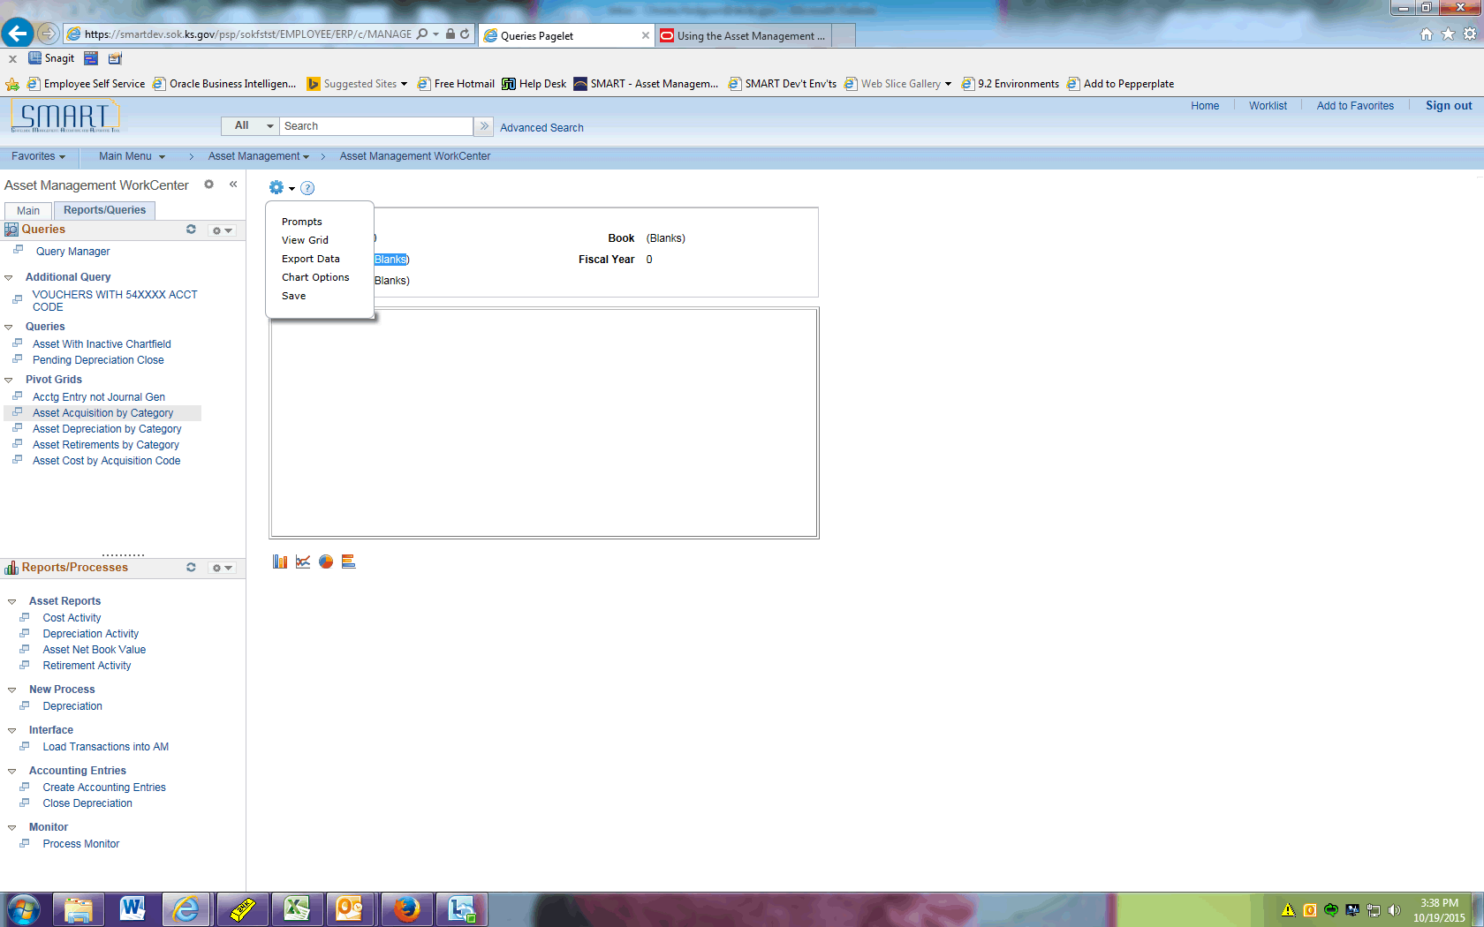

Step | Action
 | Click the Prompts menu.
 | Enter the desired information into the Business Unit field. Enter "03400".
 | Enter the desired information into the Book field. Enter "CAFR".
 | Enter the Fiscal Year.
 | Click the Ok button.

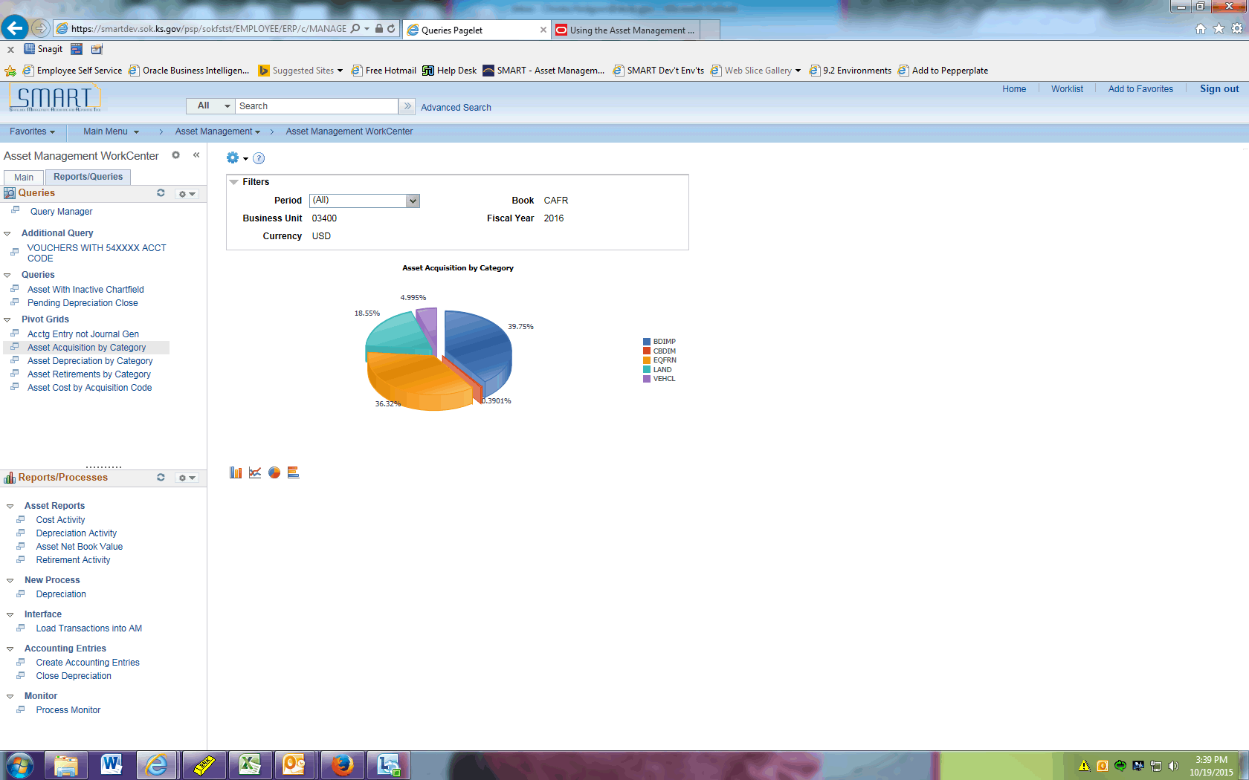

Step | Action
 | The Asset Acquisition by Category results display. Notice you have the option of selecting a specific period in the Period dropdown if desired.
 | Click the Asset Depreciation by Category link.
 | Click the Options Menu button.

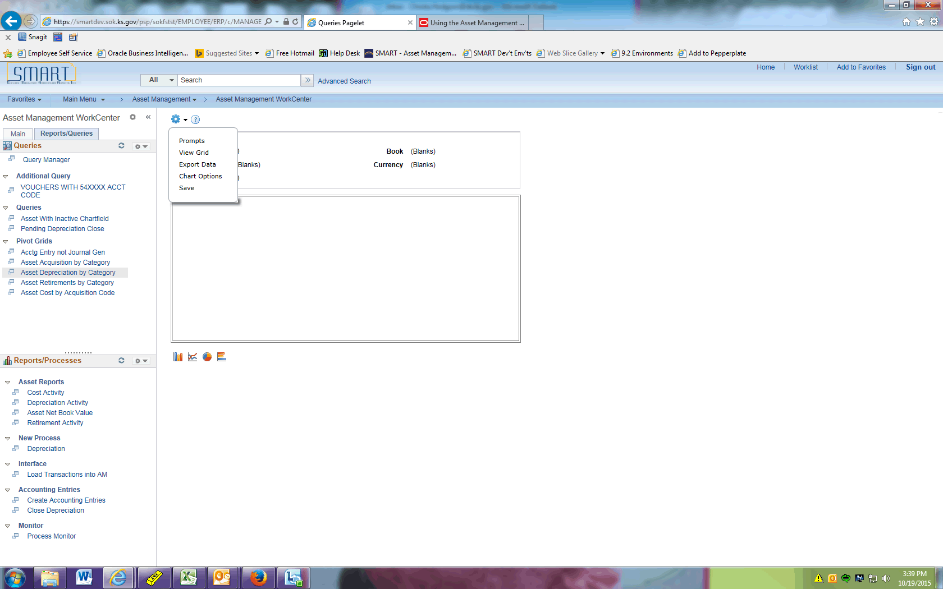

Step | Action
 | Click the Prompts menu.
 | Enter the desired information into the Business Unit field. Enter "03400".
 | Enter the desired information into the Book field. Enter "CAFR".
 | Click the Ok button.

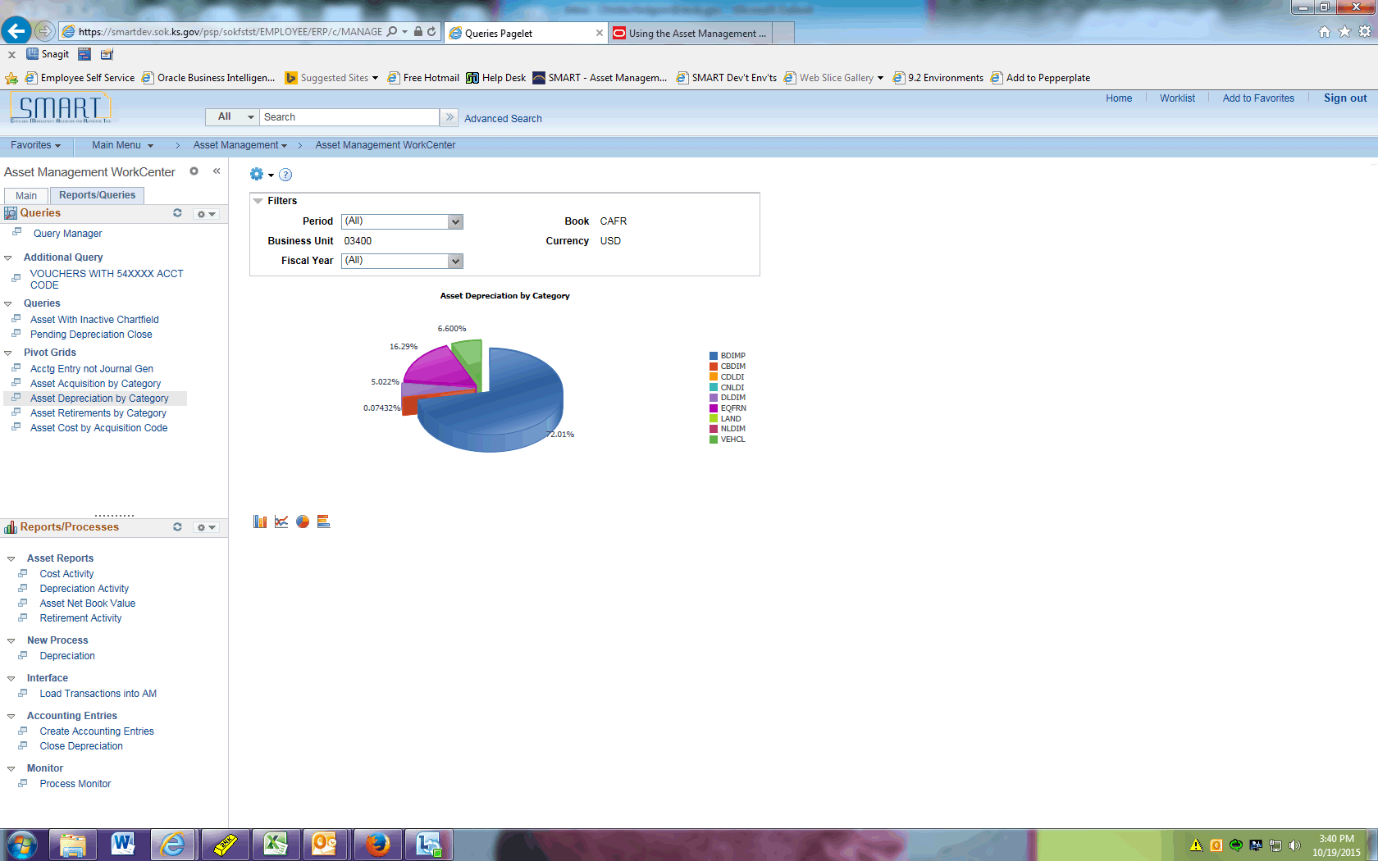

Step | Action
The Asset Depreciation by Category results display.

Notice you can change the view with the icons on the lower left. We'll do that next.
 | Click the Asset Retirements by Category link.
 | Click the Options Menu button.

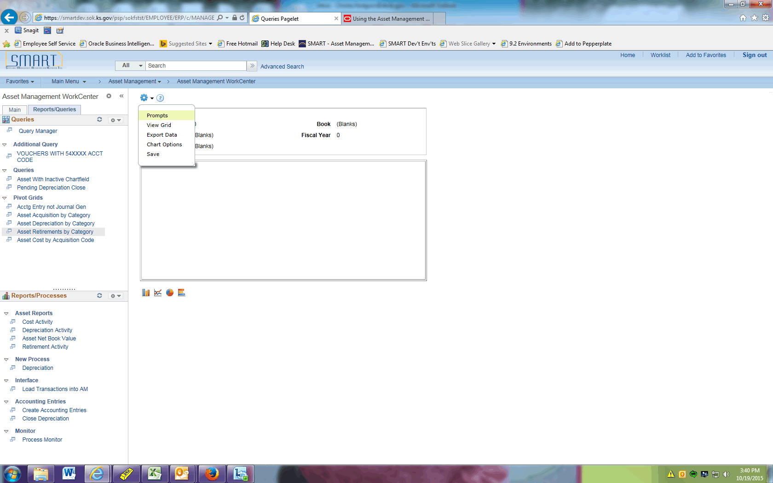

Step | Action
 | Click the Prompts menu.
 | Enter the desired information into the Business Unit field. Enter "03400".
 | Enter the Book.
 | Enter the desired information into the Fiscal Year field. Enter "2016".
 | Click the Ok button.

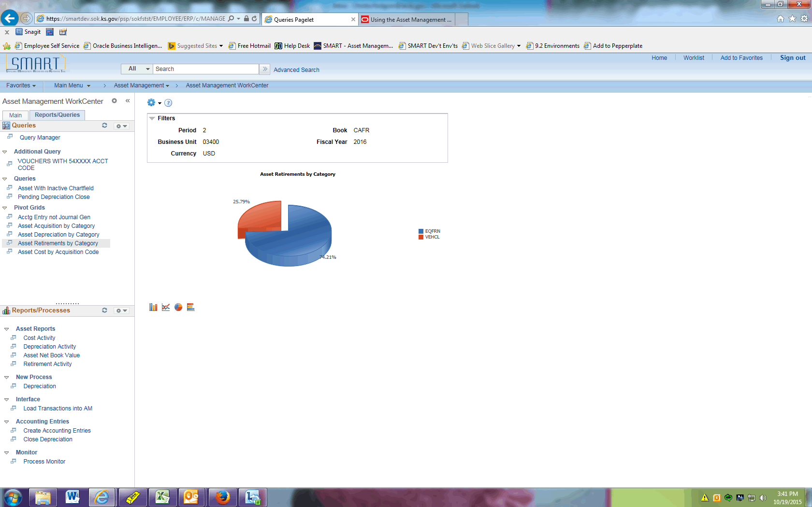

Step | Action
 | Click the Bar Chart button.

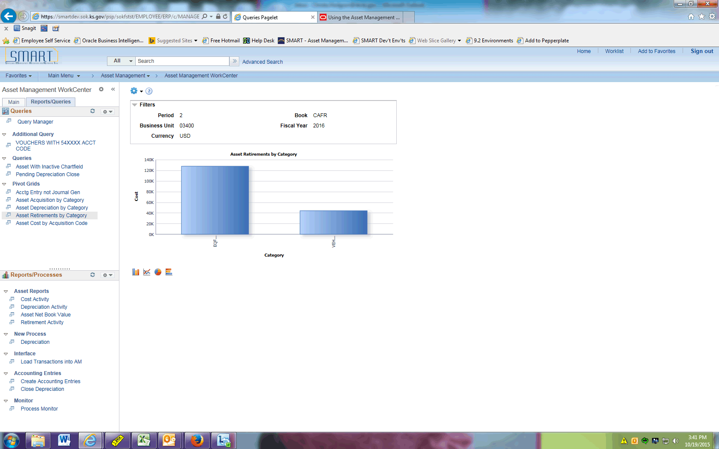

Step | Action
 | Now the data is displayed in a bar chart.
 | Click the Asset Cost by Acquisition Code link.
 | Click the Options Menu button.

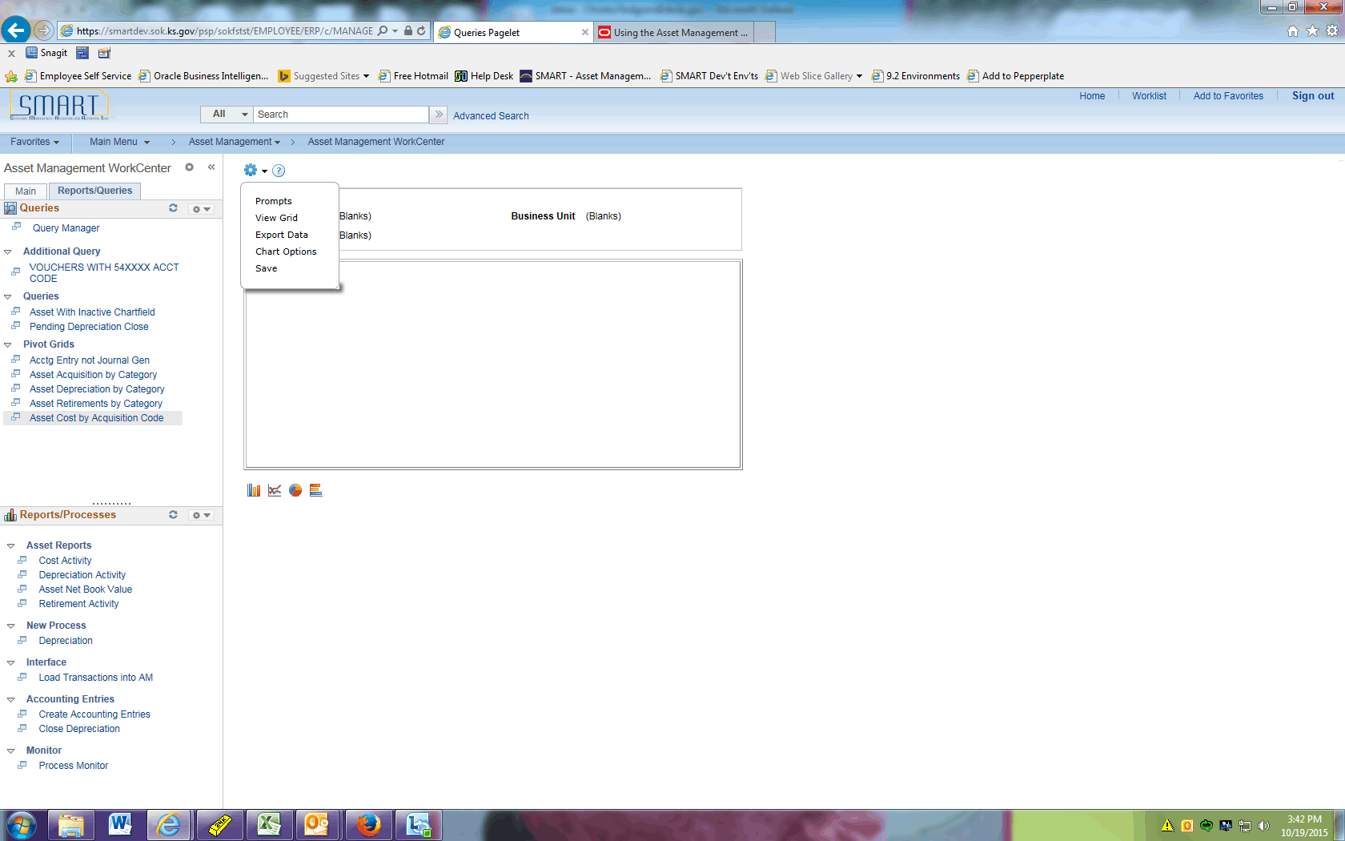

Step | Action
 | Click the Prompts menu.
 | Enter the desired information into the Business Unit field. Enter "03400".
 | Enter the desired information into the Book field. Enter "CAFR".
 | Click the Ok button.

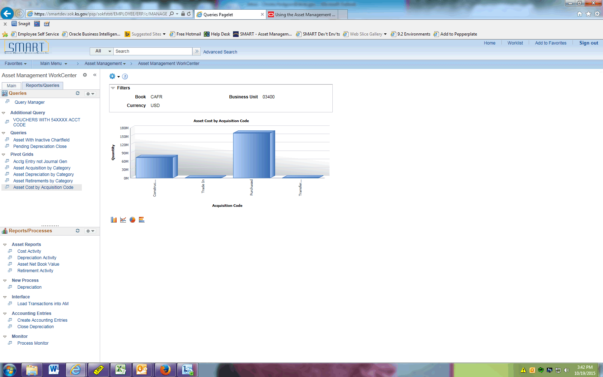

Step | Action
 | Click the Options Menu button.

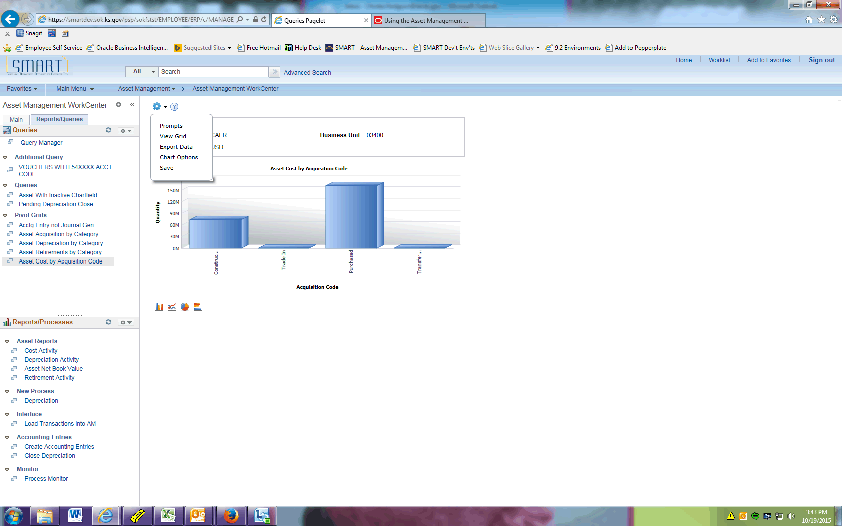

Step | Action
Next we will review how to drill down into the transaction details that make up the totals on our chart.

Click the View Grid menu.

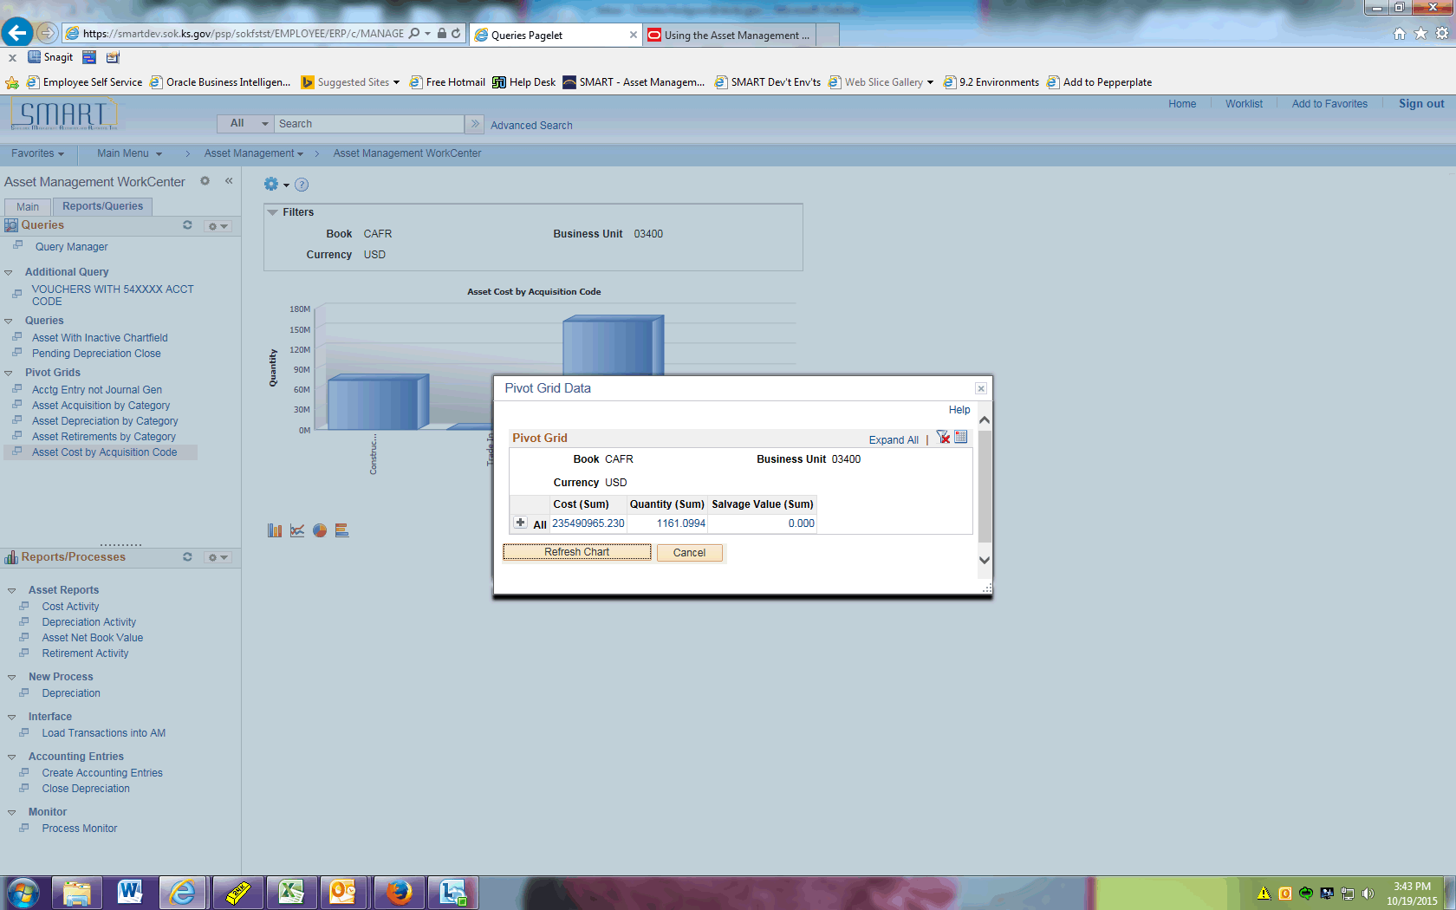

Step | Action
 | Click the All button.

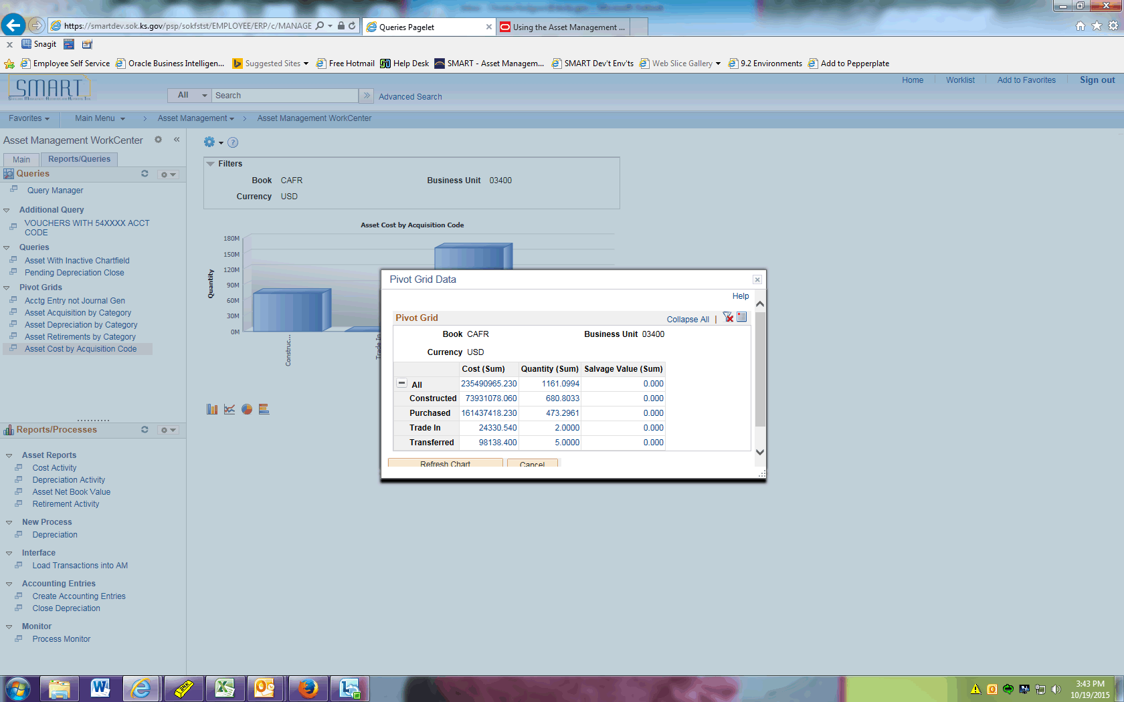

Step | Action
We want to look into the Trade In assets.

Click the Cost associated with Trade In.

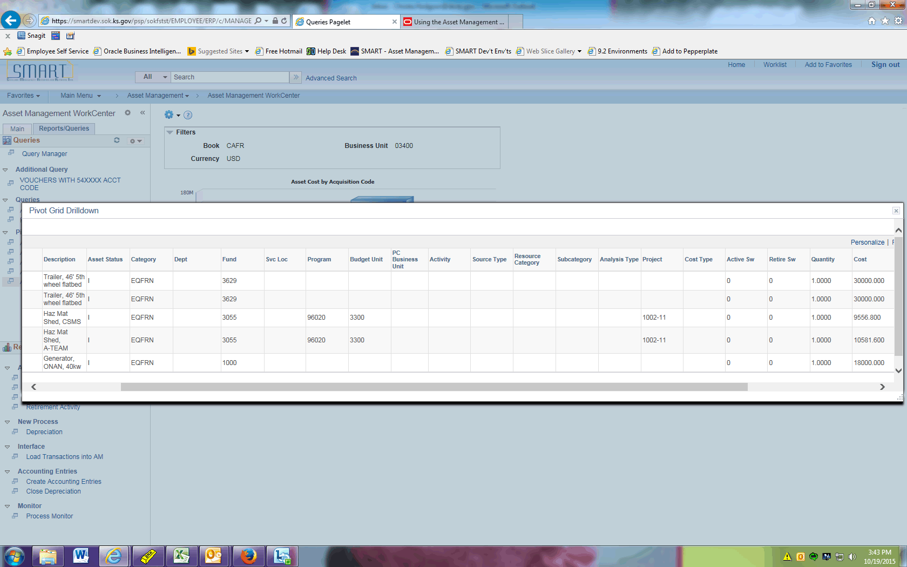

Step | Action
A new window opens with the drilldown data.

Click the Close link.
 | Click the Cancel button.

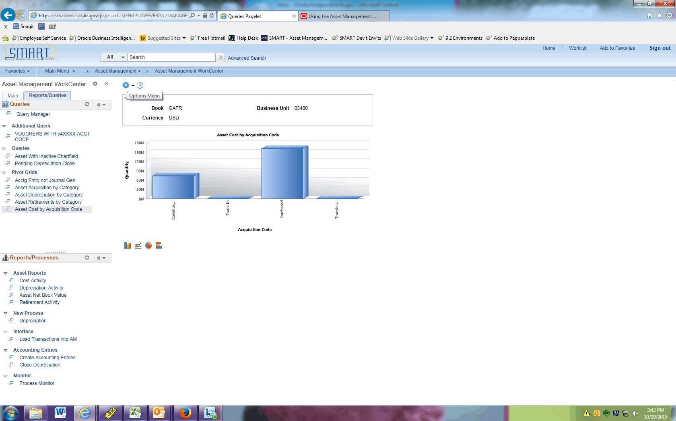

Step | Action
Now we want to export the data.

Click the Options Menu button.

Step | Action
 | Click the Export Data menu.

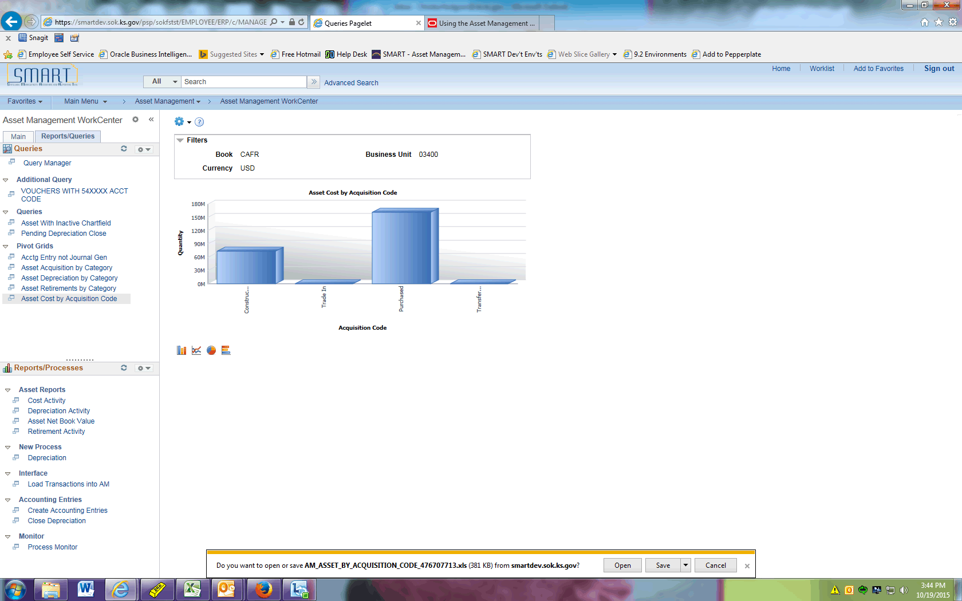

Step | Action
Click the Notification toolbar. This will open an Excel workbook with the results from your Pivot Grid.

(Note this may look slightly different depending on what internet browser you use.)
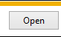
Next change the Chart Options.

Click the Options Menu button.

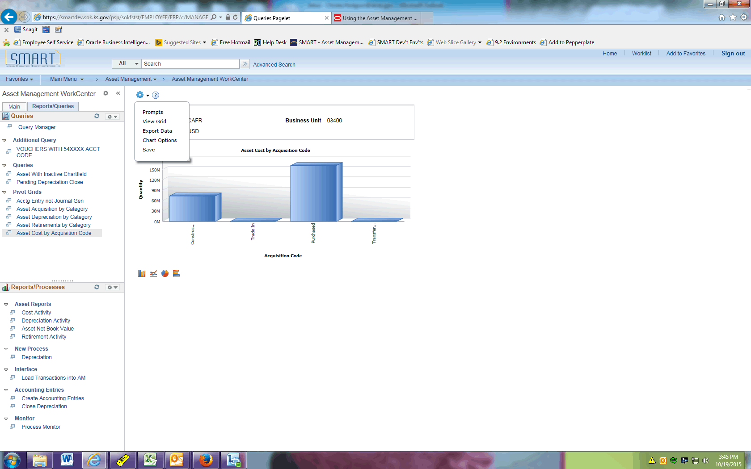

Step | Action
 | Click the Chart Options menu.
 | Click the 3D Stacked Bar Chart list item.
 | Click the Category list item.

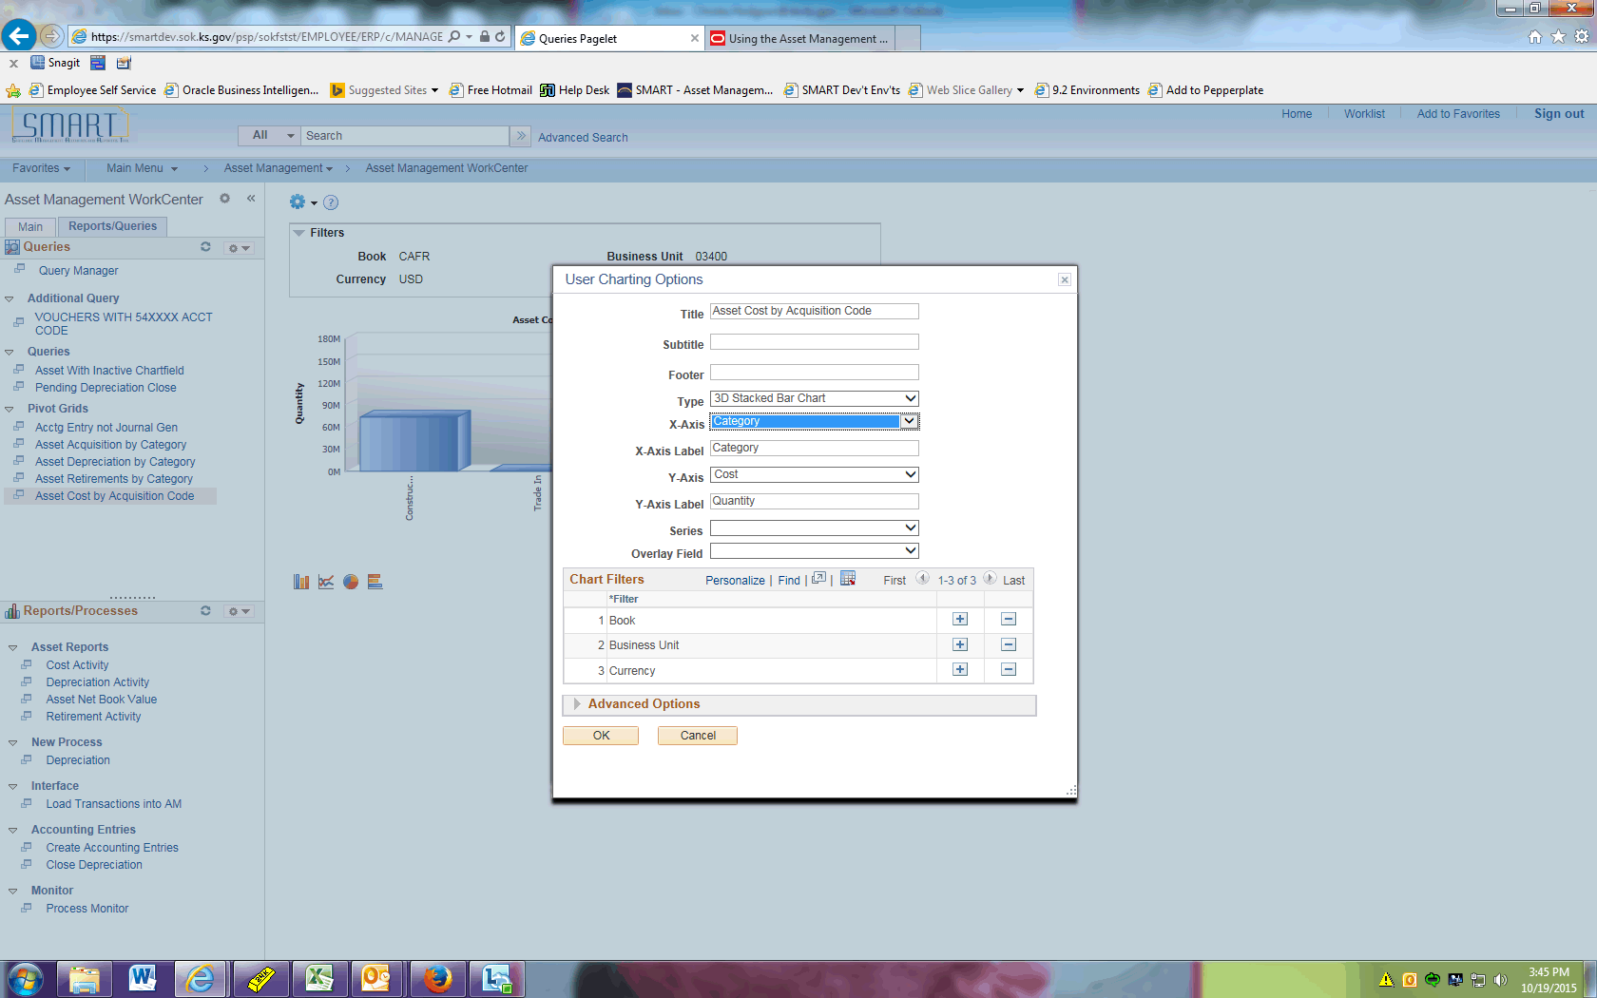

Step | Action
 | Click the OK button.

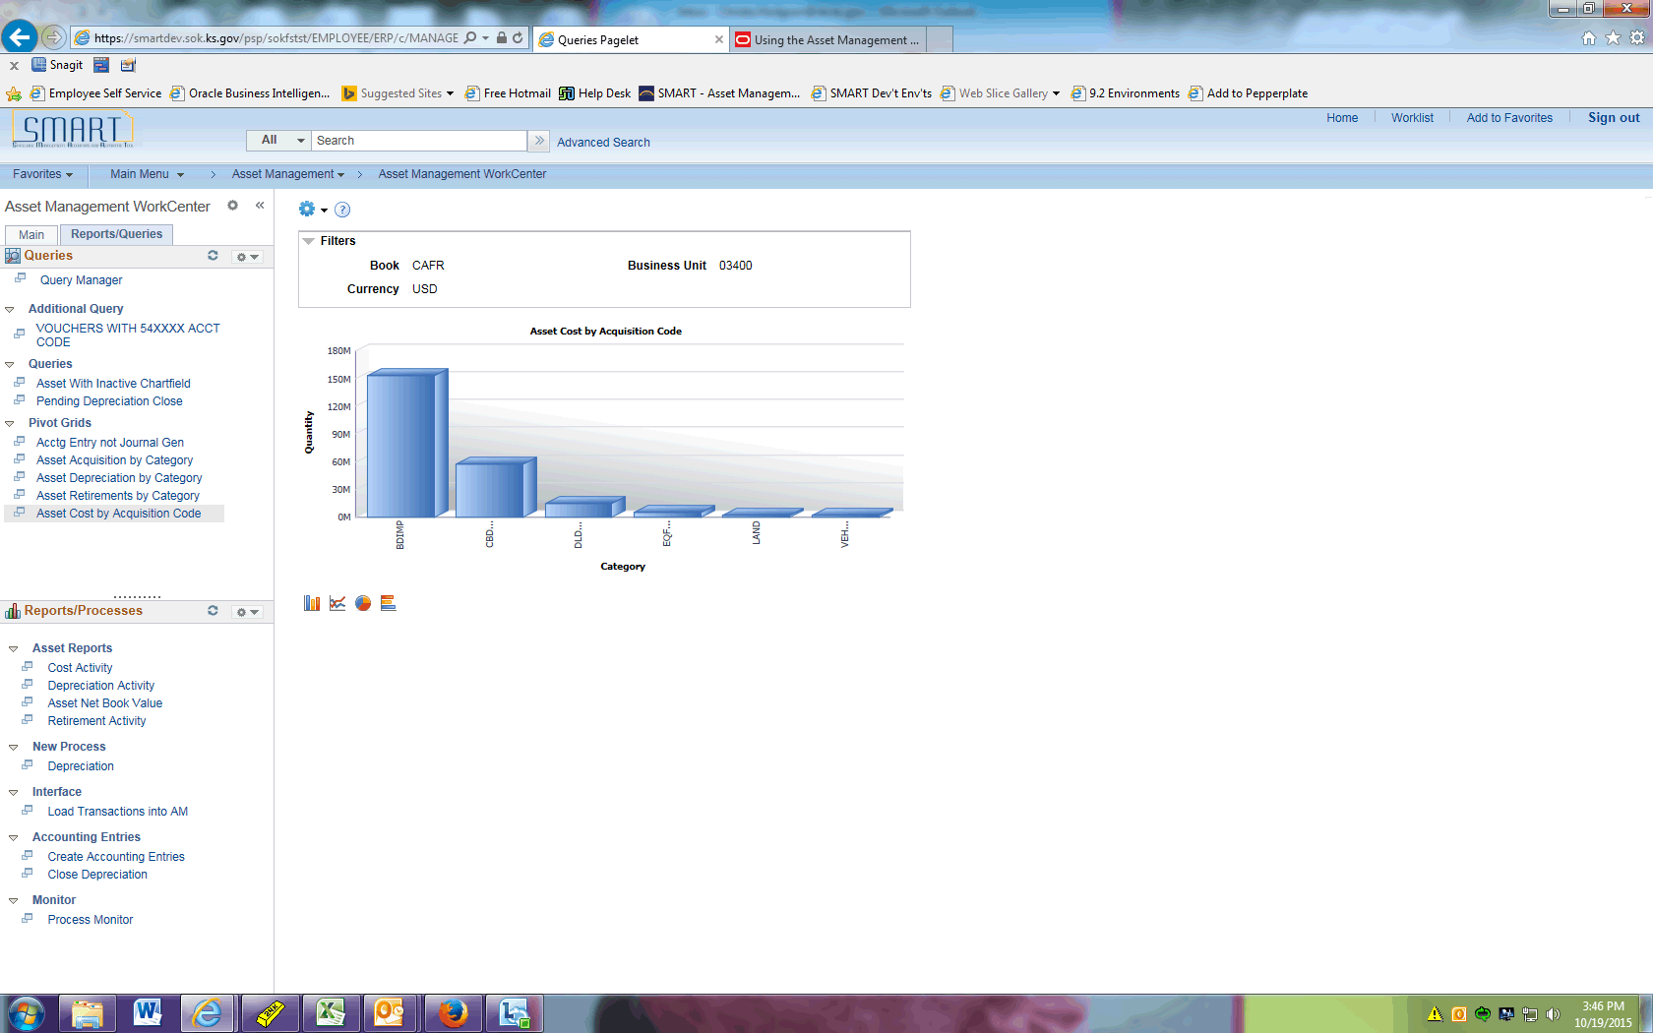

Step | Action
 | The results update with the newly specified chart options.
 | The Reports/Processes pagelet contains commonly used reports and AM batch processes. Note that agencies rarely need to kick off batch processes as these are scheduled on a nightly or monthly basis. These links will be controlled based on your security setup.

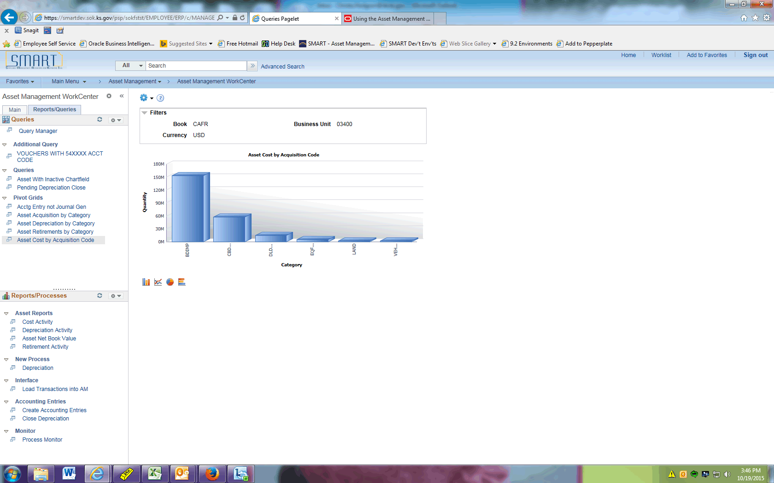

Step | Action
The Pagelets can be moved up and down for better visibility.

Click the Resize WorkCenter Pagelet button.
This concludes the 'AM - WorkCenter' topic. Thank you for taking this course.

As a reminder, WorkCenters are customizable. Additional UPKs are available to assist you with personalization if desired.
End of Procedure.

