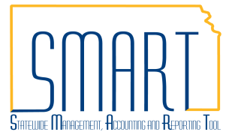
State of Kansas
Alternate Workflow Approvers
Statewide Management, Accounting and Reporting Tool

Date Created |  | 05/31/2019
Version |  | 1.0
Security |  | - Role Security: Only users with the following roles will have access to approve a voucher:  - Agency – AP Approver Set A (KAP_AGY_AP_A_APPR)  - Agency – AP Approver Set B (KAP_AGY_AP_B_APPR)  - Agency Fiscal Office Approver (KAP_AGY_AP_FO_APPR)  We recommend users have the following role to view the voucher:  - Agency AP Processor (KAP_Agy_AP_Processor)  - BU Security: Business Unit Security is applied. Agencies will only have access to the vouchers associated to their agency business unit.
Purpose |  | Alternate approvers can be set up when a user plans to be out of the office and unavailable to approve SMART documents. No change to the actual workflow setup is required to use alternate approvers. However, alternate approvers must have the appropriate approval roles.  Alternate Approvers are effective for these modules:  - Accounts Payable  - Requisitions  - Expenses  - General Ledger  Once the alternate approver is saved, it applies to the workflow for all modules until the alternate approver is removed.
Queries |  | The following queries can be run to determine users who are set up as an approver for the various origin codes. Business Unit Security is applied, and the results will contain only users associated to your agency business unit.  - KS_SET_A_B – Set A and Set B approvers  - KS_APPROVER_AP_V1 – Fiscal Office approvers
Navigation |  | SMART Homepage > My System Profile > General Profile Information
1. | SMART opens to the SMART Homepage.  Select the ‘My System Profile’ tile. | 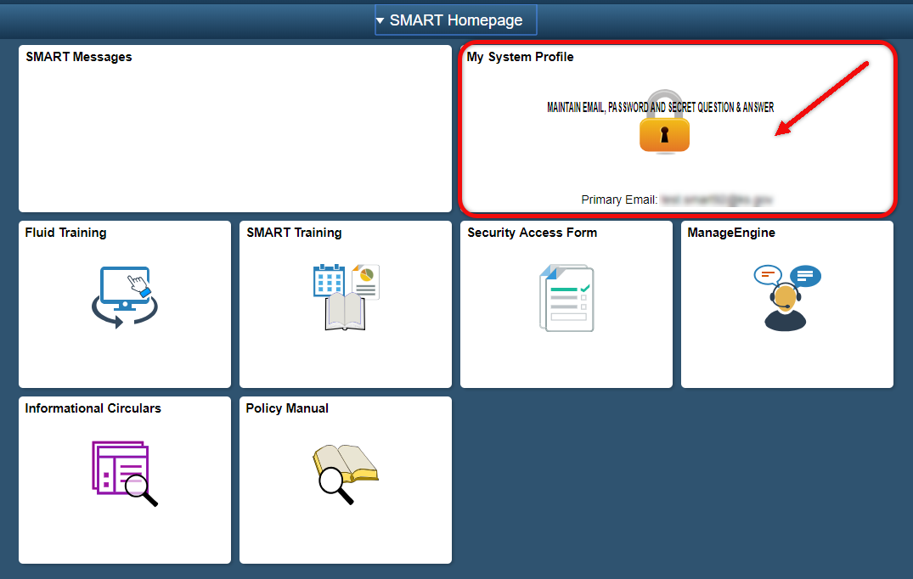
2. | In the Alternate User section:  - Enter the USER ID for the SMART user who will approve transactions in your absence in the ‘Alternate User ID’ field.  - Enter the beginning and ending dates of your absence in the ‘From Date’ and ‘To Date’ fields.  - Scroll to the bottom of the page, and click ‘Save.’ | 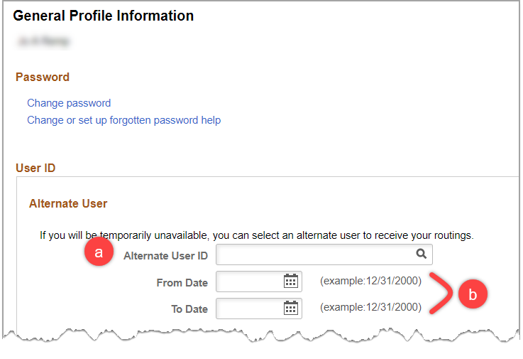  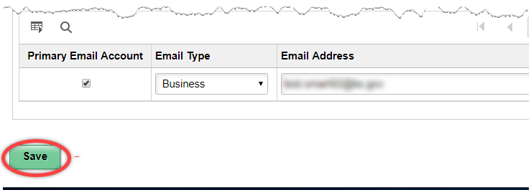
3. | The alternate approver will receive your approval notifications for the designated time period. When you return from your absence, SMART transactions assigned to the alternate approver remain in pending approval status for the alternate approver.  If you choose to approve any vouchers sent to the alternate approver upon your return to the office, see the AP Voucher Approvals job aid for instructions to retrigger workflow on a voucher.

