Training Guide – Billing
Advanced Billing Process

State of Kansas

Applicable Role(s): Billing Administrator, Billing Processor and Central BI Configurator

Table of Contents
Advanced Billing Overview 3
3
End-to-End Billing Process 3
Billing Roles 4
Finalize and Print Bills 5
5
Process Invoices 5
Researching Invoiced Bill Lines 7
Researching Invoiced Bills 7
Processing and Printing Consolidated Bills 11
Review Accounts Receivable 17
Maintaining Bills 18
18
Key Concepts 18
Credit a Bill 19
Credit an Entire Bill and Rebill 21
Credit a Bill Line and Apply to an Existing Bill 21
Creating a Bill Line Reversal and Rebill 22

Advanced Billing Overview

- Consolidated – You may have customers who want to receive multiple invoices grouped together, or consolidated, for ease in processing. With SMART Billing, you can consolidate billing by customers. To consolidate bills, you:
  - Create a consolidated bill header
  - Attach individual bills to the consolidated bill header
- Non-Consolidated – Individual bills or invoices to customers
Note: Bills are NOT invoices. Bills do not have the status of INV. Invoices are bills that have been processed and finalized. Invoices cannot be copied or updated

End-to-End Billing Process

Figure 1. Billing Lifecycle Process

Billing Roles
The following roles are involved in the Advance Billing Process:

Role | Description
Billing Administrator (BI) | This role is responsible for setting bills to "ready" status and running the finalize and print process to finalize invoices, as needed. This role also maintains agency-configured values in the Billing module.
Billing Processor | This role is responsible for creating new standard invoices and Pro Formas, copy single or groups of bills, reprint and review invoices, setting up and modifying installment schedules, creating new consolidated invoices, and printing invoices.
Central BI Configurator | This role is responsible for maintaining centrally controlled BI configuration values such as Remit To Addresses and Billing Sources.
Table 1. Advanced Billing Roles

Finalize and Print Bills

Process Invoices
- You create invoices from the bills in the billing system, with the exception of template bills, which are used to create consolidated bills. There are a number of actions, both optional and required, that you perform to generate invoices. For example, you must enter all necessary header and line information and change the status of the bill to RDY (Ready).
- Once you complete these steps, you finalize the bill, print one or more copies or create an invoice, and send it to the customer. You control when to finalize the bill, when to print the invoice, and when to send it to the customer. There is functionality in the system to email the invoice during Finalization.
- The Finalize and Print multi-process job runs the following process:
  - Preprocess and Finalization: Runs the actual bill finalization process, which produces an invoice
- Finalization changes the bill status from RDY to INV (Invoiced). Once the invoice status is INV, the invoice information can be loaded into tables for subsequent processing by receivables or general ledger.

Finalize and Print Invoices Page:
Use this page to select the parameters for printing invoices.

Page Name | Navigation
Finalize and Print | Billing Homepage > Online Billing > Create Invoices > Finalize & Print Invoices Non-Consol
 | NavBar
Finalize and Print | Navigator > Billing > Generate Invoices > Non-Consolidated > Finalize and Print Invoices

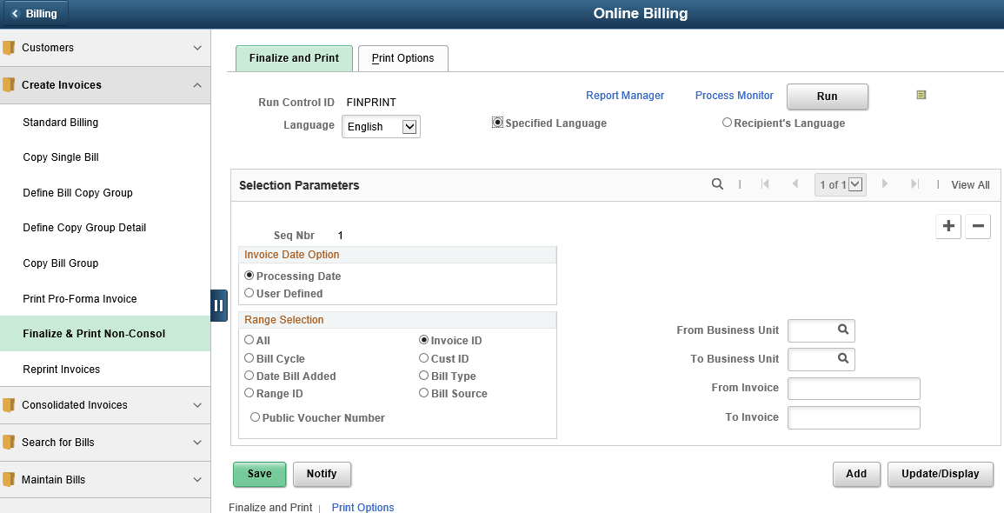
Figure 2. Finalize and Print Page
Field | Description
To and From Business Unit | Use these files to enter the same agency specific business unit. DO NOT leave these fields blank.
Range Selection | Use this section to select the range type of bills you wish to finalize and print. It is best practice to use Invoice ID so one division of an agency does not accidentally create invoices for another division of that agency who might not be ready to create their own bills.
From Invoice | Use this field to enter the invoice number you wish to process. The To and From fields change depending on which Range Selection option chosen.
To Invoice | This field is the same as the From Invoice. The To and From fields change depending on which Range Selection option chosen.
Table 2. Finalize and Print Page Elements

Researching Invoiced Bill Lines
- Using the Bill Line Search page in the Locate Bills menu, you can search for any bill line, regardless of the status. When you choose a retrieved bill line, you can drill down to the Header – Info 1 and Line – Info 1 pages in view only mode.

Researching Invoiced Bills
- In SMART Billing, you can search for bills by specifying a search criterion. This enables you to review only those bills that meet your requirements.
- You can drill back into the bill being researched from this page
Bill Search Page:
Use this page to search for invoiced bills.

Page Name | Navigation
Bill Search | Billing Homepage > Online Billing > Search for Bills > Bills Invoiced
 | NavBar
Bill Search | Navigator > Billing > Locate Bills > Bills Invoiced

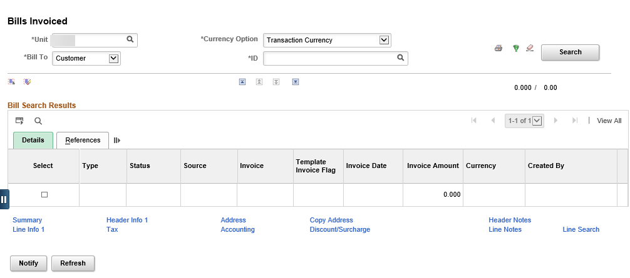
Figure 3. Bill Search Page
Field | Description
Unit | Use this field to enter the Agency specific business unit
Bill To | Use this field to select between Customer and Contract
ID | Use this field to enter the Customer ID or the contract number
Bill Search Reset | Use this icon to reset search parameters
Header Selection Criteria | Use this icon to refine bill search criteria on the Bill Search Criteria page
Table 3. Bill Search Page Elements

Bill Search Criteria Page:
Use this page to refine bill search criteria.

Page Name | Navigation
Bill Search Criteria | Billing Homepage > Online Billing > Search for Bills > Bills Invoiced > Header Selection Criteria Icon
 | NavBar
Bill Search Criteria | Navigator > Billing > Locate Bills > Bills Invoiced > Header Selection Criteria Icon

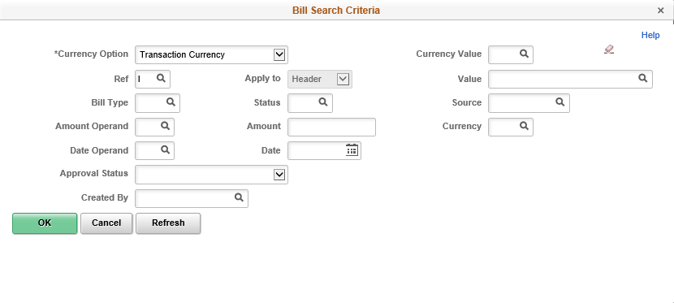
Figure 4. Bill Search Criteria Page

Header 2 Info Page:
Use this page to view additional general bill information at the header level.

Page Name | Navigation
Header 2 Info | Navigator > Billing > Locate Bills > Bills Invoiced >Header-Info 1 link > Header-Info 2 link

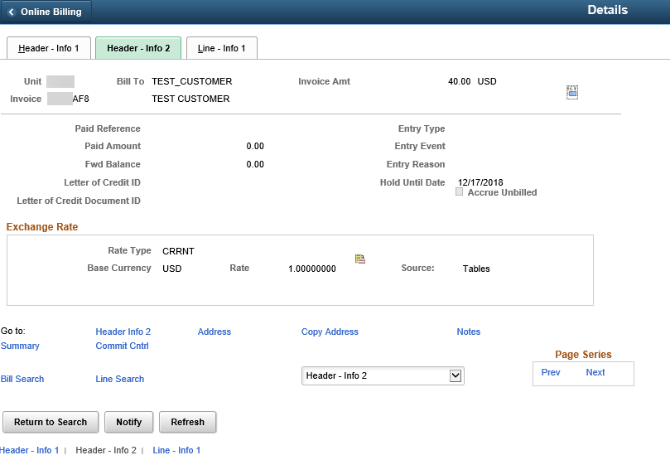
Figure 5. Header - Info 2 Page

Processing and Printing Consolidated Bills
- A consolidated bill groups individual bills for ONE customer into a single bill. This bill can be sent to different locations, if required. A consolidated bill consists of the consolidated bill header and attached bills.
- The consolidated bill header acts as the “glue” for the attached bills.
- You can pre-process, finalize, and print consolidated invoices. Consolidated bills can be finalized and invoices printed after the individual bills, and bill header status is changed to RDY. The Consolidated Finalize and Print process performs the following actions:
  - Pre-processes and finalizes the specified consolidated bills
  - Prints portrait formatted invoices
  - Prepares invoice information to move to Accounts Receivable
- It is best practice to return to the Address page to verify the address information is correct.
Figure 6. Processing and Printing Consolidated Bills Process
Header Page
Use this page to create a consolidated bill header. A consolidated bill header has its own payment term, invoice date, and due date.

Page Name | Navigation
Header | Billing Homepage > Online Billing > Consolidated Invoices > Consolidated Bill Entry
 | NavBar
Header | Navigator > Billing > Maintain Bills > Create Consolidated Header

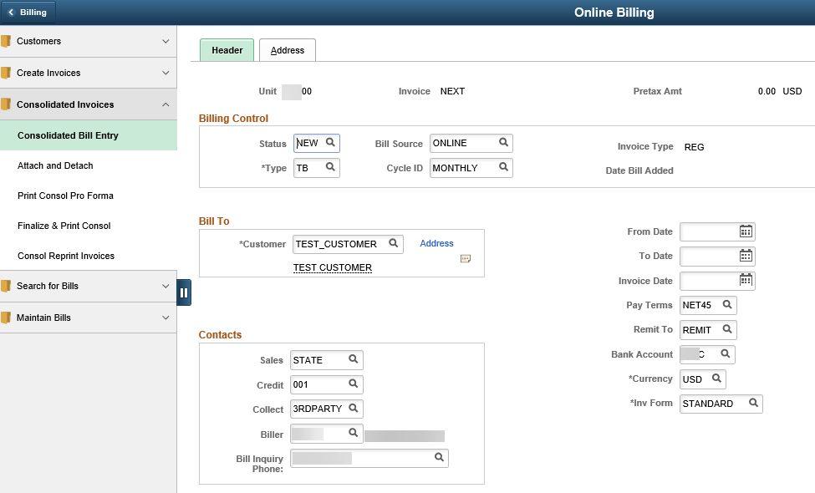
Figure 7. Header Page

Field | Description
Type | This field is also known as Bill Type, which represents a category of activity that should be grouped together on a particular bill. A different Bill Type can be established for each type of service. Bills can be searched for and reported on based on bill type. Some Bill Type examples might be Professional Services, Real Estate and Leasing, Printing, or Assets. Bill Types are not printed on the invoice.
Bill Source | SOK is only using Online or Contracts for Bill Source
Status | Use this field to enter the status of the consolidated bills: NEW when creating the header, RDY after the bills have been attached
Contacts Section | This section information defaults based on the customer ID
Table 4. Header Page Elements
Page Name | Navigation
Address Page | Billing Homepage > Online Billing > Consolidated Invoices > Consolidated Bill Entry > Address tab
 | NavBar
Address Page | Navigator > Billing > Maintain Bills > Create Consolidated Header > Address

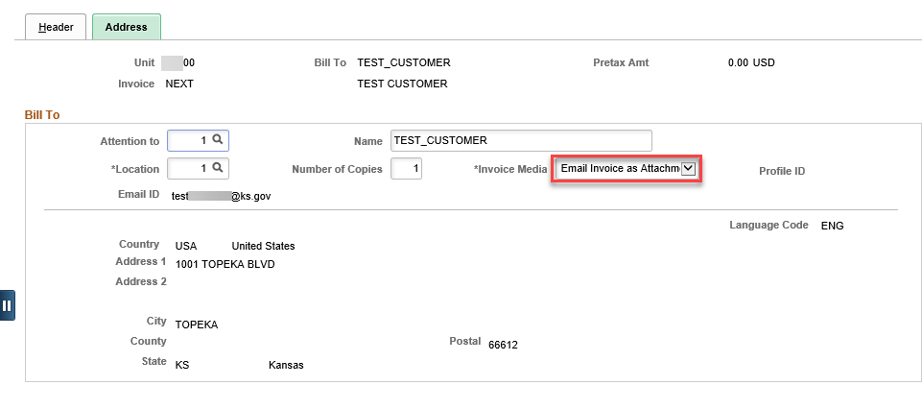
Figure 8. Address Page
Field | Description
Attention to | SMART populates this field with contact information for one contact within the customer, if one exists. This field is optional.
Name | Use this field to enter the name of the contact person
Location | Use this field to specify the location the consolidated bill is to be sent to if the customer has more than one address. Location 1 defaults.
Table 5. Address Page Field Data

Attach and Detach Bills Page:
Use this page to locate and select the bills you want to attach to the consolidated bill header.

Page Name | Navigation
Attach and Detach Bills | Billing Homepage > Online Billing > Consolidated Invoices > Attach and Detach
 | NavBar
Attach and Detach Bills | Navigator > Billing > Maintain Bills > Attach and Detach Bills

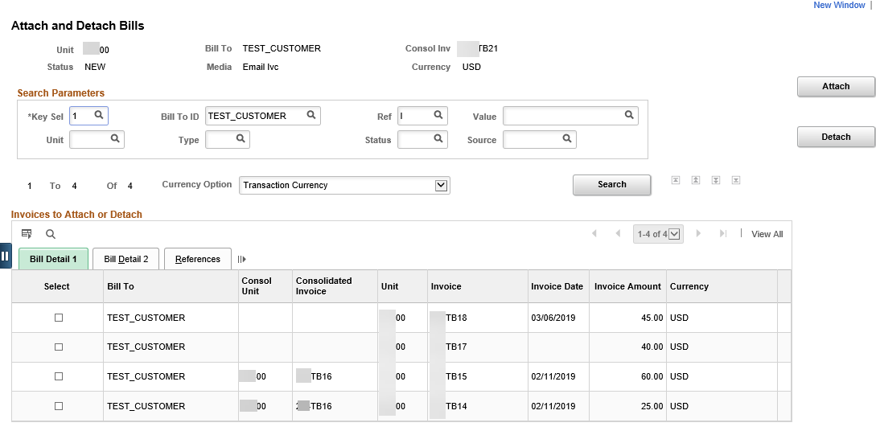
Figure 9. Attach and Detach Bills Page

Field | Description
Key Sel | The selection in this field determines the values that are available in the other search fields and the invoices that are returned. The SOK values are Customer, Contract, or Consolidation Key.
Bill To ID | This field is directly related to the selection in the Key Sel field. For example, if Key Sel is 1 Customer, then the Bill To ID would be Customer.
Ref | Use this field to reference what you want to search by. For example, C (Contract Number), I (Invoice), J (Project ID), or U (Customer).
Value | Use this field in association with Ref to narrow down your search. For example, if you selected N in the Ref field (Consolidated Invoice) then the look up for Value would only show the consolidated invoices.
Unit | Use this field to enter the Agency specific Business Unit
Type | Use this field search by bill type, if necessary
Status | Use this field to enter the Bill Status. Bills in any status other than INV can be attached to a consolidated header, but the consolidated header cannot be processed until all attached bills are in the status of RDY.
Source | Use this field to enter the bill source. SOK Bill Sources are Contracts and Online.
Sort | Use this field to view the bills in a specific sorted format by Invoice Amount, Bill To Customer, Invoice Number, or Invoice Status. All sorted information can be in ascending or descending order.
Table 6. Attach and Detach Bills Page Elements

Consolidated Final and Print Page:
Use this page to enter the process request parameters.

Page Name | Navigation
Consolidated Final and Print | Billing Homepage > Online Billing > Consolidated Invoices > Finalize & Print Consol
 | NavBar
Consolidated Final and Print | Navigator > Billing>Generate Invoice > Consolidated > Finalize and Print Invoices

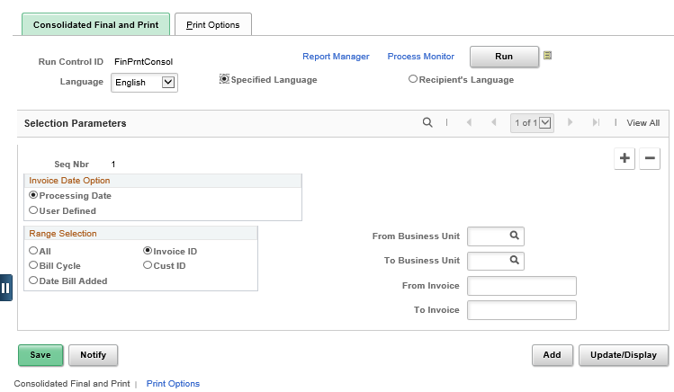
Figure 10. Consolidated Final and Print Page
Field | Description
Range Selection | Use this section to select the range type of bills you wish to finalize and print. It is best practice to use Invoice ID so one division of an agency does not accidentally create a consolidated bill for another division of that agency who might not be ready to create their own bills.
Bills To Be Processed | Use this icon to open the Bills To Be Processed Page. It is best practice to use this page to review bills before finalizing and printing.
Table 7. Consolidated Final and Print Page Elements

Bills To Be Processed Page:
Use this page to view all the bills in the range selection. The bills reflect the options that you define on the main page. Depending on how you access the page, some fields may not appear. Each line item, or invoice number, is a consolidated invoice that could have several bills attached. Only bills in a RDY status display on this page.

Page Name | Navigation
Bills To Be Processed Page | Billing Homepage > Online Billing > Consolidated Invoices > Finalize & Print Consol Bills To Be Processed Icon
 | NavBar
Bills To Be Processed Page | Navigator > Billing > Generate Invoice > Consolidated > Finalize and Print Invoices > Bills To Be Processed Icon

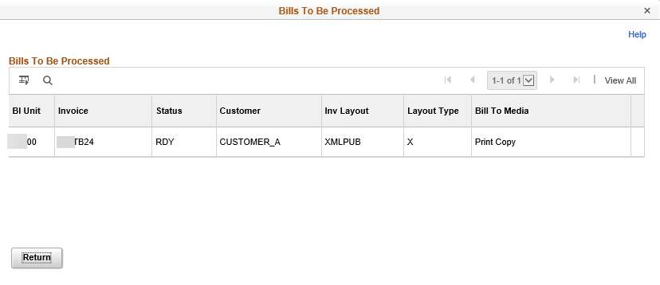

Figure 11. Bills to Be Processed Page

Review Accounts Receivable
- An automatic (batch) process loads invoice information into AR pending items after consolidated and non-consolidated invoices have been generated, or after the bills are in INV status. There is no user action required. However, verification of a successful load of pending items into AR is necessary.
AR Pending Items Pages:
Use these pages to search and verify that all bills and bill types (consolidated and non-consolidated) were loaded successfully into Accounts Receivable. The only field that is of value is Group Unit. All other fields are unknown to the end user at the time of the search.

Page Name | Navigation
BI_Pending_Items | Billing Homepage > Online Billing > Search for Bills > AR Pending Items
GROUP_ENTRY1_DSP | Billing Homepage > Process Billing Worksheets > Search for Bills > AR Single Item
ITEM_MAINTAIN | Billing Homepage > Process Billing Worksheets > Search for Bills > View Item Details

Field | Description
Group Unit | Use this field to enter your agency specific business unit
Table 8. AR Pending Items Page Field Description

Maintaining Bills

Key Concepts
- When adjusting bills you can
  - Associate new entry types, reasons, and distribution codes within the bills
  - Calculate new totals
- You can adjust a bill header or line only once.
- Rebill – You may need to credit an entire bill and rebill. For example, you discover a shipment was sent to the wrong customer.
- Bill Line Reversal – You may need to adjust bill lines after invoices are generated. For example, if a customer returns items shipped on an order or if the original bill line has incorrect information, you can adjust the bill line.
- Net Bill Line Adjustment – This is used to create an adjustment for a particular bill line. For example, a customer has been overcharged for an item.
- To adjust bills and bill lines, SMART provides the Adjust Bills function. Use the Adjust Bills function when you must make invoice changes. You can credit entire bills and rebill with one action, or select only certain lines to rebill. You can also add lines of activity and rebill, associate new entry types and reasons with the bills, associate new distribution codes, and calculate new totals. Once the new bill has been created, you can then make the necessary corrections.
- You can adjust any bill in SMART except consolidated bill headers.
  - However, if the bill originated from an external source, you can initiate the adjustment directly from Billing.

Credit a Bill
- If a customer returns goods shipped or the original invoice has incorrect information, you can adjust the entire bill by using the Adjust Entire Bill function.
- For a bill to be adjusted, the bill must have a status of INV (Invoiced)
Adjust Entire Bill Page:
Use this page to credit entire bills and reverse original invoices or to credit entire bills and rebill with the correct information.

Page Name | Navigation
Adjust Entire Bill | Billing Homepage > Online Billing > Maintain Bills > Adjust Entire Bill
 | NavBar
Adjust Entire Bill | Navigator > Billing > Maintain Bills > Adjust Entire Bill > Find an Existing Value

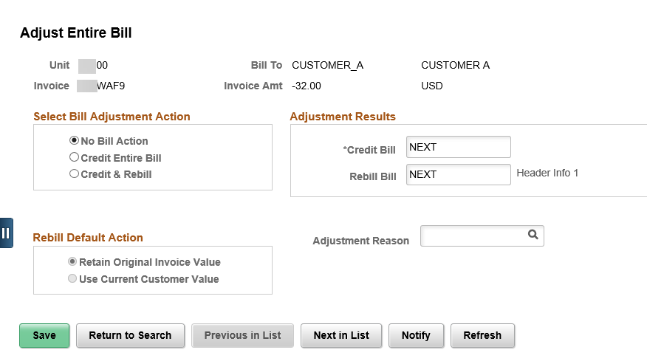
Figure 13. Adjust Entire Bill Page
Field | Description
Select Bill Adjustment Action | Use this field to select the radio button for Credit Entire Bill
Credit Bill | It is best practice to override the NEXT default value to keep a credit line history of the original bill. By using the original invoice ID with CR that precedes or follows the invoice allows for bill location.
Rebill Bill | It is best practice to override the NEXT default value to keep a credit line history of the original bill. By using the original invoice ID with RB that precedes or follows the invoice allows for bill location.
No Bill Action | No action for the displayed bill occurs at this time. When you first access the page, the system uses this value as the default action. This prevents you from adjusting a bill unintentionally. Whenever you save the process, this default action resets.
Credit Entire Bill | Create a credit bill for the displayed bill. The bill has a status of RDY (ready).
Credit & Rebill | Create a credit bill and create a copy of the displayed bill. The rebill copy has the status of NEW.
Adjustment Reason | Using the lookup, select a value that describes the reason for creating the adjustment bill.
Table 9. Adjust Entire Bill Page Elements
Adjustment History Page:
Use this page to review bill adjustment history.

Page Name | Navigation
Adjustment History | Navigator > Billing > Review Billing Information > Adjustment History > Adjustment History
 | NavBar
Adjustment History | Navigator > Review Billing Information > Adjustment History > Adjustment History

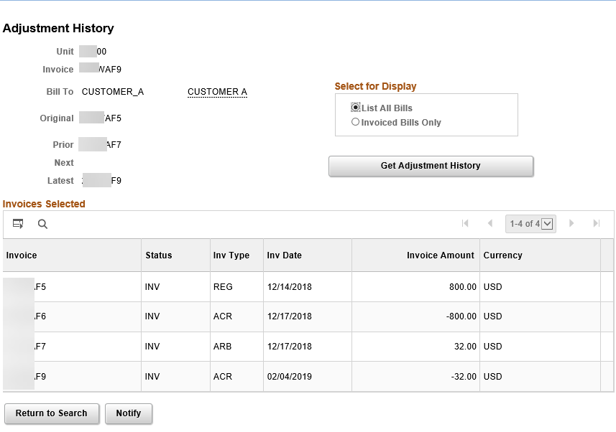
Figure 14. Adjustment History Page

Credit an Entire Bill and Rebill
- The Adjust Entire Bill function enables you to adjust the bill either by crediting the entire bill or by crediting the original bill and rebilling. The credit and rebill actions are performed in one-step.
- After the new bill is created, you can make any modifications as required. The credit bill is created with a status of RDY (Ready) and the rebill is created with a status of NEW (New).

Credit a Bill Line and Apply to an Existing Bill
- You may need to adjust bill lines after invoices are generated. For example, if a customer returns items shipped on an order or if the original bill line has incorrect information, you can adjust the bill line.
- You can choose to adjust specific bill lines and add it to an existing invoice. To do this, there must be an existing bill for the customer, and that bill must have a status of RDY (Ready) or NEW (New).
Note: You cannot add an adjustment line to an invoiced bill.

Adjust Selected Bill Lines Page:
Use this page to adjust specific bill lines.

Page Name | Navigation
Adjust Selected Bill Lines | Billing Homepage > Online Billing > Maintain Bills > Adjust Selected Bill Lines > Find an Existing Value
 | NavBar
Adjust Selected Bill Lines | Navigator > Billing > Maintain Bills > Adjust Selected Bill Lines > Find an Existing Value

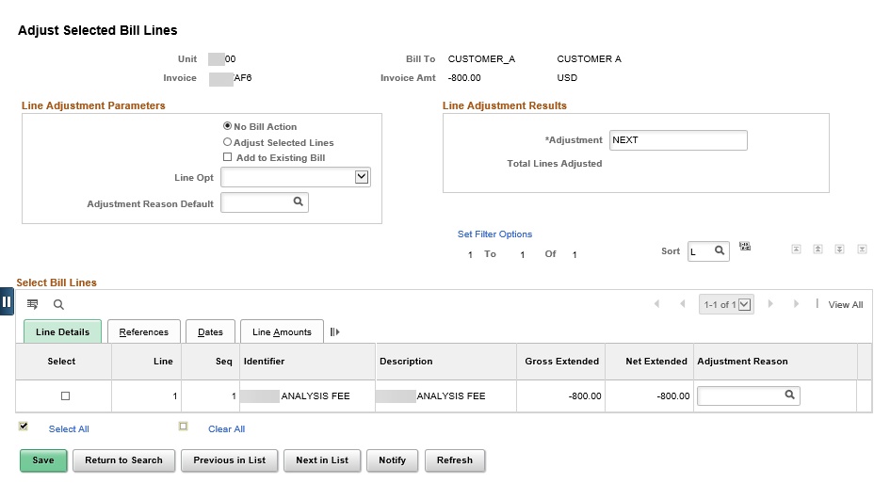
Figure 15. Adjust Selected Bill Lines Page

Creating a Bill Line Reversal and Rebill
- SMART enables you to adjust specific bill lines for an invoice. When you adjust a bill line by using the Create Reversal and Rebill action, SMART creates two new lines – one that credits the original line and another that reflects the adjustment.
Adjustment Line Summary Page:
Use this page to review the summary details of adjustment lines for a particular bill.

Page Name | Navigation
Adjustment Line Summary | Navigator > Billing > Review Billing Information > Review Line History > Find an Existing Value

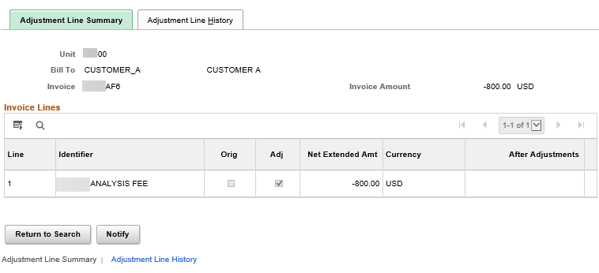
Figure 16. Adjustment Line Summary Page
Adjustment Line History Page:
Use this page to review details, including all adjustments, for each bill line.

Page Name | Navigation
Adjustment Line History | Navigator > Review Billing Information > Review Line History > Find an Existing Value >Adjustment Line History
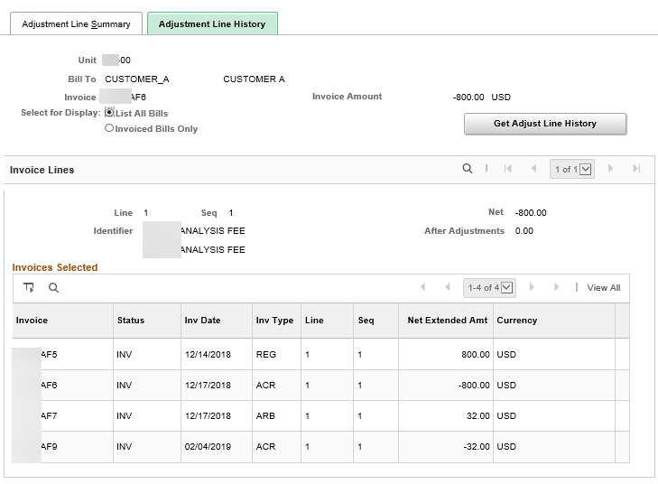
Figure 17. Adjustment Line History Page

