
State of Kansas
Adding an Attachment to a Budget Journal
Statewide Management, Accounting and Reporting Tool

Date Created: | 01/11/2015
Version: | 2.0
Last Updated Date: | 03/13/2019
Purpose: | The purpose of this job aid is to show how to add attachments to a Budget Journal.
Considerations: | There are some considerations to take regarding attachment use:  – The recommended size limit for a file being attached is 1 MB.  – Agencies should not attach CAD (Computer Aided Design) files or picture files (examples- .jpg, .tif, .png, or .gif).  – Excel, Word, PDF, or similar files are appropriate.  – Multiple attachments are allowed.  – Avoid attaching documents that do not add value to the transaction.  – System retention for attachment files is expected to be 3 years. This period may be reduced if storage space becomes an issue.  – Agencies should not rely on SMART as the method for meeting record retention policies.
Security: | Security Role Access: Only those individuals assigned the following security access roles will receive results from this report:  - KGL_AGY_BUDGET_PROCESSOR  - KGL_AGY_BUDGET_APPROVER  Business Unit Access: Business Unit Security is applied

1. | Navigation:  From the SMART Homepage dropdown link, navigate to the ‘General Ledger/KK’ page, then click  on ‘Commitment Control’ tile, then click on ‘Budget Journals’, and then click on ‘Enter Budget Journals.’  Click the ‘Add’ button.  NOTE: If you wish to enter your own Journal ID, then update the Journal ID field before clicking the ‘Add’ button. | 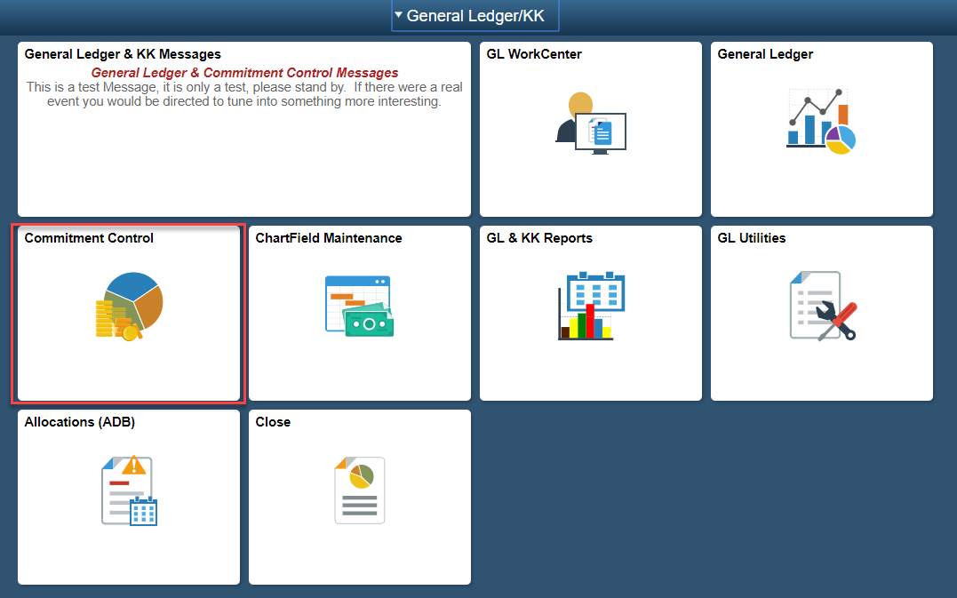  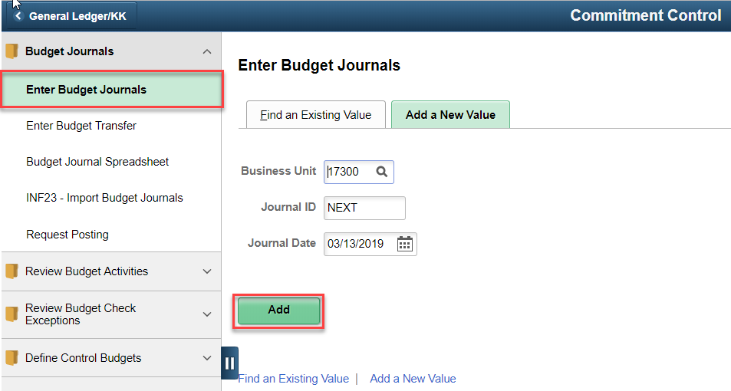
2. | Clicking the ‘Add’ button opens the ‘Budget Header’ tab of the Budget Journal.  Click the ‘Attachments’ hyperlink to add an attachment to the Budget Journal. | 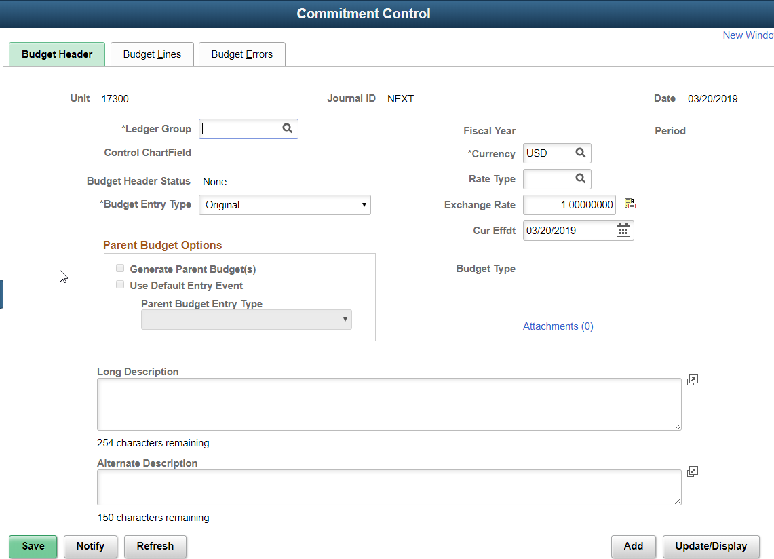
3. | Clicking the ‘Attachments’ hyperlink opens the ‘Budget Journal Attachments’ page.  Click the ‘Add Attachments’ Button. | 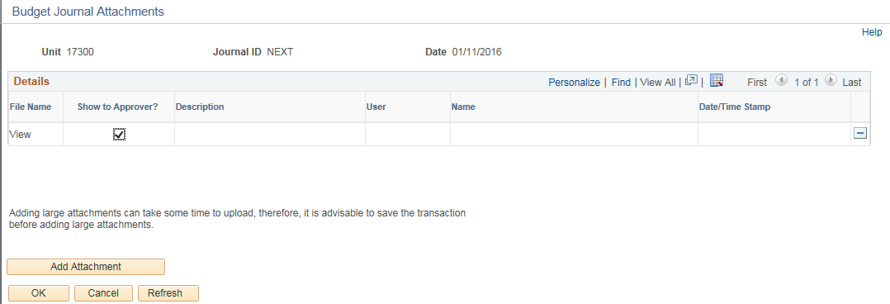
4. | Clicking the ‘Add Attachments’ Button opens the ‘File Attachment’ page.  Click the ‘Browse…’ Button to search for the file to attach. | 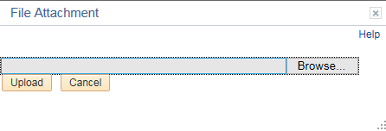
5. | Clicking the ‘Browse…’ button opens the ‘Choose File to Upload’ page on your computer.  Select the file you want to attach to the budget journal and then select the ‘Open’ button. | 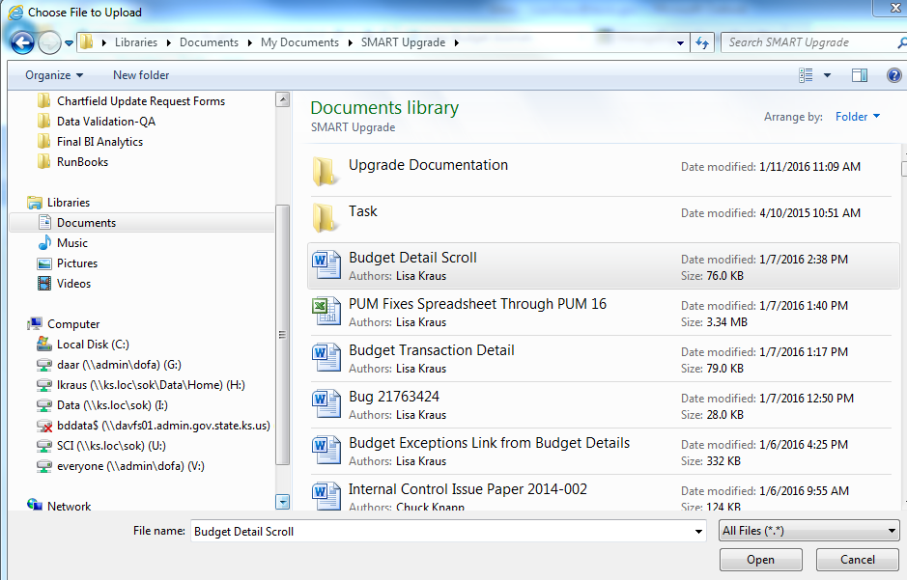
6. | This takes you back to the ‘File Attachment’  page.  Click the ‘Upload’ button. | 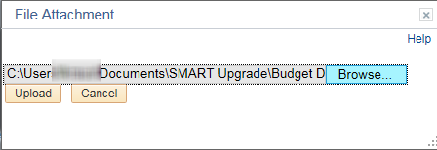

7. | This takes you back to the ‘Budget Journal Attachments’  page.  The file name you added is now displayed and you can click in the ‘Description’ box to add a description of your attachment. | 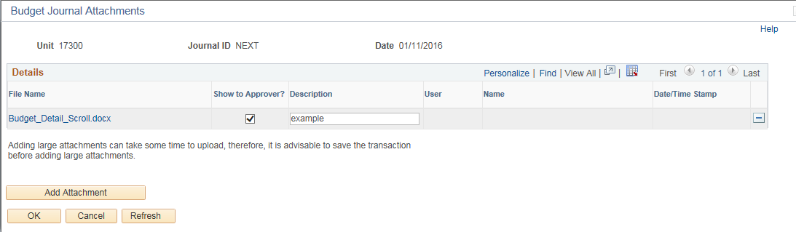
8. | If you have multiple attachments to add, then click the ‘Add Attachment’ button again. If you are done adding attachments, then click the ‘OK’ button.
9. | This takes you back to the ‘Budget Header’ tab of the Budget Journal.  Here you can see the number of ‘Attachments’ that were added. | 

