The PO Monthly Close process will run on the weekend following the first work day of the new month. Prior to that date, agencies will need to review their POs and take necessary steps if the PO should not close. The KS_PO_MAY_CLOSE query will provide a list of POs that do not have system checks in place and will close if the agency does not take some action.
- Navigation: SMART Homepage > Utilities > Query Manager or Query Viewer > KS_PO_MAY_CLOSE
- Select the “search” button.
- Enter your Business Unit ID and the Proposed Close Date.
Proposed Close Date: Enter the date that the next monthly PO Close batch process will run. The monthly PO Close batch process will run on the weekend following the first working day of the new month. The SMART Calendar provides the dates for PO Reconciliation, Events | smartweb.ks.gov.
- Select the “Run to Excel” link.
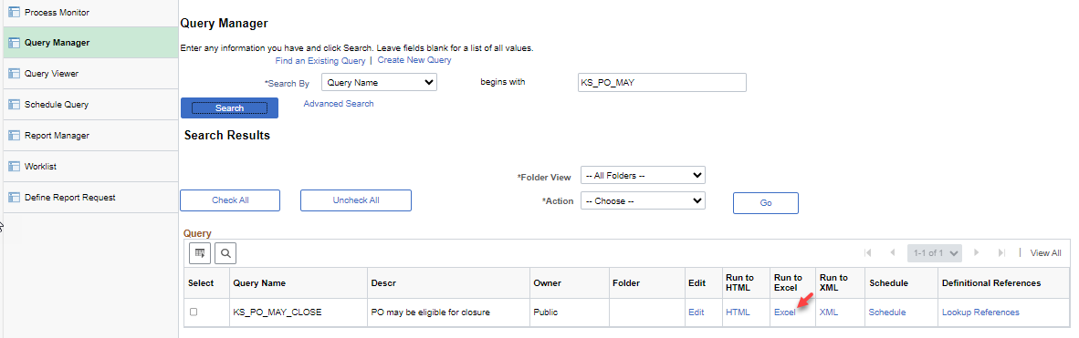

When a P-Card is associated to a PO, the matching status is set to “No Match” and should remain as “No Match”.
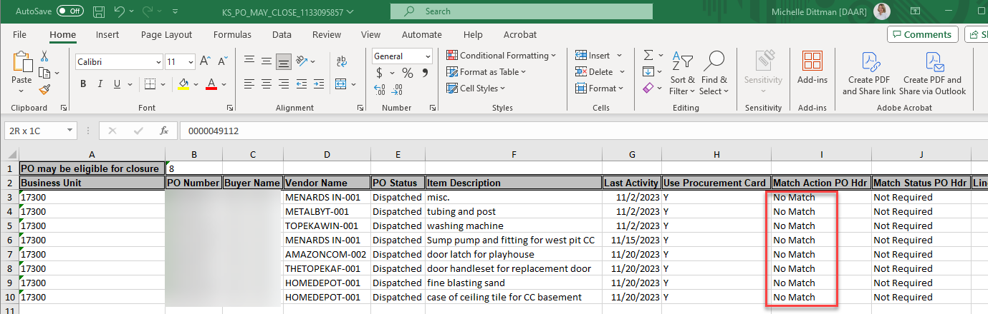

If you do not want a PO to close, you have two options:
- Change the Receiving Required field to “Receiving is Required”:
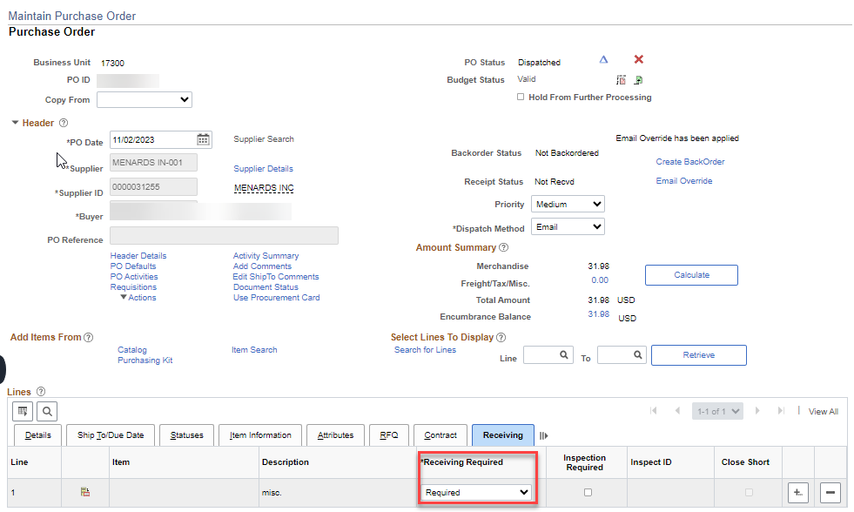

- Extend the Due Date to a date that is beyond the proposed close date. For example, the due date could be extended to the last day of the fiscal year, 06/30/2024.
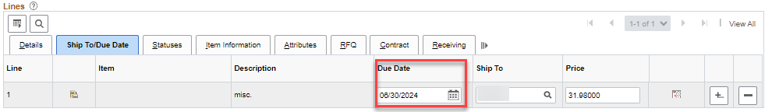

Link to the “Parameters for Closing POs” job aid: https://webadmin.ks.gov/media/cms/91eeac5b-f65e-4817-a377-eadbb03b2e64.docx

