
PCState of Kansas
PCard Link Not Appearing on PO
Statewide Management, Accounting and Reporting Tool

Date Created: | 09/05/2013
Version: | 2.0.
Last Updated Date: | 11/04/2020
There are several criteria that must be met before the ‘Use Procurement Card’ link will display on a PO:

- The PCard must have a current expiration date;
- The Buyer must have ‘proxy’ rights to the PCard;
- The Supplier Location effective date must be on or before the PO Date.

Below are steps to validate that each of these criteria has been met and provides steps to resolve issues associated with these criteria.

NOTE: The PO must be in a status OTHER THAN Dispatched.
NOTE: All new and existing suppliers have been updated to accept PCards.

SMART Security Role | Agency PCard Administrator
Fluid Navigation: Requisitions & PCards > Procurement Cards > Manage PCards > Cardholder Profile
Classic Navigation: NavBar > Navigator > Purchasing > Procurement Cards > Definitions > Cardholder Profile
- Check the PCard Expiration Date
Cardholder Profile page can be searched by Empl ID, Name, and Last Name to locate the cardholder employee.  Access that user’s PCard information by selecting their hyperlink in the Search Results. | 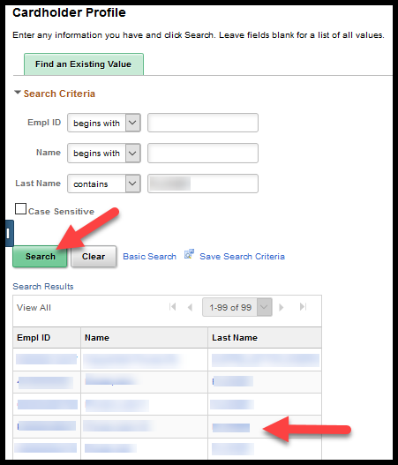
Select the Card Data tab | 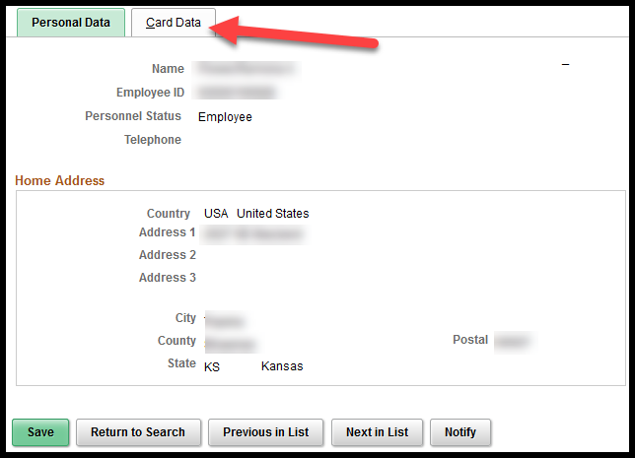
Validate that the Expiry date for the PCard is current: | 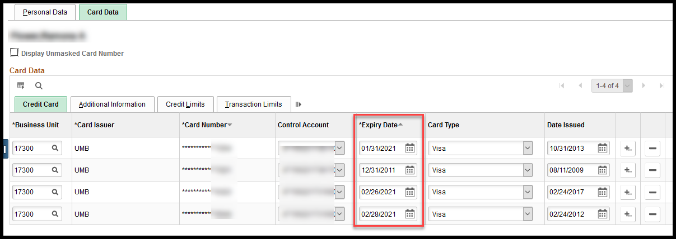
Action to take if the Expiry date is NOT current: | Update the Expiry date to some date in the future. It is acceptable to use expiration dates that are 50 or more years in the future; however, when the PCard expires or is canceled, the Agency PCard Administrator needs to enter the actual expiration or cancelation date into SMART.
NOTE: The State of Kansas does not use SMART to manage the issuance of PCards; including PCard expiration dates and PCard transaction limitations. Those items are handled by UMB Bank.
- Check to see if the Buyer has ‘Proxy’ to this PCard
On the Card Data tab select Additional Information tab. | 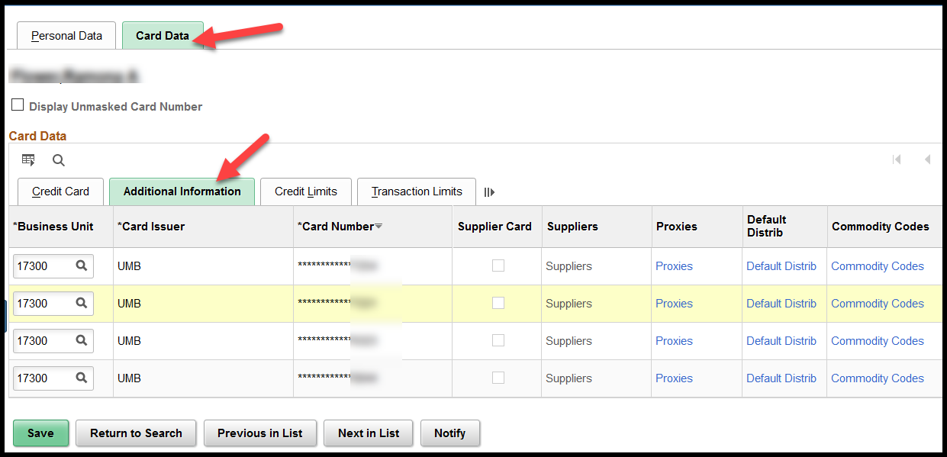
Select the Proxies link on the desired line. | 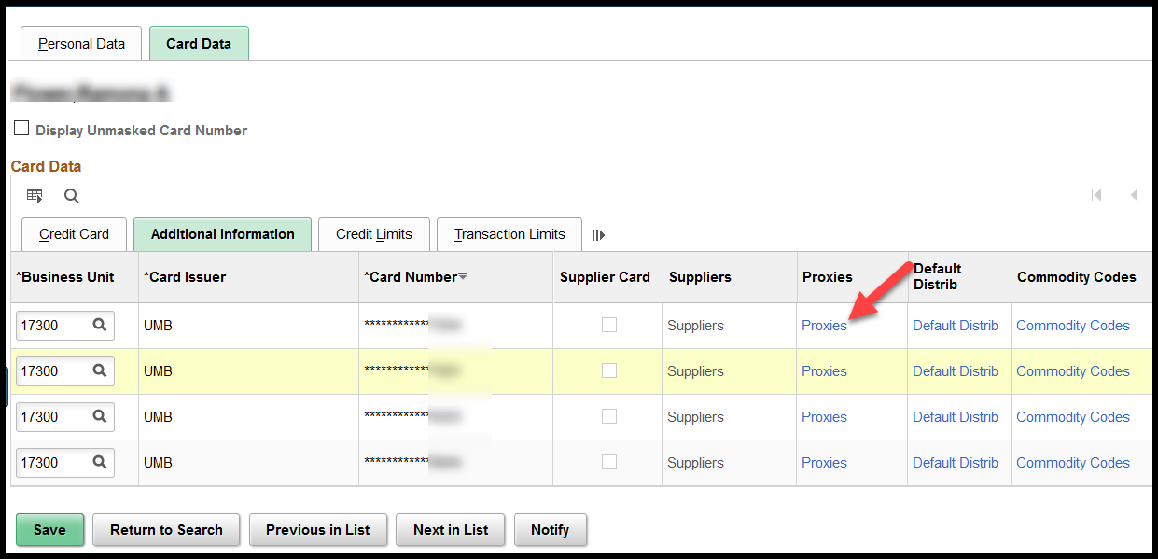
This opens the Assign Proxies page.  In the Proxies section validate that the applicable Buyer’s ID/Name is listed in the User ID column and that the appropriate Role is associated to them. | 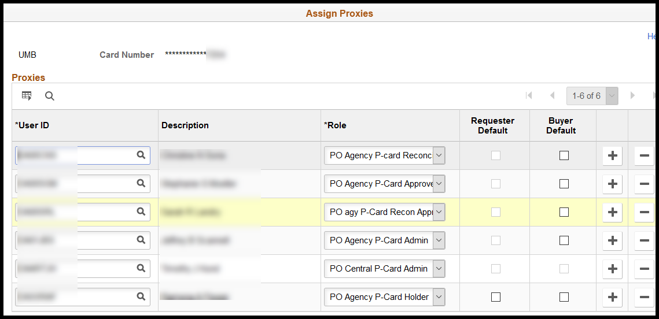
If the Buyer is not listed on the Assign Proxies page, they do not have proxie access and will need to be added.  Click the plus sign button () located at the far-right side. | 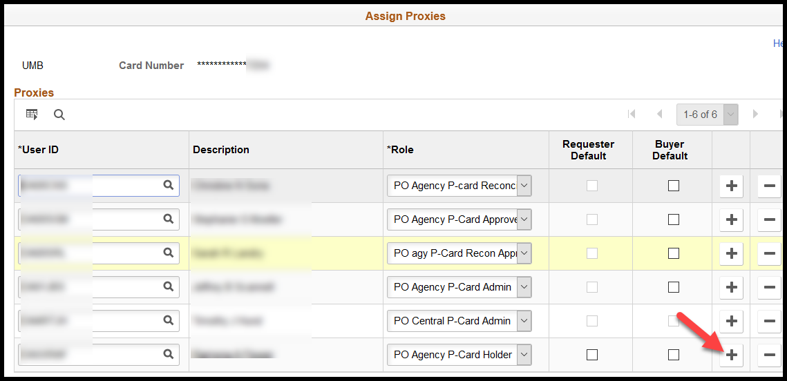
This will add a new row. In the new row, User ID column, enter the desired SMART User ID for the Buyer. | 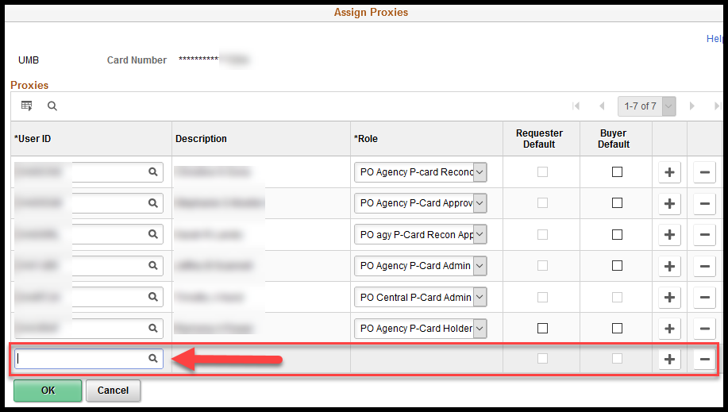
In the Role column, click the drop-down list arrow and select the desired role from the drop-down list options.  NOTE: The roles available in the Role drop down box will vary depending on the security access roles that have been assigned to the Buyer. In most cases, the PO Kansas Buyer role is the one that will be selected. | 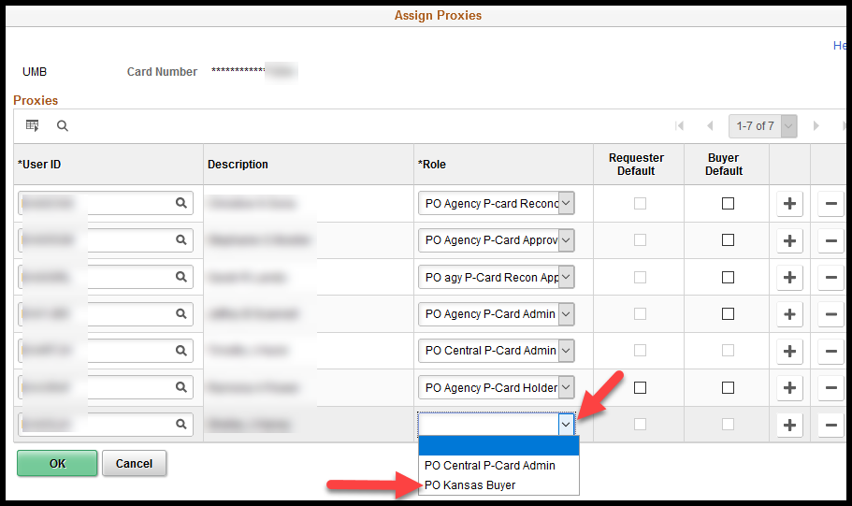
- Validate that the Supplier Location’s Effective Date is on, or before, the PO Date
Role | Kansas Buyer
Fluid Navigation: POs & Receiving > Purchase Orders > Purchase Orders > Add/Update Purchase Orders
Classic Navigation: NavBar > Navigator > Purchasing > Purchase Orders > Add/Update POs
On the Maintain Purchase Order page, Header section, make a note of the PO Date.  Click the Supplier Details link. | 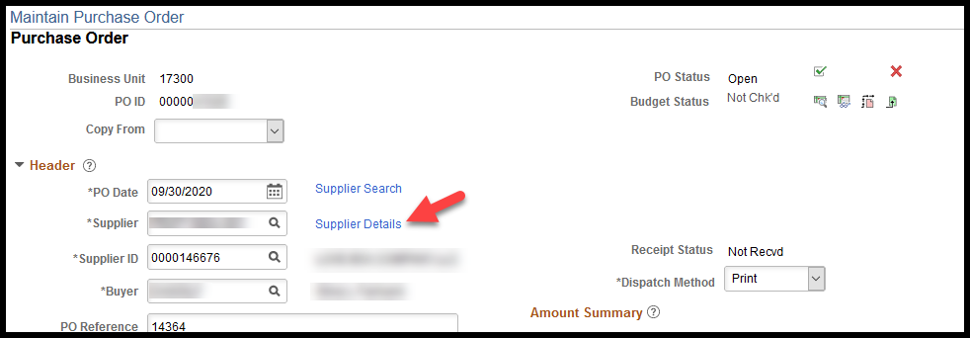
On the Supplier Details page that opens, make a note of the Location code.  Select the Supplier Information link. | 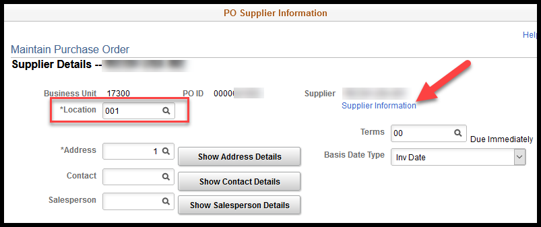
From the supplier record that opens select the Location tab. | 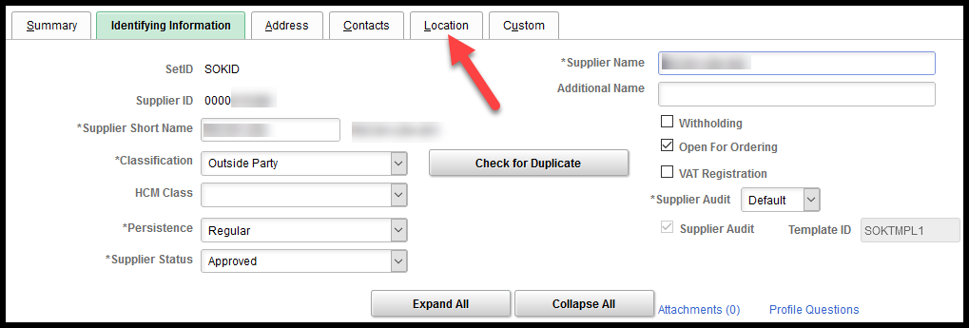
In the Location section, cycle through the available Locations to find one that has both an Effective Date on, or before, the PO Date. | 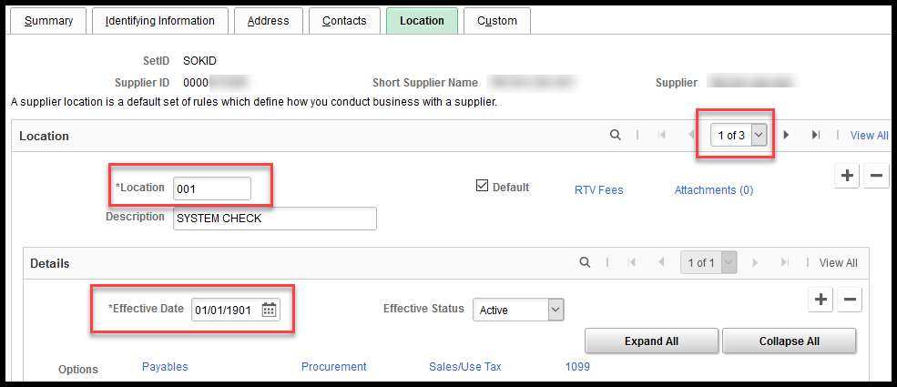
Action to take if the supplier’s Location code Effective Date is AFTER the PO Date. | Agencies should try the following options, in the following order:  - Change the Location Code on the PO  - Change the PO Date
Option 1 – Change the Location Code on the PO
Navigate to, and open, the desired PO.

In the Header section, click the Supplier Details link.
Select the Look up Location icon (magnifying glass) for the Location Code field. | 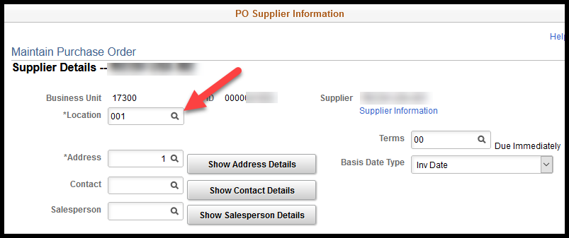
On the Look Up Location page select a different Location code (if available).  NOTE: Since this is a PCard transaction, changing the Location code will have minimal impact.  CAUTION: On PO’s that are not associated to PCards, Buyers should NOT change the Location code without first thoroughly evaluating the situation. | 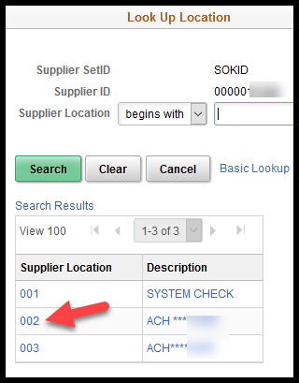
Option 2 - Change the PO Date
Navigate to, and open, the desired PO.  On the PO, in the Header section enter a new PO Date that is PRIOR to the Supplier’s Location code Effective Date.  NOTE: If a contract is associated to the PO, you will also need to verify that the new PO Date is still within the contract’s effective dates. | 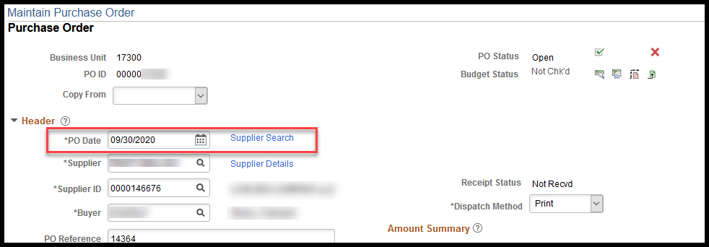
NOTE: If after attempting the solutions in this job aid the PCard link is still not showing on the PO please open a ManageEngine Service Request. Please be sure to include the following information:
- PO number
- PCard holder’s name
- Last four (4) digits of the PCard number

