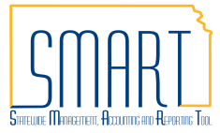
State of Kansas

PCard Disputes and Incorrect Charges

Statewide Management, Accounting and Reporting Tool

Date Created: | 04/27/2021
Revised | 03/24/2023
Version: | 3.0
Purpose: | There may be times when an agency needs to dispute an incorrect charge on a PCard.  This training document can assist agencies with the process of managing a disputed or incorrect PCard charge in SMART.
Definitions:
Disputes: If a procurement card transaction is identified as a fraudulent charge (card stolen, card number stolen), and the charges are completely unrelated to State of Kansas business, it is referred to as a dispute in SMART.

- Agency must contact the PCard Issuer (currently UMB) to obtain credits for disputes.

Incorrect Charges: Too little/too much charged by supplier, or sales tax charged.

- Agency must contact the supplier directly to obtain credits for incorrect charges, damaged goods, etc. If agreement cannot be reached with the supplier for incorrect charges, the agency can then contact UMB for assistance in obtaining the credit.

- Exception: UMB cannot assist agencies in obtaining credits for Kansas sales tax due to VISA rules.

NOTE: Credits / Negative Amounts: SMART will no longer build PCard vouchers with a negative total. A credit (negative amount) transaction will remain in Approved status on the Reconcile Statement page until there is an approved offsetting transaction to the same control account. Then a voucher will be built that nets zero or positive.

Notes: | VISA rules limit the amount of time in which credits can be requested; therefore, agencies should contact UMB and/or suppliers as soon as possible for both disputes and incorrect charges.
Security: | The PO Agency PCard Approver, Reconciler or Reconciler/Approver role is required to perform this function.
Managing Disputes and/or Incorrect Charges in SMART
Fluid Navigation: | Requisitions & PCards > Procurement Cards > Manage PCard Transactions > Reconcile Statement
Classic Navigation: | NavBar > Navigator > Purchasing > Procurement Cards > Reconcile > Reconcile Statement
Use the Reconcile Statement Search page criteria to locate PCard transactions to be reconciled.  Click the Search button.  Note: It can be helpful to clear or extend the Transaction date field beyond the one-month that defaults in. | 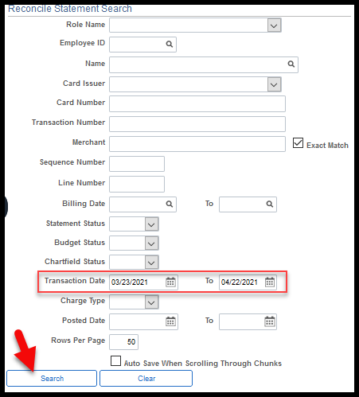
On the Reconcile Statement page select the Billing tab. | 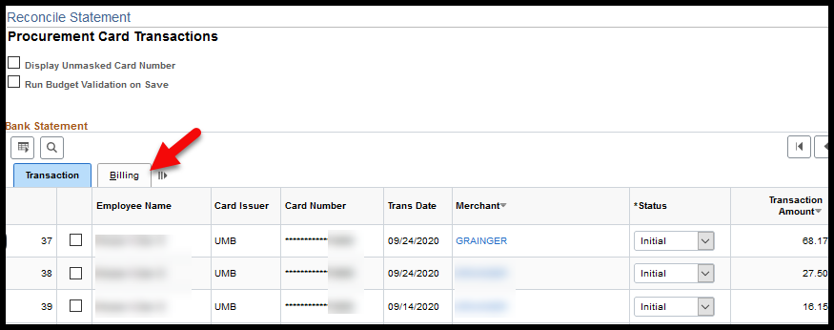
Enter an appropriate Description and enter the amount that is being disputed (incorrect) in Dispute Amount. | 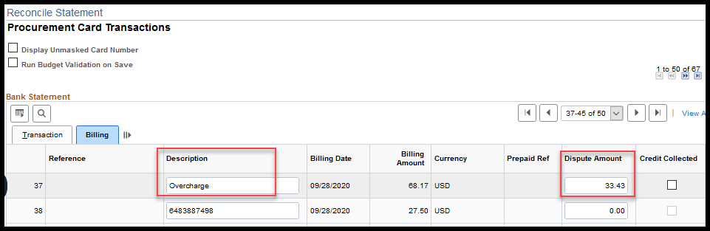
Select the Transaction tab and insure that disputed row Status remains as Initial or Staged until the credit for the disputed amount is received.  Click the Save button.  Note: If a Dispute Amount has been entered and the PCard transaction status is changed to Approved the entire PCard transaction amount will build to a PCard voucher and be paid. Entering a value in the Dispute Amount field will NOT stop a payment from being made. | 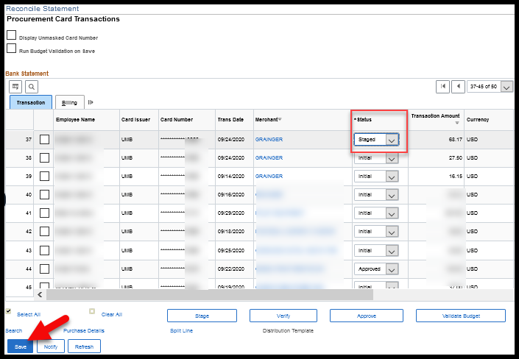
Review Disputed Transactions
Fluid Navigation: | Requisitions & PCards > Procurement Cards > Manage PCard Transactions > Review Disputes
Classic Navigation: | NavBar > Navigator > Purchasing > Procurement Cards > Reconcile > Review Disputes
Note: | The Review Disputes page is a tool provided to assist with tracking PCard transactions that are in dispute.  Neither the Dispute Amount or the Credit Collected fields have functionality behind them that would prevent payments from happening. They are to be used strictly for tracking purposes.
Use the Review Disputes Search page to review transactions that have disputed amounts associated to them.  Click the Search button.  Note: It can be helpful to clear or extend the Transaction date field beyond the one-month that defaults in. | 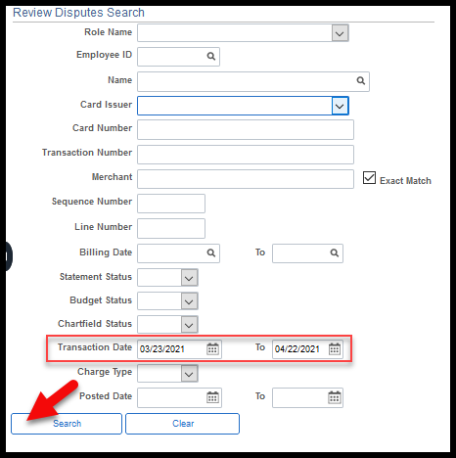
The Review Disputes page shows all PCard transactions with:  - an associated Disputed Amount  - that has not been collected  - and not built to voucher | 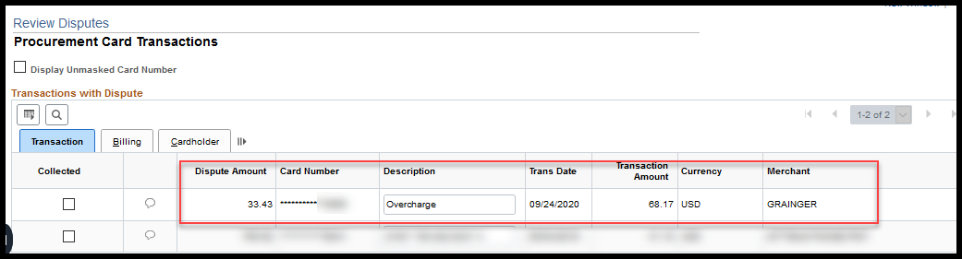
Comments can be entered by selecting the Comments & Attachments icon. | 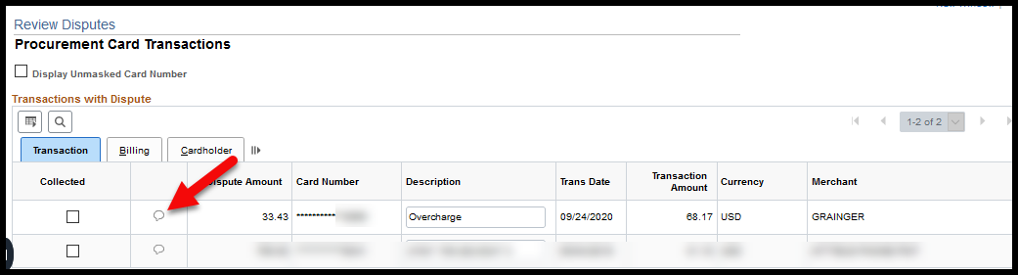
Enter a comment and/or attachment then click the OK button.  Note: Comment and attachments on ProCard Comments stay with the transaction and are also viewable from the Reconcile Statement page. | 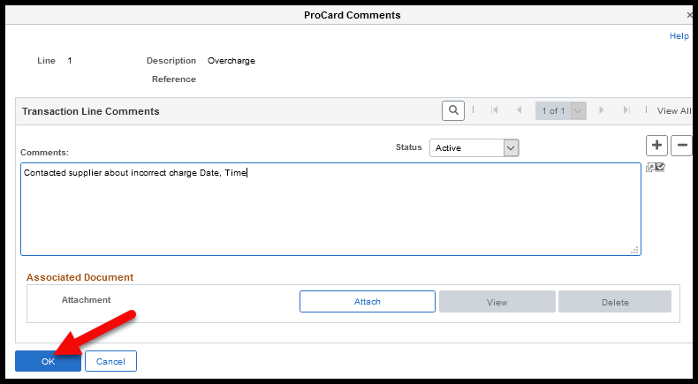
Once the credit is received, the agency can select the Collected check box from the Review Disputes page.  Click the Save button | 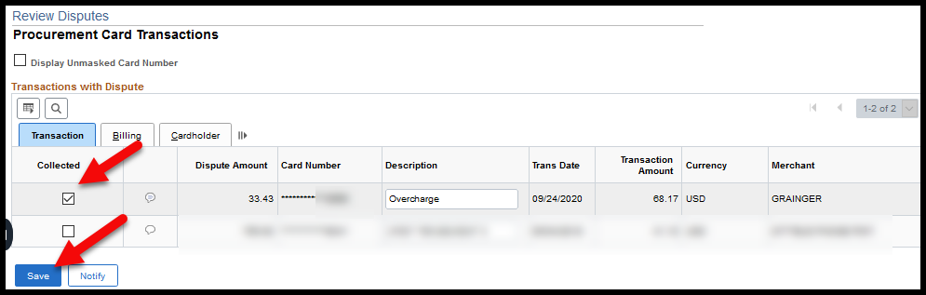
Completing Transaction After Receiving Credit
Back on the Reconcile Statement page, the comments entered on the Review Disputes page are accessible from the Comments & Attachments icon.  Click the OK button. | 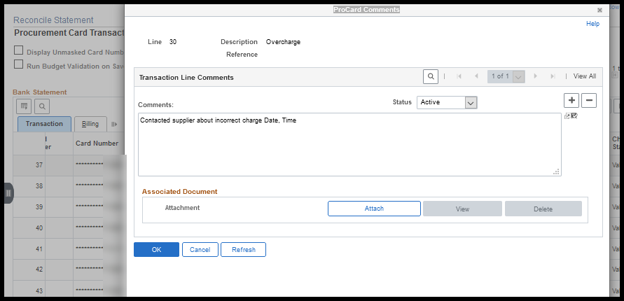
The Credit Collected checkbox will display as checked from the Reconcile Statement page, Billing tab. | 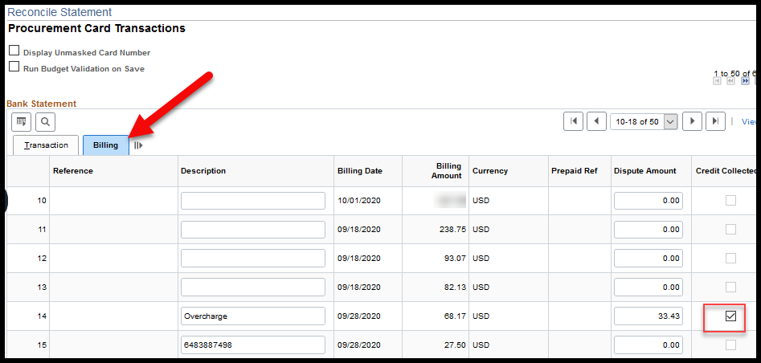
Verify or Approve the original PCard transaction AND the credit transaction.  Click the Save button.  Note: Both the original PCard transaction and the credit PCard transaction should be approved at the same time so that both transactions will build to the same PCard voucher.  This will help ensure that a credit is collected and provide for more visibility into what transpired. | 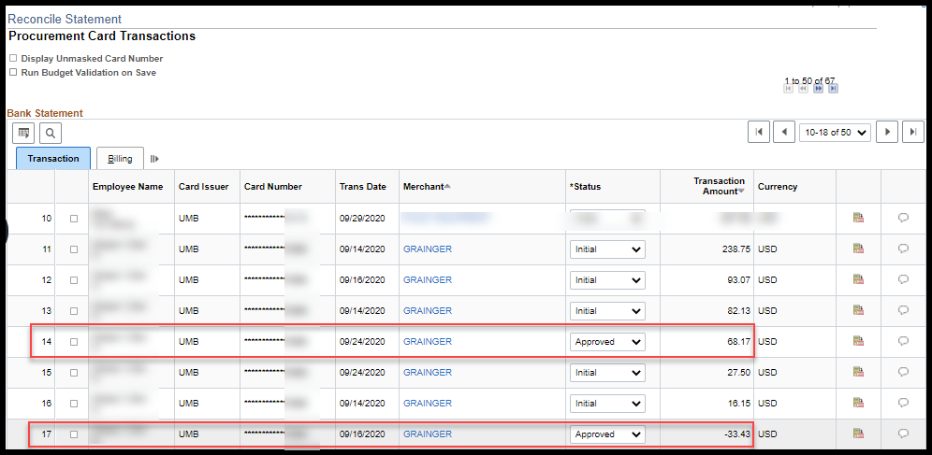
Exception: Charged Kansas Sales Tax
Note: | When sales tax has been charged by the supplier the agency should approve the original PCard transaction total and pay the total PCard transaction amount.  The agency will then need to contact the supplier directly to request a credit for the taxes paid.
The tax amount can be noted in the Dispute Amount field for tracking purposes.  Entering the Dispute Amount will NOT stop the PCard transaction from building to a PCard voucher  Approve to pay the original PCard transaction total. | 