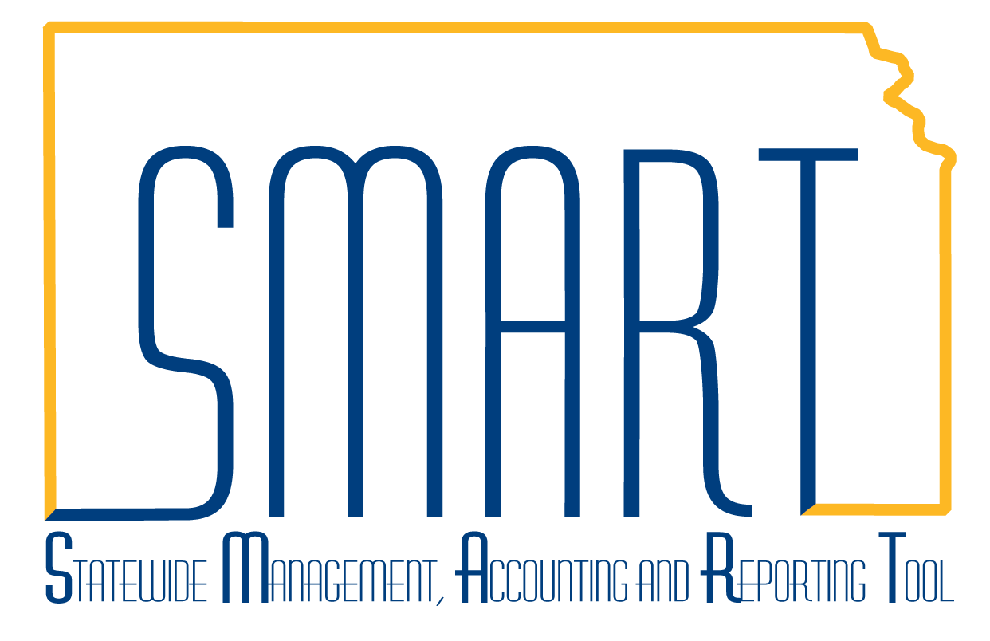
State of Kansas
Increasing the Billing Limit on an
As Incurred Contract
Statewide Management, Accounting and Reporting Tool

Date Created: | 1/18/2013
Version: | 1.2
Last Updated Date: | 07/21/2023
Scenario: | An increase in the funding amount of an award may result in a need to increase the Billing and Revenue Limits on the Contract. If billable transactions have been charged to a project exceeding the original billing limit established on the As Incurred contract and the contract is not amended, this creates OLT rows on the project Transaction List (OLT = Over the Limit). The originating transaction will continue to process for payment, but the OLT rows sent to Project Costing will not be sent forward to the billing worksheet for reimbursement processing until the contract billing limit is increased to accommodate the over-the-limit dollars.
Step 1. Navigation: Projects and Grants Homepage > Project Costing > Transaction Definitions > Transaction List or Navigator > Project Costing > Transaction Definitions > Transaction List. Identify the amount of transaction rows in OLT status. This is the minimum amount the contract billing limit must be increased by to ensure the existing transactions will process for reimbursement, or the increase in funded amount of the contract. Note the amount of all OLT rows that need to be processed through Billing. | 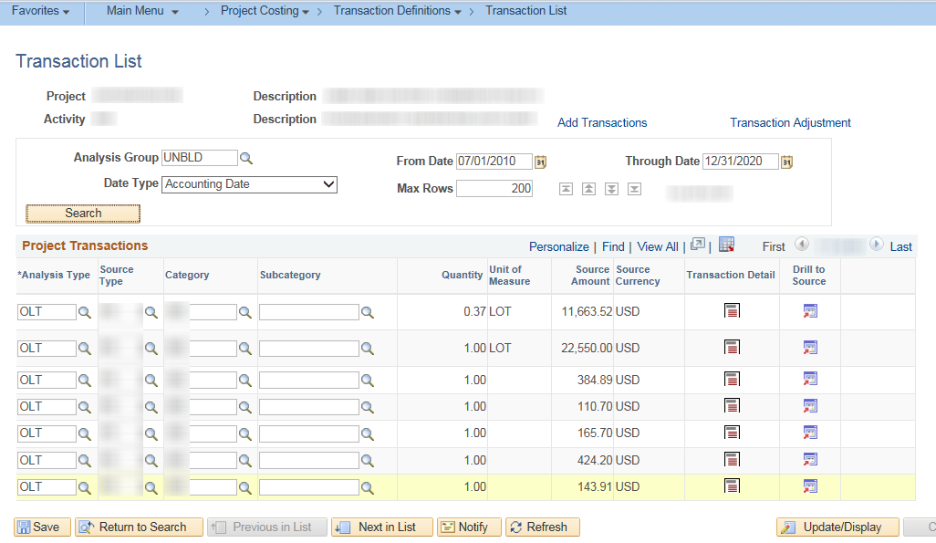
Step 2. Navigation: Projects and Grants Homepage > Customer Contracts > Customer Contracts > General Information or Navigator > Customer Contracts > Create and Amend > General Information > Lines tab. Search for the associated contract to amend it and to view the existing billing limit. Using the Related Action Framework functionality on the Lines Tab, click the arrow beside Actions and select Define Contract Terms. Determine the amount you wish to increase the billing limit, keeping in mind any upcoming transactions that may need to be accounted for. | 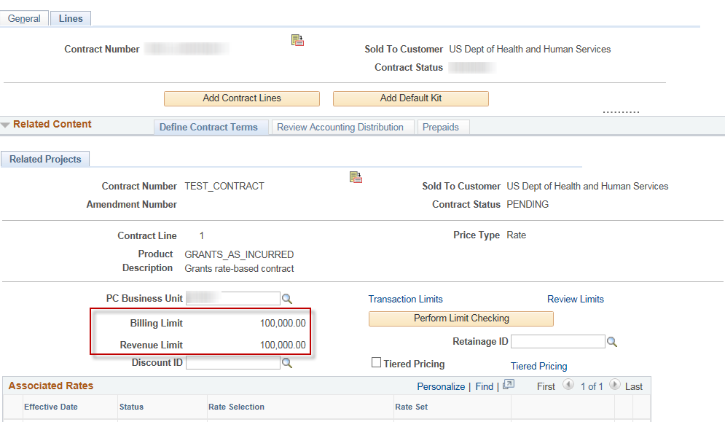
Step 3. Click the Amend Contract button on the Related Projects page to initiate the amendment. On the Contract Amendments page, enter an Amendment Type and Reason. Click Save. | 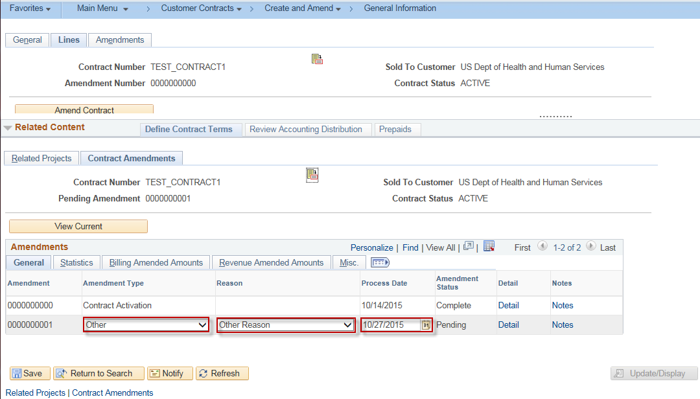
Step 4. Click back on the Related Projects tab. Select the Amount Allocation hyperlink. | 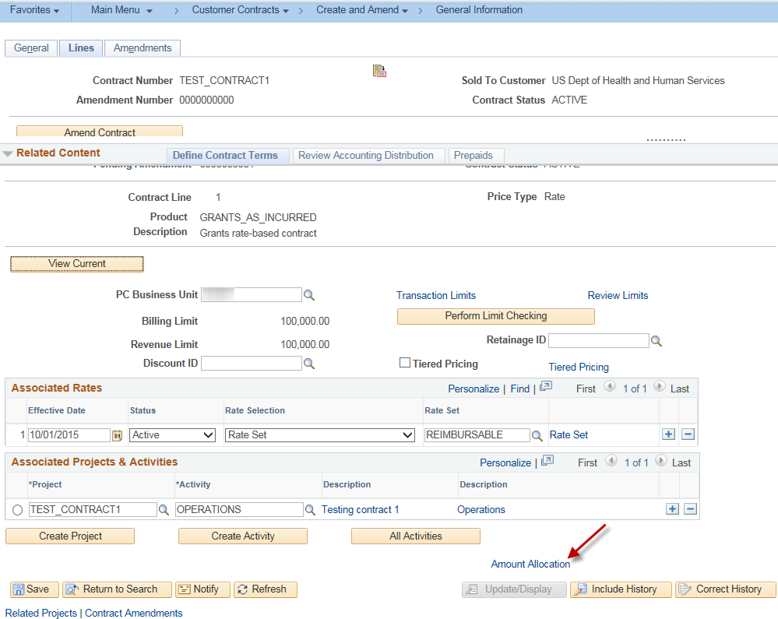
Step 5. Enter the New Billing Limit and the amount of increase in the Total Billing Adjustment. Click the Recalculate button. Verify the Unallocated Billing equals 0.00 and the Allocation is Complete. Scroll down and click Save in the Related Content window. | 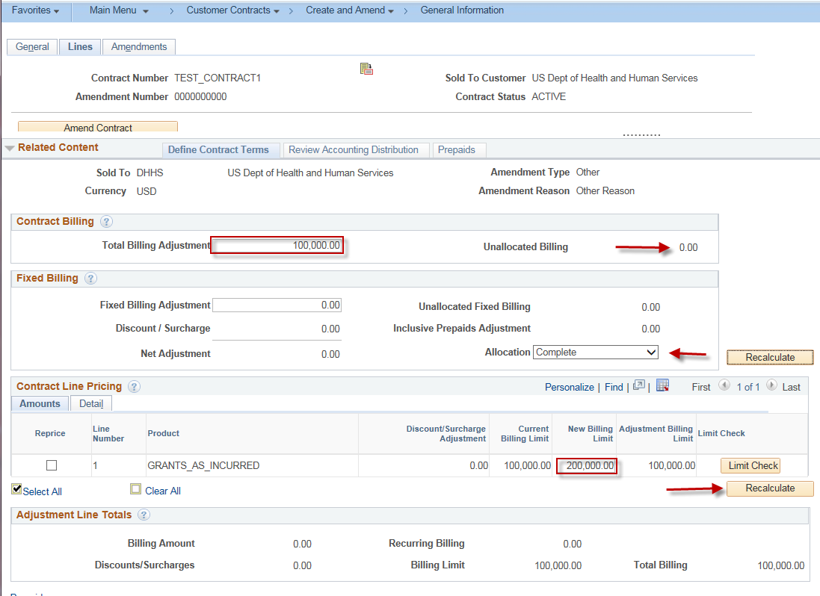
Step 6. Click on the Contract Amendments tab at the top of the page and click on the Details link on the amendment line to enter the Amendment Details page. | 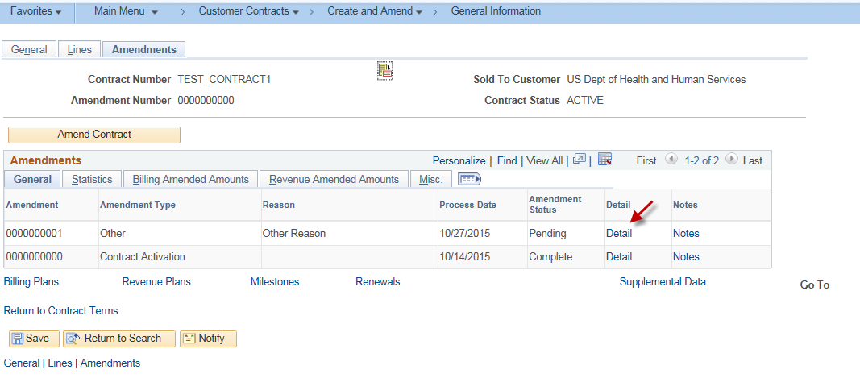
Step 7. Note the revised Billing and Revenue Limits. Toggle the Pending status to Ready. The Process Amendment button appears. | 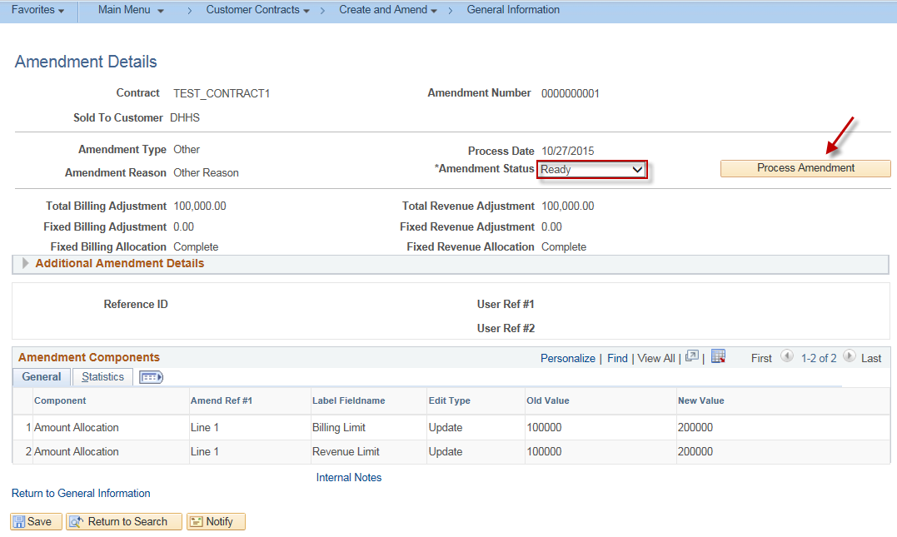
Step 8. Click the Process Amendment button to finalize the new billing limit. When the process is complete, the Amendment Status will change to Complete. Click Save. | 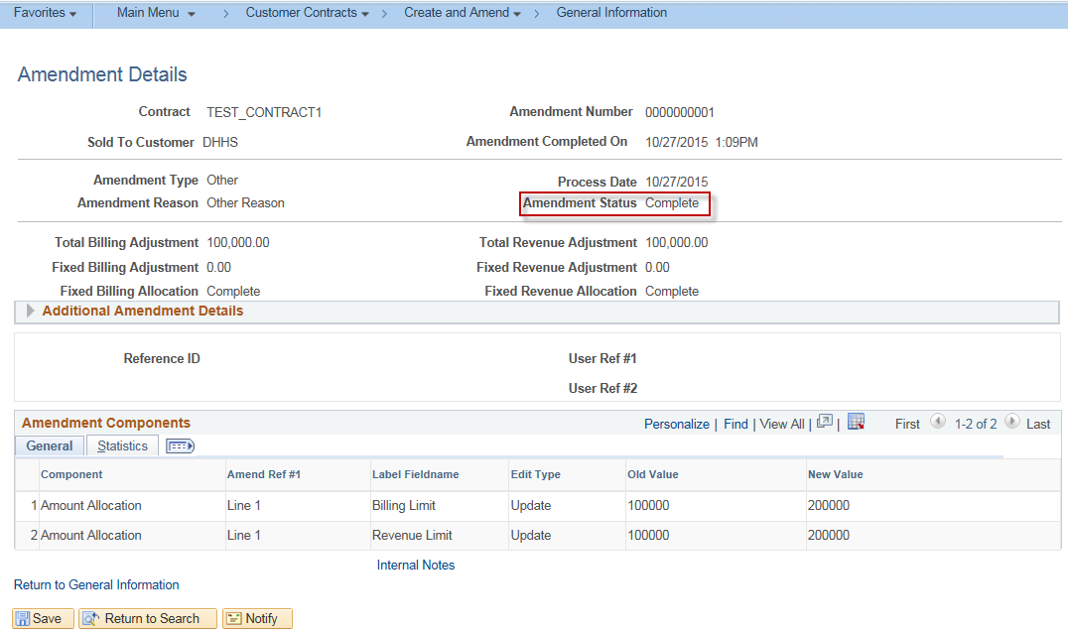
Step 9. Click the Return to General Information hyperlink. Click the Lines tab, click the Actions arrow and select Define Contract Terms. Verify the Billing and Revenue Limits. | 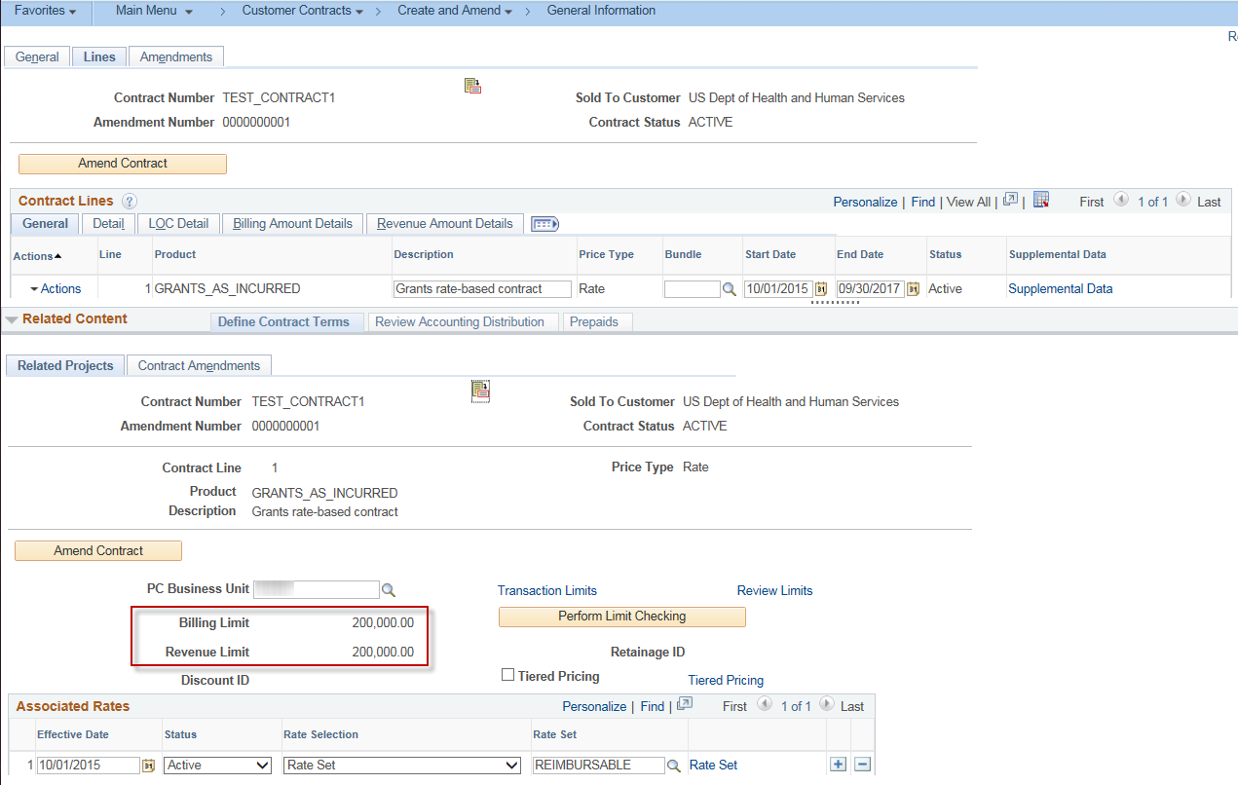
Step 10. Finally, click the Perform Limit Checking button on the same page. After the check is complete, a window will appear stating, “Limit check is complete.” Click the OK button. This ends the process.  Note: Overnight batch processing will run, changing the OLT rows on the project to BIL rows since they now fall within the increased billing limit. The new BIL rows (formerly OLT rows) will then appear on a new Billing Worksheet for processing. | 