State of Kansas
INF50 Excel Voucher Upload
Statewide Management, Accounting and Reporting Tool

Date Created | 07/07/2010
Version | 3.0
Last Update | 10/03/2022
Security | - Role Security: Only SMART users with the following roles have access to use the INF50 Excel Voucher Upload process:  - Agency AP Processor (KAP_Agy_AP_Processor)  - BU Security: Business Unit Security is applied. Users will only have access to upload vouchers for business units associated with their SMART UserID.  - The INF50 Excel Spreadsheet may not be used by any non-state employee.  - The INF50 Excel Spreadsheet may not be used on any non-state owned computer.
Purpose | Provide instructions to users for the INF50 Excel Voucher Upload process. This includes system requirements, how to complete the spreadsheet, how to submit the spreadsheet to SMART, edits applied during the process, as well as troubleshooting tips.
System Requirements | - Excel 2016, 2013, or 2010 must be installed on the user’s computer in order to use the INF50 Excel Spreadsheet.  - Make sure to enable macros when prompted to do so. This will appear as either a yellow bar across the top of the spreadsheet or as a pop-up window when the Excel spreadsheet is opened:  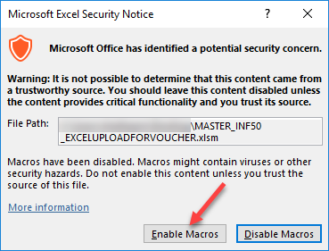  If macros are not enabled, the Excel workbook will not function properly. The macro security level may need to be adjusted in the user’s Excel program.  - The agency’s technical staff should be contacted for assistance with any setup related to use of this spreadsheet voucher.  - The INF50 Excel Spreadsheet is password protected - users cannot edit, reformat, or delete columns.

Obtain Excel Spreadsheet Upload Voucher Template | - The INF50 Excel Spreadsheet is available to any agency using the Accounts Payable module in SMART.  - The INF50 Excel Spreadsheet may be requested by logging a Kansas Service Desk Ticket.  - Template – Default Request  - Category – Accounts Payable  - Sub-Category – INF50 File request  The request will be reviewed, and the INF50 Excel Spreadsheet will be attached to the ticket and the ticket closed.  - It is recommended that the Master INF50 Excel Spreadsheet is initially saved with the default file name. When a new spreadsheet is started, create a copy of the ‘master’ spreadsheet using the ‘Save As’ function. In this manner, the original ‘master’ will be preserved should it become necessary to start over with an unaltered INF50 spreadsheet.
Entering Data in the Spreadsheet
The Voucher Header (Blue) should contain one line for each voucher.
The Voucher Line (Yellow) should be populated only once for each voucher line, and only on the same line as the first Distribution Line.
The Distribution Line (Purple) should contain as many lines as are required for the distribution line data.
The Payment Line (Green) should contain data on only the first line of the voucher (same line as the voucher header).
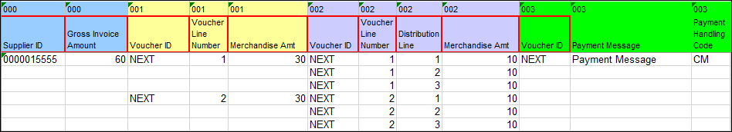
See the INF50 Excel Voucher Upload Guide to Fields for details about each field. Required fields are outlined with a red border in both the INF50 Excel Spreadsheet and the INF50 Guide to Fields.
Associating Purchase Orders to Voucher Lines:
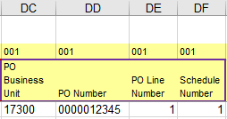
- Four PO fields must be entered on each voucher line to which a PO is being associated:
PO Business Unit (column DC)
PO Number (column DD)
PO Line Number (column DE)
Schedule Number (DF)
- These four fields are outlined with a purple border to help the user identify them as required for lines associated with POs.
- A voucher can have a mixture of lines that are associated to POs and not associated to POs.
- Multiple POs can be referenced on one voucher as long as the supplier ID is the same for each.
- The Supplier ID (column H) must be populated on the voucher header. Supplier Location and Address Sequence Number may be left blank and will take the default values from the supplier record.
- The line description, if left blank, will autopopulate based on what is on the PO. If it is populated on the INF50, that is what will populate in the voucher.
- Do not enter any data in the distribution lines (purple). All distribution line fields must be blank when associating a PO to the voucher line.
Uploading the INF50 Excel Spreadsheet, Voucher Build, & Voucher Log
- After the voucher information is entered on the spreadsheet, save the completed INF50 Excel Spreadsheet. (The location where the spreadsheet is saved will be used in step 4.) NOTE: Spaces are not allowed in the file name of the completed INF50 Excel Spreadsheet. Letters, numbers, and underscores are the only acceptable characters in the file name.

- On the Data Sheet Tab of the INF50 Excel Spreadsheet, there are two buttons across the top:
  - Generate XML allows users to generate and view the XML code that will be generated and sent to SMART. Using this button does NOT transmit any data to SMART and does not trigger all potential error messages.
  - Generate XML and Post generates the XML code AND sends the data contained in the spreadsheet to SMART. The business process is to select Generate XML and Post.
Do Not Press ‘GENERATE XML AND POST’ more than once. This button must be pressed only once to prevent duplicate submittals of spreadsheet data. Any duplicate vouchers entered in SMART must be reviewed and deleted by the agency.

- A pop-up box will display prompting the user to enter SMART sign-on credentials. Enter your SMART User ID and SMART Password and click OK.

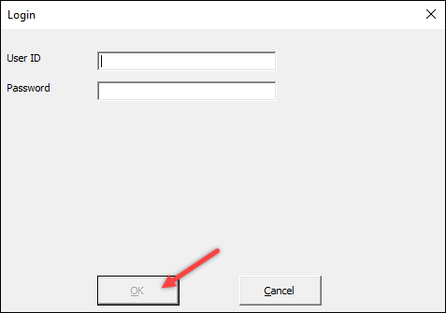

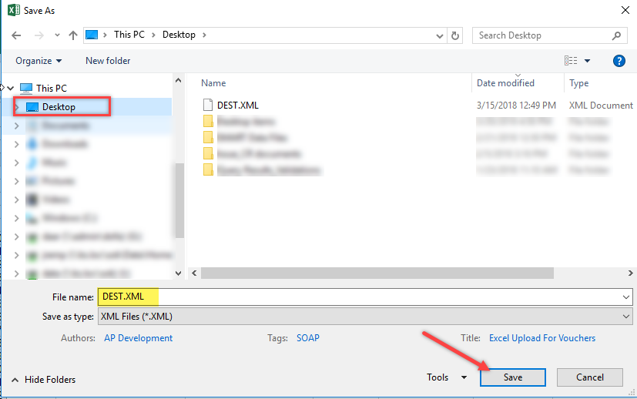
- The next screen in the Excel Voucher Upload process asks where to save the DEST file. The default file name, DEST.XML, should not be changed and this file must be saved in the same folder as the INF50 Excel Spreadsheet being uploaded. Select the Save button to continue the upload process.
- If the upload was successful, a ‘Successful’ pop-up message will display. This message indicates the number of vouchers that were imported to SMART. Select ‘OK’ to complete the process and return to the spreadsheet.
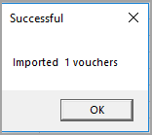
- A query has been added to validate that vouchers are on the staging tables. The query name is KS_AP_INF50_STAGED_VOUCHERS. Results from this query does not mean that all vouchers have passed all edits to build vouchers. It does mean, however, that the vouchers were loaded in SMART for further processing.

- The voucher(s) will be built the next time Voucher Build runs. The AP hourly batch is currently scheduled to run each hour between 8 a.m. and 4 p.m. Any vouchers submitted after the 4 p.m. AP hourly batch will be processed in the SMART nightly batch.

- Verify that the uploaded vouchers were created. If the vouchers are not found using the voucher search page, check Voucher Build Error Detail.

- If the vouchers are not located, open a Kansas Service Desk ticket. Specify the following information in the ticket:
- The approximate time the INF50 Excel Voucher Upload was submitted
- The Business Unit
- The voucher number(s) if not using NEXT
- The expected number of vouchers
- Attach to the ticket, the INF50 Excel Spreadsheet used to submit the vouchers and the Voucher Log file (screenshot showing transactions in question).

Voucher Log (vchrlog.xlsx)
A new feature with this version of the Excel Voucher Upload process is a voucher log file (vchrlog.xlsx). SMART creates a voucher log in the same file location where the spreadsheet and DEST file are saved. The file name is ‘vchrlog.xlsx’ and is updated each time vouchers are uploaded to SMART.

This Voucher Log contains the file name of the Excel Workbook, Date/Time the file was uploaded, Status (Success or Error), and the Log Message.

For a successful upload, the Log Message states: ‘Imported XX vouchers: (Unit, Invoice ID, Invoice Date), Description:’ followed by details specific to the upload.

When the upload attempt results in an error, a line is recorded in the voucher log with information regarding the error. This information should assist the user to correct the data and reload the spreadsheet successfully.
Below is a segment of the voucher log with one successful upload and two that resulted in errors and therefore were not uploaded:

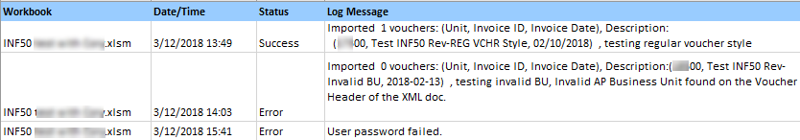

Processing Rules, Troubleshooting, & Initial Data Validations
The Excel Voucher Upload process does not perform significant editing. In addition to basic Microsoft Excel spreadsheet validation edits, the edits include:

- Voucher Style always defaults to ‘Regular’. The following voucher styles cannot be entered using the Excel Voucher Upload process: Single Payment, AP Journal Vouchers, Adjustment, Reversal, or Template.
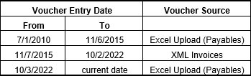
- Voucher Source always defaults to ‘Excel Upload (Payables)’ for this version of the INF50 Excel Spreadsheet. Depending on the timeframe, sometimes INF50 uploads used ‘XML Invoices’ for the Voucher Source. See table.
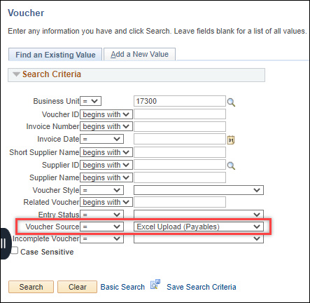
The Voucher Source can be used as a filter on the Regular Entry search page:

- Specific Field Validations:

- Required fields must contain data. Required fields are outlined in red on the INF50 Excel Spreadsheet.
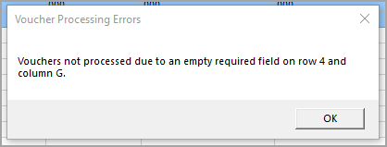
- Voucher comments must be 254 characters or less.
- All date fields must be either empty or contain a valid date.
- Chartfields must not have a trailing space.

If any of these validations fail, the upload process will stop immediately and a pop-up box will display on the screen describing the error. No entry is made to Voucher Log and no data is loaded in SMART. Above is an example of the error when Invoice Date (a required field) is blank on the spreadsheet.

- The User ID entered in the login box described earlier will populate on the voucher transaction. This is an internal control intended to ensure that the user uploading the spreadsheet cannot approve self-entered vouchers.
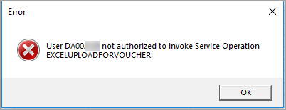
- The User ID must have the KAP_Agy_AP_Processor role which allows voucher entry. If the user does not have this role, the following error message will display in a pop-up box and an entry will be recorded in the Voucher Log. No vouchers will be loaded to SMART.

- The User ID must be authorized to use the Origin code entered in column L. Origin codes used for interfunds (‘I’ or ‘R’) are valid. The voucher will be routed to the AP Workflow defined in SMART for the origin code used. Origin codes for vouchers associated to Petty Cash, Imprest Funds, or PCards should not be entered using the INF50 Excel Voucher Upload. If no Origin is entered, ONL will default on the voucher.
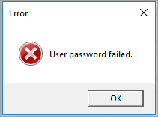
- If the User ID or Password do not validate in SMART, a pop-up box will display with an error message, and an entry will be recorded in the Voucher Log indicating that the upload was in error. When this message is received, check both the User ID and Password, since the error message does not distinguish between the two fields when identifying the error.
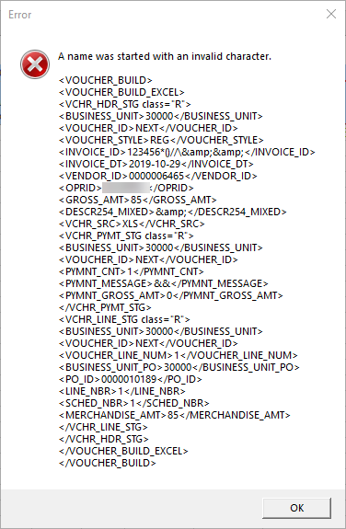
- If a special character is used in any of the fields on the INF50 Excel Spreadsheet, a pop-up box will display with a message similar to the one displayed to the right. An entry will be recorded in the Voucher Log and none of the vouchers will be loaded in SMART.

When this message is received it could be due to any special character, not necessarily what is stated in the error message. There is no way to isolate which field is causing the error message. The user should carefully review the data entered on the spreadsheet, make corrections, save the spreadsheet, and try the upload process again.

Special characters that should not be used in the spreadsheet include ampersand ‘&’ as well as ‘<’. Testing has shown that these specific special characters generate errors when used in the Payment Message field (Column IU) on the INF50 Excel Spreadsheet. This is not a comprehensive list of special characters that may cause errors during the INF50 Excel Voucher Upload process.

- If the user enters an invalid AP Business Unit (Column C), the validation process will cause the upload process to stop immediately. The data line will turn red, ‘Error’ populates in Column B, and a pop-up box will display a description of the error. An entry will be recorded in the Voucher Log as well.

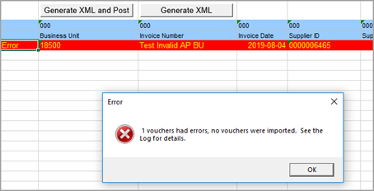
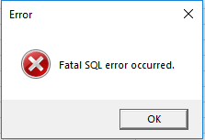
- Users might also encounter a ‘Fatal SQL’ error message. This typically means there is a data error in one of the fields. For example, one of the date fields may be entered incorrectly with a 5 digit year. There is no way to isolate which field is causing the error message. The user should carefully review the data entered on the spreadsheet, make corrections, save the spreadsheet, and try the upload process again.

- There are no limits imposed by the system regarding the number of vouchers per spreadsheet. However, it is recommended to limit the number of vouchers on one spreadsheet to one hundred.

- When loading multiple vouchers on a spreadsheet, if one of the errors described in this section are encountered, the upload process will stop immediately and display the error message. None of the vouchers will be uploaded. Users should correct the error and attempt the upload again. If there is another subsequent error, the process will stop again. This process should be repeated until no errors are detected and the upload to SMART is successful.

