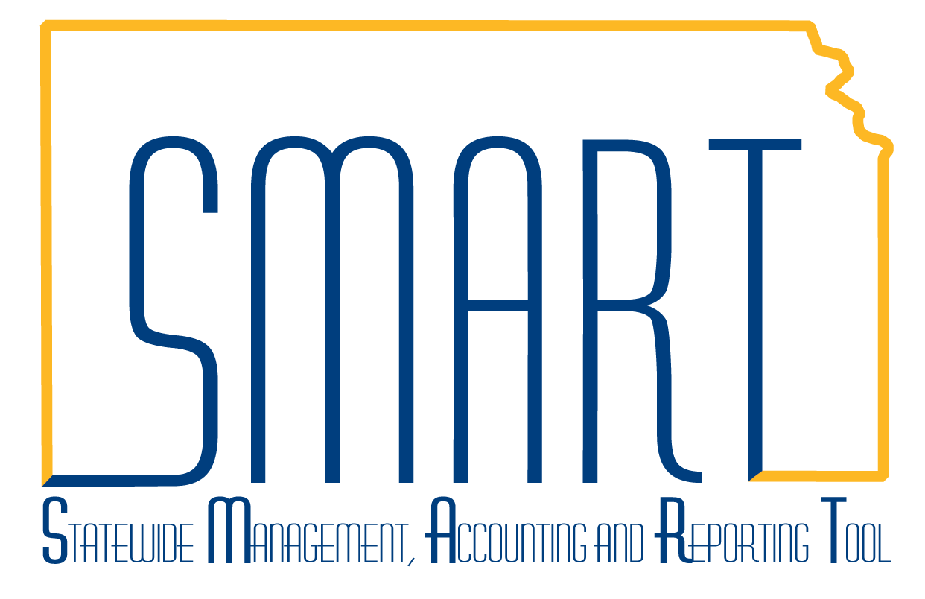
State of Kansas
DA-130 Authorization for Electronic Deposit
of Supplier Payment
Statewide Management, Accounting and Reporting Tool
Date Created: |  | September 01, 2023
Last Updated Date: |  | February 14, 2024
Reason for Job aid: |  | The DA-130 Authorization for Electronic Deposit of Supplier Payment form is used to add or change banking information for electronic deposit (ACH-Automated Clearing House) of supplier payments. This form is the official DocuSign Electronic Form used by the State of Kansas for non-employee suppliers to authorize electronic deposit of payments.
SMART security roles: |  | Agencies will need the Agency DA-130 Processor role to access the DA-130 DocuSign form from inside SMART. This role will automatically be given to any existing SMART user who already has the Agency Vendor Processor role. Any new agency staff needing this role must submit a SMART Security Access Form through their agency SMART Security Contact. The latest version of the security form contains the role in the ‘Accounts Payable – Agency Roles’ section.
1. | Agency Role as Initiator of DA-130 DocuSign Electronic Form | As the initator of the DA-130 form, the agency must fill in the Initiator information, Supplier Signer, and Agency Signer information to begin the electronic signature process. Signers will receive an email inviting them to complete and sign this document. After the form has been completed by all parties, please create a Kansas Service Desk ticket with the fully executed form and bank letter or voided check attached.  All designated recipents should be staff who are authorized to handle Personally Identifiable Information (PII).
2. | DA-130 Homepage Tile | To initiate a DA-130 electronic form, log into SMART and navigate to the SMART Homepage. The DA-130 tile is located here. Click on the Tile.  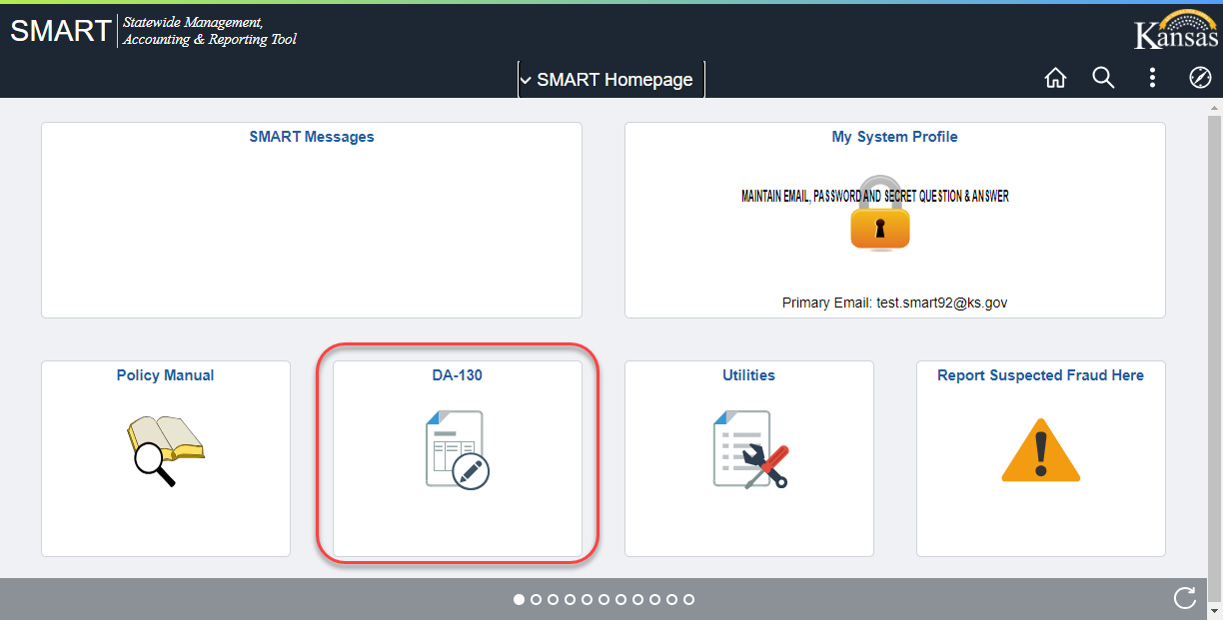
3. | Opening the DA-130 Form | Choose the DA-130 Form from the left-hand menu.  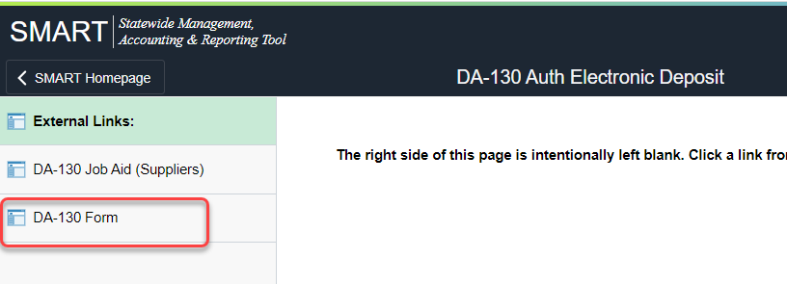  The form will generate inside the right-hand frame in SMART.  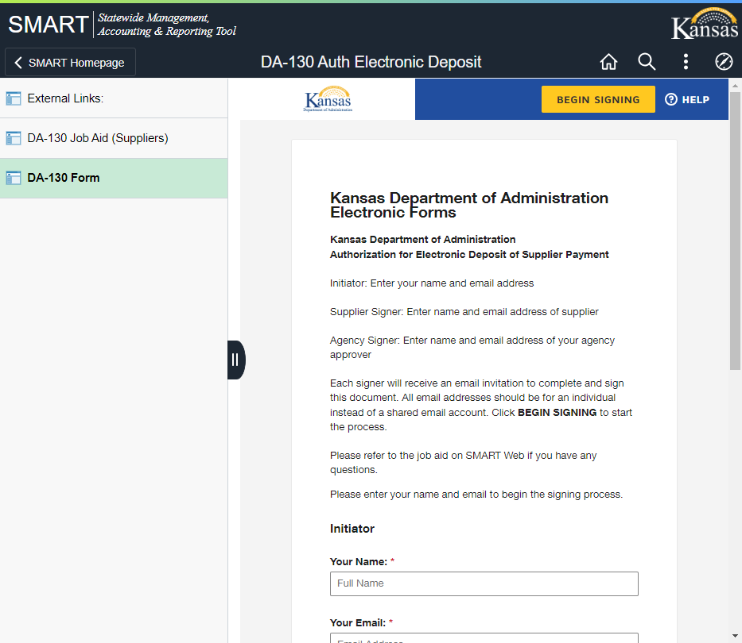

4. | Starting the DA-130 Process | Definitions:  - Initiator – the person preparing the DA-130 form to send to the supplier  - Supplier Signer – the person responsible for providing new/updated supplier information contained in Part I, II, III (if applicable) and IV of the DA-130 form as well as providing the authorized signature of the supplier. This should be a verified employee of the supplier.  - Agency Signer – the person responsible for completing the agency certification of the DA-130 document contained in Part V.  The Initiator of the form will complete all information shown on this page. The Initiator must enter the name and email address of the Initiator, the Supplier and the Agency Signer so the form can be routed electronically.  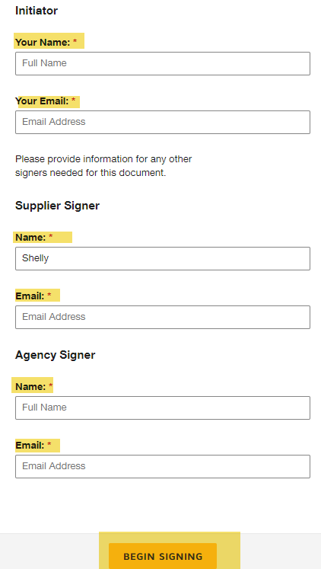  Once the Initiator completes the required information, click the ’Begin Signing’ button at the bottom.  The Initiator will click the ‘Continue’ button after reading the following statement on the screen:  Please review and complete.  Fill in SMART Supplier ID and SMART Supplier Name, if known.  For a new supplier, leave the SMART Supplier ID and SMART Supplier Name blank. SMART Supplier Name will be entered by the supplier.  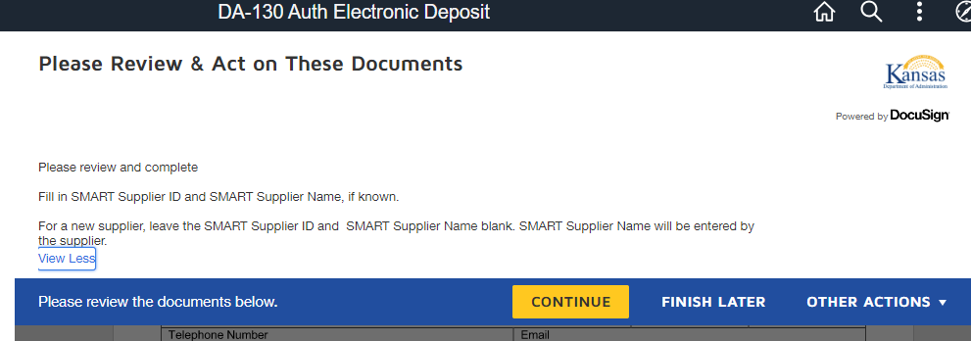

5. | Part I: Supplier Information | Enter the SMART Supplier ID and SMART Supplier Name, if known. It is optional for the Initiator to fill in the Supplier ID and Supplier Name. Do not enter a Supplier TIN or FEIN in the Supplier ID field. This should only reflect a SMART-assigned Supplier ID.  For a new supplier, leave SMART ID and Supplier Name blank.  Once complete, select the ‘Finish’ button at the top or bottom of the screen and this form will be forwarded to the supplier’s email that was setup by the Initiator.  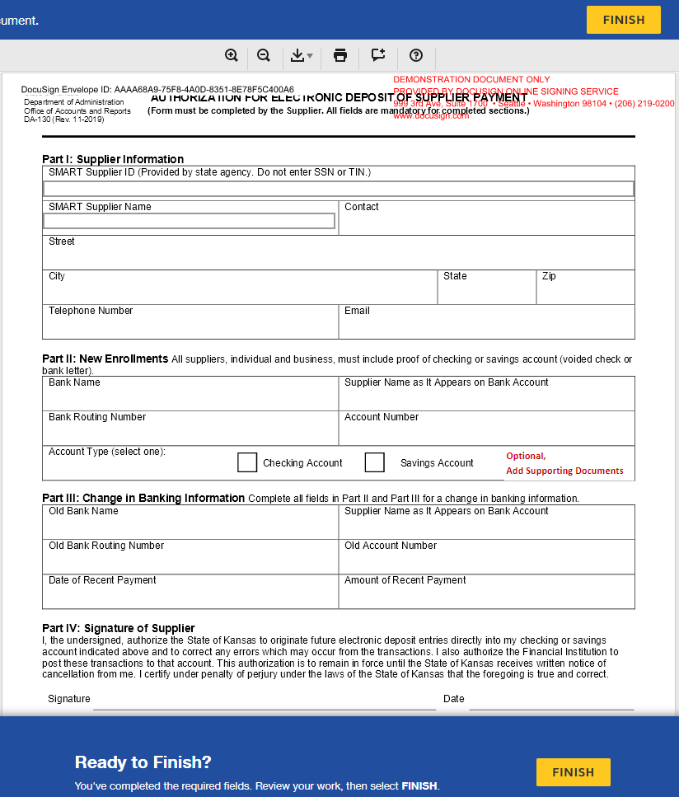

6. | Downloading and Printing the form | The Initiator may choose to Download or Print a copy of the form.  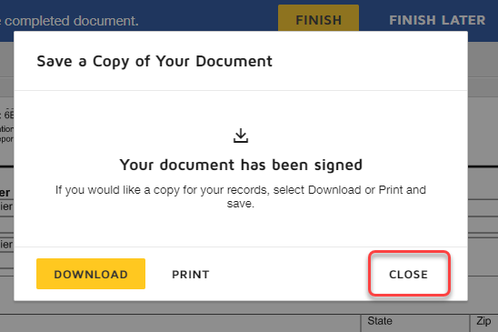  Once the ‘Close’ option has been selected, a copy of the document will be seen on the screen.  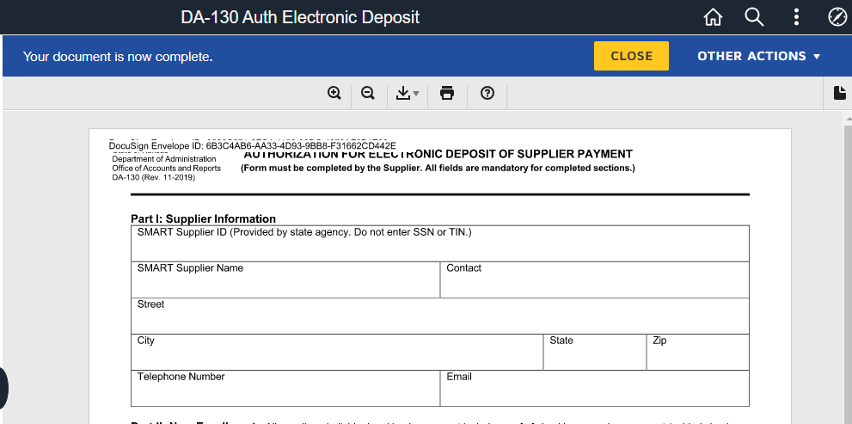  Click the ‘Close’ button to close the printable copy. The Initiator steps are complete.  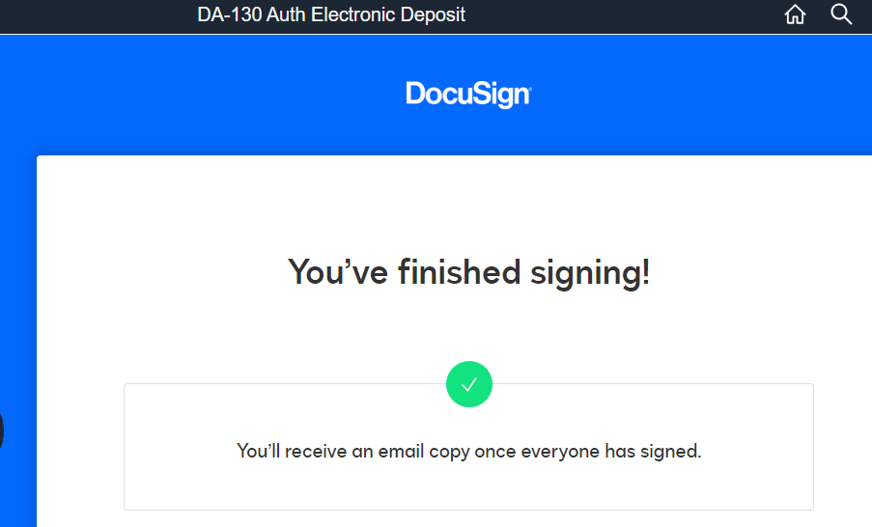
7. | Supplier Signer – Part I, II, III (if applicable) and IV | The Supplier Signer will receive an email from ‘OAR DocuSign via DocuSign’ originating from dse_NA4@docusign.net with a subject line of: AUTHORIZATION FOR ELECTRONIC DEPOSIT OF SUPPLIER PAYMENT  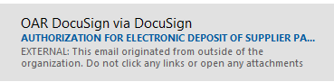  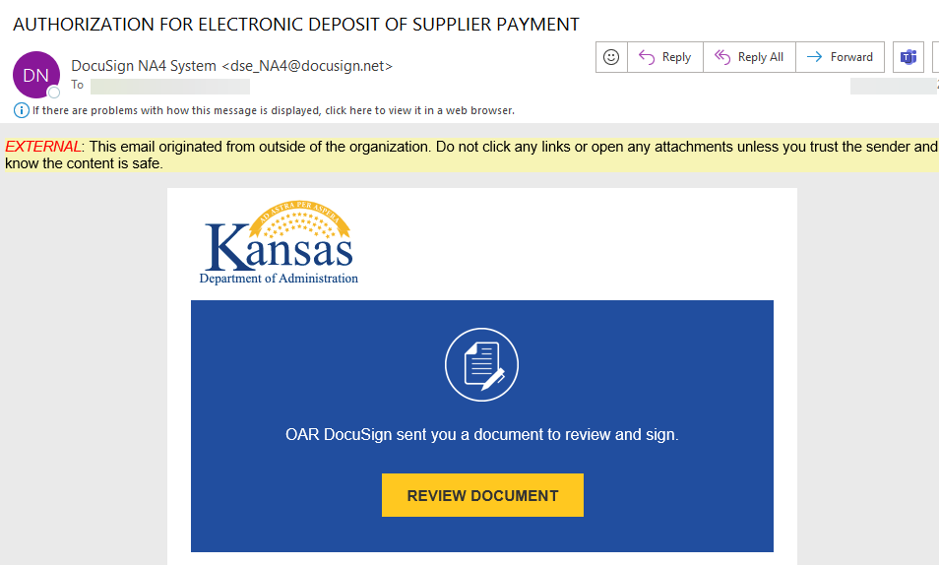  The Supplier Signer will need to Review the Document.  DocuSign will open the document in the default browser window.  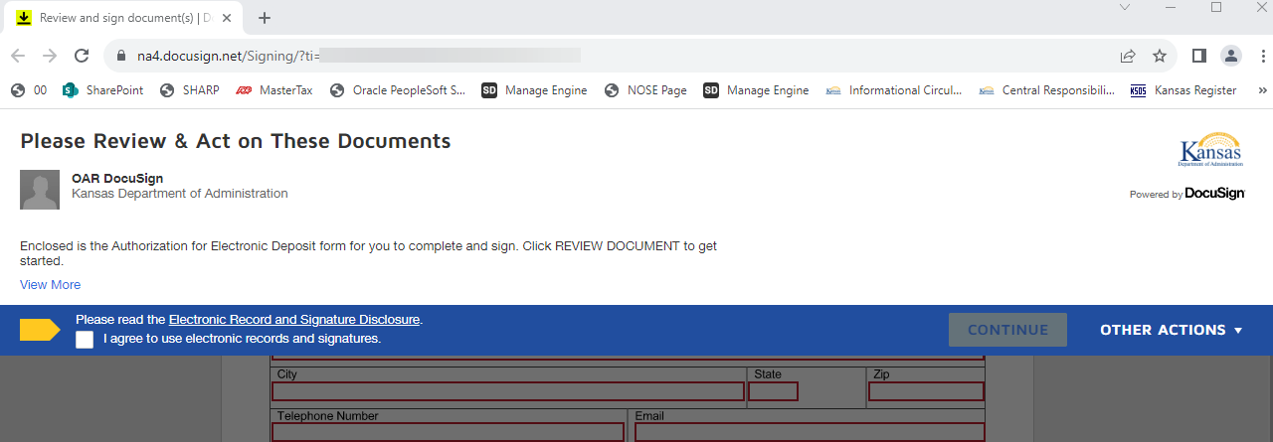  The Supplier Signer must select that they agree to the use of electronic records and signatures to continue.

8. | Supplier Signer Instructions | The Supplier Signer will need to enter the following information on the DA-130 form:  Part 1: Supplier Information  The Supplier Name, Contact Name, Street Address, City, State, Zip, Telephone Number and Email Address are all required fields.  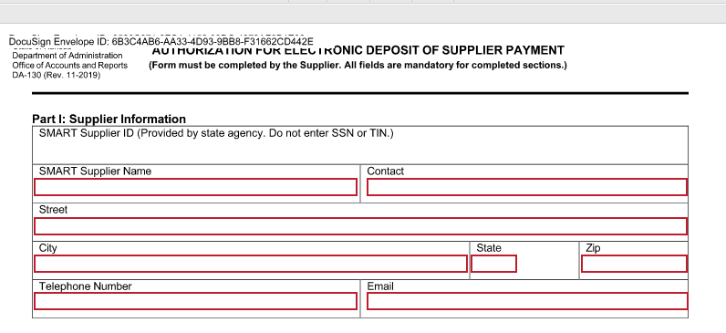  Part II: New Enrollments  The Bank Name, Supplier Name on the Bank Account, Routing Number, Account Number, and Type of Account are required.  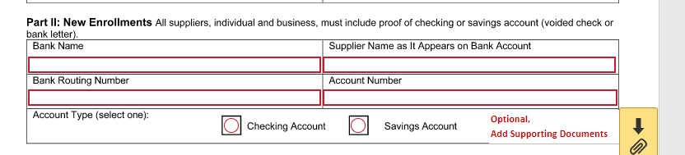  The Supplier Signer may attach their bank letter or copy of their voided check to the DA-130 by clicking on the paperclip next to ‘Add Supporting Documents’. If the Supplier chooses to not add their supporting documents, they will need to provide them to the Agency Signer for certification prior to entering the request to update SMART.  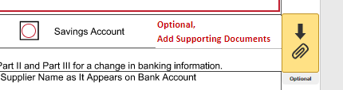  Part III: Only complete this section if the New Information is to replace an old or incorrect account. All fields in this section will become required if the Old Bank Name is entered.  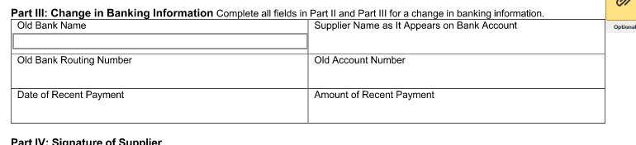  Part IV: The Supplier Signer will need to click on the ‘Sign’ button to electronically sign the form and enter their job title if applicable. The Date will default to the current date.The name the Initiator entered in Step 4 for the Supplier Signer will default on the printed name line.  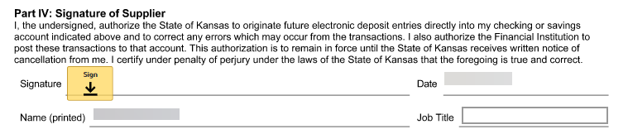  The Supplier Signer will then need to click the ‘Finish’ button at the bottom of the screen.  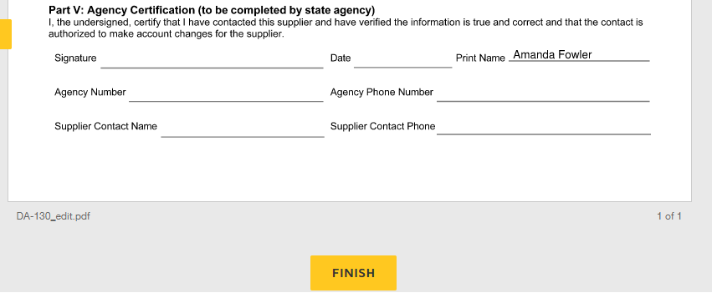  The Supplier Signer will have the option to Download or Print a copy of the form for their records. Once complete, click 'Close’.
9. | Agency Signer – Part V | If the Supplier Signer completes the DocuSign document, the workflow will route to the Agency Signer via email.  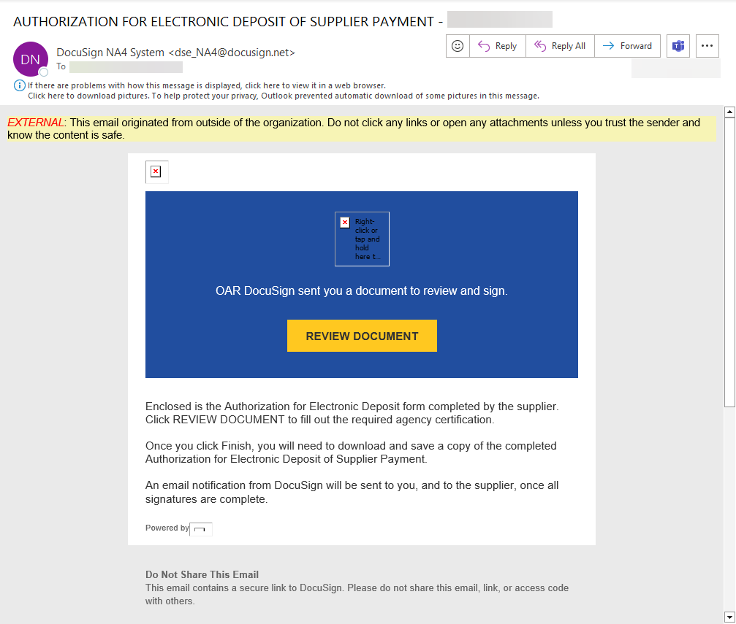  The DocuSign document will open in the Agency Signer’s default browser. The Agency Signer will need to check the box agreeing to electronic signatures to continue.  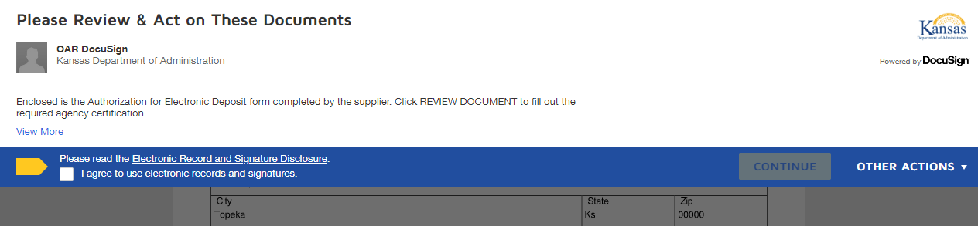  The Agency Signer will review the completed form to verify accuracy and look for any anomolies in the information provided. The Agency Signer is not allowed to update any information on the form. If any information on the form is not correct, then a new form will need to be initiated.  The Agency Signer will collect the required supporting documentation (i.e. Bank Letter or Voided Check that states Supplier Name, Routing Number and Account Number), if it was not attached to the electronic document. If it was attached to the document, it will display on page 2 of the DocuSign document.  The Agency Signer must then complete a phone call to a verified contact/phone number for the Supplier (not a phone number from an email communication with the supplier) to verify that the information entered by the Supplier was provided by an authorized employee, and that the Bank Name and Account Number is true and correct.  Once the certification is complete, the Agency Signer completes Part V: Agency Certification  The Agency Signer must click on the ‘Sign’ button to sign the document. The Date and Printed Name will automatically populate. The Agency Signer must enter their 5-digit Agency SMART Number, Phone Number, Supplier Contact Name of the individual they spoke with on the phone and the Supplier Contact Phone number via which they contacted them.  Click the ‘Finish’ button at the bottom of the screen.  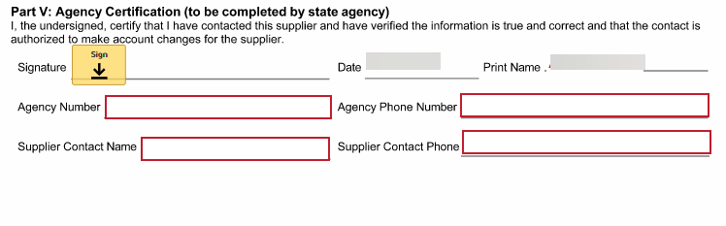  The Agency Signer should Download a copy of the document and save it for further processing. The document will need to be attached in SMART when the new supplier is entered or attached to a Kansas Service Desk request to update an existing supplier.  Instructions for creating a new supplier can be found on the SMART training website under Accounts Payable  https://smartweb.ks.gov/media/documents/creatingnewsmartsupplierrecord_A1E9ECC703AE4.docx  Instructions for how to attach to a Kansas Service Desk Ticket can be found on the SMART training website under Kansas Service Desk  https://smartweb.ks.gov/media/documents/manageengine_for_requesters_07C0E20A55DE8.doc

