

Training Guide – Asset Management
Agency Asset Processor’s Role in Integration

State of Kansas

Applicable Role(s):

Agency Asset Processor
Table of Contents

Understanding Purchasing/Accounts Payable Integration 3
Transaction Loader 4
Processing Unitization 5
Processing Consolidation 8

Integrating Purchasing and Accounts Payable with Asset Management

Understanding Purchasing/Accounts Payable Integration

AM Integration is triggered on source documents in the Purchasing and Payables modules. The two fields that trigger integration are AM Business Unit and Profile ID. It is critical that the correct Profile ID is selected on these documents to prevent processing issues in the AM module.

This document provides a high-level description of integration into the Asset Management module for an understanding of what happens in the source documents (Requisition, Purchase Order, Receipt and Voucher). Additional training documentation for how to process the asset-related source documents can be found in the Asset Management (AM), Purchasing (PO), and Accounts Payable (AP) sections of the Integration page of the SMARTWeb.

- The AM Business Unit and Profile ID can be selected on Requisitions and/or Purchase Order Distribution Lines. The AM BU and Profile ID will copy forward into future documents.
  - Note: Adjustments to existing asset costs (as in the case of Construction in Progress assets) must come from the Voucher only. The system assumes that Requisitions and Purchase Orders are for new assets. There is no place to enter an Asset ID on the Requisition or Purchase Order. This is because physical information comes from the purchasing module, while financial information comes from the Voucher. Since an adjustment to cost is financial, the integration must begin on the Voucher.
- If a Purchase Order Distribution Line specifies a Profile ID, the Receipt is identified as an asset purchase and provides an Asset Management Information page to record physical data, including serial ID, tag ID, custodian, etc. The Receipt passes the information to Asset Management so the asset can be added with its Physical Information.
  - Note: Because physical data is sent to AM after the Receipt is processed, the asset data on the Receipt must be correct. That means the Serialize/Use One Asset ID buttons have been selected if applicable and the Profile ID is correct. For this reason, some agencies have chosen to start the integration on the Voucher level. It is easier to correct errors in the AM Loader Tables when the integration begins on the Voucher because there’s no risk of incorrect data being prematurely loaded due to an incorrectly processed Receipt. The decision on where to start the integration should be made by the agency based on the Purchasing staff members’ ability to select Profile ID’s. A Voucher Processor might be more comfortable with this task because he/she is used to selecting Account Codes.
- If a Purchase Order Distribution Line specifying a profile ID is copied to the Accounts Payable Voucher, it is identified as an asset purchase and passes the Financial Information from the invoice to Asset Management to capitalize the asset once the voucher has been posted.
  - Note: The integration can also begin at this point as noted above. You do not have to start the integration on the Requisition/Purchase Order. However, if a Purchase Order is copied into the Voucher, the purchasing documentation will be available on the asset record in AM.
- The Agency Asset Processor has a chance to review the information prior to loading it into AM.

Transaction Loader

- It is the Agency Asset Processor’s job to run the Transaction Loader process (AMIF1000). This job loads the data from Purchasing and Accounts Payable into Asset Management.
- Use the “Reviewing the Transaction Loader Tables” job aid for instructions on what should be reviewed, how to run the Transaction Loader process and how to determine the Asset ID created in Asset Management.
- If there are any errors with the data, log a ManageEngine Service Desk ticket for review by the Central Asset Processor. See the “Correcting an Asset Profile Before Asset Has Been Loaded” section within the “Incorrect Asset Profiles and Corrections” job aid for additional information on error correction.
- If the Transaction Loader process does not complete successfully, log a ManageEngine Service Desk ticket for review by the Central Asset Processor.
  - Note that once your User ID has an unsuccessful Process Instance of AMIF1000, that job must be deleted before you can run the Transaction Loader again. Any subsequent jobs will not process successfully if the original unsuccessful one is not deleted first. Log a ManageEngine Service Desk ticket for assistance.
- After the Transaction Loader process has completed successfully, integration details will be available on the Asset Acquisition Details tab in Basic Add (Asset Management Homepage > Asset Transactions > Basic Add > Asset Acquisition Details tab > Interfaces Info hyperlink).

Processing Unitization
- Unitize – To divide one receipt or voucher line into more than one asset. Example: A voucher was created with one invoice line. That line had a quantity of 10 computers. The goal in Asset Management is to have 10 different Asset IDs, each with a quantity of 1 (not 1 Asset ID with a quantity of 10).
  - To accomplish unitization during the Purchasing process rather than on the voucher, the Receiver can serialize a receiving line with multiple assets and add tag numbers and serial numbers for each. This is equivalent to unitizing the asset after it has loaded to the transaction loader tables. Serialization is the preferred method if the agency begins integration in the Purchasing module.
- If the Asset Quantity is greater than 1 and there is no Asset ID assigned, it is likely unitization will be necessary.
- Process unitizations before running the Transaction Loader process, which creates assets in Asset Management.
Page Name | Navigation
FROM Asset | Asset Management Homepage>Send/Receive Information>Interface Transactions> Unitize>Find an Existing Value
 | EZ Unitize button

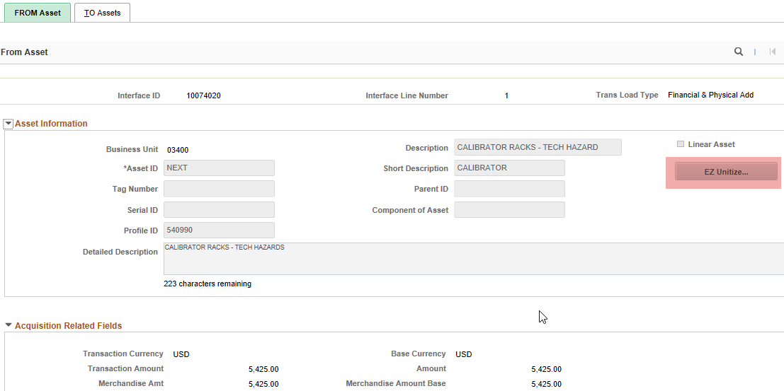

FROM Asset Page
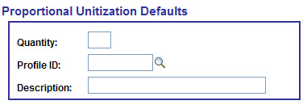
Proportional Unitization Defaults (EZ Unitize...)
Fields | Description
Quantity | Enter the number of assets to create from this transaction line.
Profile ID | The unit cost of the assets being created should be considered when selecting the Profile ID. Example: A capital profile was used on the source documents because the total cost was $5,000. However, 5 items were purchased. That means the unit cost of each item is $1,000, making it a noncapital asset.
Description | Enter a description for each asset.
FROM Asset Fields

Page Name | Navigation
TO Assets | Asset Management Homepage>Send/Receive Information>Interface Transactions>Unitize>Find an Existing Value

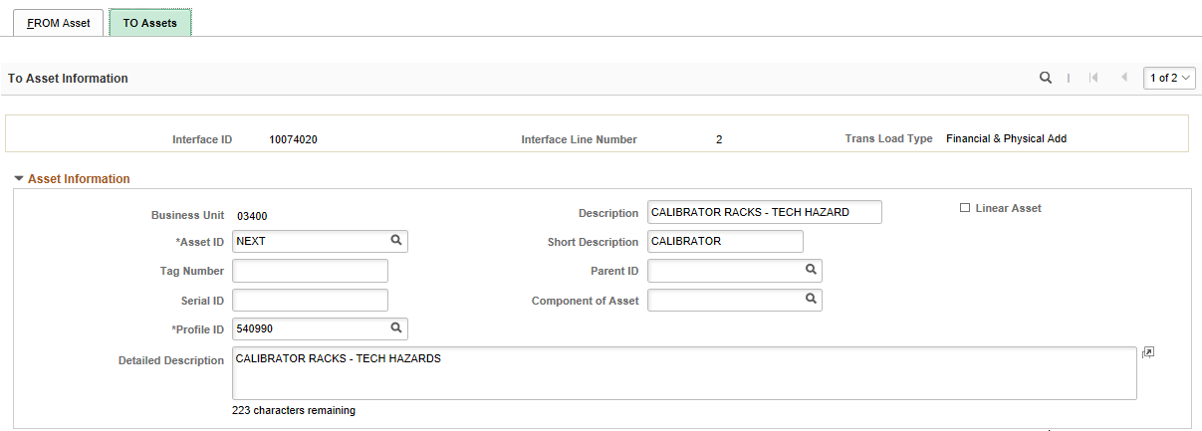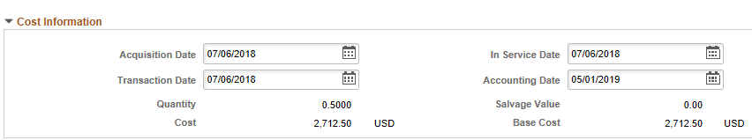
The red box above shows how many assets will be created from the unitization. This comes from the number in the Quantity field in the Proportional Unitization Defaults box.
The system will take the total cost divided by the number of units. For example, if the voucher was for $5,425 and 2 assets should be created, each asset will be worth $2,712.50.
TO Assets page
After saving, run the Transaction Loader process to load the Interface ID that was unitized. The original Interface ID status will change to “Unitized” and a new line for each new asset will be created. The new lines are what the Agency Asset Processor will load. Once the Transaction Loader process has completed, the Asset ID fields will have a value.

Processing Consolidation

- Consolidate – To combine two or more receipt lines into a single asset by selecting the transaction lines on the FROM Assets page
  - The best practice is to select the ‘use one Asset ID’ option during the Receipt or the Voucher process, especially for split funded assets.
- Process consolidation before running the Transaction Loader process.
- A key indicator that consolidation is necessary is the Quantity field in the Transaction Loader tables. If the Asset Quantity is less than 1 and there is no Asset ID assigned, it is likely consolidation will be necessary.

From Assets tab
Page Name | Navigation
FROM Assets | Asset Management Homepage>Send/Receive Information>Interface Transactions>Consolidate>Add a New Value

Use the “Add a New Value” tab to begin Consolidation.

  - Interface ID – The Interface ID value should be left blank. Once the Load Lines are consolidated, the Interface ID for the newly consolidated Load Line should match that of the original Load Line.

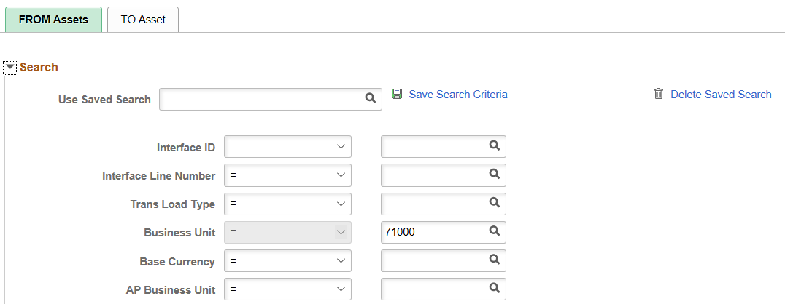
FROM Assets Chartfields Tab
Use the FROM Assets page to select the Asset Load Lines to Consolidate. Use the fields in the Search section to identify the criteria to select Load Lines.

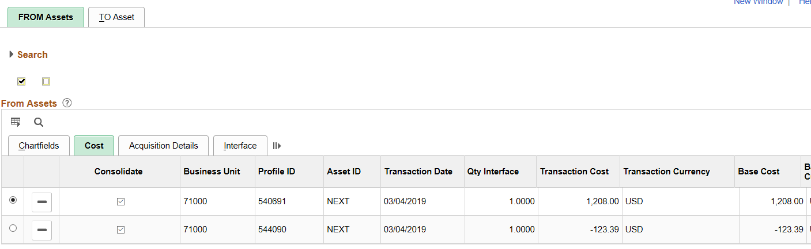
FROM Assets Cost Tab
After clicking Search, all the Load Lines that match the search criteria will be retrieved.
Use the button to delete any unwanted lines that you do not want to consolidate.

Use the Select this Row radio button to default information from one of the Load Lines into the new Consolidated Load Line.

Select only the rows to be consolidated by placing a check in the ‘Consolidate’ box.

To Asset tab

Page Name | Navigation
TO Asset | Asset Management Homepage>Send/Receive Information>Interface Transactions> Consolidate>TO Asset

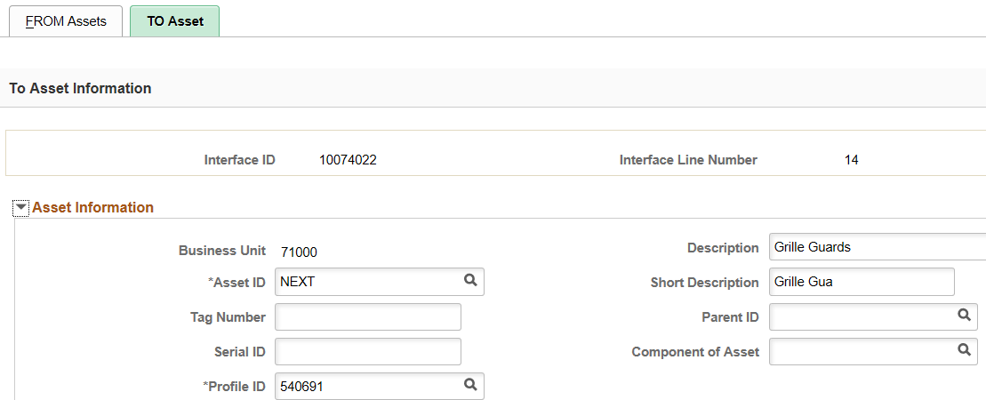
TO Asset Top of Page (Consolidation)

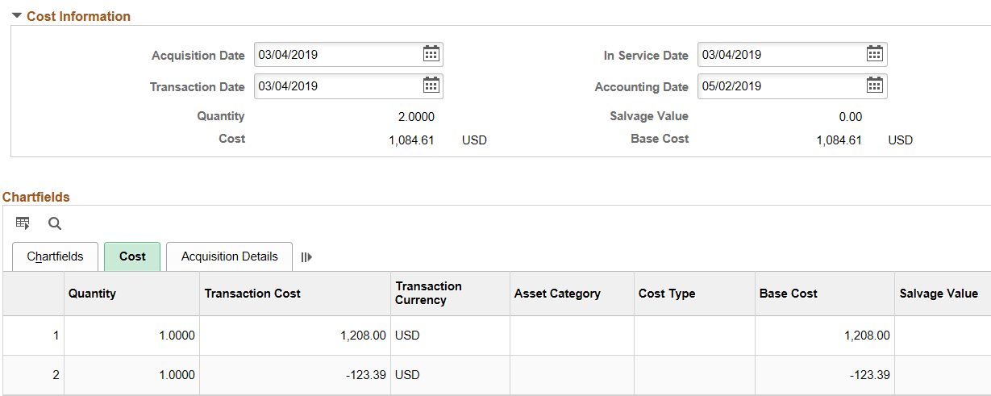
TO Asset Bottom of Page (Consolidation)

After saving, the Agency Asset Processor should run the Transaction Loader process to load the newly consolidated Interface ID. The original Interface ID status will change to “Consolidated,” and new lines will be created. The new line(s) are what the Agency Asset Processor will load. Once the process is complete, the Asset ID field will have a value.



