AM Tool 3 - Asset Purchase Orders
04/15/2019
V.1.1

This document provides instruction on how to process a Purchase Order that contains asset data. This document does not outline all steps to processing a Purchase Order; only those asset-specific steps are highlighted. Additional instruction on processing Purchase Orders can be found in the Purchasing training documents.

Foundation Information

- It is important to understand three basic asset concepts before processing an asset Purchase Order. All of these are defined in the Asset Management—The Basics Training Guide located on the SMART website under the Training page, Asset Management section.

  - You should know the definition of Asset.
  - You must have an understanding of Profile IDs.
  - You must know the Capitalization Thresholds utilized by the State of Kansas.

- Two fields trigger the integration: the AM Business Unit (your business unit) and the Profile ID. It is critical that the correct Profile ID is selected on these documents to prevent processing problems in the AM module.

- Asset Integration can begin on the Requisition, Purchase Order or Voucher. The agency should be consistent in the method chosen.

Note: Adjustments to existing asset costs (as in the case of Construction in Progress (CIP) assets) must come from the voucher only. The system assumes that Requisitions and POs are for new assets.

Note: Because physical data is sent to AM after the Receipt is processed, the asset data on the Receipt must be correct. For this reason, some agencies have chosen to start the integration on the Voucher level. It is easier to correct errors in the AM Loader Tables when the integration begins on the Voucher. The decision on where to start the integration should be made by the agency based on the Purchasing Staff Members’ ability to select Profile IDs. A Voucher Processor might be more comfortable with this task because he/she is familiar with selecting Account Codes.

Entering Asset Data on a Purchase Order

The required asset information on a Purchase Order will be sourced to the Requisition during the PO Auto Sourcing process. If the asset purchase begins with a Purchase Order (AM BU and Profile ID fields were not entered on the Requisition), the asset information can be entered on the Purchase Order for the transaction to be interfaced to Asset Management.

If the wrong asset information (Profile ID, etc.) is entered on the Requisition, it can be corrected on the Purchase Order. The correct asset information must be on the Purchase Order before the Receipt can be properly entered and interfaced to Asset Management.

Every distribution line associated with an asset purchase must be marked with the AM Unit and Profile ID. Those are the fields that trigger the integration.

Homepage Navigation: POs & Receiving Homepage>Purchase Orders>Add/Update Purchase Orders
Or
Nav Bar: Purchasing>Purchase Orders>Add/Update POs

Asset data is located here: Maintain Purchase Order>Schedules>Distributions for Schedule 1 page on the Asset Information tab in the Distribution Section.

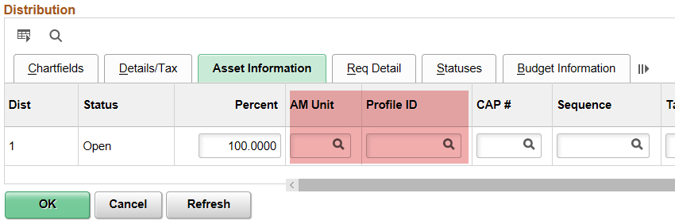
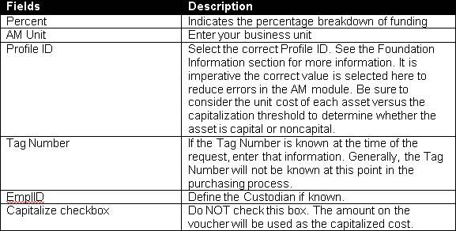

The AM Business Unit and Profile ID fields selected on the Purchase Order will copy forward into the Voucher.

Considerations When Setting Up the Requisition/Purchase Order

O Multiple Assets on Same Req/PO (one funding source): If a quantity of 3 is used on the Req/PO Line and the purchase is for 3 separate and distinct Assets, the Distribution Lines on the Asset Information page on the receipt will need to be serialized to separate the Quantity of 3 into three separate assets. See AM Scenario 1.1 for Receipt processing tips. Enter the correct quantity, especially if this PO will be copied into multiple vouchers. If a quantity of 1 is used, all costs from all vouchers tied to this PO will go to the same Asset ID in AM. If purchasing 10 vehicles (which should be 10 separate assets), use a quantity of 10.

O One Split-Funded Asset: If a quantity of 1 is used on the Req/PO Line and the purchase is distributed on more than one Distribution Line, the Distribution Lines on the Asset Information page on the receipt will need to be combined so that one split-funded asset is created. See AM Scenario 1.2 for receipt processing tips.

O Multiple Split-Funded Assets on Same PO: If multiple split-funded assets are on the same Req/PO, it is highly recommended that each asset have its own Req/PO line. Then split- funding is entered in the Accounting Lines section for the Req or the Distributions for Schedule page for the PO. See AM Scenario 1.3 for receipt processing tips.

The reasons for setting up the Req/PO with one asset per Req/PO line are:
- Each PO line is pulled into individual receipt lines, which makes accepting partial receipts easier to process.
- It is simple to combine the distribution lines on the receipt by clicking the Use One Asset ID button for each Receipt line (ie asset). Otherwise, you have to combine the Distribution Lines by clicking the Use One Asset ID button, then you have to manually split out the distribution lines and associate them to the correct assets by changing the Asset ID value (ie NEXT2, NEXT3, etc) for every chartfield set. This can result in data entry errors.
- It allows the same method of entry to be used when there are different distributions for different assets.
- Each PO line will create a Voucher Invoice line, so it is simple to tell how many assets are being purchased and the cost breakdown of each one on the voucher.

04/15/2019 - AM Tool 3 – Asset Purchase Orders Page 3 of 3

