This document provides instruction on how to process a Voucher that contains asset data. These instructions are for agencies who begin asset integration on the Voucher. Note this document does not cover every step to processing a Voucher; only the pertinent asset-related data is included.
Additional instruction on processing a Voucher can be found in the Accounts Payable training documents.
Foundation Information
It is important to understand three basic asset concepts before processing an asset Voucher. All of these are defined in the Asset Management—The Basics Training Guide located on the SMART website under the Training page, Asset Management section.

- You should know the definition of ‘Asset’.
- You must have an understanding of Profile IDs.
- You must know the Capitalization Thresholds utilized by the State of Kansas.

There are two fields that trigger the integration: the AM Business Unit (your business unit) and the Profile ID. It is critical that the correct Profile ID is selected on these documents to prevent processing problems in the AM module.

Adjustments to existing asset costs (as in the case of Construction in Progress (CIP) assets) must come from the voucher only. The system assumes that Requisitions and POs are for new assets.

AM Tool 5 – Beginning Asset Integration on Voucher
04/17/2019
V.1.1

Homepage Navigation: Accounts Payable>Vouchers>Add/Update>Regular Entry

Or

NavBar: Navigator>Accounts Payable>Vouchers>Add/Update>Regular Entry

Asset data is located on the Assets tab in the Distribution Lines Section under Invoice Lines.

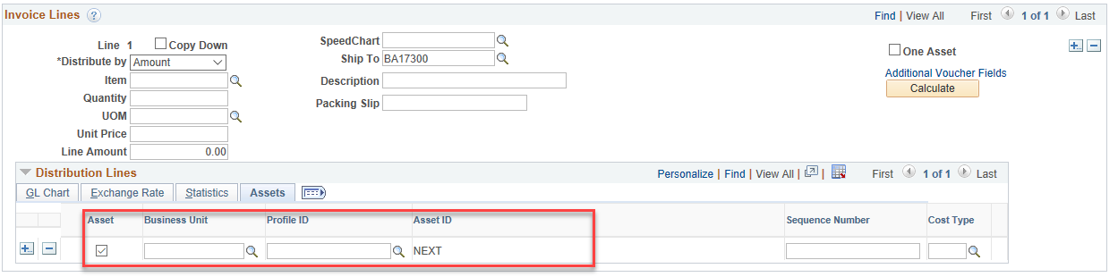
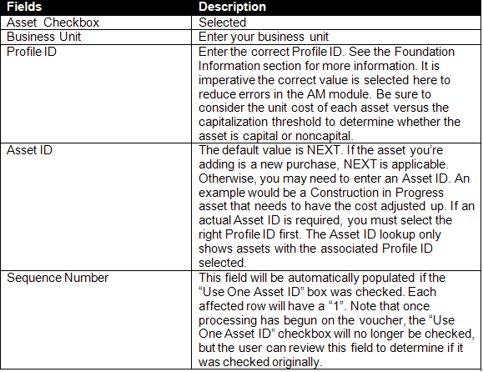

After the voucher is posted, the data will integrate into the Asset Management Loader Tables, where the Agency Asset Processor is responsible for reviewing and loading the data.

Items to Note Regarding Processing a Voucher with Asset Information

O If integration starts on the voucher for a line with a quantity > 1.000, the Agency Asset Processor will need to split the total into individual assets in the AM Loader Tables via Unitization.

O If the asset is split-funded, utilize the “One Asset” checkbox. Split-funded assets should have a single Invoice Line with multiple Distribution Lines under each Invoice Line. This tells the system that all Distribution Lines within that Invoice Line are for the same asset. This creates one split-funded asset in AM. Only those lines with the AM BU and Profile ID will integrate forward into AM, so every applicable Distribution Line should be marked with the AM Business Unit and Profile ID.
- Note that the Sequence Number field will be populated with a “1” on each funding line if the “One Asset” box was checked. After processing has begun on the voucher, the “One Asset” box will no longer be checked, but the Sequence Number field will validate that it was originally checked.

