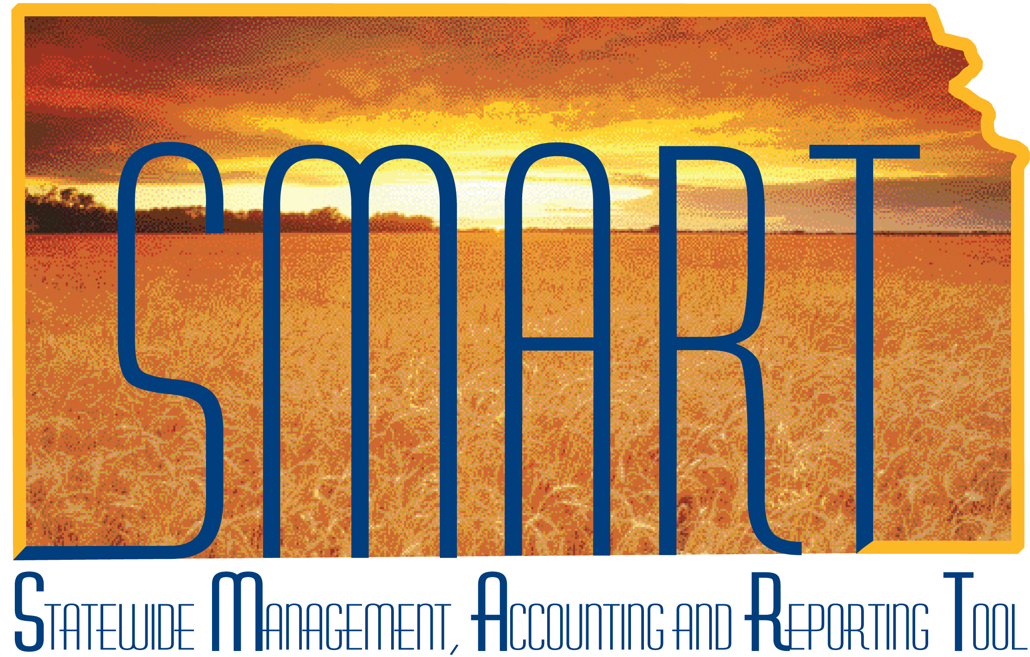

Training Guide
1099 and Withholding Information

State of Kansas

Applicable Role(s):

Agency Supplier Processor

Agency AP Processor
Table of Contents
1099 Information 3
Guide to completing the Supplier Withholding Information 4
Suppliers – Location Page - 1099 Set up 4
1099 Types and Class Information 6
Supplier Table 1099 Withholding Guide 7
Modifying 1099 Information on a Voucher 12
Examples of Reportable Payments 15
SMART 1099 Account Code Guide 17
Standard 1099 Type and Class for the State of Kansas 25

1099 Information

What is a 1099? It is an informational return to report various type of income other than wages.
The IRS requires the State of Kansas to issue 1099 forms to reportable entities (suppliers) for services, rentals, awards, certain types of grants, interest, dividends, and certain real estate purchases.
The State of Kansas, Department of Administration supports five types of 1099 Forms in SMART:
- 1099-MISC: Rents, royalties, awards, damages
- 1099-NEC: Services
- 1099-G: Governmental payments (tax refunds are the Dept of Revenue)
- 1099-INT: Interest
- 1099-S: Real estate
Two criteria must be met in order for 1099 reporting to occur for a supplier:
- The supplier must be subject to 1099 reporting
- The payment must be reportable
What suppliers are NOT (currently) reportable?
- Corporations are NOT reportable UNLESS they provide medical or legal services
- Governments
- Tax Exempt Organizations
What is an LLC?
LLC stands for Limited Liability Company. The federal government does not recognize an LLC as a classification for federal tax purposes. An LLC can be a corporation, partnership or sole proprietorship. The W-9 Form should indicate which of these entity types applies to the supplier.

Guide to completing the Supplier Withholding Information

For Complete Information on how to setup a New Supplier – Please see the Job Aid “Creating a New Supplier”.

Important! You must check the Withholding checkbox on the supplier Identifying Information tab if the supplier is subject to 1099 reporting.
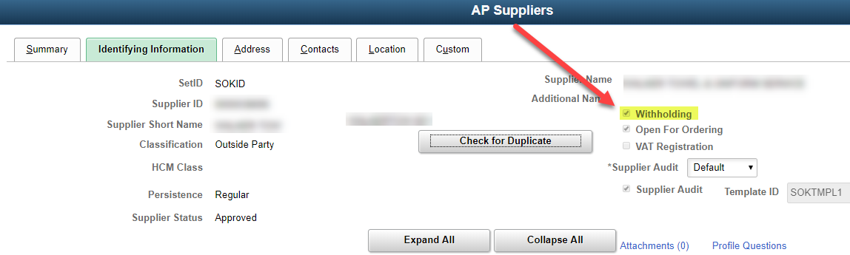

Suppliers – Location Page - 1099 Set up

Click the 1099 link on the supplier Location tab to open the Withholding Supplier Information page.
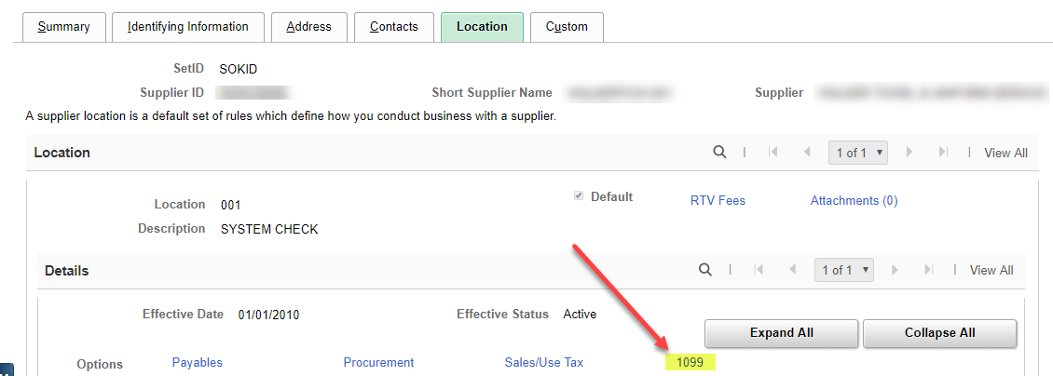

Non-Withholding Suppliers
Complete only the 1099 Reporting Information section.
Examples:
- Corporations are NOT reportable UNLESS they provide medical or legal services
- Governments
- Tax Exempt Organizations
- LLC- C corporation and LLC- S corporation

Withholding Suppliers
Complete both the 1099 Information and the 1099 Reporting Information
Examples:
- Individuals
- Sole-proprietorship
- LLC not C or S
- Medical and Legal

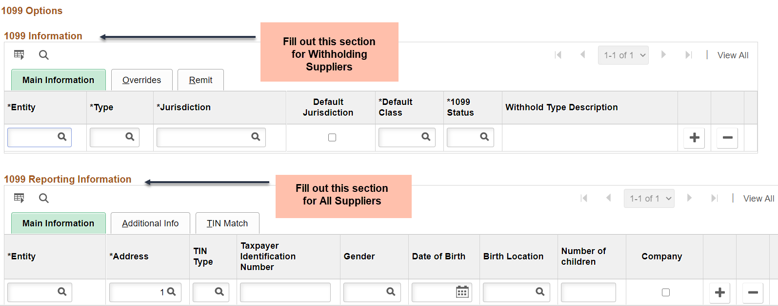

1099 Types and Class Information

- Each supplier Location MUST HAVE 1099 Reporting Information for suppliers that are reportable
- Select only 1 Type as Default Jurisdiction
- The Default Jurisdiction will initially populate on a voucher when it is created
- When entering the 1099 information for a supplier, set up as many of the classes and types you anticipate the supplier may use.
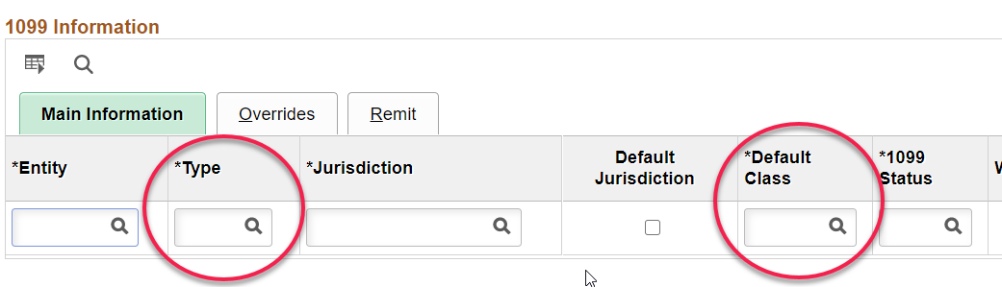

Supplier Table 1099 Withholding Guide

Fields | Description
1099 Information Section  Main Information tab  Entity | This will ALWAYS be IRS. You may select or type into the box.  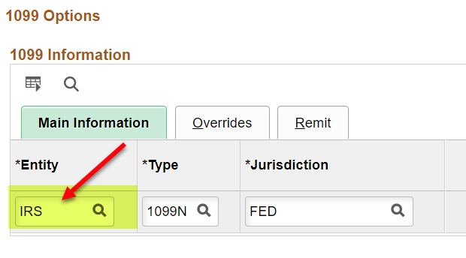
1099 Information section  Main Information Tab  Type | Key or Select the correct Type of withholding. For each withholding type, there may be classes and categories associated with the type.  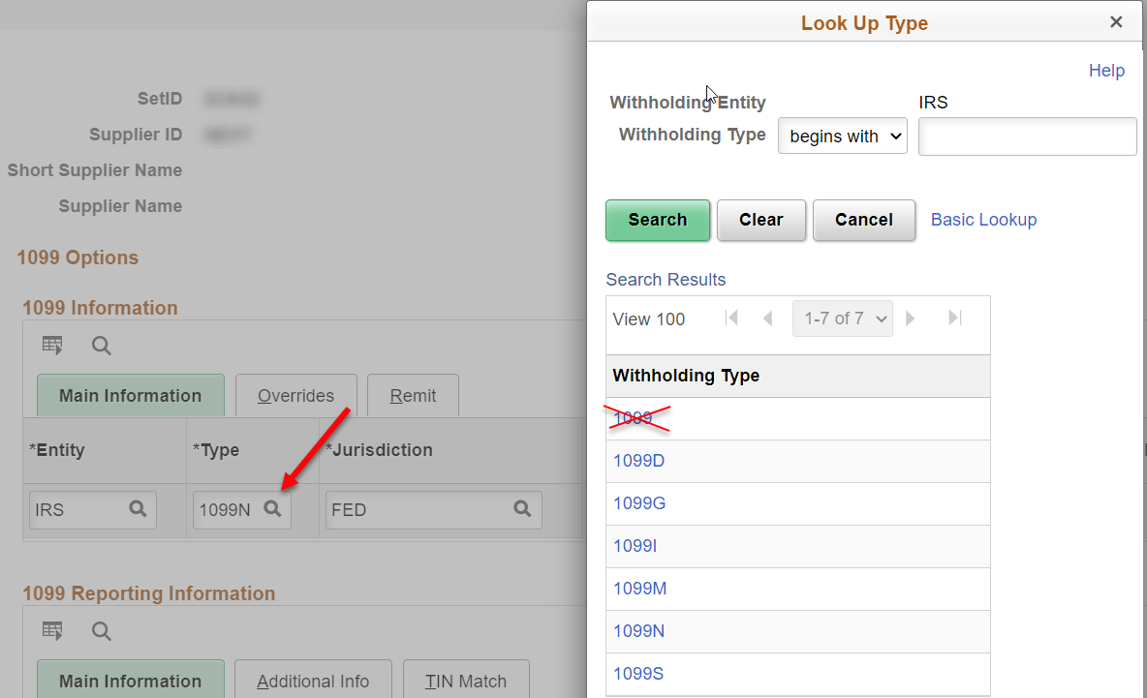  Values include: 1099N, 1099M 1099G, 1099I, and 1099S.
1099 Information Section  Main Information Tab  Jurisdiction | This will ALWAYS be FED. You may select or type into the box.  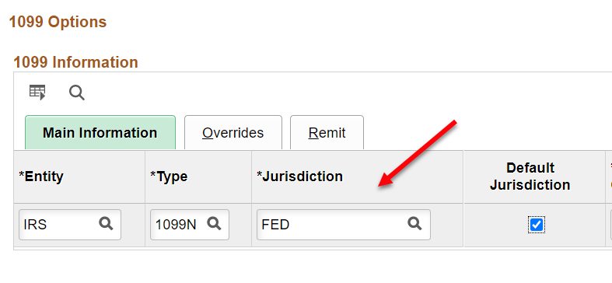
1099 Information Section  Main Information Tab  Default Jurisdiction Checkbox | Indicate which jurisdiction is the default by selecting the checkbox in that jurisdiction’s row. There must be a default checked and only 1 may be selected. This will be the Type and Class that automatically populates when a voucher is created. From the voucher screen you will be able to select other values that are available in the Supplier file.  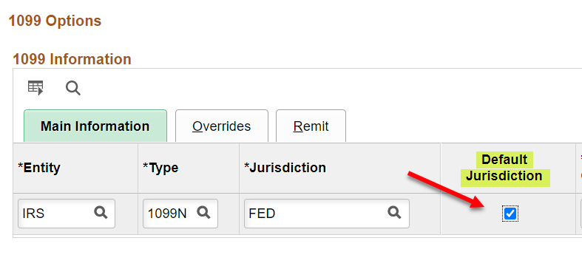
1099 Information Section  Main Information Tab  Default Class | Key or Select the correct Default Class of withholding. For each withholding type, there may be several classes and categories associated.  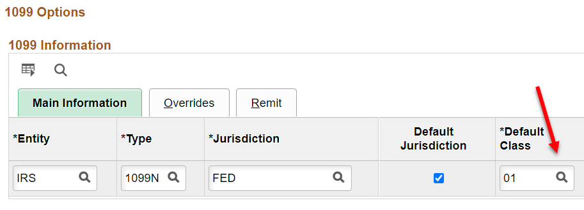  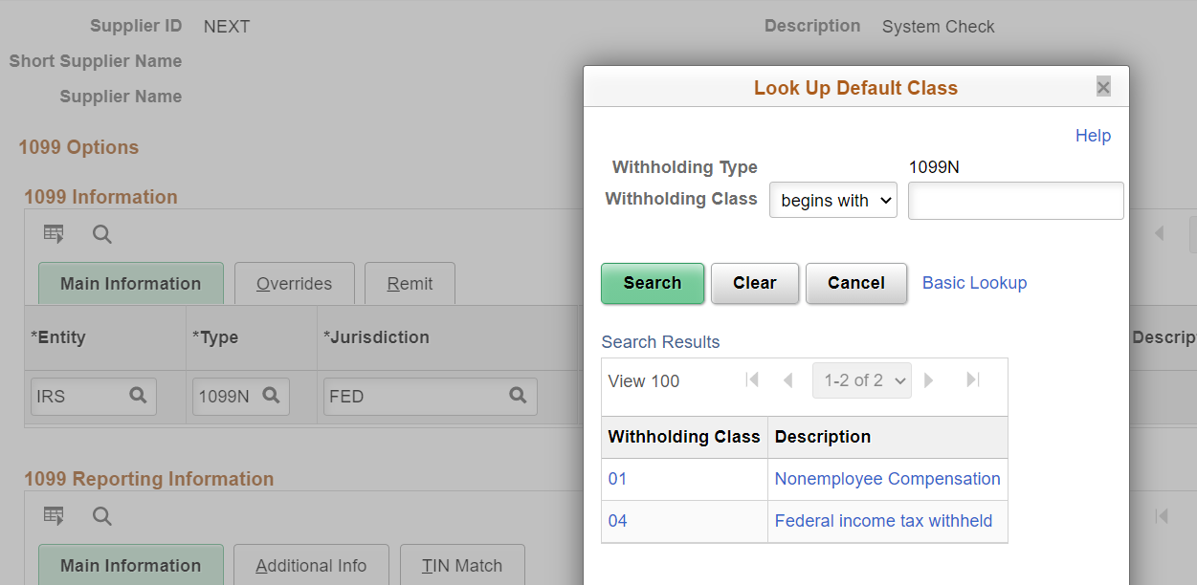
To add another Type and Class | Click the + in the 1099 Information Section  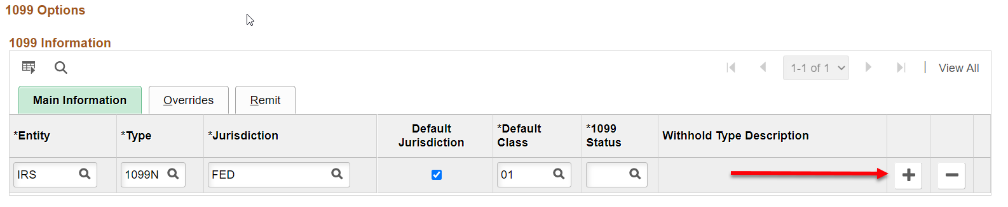
Once you have entered the 1099 Type and Class information for a withholding applicable supplier, enter the 1099 Reporting Information | 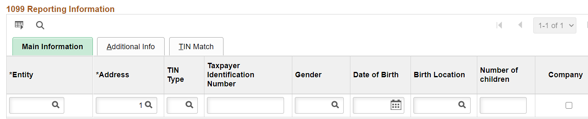
1099 Reporting Information –  Entity | The Entity is always IRS.  Once you enter the Entity, the unnecessary fields of Gender, Date of Birth, Birth Location … will disappear. The State does not use these fields.  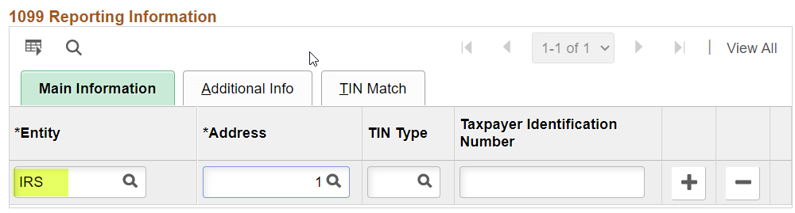
1099 Reporting Information –  Address | The Address defaults to 1. This is the address used for mailing the 1099 at year end. Do Not Change.  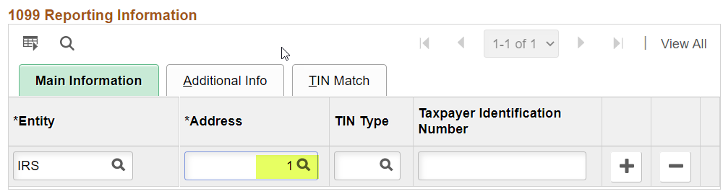
The TIN Type will either be S or F | Select the Taxpayer Identification Number (TIN) type for the supplier from these options:  F = Federal Employer ID Number  S = Social Security Number
1099 Reporting Information –  Taxpayer Identification Number | The Taxpayer Identification Number is the Social Security Number or the Federal Employer Identification Number. Enter FOREIGN for foreign suppliers that do not have a TIN.  Double check that this is entered correctly before you leave the page. Once you leave the page, it will be masked and no changes can be made to the FEIN or SSN without a Kansas Service Desk ticket to the Supplier Team. 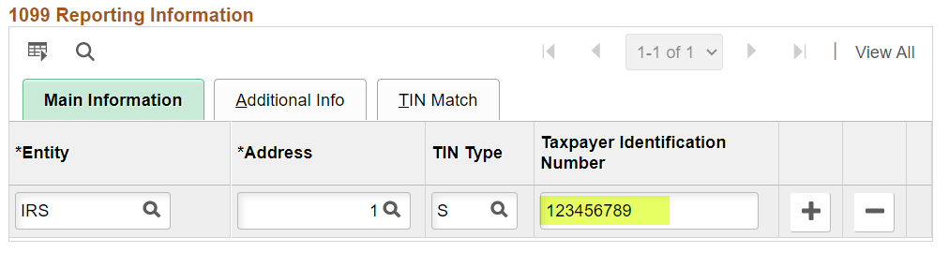
On the Address tab there is a section called Payment/ Withholding Alt Names. | This is not used for any withholding purposes.  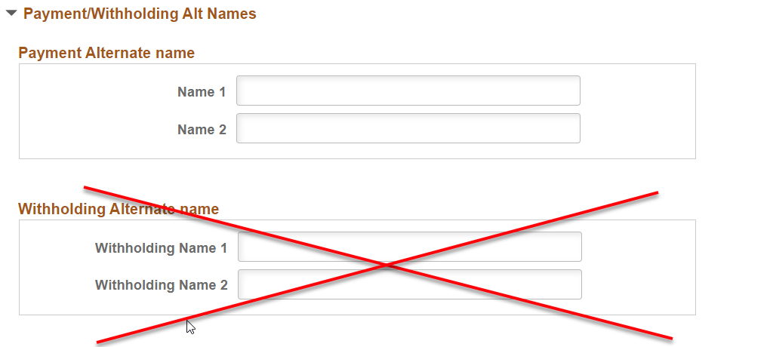

The withholding information entered on the supplier record will default to the voucher invoice lines. The voucher invoice lines should be reviewed as the default information may not be correct for the particular entry.

Modifying 1099 Information on a Voucher

Fields | Descriptions
View Withholding Details | Access the voucher, Invoice Information Tab. Click the ‘Withholding’ link to view withholding details. This is only available on vouchers in which the selected Supplier has withholding setup on the Supplier record.  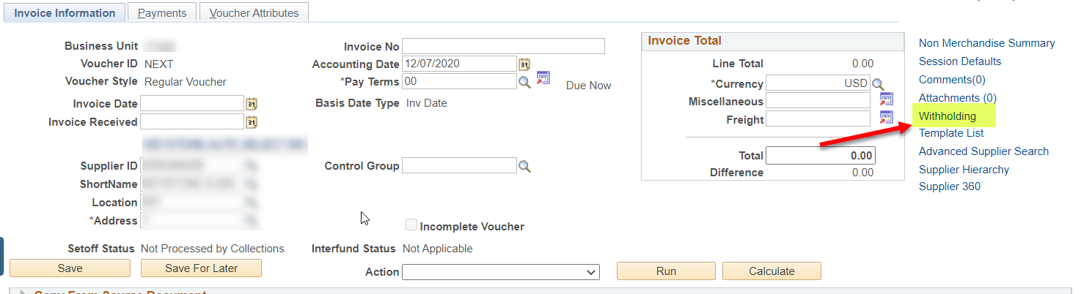  The Withholding is listed per voucher line. It will default to the Default Jurisdiction in the supplier record. If different amounts require different types, please split these into more than one voucher line and select the Withholding Type and Class per line. If the Type and Class you require is not available, please enter a Kansas Service Desk ticket with a TM-21 requesting to add the new Type and Class needed before submitting your voucher.  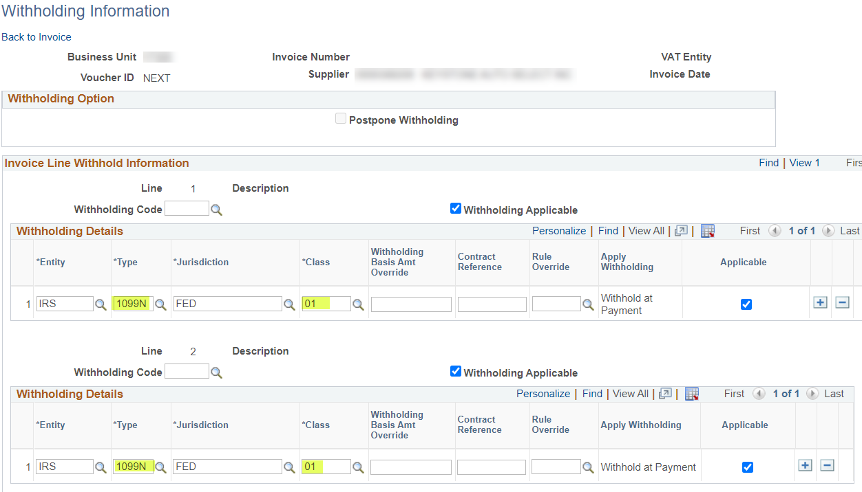
Fields | Descriptions
Modify the Withholding Status on a Voucher  - Deselect the Withholding Applicable checkboxes for the invoice lines that are not reportable. Withholding can be modified separately for each line on the voucher. | 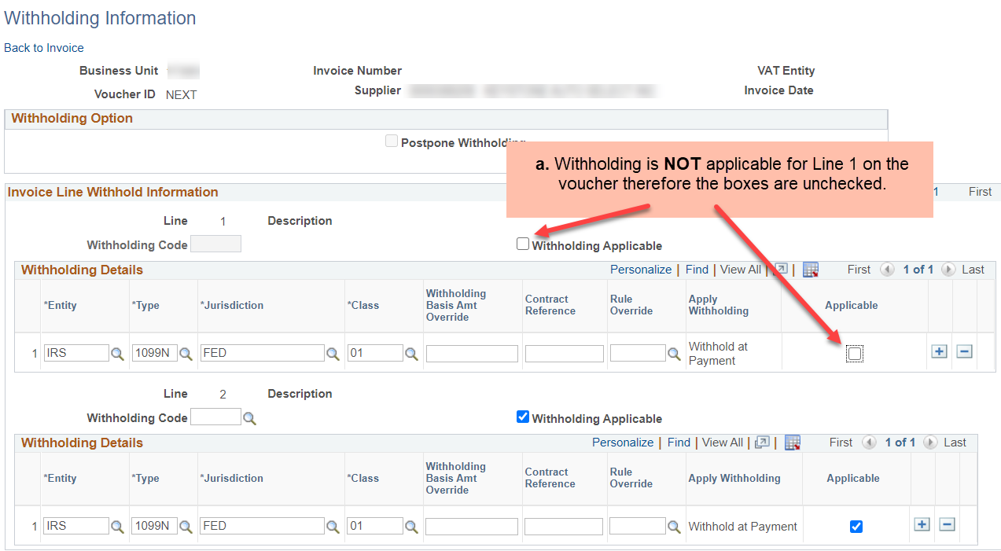
- If the payment is reportable the withholding boxes should remain checked. | 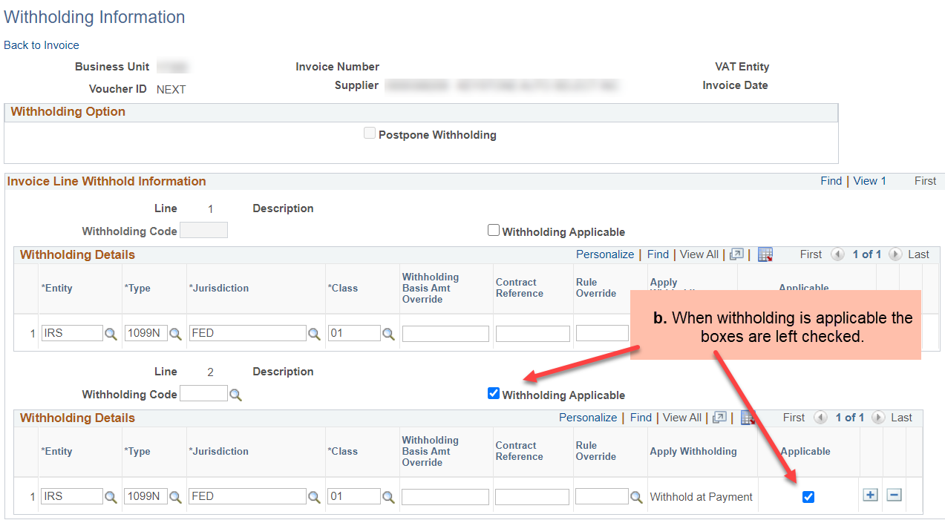
- Review the default type and class and change them as needed. Submit a Kansas Service Desk ticket to add types and classes to a supplier.  - Once all modifications are made, click the ‘Back to Invoice’ link to return to the voucher.  Save the voucher once you have exited the Withholding Information page. | 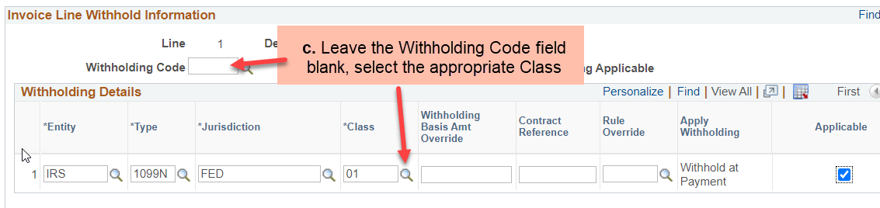  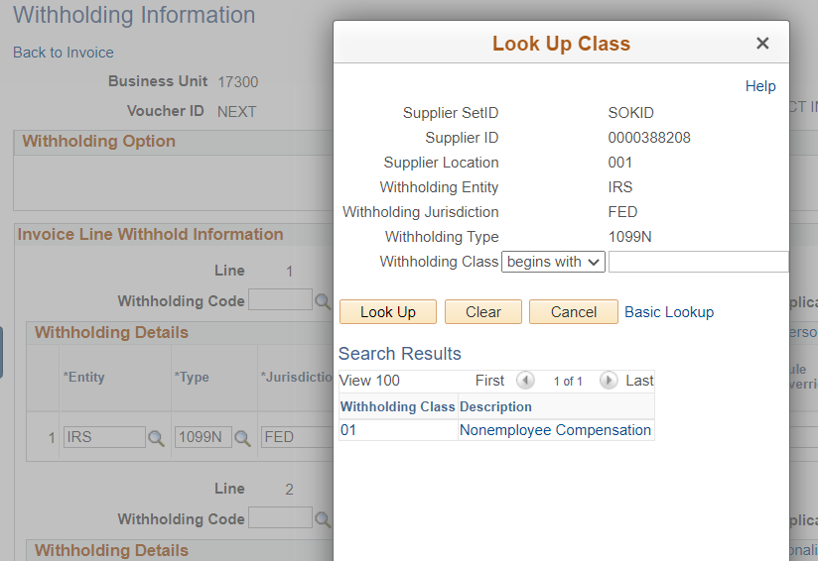  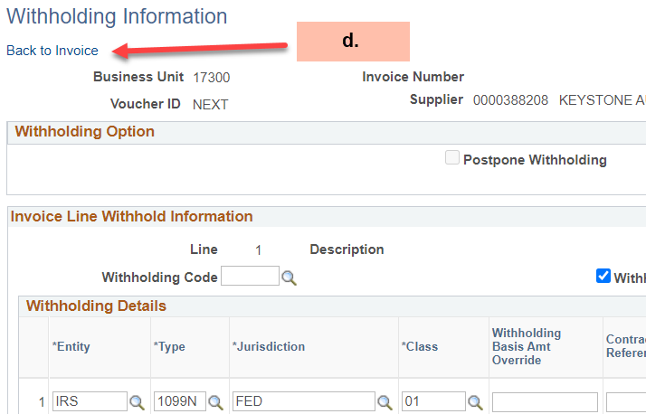

Examples of Reportable Payments

FORM 1099 MISC (1099M) - EXAMPLES OF REPORTABLE PAYMENTS
RENTS (Form 1099-MISC, Box 1) | MEDICAL & HEALTH CARE SERVICES
Office Space | (Form 1099-MISC, Box 6, includes all payments
Parking Lot Space | to Medical Service Corporations)
Welfare Rental Assistance (to Landlords) | Ambulance Services
Equipment | Dentists/Dental Services
Surface Royalties | Doctors/Medical Services
Real Property | Hospitals**
Other Property | (**except if tax exempt or owned/operated by a governmental entity)
 | Lab Services
ROYALTIES (Form 1099-MISC, Box 2) | Optometrists
Literary rights | Private Duty Nurses
Copyrights | Psychiatrists, Psychologists
Publishing Licensing fees | Rehabilitation Centers
 | Therapists
OTHER INCOME (Form 1099-MISC, Box 3) | Hospitalization
Awards (Nonemployee) | All payments to Medical Service Corporations
Prizes (Nonemployee)
GROSS PROCEEDS PAID TO AN ATTORNEY
(Form 1099-MISC, Box 10)
Gross proceeds paid to an attorney
in connection with legal services
FORM 1099-INT, 1099-G and 1099-S
EXAMPLES OF REPORTABLE PAYMENTS
INTEREST (Form 1099-INT, Box 1) | TAXABLE GRANTS (Form 1099-G, Box 6)
Interest income | Taxable Grants
PROCEEDS FROM REAL ESTATE (Form 1099-S, Box 2)
Gross Proceeds from the sale or exchange of real estate

FORM 1099 NON EMPLOYEE COMPENSATION (1099N) - EXAMPLES OF REPORTABLE PAYMENTS
(Form 1099-NEC, Box 1 -- Formerly 1099-MISC, Box 7)
Accountants/Auditors | Evaluation Consultant
Advertising Services | Expert Witnesses
Appraisers | Extermination Services
Architects | Graphic Artist
Armored Car Services | Institution Contracts
Attorneys* (who are not your employees) | Janitorial Services
(Includes Corporations)* | Keypunch Services
Auto Repair | Landscapers, Locksmiths
Board Members | Laundry Services
Chaplains | Maintenance Agreements
Cleaning Services | Non-Employee Allowance
Commercial Repairs – Hwy Vehicles | Occasional Salaries & Wages (to Non-Employees)
Computer Programming | Parcel & Delivery Services
Computer Repairs | Photographers
Construction Services | Printing Services
Consultants | Prison Labor Allowance
Contracted Repairs | Professional Service Payments
Court Appointed Workers | Protection Services
Court Reporters | Security Services
Custodial / Maintenance | Teacher/Instructor (Non-Employee)
Design & Testing | Trash Removal
Engineers | Working Interest – Oil and Gas Payments

SMART 1099 Account Code Guide

Note: Titles are presented as they appear in SMART (field length limits)

Account | Description | 1099 Type | 1099 Class | Notes
521200 | MOVING OFFICE EQUIP SUPPLIES | 1099N | 01 | Hiring temps to move is reportable.
522300 | PRINTING AND COPYING | 1099N | 01
522400 | ADVERTISING | 1099N | 01 | Purchase of ad space not reportable. Advertisement creation is reportable see 527500.
523100 | COPY PRINTING EQUIPMENT RENTAL | 1099M | 01
523200 | BUILDING SPACE RENTAL | 1099M | 01 | Rent 1099 class 01. Moving and warehouse storage is not reportable.
523300 | EQUIPMENT RENTAL | 1099M | 01
523400 | LAND RENTAL | 1099M | 01 | Includes Walk in Hunter Access (WIHA).
523600 | COMPUTER EQUIPMENT RENTAL | 1099M | 01
523700 | COMPUTER SOFTWARE RENTAL | 1099M | 01
523900 | OTHER RENTALS | 1099M | 01
524101 | PASSENGER CAR SVC OIL CHANGE | 1099N | 01
524102 | PASSENGER CAR SVC CAR WASH | 1099N | 01
524103 | PASS CAR TIRE REPAIR & INSTALL | 1099N | 01
524109 | PASS CAR SVC OTHER | 1099N | 01
524121 | PASS CAR COLLISION REPAIR | 1099N | 01
524129 | PASS CAR REPAIR OTHER | 1099N | 01
524131 | PASS CAR EQUIP INSTALL | 1099N | 01
524201 | SELF PROP SVC OIL CHANGE | 1099N | 01
524202 | SELF PROP SVC WASH | 1099N | 01
524203 | SELF PROP TIRE REPAIR INSTALL | 1099N | 01
524209 | SELF PROP SVC OTHER | 1099N | 01
524221 | SELF PROP COLLISION REPAIR | 1099N | 01
Account | Description | 1099 Type | 1099 Class | Notes
524229 | SELF PROP REPAIR OTHER | 1099N | 01
524231 | SELF PROP EQUIP INSTALL | 1099N | 01
524300 | REPAIR AND SVC EQUIP FURN | 1099N | 01
524400 | REPAIR AND SVC BLDG GROUND | 1099N | 01
524501 | REPAIR & SVC ROADSIDES | 1099N | 01
524502 | REPAIR & SVC BRIDGES | 1099N | 01
524503 | REPAIR & SVC REST AREA | 1099N | 01
524504 | REPAIR & SVC TRAFFIC LIGHTING | 1099N | 01
524505 | REPAIR & SVC CONCRT TRAVEL WAY | 1099N | 01
524506 | REPAIR & SVC BITUMINOUS TR WAY | 1099N | 01
524507 | REPAIR & SVC SHOULDERS | 1099N | 01
524508 | REPAIR & SVC WEED SPRAYING | 1099N | 01
524590 | REPAIR & SVC HWY BRIDGE OTHER | 1099N | 01
524700 | REPAIR & SVC COMPUTER EQUIP | 1099N | 01
524800 | COMPUTER SOFTWARE MAINT SVC | 1099N | 01
524900 | REPAIR & SVC OTHER | 1099N | 01
525X20 | HIRE OF CAR PLANE BUS | 1099M | 01 | T&E paid to employees are not reportable; taxable if paid to supplier.
525X30 | STATE CAR EXPENSE-IN STATE | 1099N | 01 | Repairs are taxable if paid direct to supplier, supplies are not reportable.
525X70 | AIR RAIL AND BUS FARE | 1099N | 01
525X80 | MEALS AND LODGING | N/A |  | T&E paid to employee - not reportable.
525X80 | MEALS AND LODGING | 1099M | 01 | Hotels - paid direct to supplier reportable.
525X80 | MEALS AND LODGING | 1099N | 01 | Meals - paid direct to supplier reportable.
525X90 | NON SUBSISTENCE | 1099N  1099M | 01 or 03 | Taxable if paid direct to supplier; conference registration 1099M class 03.
Account | Description | 1099 Type | 1099 Class | Notes
526100 | RECRUITMENT EXPENSES | 1099M  1099N | 01 or 01 | Reimbursements are generally not reportable. Payments direct to supplier reportable. Hotel/rental 1099M, Services 1099N
526200 | HONORARIUMS | 1099N | 01 | Possibly could be 1099M Class 03.
526320 | COMPUTER PROGRAMMING NOT OITS | 1099N | 01
526330 | DATABASE ACCESS FEES NOT OITS | 1099N | 01
526400 | COURT COSTS | 1099N | 01
526500 | LABORATORY FEES | 1099N | 01 | Non-medical
526500 | LABORATORY FEES | 1099M | 06 | Medical
526501 | LAB RANDOM EE DRUG TEST | 1099M | 06
526502 | LAB RANDOM ALCOHOL TEST | 1099M | 06
526610 | JOB RELATED TRAIN & CONF REG | 1099N | 01 | Taxable if paid direct to supplier.
526700 | BOARDING HOME PAYMENTS | 1099M | 01
526800 | REHAB CLIENT MAINT AND TUITION | 1099N | 01 | 1099M Class 01 for lodging.
526900 | OTHER FEES | 1099N | 01
526910 | CREDIT CARD FEES AND CHARGES | 1099N | 01 | Generally supplier is not reportable.
526920 | BANK FEES | 1099N | 01 | Generally supplier is not reportable.
526960 | E-CHECKS FEES AND CHARGES | 1099N | 01 | Generally supplier is not reportable.
526970 | MILITARY ACTIVATION PAYMENT | 1099M | 03
527010 | STAFFING & RECRUITING SERVICES | 1099N | 01
527020 | FISCAL AGENT SERVICES | 1099N | 01
527030 | OUTSOURCED PROGRAM ADMIN | 1099N | 01
527040 | REAL ESTATE APPRAISAL SERVICES | 1099N | 01
527050 | INSTITUTIONAL FOOD SERVICE | 1099N | 01
527100 | ARCHITECTS AND ENGINEERS | 1099N | 01
527200 | ATTORNEYS AND LAWYERS | 1099N | 01
Account | Description | 1099 Type | 1099 Class | Notes
527201 | ASSIGNED COUNSEL-CNTRCT LAWYER | 1099N | 01
527202 | ASSIGNED COUNSEL-NONCNTRCT LAW | 1099N | 01
527300 | PHYSICIANS AND MEDICAL ASSOC | 1099M | 06
527400 | HOSPITALS AND NURSING HOMES | 1099M | 06
527500 | ADVERTISING AND MARKETING | 1099N | 01 | Services
527600 | VETERINARIANS | 1099N | 01 | 1099 reportable regardless of corporate status.
527700 | LECTURERS AND ENTERTAINERS | 1099N | 01
527800 | ACCOUNTANTS AND AUDITORS | 1099N | 01
527850 | BANKING AND INVEST SVCS OTHER | 1099N | 01
527851 | SECURITIES LENDING AGENT FEES | 1099N | 01
527852 | SECURITIES LENDING BROKER FEES | 1099N | 01
527853 | EXTERNAL INVESTMENT MANAGER | 1099N | 01
527854 | GENERAL PARTNER EXPENSES | 1099N | 01
527860 | ACTUARIAL SERVICES | 1099N | 01
527910 | INFORMATION SYSTEMS CONSULTING | 1099N | 01
527919 | CONSULTING SERVICES OTHER | 1099N | 01
527970 | EXPERT WITNESS FEES | 1099N | 01
527980 | COURT REPORTER FEES | 1099N | 01
527990 | OTHER PROFESSIONAL FEES | 1099N | 01
527991 | FED GRANT ADMIN EXCL F&A | 1099N | 01
528600 | SOLID WASTE CHARGES | 1099N | 01 | Payment for garbage disposal is reportable as 1099N class 01, dumping fees are not reportable.
529100 | DUES AND SUBSCRIPTION | N/A |  | Periodicals not reportable.
529100 | DUES AND SUBSCRIPTION | 1099N | 01 | Memberships & dues
529200 | LAUNDRY, DRY CLEANING AND TOWEL SERVICE | 1099N | 01
529500 | NON-EMPL REWARDS, PREMIUMS & BOUNTIES-IRS REPORT | 1099M | 03 | Paid to winner.
Account | Description | 1099 Type | 1099 Class | Notes
529500 | NON-EMPL REWARDS,PREMIUMS & BOUNTIES-IRS REPORTABL | 1099N | 01 | Services creating product.
529500 | NON-EMPL AWARDS, REWARDS, PREMIUMS &BOUNTIES-NOT IRS | N/A |  | Purchase of commodity type items not reportable.
529800 | EMPLOYEE AWARDS | 1099N | 01 | Cash equivalents for employees are reported through SHARP. Supplier services 1099N class 01.
542010 | BUILDINGS | 1099N | 01 | Construction
542010 | BUILDINGS | 1099S | 01 | Purchase: reportable if agency is closing agent.
542020 | BUILDING IMPROVEMENTS | 1099N | 01 | Construction
542090 | BUILDINGS NON CAP | 1099N | 01
542091 | BUILDING IMPROVEMENTS NON CAP | 1099N | 01
542110 | FCIP-INTEREST-BI-C/I | 1099I | 01 | Facility conservation improvement program.
543100 | LAND AND INTEREST IN LAND | 1099S | 01 | Reportable if agency is closing agent.
543112 | RELOC ASSIST ROW NO SETOFF | N/A |  | Not reportable.
543190 | LAND & INTERESTS NON CAP | 1099S | 02 | Reportable if agency is closing agent.
543190 | LAND & INTERESTS NON CAP | 1099M | 01 | Temp Easement
543190 | LAND & INTERESTS NON CAP | 1099M | 03 | Damages
544010 | DEPRECIABLE LAND IMPROVEMENTS | 1099N | 01 | Construction
544020 | NON DEPR LAND IMPROVEMENTS | 1099N | 01 | Construction
544090 | DEPR LAND IMPROVEMENTS NON CAP | 1099N | 01 | Construction
544091 | NON DEPR LAND IMPROVE NON CAP | 1099N | 01 | Construction
545001 | HWY BRIDGE CONSTR CONTRACTS | 1099N | 01
545003 | HWY BRIDGE CONTRACTOR MATER | N/A |  | Not reportable.
545004 | HWY CONTRACTOR MATER TAKE OVER | N/A |  | Not reportable.
545005 | HWY BRIDGE SALVAGED MATERIALS | N/A |  | Not reportable.
545006 | HWY BRIDGE UTILITY ADJUSTMENTS | N/A |  | Not reportable.
Account | Description | 1099 Type | 1099 Class | Notes
545090 | HWY BRIDGE CONSTR OTHER | 1099N | 01 | Construction
552040 | UNCLAIMED PROPERTY INTEREST | 1099I | 01 | 1099 generated by STO outside of SMART.
552050 | UNCLAIMED PROPERTY DIVIDEND | 1009DIV | 01 | 1099 generated by STO outside of SMART.
552060 | UNCLAIMED PROPERTY ROYALTY | 1099M | 02 | Submitted on a spreadsheet.
552400 | WORKERS COMPENSATION CLAIMS | N/A |  | Payments to claimants not reportable.
552400 | WORKERS COMPENSATION CLAIMS | 1099M | 06 | Medical services.
552400 | WORKERS COMPENSATION CLAIMS | 1099M | 10 | Settlements paid to attorneys.
552700 | CIVIL RIGHTS CONCILIATION | 1099M | 03
552700 | CIVIL RIGHTS CONCILIATION | 1099M | 10 | Payment to attorneys for settlement.
552800 | PROMPT PAYMENT ACT INT PENALTY | 1099I | 01
552900 | OTHER CLAIMS
552900 | OTHER CLAIMS | 1099N | 01 | Services
552900 | OTHER CLAIMS | 1099M | 06 | Medical
552900 | OTHER CLAIMS | 1099M | 10 | Payment to attorneys for settlement.
553010 | EMPLOYMENT SECURITY BENEFITS |  |  | Reported outside of SMART.
555100 | DIRECT STATE WELFARE ASSIST | 1099N | 01 | Welfare benefits paid to clients are not reportable. Payments to suppliers are reportable. Agencies 039,264,521,629
555110 | DIR ST WELFARE ASSIST SETOFF | 1099N | 01 | Welfare benefits paid to clients are not reportable. Payments to suppliers are reportable. Agencies 039,264,521,629
555150 | DIR ST WELFARE ASSIST RENT | 1099M | 01 | Welfare benefits paid to clients are not reportable. Payments to suppliers are reportable. Agencies 039,264,521,629
555160 | DIR ST WELFARE ASSIST MEDICAL | 1099M | 06 | Welfare benefits paid to clients are not reportable. Payments to suppliers are reportable. Agencies 039,264,521,629
555200 | DIRECT FEDERAL WELFARE ASSIST | 1099N | 01 | Welfare benefits paid to clients are not reportable. Payments to suppliers are reportable. Agencies 039,264,521,629
Account | Description | 1099 Type | 1099 Class | Notes
555210 | DIR FED WELFARE ASSIST SETOFF | 1099N | 01 | Welfare benefits paid to clients are not reportable. Payments to suppliers are reportable. Agencies 039,264,521,629
555250 | DIR FED WELFARE ASSIST RENT | 1099M | 01 | Welfare benefits paid to clients are not reportable. Payments to suppliers are reportable. Agencies 039,264,521,629
555260 | DIR FED WELFARE ASSIST MEDICAL | 1099M | 06 | Welfare benefits paid to clients are not reportable. Payments to suppliers are reportable. Agencies 039,264,521,629
555270 | FED WELFARE ASSIST PARTIC FEE | 1099N | 01
555850 | HOUSING ASSISTANCE | 1099M | 01
555900 | OTHER SPECIAL GRANTS |  |  | Agencies are responsible for knowing if the grant is taxable, and if so what type and class.
555900 | OTHER SPECIAL GRANTS | 1099G | 06 | Agency 300 ROZ grants.
556200 | STIPENDS INSTRUCTIONAL GRANTS | 1099M | 03 | Agency 379
557400 | NAFTA TAA CLIENT ALLOWANCES | 1099G | 05 | Agency 300
559200 | ROYALTY PAYMENTS | 1099M | 02
559300 | LOTTERY PRIZE CLAIMS |  |  | 1099 generated by Lottery outside of SMART
559305 | RETAILER PAID PRIZES |  |  | Reportability determined by lottery
559307 | PRIZE TEMPORARY |  |  | 1099 generated by Lottery outside of SMART.
559310 | COMMISSIONS RETAILER ONLINE |  |  | 1099 generated by Lottery outside of SMART.
559320 | COMMISSIONS RETAILER INSTANT |  |  | 1099 generated by Lottery outside of SMART.
559330 | CASHING COMMISSION |  |  | 1099 generated by Lottery outside of SMART.
559340 | SELLING BONUS |  |  | 1099 generated by Lottery outside of SMART.
559350 | FREE TICKETS |  |  | 1099 generated by Lottery outside of SMART.
559360 | ONLINE TICKET ALLOWANCE |  |  | 1099 generated by Lottery outside of SMART.
Account | Description | 1099 Type | 1099 Class | Notes
559370 | PROMOTIONAL EXPENSES |  |  | 1099 generated by Lottery outside of SMART.
559380 | INSTANT COUPONS |  |  | 1099 generated by Lottery outside of SMART.
559390 | MISC LOTTERY SALES EXPENSES |  |  | 1099 generated by Lottery outside of SMART.
559400 | KS BREEDING DEVELOPMENT SUPP | 1099M | 03
559500 | INTEREST ON APP DEPOSIT REFUND | 1099I | 01
559800 | AGRICULTURAL CONSERVATION PROG | 1099G | 06 | Agency 046
559900 | OTHER GRANT CLAIM SHARED REV |  |  | Agencies are responsible for knowing if the grant is taxable, and if so what type and class.
559900 | OTHER GRANT CLAIM SHARED REV | 1099G | 06 | Agency 300 ROZ grants.
561200 | BOND INTEREST | 1099I | 01
561300 | LOAN INTEREST | 1099I | 01
561500 | BLANKET FINANCING INTEREST | 1099I | 01
561900 | OTHER DEBT INTEREST | 1099I | 01
561950 | ARBITRAGE REBATE EXPENSE | 1099N | 01

Standard 1099 Type and Class for the State of Kansas
Code | Description | Entity | Type | Jurisdiction | Class
M01 | Rents | IRS | 1099M | FED | 01
M02 | Royalties | IRS | 1099M | FED | 02
M03 | Prizes, Awards, etc. | IRS | 1099M | FED | 03
M06 | Medical and Health Care Pymnts | IRS | 1099M | FED | 06
M10 | Gross Attorney Proceeds | IRS | 1099M | FED | 10
N01 | Non-Employee Compensation | IRS | 1099N | FED | 01
G01 | Unemployment Compensation  Agency 296 | IRS | 1099G | FED | 01
G02 | State/Local Tax Refunds, etc.  Agency 565 | IRS | 1099G | FED | 02
G05 | RTA  Agency 300 | IRS | 1099G | FED | 05
G06 | Taxable Grant | IRS | 1099G | FED | 06
S02 | Gross Proceeds | IRS | 1099S | FED | 02
I01 | Interest Income not in class 3  Agency296/565 | IRS | 1099I | FED | 01

Only used by the State Treasurer’s office

Code | Description | Entity | Type | Jurisdiction | Class
D01A | Total Ordinary Dividends | IRS | 1099D | FED | 01A
D01B | Qualified Dividends | IRS | 1099D | FED | 01B
D02A | Total Capital Gain Distr. | IRS | 1099D | FED | 02A
D02B | Unrecap. Sec. 1250 Gain | IRS | 1099D | FED | 02B
D02C | Section 1202 Gain | IRS | 1099D | FED | 02C
D02D | Collectibles (28%) Gain | IRS | 1099D | FED | 02D
D03 | Nondividend Distributions | IRS | 1099D | FED | 03
D04 | Federal Income Tax Withheld | IRS | 1099D | FED | 04
D05 | Investment Expenses | IRS | 1099D | FED | 05
D06 | Foreign Tax paid | IRS | 1099D | FED | 06
D07 | Foreign Country or US Possession | IRS | 1099D | FED | 07
D08 | Cash Liquidation Distributions | IRS | 1099D | FED | 08
D09 | Noncash Liquidation Distributions | IRS | 1099D | FED | 09

