Step | Action
Begin by navigating to the General Ledger WorkCenter.
Click the Scroll Down arrow.
 | Click the General Ledger menu.
 | Click the General Ledger WorkCenter.
 | Use the General Ledger WorkCenter page to access work items, links, queries, reports, and processes that are specific to your position.
 | The My Work pagelet is set up with two groups.
 | The first group label is Current Work. These alerts include items that require further processing, such as journals pending approval or incomplete journals.
 | The second group label is Exceptions. These alerts show the journals with the various types of errors that require attention.
The other pagelets in the WorkCenters -- Links, Reports and Processes and Queries -- can be Personalized with page, report, and query links.

Note that Personalization is not available for the My Work Pagelet. The standard set-up provides consistency across all agencies and modules.
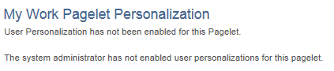
You have successfully reviewed the My Work pagelet.

End of Procedure.

