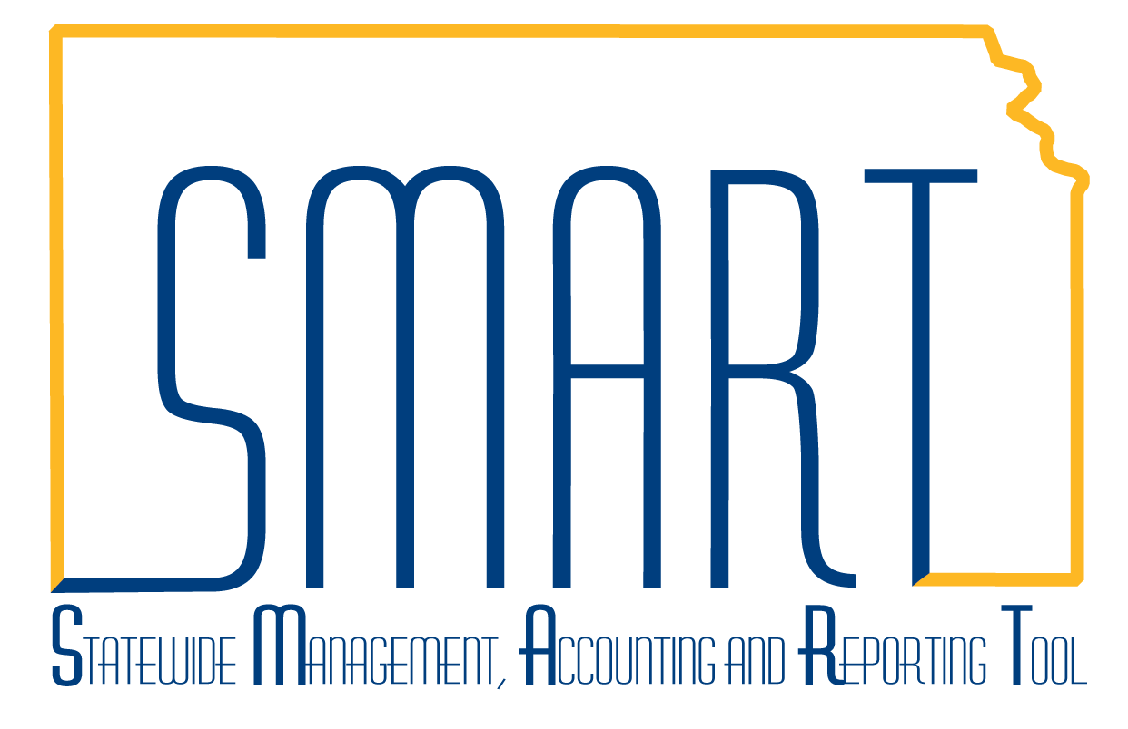**State of Kansas**



**Creating Expense Reports**

***Statewide Management, Accounting and Reporting Tool***

### Creating Expense Reports

SMART Expenses makes it easy to transform a handful of receipts into a final expense reimbursement.  This topic discusses how to convert expense transactions into **expense reports** that meet your auditing standards and approval policies.  Expenses supports a variety of features designed to streamline your entry.  The way in which you set up your expense system determines what data is required and how your accounting system processes it.  For example, if an employee takes a business trip that affects different departments within your agency fund, the expense report can reflect this so that the appropriate departments share the expenses.

SMART Expenses provides functionality to decrease the time that you spend entering expense reports.  You can:

• Create expense reports populated with information from user defaults

• Apply cash advances to expense reports

• Copy multiple expense lines at one time on an expense report

• Insert multiple rows at one time on the **Expense Report Entry** page

• Save an expense report with errors or missing information

Procedure

In this scenario, you are an Agency Expense Processor who is authorized to enter your own transactions. You will create an expense report for expenses related to a meeting in Wichita.

This example will help you when entering expense reports with travel occurring between November 13, 2015 and December 31, 2015. You will continue to use the old expense types that differentiate between in state (IS), out-of-state (OS), high-cost (HC) and international (INT). You will also use the old rates that are effective until December 31, 2015 and were mentioned in information circular 16-A-002 FY 2016 Subsistence Rates.

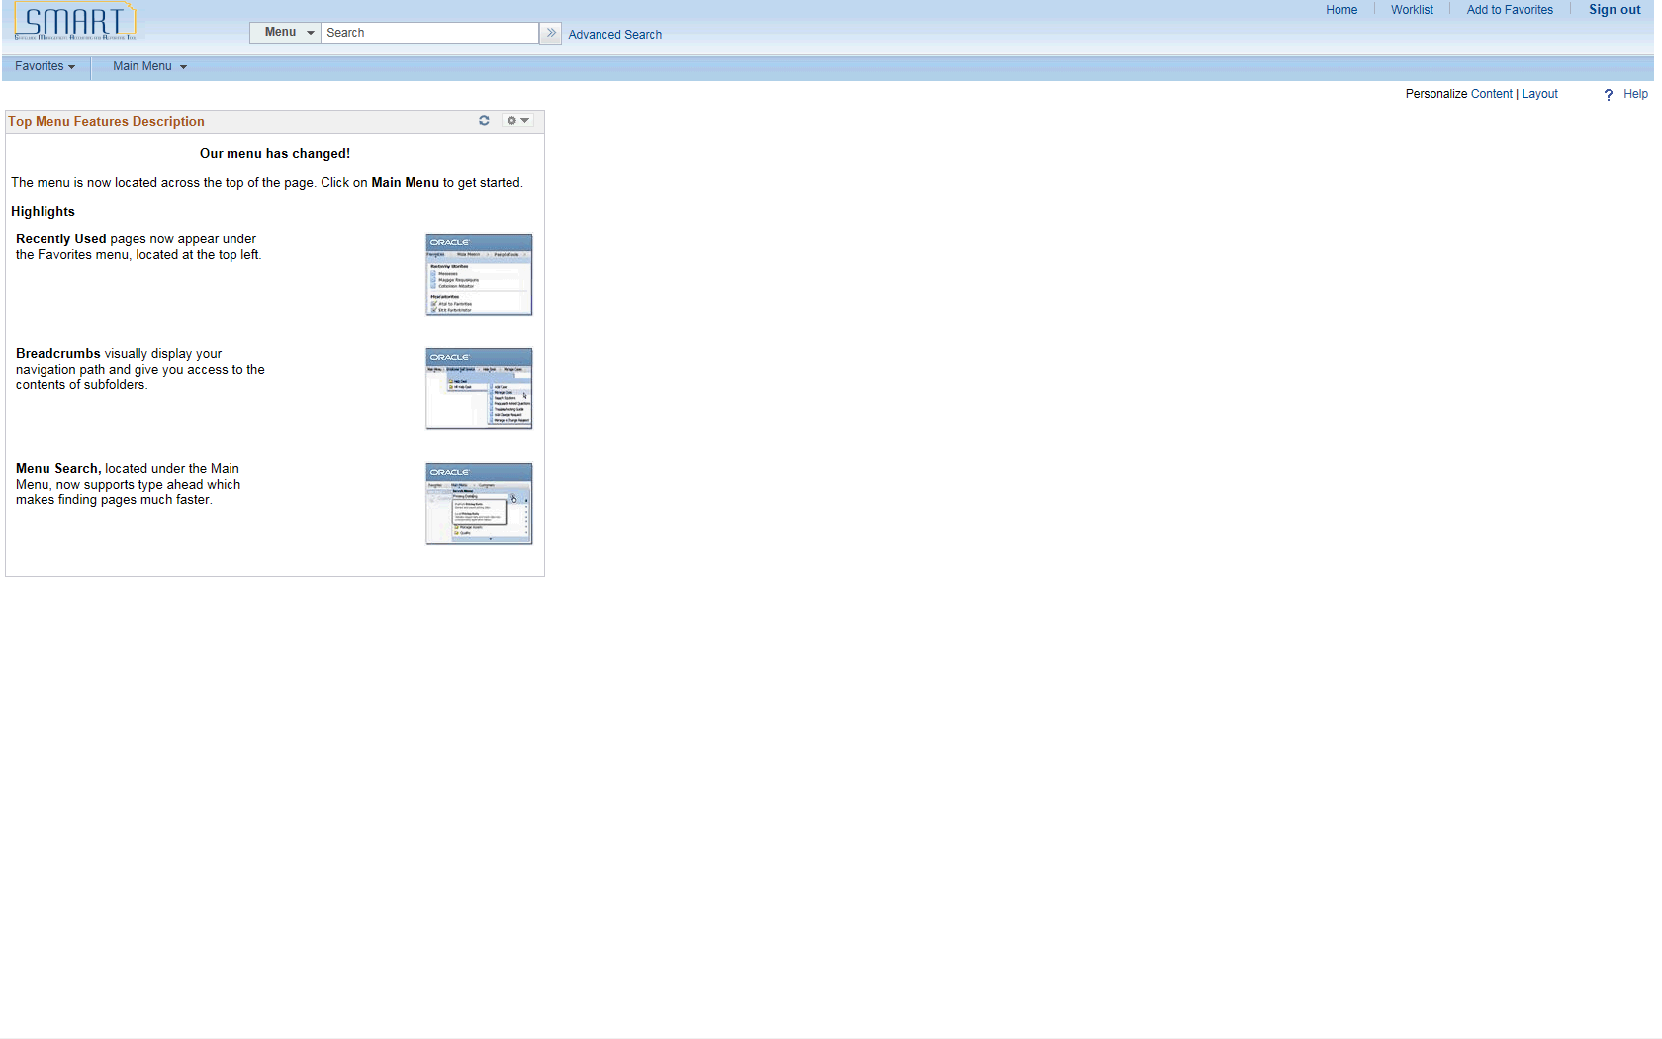

| **Step** | **Action** |
| --- | --- |
|  | Begin by navigating to the **Create Expense Report** page.  Click the **Main Menu** button. |
|  | Click the **Employee Self-Service** menu. |
|  | Click the **Travel and Expense Center** menu. |

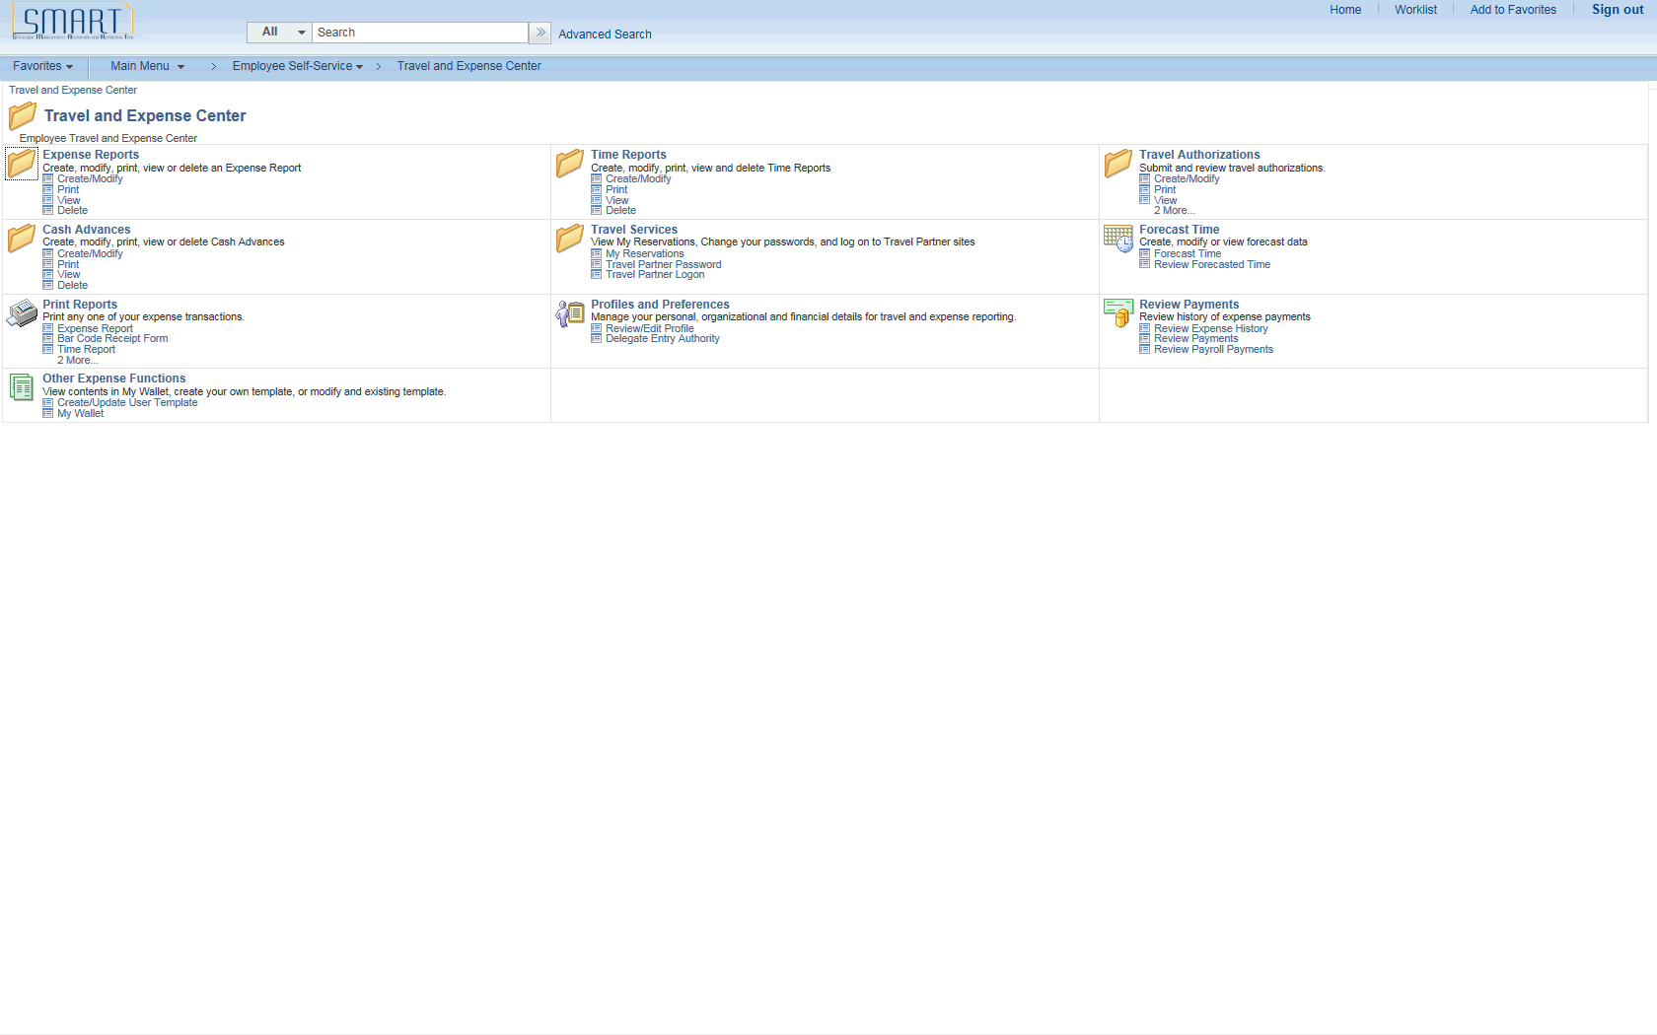

| **Step** | **Action** |
| --- | --- |
|  | Click the **Create/Modify** link. |

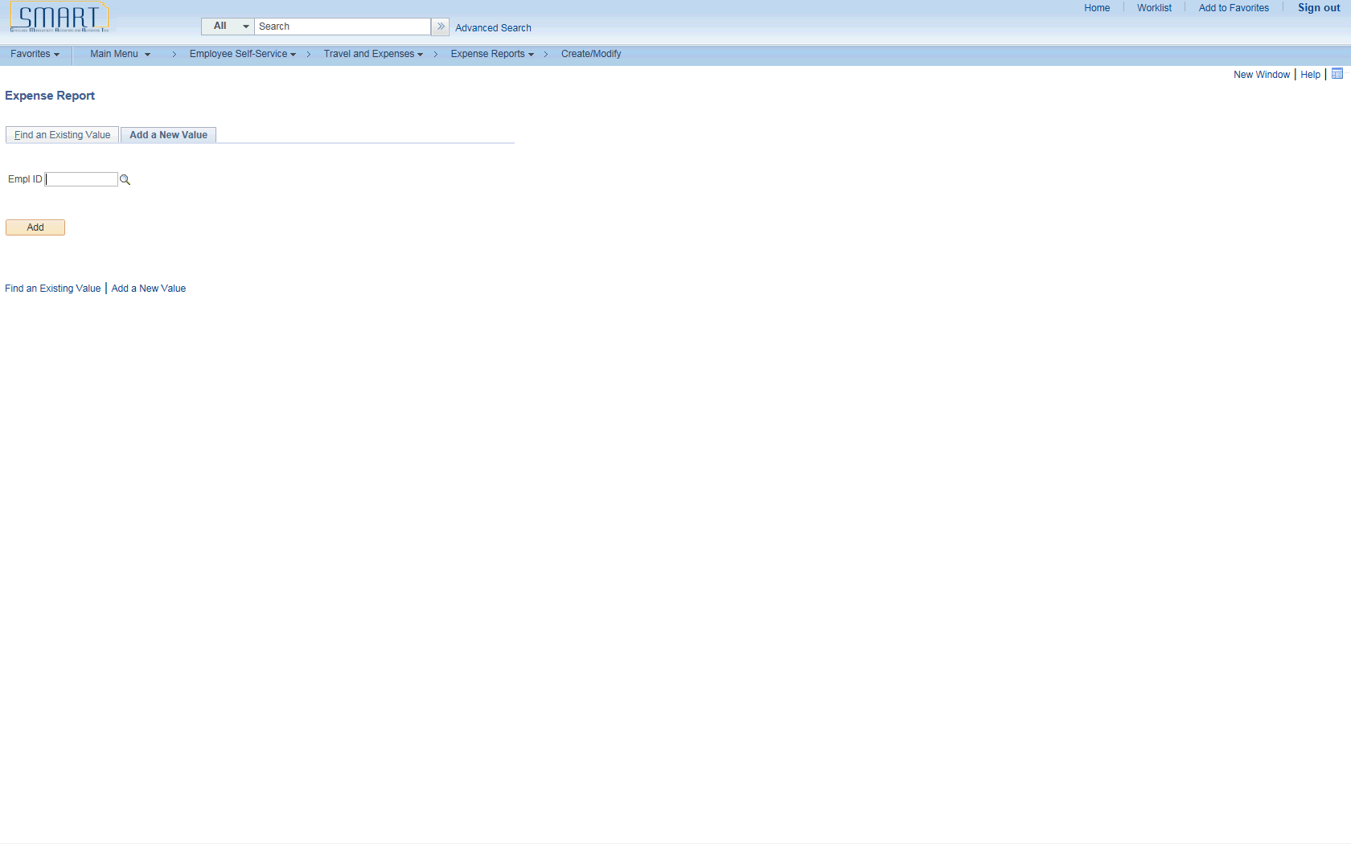

| **Step** | **Action** |
| --- | --- |
|  | Enter your **Empl ID.**  Enter the desired information into the **Empl ID** field. Enter "**KS92TEST3**". |
|  | Click the **Add** button. |
|  | The **Create Expense Report** page enables you to easily add expense lines and provide general information as well as other details that are specific for expense types.  You may use the **Employee Profile - User Defaults** page to set up default values for report description, business purpose, originating location, expense location, payment method, and distributions. These defaults populate the expense report automatically when you create expense reports, but you may override these defaults during entry depending on your security level. |

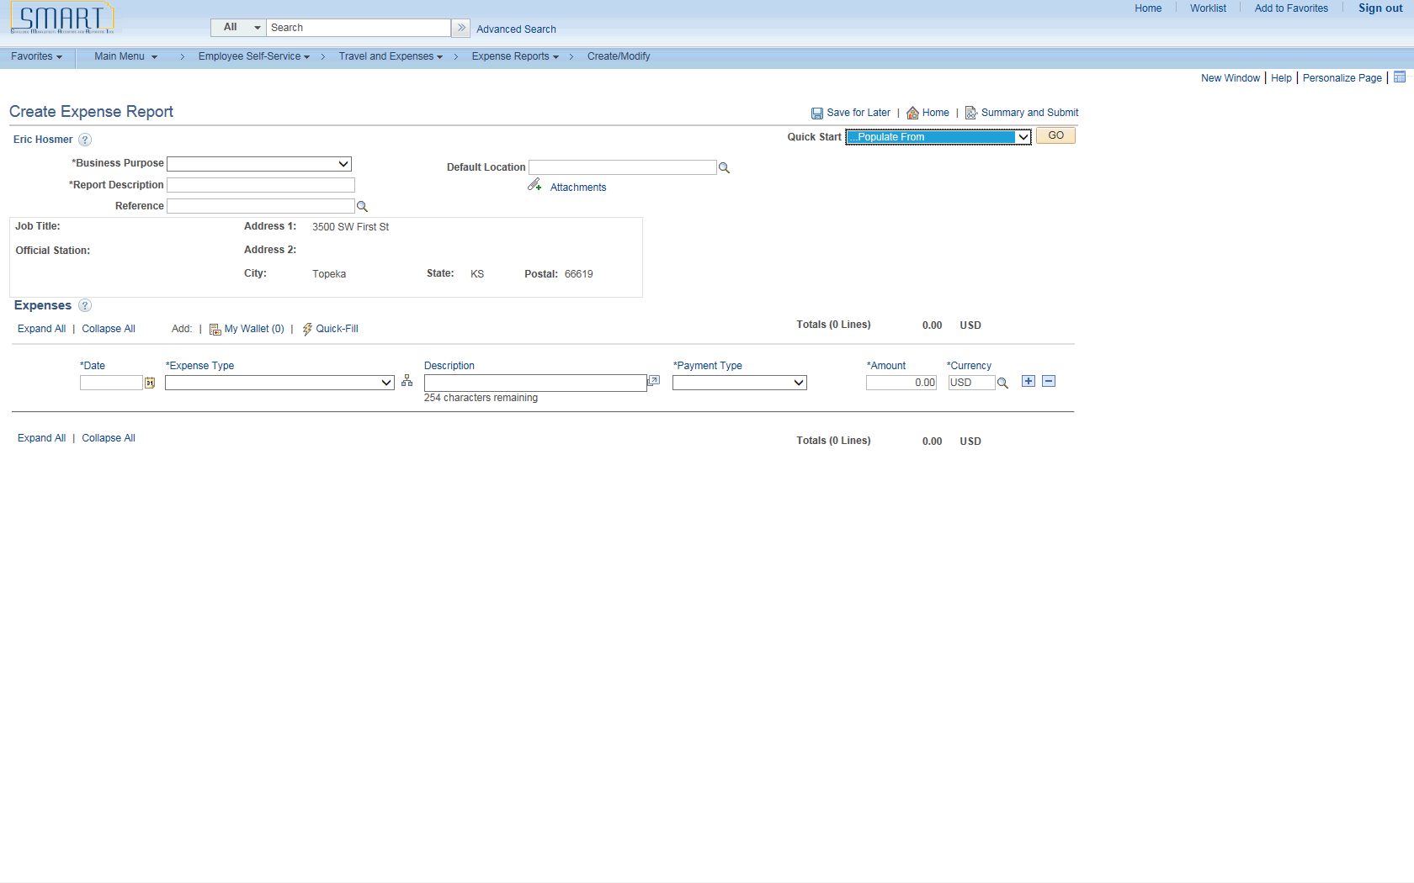

| **Step** | **Action** |
| --- | --- |
|  | Click the **Quick Start** list. |

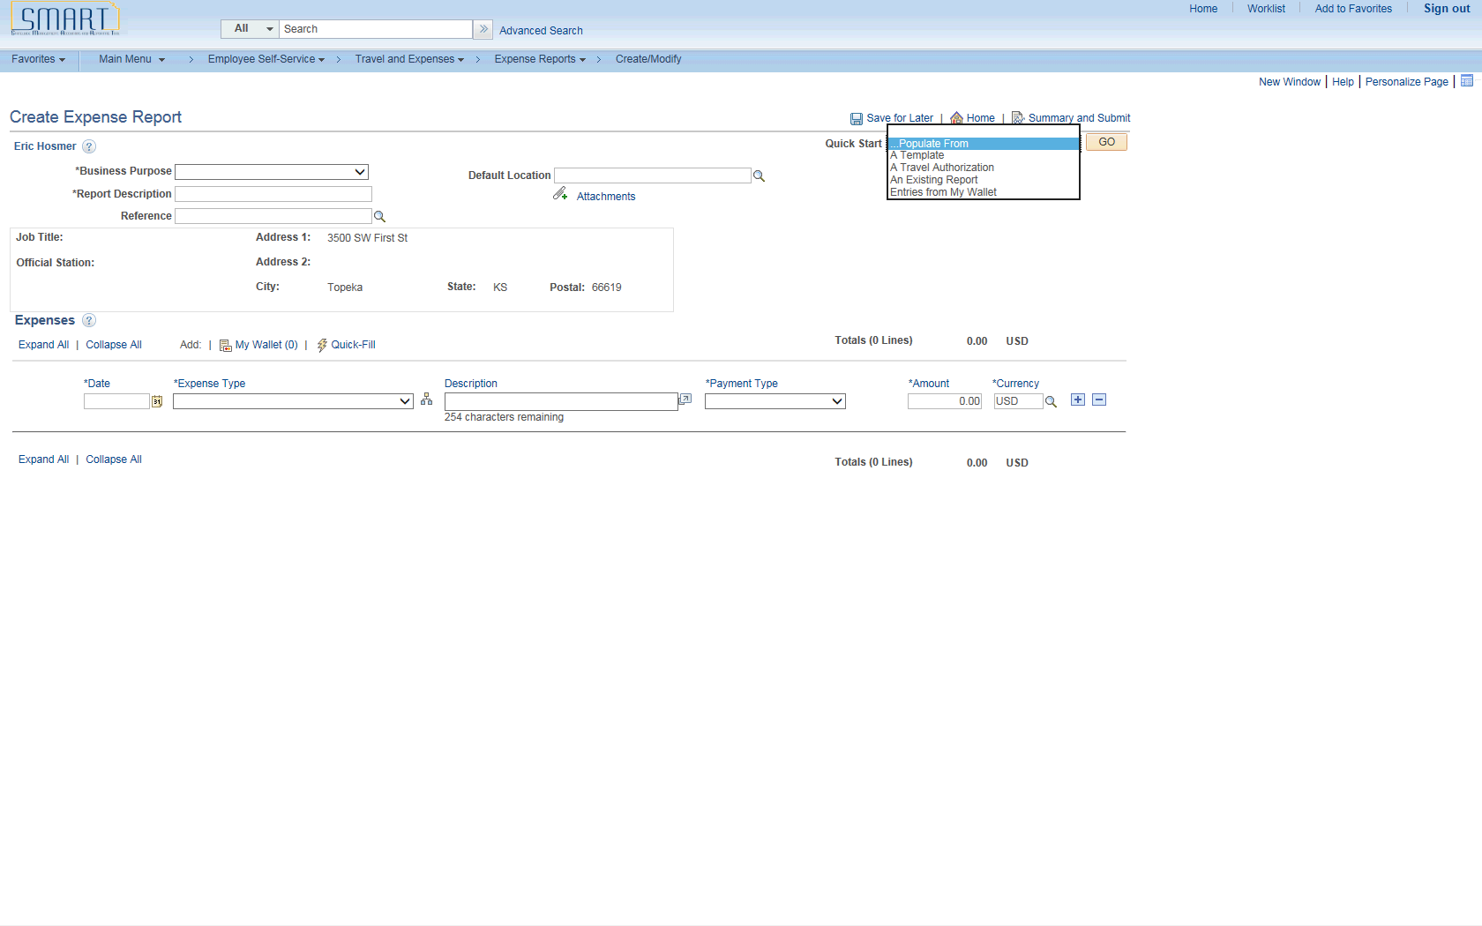

| **Step** | **Action** |
| --- | --- |
|  | The **Quick Start** menu allows you to select a creation method for your expense report. Expenses initially displays this field based on the setting of your default creation method on the **Employee Profile - User Defaults** page, which you can override.  Values are:  •**A Template:**Click to access the Select a Template page, where you can select a template on which to base a new expense report.  •**A Travel Authorization:**Click to access the Copy from Approved Travel Authorization page, where you can select an approved travel authorization from which to create a new expense report.  •**An Existing Report:** Click to access the Copy from Existing Expense Report page, where you can select an existing expense report that contains similar information.  •**Entries from My Wallet:**State of Kansas does not use My Wallet.  **Note:** Once you select an option from this drop down box or select an expense type, this drop down box changes from Quick Start to Action.  Click the **Populate Form** list item. |

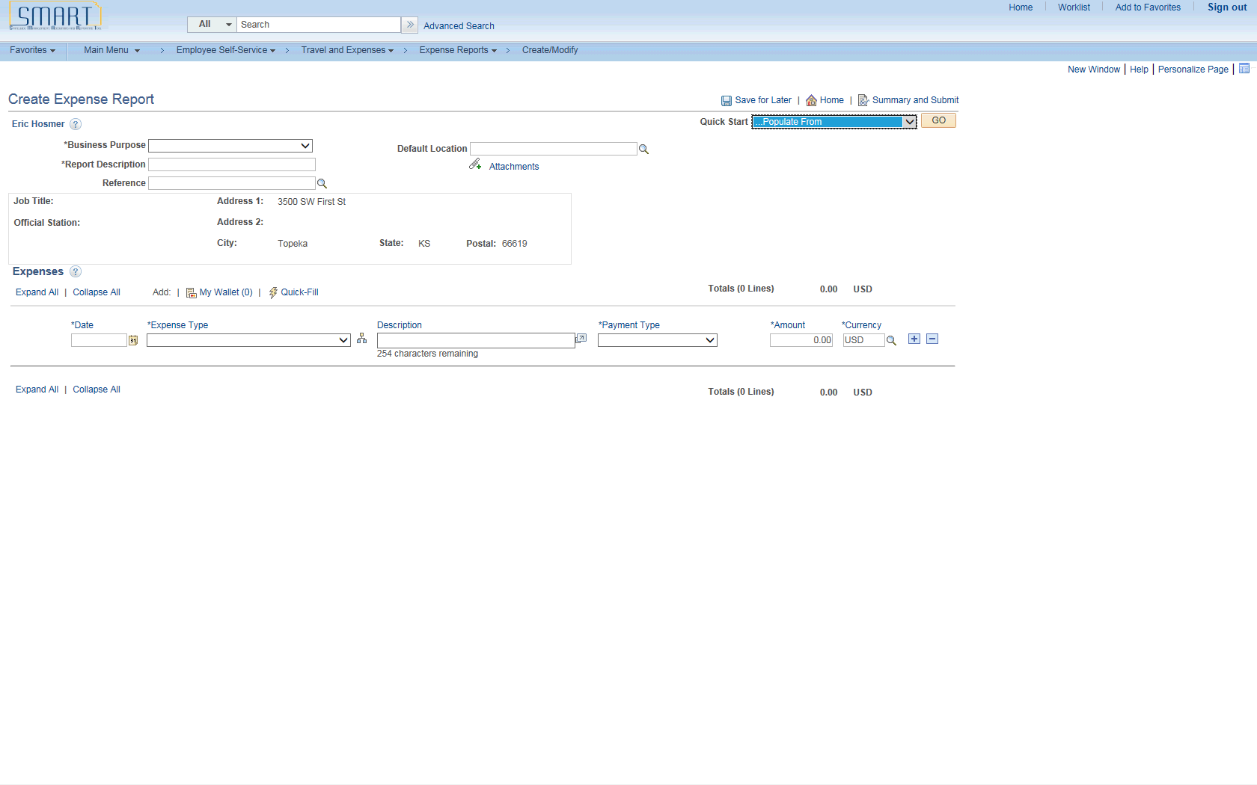

| **Step** | **Action** |
| --- | --- |
|  | Select a business purpose from the predefined list.  Click the **Business Purpose** list. |

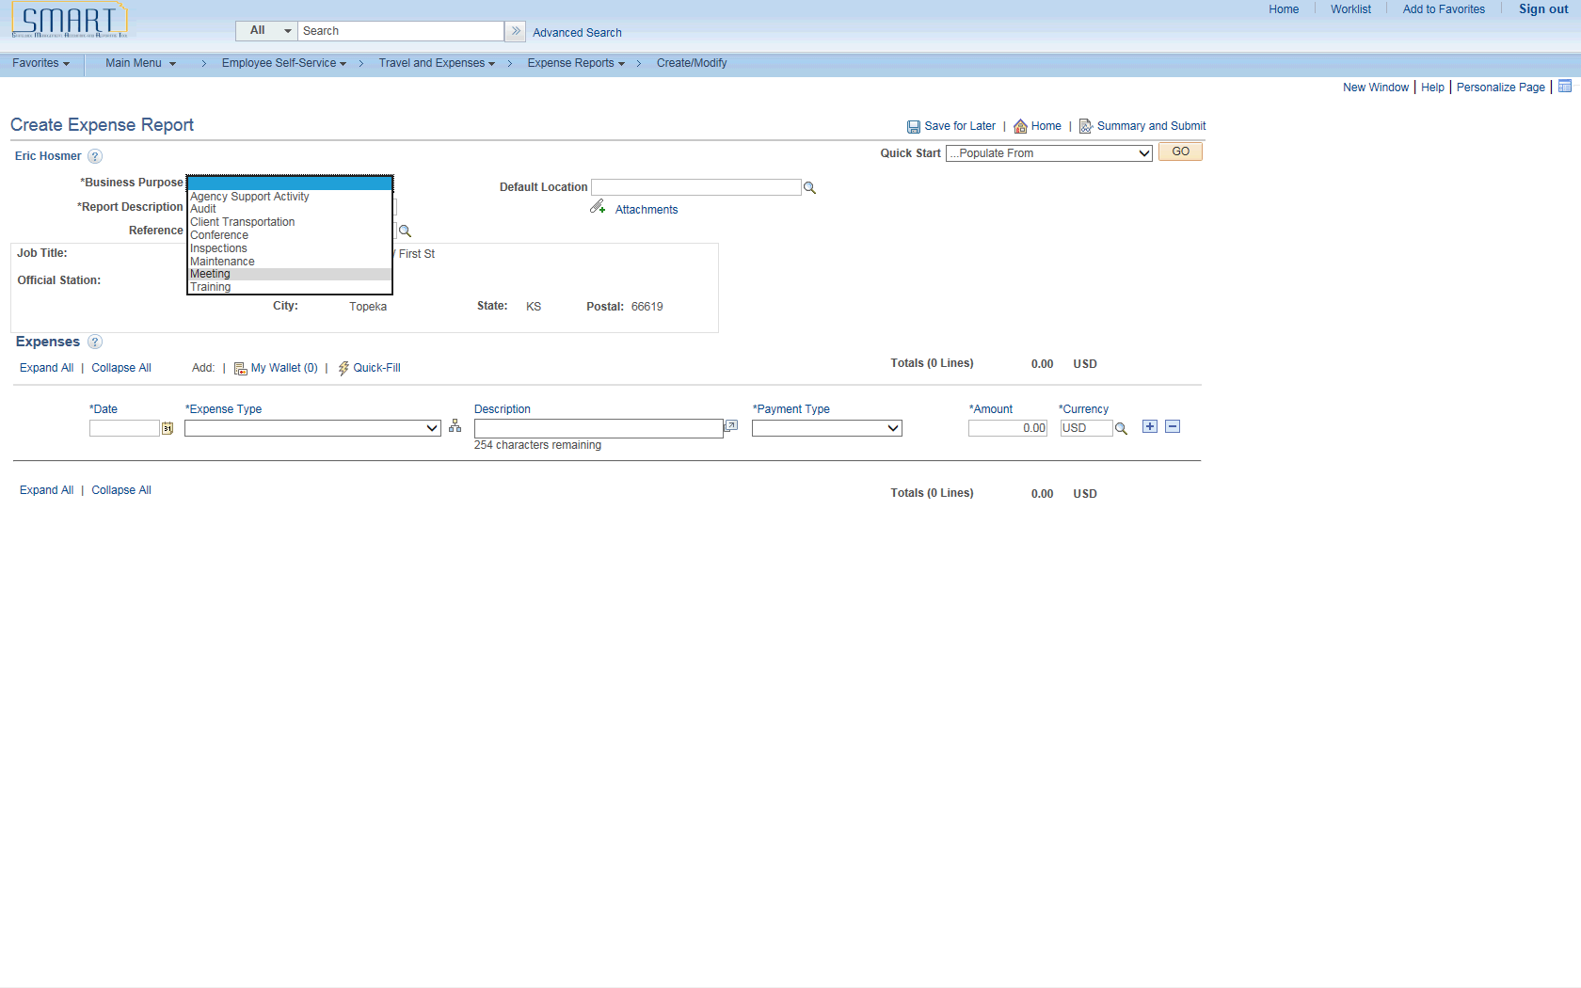

| **Step** | **Action** |
| --- | --- |
|  | Click the **Meeting** list item. |

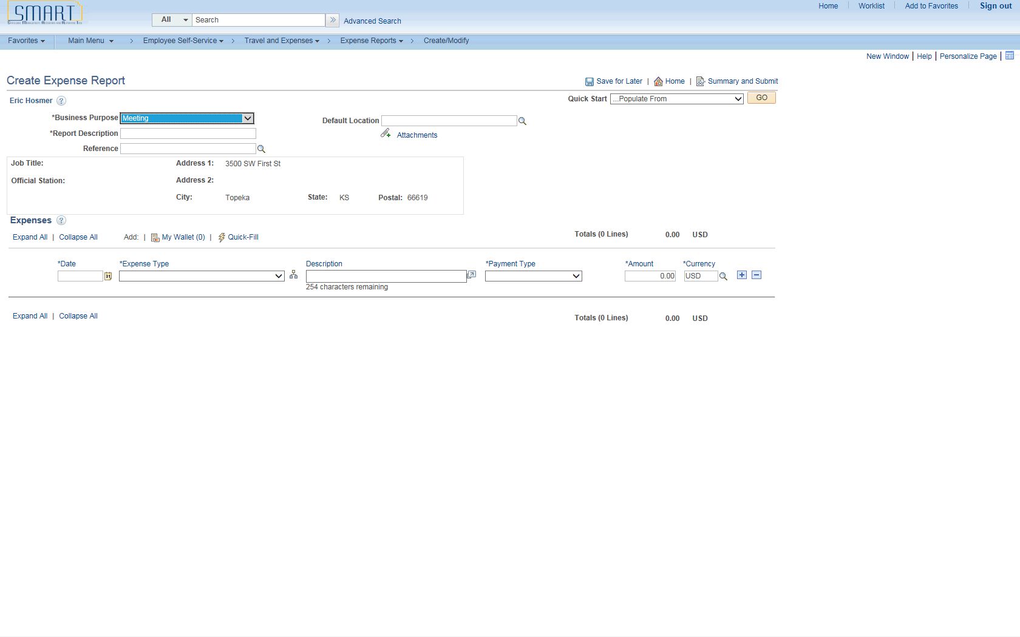

| **Step** | **Action** |
| --- | --- |
|  | Enter a description to identify the expense report.  Enter the desired information into the **Report Description** field. Enter "**Meeting in Wichita**". |
|  | Enter the date when the transaction began or occurred.  Enter the desired information into the **Date** field.  For this simulation, enter "**06/03/2015**". |
|  | Select an expense type.  Click the **Expense Type** list. |

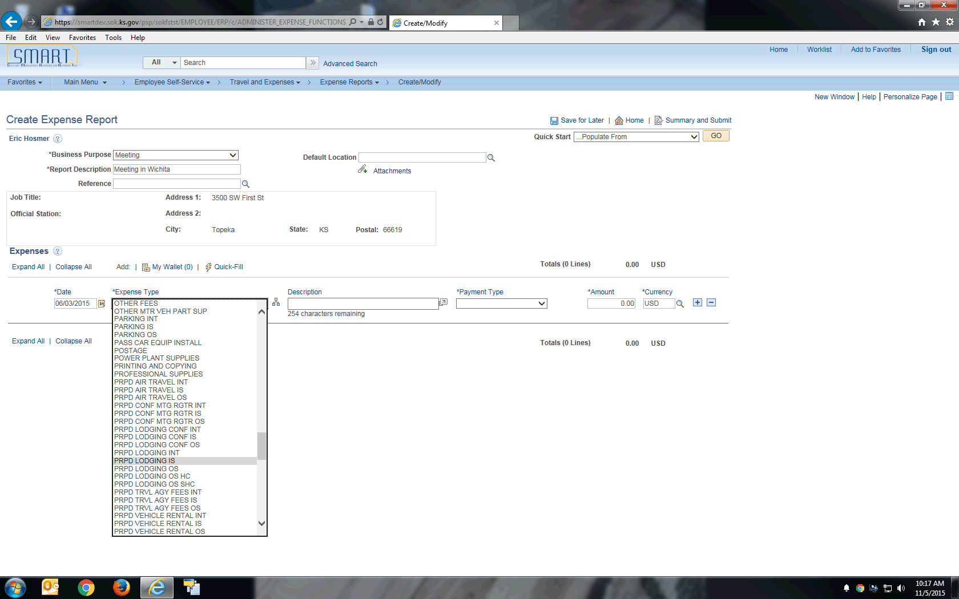

| **Step** | **Action** |
| --- | --- |
|  | Click the **PRPD LODGING IS** list item. |

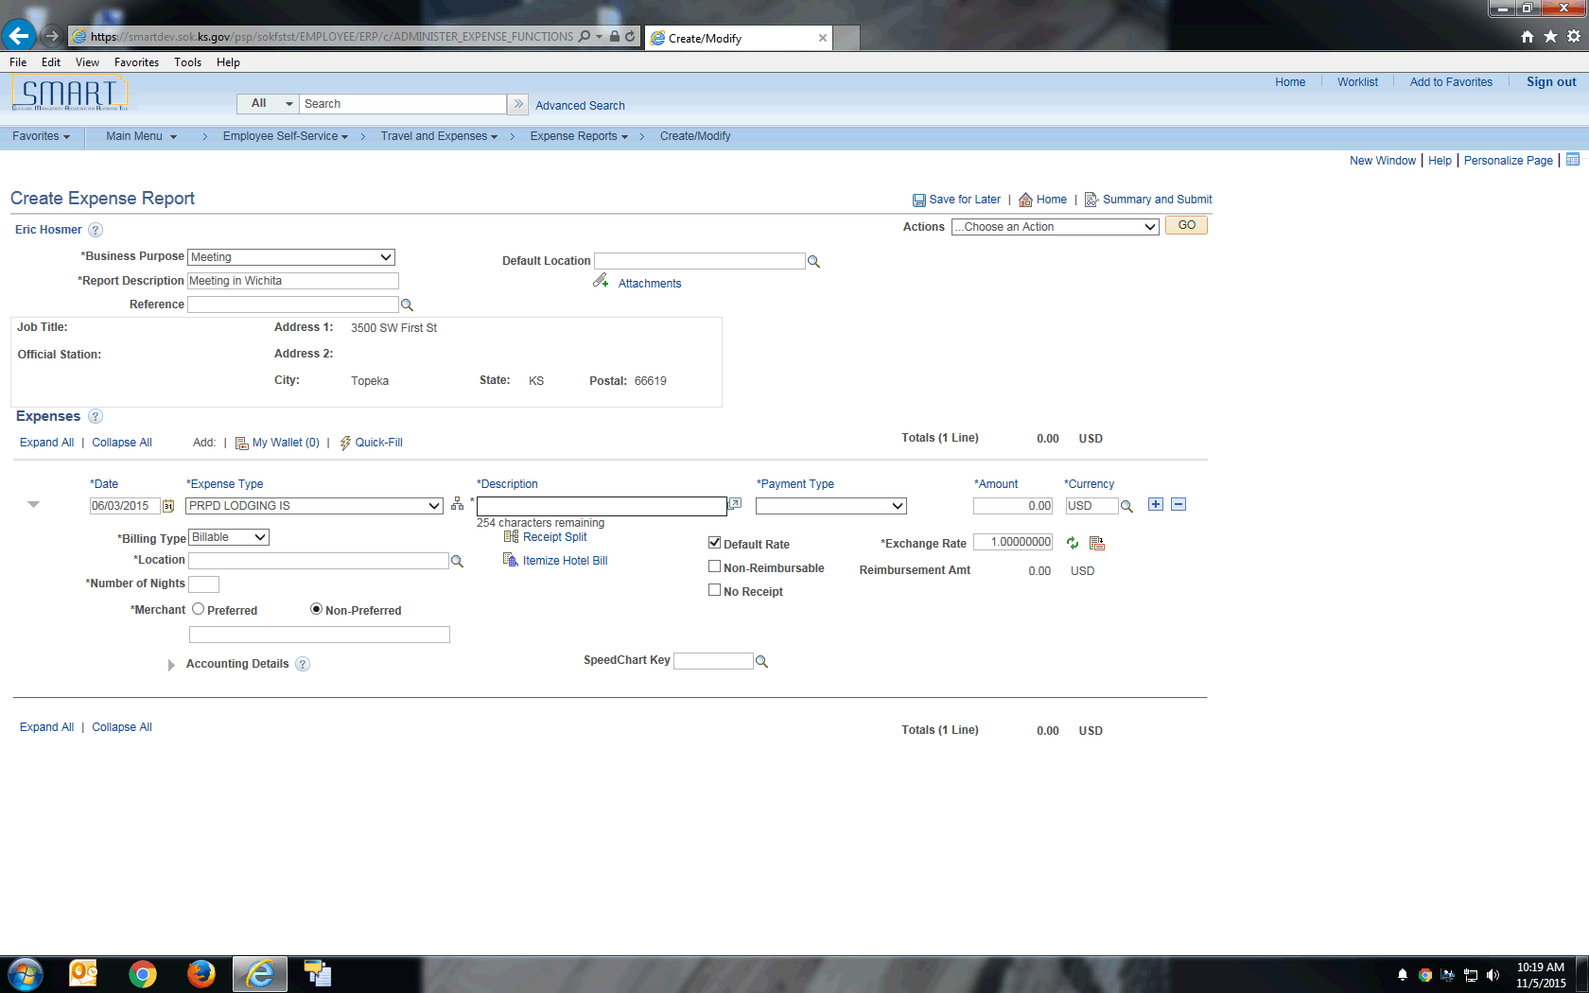

| **Step** | **Action** |
| --- | --- |
|  | Enter a description about the expense transaction.  Enter the desired information into the **Description** field. Enter "**Hotel in Wichita**". |
|  | Enter how you paid for the expense. This value may appear by default if a payment type is entered in the Expense defaults group box on the **Employee Profile - User Defaults** page.  Click the **Payment Type** list. |

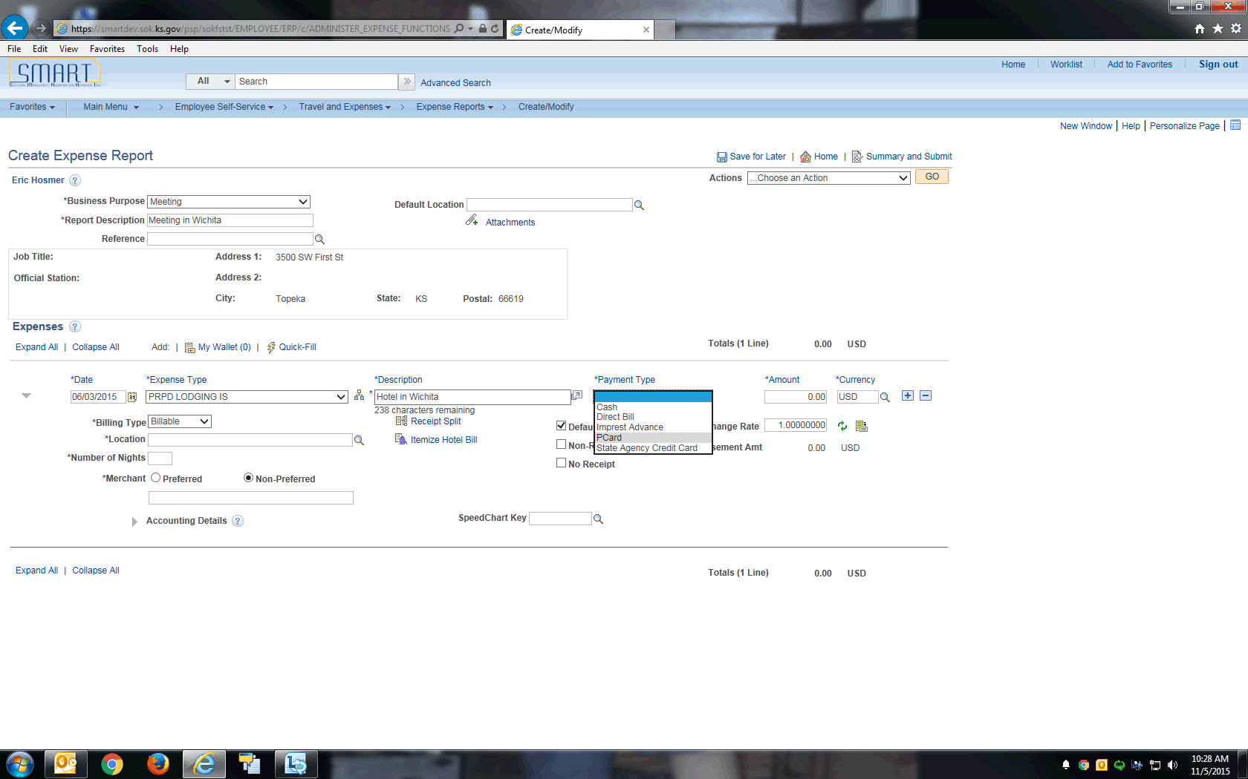

| **Step** | **Action** |
| --- | --- |
|  | **Note:** The Expense Type and Payment Type should always match. This means that a prepaid Expense Type should have a corresponding prepaid Payment Type. If a mismatch occurs, the resulting accounting entries generated by SMART will be incorrect and the correcting entry would be separate transaction.  Click the **PCard** list item. |

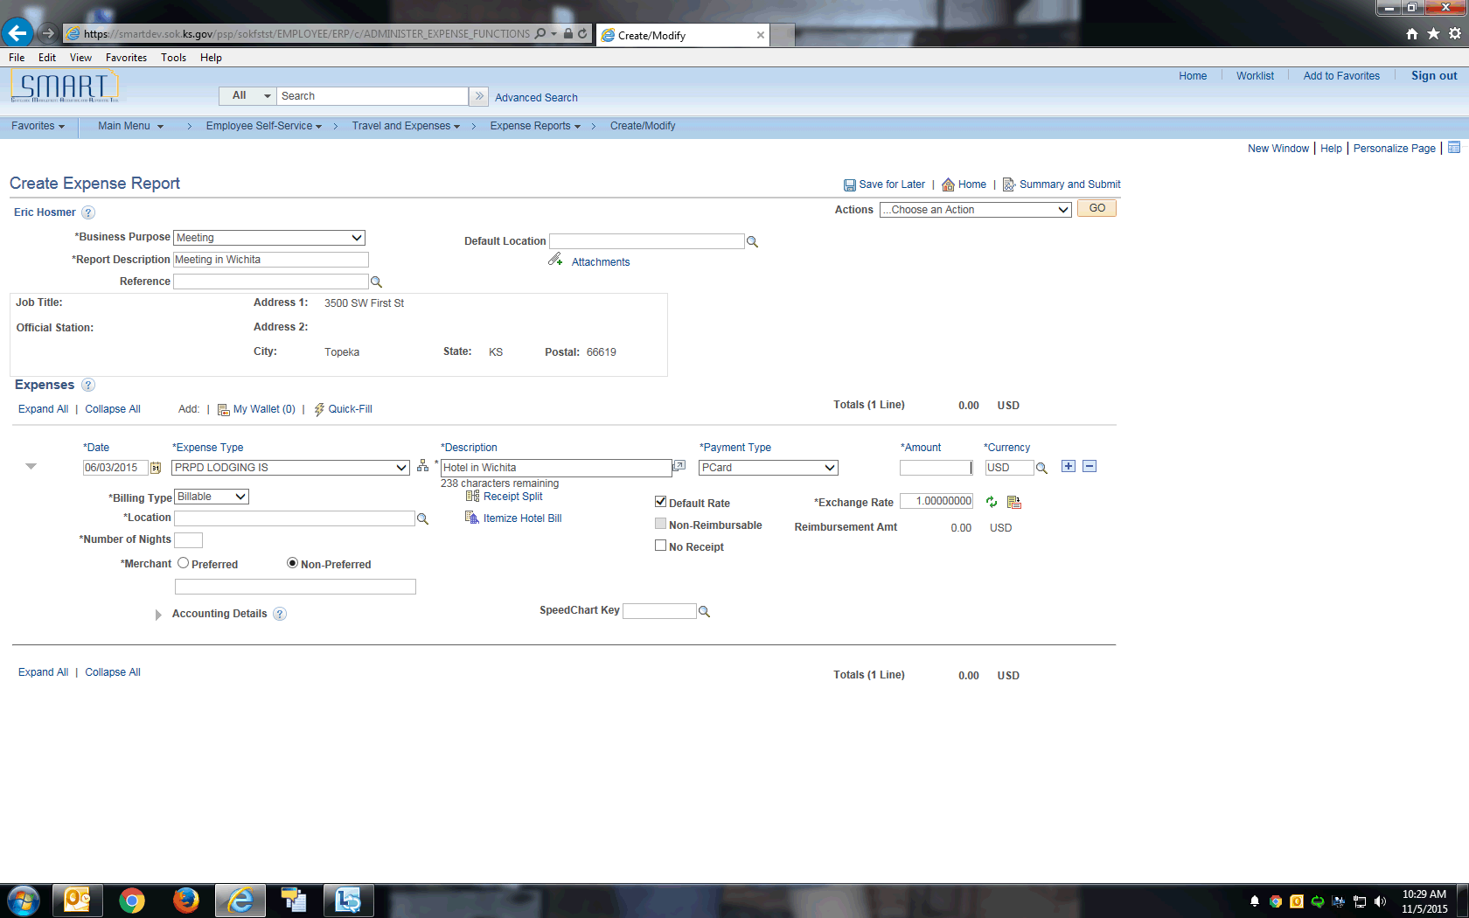

| **Step** | **Action** |
| --- | --- |
|  | Enter the amount that you spent for the expense line.  Enter the desired information into the **Amount** field. Enter "**120.00**". |
|  | Select the location where you incurred the expense.  Click the **Look up** button. |
|  | The **Locations** in Look Up are listed alphabetically starting with the two-letter state abbreviation, followed by the city name.  Example: KS, TOPEKA |
|  | Enter the desired information into the **Location** field. Enter "**KS, WICHITA**". |
|  | Click the **Look Up** button. |
|  | Click the **KS, WICHITA** link. |
|  | Another option when entering the expense location is to key the value directly into the **Location** field. For example, Wichita, KS would be keyed as KS, WICHITA into the **Location** field. Please pay attention to capitalization, commas and spacing. It must be exact for SMART to take the value. If the value is entered incorrectly, you will receive an error that must be corrected before you can continue. |
|  | Enter the number of nights that the expense covers.  Enter the desired information into the **Number of Nights** field. Enter "**1**". |
|  | The **Merchant** button will default to Non-Preferred. Enter the merchant used for this expense.  Enter the desired information into the **Merchant** field. Enter "**Marriott**". |
|  | Click the **Expand Accounting Lines** button. |
|  | Use the **Accounting Details** section to view or modify the accounting ChartFields for the expense line.  The Accounting Detail Default View field on the **Employee Profile - User Defaults** page determines if this section is collapsed or expanded when a user enters the expense type. |
|  | Click the **Collapse Accounting Lines** button. |
|  | Click the **Insert Line** icon to add a new expense line. When you add a new line, SMART validates the data on the previous expense line. If an error is detected by SMART, a red flag will appear next to the previous line, which must be fixed prior to submitting the expense report.  Click the **Insert Line** button. |
|  | Select an expense type.  Click the **Expense Type** list. |

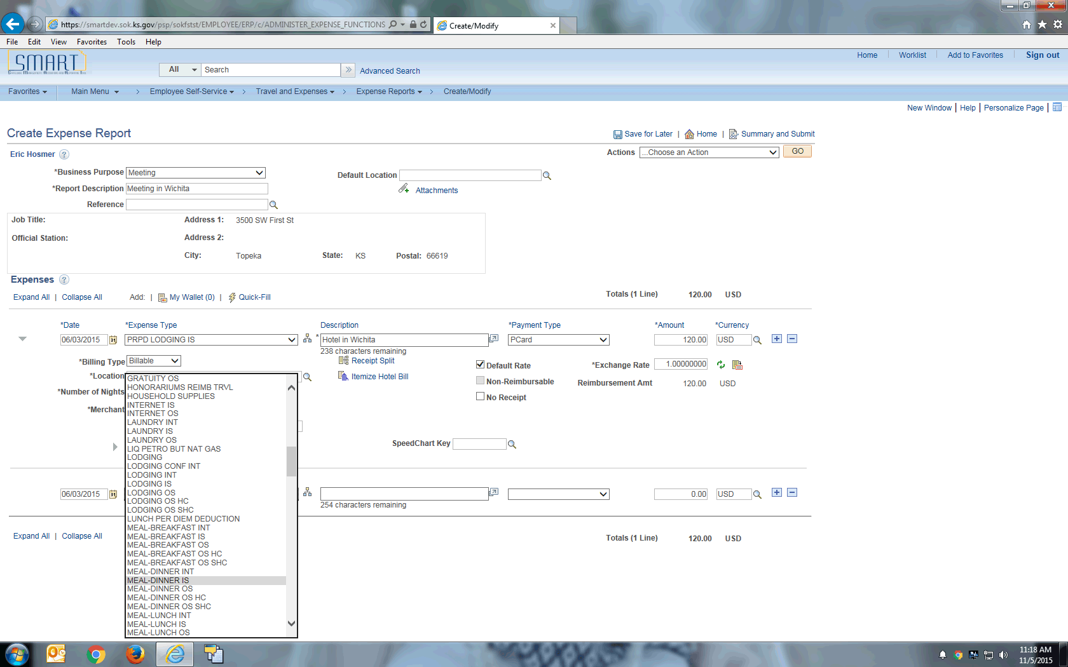

| **Step** | **Action** |
| --- | --- |
|  | Click the **MEAL-DINNER IS** list item. |

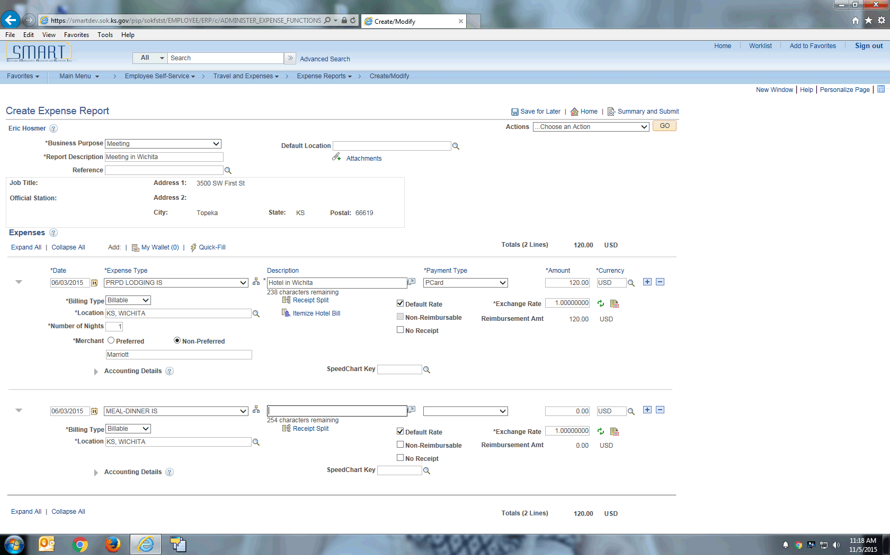

| **Step** | **Action** |
| --- | --- |
|  | Enter a description about the expense transaction.  Enter the desired information into the **Description** field. Enter "**Dinner paid**". |
|  | Enter how you paid for the expense. This value may appear by default if a payment type is entered in the Expense defaults group box on the **Employee Profile - User Defaults** page.  Click the **Payment Type** list. |

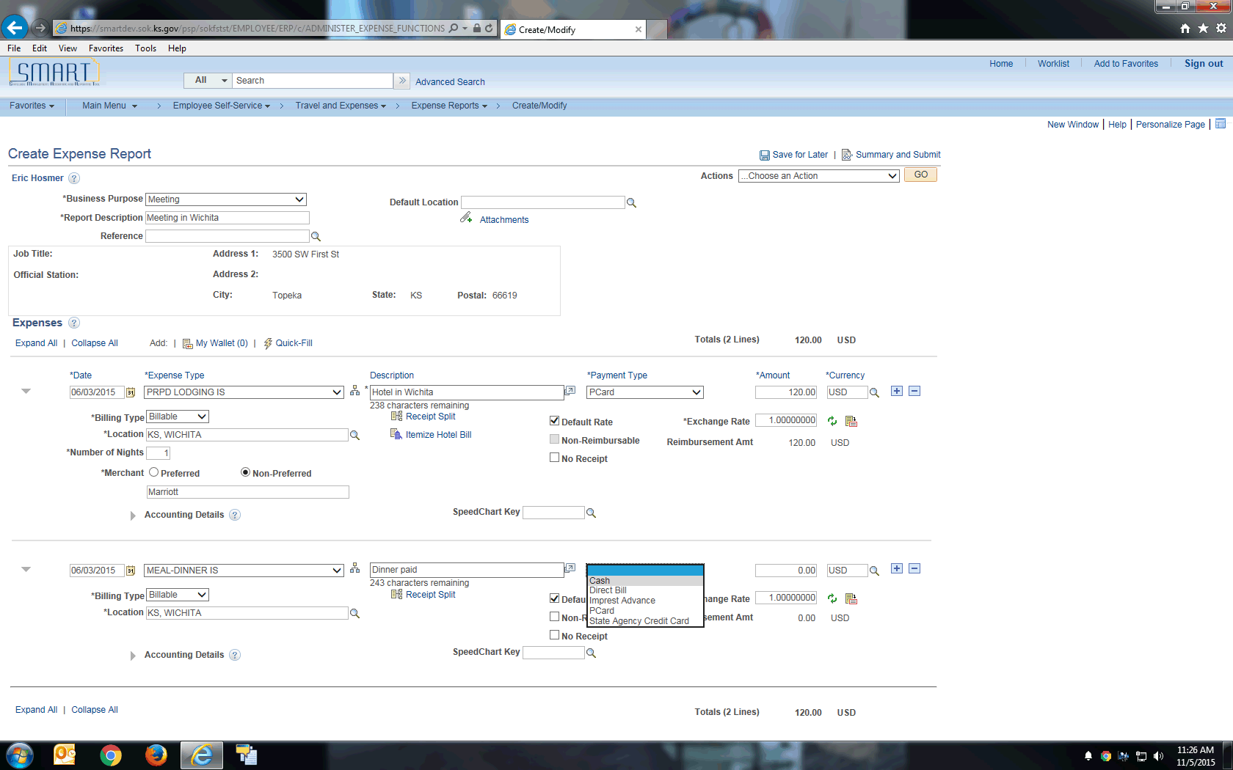

| **Step** | **Action** |
| --- | --- |
|  | **Note:** The Expense Type and Payment Type should always match. This means that a regular Expense Type (not a prepaid expense type) should have a corresponding regular Payment Type (not a prepaid payment type). If a mismatch occurs, the resulting accounting entries generated by SMART will be incorrect and the correcting entry would be separate transaction.  Click the **Cash** list item. |

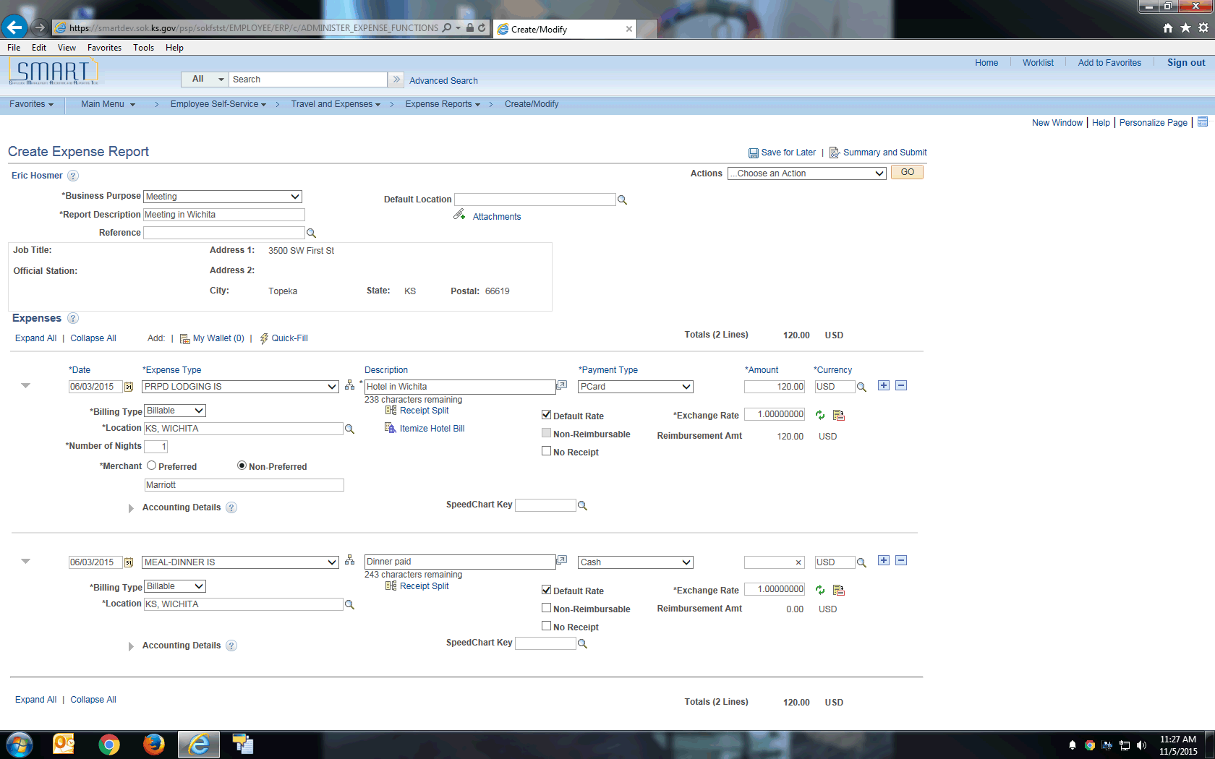

| **Step** | **Action** |
| --- | --- |
|  | Enter the amount that you spent for the expense line.  Enter the desired information into the **Amount** field. Enter "**25.00**". |
|  | SMART Expenses populates the **Location** field if you enter a **Default Location** in the general information section above, or if you have entered a previous expense line with a location.  **Location** is populated here due to the location being selected in expense line 1. You can override this value if needed. |
|  | Select the **Save for Later** link to save the expense report without submitting it for approval. This allows you to create an expense report as you are incurring expenses and save it for a later time when you are ready to submit it.  Click the **Save for Later** link. |
|  | Click this link to view a summary of your expense lines and submit the report.  Click the **Summary and Submit** link. |

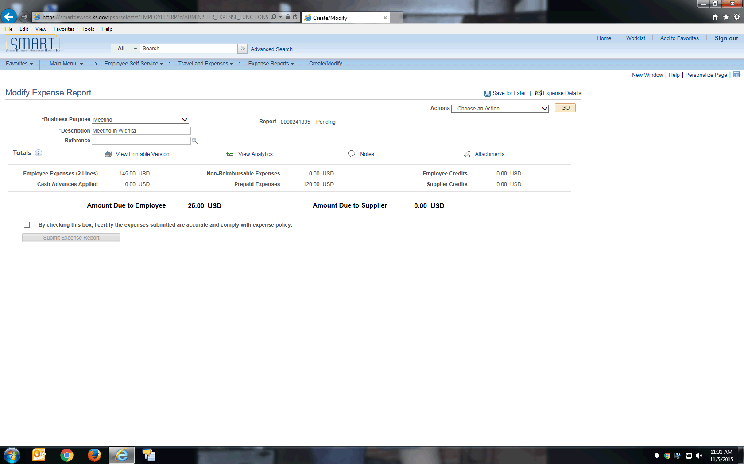

| **Step** | **Action** |
| --- | --- |
|  | Click the **Submit Checkbox** option. |
|  | Click the **Submit Expense Report** button. |

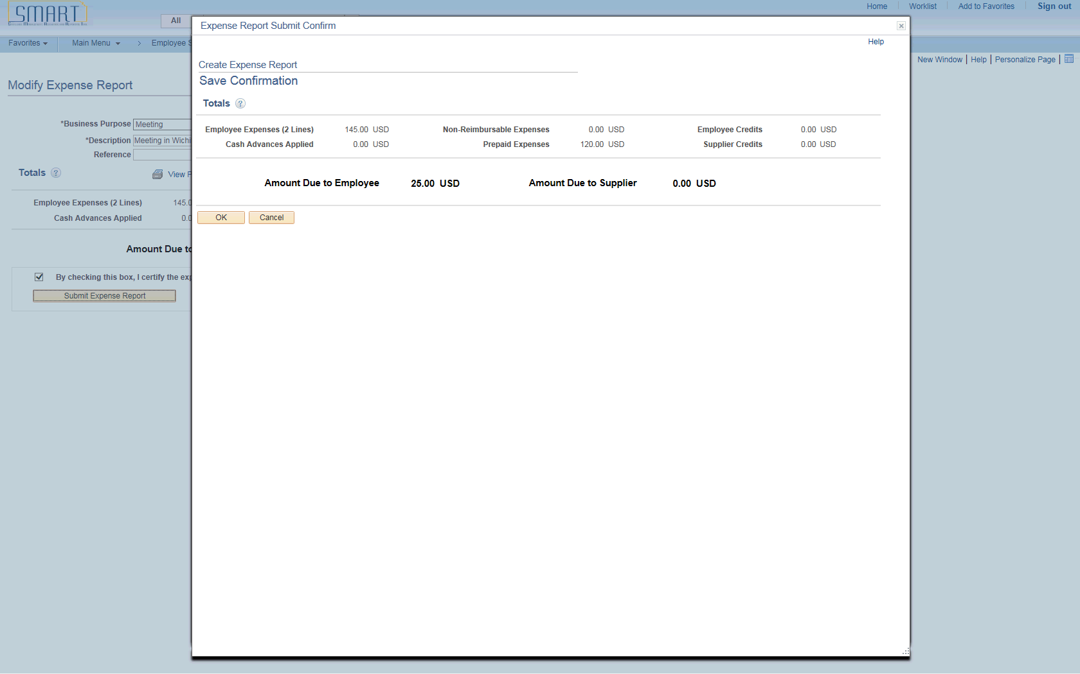

| **Step** | **Action** |
| --- | --- |
|  | SMART provides a confirmation page to make sure you want to submit the expense report.  Click the **OK** button. |
|  | **Congratulations!** You have successfully completed the **Creating Expense Reports** topic.  **End of Procedure.** |