**State of Kansas**

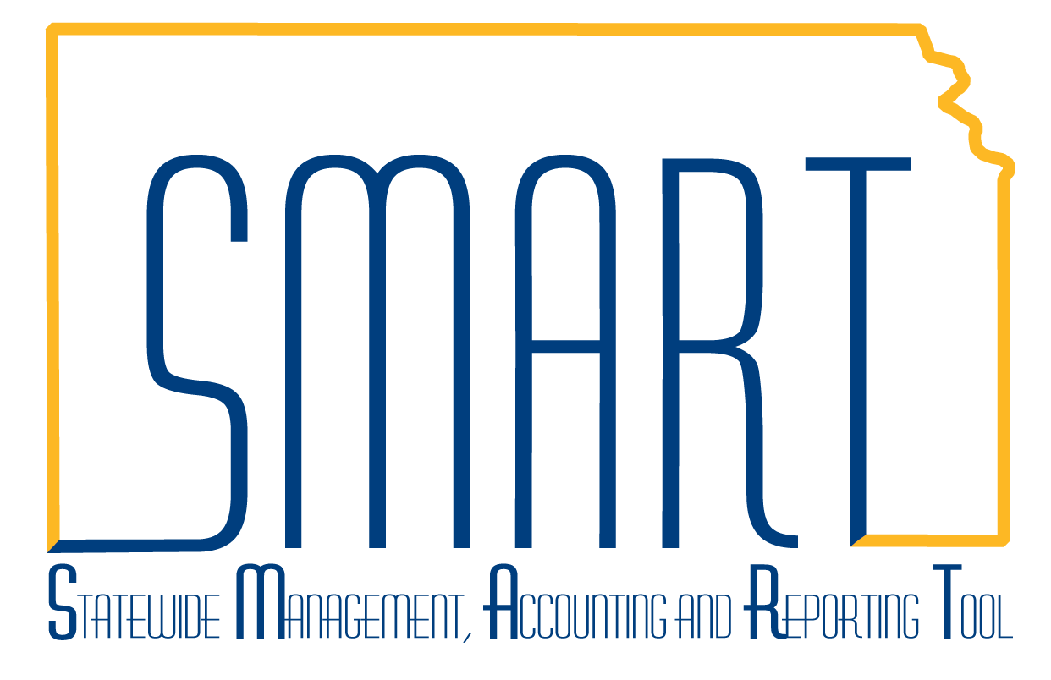

**Billing Manager Dashboard**

***Statewide Management, Accounting and Reporting Tool***

|  |  |
| --- | --- |
| **Date Created:** | 11/11/2015 |
| **Version:** | 1.0 |
| **Last Updated Date:** | 11/11/2015 |
|  | The Billing Manager Dashboard provides three pivot grids useful in obtaining a visual overview of Invoice Analysis by Month, Bills by Status, and Incomplete Invoice Process.  Note: On the Incomplete Invoice Process pivot grid, the Bill Source field did not populate in the data tables prior to the Upgrade. As data accumulates, this grid should populate. |
| Navigation: Billing > Billing Manager Dashboard  Select the gear icon and select *Prompts*. |  |
|  |  |
| Enter the criteria for the prompt. Click *OK*. |  |
|  |  |
| After the grid updates, use the filters to further limit results. |  |
|  |  |
| The grids provide many hyperlinks or *Action* links to drill down into the data. |  |
|  |  |
| Results are limited to 100. Click *Return* or *X* to close the Pivot Grid Drilldown. |  |
|  |  |
| Clicking on the Bar Chart, then clicking the Detailed View also activates the Privot Grid Drilldown with the detail for the month selected. |  |
|  |  |
| The icons in the screenshot allow for the personalization of the chart. |  |
|  |  |
| The grids provide the ability to download the data. |  |