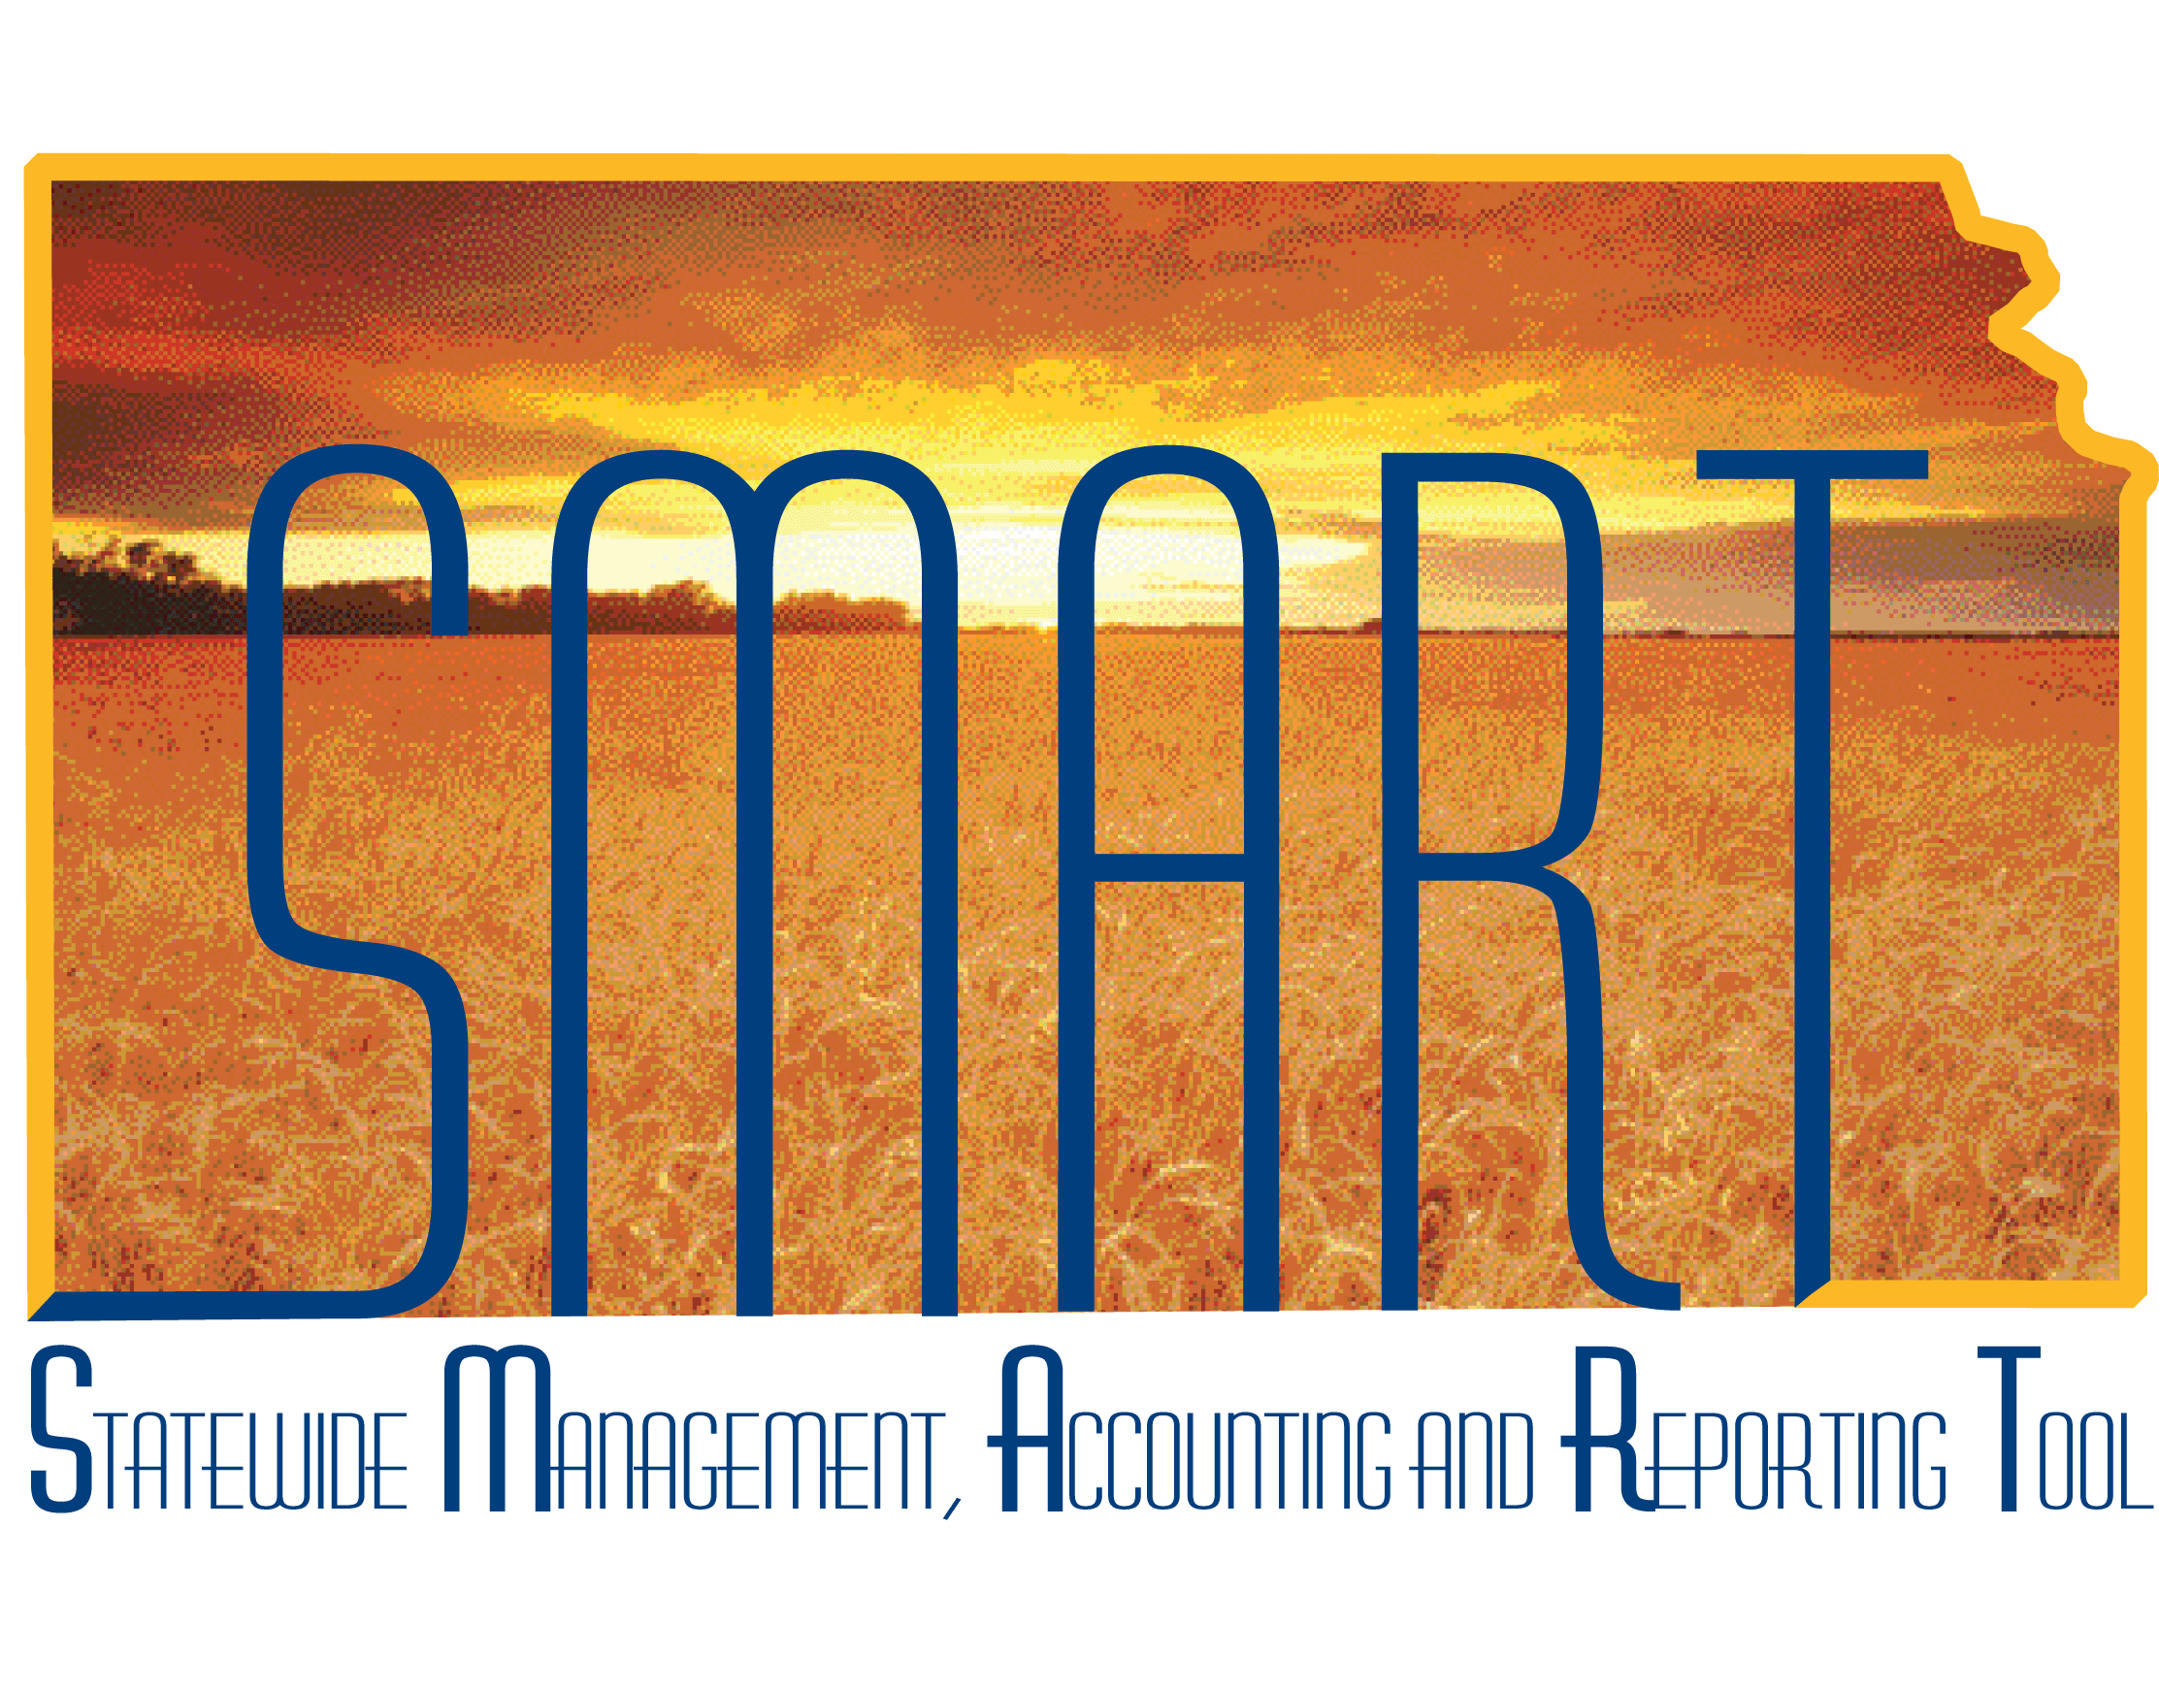

Training Guide –

Using Budget Inquiries

State of Kansas

Applicable Roles:

Agency Budget Processor

Agency Budget Approver

**TABLE OF CONTENTS**

Topic 1: Budget Overview 3

Topic 2: Ledger Inquiry Set 6

Topic 3: Budget Detail Inquiry 8

# Topic 1: Budget Overview

The **Budget Overview** inquiry component provides summarized and detailed information about activity across control budgets. This inquiry can be saved with a name so that the criteria that you choose are saved and can be used again. You can create a different inquiry with a different name to save a different set of criteria, delete the inquiry, or clear the criteria and start again. Use the **Budgets Overview** inquiry to:

* View budget details, such as the available amount remaining, the attributes, and the amounts used by each ledger (encumbrance, expense, and others) in the budget.
* View associated budgets and budget attributes

**Procedure:**

1. Navigate to the **Budget Overview Inquiry** page from the Home page:

|  |  |
| --- | --- |
| Page name | Navigation |
| Budget Overview | Main Menu>Commitment Control>Review Budget Activities>Budgets Overview |

*Table 1. Budgets Overview Navigation*

1. Enter the description, Business Unit, Ledger Group/Set and LedgerGroup information. Review the Budget Period range and add ChartField Criteria to narrow the results. Click the **Search** button to display the results.

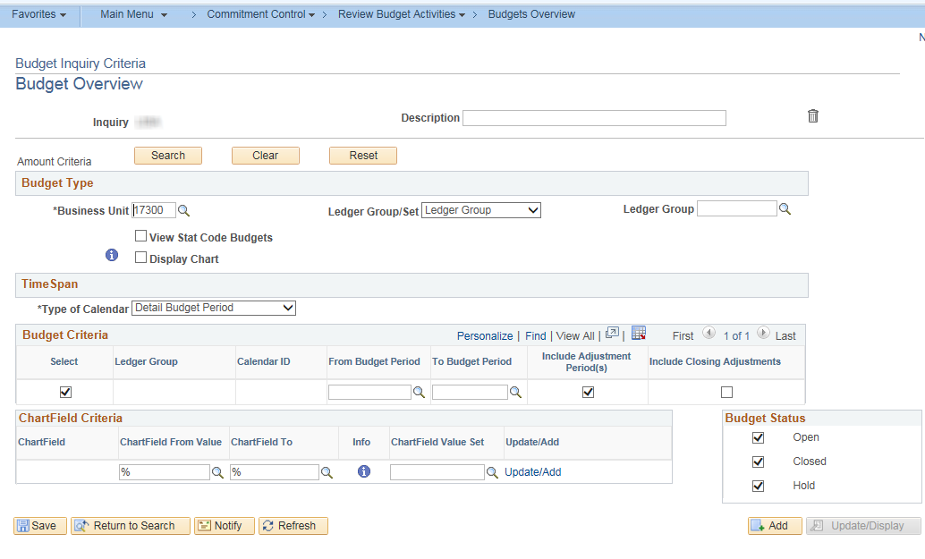

*Figure 1. Budget Overview Page*

| **Field** | **Description** | |
| --- | --- | --- |
| **Description** | | Enter a Description of the Inquiry |
| **http://download.oracle.com/docs/cd/E13228_01/fscm9pbr0/eng/psbooks/fscc/img/image94.gif** | | After criteria is entered, click to run your request and display the **Budgets Overview - Inquiry** **Results** page, where you can view the results based on the criteria you establish on this page |
| **http://download.oracle.com/docs/cd/E13228_01/fscm9pbr0/eng/psbooks/fscc/img/image95.gif** | | Click to remove existing criteria from the page |
| **http://download.oracle.com/docs/cd/E13228_01/fscm9pbr0/eng/psbooks/fscc/img/image96.gif** | | Click to populate default fields if you accidentally change the **Business Unit, Ledger Group, Ledger****Inquiry Set***,* or **Type of Calendar** while you are entering your inquiry criteria |
| **http://download.oracle.com/docs/cd/E13228_01/fscm9pbr0/eng/psbooks/fscc/img/image97.gif** | | Click to delete this inquiry |
| **Business Unit** | | Enter your agency’s Business Unit |
| **Ledger Group/Set** | | Select either the Commitment Control **Ledger Group** or **Ledger Inquiry Set** whose budgets you want to inquire. |
| **View Stat Code Budgets** | | Leave unchecked. Most agencies do not use statistic codes or statistic code budgets. |
| **Display Chart** | | Select to display an analytical chart of the Commitment Control **Budget to Total Activity** and **Budget to Commitments** on the **Budget Overview Inquiry Results** page |
| **http://download.oracle.com/docs/cd/E13228_01/fscm9pbr0/eng/psbooks/fscc/img/image98.gif** | | Click the **Information** button to view descriptions of the ChartField criteria field |
| **Type of Calendar** | | Select the calendar that you want to use for this inquiry:   * **Detail Accounting Period** – results will be by Fiscal Year and accounting period for ALL budget periods * **Detail Budget Period** – results will be by Budget Period for ALL fiscal years. * **Summary Accounting Period** – No Summary Accounting Periods configured * **Summary Budget Period** – results will be by Fiscal Year for ALL budget periods |
| **From Budget Period and To Budget Period** | | Enter the **budget periods** that you want to apply to this inquiry. If you are inquiring on a ledger inquiry set or a ledger group with rulesets using different calendars more than one row may appear: one for each ledger group in the ledger inquiry set and one for each calendar in the ledger group. |
| **Include Adjustment Period(s)** | | Click to include closing adjustment entries. |
| **Include Closing Adjustments** | | SMART does not use the budget closing process. |
| **ChartField Criteria** | | Enter the ChartField value range for each ChartField for the budgets that you want to view. You can use the **ChartField From Value** and **ChartField To** fields to enter a range of values. You can also use the % wildcard. For example, enter 5% in **ChartField Value** field to see all accounts that begin with 5, such as 500000 to 599999. |
| **Budget Status** | | Select one or more check boxes:   * **Open** to include open budgets in your inquiry * **Closed** to include closed budgets in your inquiry * **Hold** to include budgets on hold in your inquiry |

*Table 2. Budget Overview Page Elements*

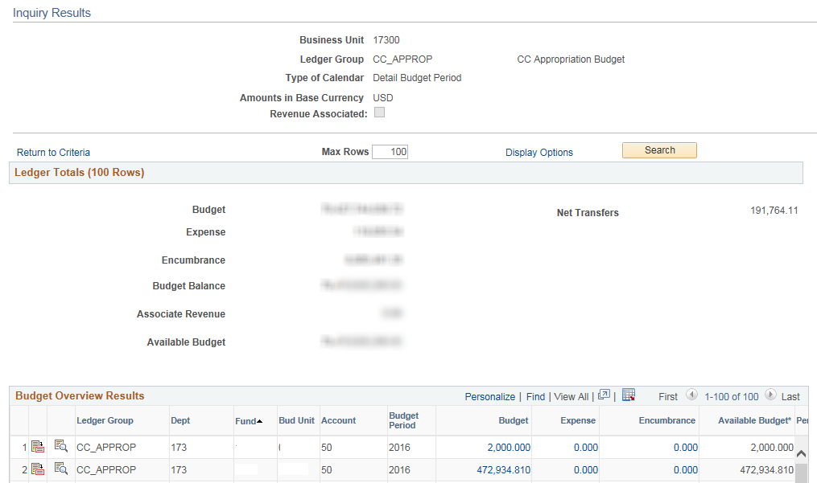

*Figure 2. Inquiry Results Page*

# Topic 2: Ledger Inquiry Set

Use the **Ledger Inquiry Set** page to create ledger inquiry sets which allows the user to inquiry across multiple ledgers. **Ledger Inquiry Sets** are especially useful for inquiring on associated expenditure and revenue budgets.

**Procedure:**

1. Navigate to the **Ledger Inquiry Set** page from the Home page.

|  |  |
| --- | --- |
| Page name | Navigation |
| Ledger Inquiry Set | Main Menu> Commitment Control> Review Budget Activities> Ledger Inquiry Set |

*Table 3. Ledger Inquiry Set Navigation*

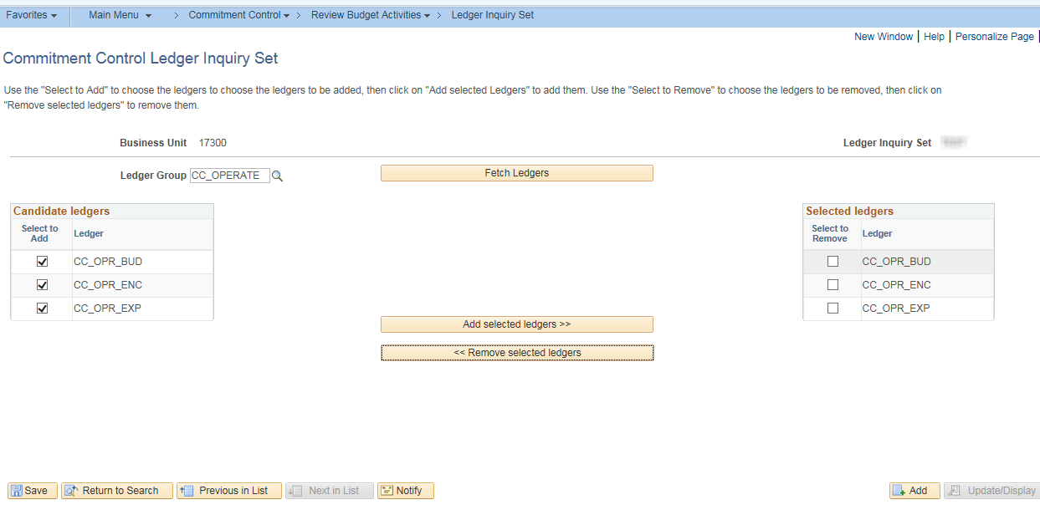

*Figure 3. Ledger Inquiry Set Page*

| **Field** | **Description** | |
| --- | --- | --- |
| **Ledger Group** | | Select a Commitment Control **Ledger Group**, which contains the ledgers that you want to include in the ledger inquiry set. *Multiple Ledger Groups* can be added to the inquiry set. |
|  | | Click to display the ledgers within the selected group that are candidates for this ledger inquiry set |
| **Candidate ledgers** | | Click the “Select to add” box next to the ledgers that you want to include in this ledger inquiry set |
| **http://help.ps89.dev.web.gov.state.ks.us/PSOL/htmldoc/eng/psbooks/fscc/img/image88.gif** | | Click to add the selected candidate ledger to the list of selected ledgers |
| **Selected ledgers** | | You can display the amounts in these ledgers using the **Budget Overview - Inquiry Results** page. You can also select any of the ledgers that you want to remove from this list. |

*Table 4. Ledger Inquiry Set Page Elements*

# Topic 3: Budget Detail Inquiry

The **Budgets Detail** inquiry is similar to the **Budget Overview** inquiry page, except that it enables you to view data for a specific budget. In order to use this page:

* Select key ChartField criteria to view a specific control budget.
* Use the drill down features to view the details of the budget ledger, budget journals, and budget activity.

**Procedure:**

1. Navigate to the **Budget Details** inquiry page from the Home page.

|  |  |
| --- | --- |
| Page name | Navigation |
| Commitment Control Budget Details | Commitment Control>Review Budget Activities>Budget Details |

*Table 5. Budget Detail Inquiry Navigation*

1. On the **Search Criteria** page, enter Business Unit and Ledger Group being inquiried.

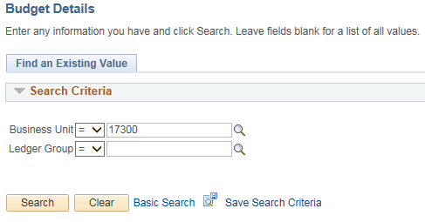

Figure 4. Budget Details Search Criteria page

1. Enter ChartFields and Budget Period into the **Budget Inquiry Criteria** page. Click the *Search* button.

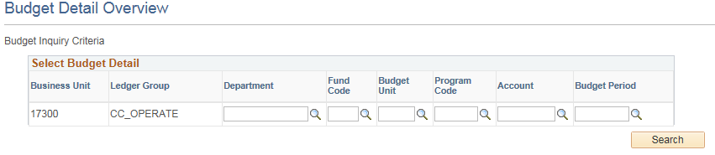

*Figure 5. Budget Inquiry Criteria page*

1. The **Budget Details** page will be displayed. The Budget ledger and Activity Log can be drilled into from this page. See the table below options.

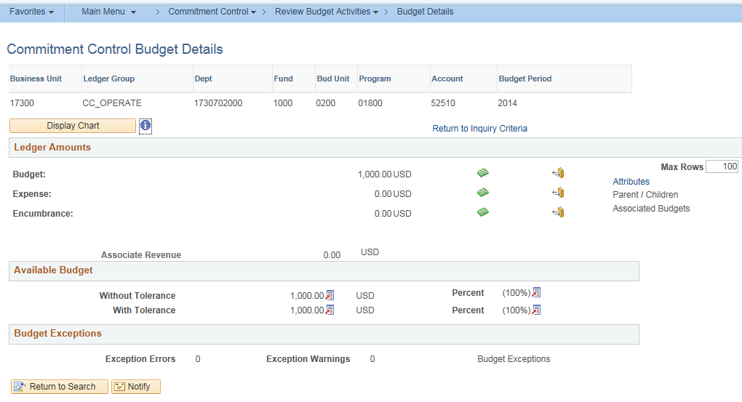

*Figure 6. Commitment Control Budget Details*

| **Field** | | **Description** |
| --- | --- | --- |
|  | Click this button to display a two-dimensional bar chart graph (Figure 7) if the budgeted amount is not equal to zero, or a pie chart if the budgeted amount is equal to zero or a budget does not exist. | |
|  | Click the **Drill to Ledger** button to access the **Ledger** page. (Figure 8) This page will show the ledger activity by accounting period. | |
|  | Click the **Drill to Activity Log** button to display the budget activity lines on the **Activity Log** page (Figures 9 & 10). These lines consist of the budget ChartFields and amounts for each budget activity. | |
| Attributes | Click to open the **Budget Detail Attributes** page (Figure 11), where you can view the budget status, Commitment Control option, begin, and end dates. | |
| Associated Budgets | Click to open the **Associated Revenue Budgets** page or the **Associated Expense Budget** page, where you can view the ChartField values and budget amounts for associated revenue or expense budgets. This link is unavailable if there are no revenue or expense budgets associated with this budget. | |
| With Tolerance | The total amount available including the tolerance percentage. The State of Kansas does not use budget tolerance... | |
| http://download.oracle.com/docs/cd/E13228_01/fscm9pbr0/eng/psbooks/fscc/img/image115.gif | View the formula used for the system calculation of the **Without Tolerance** field and **With Tolerance** field amounts and their percentages. | |
| Forecasts | Click link to open the **Budget Forecast Amounts** page, where you can view forecast amounts for the budget. This link is available only for current budgets. | |

*Table 6. Commitment Control Budget Details Page Elements*

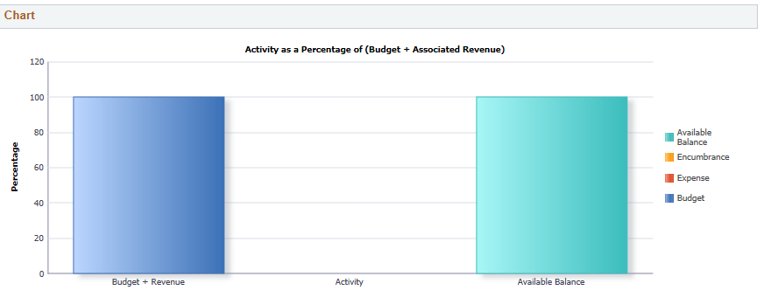

*Figure 7. Commitment Control Budget Details Display Chart*

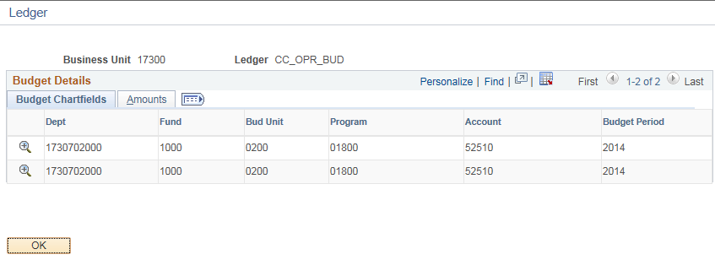

*Figure 8. Drill to Ledger Page*

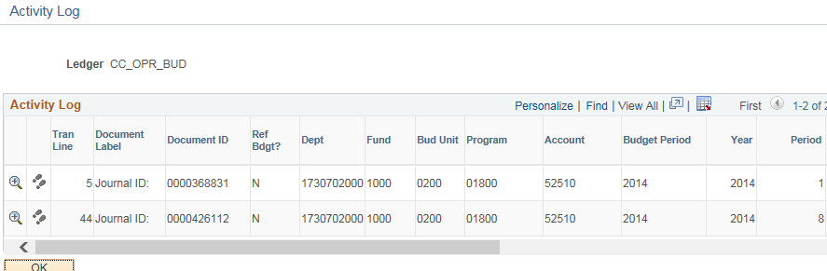

*Figure 9. Activity Log, Left Side of Page*

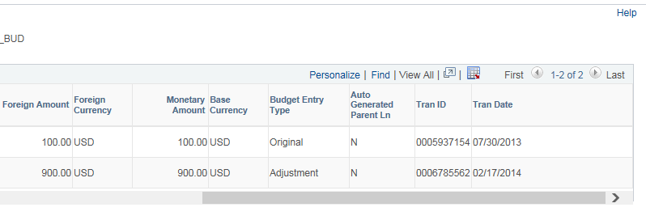

*Figure 10. Activity Log, Right Side of Page*

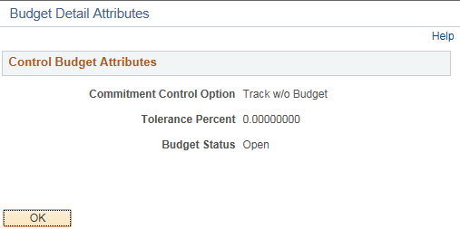

*Figure 11. Budget Detail Attributes Page*