**State of Kansas**

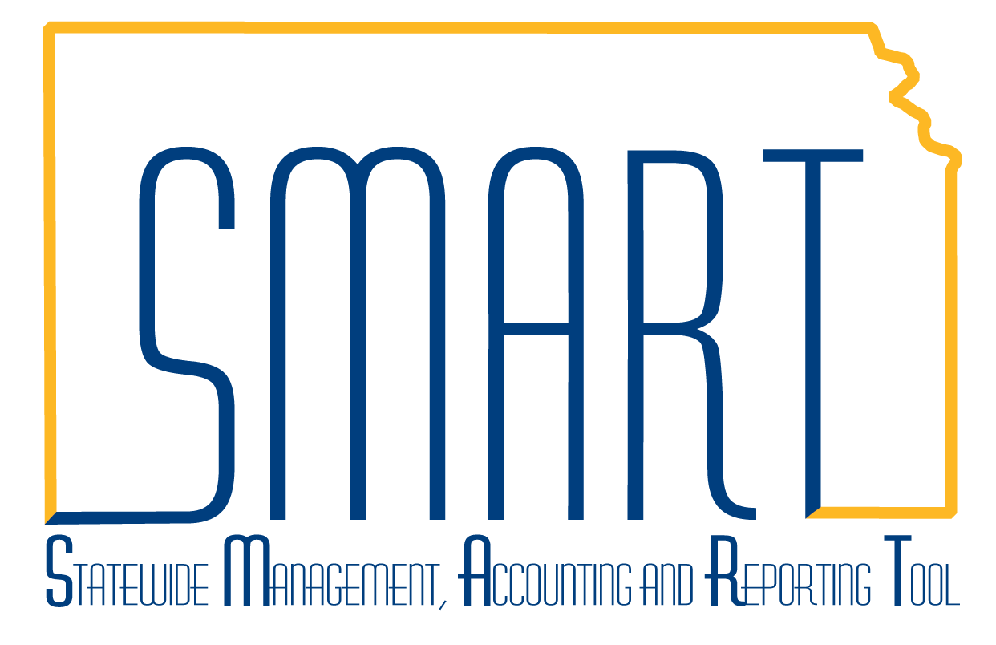

**AP Voucher Approval**

***Statewide Management, Accounting and Reporting Tool***

|  |  |
| --- | --- |
| **Date Created:** | 11/16/2015 |
| **Version:** | 1.0 |
| **Last Updated Date:** | 11/16/2015 |
| **Purpose of the Configuration:** | AP Voucher Approval Workflow |
| **General Information** | Vouchers must now be **budget checked** before they are eligible for approval.  The Navigation for Voucher approval is Accounts Payable>Vouchers>Approve>Approval Framework – Vouchers. |
| **1** | Enter a voucher in SMART. |
| **2** | Voucher must be budget checked in SMART. The preferred practice is to let the voucher be picked up in hourly batch for this to occur. |

|  |  |
| --- | --- |
| **3** | Once the voucher has been budget checked, the Preview Approval link is displayed on the Summary Tab. |
| **4** | Selecting the Preview Approval Link displays the expected approval path for the voucher. ‘Preview Approval’ means that the voucher is not yet in workflow, and is not available for approval either from the Approval navigation or the worklist. |

|  |  |
| --- | --- |
| **5** | Best Practice is to let the AP Hourly Batch enter the vouchers into workflow.  However, if a voucher must be approved prior to the next hourly batch, users can submit the voucher to workflow immediately by selecting the ‘Submit Approval’ Button on the Invoice Information Tab of the voucher. |
| **6** | The following pop-up box displays in which the user can add approval comments if desired. When comments are complete, select OK. |

|  |  |
| --- | --- |
| **7** | The ‘Pending Approval’ link will change to ‘Approval History’. |

|  |  |
| --- | --- |
| **8** | Once the approval status is ‘Pending’ the voucher is available to Approve either from the Worklist, or using the Accounts Payable > Vouchers > Approve > Approval Framework – Vouchers navigation (screenshot below displays the result for the Set A approver).  The ‘Approve’ Button is available, as is Deny. Select the ‘Add Comments’ button if additional information needs to be added for approval. |

|  |  |
| --- | --- |
| **9** | Once the Set A approver has selected ‘Approve’, the ‘Pending’ status for the Set A approver changes to ‘Approved’ and now the Set B approver box is ‘Pending’. |

|  |  |
| --- | --- |
| **10** | When the Set B approver navigates to the voucher approval screen, this is how the voucher is displayed. The Set B approver can Approve, Deny, Pushback (send the voucher back one level to Set A), Add Comments, or put the approval on Hold. |
| **11** | Step 10 is repeated by the Agency Fiscal Office Approver (for all vouchers), and by the A & R Approvers (for vouchers $5,000 and greater). |