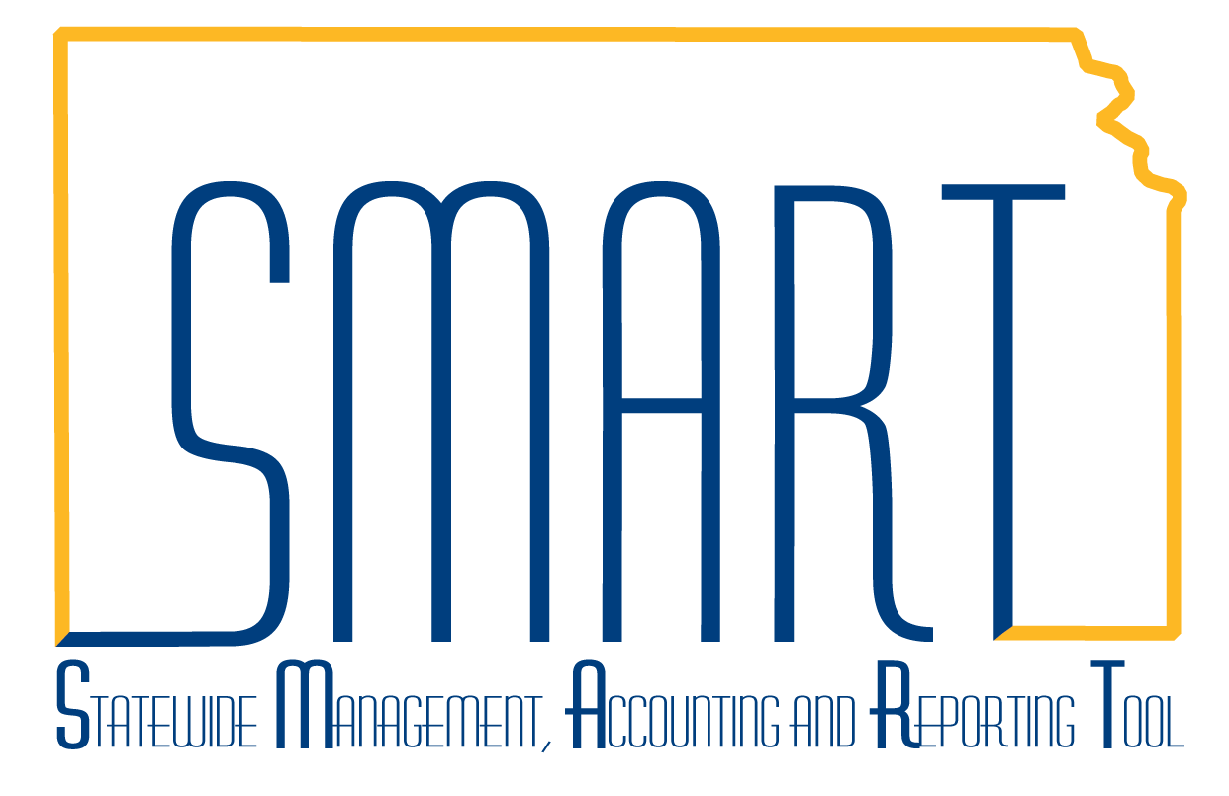
State of Kansas

Employee Info & Security – Update Profile, Authorize Expense Users

Statewide Management, Accounting and Reporting Tool

Date Created: | 07/20/2010
Last Updated Date: | 02/10/2021
Version: | 2.0
Overview: | An employee must have a valid employee profile for their agency to reimburse them through the Expenses module/EX.  An employee must be a proxy/authorized user to create expense documents on behalf of another employee. An expense document is an expense report/ER, travel authorization/TA, or a cash advance/CA and is comprised of transactions.  Reimbursing Expenses for an Employee of Another Agency  Best practice is for the employee’s agency to reimburse the employee as usual (including securing any necessary travel authorizations) and then create an interfund to receive payment from the agency reimbursing the employee’s expenses. Using this method, there is no need for the reimbursing agency to create a unique profile ID.  Employees & Non-Employees and Employee IDs & Unique Profile IDs  A person is an employee of the agency reimbursing them if that agency has a State of Kansas/SoK employee ID in Sharp for them. The employee will also have a profile in EX associated to their employee ID for that agency.  The format for a SoK employee ID is an alpha character followed by a 10-digit number.  Examples: K0000012345 J0000123456 W0000012345  A person is not an employee of the agency reimbursing them if that agency does not have a SoK employee ID in Sharp for them—the person is a non-employee of that agency. Also, the person will not have a profile in EX for that agency.  For a non-employee, the agency must add a profile in EX using a unique profile ID which the agency assigns and is for use in EX only.  The unique profile ID should consist of 11 characters. The first 3 characters should be the agency number; the remaining 8 characters should be any combination of alphanumeric characters. The ID should not start with an alpha character.  Examples: 17312345678 173ABCDEFGH 1730000JDoe  Table of Contents  Update Profile……….…………………….…………………..……….….…….…… Page 3  Authorize Expense Users......……………………………..….………….……….… Page 9

Overview:  (cont’d) | This job aid replaces the following job aids which have been removed from SMART Web:  - Adding a Bank Account to an Employee Travel and Expense Profile  - Adding an Expense Payee  - Adding a Non-Employee for Travel and Expenses 11-19-12  - Default ChartField Values  - Setting Up Proxies
Security: | Role: Only individuals with the following role can update a profile:  - Agency T&E Maintainer (KAP_Agy_T_E_Maintainer)  Only individuals with the following role can authorize expense users:  - Agency T&E Maintainer (KAP_Agy_T_E_Maintainer)  BU: Agencies can only update profiles and authorize expense users for employees of their agency business unit.

Update Profile

1 | To add a profile, click Add a New Value.  To update a profile, click Find an Existing Value. | Navigation: Expenses > Employee Info & Security > Employee Profile > Update Profile  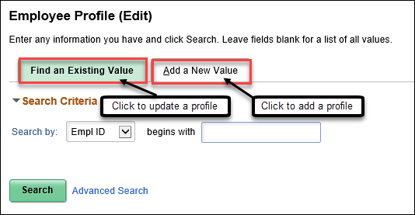
2 | To add a profile, enter a unique profile ID, click Add.  To update a profile, search by any of the listed options, enter the criteria, click Search. | 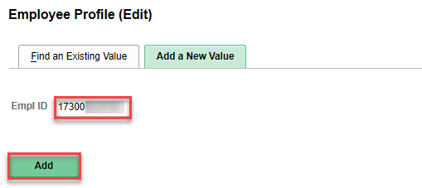  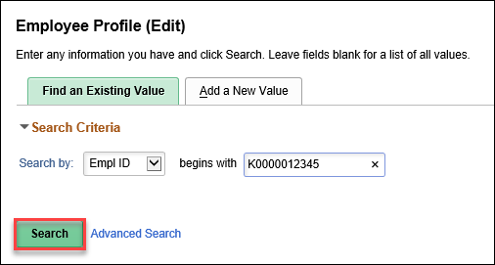  Note: The screenshot above shows a search by Empl ID, a unique profile ID may be entered instead.
3 | Note: The remaining steps are the same whether adding or updating a profile.  On the Employee Data tab:  To add or update a profile, enter or edit the highlighted fields, click Save. | 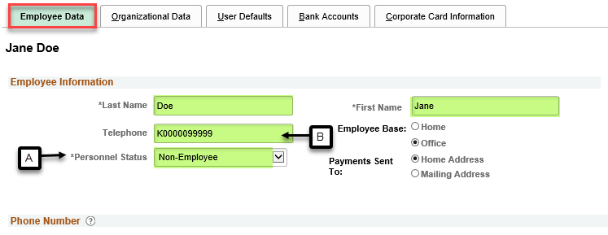  A – Personnel Status – For an employee, select Employee. For a non-employee, select Non-Employee.  B – Telephone – For an employee, leave blank. For a non-employee, if the non-employee has a SoK employee ID in Sharp for another agency, enter the employee ID. Otherwise, leave blank.
4 | On the Organizational Data tab:  To add or update a profile, enter or edit the highlighted fields, click Save. | 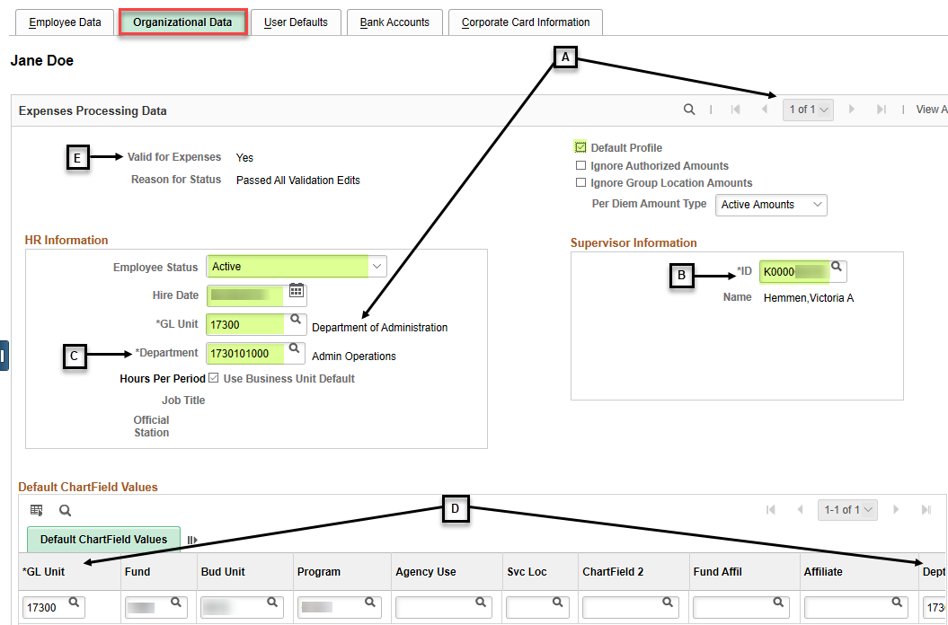  A – If there are multiple rows, navigate to the row for your GL Unit and confirm it is checked as the Default Profile.  B – ID – Select the SoK employee ID for the first-level/HR Supervisor expense document approver. This is used for EX approval workflow only and may differ from the supervisor the employee actually reports to for timekeeping, assignments, etc. The supervisor Name auto-populates based on the ID selected.  C – Department - Select the department. Approval workflow for the second-level/Department Expense Manager/Expense Manager and third-level/ Agency Fiscal Office/Prepay Auditor is based on the selected department. This is used for EX approval workflow only and may differ from the department the employee actually works for. The Department name auto-populates based on the Department selected.  See job aid titled Approvals – Approve Transactions… for additional detail.  D – GL Unit and Dept auto-populate based on the GL Unit and the Department selected. Other Default ChartField Values are optional unless creating a cash advance. If creating a cash advance, Fund, Bud Unit, and Program values are required.  Default ChartField Values entered will default into expense documents but can be edited as needed.  E – After saving, confirm Valid for Expenses is Yes. If Valid for Expenses is No, click Validate, then Save, and confirm Valid for Expense is Yes.  If Valid for Expenses is No and the Reason for Status is Invalid Department:  Navigate to the row with the invalid department (it may be another GL Unit). Click the look up for the Department, select the first valid value, and click Save. Then click Validate, then Save, and confirm Valid for Expenses is Yes.  It is acceptable to change the department on rows that are not checked as the Default Profile because transactions are only processed against the row marked as the Default Profile.
5 | On the User Defaults tab:  To add or update a profile, enter or edit the highlighted fields, click Save. | 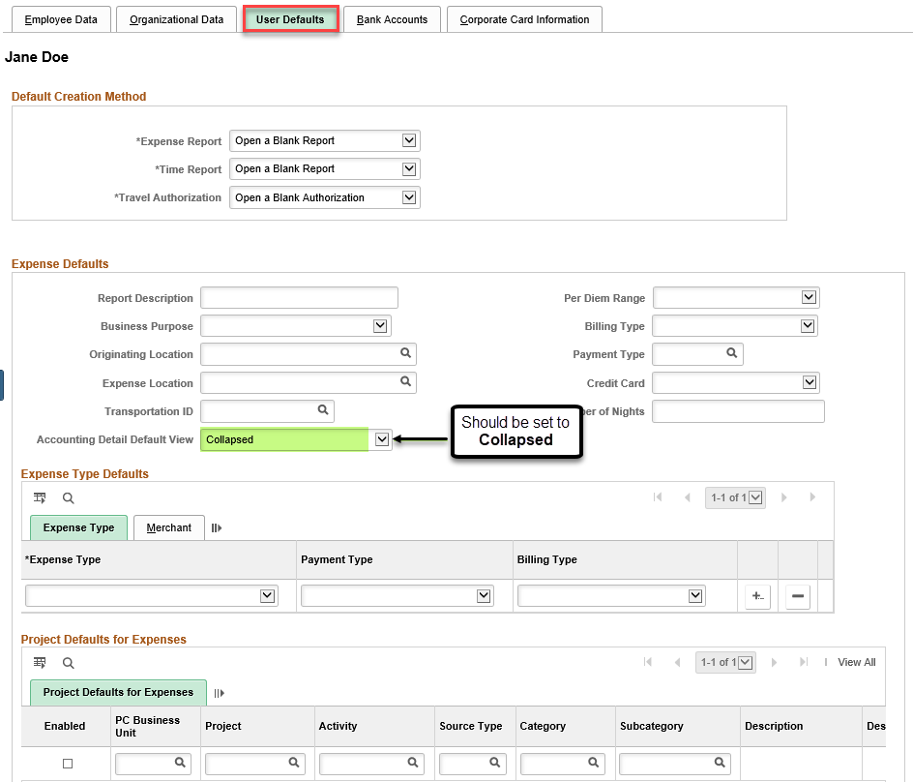  Default Creation Method values should not be changed.  Expense Defaults (other than Accounting Detail Default View), Expense Type Defaults, and Project Defaults for Expenses values are optional. Values entered will default into expense documents but can be edited as needed.

6a | On the Bank Accounts tab:  To add or update a profile, enter or edit the highlighted fields.  Note: You should also enter or edit the Bank Account Detail, see step 6b. | 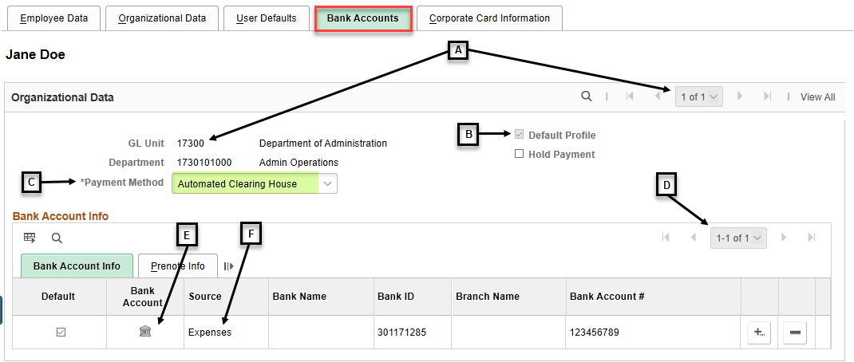  A – If there are multiple rows, navigate to the row for your GL Unit.  B – The Default Profile checkbox auto-populates based on the row checked as the Default Profile on the Organizational Data tab.  C – The Payment Method must be Automated Clearing House. If another payment method is selected, the payment will not be picked up by paycycle and will not be paid.  D – If there are multiple rows, either edit the row with the Default checkbox checked or add a new row. Enter the correct bank account info. If adding a new row, be sure to check the Default checkbox on the new row.  E – For the row with the Default checkbox checked, click the bank account icon to navigate to the Bank Account detail.  F – Sharp bank account information does not flow to Smart. Any bank account information updates must be entered directly in Smart. The Source for bank account information entered directly in Smart shows as Expenses.  When Smart was implemented on 07/01/2010, Sharp bank account information was used to populate Smart. The Source for bank account information from Smart implementation shows as Payroll.
6b | On the Bank Accounts tab – Bank Account detail:  To add or update a profile, enter or edit the highlighted fields, click OK.  Click Save. | EX payments can be direct-deposited only and to one account only. Information from the employee’s Form DA-184, “Authorization for Direct Deposit of Employee Pay and/or Employee Travel and Expense” should be used as needed to enter or edit fields.  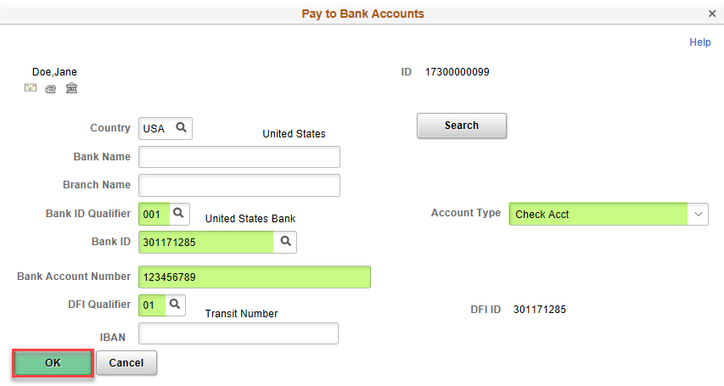  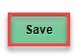  Required values, other fields are optional:  - Bank ID Qualifier – should be 001, no other value is acceptable.  - Bank ID – should be the routing number for the employee’s bank.  - Bank Account Number – should be the employee’s bank account number, only one bank account can be entered, payments cannot be paid to more than one account.  - DFI Qualifier – should be 01, no other value is acceptable.  - Account Type – should be Check Acct for checking or Time Dep for savings.
7 | The Corporate Card Information tab:  This tab is not used by the State of Kansas. | 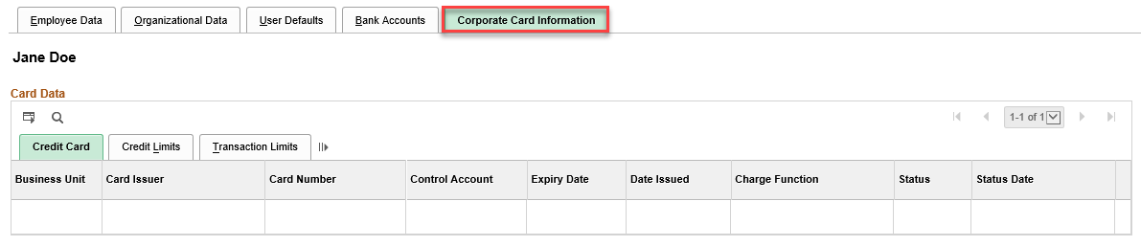

Authorize Expense Users

To quickly establish authority for one user ID to create/modify and view expense documents for multiple employees, choose to authorize multiple employee IDs for one User ID.

1 | To authorize multiple user IDs for one employee ID, click Employee ID.  To authorize multiple employee IDs for one user ID, click User ID. | Navigation: Expenses > Employee Info & Security > Authorize Expense Users  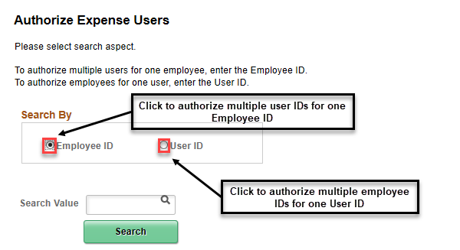
2 | To authorize multiple user IDs for one employee ID, enter the Empl ID, click Search.  To authorize multiple employee IDs for one user ID, enter the User ID, click Search. | 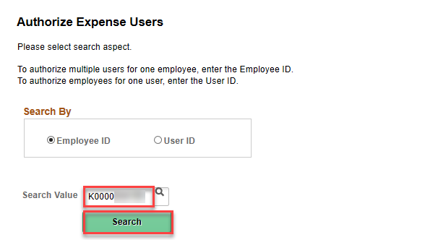  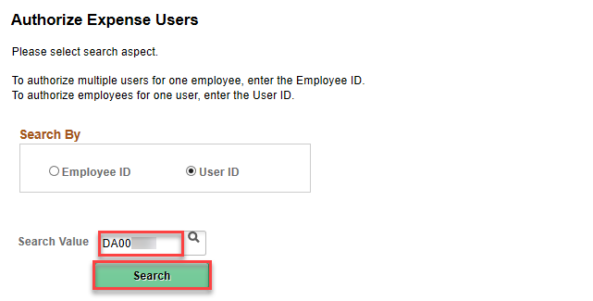
3 | If search was by Employee ID, this screen appears:  If search was by User ID, this screen appears: | 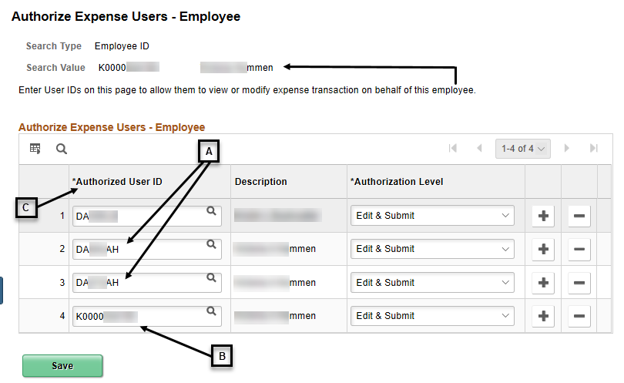  The existing Authorized Expense Users show. A listed User ID can create/modify and view expense documents on behalf of the employee used for the Search Value.  A – Mutiple user IDs for one employee may show.  B – The Employee ID used for the Search Value shows.  C – Authorized user rows are sorted in Authorized User ID ascending order.  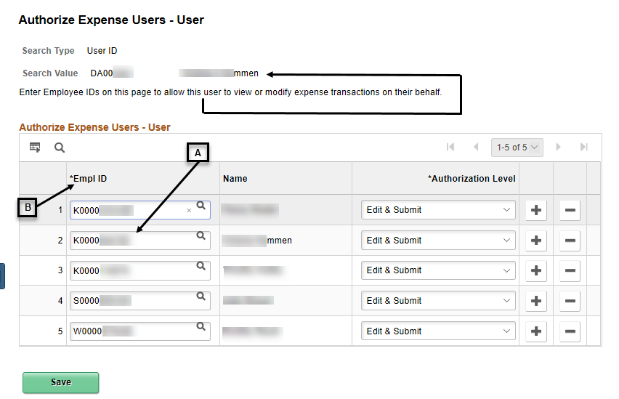  The existing Authorized Expense Users show. A listed Empl ID’s expense documents can be created/modified and viewed by the user ID used for the Search Value.  A – The Employee ID for the User ID used for the Search Value shows.  B – Authorized user rows are sorted in Empl ID ascending order.
4 | Note: The remaining steps are the same whether the search was by employee ID or User ID.  To add an Authorized Expense User, click any + to add a new row. | 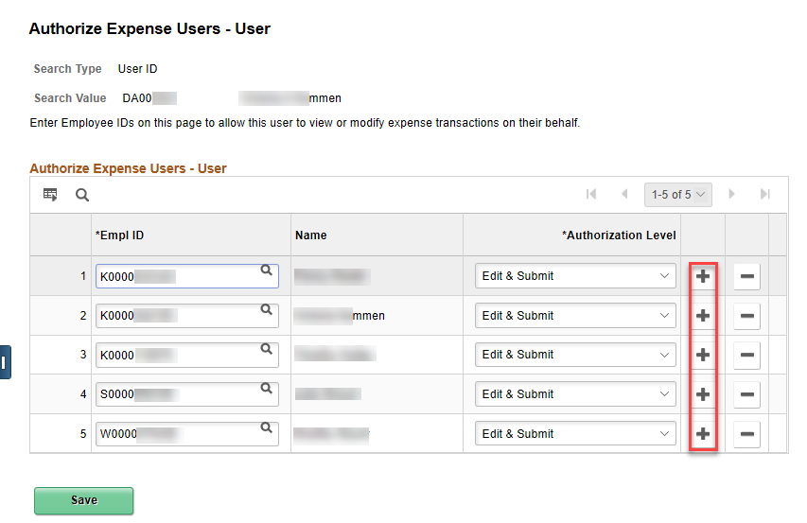  The added row will appear below the row from where the + was clicked.  Note: The screenshot above shows a search by user ID screen.
5 | On the added row, enter the Empl ID or User Id for the new Authorized Expense user, click Save. | 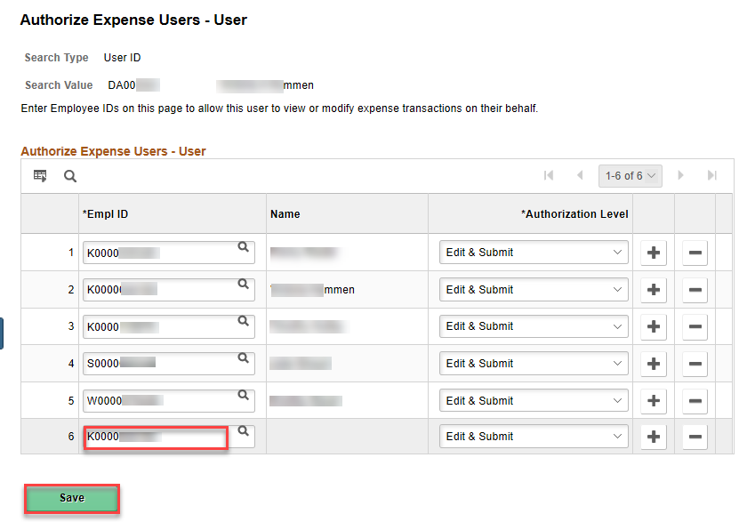  The new authorized user’s Description or Name auto-populates after Save is clicked.  The new row will be sorted in Authorized User ID or Empl ID ascending order when the Authorized Expense Users page is opened thereafter.  Note: The screenshot above shows a search by user ID screen.
6 | To delete an Authorized Expense User, click – on the row with the user to be deleted.  Click OK.  Click Save. | 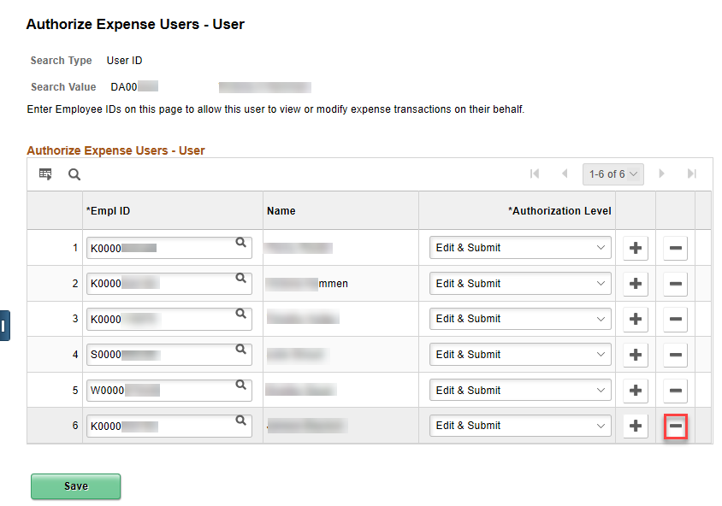  Note: The screenshot above shows a search by user ID screen.  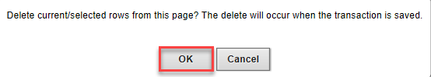  The row with the user to be deleted no longer shows.

