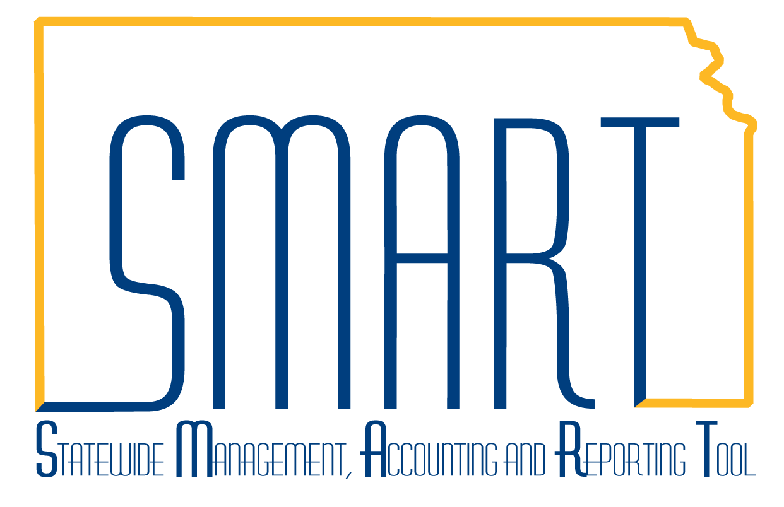
State of Kansas

Approvals – Approve Transactions, Modify Approved Transactions, Reassign Approval Work, Approver Assignment

Statewide Management, Accounting and Reporting Tool

Date Created: | 01/18/2013
Last Updated Date: | 02/10/2021
Version: | 2.0
Overview: | Approvals are required for expense document processing. An expense document is an expense report/ER, travel authorization/TA, or a cash advance/CA and is comprised of transactions.  Table of Contents  Approve Transactions………………………….…………………….….…….…… Page 5  Modify Approved Transactions......…………………………………….……….… Page 7  Reassign Approval Work.……………………………………………….….……… Page 8  Approver Assignment…….……………………………………….……...………… Page 9  Approval workflow is the process that automatically routes expense documents for approval in the Expenses module/EX. Approval workflow is maintained by each agency. An expense document is routed for approval based on the workflow in place at the time it is submitted for approval.  The approval workflow for an expense document is reflected on the expense document in the Approval History section. The Approval History shows only after an expense document has been submitted for approval. For an expense report/ER or a travel authorization/TA, it is located at the bottom of the Summary page. For a cash advance/CA, it is located at the bottom of the only page that shows for a CA.
Overview:  (cont’d) | Following is an example of the Approval History for an ER in Paid status:  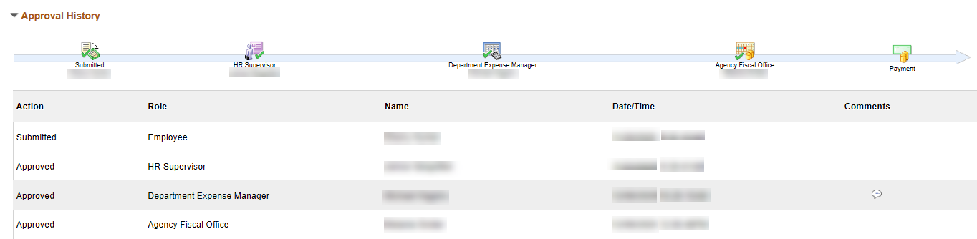  Note: The Approval History for TAs and CAs is similar.  Approval History Icons  The Approval History icons are shown on one horizontal line and are sometimes referred to as train stops. The icons graphically represent each step of the expense document approval workflow.  - For all expense documents, there is an icon for when the expense document is submitted. The Submitted icon reflects the name of the employee/traveler.  - For all expense documents, there are icons for each approval level:  Note: CAs show only the Submitted icon when the CA is in Paid status.  - The icons for the approval levels reflect an individual’s name if the approver is not in a pool of approvers. Otherwise, the icons reflect (Pooled) until an approver in the pool approves, then (Pooled) is replaced with that individual’s name.  - The HR Supervisor icon changes from monochrome to color when the document is submitted for approval.  - The Department Expense Manager icon changes from monochrome to color when the document has been approved by the Department Expense Manager.  - The Agency Fiscal Office icon changes from monochrome to color when the document is awaiting Agency Fiscal Office approval whether the Agency Fiscal Office approver is (Pooled) or not.  - For ERs and CAs, there is an icon for when the expense document has progressed to payment. The Payment icon changes from monochrome to color when the document is in Approved for Payment status.  Approval History Text Lines  The Approval History text lines are shown vertically and textually represent each step of the expense document approval workflow.  - For all expense documents, the Submitted text line reflects the name of the employee who submitted the expense document. The name will differ from the employee/traveler name reflected on the Submitted icon if the expense document was submitted by an authorized user/proxy.  - The text lines for the approval levels reflect the action completed, the approval level/role and name of the approver, and the date and time of approval.  - A Comments column shows with a call-out icon only if comments have been added by an approver. Click the call-out icon to see the Comments.  - A text line for an approval level does not show until the approval is completed.
Overview:  (cont’d) |  | This job aid replaces the following job aids which have been removed from SMART Web:  - Reassigning Approvals  - Updating Department Approvers  - Updating Employee Supervisor in T&E  - Updating Fiscal Approvers  - Workflow Maintenance Supervisor Setup  Levels of Approval and Approvers  For ERs and TAs, there are three levels of approval. For CAs, there are only two levels of approval—there is no second-level approval for CAs.  - First-level approval – approval by the HR Supervisor role:  - Is updated by the agency in the employee/traveler’s EX Employee Profile-Organizational Data tab.  - Can only be an individual.  - Is for all departments for the employee, approval cannot be limited to a range of departments.  - Is for EX approval workflow only and may differ from the supervisor the employee actually reports to for timekeeping, assignments, etc.  - The employee submitting an expense document cannot also be the first-level approver.  - Second-level approval – approval by the Department Expense Manager role:  - Is updated by the agency in Approver Assignment.  - Can be an individual or a group/pool of individuals.  - For each approver, approvals can be limited to a range or ranges of departments. The department is listed on the employee’s EX Employee Profile-Organizational Data tab.  - Third-level approval – approval by the Agency Fiscal Office role:  - Is updated by the agency in Approver Assignment.  - Can be an individual or a group/pool of individuals.  - For each approver, approvals can be limited to a range or ranges of departments. The department is listed on the employee’s EX Employee Profile-Organizational Data tab.  Note: An approver can be an approver for multiple levels, their initial approval will auto approve all remaining approval levels.  The person who submits an expense document cannot also be the first-level/HR Supervisor approver but can be the second- or third-level approver.  ERs and CAs (but not TAs) for more than $5,000, are routed for A&R approval after the ER is approved by the Agency Fiscal Office approver.

Security: | Note: An expense document ( an ER, TA, or CA) is comprised of transactions.  Role: Only individuals with the following role can approve transactions:  - Agency T&E Approver (KAP_Agy_T_E_Approver)  Role: Only individuals with the following role can modify approved transactions:  - Agency T&E Approver (KAP_Agy_T_E_Approver)  Roles: Only individuals with the following role can reassign approval work:  - Agency T&E Maintainer (KAP_Agy_T_E_Maintainer)  Roles: Only individuals with the following roles can assign approvers:  - For first-level approvers - Agency T&E Maintainer (KAP_Agy_T_E_Maintainer)  - For second-level and third-level approvers – Agency T&E Workflow Maintainer (KAP_Agy_T_E_WF_Maintainer)  BU: Agencies can only approve transactions, modify approved transactions, reassign approval work, and assign approvers for employees of their agency business unit.

Approve Transactions

Only expense documents/transactions in your approval queue show for your approval.

Expense documents can be accessed via Worklist or Approve Transactions:

Steps to approve an expense document via Worklist are preceded with an A.

Steps to approve an expense document via Approve Transactions are preceded with an B.

A – Approve an expense document via Worklist

A1 | To approve an expense document via Worklist, click the Actions List icon in the upper right-hand corner of any EX page, then click Worklist. | 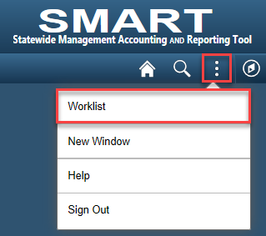
A2 | Click the Link to open the expense document requiring approval. | 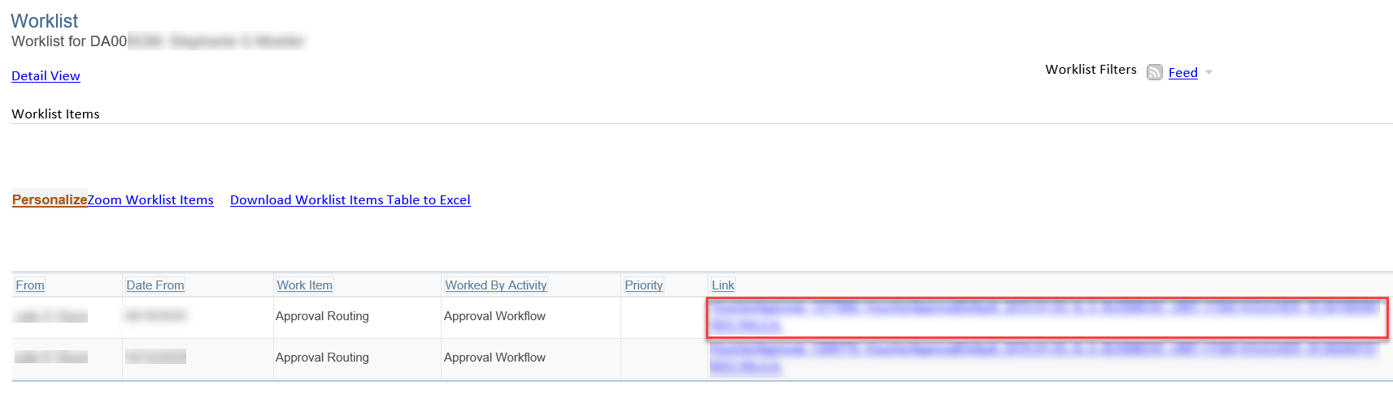  From the opened expense document:  - To approve the document, click Approve, then click OK on the Submit Confirmation screen. The document is routed for any additional approvals and the document no longer shows on your Worklist.  - To send the document back for revision, enter Comments, then click Send Back. The document is routed/returned to the submitter. The document status changes to Pending which allows the submitter to revise the document or delete it. The document no longer shows on your Worklist.  - To deny the document, enter Comments, then click Deny. The document is routed/returned to the submitter. The document status changes to Denied. The document no longer shows on your Worklist.  In December 2018, the ability to delete denied ERs and TAs was removed as it was causing issues in SMART. Denied ERs and TAs will not show in the search results. Approvers should utilize Send Back for any expense document to be deleted.
B – Approve an expense document via Approve Transactions

B1  B1 | To approve (only) an expense document, select the checkbox for the expense document to be approved, click Approve.  For multiple expense documents to approve, multiple checkboxes can be selected.  Click OK.  Note: This is another way to approve but can also be used to send back or deny.  To approve, send back, or deny an expense document, click the link to open the expense document requiring approval. | Navigation: Expenses > EX Approvals > Approve Transactions  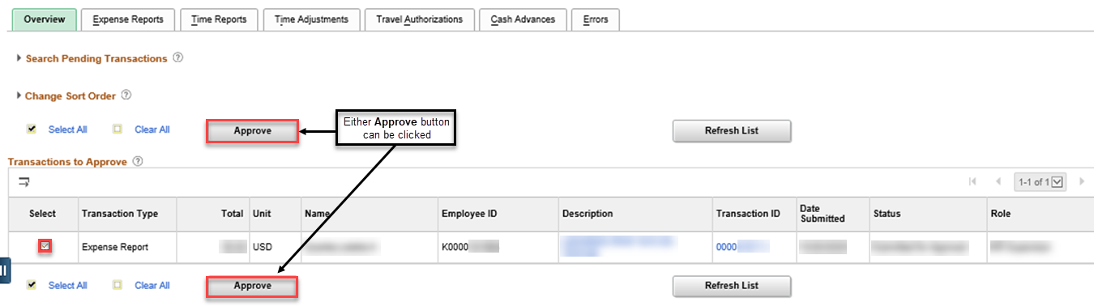  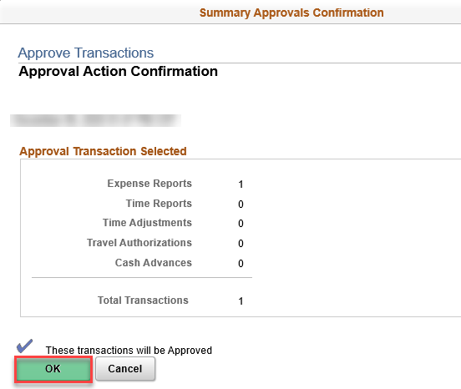  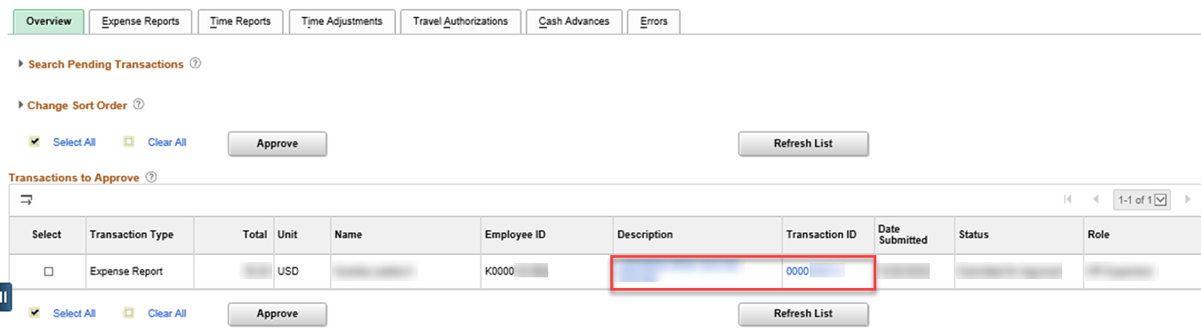  From the opened expense document:  - To approve the document, click Approve, then click OK on the Submit Confirmation screen. The document is routed for any additional approvals and the document no longer shows on your Worklist.  - To send the document back for revision, enter Comments, then click Send Back. The document is routed/returned to the submitter. The document status changes to Pending which allows the submitter to revise the document or delete it. The document no longer shows on your Worklist.  - To deny the document, enter Comments, then click Deny. The document is routed/returned to the submitter. The document status changes to Denied. The document no longer shows on your Worklist.  - In December 2018, the ability to delete denied ERs and TAs was removed as it was causing issues in SMART. Denied ERs and TAs will not show in the search results. Approvers should utilize Send Back for any expense document to be deleted.
Modify Approved Transactions

Expense documents can be modified via Modify Approved Transactions only when the document:

- Is in Approved for Payment (for ERs and CAs) or Approved (for TAs) status and

- The document Post State is Not Applied (for ERs and CAs only)

Modify approved expense documents to correct the chartfield values.

You cannot modify an approved expense document that you submitted.

1 | To modify an approved expense document, click the related link to open the expense document requiring correction.  Make the necessary corrections, click Save. | Navigation: Expenses > EX Approvals > Modify Approved Transactions  Alternate Navigation:  For ERs: Expenses > Expense Reports > Modify Approved Transactions  For TAs: Expenses > Travel Authorizations > Modify Approved Travel Auth  For CAs: Expenses > Cash Advances > Modify Approved Cash Advances  Note: It may take several seconds for the following screenshot to appear.  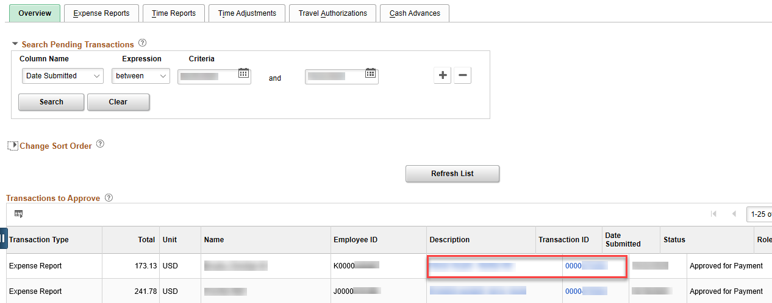  The Overview tab includes all expense documents. Click the Expense Reports, Travel Authorizations, or Cash Advances tab to search for a specific document type.

Reassign Approval Work

1 | To reassign an expense document, search by any of the listed options, enter the criteria for the approver you are reassigning the expense document from, click Search. | Navigation: Expenses > EX Approvals > Reassign Approval Work  Alternate Navigation: Expenses > Employee Info & Security > Reassign Approval Work  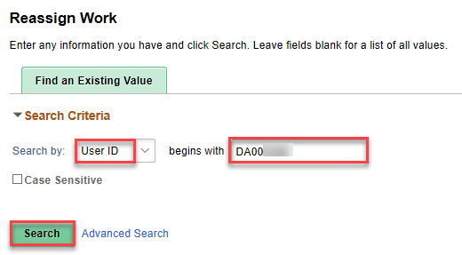  Note: The screenshot above shows a search by User ID.
2 | Enter the User ID for the approver you are reassigning the expense document to.  Select the checkbox for the document to reassign, click Reassign.  For multiple documents to reassign, multiple checkboxes can be selected. | 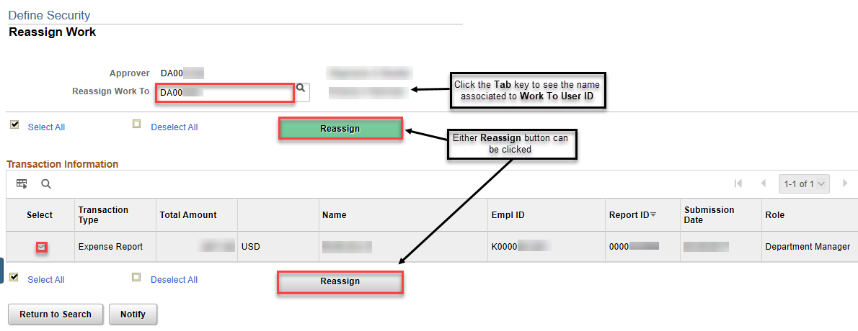  Note: The approver the expense document is reassigned to must have Agency T&E Approver (KAP_Agy_T_E_Approver) role to approve it.  Once the expense document is reassigned:  - The document no longer shows on the Worklist or Approve Transactions for the approver the document was reassigned from. The document shows on the Worklist and Approve Transactions for the approver the work was assigned to.  - A line is added to the reassigned document Approval History for the reassignment and includes the approval level/role and name of the approver the document was reassigned to. The line includes a link to comments which include the user ID for the approver the document was reassigned from and the user ID for the approver the document was assigned to.  - The reassigned document can be approved as usual.

Approver Assignment

The first-level/HR Supervisor approver is assigned in the employee’s EX Employee Profile on the Organizational Data tab. See job aid titled Update Profile, Authorize Expense Users for additional detail.

Note: Steps to assign a second-level/Department Expense Manager/Expense Manager are preceded with A.

Steps to assign a third-level/Agency Fiscal Office/Prepay Auditor are preceded with B.

A – Assign a second-level/Department Expense Manager/Expense Manager

A1 | To assign a second-level approver, click Find an Existing Value. | Navigation: Expenses > EX Approvals > Approver Assignment  Alternate Navigation: Expenses > Employee Info & Security > Approver Assignment  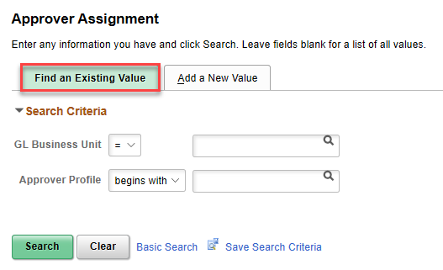
A2 | Enter your business unit, click Search. | 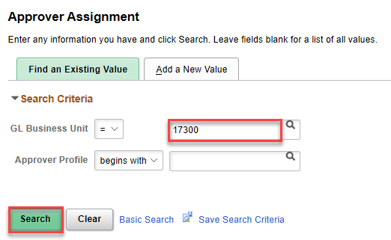
A3 | Click EXPENSE MANAGER. | 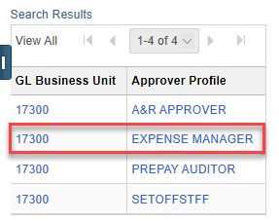  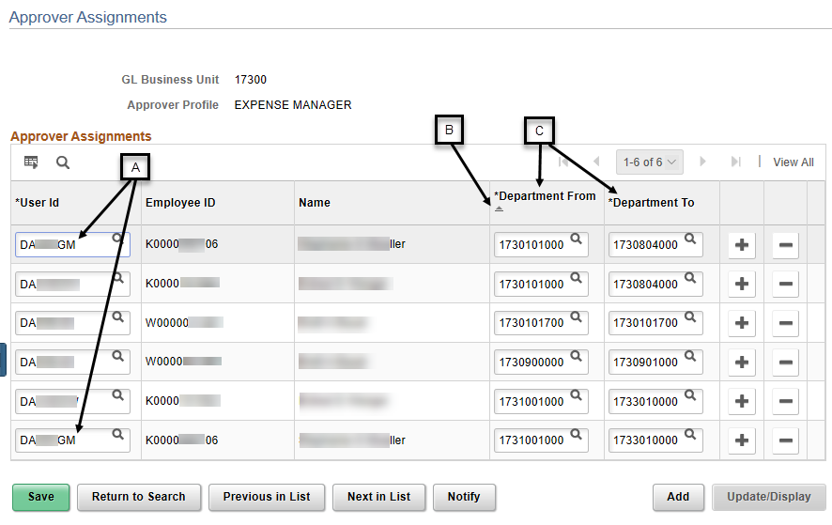  The existing Expense Manager approvers show.  A – An approver can be an approver for multiple ranges.  B – Approver rows are sorted in Department From ascending order.  C – For each approver row, approvals are limited to the department range shown.
A4 | To add an Expense Manager, click any + to add a new row. | 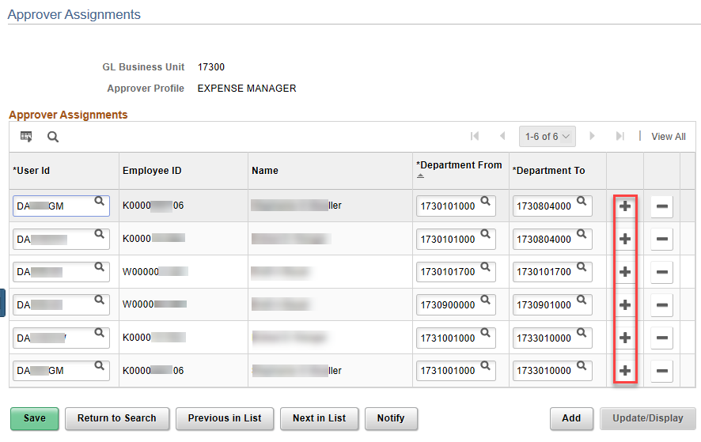  The added row will appear below the row from where the + was clicked.
A5 | On the added row, enter the new approver’s User ID, then enter the range of departments for which the new approver should approve, click Save. | 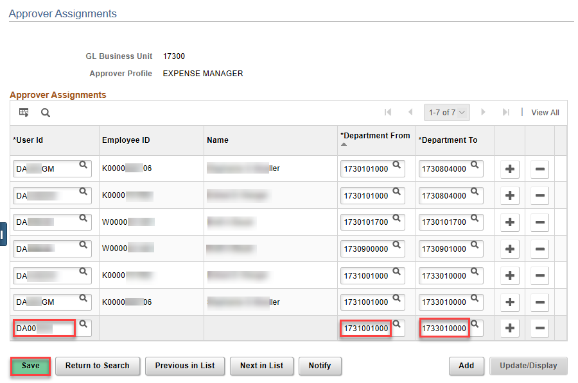  The new approver’s Employee ID and Name auto-populate after Save is clicked.  The new row will be sorted in Department From ascending order when the Approver Assignments page is opened thereafter.
A6 | To delete an Expense Manager, click – on the row with the approver to be deleted.  Click OK.  Click Save. | 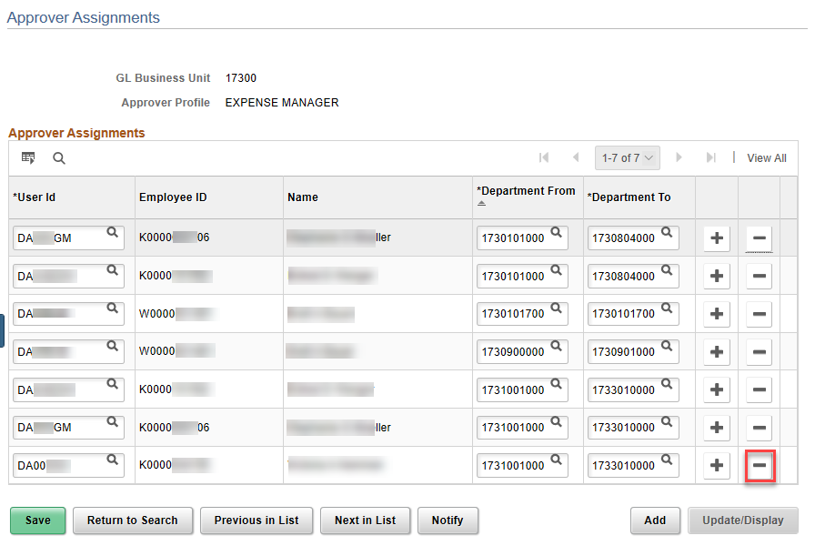  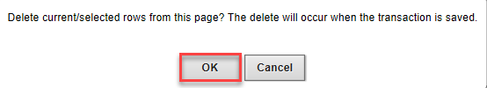  The row with the approver to be deleted no longer shows.

B – Assign a third-level/Agency Fiscal Office/Prepay Auditor

B1 | To assign a third-level approver, click Find an Existing Value. | Navigation: Expenses > EX Approvals > Approver Assignment  Alternate Navigation: Expenses > Employee Info & Security > Approver Assignment
B2 | Enter your business unit, click Search.
B3 | Click PREPAY AUDITOR. | 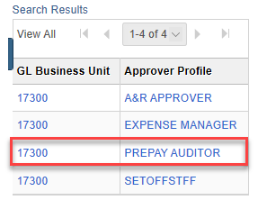  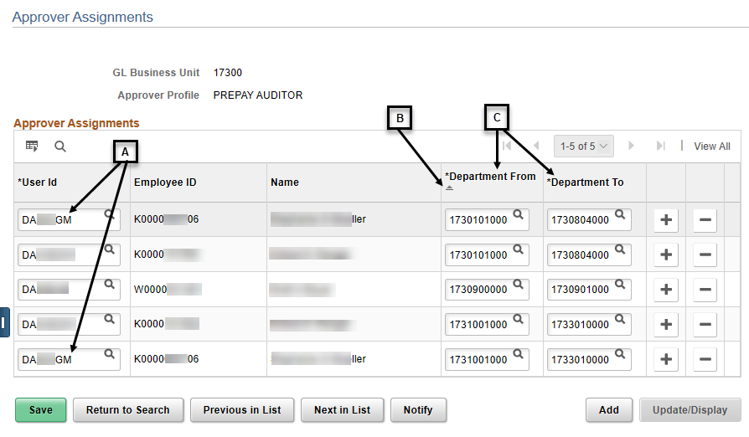  The existing Prepay Auditor approvers show.  A – An approver can be an approver for multiple ranges.  B – Approver rows are sorted in Department From ascending order.  C – For each approver row, approvals are limited to the department range shown.
B4 | To add a Prepay Auditor, click any + to add a new row. | 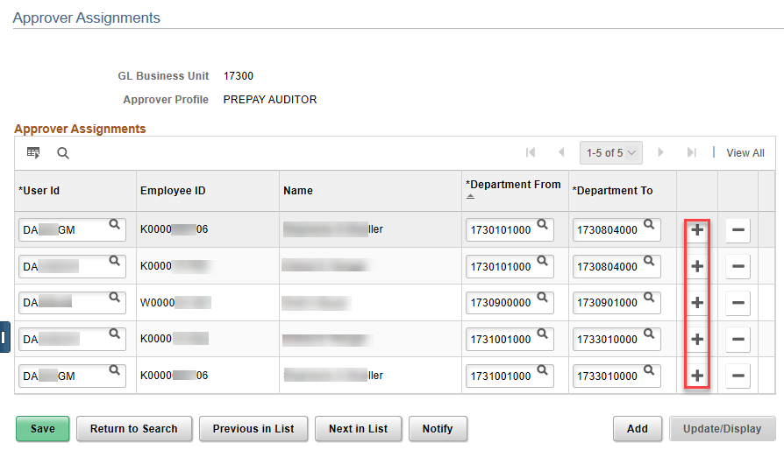  The added row will appear below the row from where the + was clicked.
B5 | On the added row, enter the new approver’s User ID, then enter the range of departments for which the new approver should approve, click Save. | 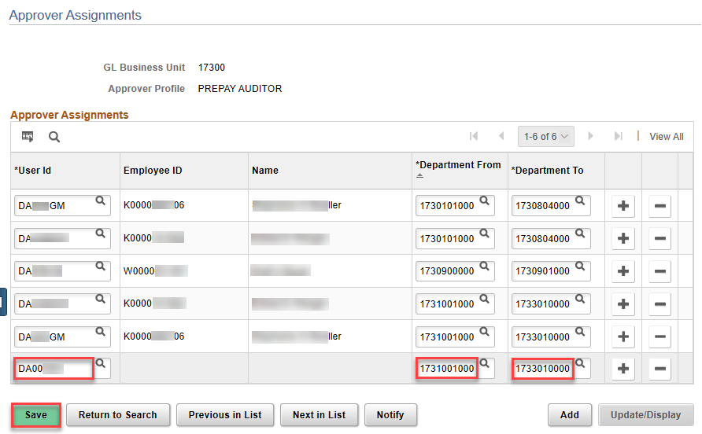  The new approver’s Employee ID and Name auto-populate after Save is clicked.  The new row will be sorted in Department From ascending order when the Approver Assignments page is opened thereafter.
B6 | To delete a Expense Manager, click – on the row with the approver to be deleted.  Click OK.  Click Save. | 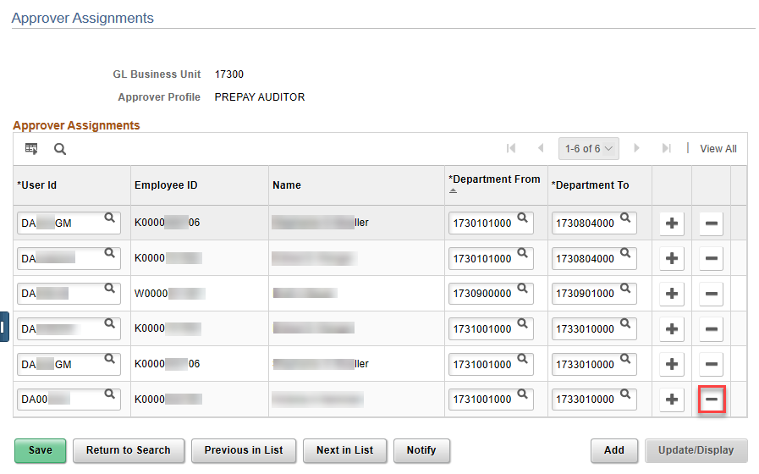  The row with the approver to be deleted no longer shows.

