SMART 9.2 Training

Travel and Expenses

Creating Expense Reports - January 1, 2016 or later
This example will assist you when entering expense reports with expense dates of January 1, 2016 or later.

Things to consider:
- This job aid is to be used as a functional example only.
- This job aid is not intended to represent actual rates, locations or travel policies.
- Please refer to Informational Circulars, the State of Kansas Employee Travel Expense Reimbursement Handbook, and the CONUS query in SMART for rates, locations or travel policies.
- The CONUS query in SMART contains all CONUS locations along with meals and incidental expenses daily amounts, per diem deductions and lodging rates. The query can be found at Main Menu>Reporting Tools>Query>Query Viewer. Query name: KS_EX_CONUS_RATES
- You should only use the location value KS, STANDARD CONUS RATE in the Location field if your city or county are not listed.
- For travel related expenses, the Location field is the place where the official business occurred.
- For expenses unrelated to travel, the Location field is the place where the expense occurred.
- All fields marked with an asterisk (*) are required fields.

Procedure
In this scenario, you are an Agency Expense Processor and you are authorized to enter your own transactions. You will create an expense report for expenses related to a two-day meeting in Wichita, KS.

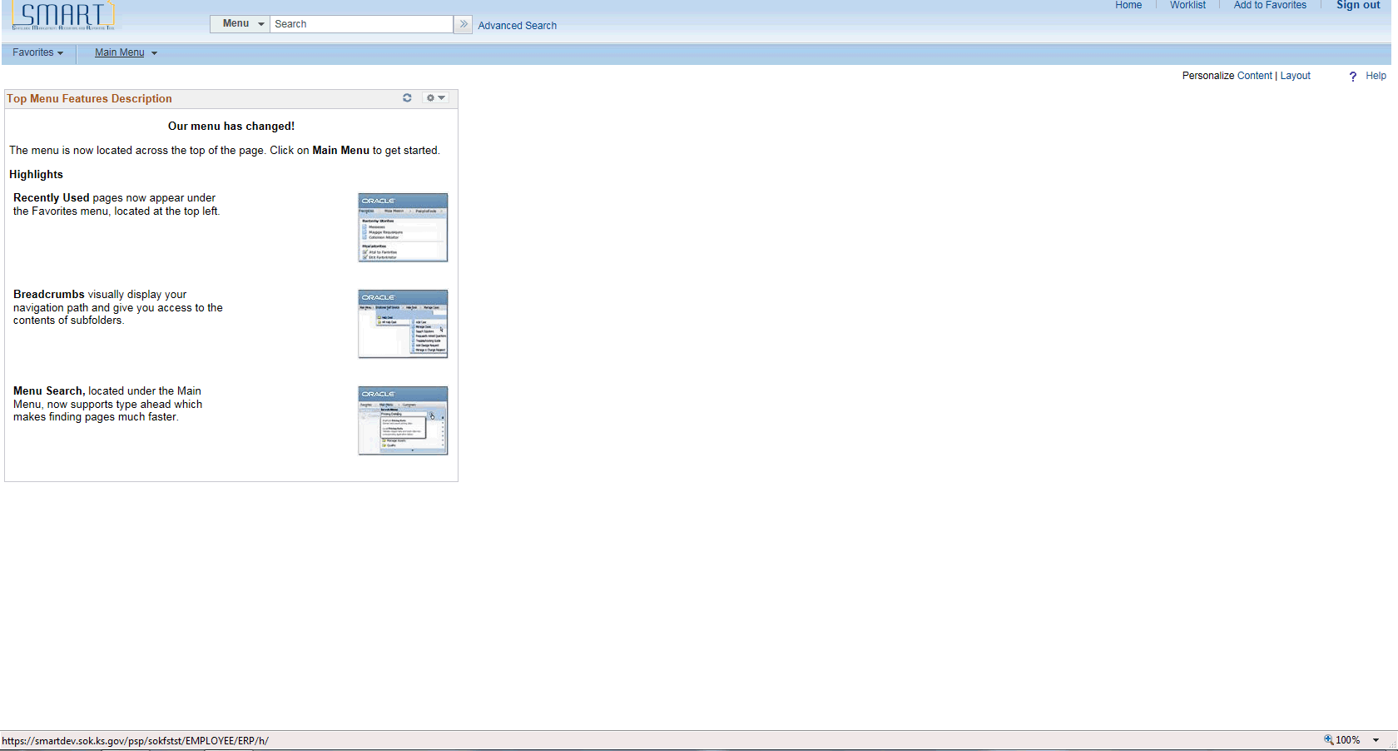

Step | Action
Begin by navigating to the Create Expense Report page.

Click the Main Menu button.
 | Click the Travel and Expenses menu.
 | Click the Travel and Expense Center menu.

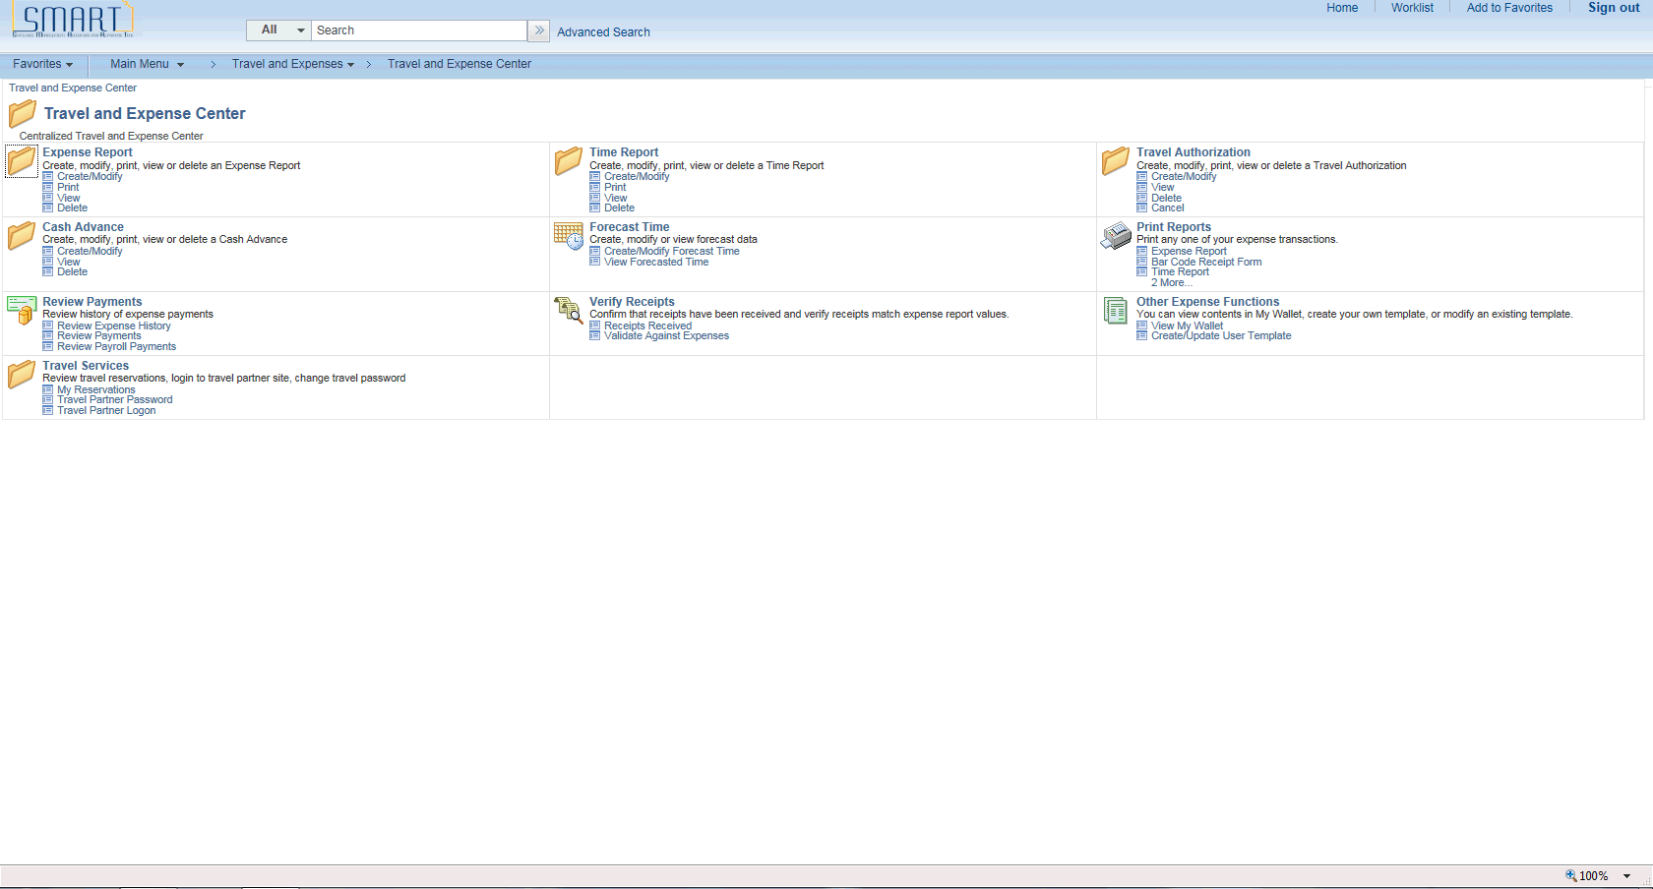

Step | Action
Click the Create/Modify link.
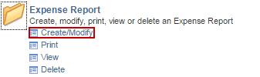

Step | Action
Enter your Empl ID.

Enter the desired information into the Empl ID field.
 | Click the Add button.
The Create Expense Report page enables you to easily add expense lines and provide general information as well as other details that are specific for expense types.

You may use the Employee Profile - User Defaults page to set up default values for report description, business purpose, originating location, expense location, payment method, and distributions. These defaults populate the expense report automatically when you create expense reports, but you may override these defaults during entry depending on your security level.

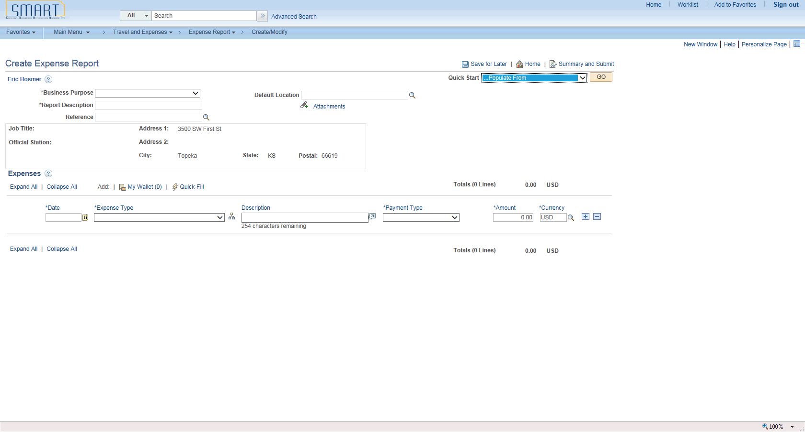

Step | Action
Select a business purpose from the predefined list.

Click the Business Purpose list.

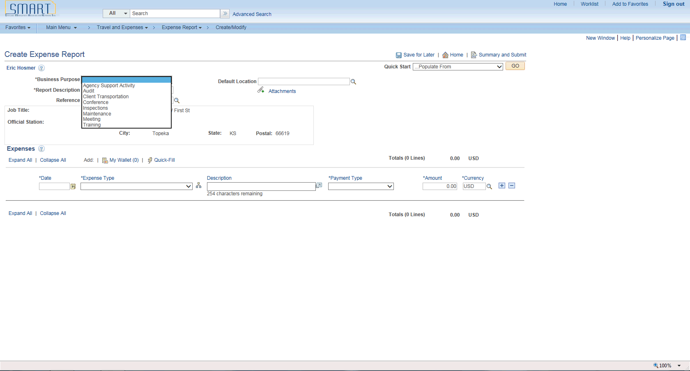

Step | Action
 | Click the Meeting list item.

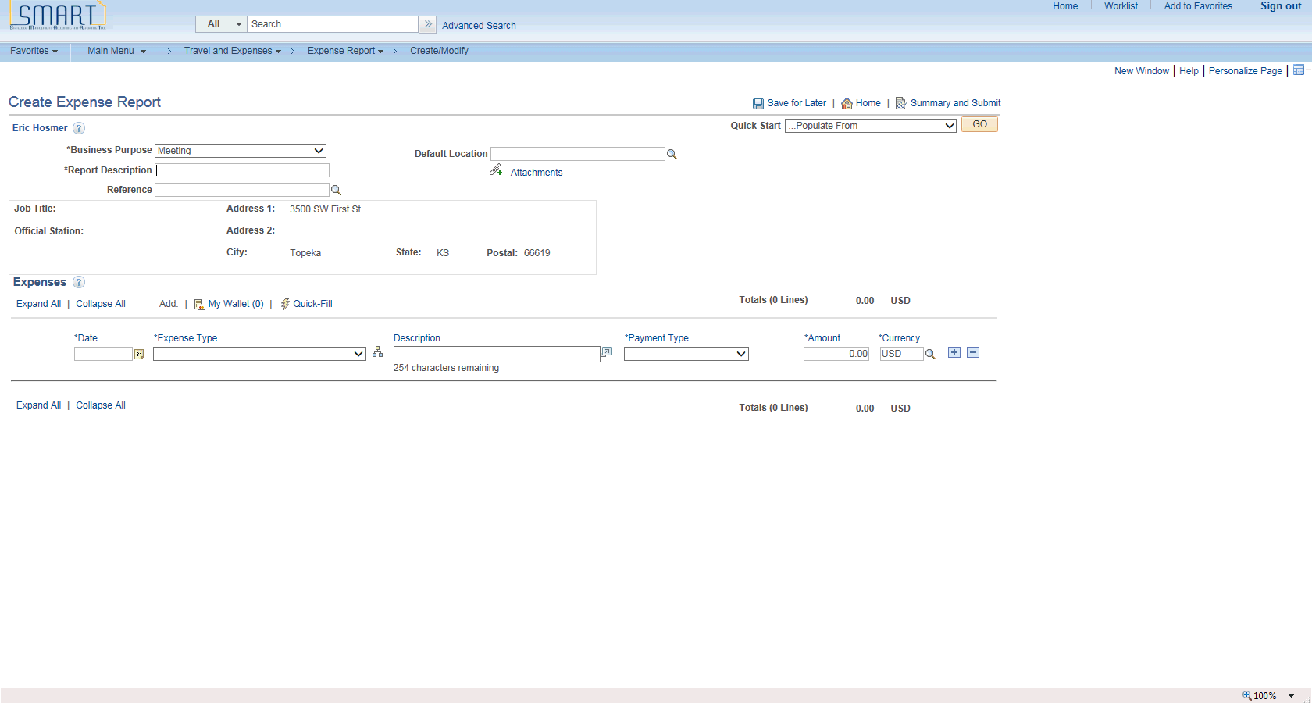

Step | Action
Enter a description to identify the expense report.

Enter the desired information into the Report Description field.
Enter the date when the expense began or occurred.

Enter the desired information into the Date field.
Select an expense type.

Click the Expense Type list.

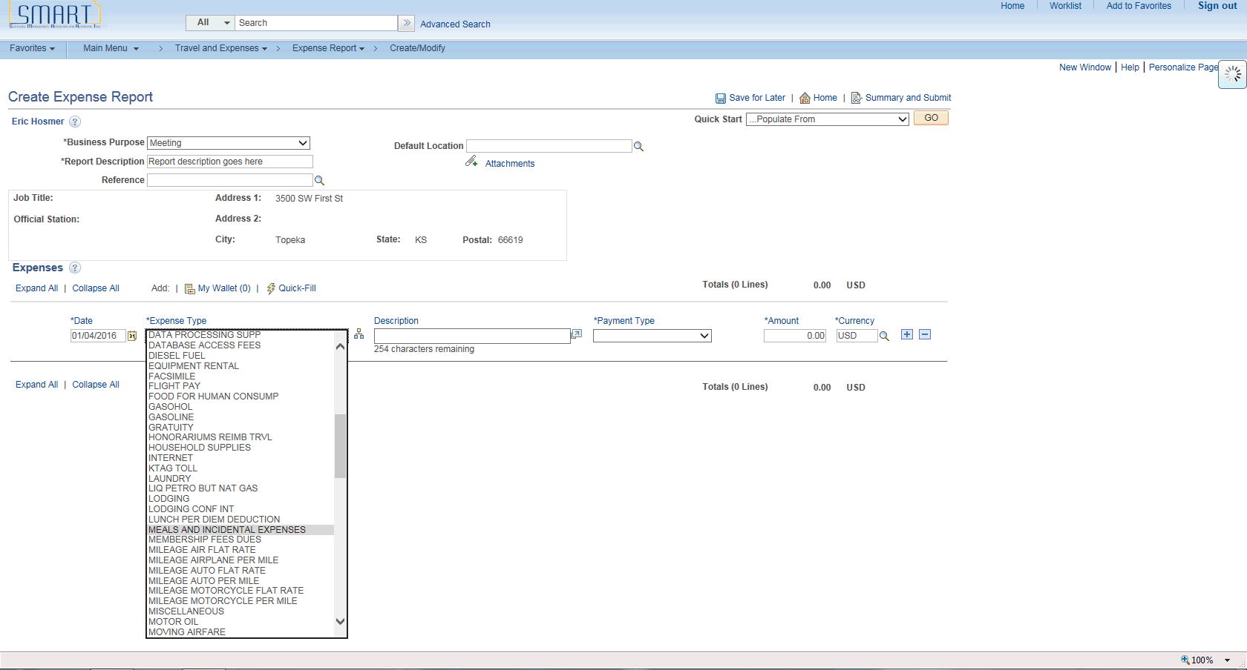

Step | Action
 | Click the MEALS AND INCIDENTAL EXPENSES list item.

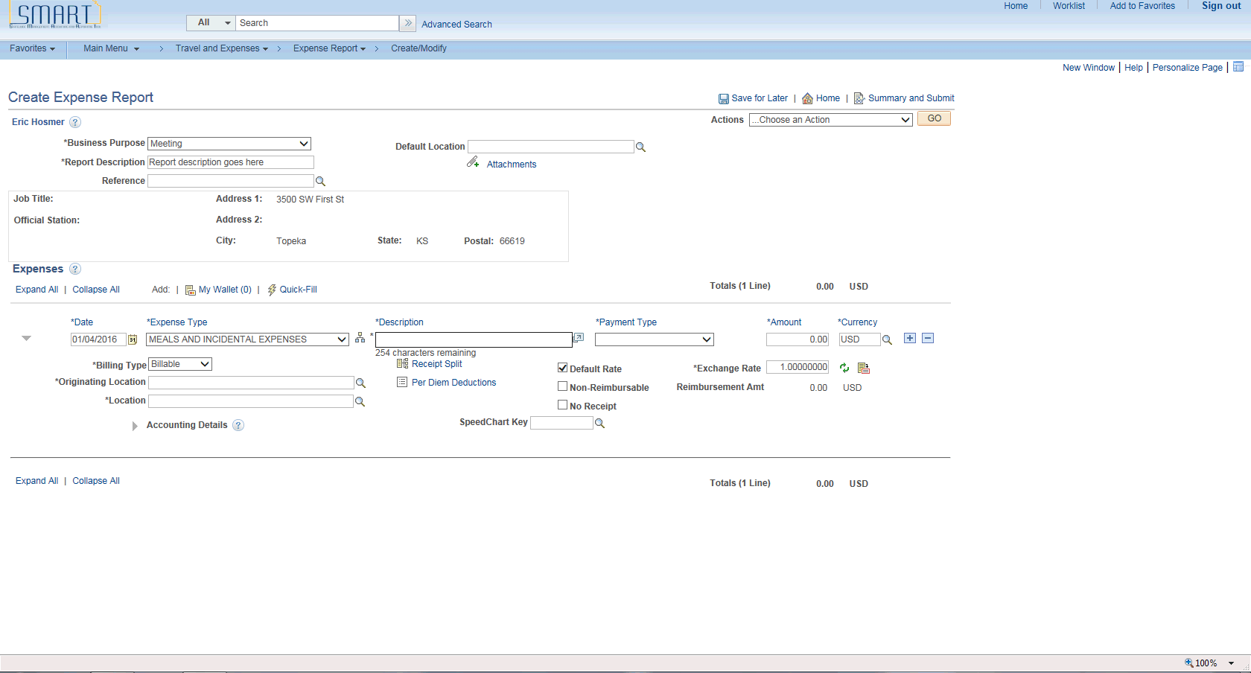

Step | Action
Enter a description about the expense transaction.

Enter the desired information into the Description field.
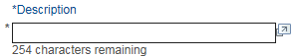
Enter how you paid for the expense. This value may appear by default if a payment type is entered in the Expense defaults group box on the Employee Profile - User Defaults page.

Click the Payment Type list.

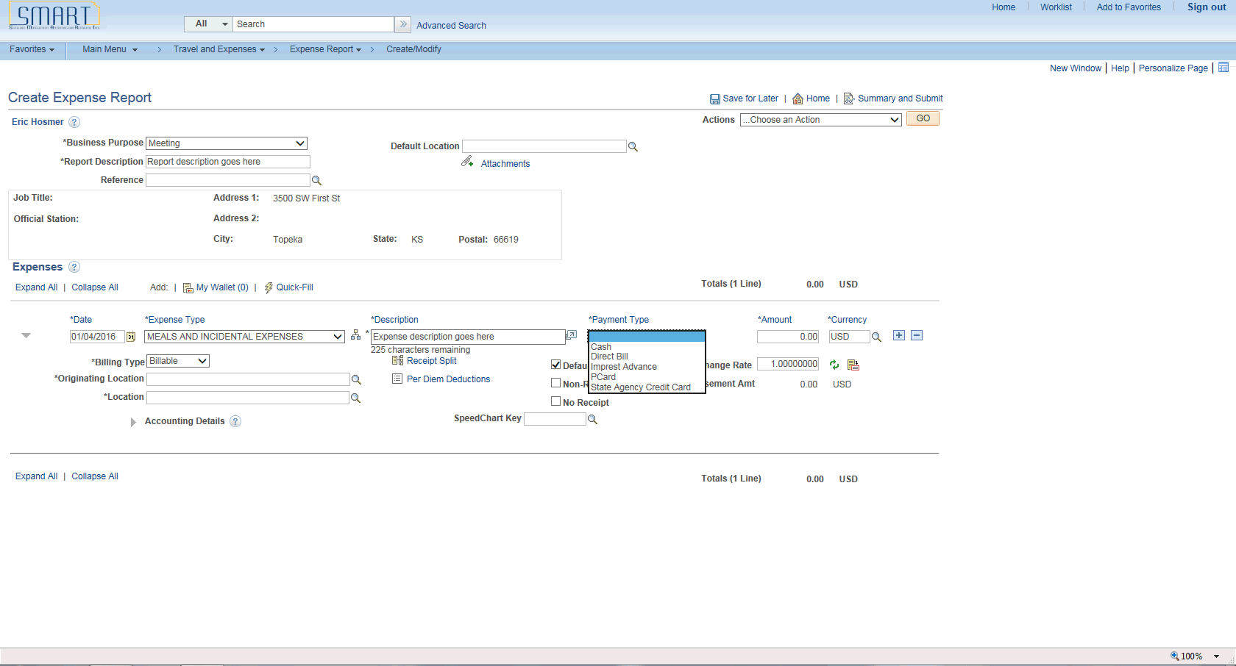

Step | Action
Note: The Expense Type and Payment Type should always match. This means that a regular Expense Type (not a prepaid expense type) should have a corresponding regular Payment Type (not a prepaid payment type). If a mismatch occurs, the resulting accounting entries generated by SMART will be incorrect.

Click the Cash list item.

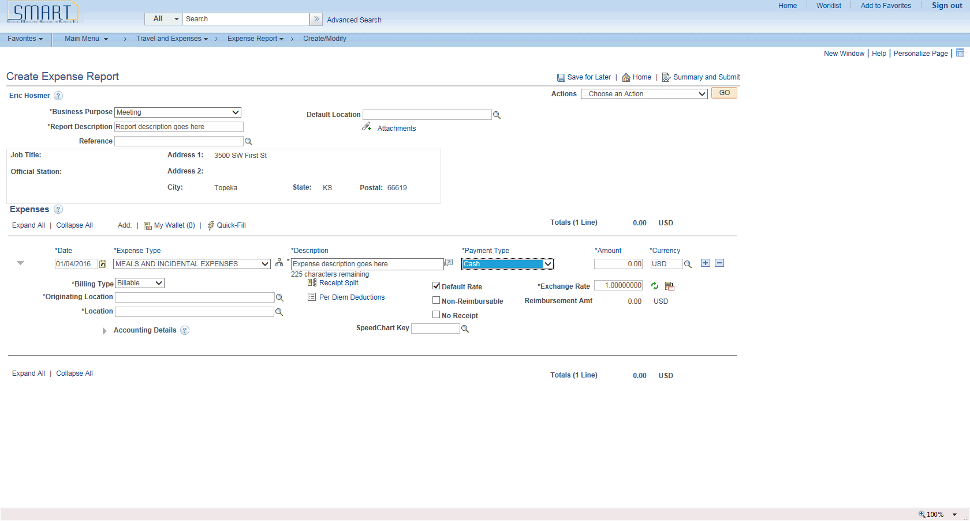

Step | Action
Enter the Originating Location. This location will typically be where your office or home is located.

Click the Look Up button to the right of the Originating Location field.
The locations in Look Up are listed alphabetically starting with the two-letter state abbreviation, followed by the city name.

Example: KS, TOPEKA
Note: The top search field "Originating Location" corresponds to the left column (numeric value) in the search results.

The bottom search field "Originating Location" corresponds to the right column (ST, CITY) in the search results. It is recommended that you search using the bottom search field and key the two-letter state followed by the city.

Enter the desired information into the bottom Originating Location search field.
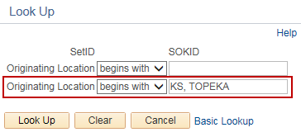
 | Click the Look Up button.
Click the KS, TOPEKA link.
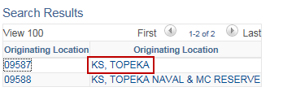
 | Click the Look Up button to the right of the Location field.
Enter the desired information into the Location field.

Note: For travel related expenses, the Location field is the place where the official business occurred.
 | Click the Look Up button.
 | Click the KS, WICHITA link.
Another option when entering a location is to key the value directly into the field. For example, Topeka, KS would be keyed as KS, TOPEKA into the Originating Location field and Wichita, KS would be keyed as KS, WICHITA into the Location field.

Please pay attention to capitalization, commas and spacing. It must be exact for SMART to take the value. If the value is entered incorrectly, you will receive an error that must be corrected before you can continue.
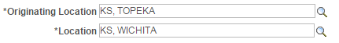
Beginning January 1, 2016, SMART uses the federal CONUS rates to populate the Amount field. The rate will automatically populate once you fill in the Location field.

Note: For travel related expenses, the Location field is the place where the official business occurred.

If a traveler is gone for a partial day, SMART will calculate the quarter(s) first, and then the meal per diem deduction(s) is applied.
The Start Time is typically when you left on your travel.

Enter the desired information into the Start Time field.
The End Time is typically when you returned from your travel.

Enter the desired information into the End Time field.
 | Click the Per Diem Deductions link located under the Description field.

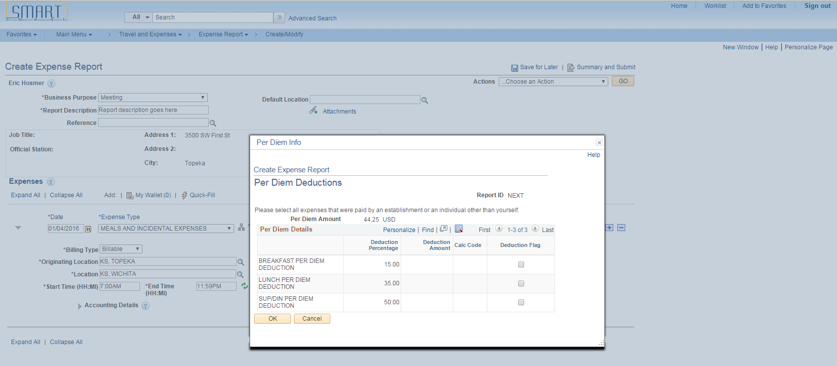

Step | Action
The Per Diem Deductions are a percentage and not a dollar amount.

Breakfast Per Diem Deduction - 15%
Lunch Per Diem Deduction - 35%
Sup/Din (Supper/Dinner) Per Diem Deduction - 50%

In this scenario, dinner was provided. The traveler will be paid for breakfast and lunch.

Click the Sup/Din Per Diem Deduction Flag option.
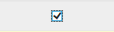
 | Multi-city travel example: A user traveled from Wichita to Garden City (different per diem rates) in the same day and breakfast was provided. Check the Breakfast Per Diem Deduction Flag on the MIE expense line for Wichita AND the MIE expense line for Garden City to ensure breakfast is deducted properly for that day.
 | Click the OK button.
In this example, SMART calculated the MIE Amount based on the following:

The traveler left at 7 a.m. and will be paid for 3 quarters. Dinner is provided so the traveler will only be reimbursed for breakfast and lunch.

Note: This is an example scenario only, used to show SMART functionality. Please refer to the State of Kansas Employee Travel Expense Reimbursement Handbook for specific policies and guidelines for meal reimbursement.

MIE amount for a full day in Wichita, KS = $59
Meal allowance for 3 quarters ($59 X .75) = $44.25
Less per diem deductions (see below) ($44.25 - $22.13) = $22.12
Amount for meals = $22.12

Per diem deductions:
Dinner = ($44.25 X 50%) = $22.13 will be deducted

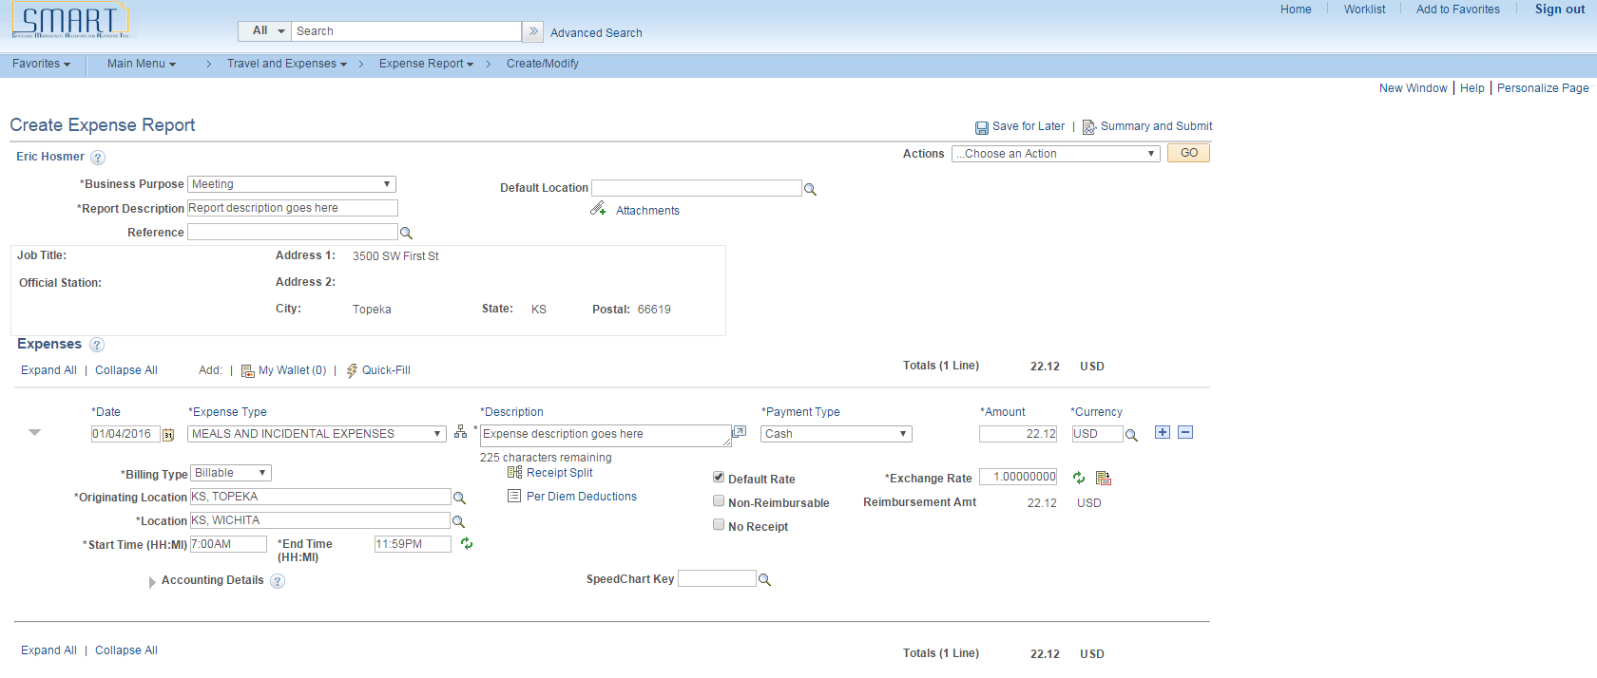

Step | Action
 | Click the Expand Accounting Lines button.
Use the Accounting Details section to view or modify the accounting ChartFields for the expense line.

The Accounting Detail Default View field on the Employee Profile - User Defaults page determines if this section is collapsed or expanded when a user enters the expense type.

Click the Collapse Accounting Lines button.
Click the Insert Line icon to add a new expense line. When you add a new line, SMART validates the data on the previous expense line. If an error is detected by SMART, a red flag will appear next to the previous line, which must be fixed prior to submitting the expense report.

Click the Insert Expense Line button.
Select an expense type.

Click the Expense Type list.

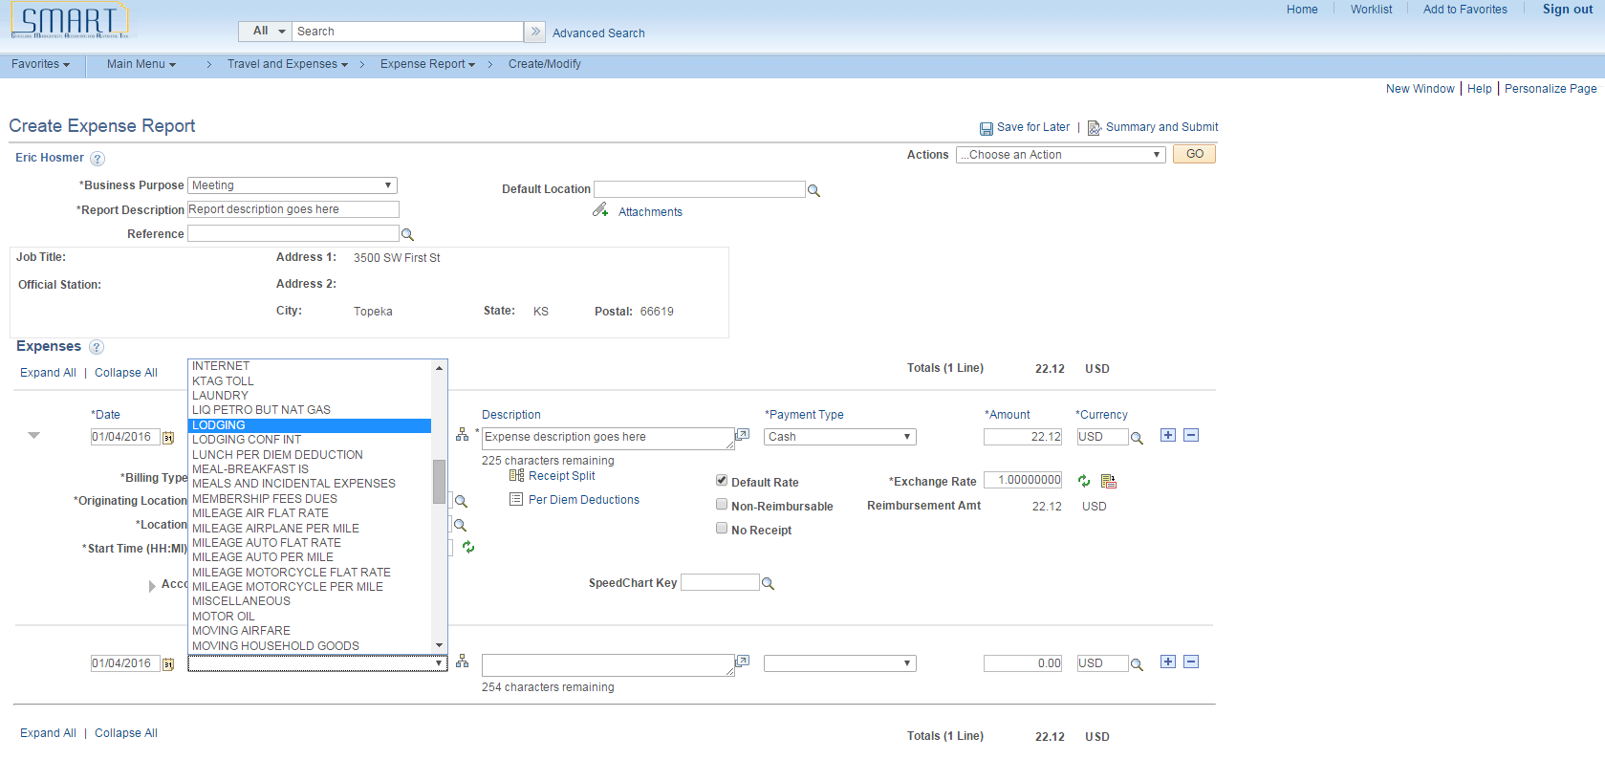

Step | Action
 | Click the LODGING list item.

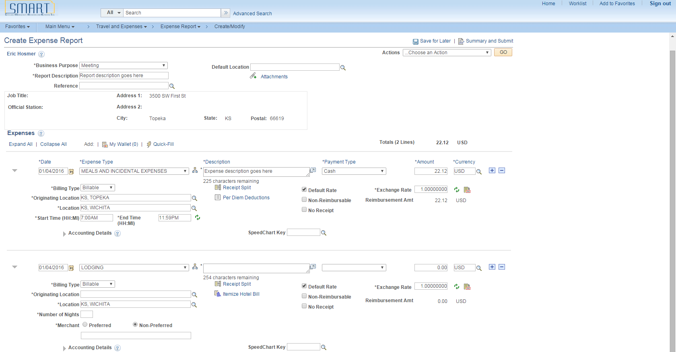

Step | Action
Enter a description about the expense transaction.

Enter the desired information into the Description field. 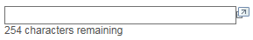
Enter how you paid for the expense. This value may appear by default if a payment type is entered in the Expense defaults group box on the Employee Profile - User Defaults page.

Click the Payment Type list.
Note: The Expense Type and Payment Type should always match. This means that a regular Expense Type (not a prepaid expense type) should have a corresponding regular Payment Type (not a prepaid payment type). If a mismatch occurs, the resulting accounting entries generated by SMART will be incorrect.

Click the Cash list item.

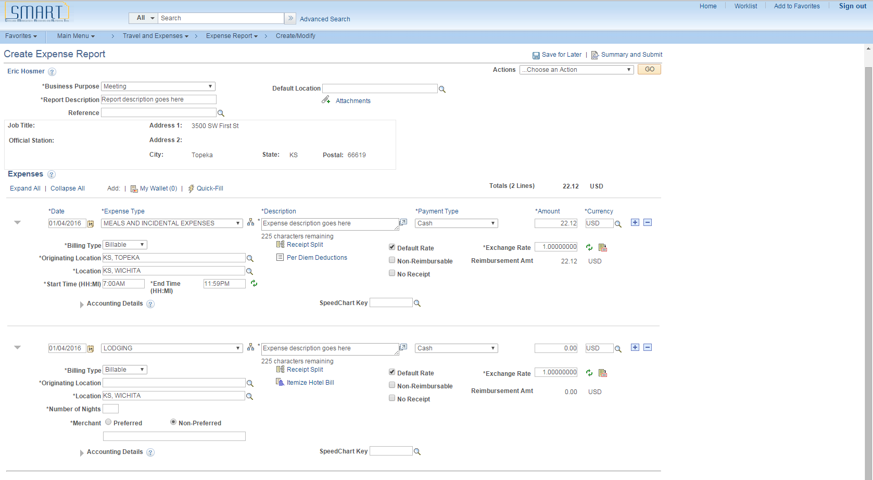

Step | Action
Enter the amount that you spent for the expense line.

Enter the desired information into the Amount field.
SMART will populate the Location field if you enter a Default Location in the general information section above, or if you have entered a previous expense line with a location.

Location is populated here due to the location being selected in expense line 1. You can override this value if needed.

Note: For travel related expenses, the Location field is the place where the official business occurred. Also, Default Location is not a required field.
Select the Originating Location. This will typically be the traveler's office or home.

Click the Look Up button to the right of the Originating Location.
The Originating Location in Look Up is listed alphabetically starting with the two-letter state abbreviation, followed by the city name.

Example: KS, TOPEKA

Enter the desired information into the Originating Location field.
 | Click the Look Up button.
 | Click the KS, TOPEKA link.
Another option when entering a location is to key the value directly into the field.

For example, KS, TOPEKA would be keyed into the Originating Location field, and KS, WICHITA into the Location field. Please pay attention to capitalization, commas and spacing. It must be exact for SMART to take the value. If the value is entered incorrectly, you will receive an error that must be corrected before you can continue.
Enter the number of nights the expense covers.
Enter the desired information into the Number of Nights field.
The Merchant button will default to Non-Preferred. Enter the merchant used for this expense.

Enter the desired information into the Merchant field.
Select the Save for Later link to save the expense report without submitting it for approval. This allows you to create an expense report as you are incurring expenses and save it for a later time when you are ready to submit it.

Click the Save for Later link.
When you click Save for Later, SMART validates the information entered on each expense line. If an error exists, a red flag will appear next to the expense line that needs corrected. Errors must be corrected before the expense report can be submitted for approvals.

Click the Expense Report Line Errors button (red flag).

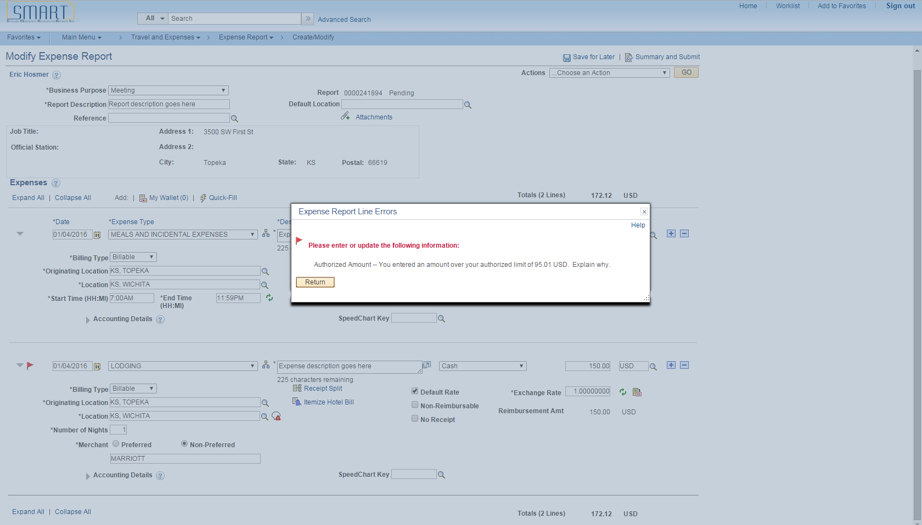

Step | Action
The Expense Report Line Errors box will tell you how the error occurred.

Click the Return button.

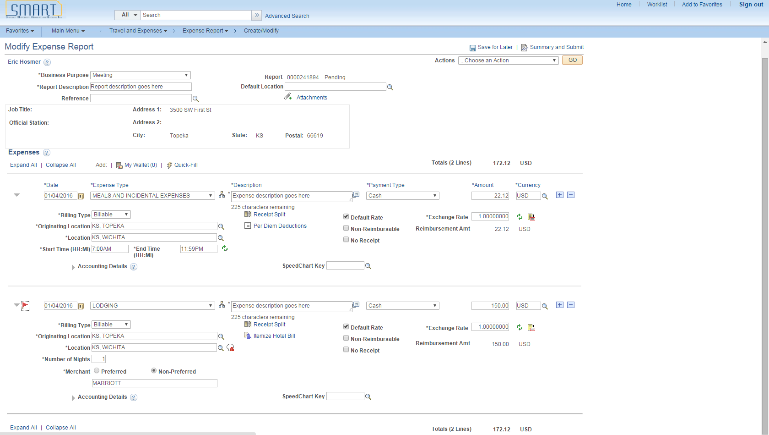

Step | Action
To correct the error on this expense line, we need to enter a reason why the keyed amount exceeds the authorized rate.

Click the Authorized Amount Exceed Comment button.

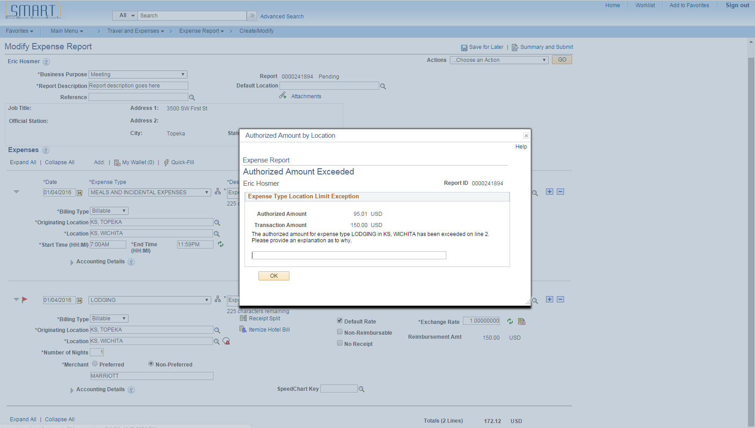

Step | Action
Please provide an explanation of why the authorized amount was exceeded.

Enter the desired information into the Comment field.
 | Click the OK button.
 | Once all errors are corrected, click the Save for Later link to verify that no errors still exist.

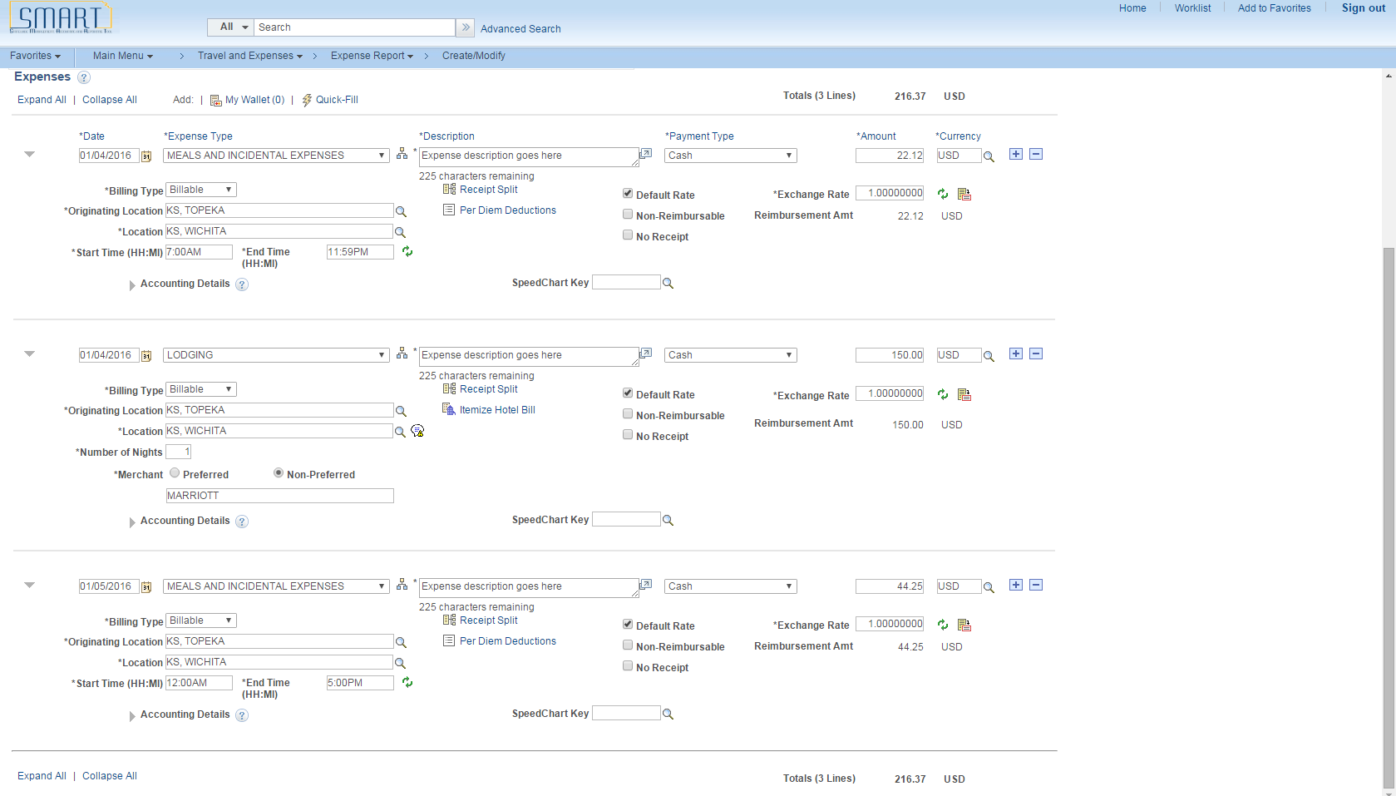

Step | Action
Click the Insert Line icon to add a new expense line. When you add a new line, SMART validates the data on the previous expense line. If an error is detected by SMART, a red flag will appear next to the previous line, which must be fixed prior to submitting the expense report.

Click the Insert Expense Line button.
Repeat steps 11 – 36 to add a third expense line. The third expense line will be for Meals and Incidental Expenses the day the traveler returns to Topeka.

In this example, SMART calculated the MIE Amount based on the following:

The traveler stayed overnight in Wichita, KS. They conducted official state business in Wichita and returned to Topeka at 5 p.m. The traveler will be paid for 3 quarters and no meals were provided.

Start Time: 12:00AM
End Time: 5:00PM

MIE amount for a full day in Wichita, KS = $59
Meal allowance for 3 quarters ($59 X .75) = $44.25
Less per diem deductions ($0) = $44.25
Amount for meals = $44.25
Click this link to view a summary of your expense lines and submit the report.

Click the Summary and Submit link.

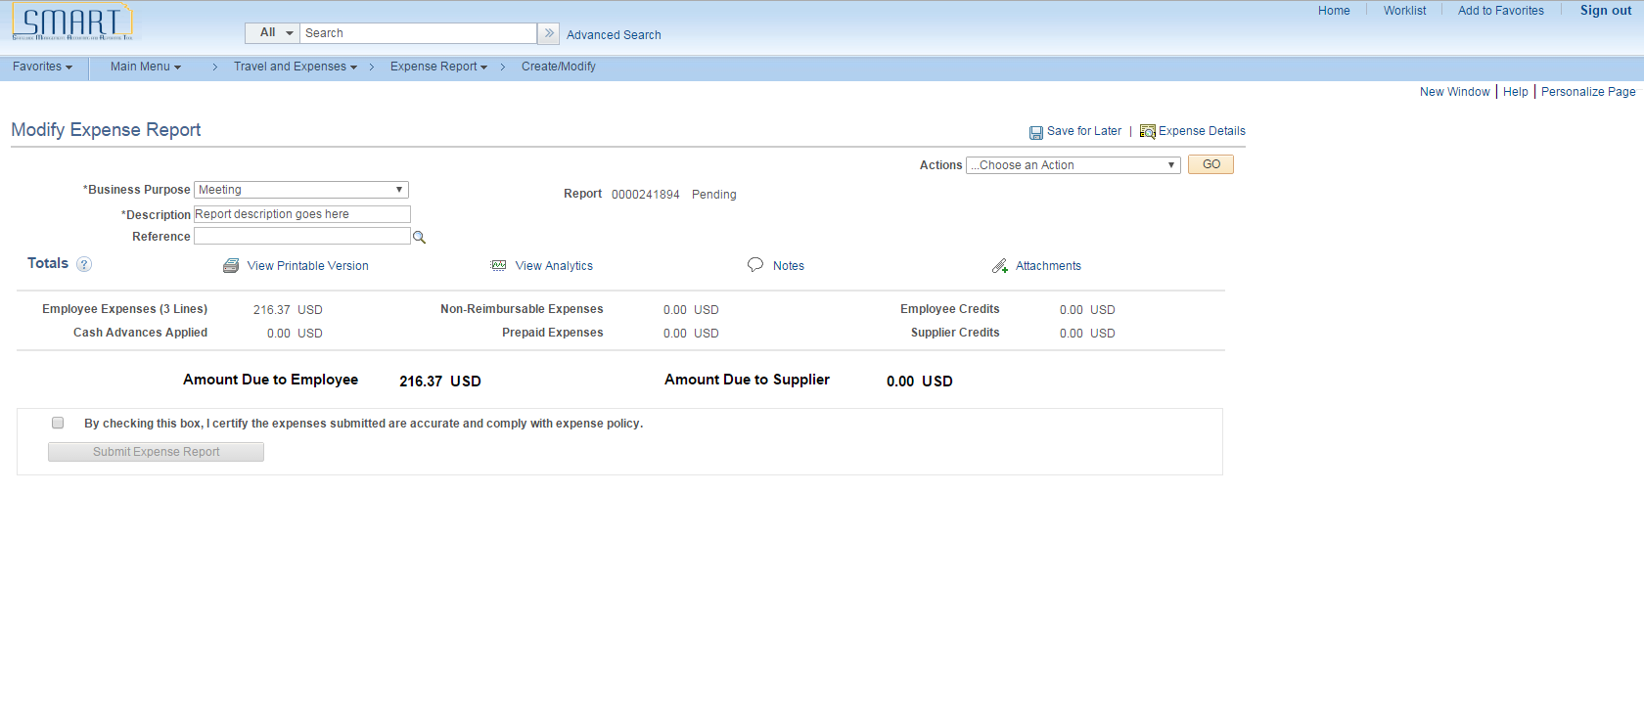

Step | Action
 | Click the Submit Certification Checkbox.
 | Click the Submit Expense Report button.

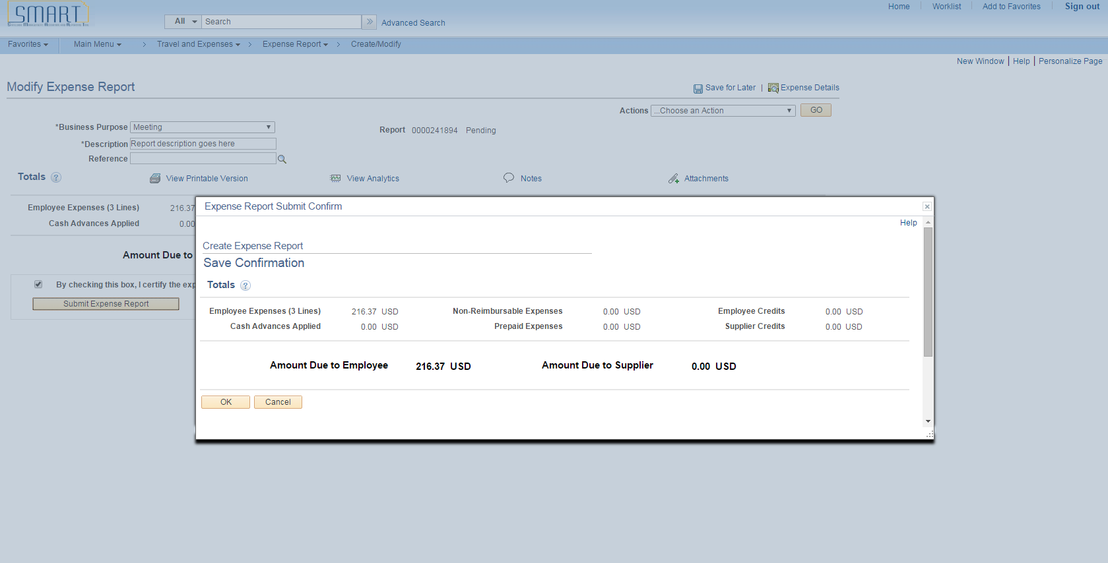

Step | Action
SMART provides a confirmation page to make sure you want to submit the expense report.

Click the OK button.

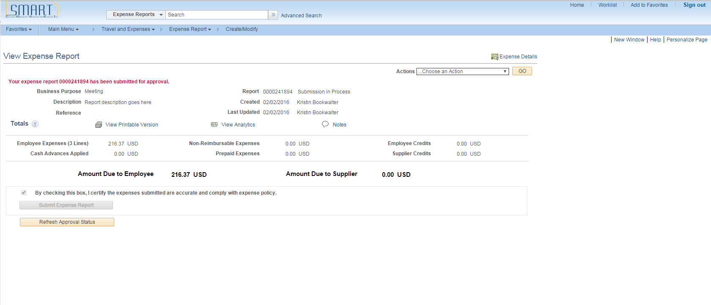

Step | Action
After you submit the expense report, you can click the Refresh Approval Status button to view where the report is in the approval workflow.

Click the Refresh Approval Status button.
The report status has changed from Submission in Process to Submitted for Approval.

Additionally, the Approval History is now visible.
 | End of Procedure.

