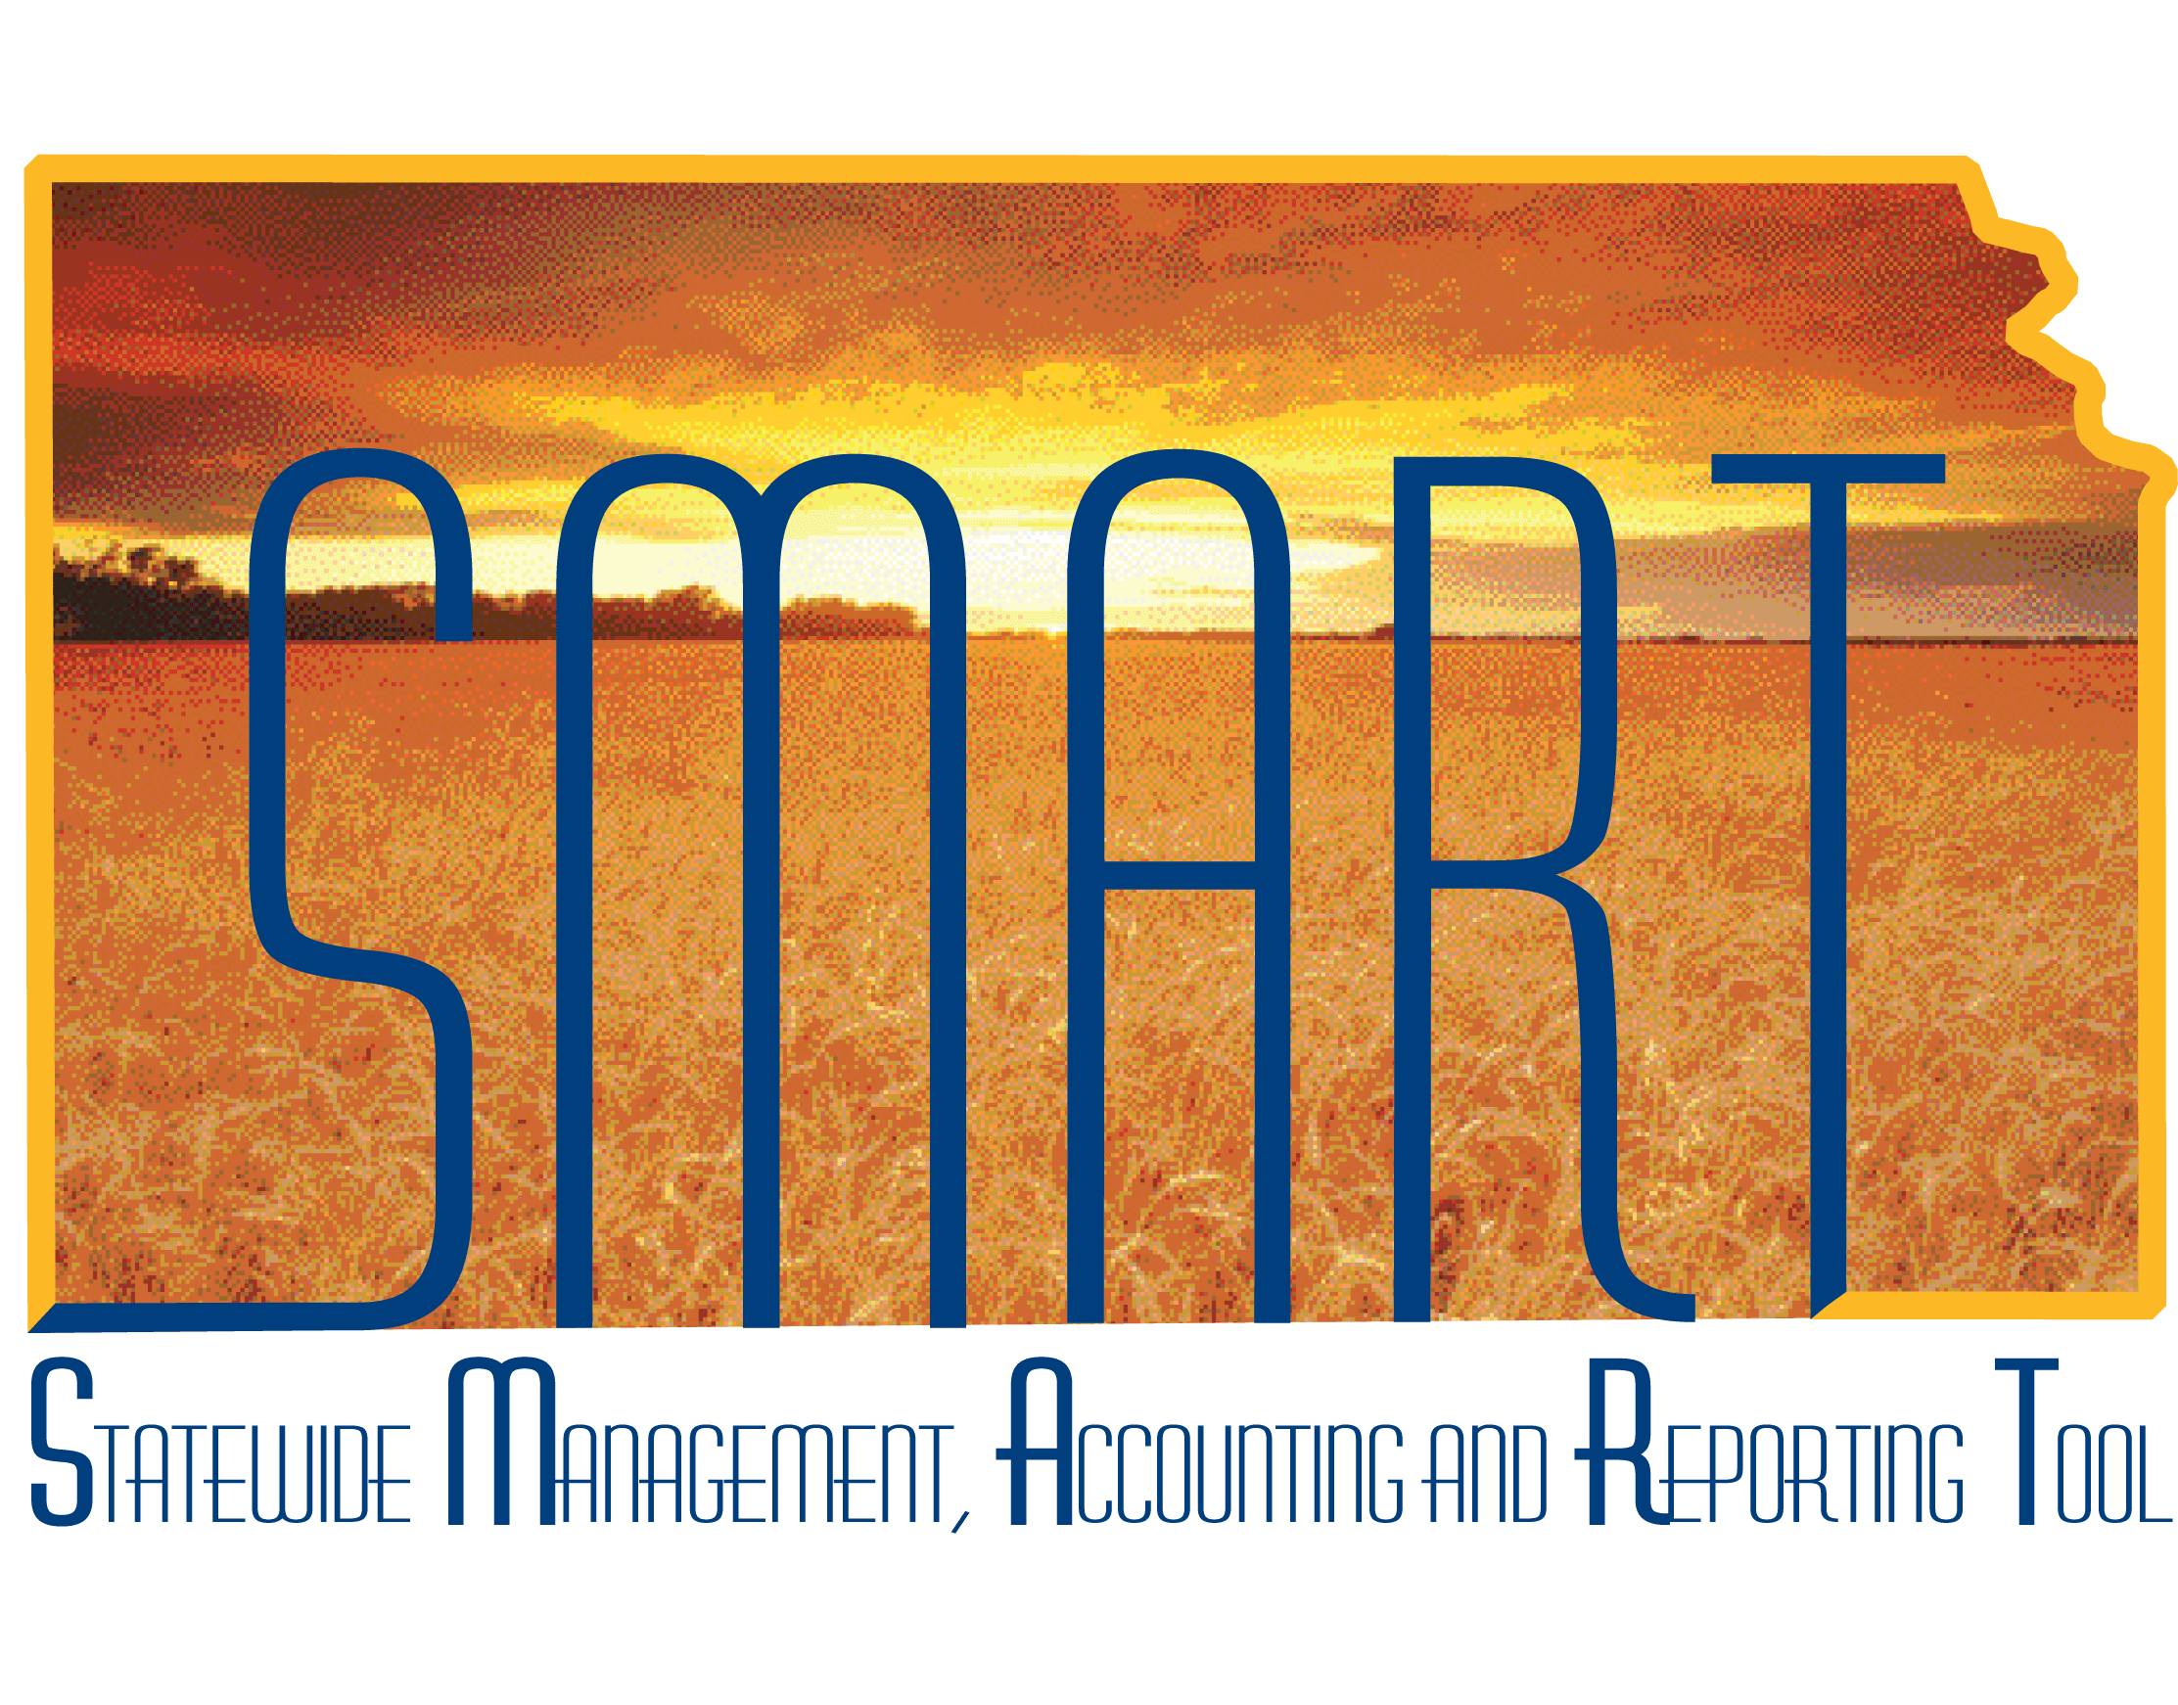

Training Guide – SMART Security

SMART Security Liaison

State of Kansas

**Applicable Role(s):**

*SMART Security Liaison*

*Kansas Service Desk Contact*

*Agency Security Contact*

**For Questions Contact the Kansas Service Desk at 785-368-8000**

SMART Security Liaison

**Training Guide**

**Statewide Management, Accounting and Reporting Tool**

**Table of Contents**

**1.0 Rules** ………………………………….…………………………………………………………………………… **3**

**2.0 Tools** ….…………………………….……………………………………………………………………………. **4**

**3.0 Links / Locations** …………………………………………………….…………………………………… **5**

**4.0 Entering a Request** …………………………………………….……………...……………………… **6**

**5.0 Request Completion** ……………………………………………………….…………………………… **8**

**6.0 Security Liaison Query** ………………………………………………………………………………… **9**

SMART Security Liaison

**Training Guide**

**Statewide Management, Accounting and Reporting Tool**

**1.0 Rules**

A SMART Security Liaison performs very important functions for their agency. Included in these functions are: requesting SMART security roles for new employees, initiating deactivation for employees leaving the agency, and approving and sending requests to change existing employees’ access.

An Agency may designate more than one Security Liaison. In fact, this is recommended so in the event that one Liaison is out of the office, there is another available to handle the duties. Lastly, it is important to understand that the Security Liaison role in your Agency is the only role that can perform these functions. They are:

* New security liaisons can only be authorized by an existing security liaison or the head of the agency.
* A security liaison must also be established as a Service Desk contact because all security access forms are sent to the SMART Security team via Service Desk requests in ManageEngine.
* SMART Security Access Forms for employees must be initiated by the security liaison of an agency and sent through the Kansas Service Desk ManageEngine tool.
* If the security request includes access to multiple business units of which the initiator of the request is NOT the designated security liaison, permission must be given by the security liaison from the other agency(s) and/or the Director of the Office of Systems Management for the Department of Administration.
* All agencies have a FIVE-digit agency number for which they are able to request access. If a Security Liaison is designated for an agency, this means they can request access for any derivative of that agency number as long as the first THREE numbers indicate their agency. For example, the Department of Administration is agency 17300. The Security Liaison for agency 17300 may request roles be given to employees for 17300, 17301, 17302, 17311, etc. If a request for access to 17400 was submitted, this would be denied, unless the Security Liaison was designated for both agencies 17300 AND 17400.
* The SMART Security Team requires that only one SMART Security Access form be included per Service Desk request.

SMART Security Liaison

**Training Guide**

**Statewide Management, Accounting and Reporting Tool**

# 2.0 Tools

1. The SMART Security Access Form is the official document used by the security liaison to request SMART access. A portion of the form is pictured below. The form is housed at: <https://smartweb.ks.gov/policy-forms/security-access-forms>.

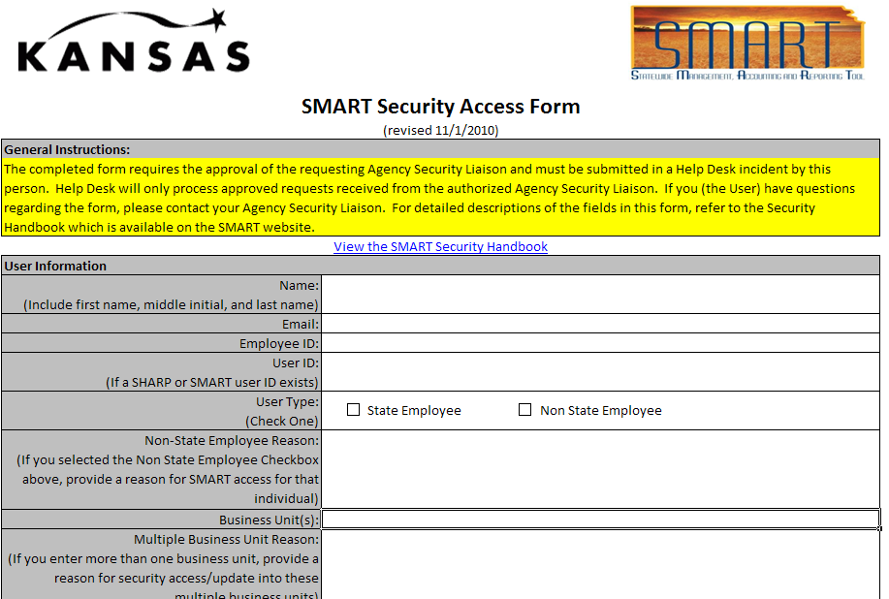

1. For instructions on filling out the form, there is a SMART Security Handbook. A portion of the document is pictured below and the Handbook is housed at: <https://smartweb.ks.gov/policy-forms/security-access-forms>.

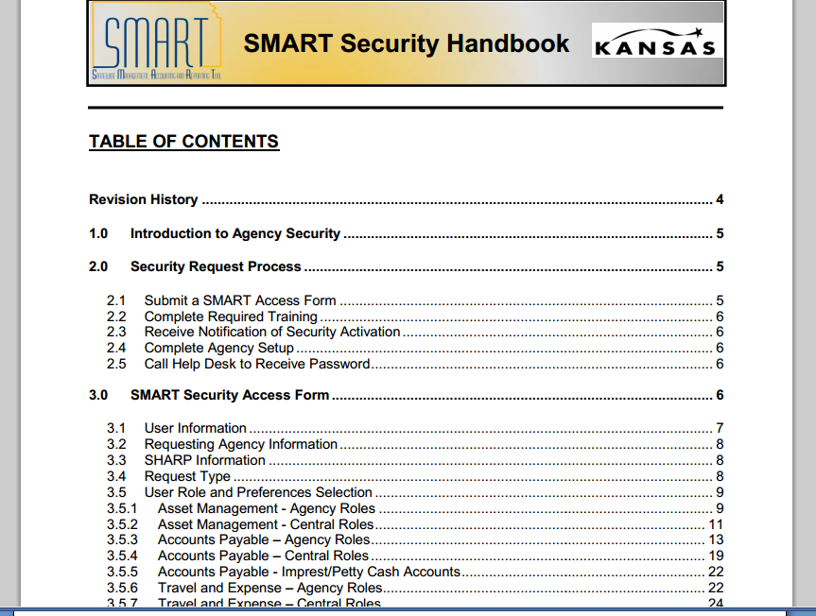

SMART Security Liaison

**Training Guide**

**Statewide Management, Accounting and Reporting Tool**

1. For assistance in determining the training needed for particular roles, there is the ‘User Role to Training Course Mapping Spreadsheet’. A portion of the spreadsheet is pictured below as is the link to where the document is housed. <https://smartweb.ks.gov/policy-forms/security-access-forms>.

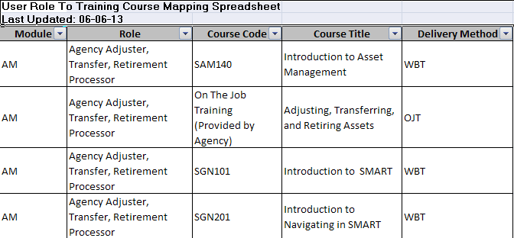

# 3.0 Links / Locations

1. Kansas Service Desk - <https://sokdahelpdesk.ks.gov/>.
2. SMART Security Form, SMART Security Handbook, User Role to Course Mapping Instruction sheet, Security Liaison Training Guide - <https://smartweb.ks.gov/policy-forms/security-access-forms>

SMART Security Liaison

**Training Guide**

**Statewide Management, Accounting and Reporting Tool**

# 4.0 Entering a Service Request

1. Go to the ManageEngine tool via this link: <https://sokdahelpdesk.ks.gov/>  
   Enter your ManageEngine Username and Password.  
   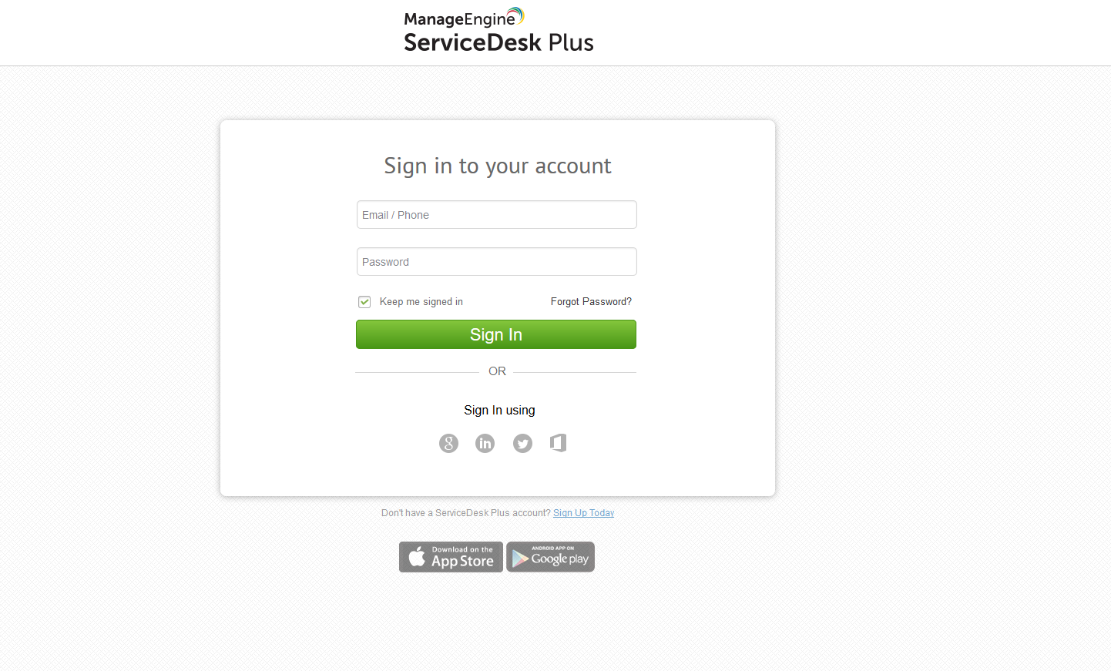
2. From the **Home** tab, click the “Create an Incident” or “New Request” buttons.

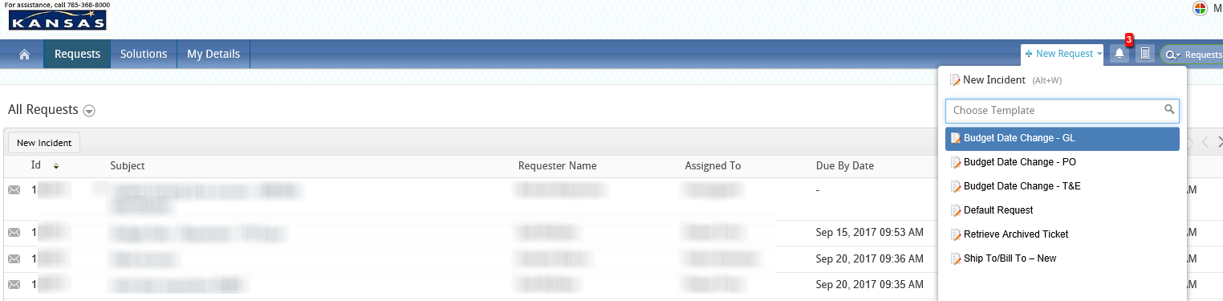

SMART Security Liaison

**Training Guide**

**Statewide Management, Accounting and Reporting Tool**

1. Your name and agency information should automatically populate for you. Select the **Category** “Security” and then select either the **Subcategory** “New User Requests” or “Update Existing User”.

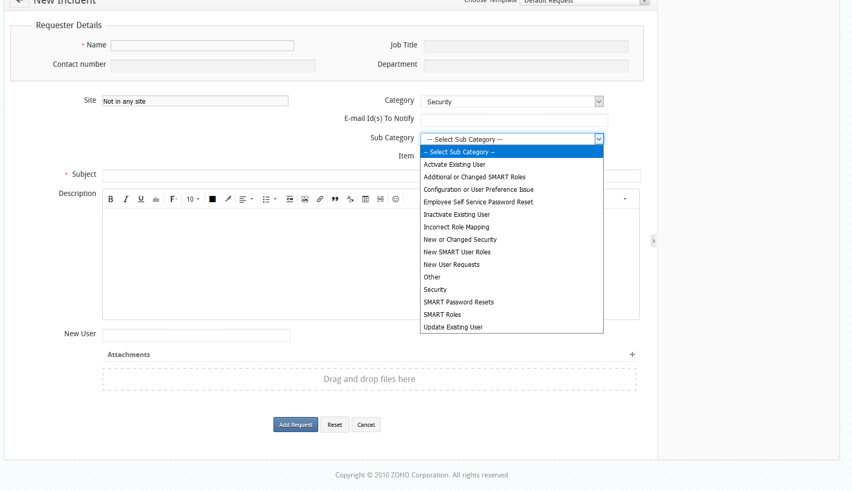

1. Be sure to include the name of the user to be updated in the Subject or Description.
2. Next, scroll down to the **Attachments** section and attach the security access form you filled out for your employee. Select the file, and click the “Open” button.

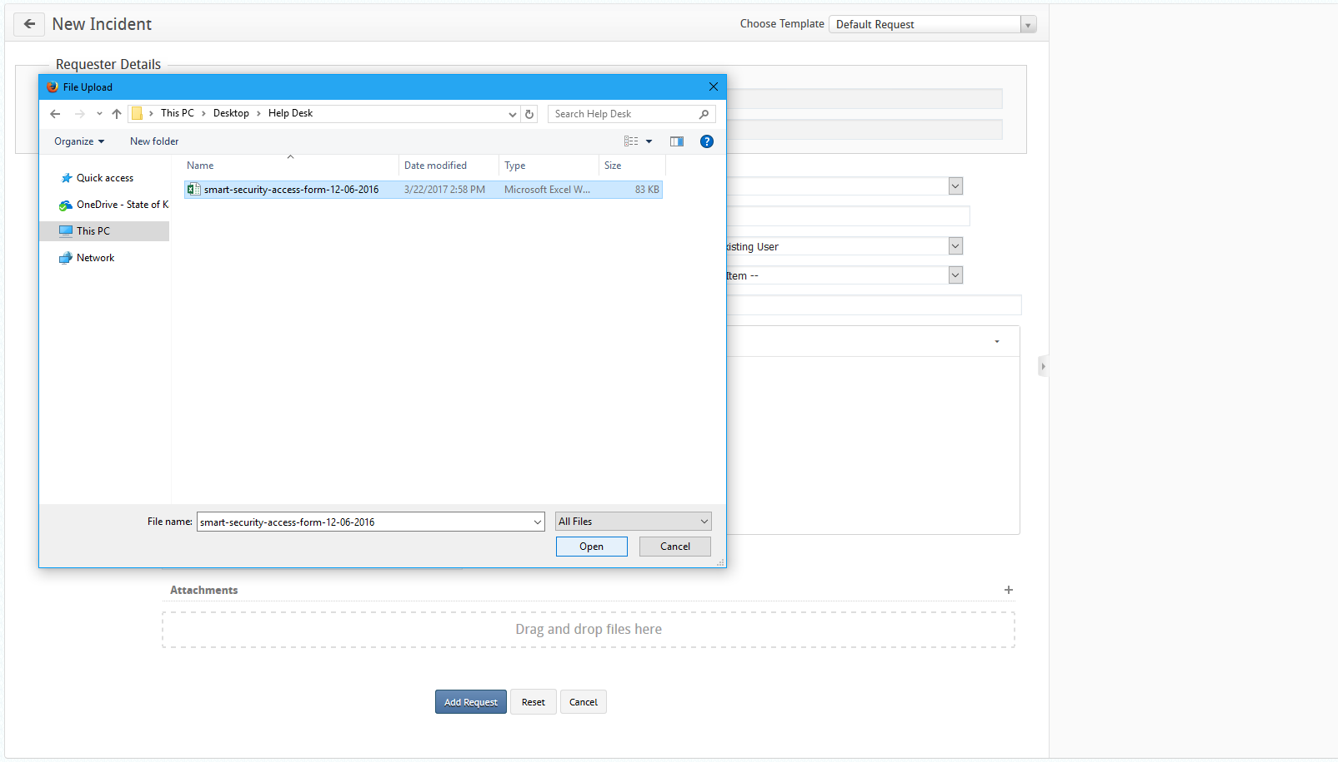

SMART Security Liaison

**Training Guide**

**Statewide Management, Accounting and Reporting Tool**

1. Click the “Add request” button.

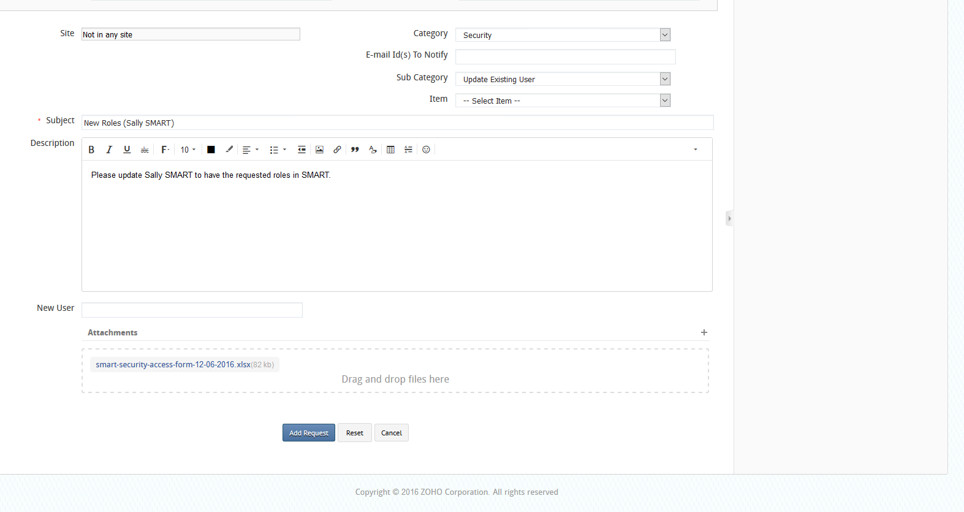

1. The Service Desk assigns a **Request ID** to the request. This is displayed at the top right of the service request.

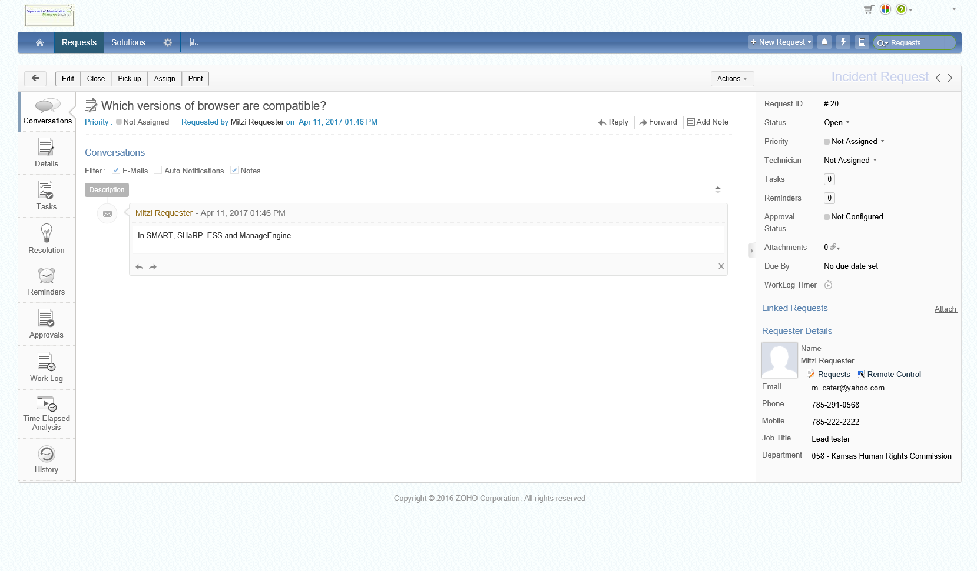

# 5.0 Request Completion

You will receive notification via e mail from the security team when the changes have been made. As the SMART Security Liaison, you will be responsible for informing your employee of the contents of the e mail.

If for any reason the changes are not as requested, perform a reply via email and the ticket will be reopened and worked again. (Adding a reply to the request in ManageEngine itself will **not** result in the ticket being reopened).



# 6.0 Security Liaison Query

Our goal in providing this tool to you is to empower the Security Liaisons.  You no longer need to send a ManageEngine Help Desk request to find out what IDs are tied to what roles, etc.

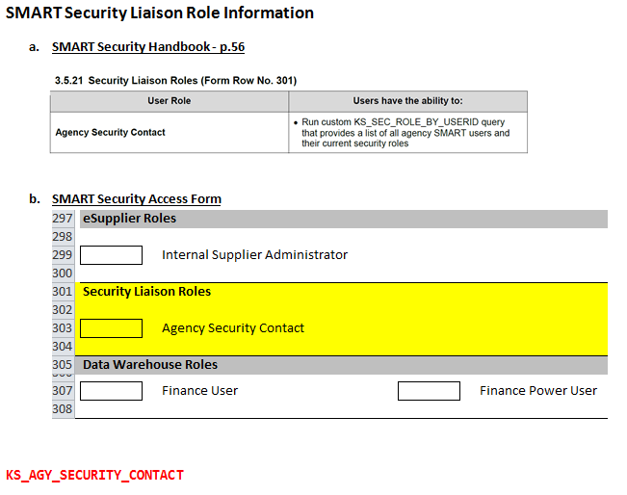

1. Simply sign in to SMART and follow this path: SMART: *Main Menu >* *Reporting Tools>Query>Query Viewer*
2. Select the Query Name: **KS_SEC_ROLE_BY_USERID** then click SEARCH

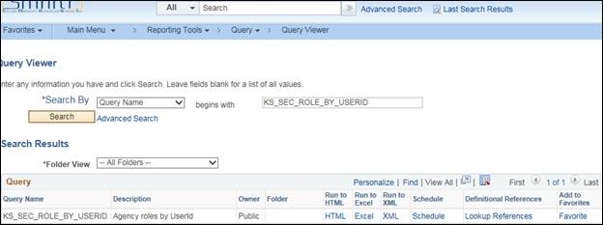

1. Choose HTML or Excel
2. Enter the USER ID desired or enter the name of the role you wish to see in ‘Role Name’ (KAP_Agy_AP_Processor = Agency AP Processor)  
   (Entering % in in either field indicates you want to see ALL IDs or ALL Roles.)

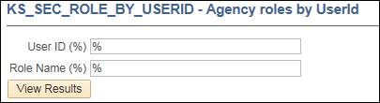

1. Click on ‘View Results’

The list below was requested in Excel format.  User IDs and other information is covered for security purposes below, but your agency information will be presented to you in columns A, B, C, D, E.

