
State of Kansas
Scheduling a Query
Statewide Management, Accounting and Reporting Tool

Date Created: 11/25/2015

Version: 2—updated for 9.2
Purpose of this document:

This document teaches you how to:
- Schedule a query in SMART
- View results of a scheduled query
- Cancel a recurring query

Why would I need to schedule a query in SMART?

- A query initiated online in SMART may time-out due to the amount of processing time the query takes to generate. Scheduled queries avoid the possibility of ‘time-outs.’

- A query initiated online in SMART may have limitations restricted to the number of ‘search results’ that can be returned in the query results. In this example, a user may receive an error message in SMART that states ‘Query Result Set Too Large.’ Queries that are scheduled in SMART do not have limitations on the number of search results that can be included in the query.

- You may want to run a query or queries on a recurring basis in SMART. Scheduling a query instructs SMART to ‘run’ the query or queries on a designated recurring basis. This prevents the user from having to manually run the query or queries. SMART will automatically run the query when it is scheduled to run.

- Please note that any scheduled or user-initiated query that is still running at 6 p.m. on Monday thru Friday will be cancelled so nightly batch can begin on time. If the query is cancelled, Process Monitor will show the query instance with a ‘Cancelled’ Run Status. The user will need to re-run the query when the system re-opens.

Scheduling a Query in SMART
Step | Action
1. | To begin, navigate to SMART’s ‘Query Viewer’:  Reporting Tools > Query > Query Viewer
2. | Search for the query you wish to schedule. In this example, we will Search By the Query Name of “KS_EX_RPT_NOT_POSTED”.  Search By field: ‘Query Name’  ‘begins with’ field: Enter the name of the query for which you are searching.  Click the Search button.
3. | In the Search Results – Query section:  Click the ‘Schedule’ link, located in the ‘Schedule’ column:  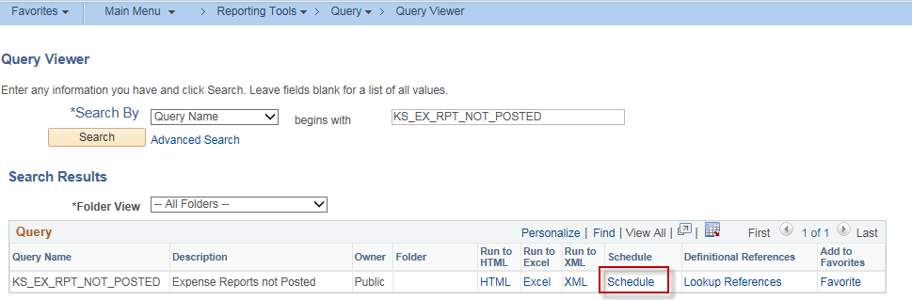  Clicking the ‘Schedule’ link prompts SMART to open the ‘Scheduled Query’ page.
4. | On the ‘Scheduled Query’ page, SMART should default to the ‘Add a New Value’ tab.  In this example, the Private Query field is set to N (No). The Query Name field is already populated with the query name. Populate the Run Control ID field.  Note: For ease of finding or editing scheduled queries in the future, it is recommended that your Run Control ID be the same as the Query Name. In this example, ‘KS_EX_RPT_NOT_POSTED’ is entered in the Run Control ID field.  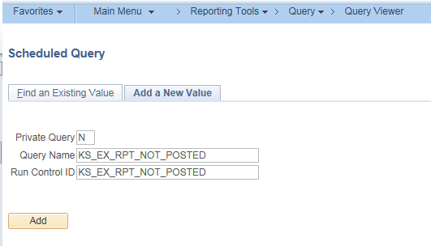
5. | Click the Add button.  For a query with Prompts:  If the query you are scheduling has prompts, the applicable prompts will display immediately after clicking Add. Populate the Prompts and click OK. If any changes need to be made to the prompts, select the ‘Update Parameters’ link on the Schedule Query page  .  Note: Later, you will have the opportunity to schedule the query as a one-time run or as a recurring instance (Step 7 of this training document). If the query has parameters that can change between runs (example—Fiscal Year and Period), you should schedule it as a one-time run. The prompt values you enter as part of the Run Control ID do not update automatically.  Enter a Description. You can use the Query Name to populate the Description.  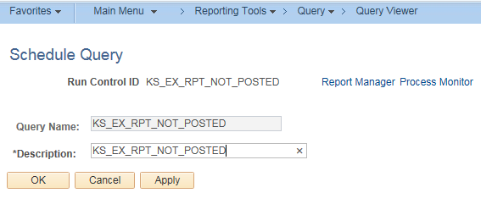
6. | Click the Apply button. The Process Scheduler Request page will display.  Note: If you are re-using a Run Control ID, you’ll click Run instead of Apply.  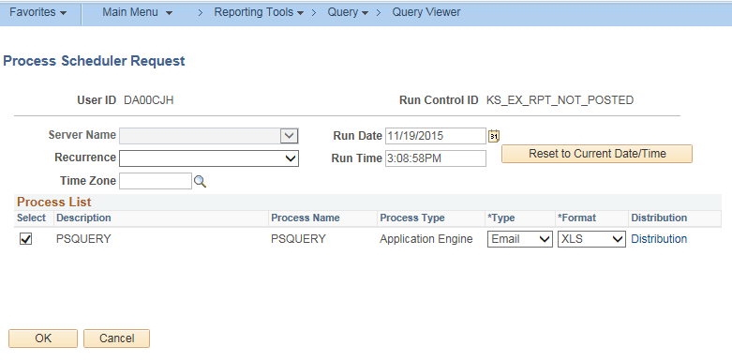
7. | The Process Scheduler Request page is where you determine whether this scheduled query runs once or on a recurring basis. You also determine if the results should be distributed to any user(s).  Schedule a One-Time Run Query  - If you need to schedule this query for a one-time run only, specify the ‘Run Date’ and ‘Run Time.’ The current date and time will default.  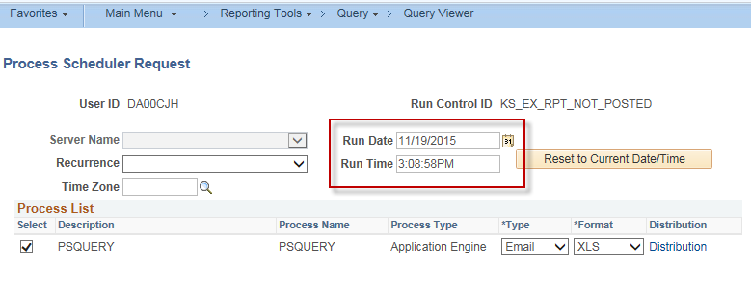  Schedule a Recurring Query  **To avoid interfering with the regularly scheduled SMART batch processes, please do NOT schedule any queries to run between the hours of 6:00 PM and 7:00 AM, Monday through Friday.  - If you would like to schedule the query on a recurring basis, select the appropriate ’Recurrence’ option from the ‘Recurrence’ drop-down list.  Note: The ‘Run Time’ value changes based on the ‘Recurrence’ option selected.  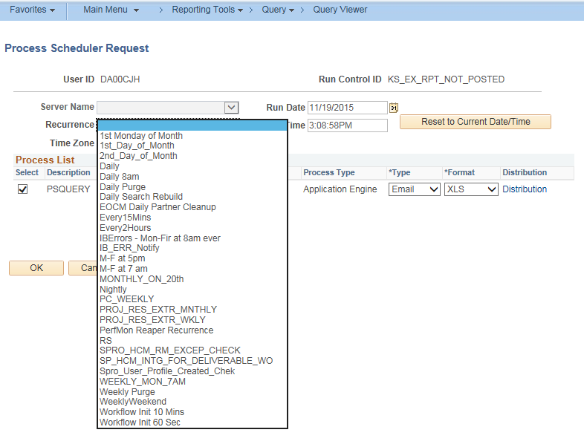
8. | Select the desired values in the Process List section:  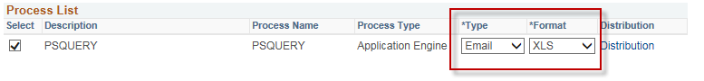  For either a ‘One-Time Run’ query or a ‘Recurring Schedule’ query, specify the ‘Type’ and ‘Format’ (for the generation of the query information).  - Type: Select ‘Web’ if you wish to view the query results online. Select ‘Email’ if you wish to have the results emailed to you and/or other users. Please note, due to email system limitations, the ‘Email’ option will not work if the query results are 10MB or greater.  - Format: Select one (1) of the following Format options from the drop down list:  - HTM—Produces an HTML file. This file Format can NOT be manipulated or edited.  - PDF—Produces a PDF file. This file Format can NOT be manipulated or edited.  - TXT—Produces a CSV file (text delimited file). The file is opened in ‘Excel’ (or other spreadsheet software). Select this option if your agency uses ‘Excel 97’ version or earlier versions. This file CAN be manipulated and/or edited.  - XLS—Produces an Excel file (‘.xls’). Select this option if your agency uses ‘Excel 2000’ version or later. This file CAN be manipulated and/or edited.  Note: There is also a file size limitation in Excel. If you select ‘XLS’ and receive an error when trying to open your file, it is recommended you rerun and select ‘Web’ as the Type and ‘TXT’ as the Format to view the results online. If you wish to have the results emailed as a hyperlink, you can select a Type of ‘Web’ and then select the ‘Email Web Report’ option on the Distribution page (step 9).
9. | If you wish to have the scheduled query automatically distributed, click the Distribution hyperlink. This is an optional step.  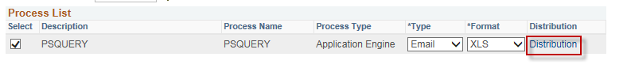  Clicking the Distribution hyperlink opens the Distribution Detail page.  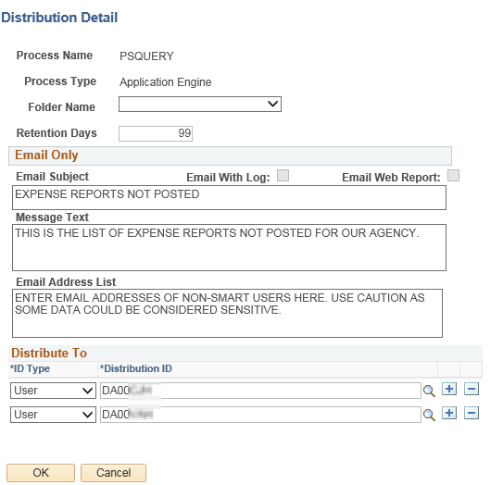  Populate the following fields. Note the recipient(s) must have security access to view the query results.  Email Only section—Use this section when sending the results via email.  - Email Web Report: Defaults as not selected if a Type of ‘Email’ was selected; Select this option if you wish to have another Type emailed to you.  - Email Subject: Enter the subject line for the email.  - Message Text: Enter the text for the email.  - Email Address List: Enter all the email addresses of the intended recipients, separated by a comma (,). This is necessary for non-SMART users. Use caution as some data may be considered sensitive.  Distribute To section—Use this section if you wish to grant online access to query  results via the Process Monitor (‘Web’ type) or to have the results emailed (‘Email’  type) to SMART users.  - ID Type: Select User. Do NOT select Role, as this will distribute your query results to every user with the specified role.  - Distribution ID: Enter the User ID’s of the SMART users who should have access to view the query results online or receive the query results via email. Note that your User ID will automatically be entered. Click the ‘+’ button to add additional rows.  Once all the fields have been populated, click OK. The Process Scheduler Request page will display.
10. | Click OK again. The Process Instance will display on the upper right.  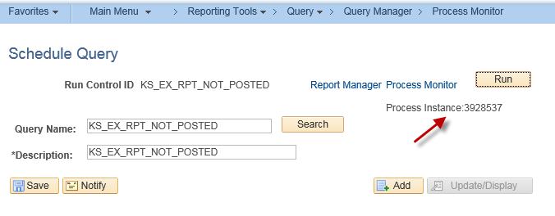

11. | Click the Process Monitor hyperlink. Once the Process Instance has a Run Status of Success and Distribution Status of Posted, the query results are available for online viewing. If you have selected to distribute by email, the system-generated email with the results or the link will be sent at this time.  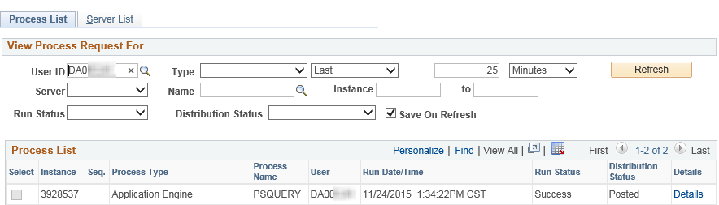

Viewing Results for Scheduled Query
This section is not applicable to users who have had the query results emailed to them. They can simply click the attachment or select the hyperlink and navigate directly to the query results. These instructions are for users who are accessing the results online.
Step | Action
1. | Navigate to the ‘Process Monitor’ page in SMART:  PeopleTools > Process Scheduler > Process Monitor
2. | On the Process Monitor page in the’ View Process Request For’ section:  Enter the ‘Search Criteria’, as follows:  User ID: Enter your SMART User ID  Type: From the drop-down list, select ‘Application Engine’.  Last: Enter the time period for which you wish to view results.  In this example: The number ‘2’ was entered in the field, and the ‘Days’ option was selected from the drop-down list to indicate ‘within the last 2 days’  Name: Select or enter ‘PSQUERY’.  Click the Refresh button to update the data in the Process List section.  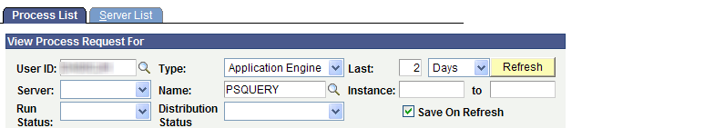  Note: If you are viewing a recurring query, you will see process Instances associated with future Run Dates/Times. Future Instances have a ‘Run Status’ of ‘Queued’, and a Distribution Status of ‘N/A’.  Recurring queries have a ‘Recurring’ icon (green arrow icon).
3. | In the Process List section, click the ‘Details’ link for the process Instance you wish to view.  The query results will not be available until there is a ‘Run Status’ of ‘Success’ and a ‘Distribution Status’ of ‘Posted’ for the process Instance.
4. | Clicking the ‘Details’ link on the Process List page opens the Process Detail page.  The Process Detail page is used to access and view the query results. The query results are accessed by clicking the ‘View Log/Trace’ link, which is located in the Actions section of the page (lower right corner of page):  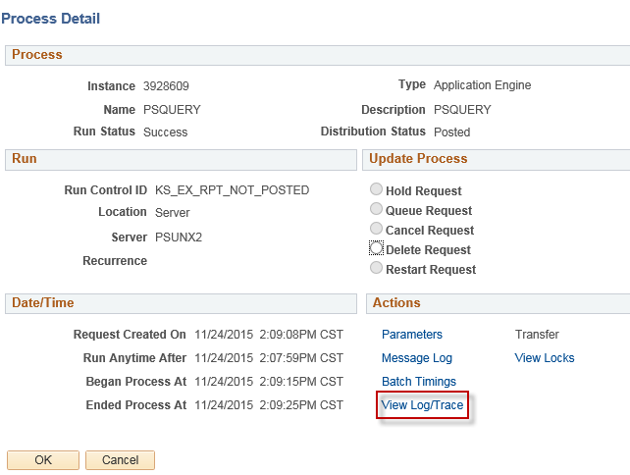
5. | Clicking the View Log/Trace link on the Process Detail page opens the ‘View Log/Trace’ page. The query results are displayed in the File List section of the View Log/Trace page. Select the appropriate link.  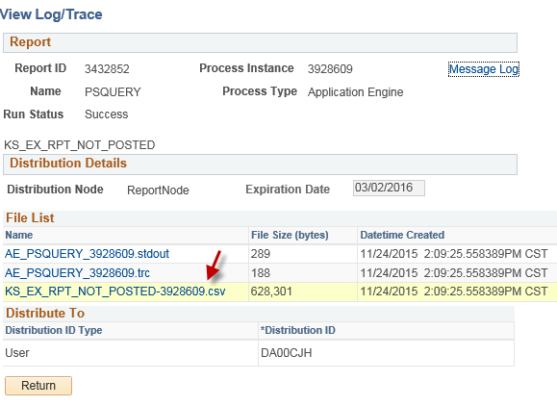  Please note: if the query results are in a text format (CSV file) and you want to open in Excel, you may want to Save or Save as, and then open Excel and open the file you saved. This will allow your file results to open with the Text Import Wizard, which allows you to format the fields as you desire.

Cancelling a Recurring Query
Step | Action
1. | To begin, navigate to SMART’s ‘Query Viewer’:  Reporting Tools > Query > Query Viewer
2. | Search for the query you wish to cancel.  In this example, we will search for the query named ‘KS_EX_RPT_NOT_POSTED’.
3. | Click the Schedule link.  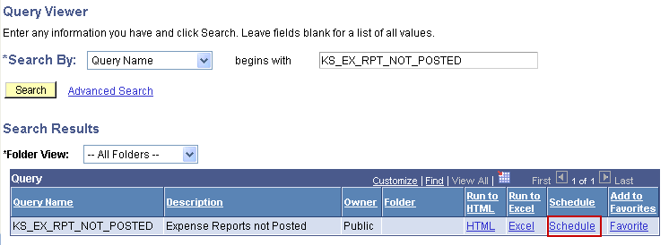
4. | On the Find an Existing Value tab, search for the existing ‘Run Control ID’ used to schedule the query.  In this example: The ‘Run Control ID’ is named “QUERY”.  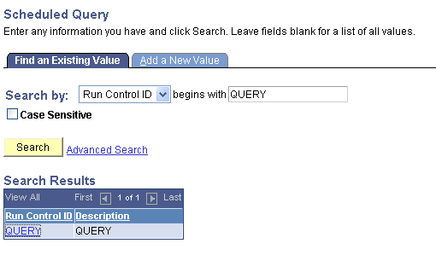  Select the ‘Run Control ID’ link to open the “Schedule Query” page.
5. | On the Schedule Query page, click the “Process Monitor” link (located in the top right corner).  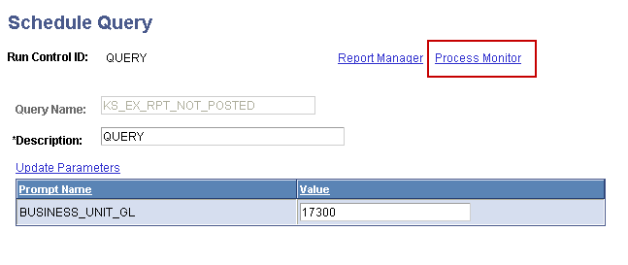

6. | On the Process Monitor page:  You may have to enter search parameters to find a queued process Instance of the query you wish to cancel. If so, enter the following criteria:  User ID: Enter your SMART User ID  Type: Select the “Application Engine” option from the drop-down list  Last: Specify the time period containing a ’Queued’ process Instance of the query you wish to cancel.  In this example: ‘3’ and ‘Days’ were selected  Name: Select or enter “PSQUERY”.  Click the Refresh button to locate ‘Queued’ process Instances of the query you wish to cancel. These will have the status ‘Queued’ in the Run Status column.  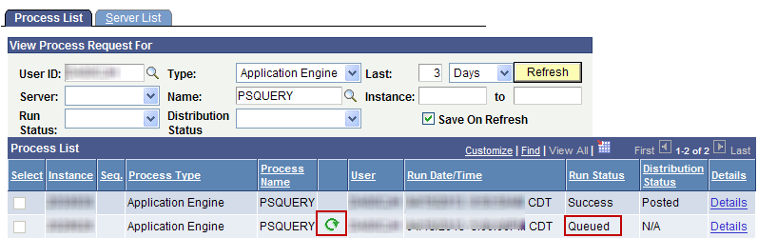  Once you have located a process Instance for the query you wish to cancel, click the green arrow icon for the Instance:

7. | Clicking the green arrow icon, opens the “Recurring Process/Job” page.  Click the Stop button (to prevent new process Instances from generating for the query).  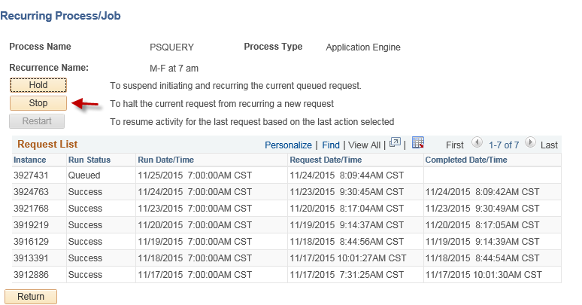  Note: Any Process Instances occurring after the date/time you cancel the query will be stopped. If a query has already been requested (refer to the Request Date/Time column), the queued Process Instance will generate a query. You have the option to cancel the queued Process Instance by selecting the Details hyperlink on the queued request. Then Select ‘Cancel Request’ on the Process Detail page.  

