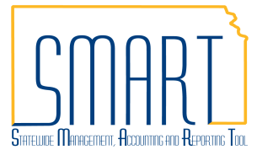
State of Kansas
PO Month End Checklist
Statewide Management, Accounting and Reporting Tool

Date Created: |  | 05/13/2015
Version: |  | 2.0
Last Updated Date: |  | 02/16/2021
Tasks each should complete at the end of the month:
- Open / Pending / Approved Requisitions – Stalled in workflow
- Sourcing Workbench Errors
- Un-Dispatched POs
- KS_PO_CLOSED_PO
- KS_PO_MAY_CLOSE
- PO Budgetary Activity Report – outstanding encumbrances
- PCard Transactions
- Open / Pending / Approved Requisitions
At the end of each month it is recommended that each agency look for requisitions that are not moving through workflow as expected using the Manage Requisitions page.
Navigation: Requisitions & PCards > Manage Requisitions > Manage Requisitions
In the Search Requisitions section, requisitions can be filtered by Request Status. | 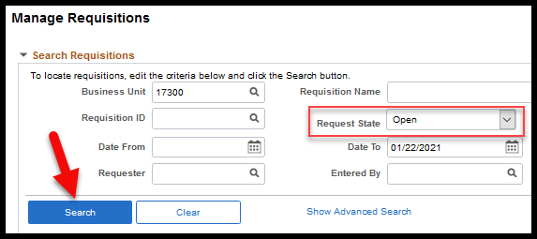

Options for managing a requisition unexpectedly still in Open status:
Submit the requisition to workflow by selecting Edit from the Select Action dropdown of the requisition and clicking Go. | 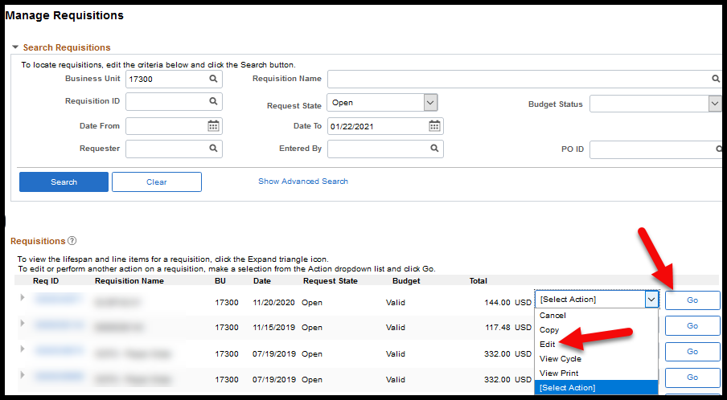
On the Edit Requisition – Review and Submit page that displays, select the Save & Submit button. | 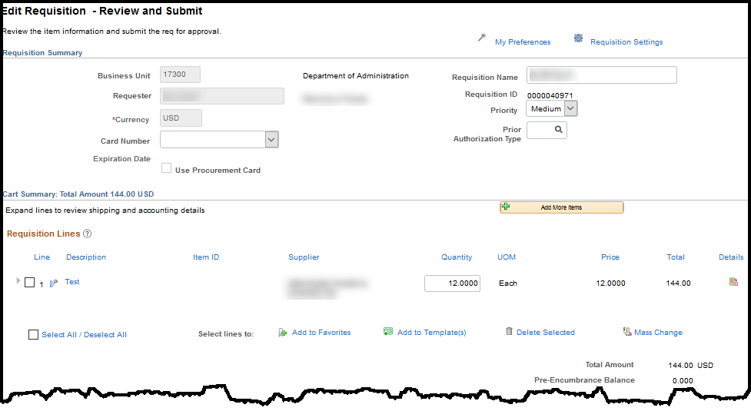  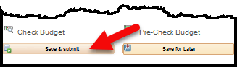
Cancel the requisition by selecting Cancel from the Select Action dropdown of the requisition and clicking Go. | 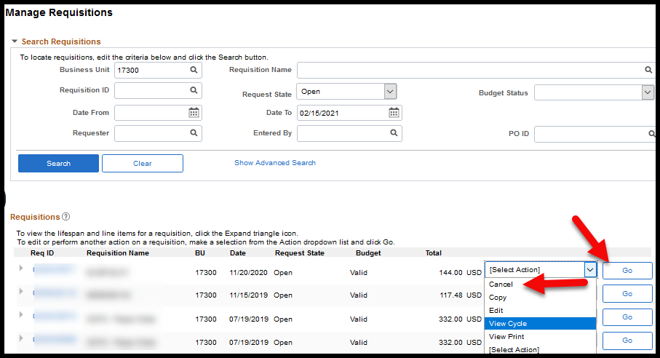
Options for managing a requisition unexpectedly still in Pending status:
Check the workflow progress of a requisition by either selecting the Expand Section arrow to the left of the Req ID and select the Approvals icon. | 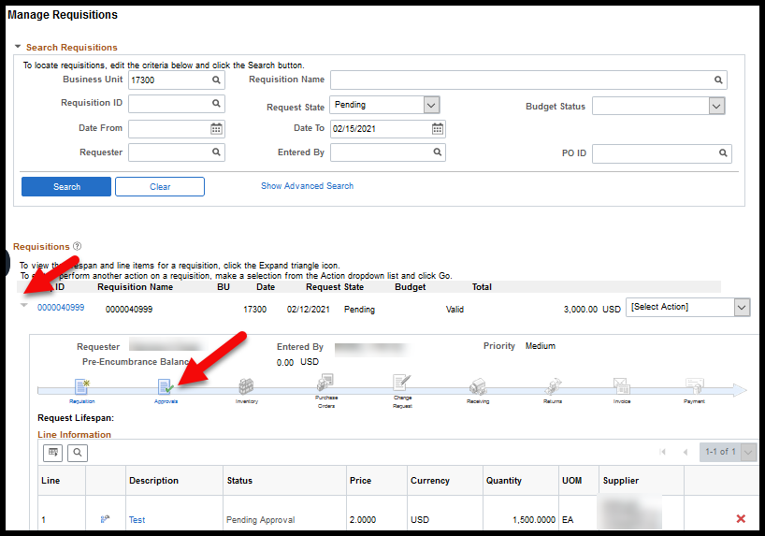
Or by selecting Approvals from the Select Action dropdown of the requisition and clicking Go. | 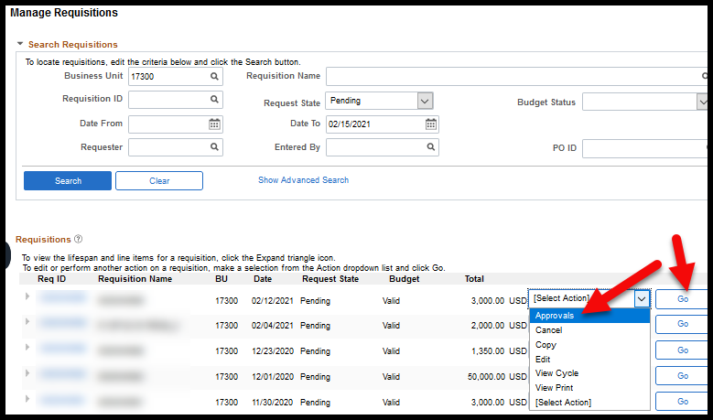
Workflow progress is displayed on the Approval Status page. It shows what approvers are required in workflow and whom the requisition is currently awaiting approval from. | 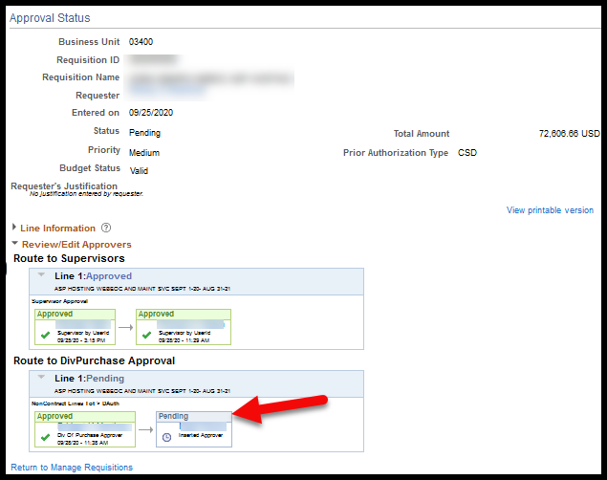
Note: If there is an approver showing in workflow that has left the organization, please submit a ManageEngine Service Desk request and provide the User ID of who should replace this approver.
Cancel the requisition by selecting Cancel from the Select Action dropdown of the requisition and clicking Go.
Options for managing a requisition unexpectedly still in Approved status and not sourcing to a PO:
Check the line Source Status of a requisition by selecting the Req ID link and being taken to the Requisition Details page. | 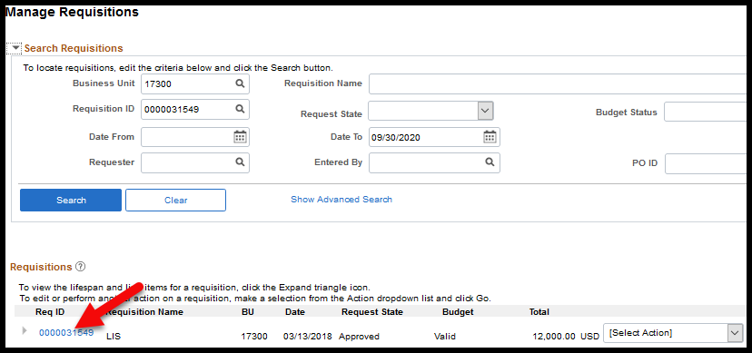
If the Source Status is Available, and the requisition has completed workflow as approved for more than an hour, it’s likely the RFQ Required was selected. | 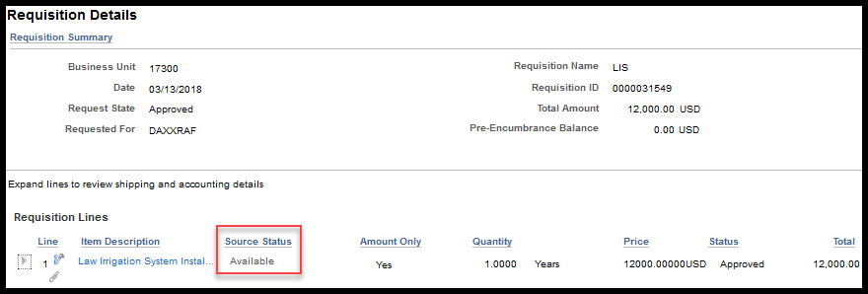
Note: The RFQ Required being selected prevents a requistion from ever sourcing to a PO directly. RFQ Required should ONLY be selected on requisitions intended to go out for bid.
Confirm RFQ Required was selected by selecting Edit from the Select Action dropdown of the requisition on the Manage Requisitions page and clicking Go. | 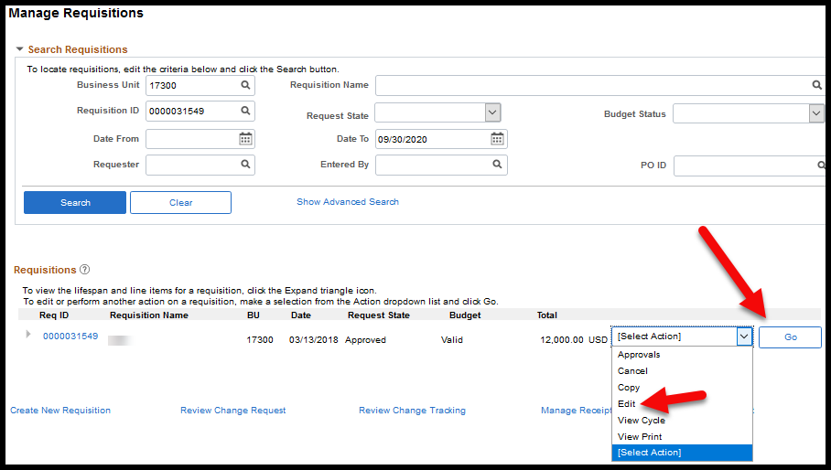
Select the Line Details icon for each line on the Edit Requisition – Review and Submit page that displays. | 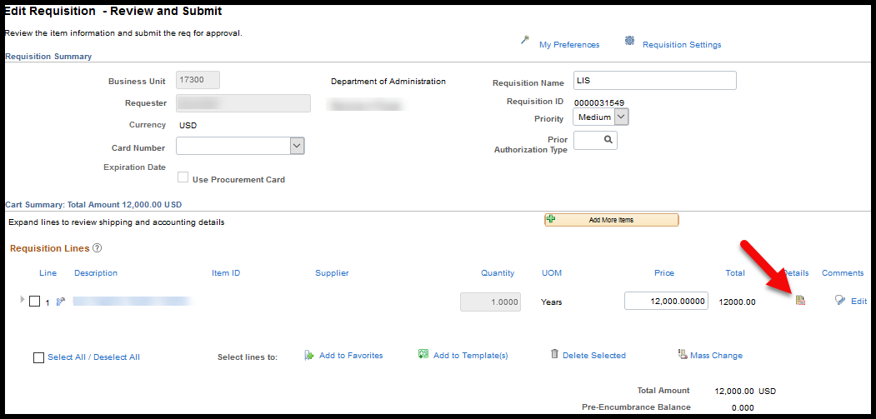
Check if RFQ Required was selected on the Line Details page. | 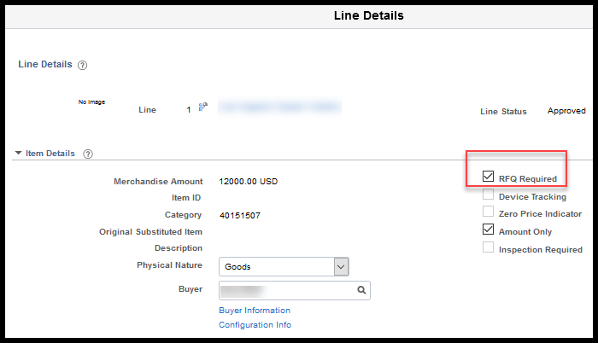
Or, if the Source Status is Error the requisition is likely stuck on the Sourcing Workbench. | 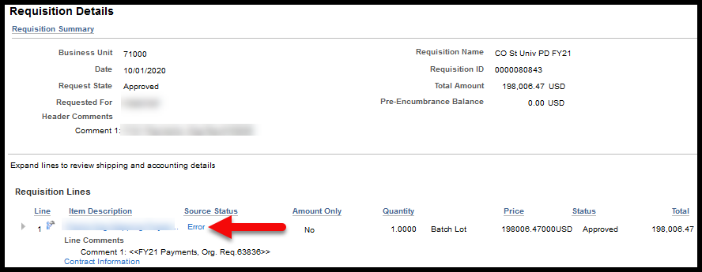
Select the Error link to be taken to the Sourcing Workbench – Sourcing Details for Staging Information about the requisition error. | 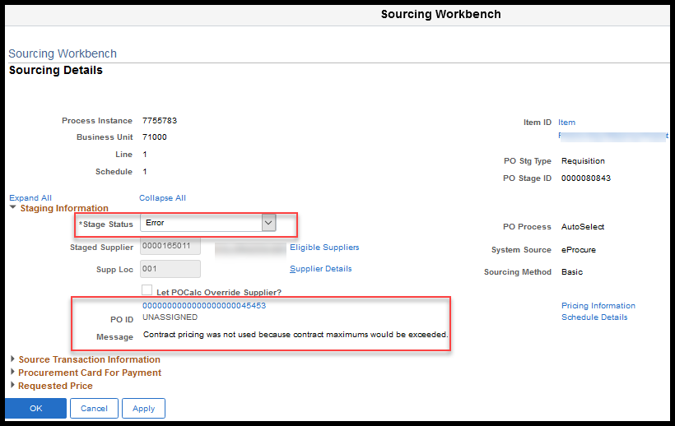
Note: For any issue that cannot be determined by the agency, please submit a ManageEngine Service Desk Request.
- Sourcing Workbench Errors
At least at the end of the month, if not more frequently, it is recommended that each agency check the Sourcing Workbench for requisitions not sourcing to POs due to errors.
Navigation: Requisitions & PCards > Manage Requisitions > Sourcing Workbench OR POs & Receiving > Purchase Orders > Mange Purchase Orders > Sourcing Workbench
Please see the job aid, Working Errors on the Sourcing Workbench, located on the SMART Web for more information about resolving the errors.
- Un-Dispatched POs
At the end of each month it is recommended that each agency look for Purchase Orders (POs) that are not dispatched as expected using the Add/Update Purchase Orders page.
Navigation: POs & Receiving > Purchase Orders > Add/Update Purchase Orders > Find an Existing Value
In the Search Criteria section, POs can be filtered by PO Status. | 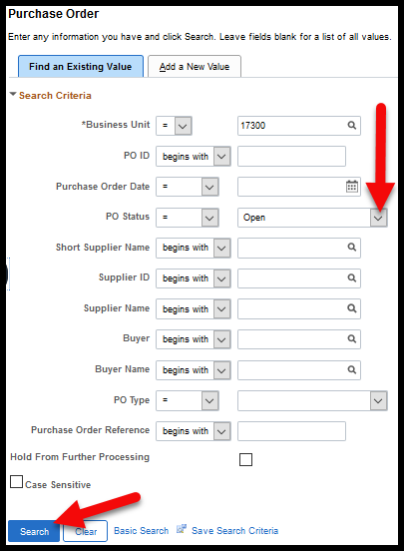
Note: Updates to the PO will need to be made by the POs Buyer or by a user who has been given authority to make changes for the listed Buyer by SMART Security via a ManageEngine Service Desk Request.
Options for managing a PO unexpectedly still in Open status:
Approve the PO so that it can be dispatched by selecting the Approve icon. | 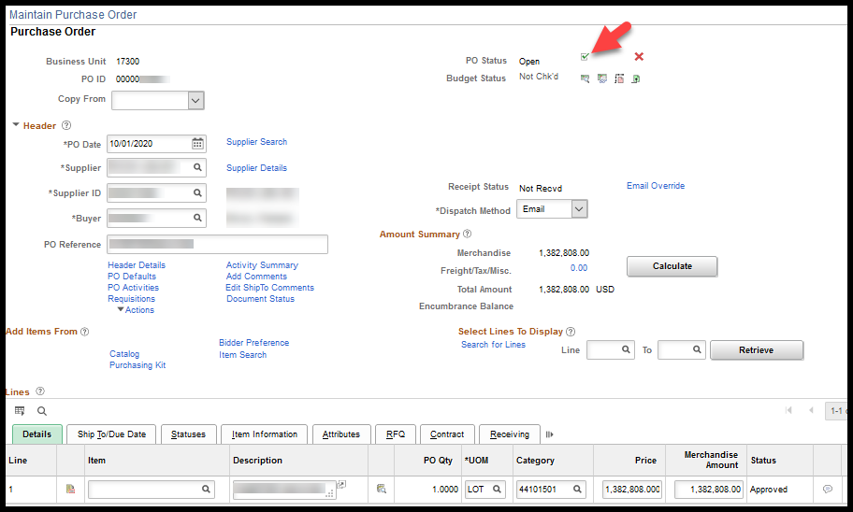
Or cancel the PO if no longer needed by selecting the Cancel PO icon. | 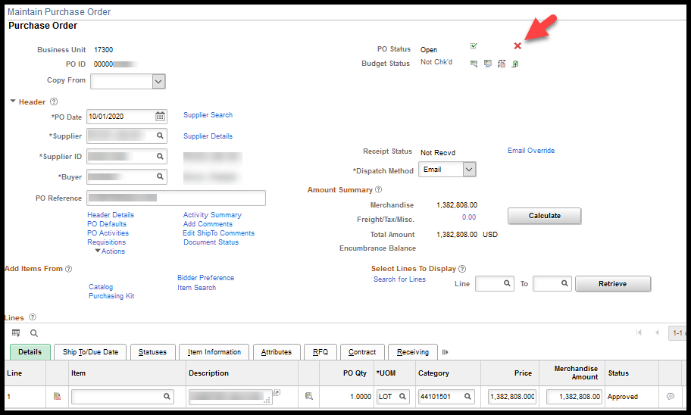
Note: The PO cannot be canceled if the PO has vouchers against it and was put into Open status by a change order.
Options for managing a PO unexpectedly still in Approved status:
Check the Budget Status on the PO. If in Error, select the link for more information about the budget error. | 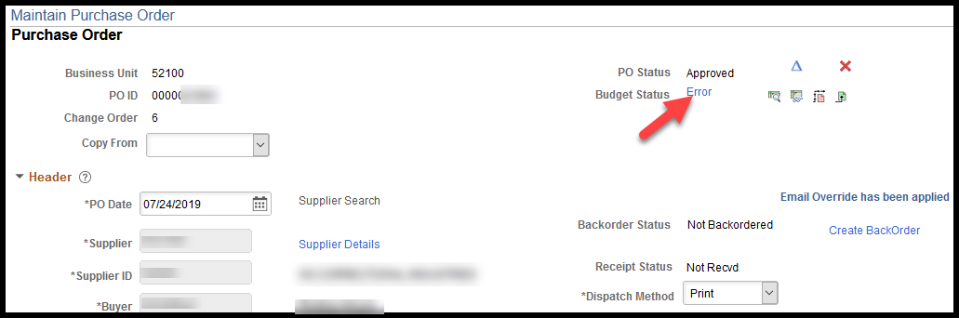
Please see the job aid, Reviewing Budget Check Exceptions, located on the SMART Web for more information about resolving the errors.
Check the Dispatch Method on the PO. If the agency default is Email and that is the desired method for this PO, select the Header Details link to find out if the supplier record has an email for dispatch associated to it. | 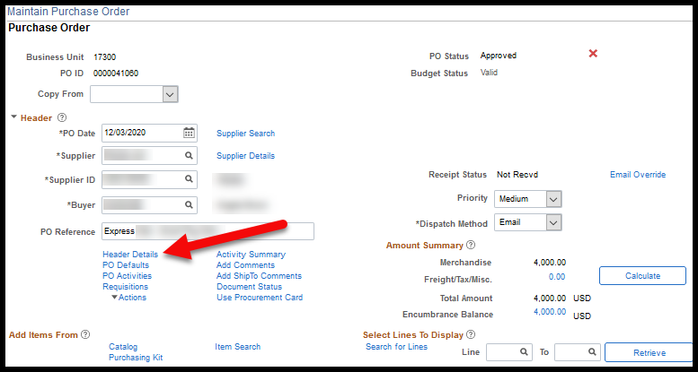
On the PO Header Details page check to see if there is an Email ID populated under the Supplier/Contact Fax/Email section.  If populated and accurate to where the PO should go, no change is needed. | 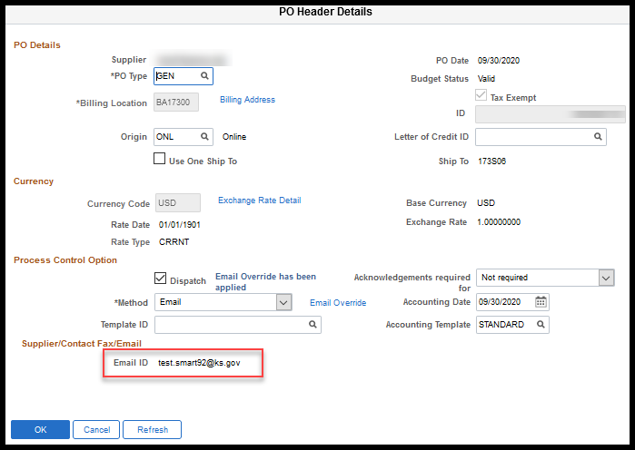
If not populated or inaccurate to where the PO should go, there are options. | 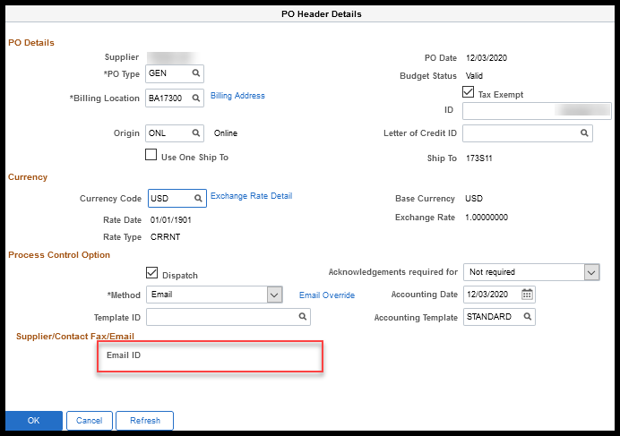
Use the Email Override feature to provide a one-off email for dispatch.  Please see job aid, Modifying PO Email Destinations, for more information. | 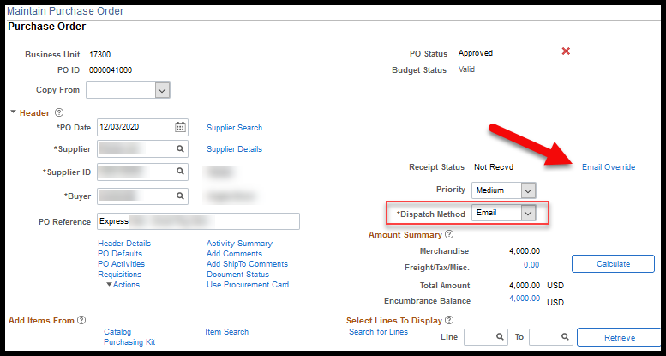
Or change the Dispatch Method to Print and notify the supplier via a different method. | 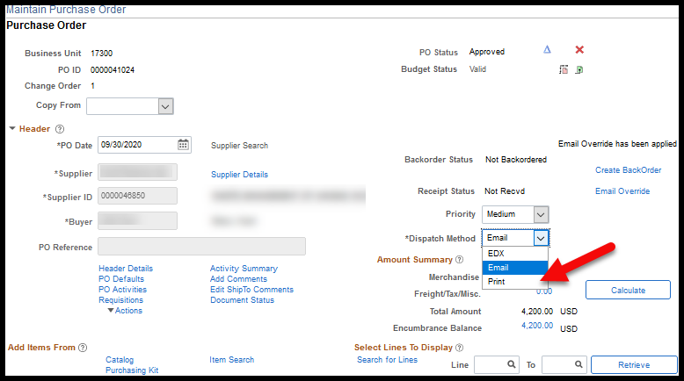
- KS_PO_CLOSED_PO
The PO Close monthly process runs on the Saturday following the first work day of the new month. The KS_PO_CLOSED_PO query will provide a list of the POs that were cloased during the PO Close monthy porcess.
Navigation: POs & Receiving > PO Utilities > Query Viewer
Please see the job aid Using the KS_PO_CLOSED_POS Query, located on the SMART Web for more information about running the query.
- KS_PO_MAY_CLOSE
The KS_PO_MAY_CLOSE query provides a list of POs that may close during the next PO Close monthly process run. Agencies are encouraged to run this report prior to the PO Close montly process running the Saturday following the firest work work day of the new month.
Navigation: POs & Receiving > PO Utilities > Query Viewer
Please see the job aid Using the KS_MAY_CLOSE Query, located on the SMART Web for more information about running the query.
- PO Budgetary Activity Report
The PO Budgetary Activity Report is used to indentify POs that have an outstanding encumbrance. It is recommended that this report be reviewed monthly to indentfy puurchase orders carrying encumbrances that should not.
Navigation: POs & Receiving > PO & Receiving Reports > KS PO Budgetary Activity
Anlyze the report to identify if the oustanding balance is no longer valid, for example:
- Has the supplier been paid without the PO being associated?
- Is the PO still needed for the payment for which it was encumbered?
- Should the remaining encumbrance be released?
If the encumbrance should be released based on the analysis, the procedure for release should be whether a contract was associated to the PO.
If a contract IS associated to the PO, please see job aid Closing a Contract PO Not Used in Full, located on the SMART Web for more information about returning the unspent purchasing amounts back to the contract.
If a contract IS NOT associated to the PO, please see job aid Manual PO Close Process, located on the SMART Web for information about closing a PO.
- PCard Transactions
At least at the end of the month, if not more frequently, it is recommended that each agency run the KS_PO_PCARD_STATUS report to view PCard transactions that have not yet been vouchered.
Navigation: POs & Receiving > PO Utilities > Query Viewer
To review this report based on a monthly statement cycle, enter the Billing Date as the first day of the billing cycle on the 21st of the month to be reviewed. However, this report can be ran for any date period.
Please see job aid Procurement Card Training Guide, located located on the SMART Web for information about processing PCard transactions.

