State of Kansas
Requisition Attachments for Office
of Procurement and Contracts
Statewide Management, Accounting and Reporting Tool

Date Created: | 02/22/2016
Version: | 2.0
Last Updated Date: | 6/25/2020
Process: | When sending a Requisition to the Office of Procurement and Contracts, attachments are often required. This training document will give you the steps needed to attach your documents where the Office of Procurement and Contracts can easily access them.  Due to the delivered system design, Attachments at the Header level are difficult to access. Please attach all documentation at the Line level on Requisitions.
Comments & Attachments – Line Level | - When on the ‘Requisition Review and Submit’ page, under the Comments section click Add or Edit or the icon to add attachments to the Requisition line.  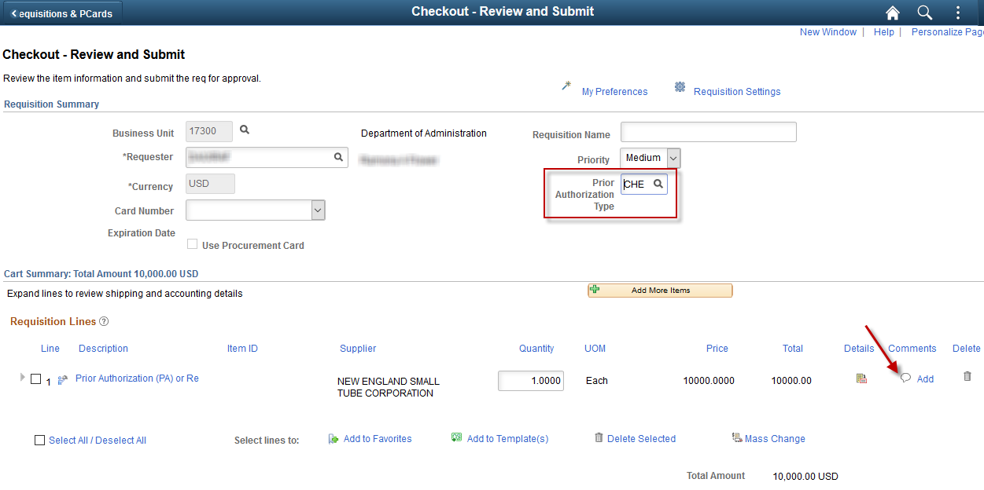  *NOTE: Attachments are only needed on one (1) line. Please do not put the same attachments on every line of the Requisition.

Add Attachments | - Click the Add Attachments button, then you will be prompted to Browse for the document and then Load the document.  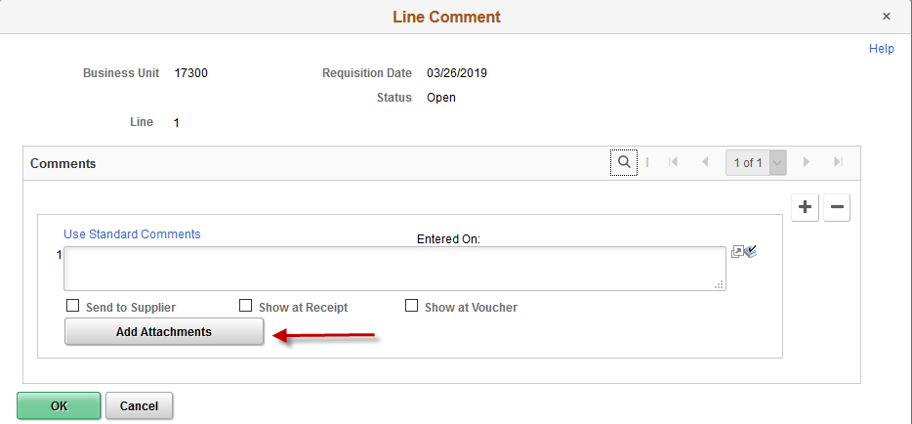
Multiple Attachments | - If you have multiple attachments to enter on one line, you can press the Add Attachments button again. Or the + button if more comments are needed.  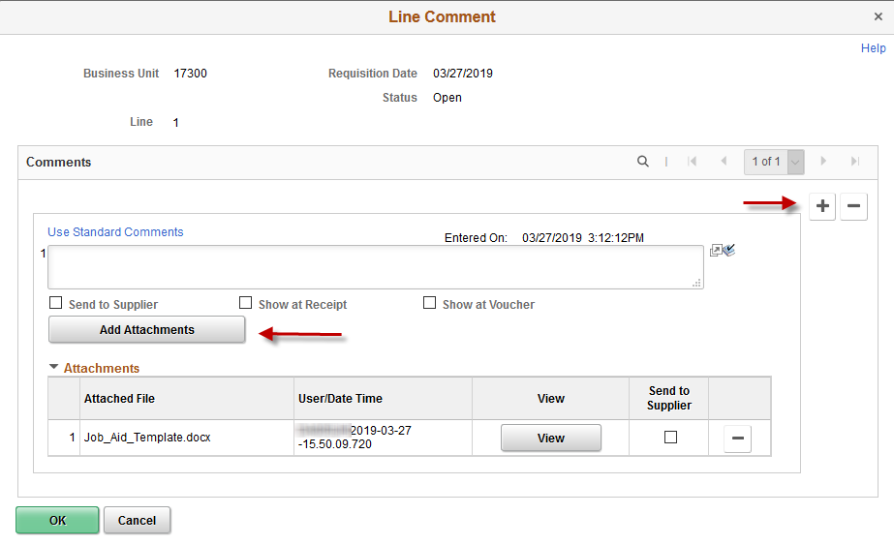

Finish Requisition | - When done adding attachments, click the OK button.  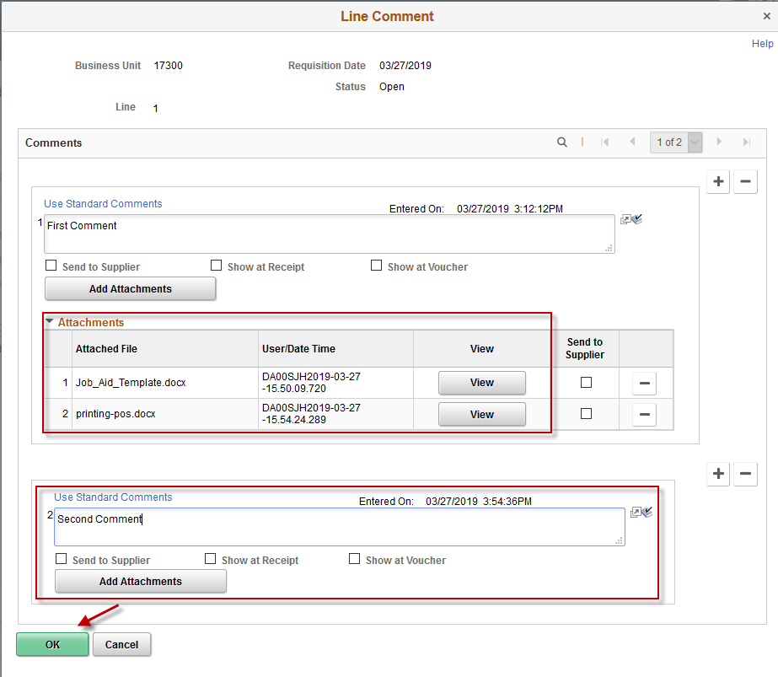  - Finish your Requisition as normal.

