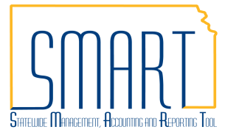
State of Kansas
Manage Requisitions
Statewide Management, Accounting and Reporting Tool

Date Created: | 11/04/2015
Version: | 3.0
Last Updated Date: | 6/25/2020
Fluid Navigation | Begin by navigating to the Requisition Settings page using fluid homepages.  - Click the Requisitions & Pcards homepage link  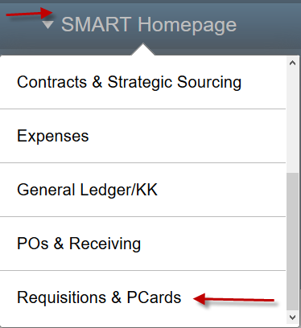
- Click the Manage Requisitions tile
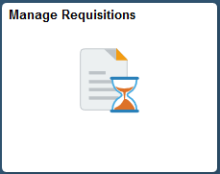
- Select the Manage Requisitions page
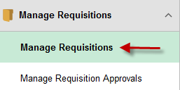
Classic Navigation | Or, begin by navigating to the Requisition Settings page using classic navigation.  - Click the NavBar icon
- Click the Navigator icon
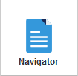
 | - Click the eProcurement link
- Click the Manage Requisitions link
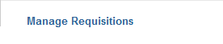
Manage Requisitions Page | Use the Manage Requisitions page to view a list of requisitions in various statuses. From the Manage Requisitions page, the following tasks can be performed for requisitions:  - Review details  - View approval workflow  - Cancel  - Copy  - Edit
Search Requisitions | Using the Manage Requisitions page – Search Requisitions function, specific requisitions can be located by specifying specific search criteria such as Requisition ID, dates, Requester, Entered By (Requisitioner who entered the requisition), and by PO ID (if already sourced to a PO).  Note: Only users with appopriate security are able to view the Requester and Entered By fields.
Requistion Details | Select the Req ID link for a specific requisition to access the Requisition Details page where details about the specific requisition can be viewed.  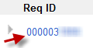  Note: The PO Information and Contract Information links will appear only if a purchase order has been created for the requisition, or a contract has been applied to the requisition.

Select Action – Approvals, Cancel, Copy, & Edit | The Select Action list enables users to perform requisition maintenance functions including:  - Approvals to view the progress and status of the requisition approval(s)  - Cancel if the requisition no longer needs to be processed  - Copy to copy the existing requisition to create a new requisition  - Edit to modify the existing requisition  - For example, to add comments or change shipping information  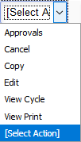  Note: These options exist for each requisition available on the Manage Requisitions page. Actions may be performed on only one requisition at a time. To do so, simply click the Select Action list in the row of the desired requisition.
 | After a selection has been made from the Select Action drop-down list, click the Go button.
Edit Requisition Page | If the Edit action is selected, the user may receive a message advising that the requisition has already been submitted into the approval workflow process and warning that editing could restart workflow.  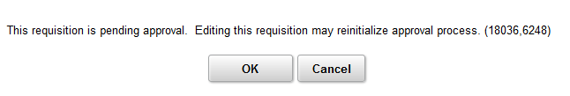  Note: Edits, including adding comments and attachments or updating the account code, can be made to the requisitions without starting approval workflow. However, any chartfield change, other than the account code, or change to the Ship To, will restart approval workflow.
Uses & Accessibility | The Edit Requisition page is used to perform activities, such as adding comments, changing quantities ordered, and modify schedule and/or distribution information.  This page is accessible only for open or pending requisitions and is inaccessible for requisitions that have been canceled or sourced to a purchase order (PO).
Requisition Lines | The items added to the requisition are displayed in the Requisition Lines section. The Requisition Lines section includes details such as the Description of the items, Quantity of items ordered, and the Total amount of the requisition.

Comments & Attachments – Line Level | The Comments icon opens the Line Comments page, which allows for comments and attachments to be added to a requisition.  Note: The Line Comments button will appear ‘empty’ if no line comments have been entered. If Line Comments have been entered, the Line Comments button will appear with ‘lines’, indictating there is information available for review.  Use the Line Comments page to record a comment about the requisition line item, or to communicate a comment about the line item to the supplier. Select the Send to Supplier check box to send the comment to the supplier.  Selecting the Add Attachment button allows attachments to be associated to the requistions using SMART provided prompts to guide the user through the file attachment process.  For information regarding Attachment policies:  - Info Circular 16-A-007 Attachments in SMART (October 12, 2015_ Supersedes: 16-A-005 – Regarding attachments for audit review  - Requisition Attachments for Procurement and Contracts – Regarding where to attach documents for Prior Authorization support
Shipping / Accounting Lines | Additional editing can be performed from this page. Clicking the Expand Section button displays additional information related to the requisition line, including the shipping line and accounting line(s).  Notice thst SMART auto assigns a Shipping Line to the requisition line.
Managing Shipping Lines | If desired, use the + button to add additional Ship To locations. This function allows you to split the Shipping Line (schedule) into multiple Ship To address lines.  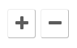  Note: If you split the schedule, be sure to adjust the Quantity and update the Ship To locations for each schedule line.  Alternatively, if there are multiple schedule lines and you need to delete or remove a schedule line, use the – button to delete or remove shcedule lines as desired.

One Time Address | If necessary, use the Add One Time Address link to navigate to the Shipping Address page.  Clicking the Add One Time Address link opens the Shipping Address page.  The Shipping Address page is used to enter a shipping address that is not currently defined in SMART as a “Ship To” location.  Use the Shipping Address page to update the shipping address information for the requisition line to make a one-time shipping address change, for example, a shipment to a construction site or other temporary location.
Due Date | The Due Date can be used to establish when delivery should be made for the line item.
Managing Accounting Lines | Use the Accounting Lines section, Chartfields1, and Chartfields2 tabs to modify chartfield values as necessary. Use the Chartfields1 tab to edit default chartfield values of Location, Percent, Merchandise Amt and GL Unit.  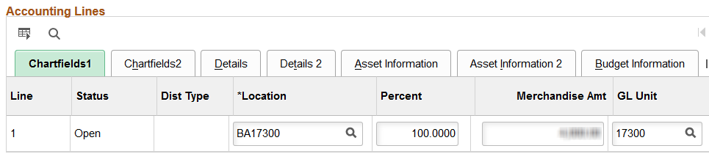  Use the Chartfield2 tab to edit default chartfield values and to enter the Account code for the accounting line (these source to the PO as distribution lines).  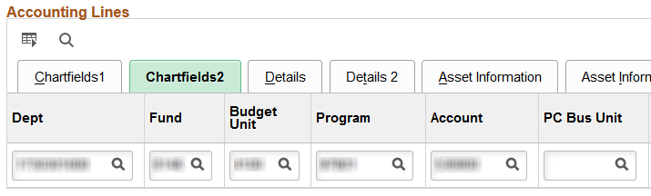  If desired, use horizontal scrollbar to navigate to the far right side of the page to access additional chartfield information and to access the buttons used for splitting or removing accounting (distribution) lines.  If necessary, use the + button to add additional accounting lines to split the distribution (funding) for the requisition line. Alternatively, use the – button to delete or remove accounting (distribution) lines as necessary.  Note: The State of Kansas is not using the Details tab.

Asset Information | If the item is to become a fixed asset item, use the Asset Information tab to enter asset details for the item.  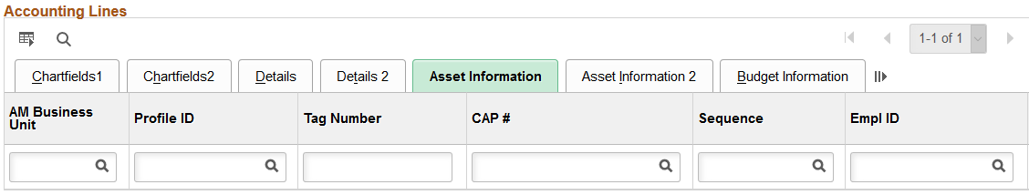  Note: It is State of Kansas business practice that any agency with assets that have a value of $5,000.00 or greater is required to use the Asset Management module in SMART.  For more information about asset management, please refer to the ‘PM 13,001 – Capital Asset Records’ policy manual located on the Kansas Department of Administration website at:  https://www.admin.ks.gov/offices/chief-financial-officer/policy-manual
AM Business Unit & Profile ID | Use the AM Business Unit field to enter an Asset Management business unit number to associate with the asset item.  If you consider an item to be an asset, you must populate both the AM Business Unit field and the Profile ID field. Both of these fields must contain data for the information to be passed through SMART into the Asset Management module.  The Profile ID sets defaults for the asset such as asset class, asset type and depreciation rules in the Asset Management Module. The Profile ID field becomes a required data entry field whenever dates are entered in the AM Business Unit field.  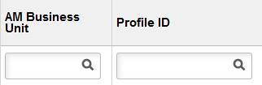  Note: If you enter data in the AM Business Unit field, you must also enter data in the Profile ID field. SMART will not allow you to progress forward until this is completed.
Tag Number | Enter the asset Tag Number if available, into the Tag Number field.  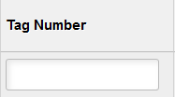  Note: When using asset tag numbers, you need to split the lines (add additional lines) using the + button. SMART allows only a Quantity of one on each line for which an asset tag number is being entered.

Line Details –  Contract & RFQ Required | To review the line detail information, use the Line Details icon to open the Line Details page, where line detail information, such as adding a Contract ID or making the line RFQ Required, may be edited as necessary.  Use the Contract ID field to enter the Contract ID number if applicable to your requisition. If you do not know the Contract ID number, use the Lookup button (magnifying glass) to view and select from the available list of Contract ID numbers.  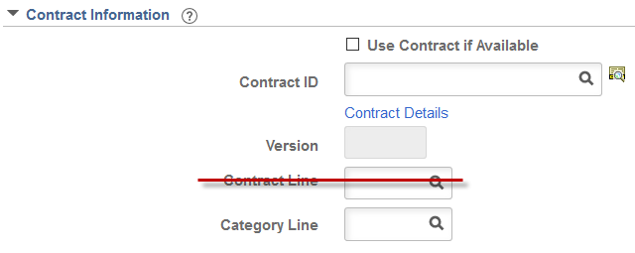  Note: The State of Kansas is not using the Contract Line field for requisitions. Please do not enter data in the Contract Line field for a requisition.  Use the RFQ Required checkbox if this requistion is intended to be bid.  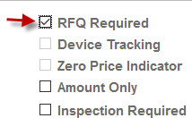  If you edit information on the Line Details page, use the OK button to submit the changes.
Mass Change | The Mass Change link can be used to add or change the Supplier ID, Buyer, Category, Contract ID, Ship To Location, Chartfield information, Asset Information, or to apply the RFQ Required checkbox to any one line, multiple lines, or all lines.  Note: Only the Requisition lines that have been selected by checking the box to the left of their line information, will be affected by the changes/additions completed on the Mass Change link.  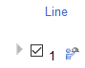
Not Saving Changes | If it is decided that the changes made are not needed merely navigate off the page without saving.  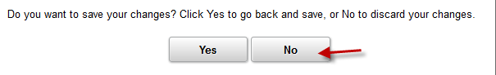
Save for Later | The save, preview, and submit requisition functions are located at the bottom of the page. Use the right scrollbar to navigate to the bottom of the page, if necessary.  Note: Budget checking in SMART is performed by an hourly batch process. Therefore, you do not need to use the Check Budget icon on the Review and Submit page of the requisition.  Use the Save for Later button to save the requisition for later use. When you click the Save for Later button, SMART will stay on the Review and Submit page.  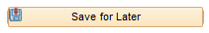  Note: It is important to know that the Save for Later button does not submit the requisition into the SMART approval workflow process. Using the Save for Later button enables you to save the requisition for later use, and access it again from Manage Requisitions, without entering the requisition into the SMART workflow approval process.
Save & Submit | The Save & Submit button is used to save the requisition, and submit it for approval, sourcing and dispatching to the supplier.  Note: Invalid chartfield values or chartfield combinations on the requisition will cause an error message when a requisition is saved. If the error message displays, correct the entry of chartfield values on the requisition and save the requisition.  Note: The requisition remains editable while the requisition status is “Open” or “Pending”.
Confirmation | The Confirmation page informs the user that the request has been successfully saved and submitted into workflow for approval. The Confirmation page provides summarized information about the request, including the requisition ID and total price, and provides an overview of the workflow approval routing for the requisition.  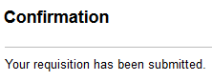
View Printable Version | If desired, the View printable version link can be used to preview and print the requisition.  Note: It is State of Kansas best practice not to print requisitions as all information is stored and accessible in SMART.  Click the View printable version link.
Manage Requisitons | The Manage Requisitions link can be used to navigate back to the Manage Requisitions page where you can further process the requisition.

