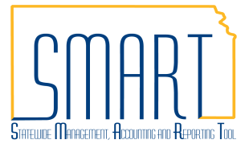
State of Kansas
Creating Requisitions Summarization
Statewide Management, Accounting and Reporting Tool
Date Created: | 10/20/2015
Version: | 3.0
Last Updated Date: | 6/23/2020
Fluid Navigation | Begin by navigating to the Requisition Settings page using fluid homepages.  - Click the Requisitions & Pcards homepage link  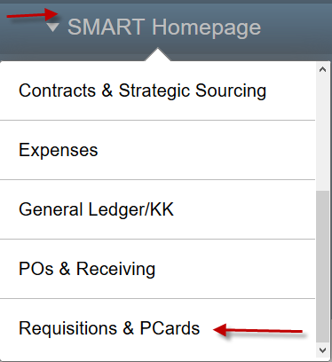
- Click the Create Requisitions tile
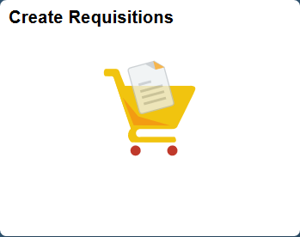
Classic Navigation | Or, begin by navigating to the Requisition Settings page using classic navigation.  - Click the NavBar icon
- Click the Navigator icon
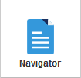

 | - Click the eProcurement link
 | - Click the Requisition link
Requisition Settings Page  Business Unit | The Business Unit search field defaults based on your agency number. Depending on your security level, you can accept the default or enter a different business unit number.
Requester | Use the Requester field to enter the SMART User ID for the Requester. You MUST replace the Default Requester ID with a valid SMART User ID.  Select a Requester who holds a procurement card. This enables you to use the Requester’s procurement card information on the requisition.  Note: If you do not know the Requester’s SMART User ID, use the Lookup button (magnifying glass) to display a list of available values.
Requistion Name | Use the Requisition Name field to enter a requisition description, if desired.
Prior Authorization Type | Use the Prior Authorization Type field to enter a prior authorization type, as needed.  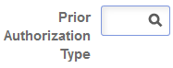  Note: If you do not know the Prior Authorization Type code, use the Lookup button (magnifying glass) to display a list of availabe values.  For information regarding Processing Prior Authorization Requisitions, please go to http://www.da.ks.gov/purch/11-03Circular.doc

Procurement Card | For the State of Kansas, SMART defaults the procurement card information into the requisition if:  - The Requester holds a procurement card  - The Requisitioner enters the (procurement card holding) Requester’s SMART User ID in the Requester field when creating the requisition  Note: All suppliers are now setup to accept PCards.  If a Requester holds more than one procurement card for the State of Kansas, use the Card Number drop-down list to choose the correct procurement card number.  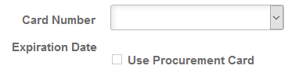  For security purposes, SMART encrypts the procurement card number allowing the Requisitioner to view only the last four digits.  Once a card is assigned, the expiration date will auto fill and the Use Procurement Card checkbox will be checked.  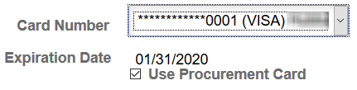  If the Requester was set up to use a procurement card as the default payment method on requistions, SMART automatically defaults procurement card information on every requisition that is created using that Requester. If necessary, change the procurement card number to the correct card number using the Card Number drop-down list.  If you are creating a requisition that should not be paid with a procurement card, simply remove the default selection in the Use Procurement Card check box by clicking in the check box. Deselecting the Use Procurement Card check box removes the Requester’s procurement card information from the Requisition.
Buyer | Use the Buyer field to assign a buyer to a requisition. Buyer is required and can be entered here for all lines or can be entered on the Review and Submit page per line. The Buyer will also default in based on what has been associated to the Requester ID when the Requistion Settings page is confirmed.  Note: If you do not know the Buyer ID, use the Lookup button (magnifying glass) to display a list of availabe values.
Remaining Fields | The remaining fields on the Requisition Settings page may remain blank.  However, if your requisition is is not being bid and the supplier is known, or has multiple lines with the same chartfields, it may be in your best interest to fill in some additional fields before continuing.

Override | To apply changes to defaulted fields, such as the Ship To and chartfields, with the field settings you define here, click the Override radio button.  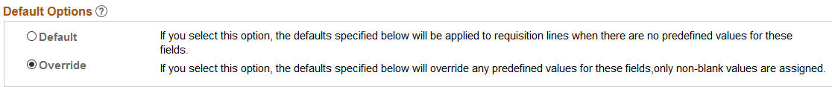
Supplier | Use the Supplier field to assign a Supplier to the entire requisition.  Supplier Location field will autopopulate based on the default location once the Supplier is chosen, but may be manually updated if a different payment location type (e.g. ACH) has been requested.  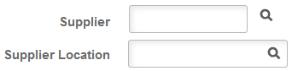  Note: If you do not know the Supplier ID, use the Lookup button (magnifying glass) to display a list of availabe values.
Category | Use the Category field to assign the same Category Code on each requisition line.  Note: If you do not know the Category Code, use the Lookup button (magnifying glass) to display a list of available values.
Unit of Measure | The Unit of Measure will default as EA, you can change the UOM on the Requisition Settings page or when adding items, if desired.  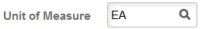  Note: If you do not know the Unit of Measure, use the Lookup button (magnifying glass) to display a list of availabe values.
Ship To | The Ship To address will default in values associated to the Requester ID when the Requistion Settings page is confirmed. This can be modified here or on the Review & Submit page.  Note: If you do not know the Ship To, use the Lookup button (magnifying glass) to display a list of availabe values.
Due Date | Use the Due Date field on this page if all lines for the requisition will have the same due date. This can be modified on the Create Requisition or Review & Submit pages.  Note: The Due Date can be selected using the Calendar icon.

Asset Information | Use the Asset Information tab on this page if all lines for the requisition will have the same asset information. This can be modified on the Review & Submit page.  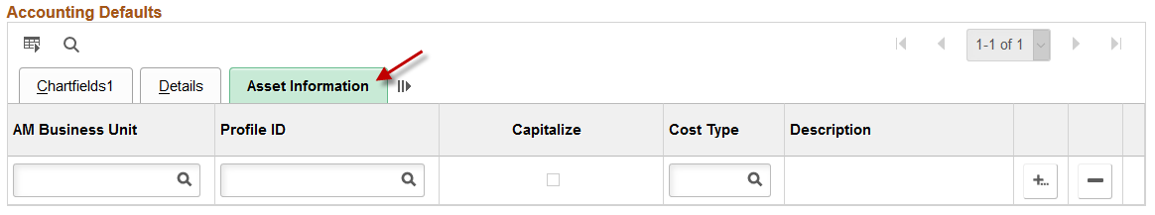  Note: It is State of Kansas business practice that any agency with assets that have a value of $5,000.00 or greater is required to use the Asset Management module in SMART.  For more information about asset management, please refer to the ‘PM 13,001 – Capital Asset Records’ policy manual located on the Kansas Department of Administration website at:  https://www.admin.ks.gov/offices/chief-financial-officer/policy-manual
Apply Requisition Settings | To add items or services to the requisition, scroll to the bottom and click ‘OK’. Clicking the OK button progresses you to the Create Requisition page.  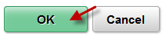
Chartfield Defaults | A pop-up box will appear, advising the default values associated with the entered Requester ID. Click Yes through this message.  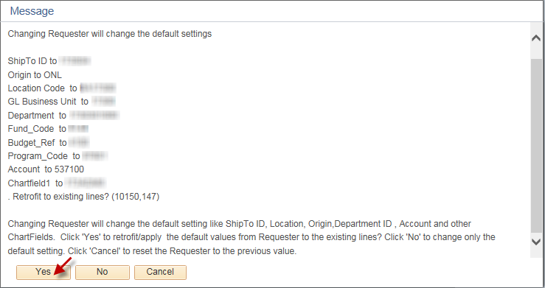
Requisition Page  Special Requests | Click the Special Requests link. The Special Requests option is commonly used to add items or services to a Requisition.  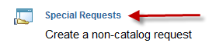
Item Description | The Item Description field is used to enter the description of what’s being requisitioned.
Price | The Price field is used to enter the cost of the items being requisitioned.

Unit of Measure | The Unit of Measure field has a default value from the Requisition Settings page. It may also be changed here as needed.  Note: If you do not know the Unit of Measure, use the Lookup button (magnifying glass) to display a list of availabe values.
Quantity | The Quantity field is used to enter the number of these items being requisitioned.
Category Code | The Category Code field has a default value from the Requisition Settings page, if one was entered.  If not, you will need to choose a Category Code for the requested item.  If one was entered, you can change the default Category Code for this item.  Note: If you do not know the Category Code, use the Lookup button (magnifying glass) to display a list of availabe values.
Due Date | Use the Due Date field has a defalut value from the Requistion Setting page, if one was entered.  If not, you will need to choose a Due Date for the requested item.  If one was entered, you can change the default Due Date for this item.  Note: The Due Date can be selected using the ‘Calendar’ icon.
Supplier | The Supplier ID and Supplier Name fields have a default value from the Requisition Settings page, if one was entered.  If not, you will need to enter a Supplier ID and/or Supplier Name at this time.  If one was entered, you can change the default Supplier ID and/or Supplier Name at this time.  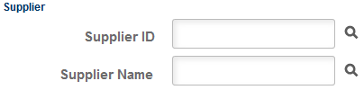  Note: If you do not know the Supplier ID or Supplier Name, use the Lookup button (magnifying glass) to display a list of availabe values.

Add to Cart | Scroll to the bottom of the page, and click the Add to Cart button.  Note: Clicking the Add to Cart button removes the item description, price and quantity information that you entered and reverts the Unit Of Measure, Category, Due Date, Supplier ID and Supplier Name fields to their default values.
Checkout | Once all the items or services have been added to the requisition, use the Checkout button at the top of the page to review and submit the requisition.
Checkout – Review and Submit | Use the Checkout – Review and Submit page to review and edit the requisition details, prior to saving and submitting the requisition into the SMART workflow process for approval.
Requisitions Settings | To change any of the default information entered on the Requisitions Settings page, click the Requisition Settings link near the top of the Review and Submit page.  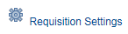  Note: Any changes made on this page, will affect all of the requisition lines on the Review and Submit page.
Requisition Lines | The items added to the requisition are displayed in the Requisition Lines section. The Requisition Lines section includes details such as the Description of the items, Quantity of items ordered, and the Total amount of the requisition.
Shipping / Accounting Lines | Additional editing can be performed from this page. Clicking the Expand Section button displays additional information related to the requisition line, including the shipping line and accounting line(s).  Notice thst SMART auto assigns a Shipping Line to the requisition line.
Managing Shipping Lines | If desired, use the + button to add additional Ship To locations. This function allows you to split the Shipping Line (schedule) into multiple Ship To address lines.  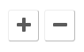  Note: If you split the schedule, be sure to adjust the Quantity and update the Ship To locations for each schedule line.  Alternatively, if there are multiple schedule lines and you need to delete or remove a schedule line, use the – button to delete or remove shcedule lines as desired.

One Time Address | If necessary, use the Add One Time Address link to navigate to the Shipping Address page.  Clicking the Add One Time Address link opens the Shipping Address page.  The Shipping Address page is used to enter a shipping address that is not currently defined in SMART as a “Ship To” location.  Use the Shipping Address page to update the shipping address information for the requisition line to make a one-time shipping address change, for example, a shipment to a construction site or other temporary location.
Managing Accounting Lines | Use the Accounting Lines section, Chartfields1, and Chartfields2 tabs to modify chartfield values as necessary. Use the Chartfields1 tab to edit default chartfield values of Location, Percent, Merchandise Amt and GL Unit.  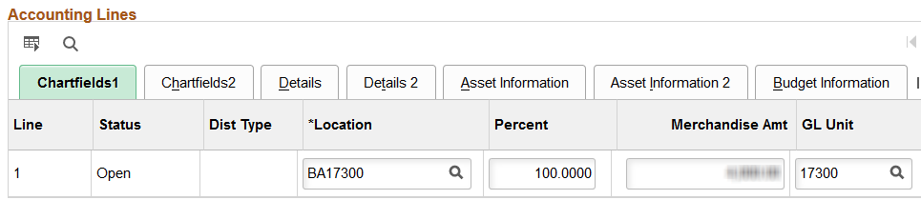  Use the Chartfield2 tab to edit default chartfield values and to updatethe Account code for the accounting line, if needed. The Account code will default in from the category code selected, but it is the agencies responsibility to ensure the correct account code for their purchase is used. The Accounting lines will source to the PO as distribution lines.  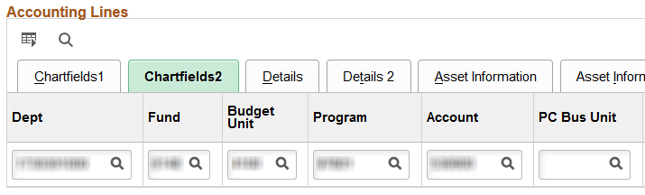  If desired, use horizontal scrollbar to navigate to the far right side of the page to access additional chartfield information and to access the buttons used for splitting or removing accounting (distribution) lines.  If necessary, use the + button to add additional accounting lines to split the distribution (funding) for the requisition line. Alternatively, use the – button to delete or remove accounting (distribution) lines as necessary.  Note: The State of Kansas is not using the Details tab.

Asset Information | If the item is to become a fixed asset item, use the Asset Information tab to enter asset details for the item.  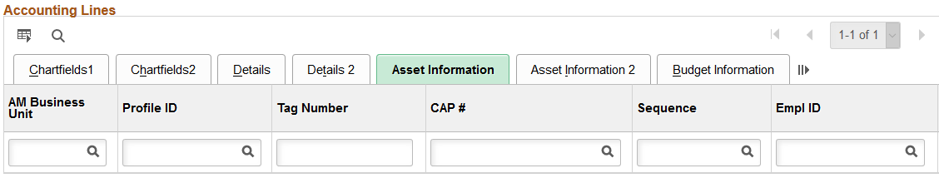  Note: It is State of Kansas business practice that any agency with assets that have a value of $5,000.00 or greater is required to use the Asset Management module in SMART.  For more information about asset management, please refer to the ‘PM 13,001 – Capital Asset Records’ policy manual located on the Kansas Department of Administration website at:  https://www.admin.ks.gov/offices/chief-financial-officer/policy-manual
AM Business Unit & Profile ID | Use the AM Business Unit field to enter an Asset Management business unit number to associate with the asset item.  If you consider an item to be an asset, you must populate both the AM Business Unit field and the Profile ID field. Both of these fields must contain data for the information to be passed through SMART into the Asset Management module.  The Profile ID sets defaults for the asset such as asset class, asset type and depreciation rules in the Asset Management Module. The Profile ID field becomes a required field whenever data is entered in the AM Business Unit field.  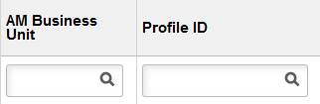
Tag Number | Enter the asset Tag Number if available, into the Tag Number field.  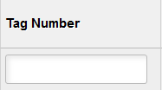  Note: When using asset tag numbers, you need to split the lines (add additional lines) using the + button. SMART allows only a Quantity of one on each line for which an asset tag number is being entered.

Line Details –  Contract | To review the line detail information, use the Line Details icon to open the Line Details page, where line detail information, such as adding a Contract ID or making the line RFQ Required, may be edited as necessary.  Use the Contract ID field to enter the Contract ID number if applicable to your requisition. If you do not know the Contract ID number, use the Lookup button (magnifying glass) to view and select from the available list of Contract ID numbers.  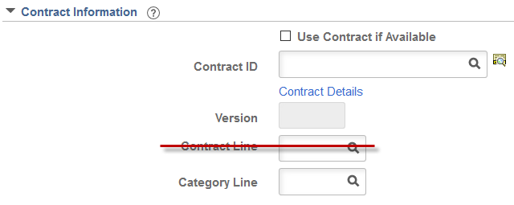  Note: The State of Kansas is not using the Contract Line field for requisitions. Please do not enter data in the Contract Line field for a requisition.  Important: If the supplier/puchase is under contract the contract must be applied to all lines of the requisition. Please see ‘Policy Manual 10,300 – Statewide Encumbrance Policy’ for more details.
Line Details - RFQ | Use the RFQ Required checkbox if this requistion is intended to be bid.  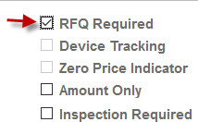  Note: If the RFQ Required checkbox is selected the requisiton WILL NOT source to a PO, as the intention of RFQ Required is that the requistion is inted to be bid.
Line Details – Amount Only | Use the Amount Only checkbox if payments need to be made by dollar amount and not by specific quantity.  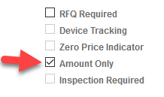  Note: If you edit information on the Line Details page, use the OK button to submit the changes.

Mass Change | The Mass Change link can be used to add or change the Supplier ID, Buyer, Category, Contract ID, Ship To Location, Chartfield information, Asset Information, or to apply the RFQ Required checkbox to any one line, multiple lines, or all lines.  Note: Only the Requisition lines that have been selected by checking the box to the left of their line information or using the Select All / Deselect All link, will be affected by the changes/additions completed on the Mass Change link.  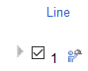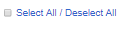
Comments & Attachments – Line Level | The Comments icon opens the Line Comments page, which allows for comments and attachments to be added to a requisition.  Note: The Line Comments button will appear ‘empty’ if no line comments have been entered. If Line Comments have been entered, the Line Comments button will appear with ‘lines’, indictating there is information available for review.  Use the Line Comments page to record a comment about the requisition line item, or to communicate a comment about the line item to the supplier. Select the Send to Supplier check box to send the comment to the supplier.  Selecting the Add Attachment button allows attachments to be associated to the requistions using SMART provided prompts to guide the user through the file attachment process.  For information regarding Attachment policies:  - Info Circular 16-A-007 Attachments in SMART (October 12, 2015_ Supersedes: 16-A-005 – Regarding attachments for audit review  - Requisition Attachments for Procurement and Contracts – Regarding where to attach documents for Prior Authorization support
Save for Later | The save, preview, and submit requisition functions are located at the bottom of the page. Use the right scrollbar to navigate to the bottom of the page, if necessary.  Note: Budget checking in SMART is performed by an hourly batch process. Therefore, you do not need to use the Check Budget icon on the Review and Submit page of the requisition.  Use the Save for Later button to save the requisition for later use. When you click the Save for Later button, SMART will stay on the Review and Submit page.  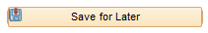  Note: It is important to know that the Save for Later button does not submit the requisition into the SMART approval workflow process. Using the Save for Later button enables you to save the requisition for later use, and access it again from Manage Requisitions, without entering the requisition into the SMART workflow approval process.
Save & Submit | The Save & Submit button is used to save the requisition, and submit it for approval, sourcing and dispatching to the supplier.  Note: If you enter invalid chartfield values or chartfield combinations on the requisition, you will receive an error message when trying to save the requisition. If you receive an error message, correct the entry of chartfield values on the requisition and save the requisition.
Confirmation | The Confirmation page informs the user that the request has been successfully saved and submitted into workflow for approval. The Confirmation page provides summarized information about the request, including the requisition ID and total price, and provides an overview of the workflow approval routing for the requisition.

