State of Kansas
Project Costing WorkCenter
Statewide Management, Accounting and Reporting Tool

Date Created: | 10/20/2015
Version: | 1.0
Last Updated Date: | 3/6/2019
Purpose of the Configuration:
Security: | - Role Security: Project Costing Viewer  BU Security: Business Unit Security is applied
Scenario: | The Project Costing WorkCenter is a useful tool and provides access to several different work pages from one central page.  Note: One caveat pertaining to Project Costing WorkCenter, Pre-Billing Exceptions, the user must be using My Projects fuctionality for Deferred Billing Transactions and PC Unpaid Vouchers to return results.  While this is not a depiction of what should be on the user’s WorkCenter, this is a job aid assisting users on the My Work section and personalizing the other sections of the WorkCenter.
Navigatation: Projects and Grants Homepage > WorkCenters > Projects WorkCenter or Navigator > Project Costing > Projects WorkCenter.  Note: The Projects WorkCenter filters default with the user’s Business Unit. The user may want to filter results to the queries behind the links in the My Work section. The My Work section cannot be personalized as to what links are displayed, but does provide the option of filters. | 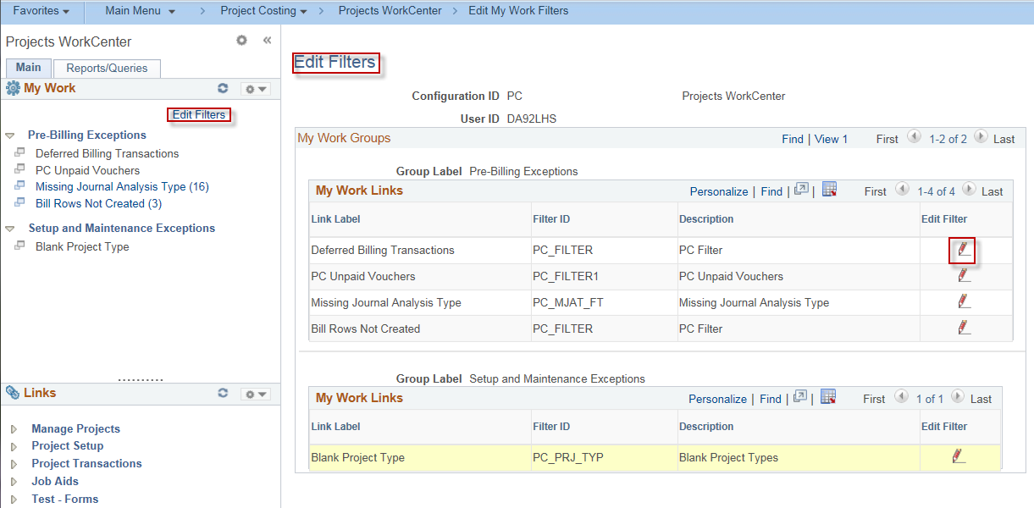
Edit Filters: Click Edit Filters in the My Work section of the Projects WorkCenter | 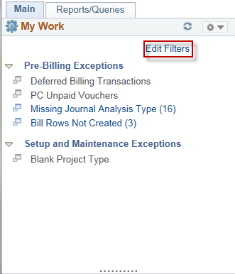
In the main window of the WorkCenter, the Edit Filters for the My Work Groups will display. The user can select the View All. The pencil icon will provide access to edit the filters. | 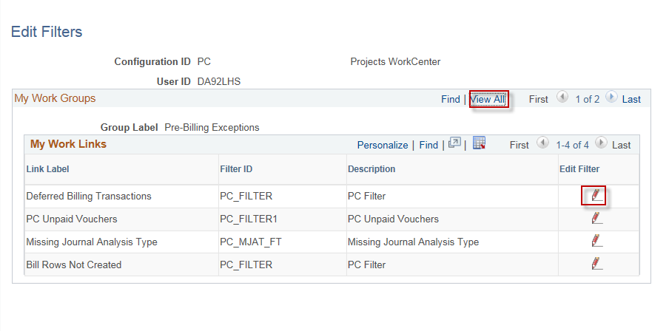
Select the pencil icon for any of the links needing a filter. Depending on which link selected, the filter will display similar to the screenshot.  Note: The Business Unit should default. The options of <, >, =, plus more operators, are available to further narrow results. | 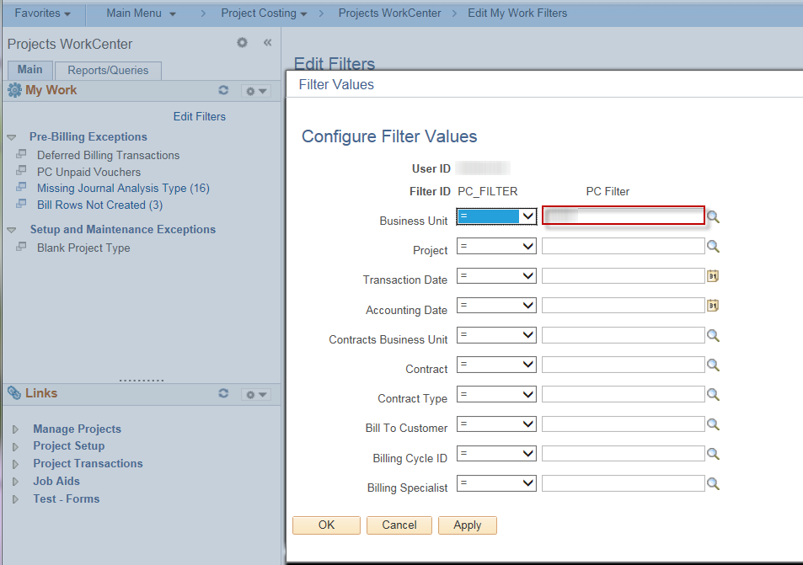
Links – Personalization  Click the dropdown arrow next to the gear icon to access the Links Pagelet Personalization. | 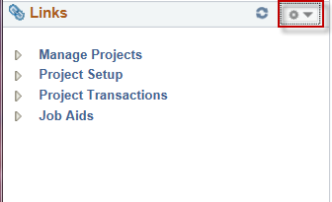
The Personalization pages provide many possibilities for personalization.  Note: Select the View All to view all groups without reloading each group individually.  The groups can be collapsed or open when the WorkCenter initially loads by checking or unchecking the checkbox next to Start Group Collapsed. | 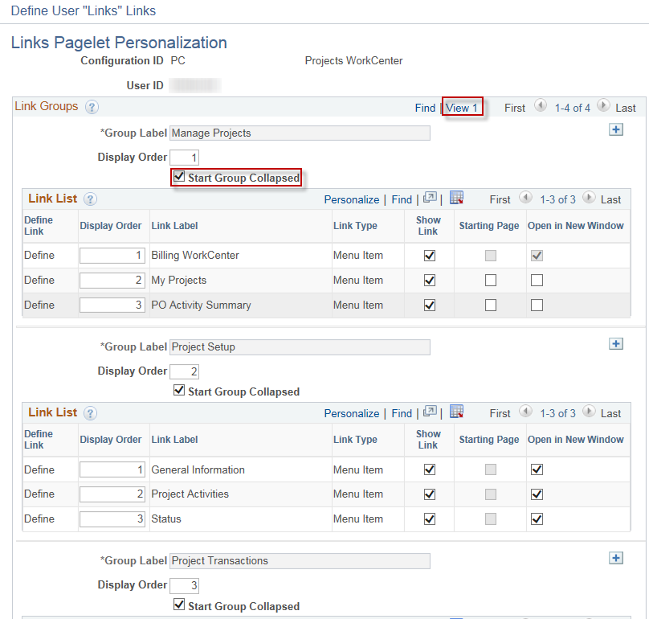
Within a group, the user can decide whether to show the link or not.  The user also has the ability to have the link open either on the main page of the WorkCenter or open in a new window, whichever is more useful to the user.  Note: There can only be one (1) Starting Page for the entire WorkCenter. Starting page indicates that whatever is selected will appear in the main window of the WorkCenter when the WorkCenter is initially accessed. | 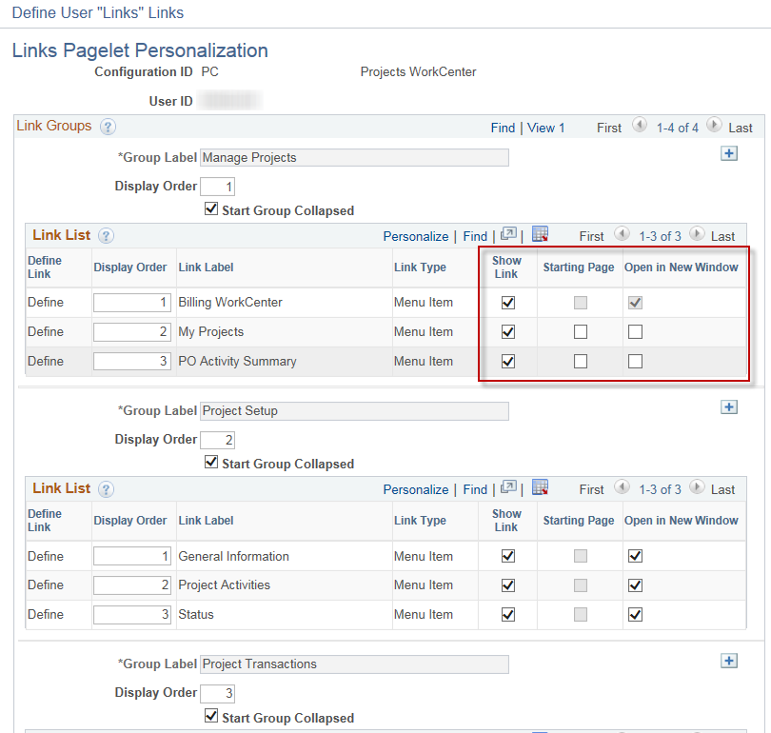
The user can add a group by clicking the + button. More links in a group may be added by clicking the + sign on a line within the group. | 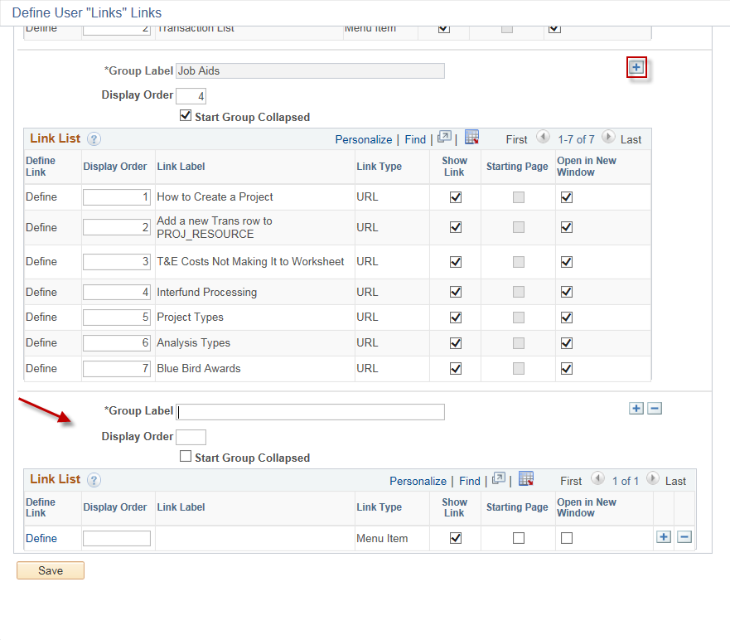
To add Menu Items or URL to your group, click the Define hyperlink on the Define User Links page in the new group. You have the option of choosing to add a Menu Item or a URL.  Note: If entering a URL, either copy and paste, or type in the URL. The Label allows you to name it appropriately. | 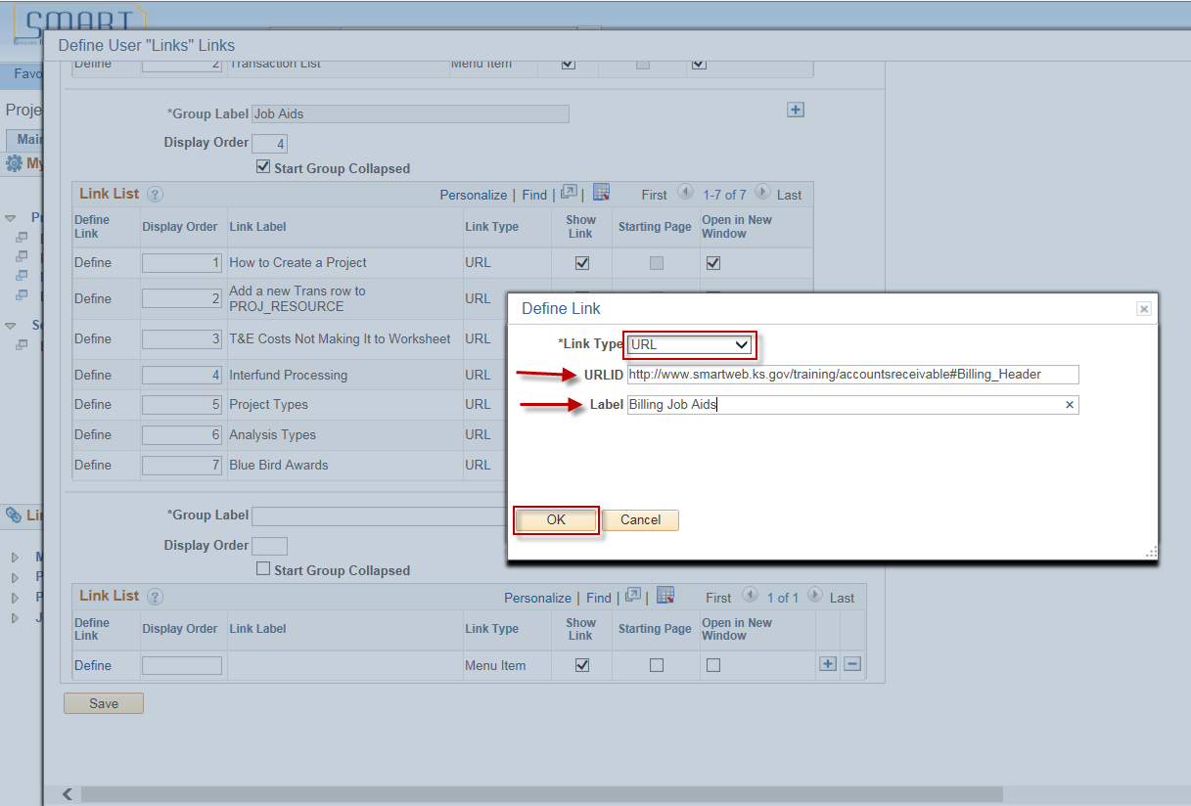
If adding a Menu Item, click the Select Menu Item hyperlink. | 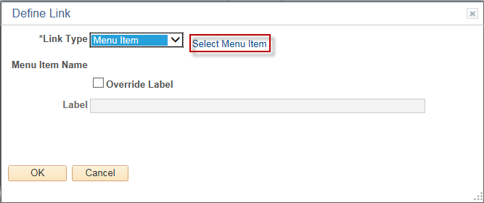
The display should be Menu Items that the user has access to based on security roles. Select a Menu Item. | 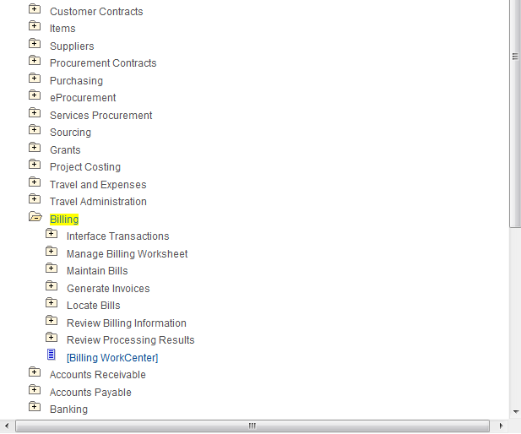
The user is able to reorder the groups in the order that is useful to the user by changing the Display Order numbering. Click Save when all changes have been completed.  Note: Existing Groups can not be deleted or renamed, but the Display Order, and checkboxes for showing the Show Link, Starting Page, and Open in a New Window can. New groups added by the user can be deleted. | 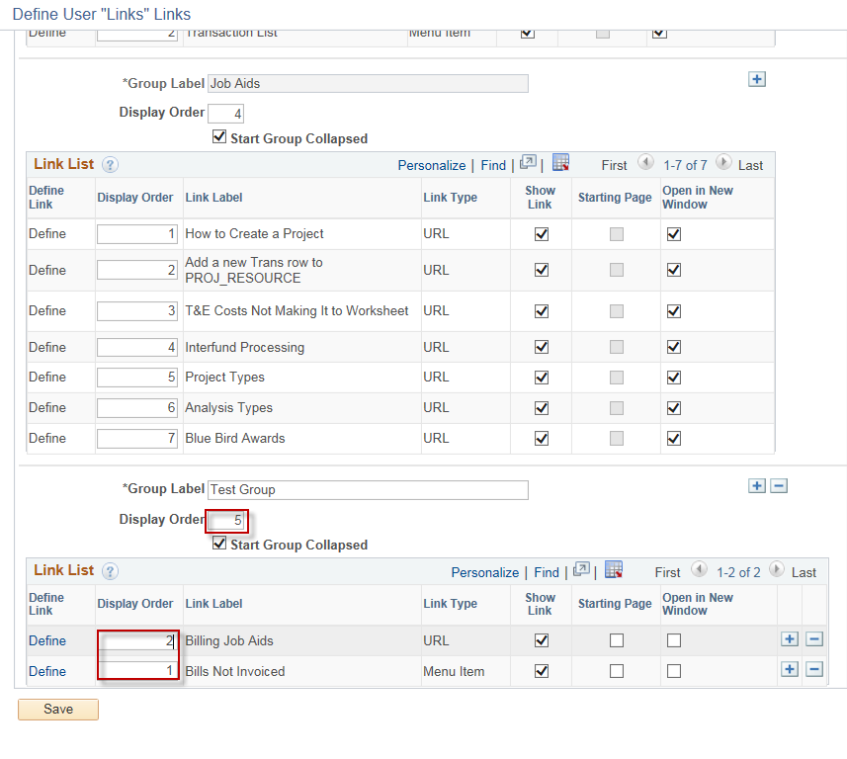
After Refreshing the page, the new group appears as a Link. | 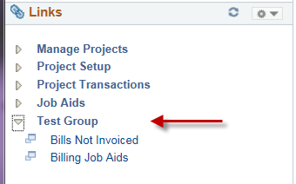
The Reports/Queries tab can be personalized following the same steps as personalizing Links. | 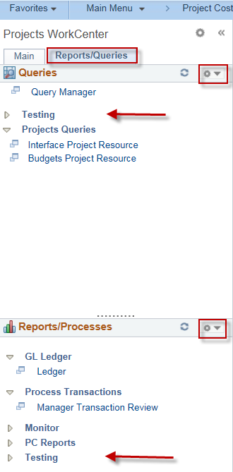
Selecting Queries: The default when adding additional queries is Query. For Project Costing users, enter KS_PC in the search criteria, click Search to display a list of Kansas Project Costing queries. If looking for queries from other modules, follow the same naming convention, substituting module initial for PC.  Note: Pivot Grids pertaining to Project Costing are as delivered and have not been tested for accuracy. Some are more meaningful than others, depending on the agency’s business processes. | 