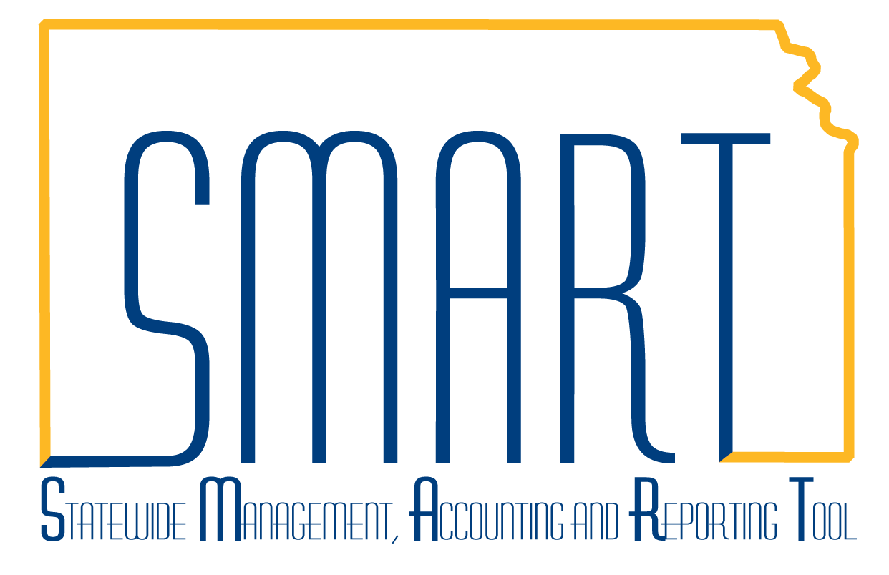
State of Kansas
How to fix Travel & Expense costs that are
not making it to the Billing Worksheet
Statewide Management, Accounting and Reporting Tool

Date Created: |  | 10/27/2014
Version: |  | 1.0
Last Updated: |  | 2/28/2019
Reason for Job aid:  This job aid will be helpful for those agencies that use the Customer Contracts and Billing modules in conjunction with Project Costing and Grants.  There are two situations where this job aid will be useful in correcting the Travel & Expense transactions so they can be billed in SMART.  Scenario 1: If the original expense report contains lines that were changed to a Billing Type of “Nonbillable” in error, although the grant/project/activity were added to the distribution lines.  Scenario 2. If the original funding was not charged to a grant/project/activity, the Billing Type was changed to “Nonbillable”, and a journal expense report must be completed to correct the funding.  Note: Normally when any Travel and Expenses Report is created, the Billing Type defaults to “Billable” to enable overnight processes to bring these items into the Billing module if the agency is utilizing the Customer Contracts and Billing modules. A journal expense report will inherit the Billing Type from the original expense report. |  | For Scenario 1: Proceed to Step 1.  For Scenario 2: The agency Travel and Expenses Maintainer will create the Journal Expense Report following the instructions on the Creating a Journal Expense Report.  SMART does not automatically pick up the journal entries because these cannot be marked as “Billable” anywhere on the journal expense report.  Once the journal processes and has a Journal Status of “P” (Posted) and Budget Status of “V” (Valid), proceed to Step 1.
1. | Navigation: Projects and Grants Homepage > Project Costing > Manage Projects > Manager Transaction Review or Navigator > Project Costing > Interactive Reports > Manager Transaction Review.  The Agency Projects Manager or Agency Grants Manager will have the ability to view and update this process. At a minmum, enter the Project Business Unit and Project. Other criteria, such as Activity, Employee ID, From Date, and Through Date will limit your results, as desired. The Detail radio button should be selected. Click the Search button. | 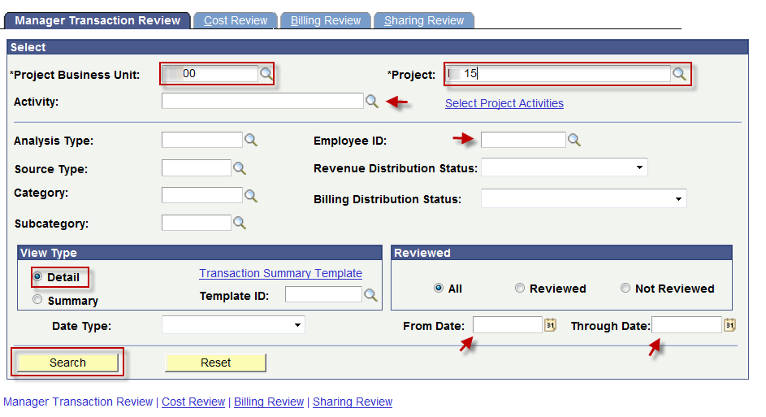
2. | When the results are displayed on the Cost Review tab, click the Transaction Details tab and locate the transaction. (Click the “View All” to display results, if necessary.) | 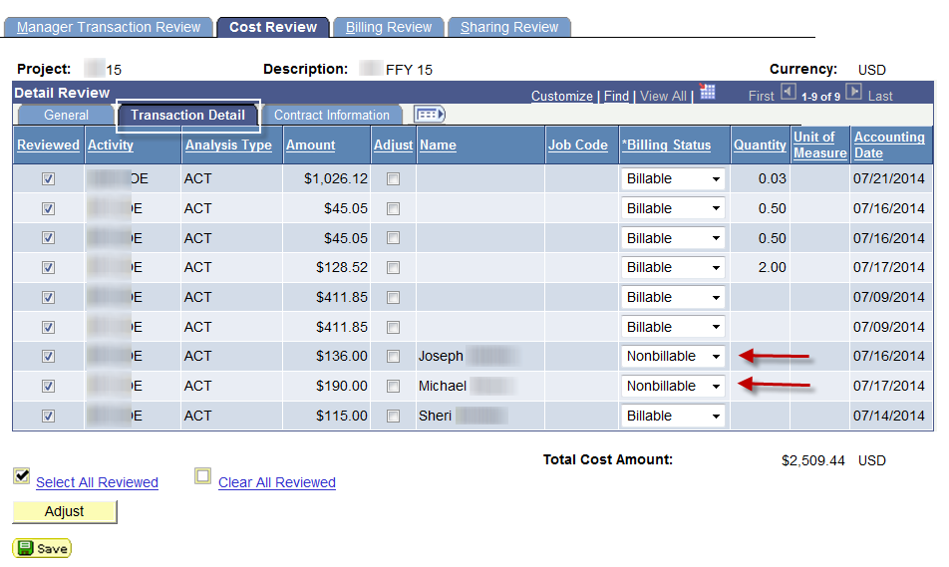
3. | Under the Billing Status column, you have the ability to toggle the expense from “Nonbillable” to “Billable”. Depending on whether all the transactions had previously been reviewed, confirm the check box in the corrected line is selected in the “Reviewed” column. Click the Save button. | 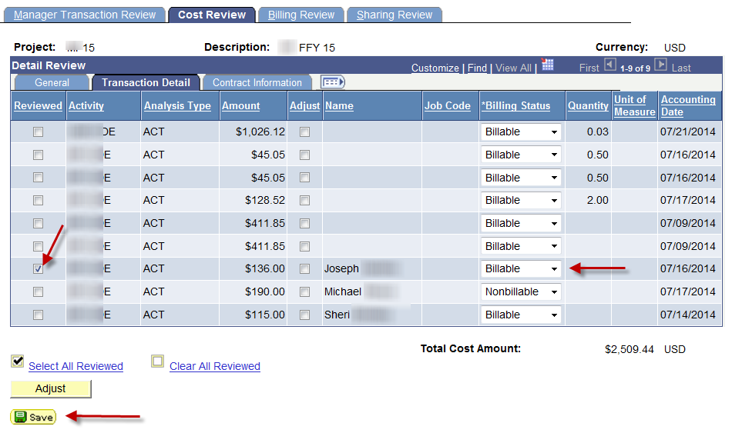
4. | Navigation: Billing Homepage > Process Billing Worksheets > Non-Consol Invoice Processing > Update Billing Worksheet or Navigator > Billing > Manage Billing Worksheet > Update Billing Worksheet. The item should be picked up by the overnight batch processes and appear on the billing worksheet the following day. | 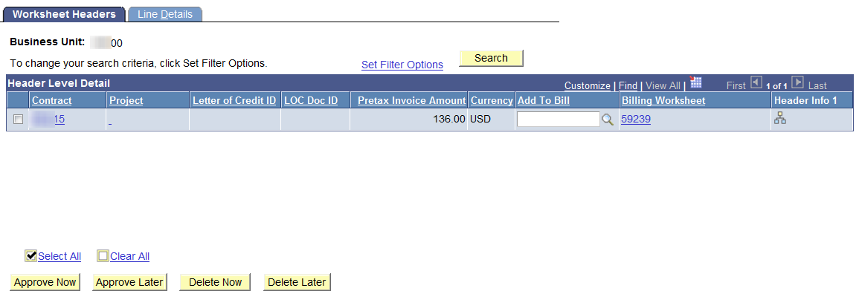
5. | Depending on the dates of the original transactions, some costs may not be picked up during the overnight processes and not appear on the billing worksheet the following day. If this occurs, submit a Service Desk ticket indicating the above process has been completed and include the Project, Activity, and Accounting Date of the transaction. A SMART Team member will need to manually process your transaction(s) to the billing worksheet.

