State of Kansas
Adding a transaction row directly to the
Project Costing Transaction List
Statewide Management, Accounting and Reporting Tool

Date Created: | 2/26/2019
Version: | 1.1
Last Updated Date: | 2/26/2019
Process: | When an agency over or under charges for a project-related transaction and it flows through to the billing worksheet, it may become necessary to adjust the amount by manually adding a row to the Transaction List in either a positive or negative amount to net the true amount when both transactions are processed from the billing worksheet together via consolidated invoicing. This method is also used to account for accidental over-draws on previous grant-related transactions.
Step 1. Navigation: Projects and Grants Homepage > Project Costing > Transaction Definitions > Add Transactions or Navigator > Project Costing > Transaction Definitions > Add Transactions. | 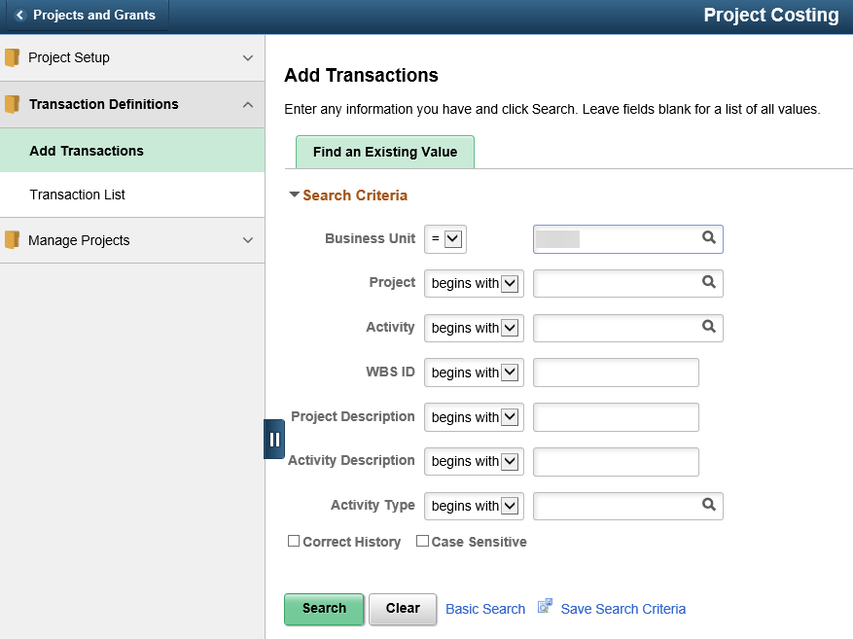
Step 2. Enter the Project/Activity you wish to transact against and click Search. | 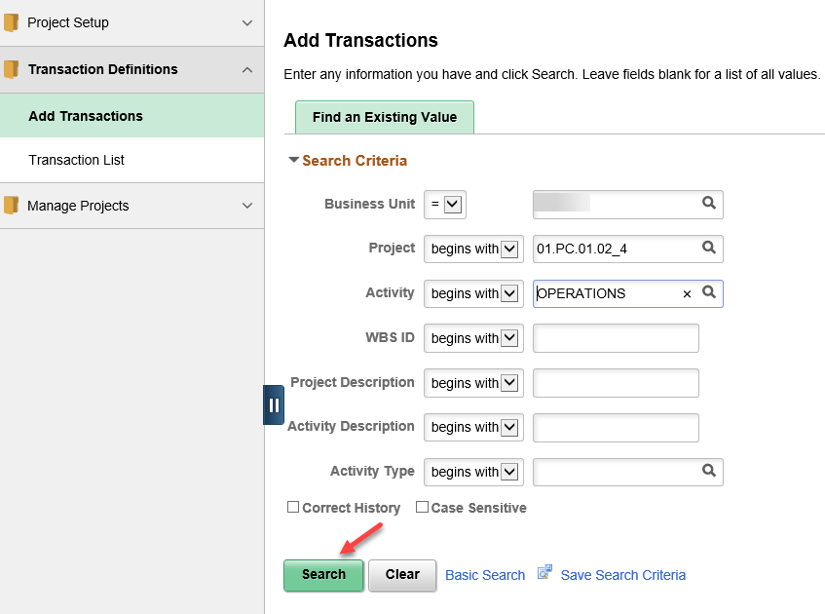
Step 3. Enter an Analysis Group of “ALL” to allow entry of any Analysis Type transaction. | 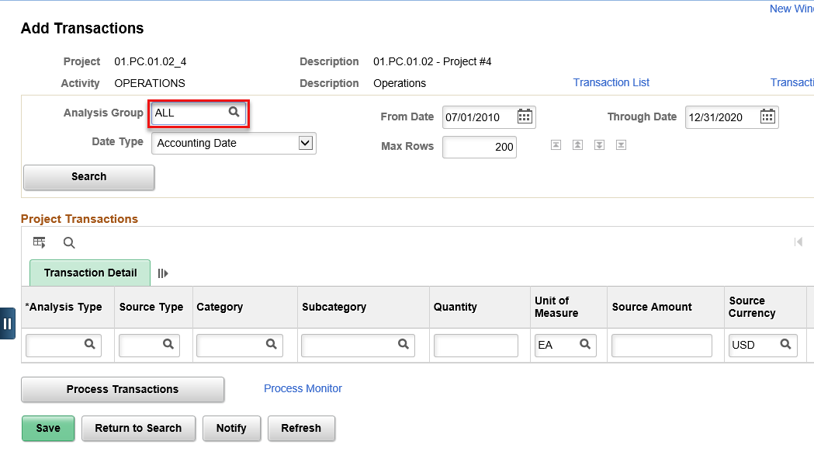
Step 4. Enter the appropriate Analysis Type, Source Type (optional), Category (optional), Subcategory (optional), Amount, etc. onto the transaction line.  Click the Transaction Detail icon to enter GL ChartField information. | 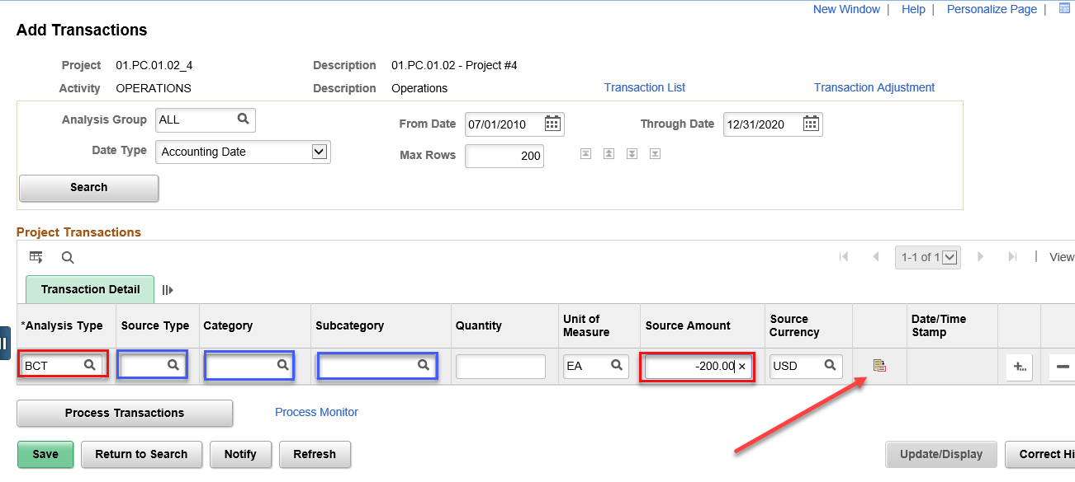
Step 5. Click Save and then click the “Process Transactions” button to post the transaction row to the Project Costing Transaction List. A pop-up message will indicate the process has begun. | 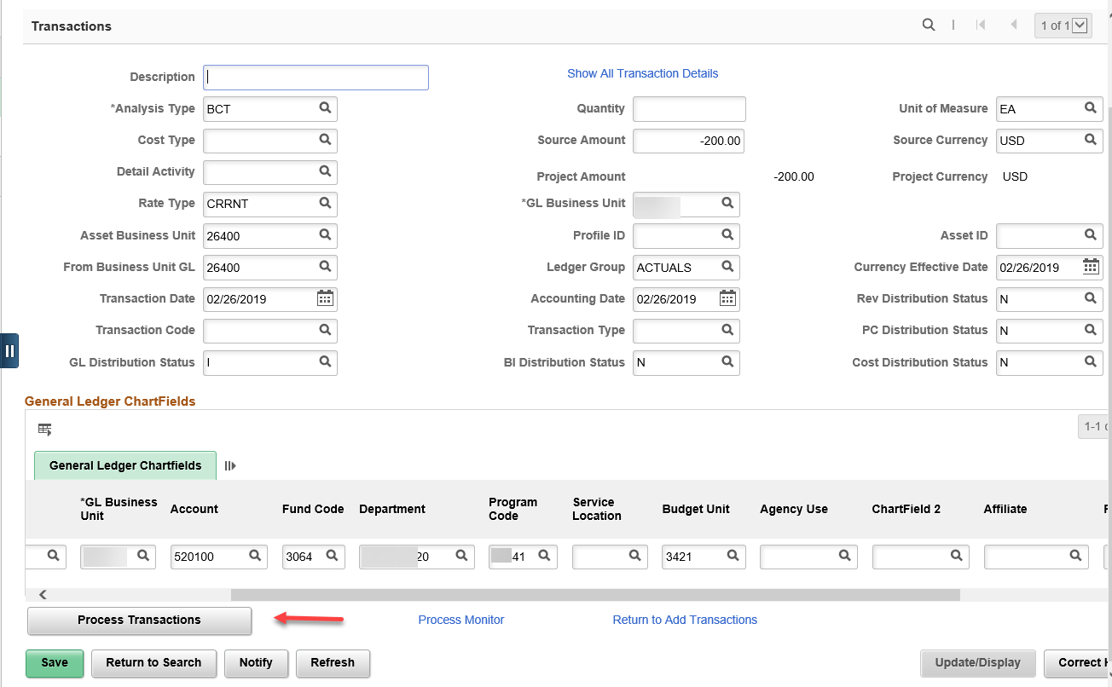
Step 6. Click on the “Process Monitor” link to view the processing status. Periodically click the yellow “Refresh” button until the Run Status = Success & the Distribution Status = Posted. | 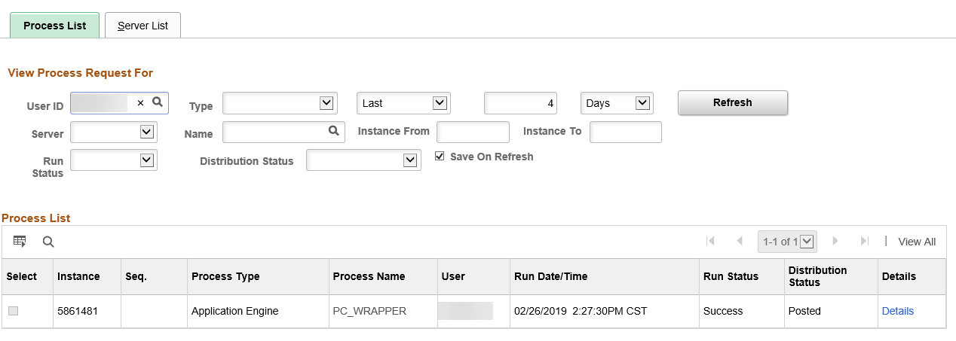
Step 7. Navigation: Projects and Grants Homepage > Project Costing > Transaction Definitions >Transaction List or Navigator > Project Costing > Transaction Definitions > Transaction List. Validate that the transaction was added to the Transaction List by entering the Project/Activity used on the transaction & click Search. | 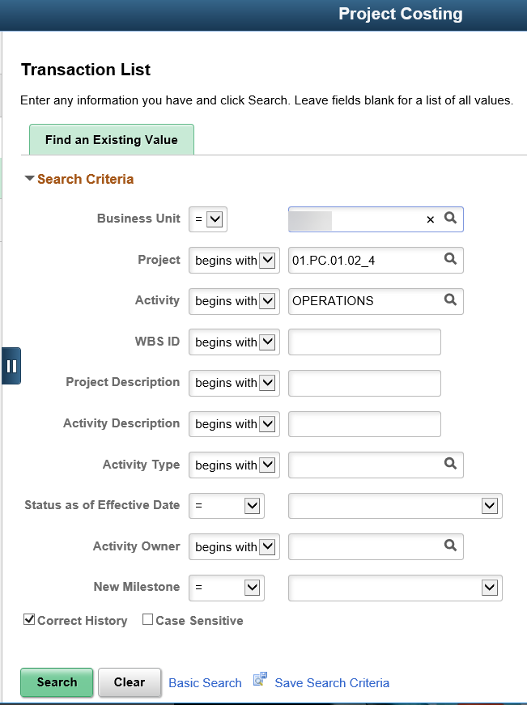
Step 8. Enter an Analysis Group of “ALL” & a “From Date” and “To Date” of Today (the day the transaction was posted) to view the transactions that have been posted on this date. Click Search. | 