State of Kansas
Adding Sponsors
Statewide Management, Accounting and Reporting Tool

Date Created: | 03/8/2019
Version: | 1.0
Last Updated Date: | 3/8/2019
Process:
Step 1. Navigation: Projects and Grants Homepage > Grants > Creating a Grants > Sponsor General Information > Add a New Value or Projects and Grants homepage > Customer Contracts > Sponsor > Sponsor General Information or Navigator > Grants > Sponsors > General Information.  Enter the Business Unit and Customer ID. Click Add. | 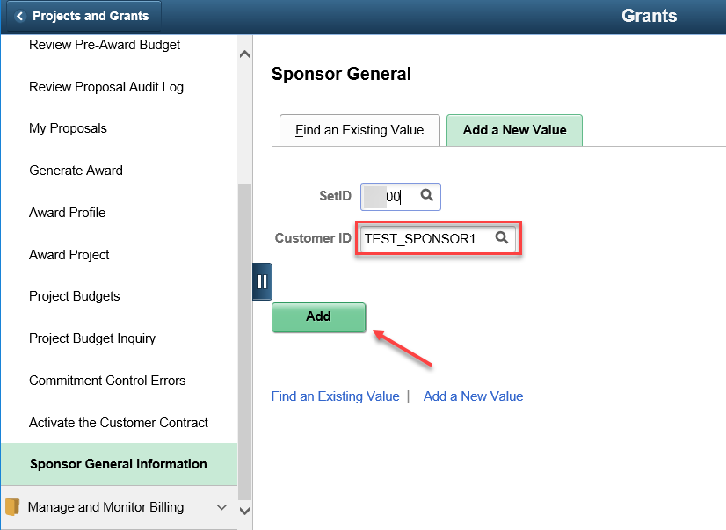
Step 2. Verify the status defaults as Active. Accept or update the Date Added and Since dates. Enter the Name 1, Short Name, Currency Code, and Rate Type. | 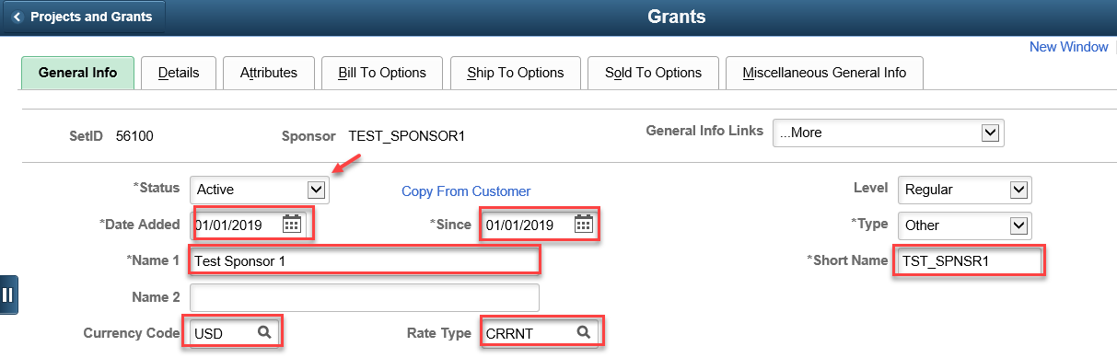
Step 3. In the Roles section, select the appropriate checkboxes. | 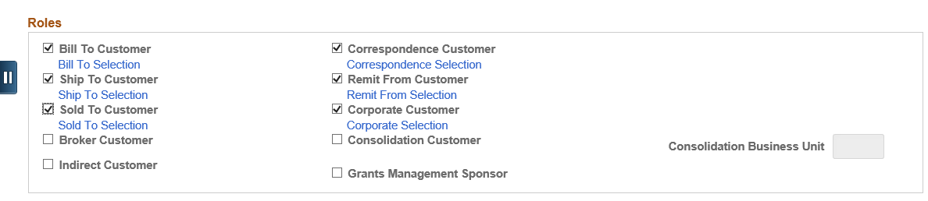
Step 4. In the Support Teams section, use the lookup to select value for Team Code. Check the Default checkbox. | 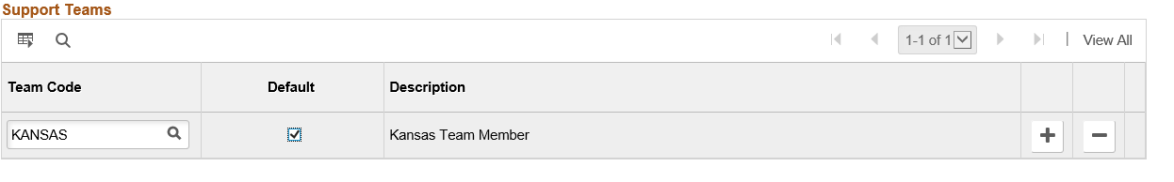
Step 5. In the Address Locations section, select the appropriate checkboxes. Use the plus or minutes icon to add additional addresses. | 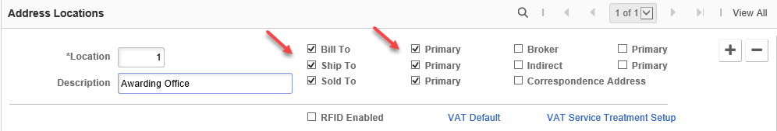
Step 6. In the Address Details section, verify the Effective Date and Status of Active. Enter the Address in the appropriate fields. | 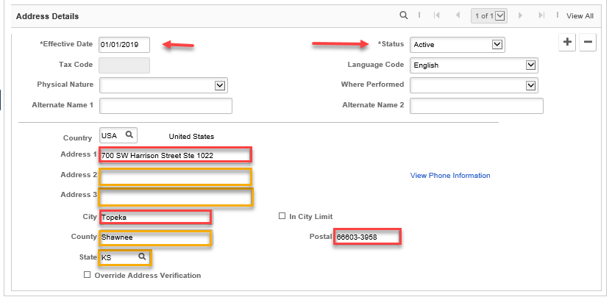
Step 7. On the Bill To Options tab, verify the Effective Date and Status of Active. Use the lookup to select the Credit Analyst, AR Specialist, and Collector. Click Save. | 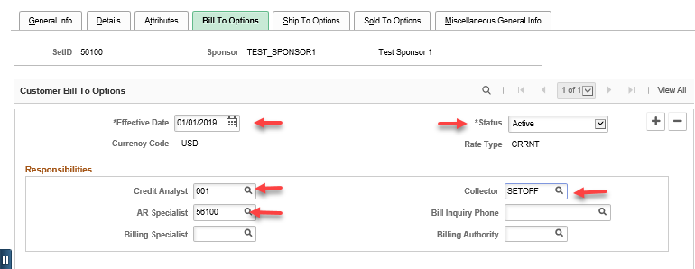
Step 7. (Optional)  Salary Cap  On the Details tab, enter the Salary Cap.  LOC Details  Check the Letter of Credit checkbox and use the lookup to select an existing code. If entering an new Letter of Credit code (the account number used when completing the draw), please enter a Service Desk ticket.  Click Save. | 