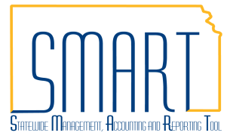
State of Kansas
Modify Sold To Customer
Statewide Management, Accounting and Reporting Tool

Date Created: | 10/14/2015
Version: | 1.0
Last Updated Date: | 2/28/2019
Purpose of the Configuration:
Security: | - Role Security: Customer Contracts Manager
Scenario | A Customer Contract has been entered, and the incorrect Sold To Customer was entered. While the Contract status is still in Pending status, the Sold To Customer can be modified. This is new functionality released with the 9.2 upgrade.
Step 1. Navigation: Projects and Grants Homepage > Customer Contracts > Customer Contracts > Modify Sold To Customer or Navigator > Customer Contracts > Create and Amend > Modify Sold To Customer. On the Search page, enter the following information:  Business Unit  Contract  Note: If the Contract ID is not known, the Search will pull up all contracts in Pending status. Select the contract requiring the Sold To Customer modification. | 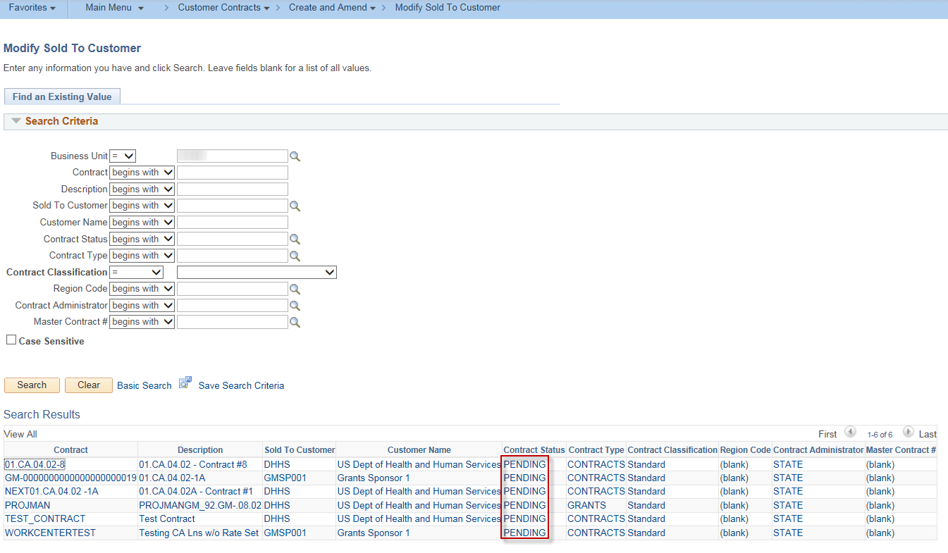
Step 2. The Modify Sold To Customer page displays. | 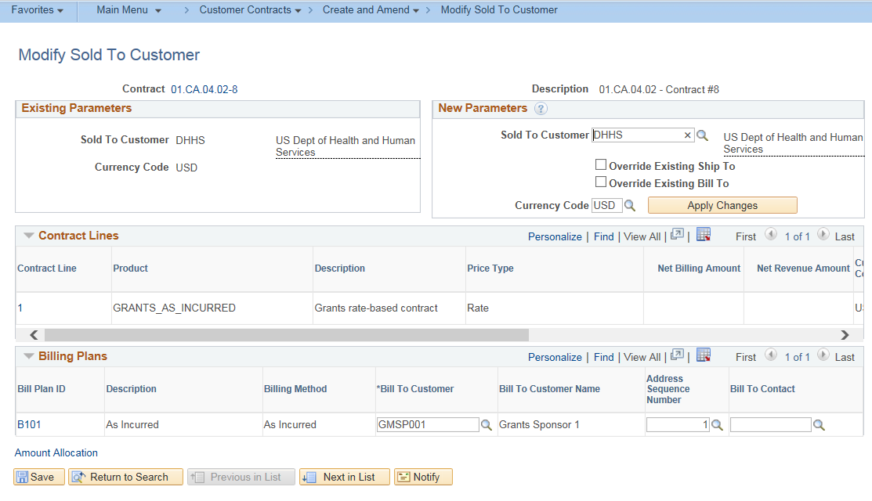
Step 3. In the New Parameters grid, use the lookup to select the desired Sold To Customer. | 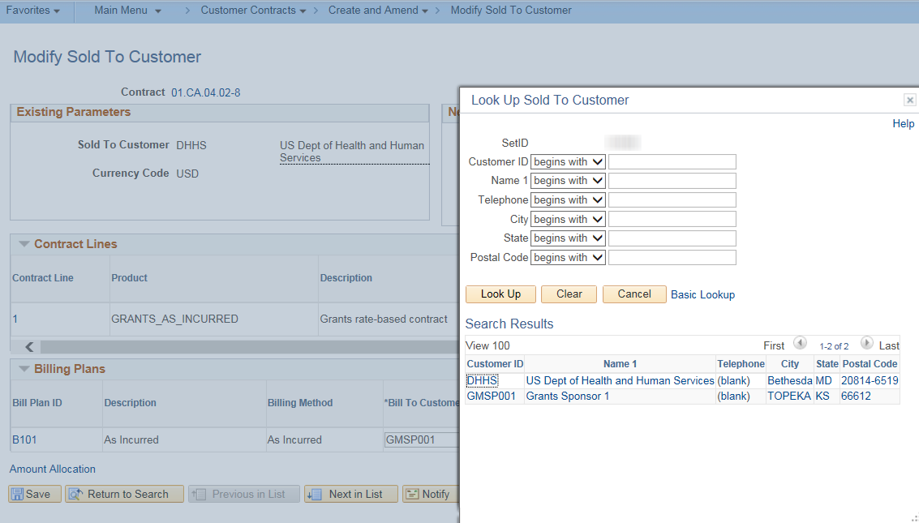
Step 4. Select the Override Existing Ship To and Override Existing Bill To checkboxes and click the Apply Changes button. | 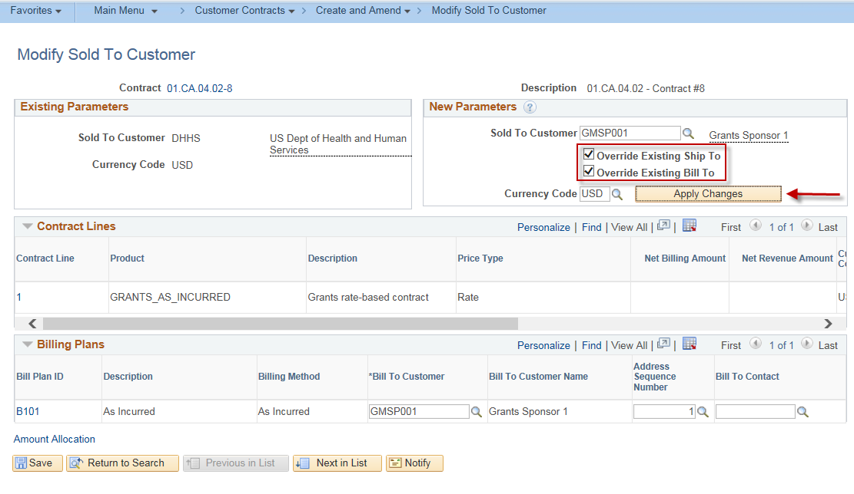
Step 5. Click the Save button.  Note: After the modification has been saved, the Existing Parameters will change and should match the changes applied.  Note: If using LOC ID, the contract must be updated before the contract is activated. See the job aid on How to Create a Customer Contract for instructions. | 