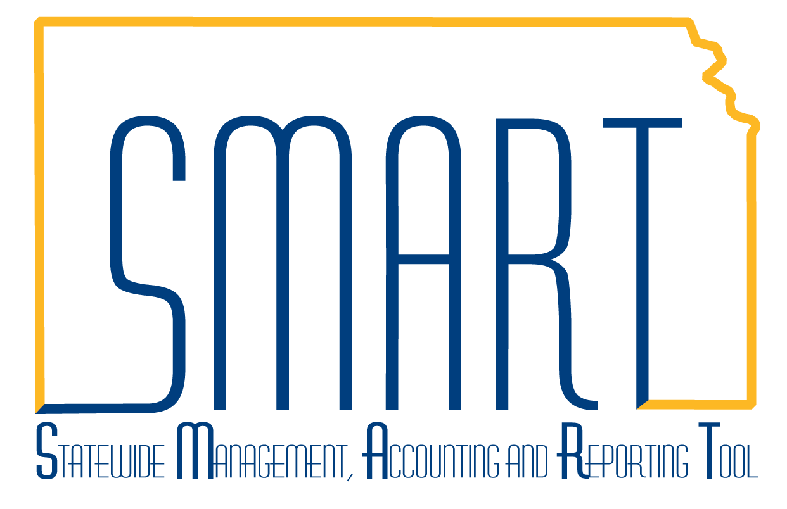
State of Kansas
How to Create a Customer Contract
Statewide Management, Accounting and Reporting Tool

Date Created: |  | 2/28/2019
Version: |  | 1.1
Scenario: |  | Customer Contracts is the link between Project Costing and Billing. When a project is attached to a contract, reimbursable project costs are funneled to the billing worksheet for processing. Revenue recognition and unbilled AR accounting entries are automatically written to the General Ledger.  This job aid demonstrates how to create a new customer contract and associate it with a project. It assumes the contract is being created online and has not been generated from the Grants Generate Award process. While the Project may be created in this module, some users prefer to create the project and activity in the Project Costing module before entering the Contract.  New functionality released with 9.2 upgrade is included on Steps 8 – 18. The navigation path is now a breadcrumb path at the top of the SMART page.
1. | Navigation: Projects and Grants Homepage > Customer Contracts > Customer Contracts > General Information > Add a New Value or Navigator > Customer Contracts > Create and Amend > General Information.  The Business Unit should default based on user security. Enter the Contract Number in the Contract field and the Sold To Customer and click the Add button. | 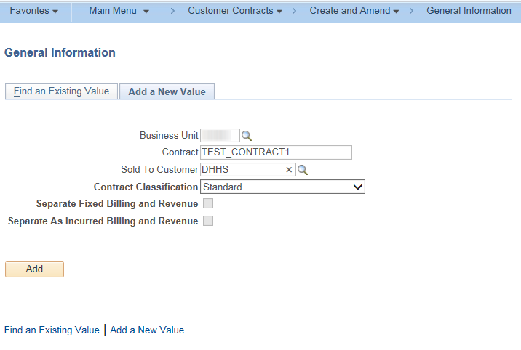
2. | On the General tab, enter data into the Description field. Verify the Use Project ChartFields checkbox is checked. Click Save. | 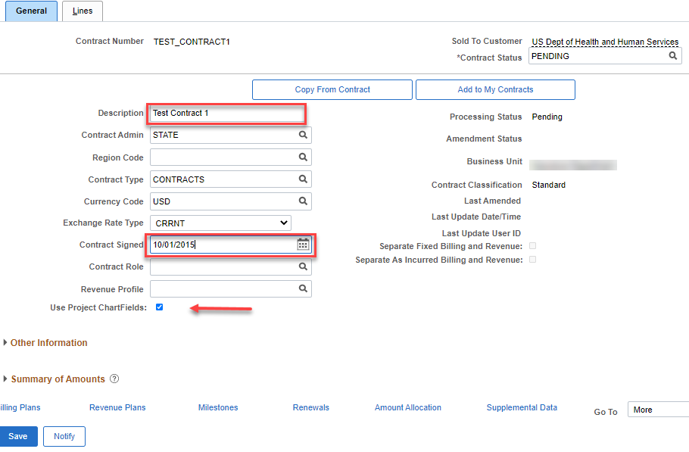  Note: The Contract Signed date defaults to the contract creation date. This can be updated by the user, if needed.
3. | Click on the Lines tab, then click the Add Contract Lines button to add a product to the contract line. | 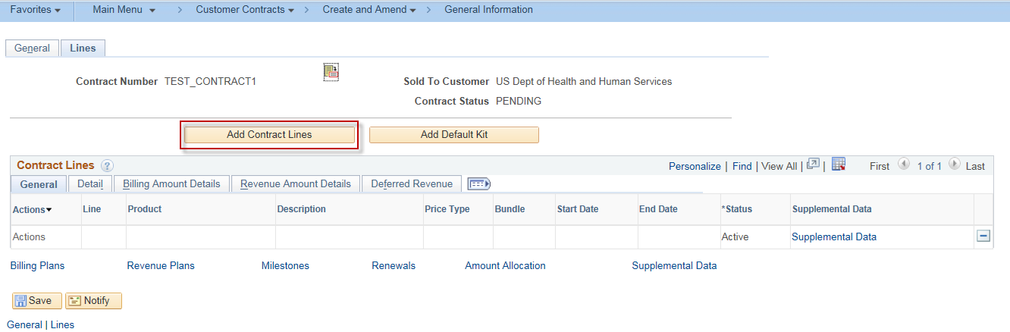
4. | On the Add Contract Lines page, select a Product Group of CONTRACTS and a Price Type of Rate, click Search.  Note: Products identify the desired billing and revenue recognition method to be used for the reimbursable project costs. In general, the State of Kansas uses an As Incurred method. | 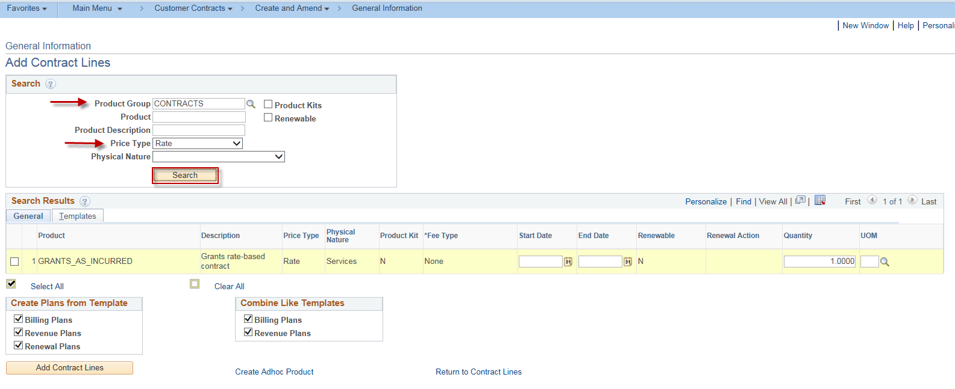
5. | Check the box next to the GRANTS_AS_INCURRED product, then click the Add Contract Lines button. | 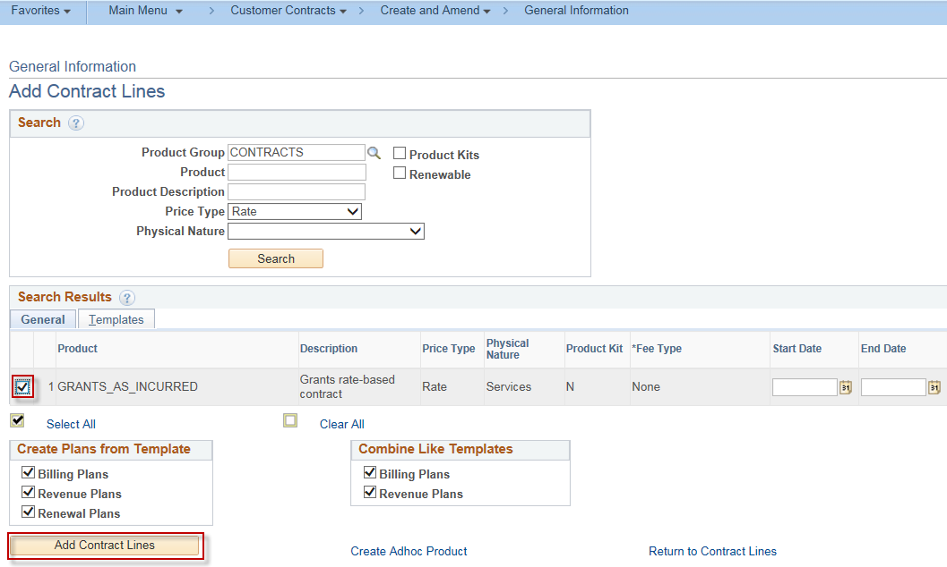
6. | A confirmation screen will display indicating that 1 line has been added to the contract. Click the Return to Contract Lines link. | 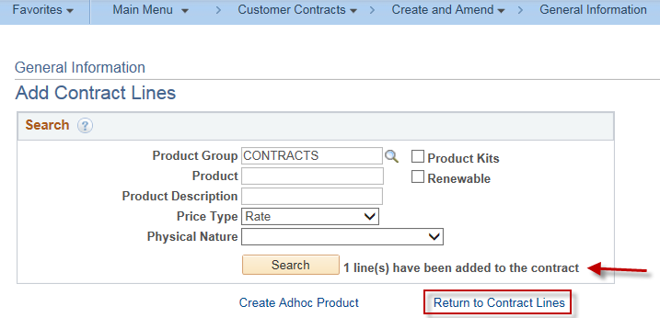
7. | A GRANTS_AS_INCURRED product now displays on the Lines tab of the contract. Enter data into the following fields, then click Save:  Start Date  End Date  Note: With the 9.2 upgrade, the Billing Amount Details and Revenue Amount Details are on separate tabs. | 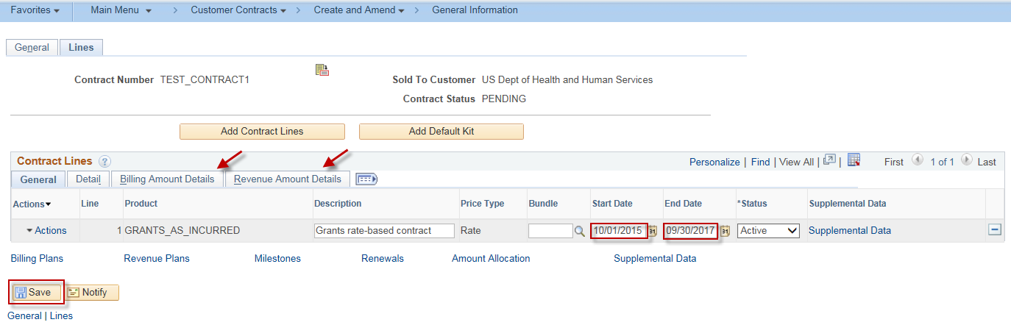
8. | Note: LOC is the Letter of Credit account number of the Grant Sponsor. If completing a Blue Bird Award and to utilize the Federal Financial Report for multiple grants released with the 9.2 upgrade, the LOC ID should be entered on the contract. If the agency does not want to use this functionality, omit Steps 8 – 10. The LOC ID will first need to be entered on the Sponsor. Projects and Grants Homepage > Grants > Creating a Grant > Sponsor General Information > Details tab.  To enter the LOC ID on the contract, scroll to the right and use the lookup of the Go To More. Select Billing Options. | 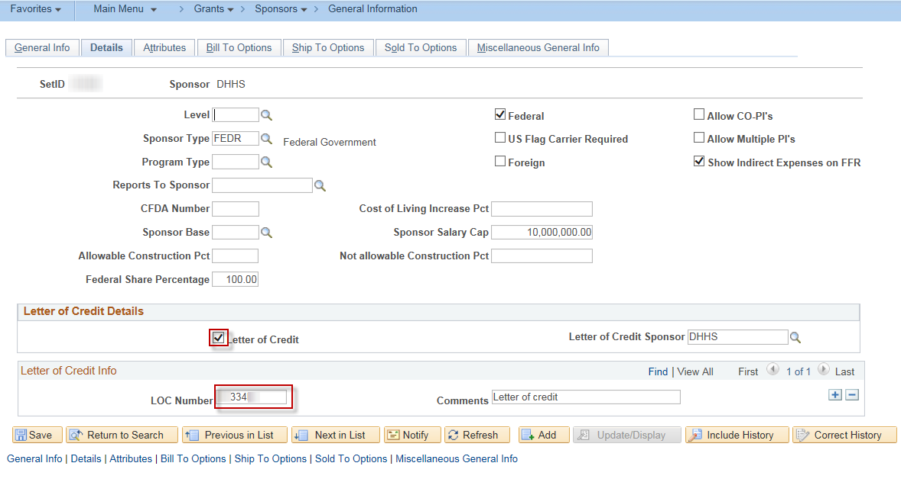  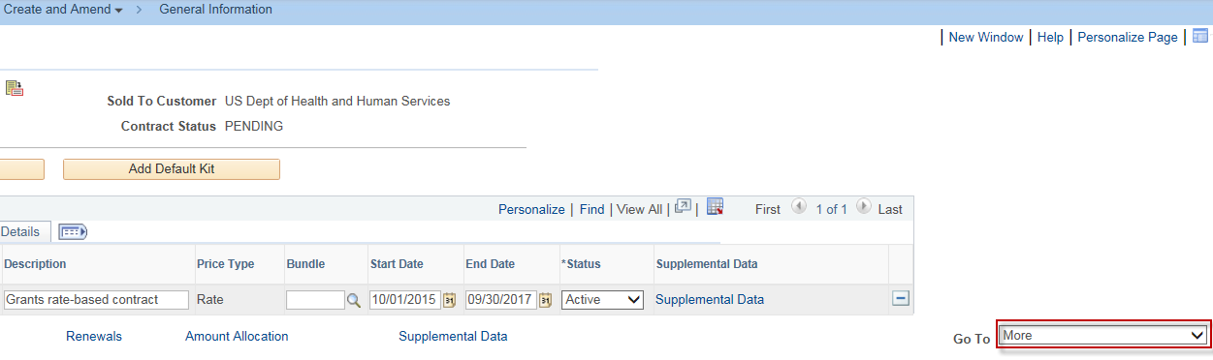
9. | The Letter of Credit radio button is selected. Use the Letter of Credit lookup to select the LOC account number. Click Save.  Note: Best practice is to use the lookup to select the LOC ID. | 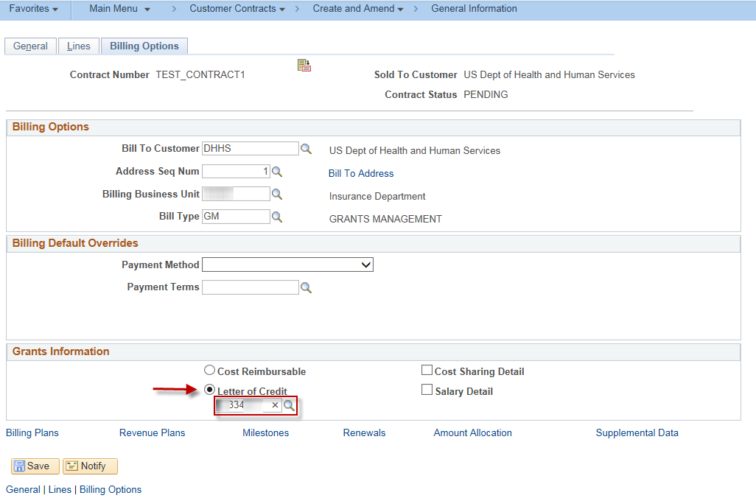
10. | Click on the Lines tab. In the Contract Lines grid, click the LOC Detail tab. Enter the LOC Doc ID. Click Save.  Note: The Sponsor Draw Down Report uses this field as a key field for pulling data. | 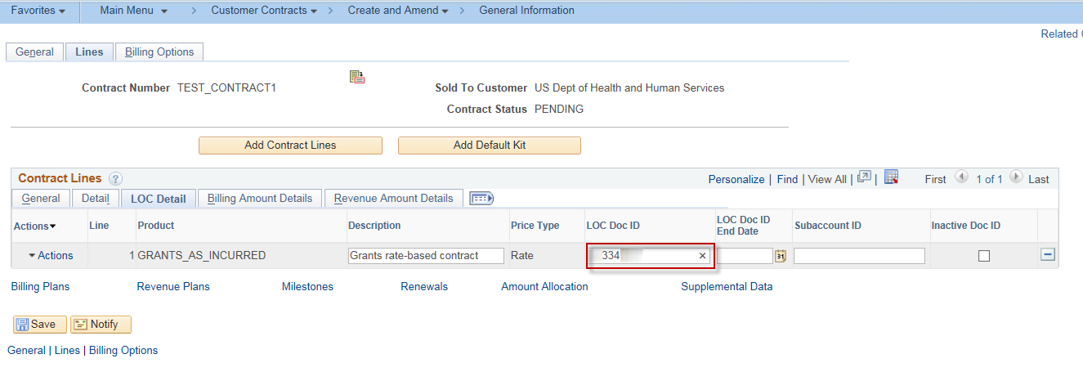
11. | Click on the General tab in the Contract Lines grid. Click the Actions hyperlink. Select the Define Contract Terms.  Note: While the navigation from the 9.0 environment is still available, the 9.2 SMART environment provides the Related Action Framework. The Details tab continues to allow access to Contract Terms and Distribution. | 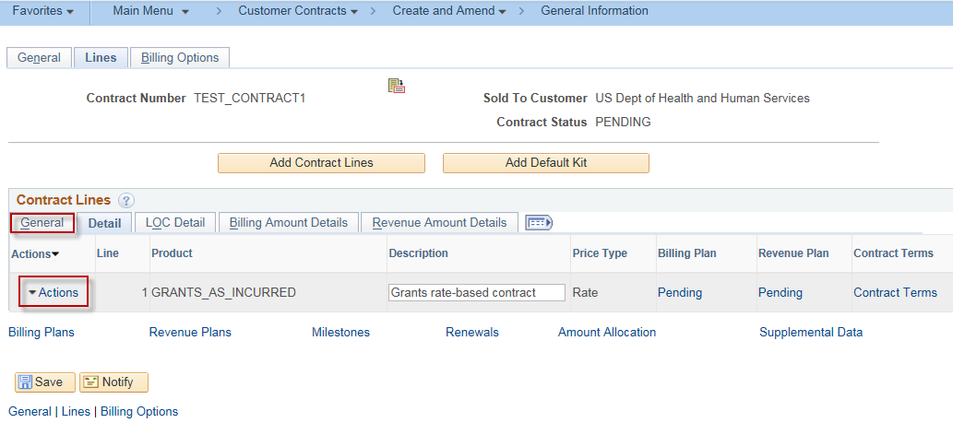
12. | The Related Action Framework provides a split window and the ability to perform several actions without navigating away from the Contracts page. The bottom portion can be raised or lowered to resize the bottom window by hovering over the …… in the middle of the screen and grabbing the window by left clicking and moving it up or down, which is indicated on the screenshot. | 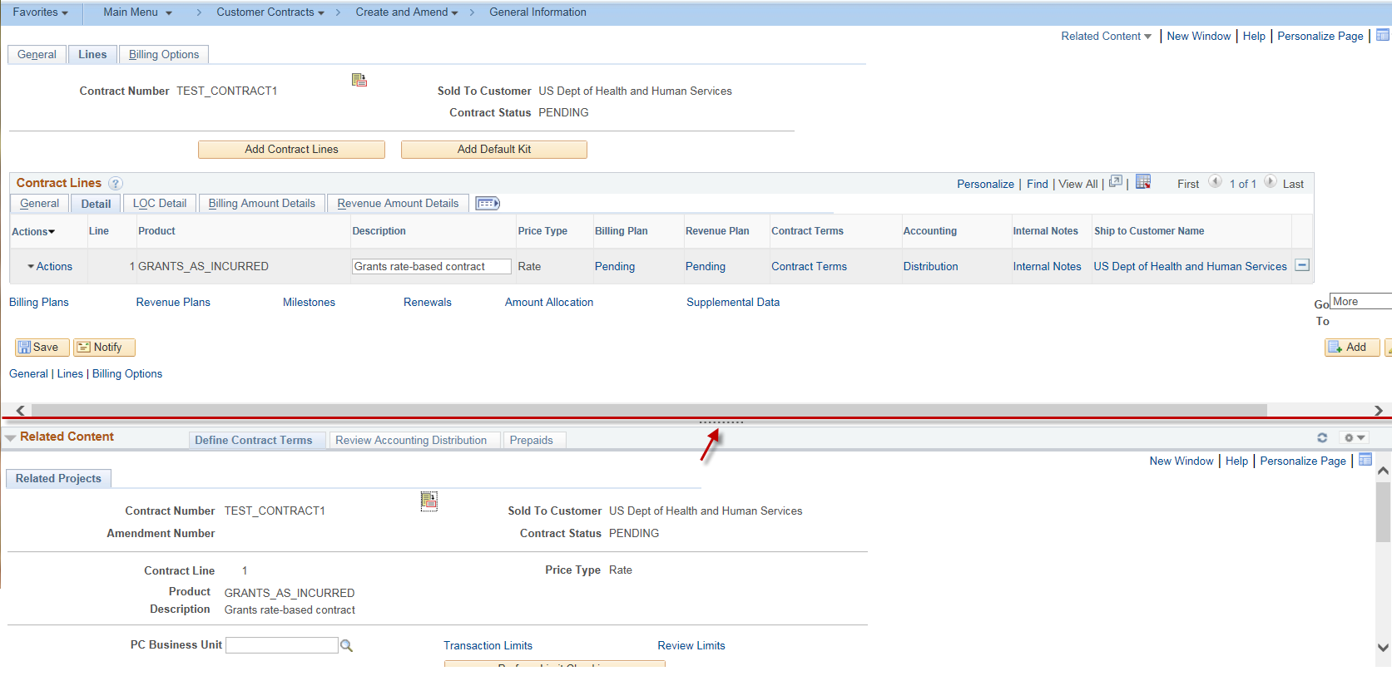
13. | Select the Define Contract Terms tab in the lower split screen. The Related Projects tab is where projects and activities are associated to a contract. Enter data into the following fields, then click Save:  PC Business Unit  Project  Activity  Also verify the desired effective date. Update, if necessary. The current date will default.  Note: Best practice is to enter the Project and Activity first by following instructions of the How to Create a Project Job Aid. | 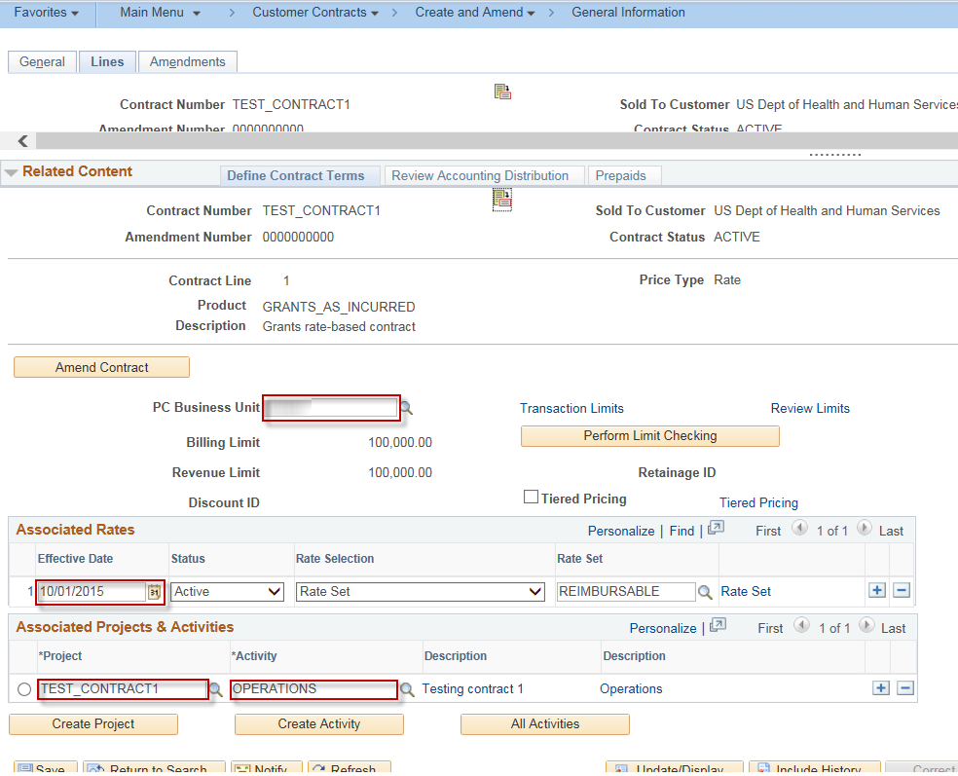  If a project has multiple activities and they are all reimbursable, every project/activity combination must be added to the Associated Projects & Activities section of the page.
14 | Click the Review Accounting Distribution tab in the Related Content Grid. Verify the AR_REIMB has defaulted in the Revenue Forecast, Distribution Code field. In the Unbilled AR grid, enter the appropriate Distribution codes. Click Save.  Note: The user will receive the Message concerning the UAR accounting distribution line has been changed. Click OK.  Failure to enter the Fund and Budget Unit before activating the Customer Contract will result in an error stating  “The accounting for one or more lines is not valid. Contract cannot be activated.” Please note that the Fund and Budget Unit you select on the Accounting Distribution page will not be on the revenue or billing transactions – the system only looks at the Fund and Budget Unit that were included on the source transaction. | 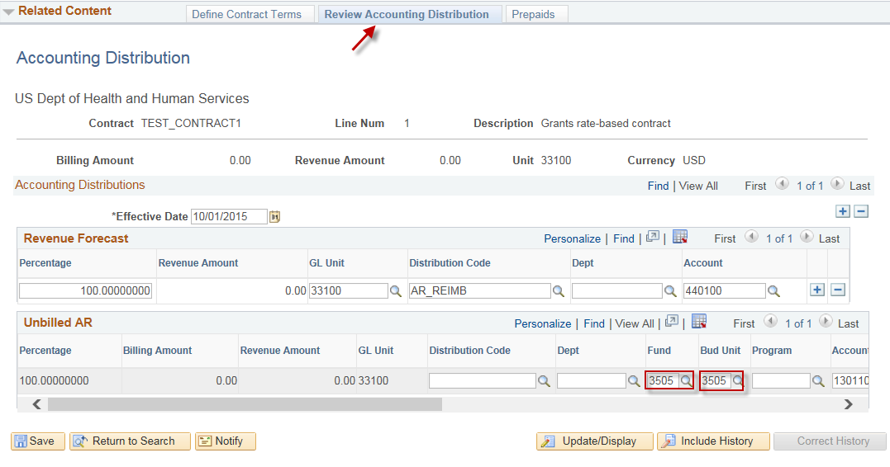  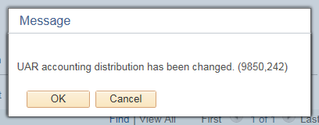
15. | In the General Information page (upper portion of the page), select the General tab. Again, click Save. Select the Amount Allocation hyperlink. | 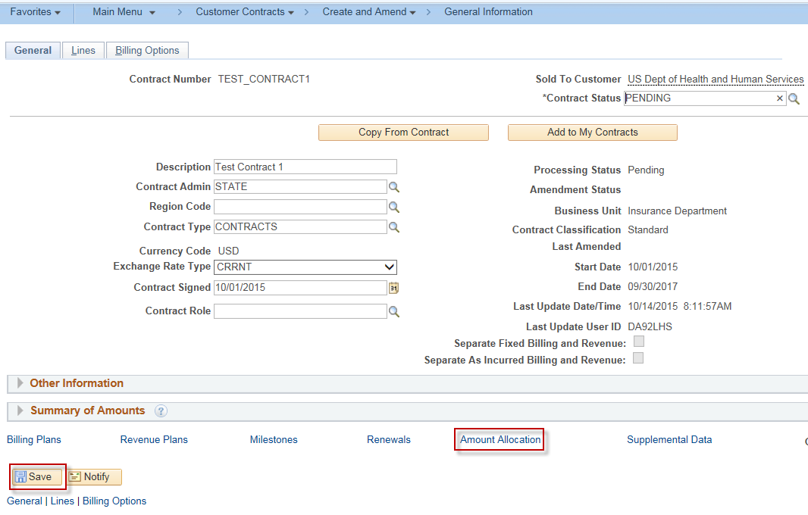
16. | The Billing Allocation window opens. Under the Contract Line Pricing grid, enter the Billing Limit for the Contract Line. In the Contract Billing grid, enter the Total Billing amount. Click the Recalculate button. Confirm that the Unallocated Billing Amount equals 0.00. Click Save. The Allocation should now be Complete. Click Save. Click the Return to General Information hyperlink on the Billing Allocation page. | 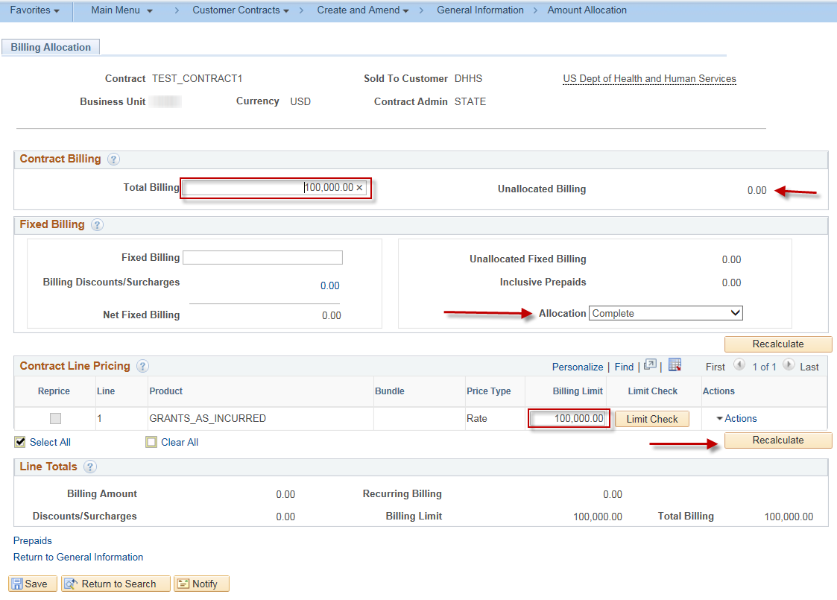  Note: The Billing Limit field identifies the dollar limit for reimbursement. Any project transactions that exceed this amount will not be sent to the billing worksheet for processing until an amendment is processed increasing this field value.
17. | The User now has the ability to review the Summary of Amounts which displays As Incurred Billing Limits and the As Incurred Revenue Limits. Click the arrow on the Summary of Amounts on the General tab. | 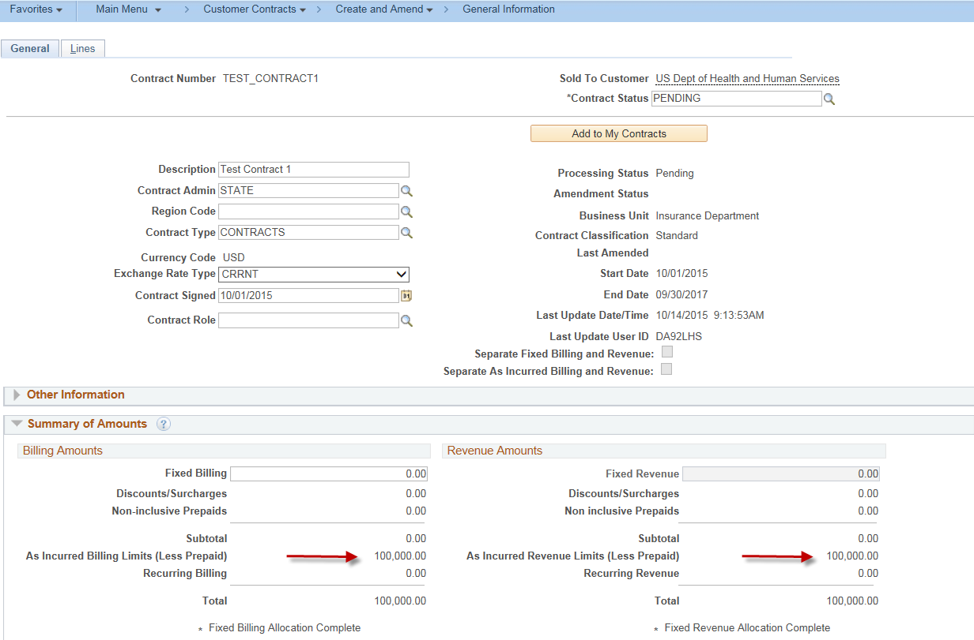
18. | On the General tab, update the Contract Status field to ACTIVE. Click Save.  Note: If an error has been made on the Sold To Customer, while the contract is still in Pending status, the user has the opportunity to modify the Sold to Customer. See the Modify Sold To Customer Job Aid. If the Sold to Customer is updated and LOC ID is being used, that will also require updating before the contract is activated. | 