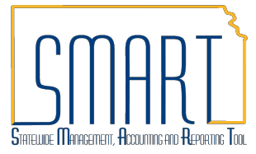
State of Kansas Reviewing Budget Check Exceptions
Statewide Management, Accounting and Reporting Tool

View Budget Check Exceptions for Purchase Orders

Roles: Agency Budget Processor, Agency Budget Approver

Navigate to: Commitment Control > Review Budget Check Exceptions > Purchasing and Cost Management > Purchase Order
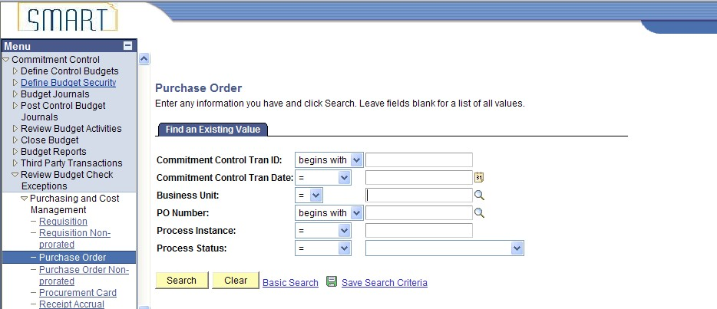

- Enter your agency’s business unit (i.e. 17300). Select Process Status of Errors Exist from the drop down menu to view all purchase orders in budget check error. Once you have entered the business unit and process status, click the Search button. The Search Results will appear under the selection criteria. Click on any of the hyperlinks to pull up the budget check exception details.
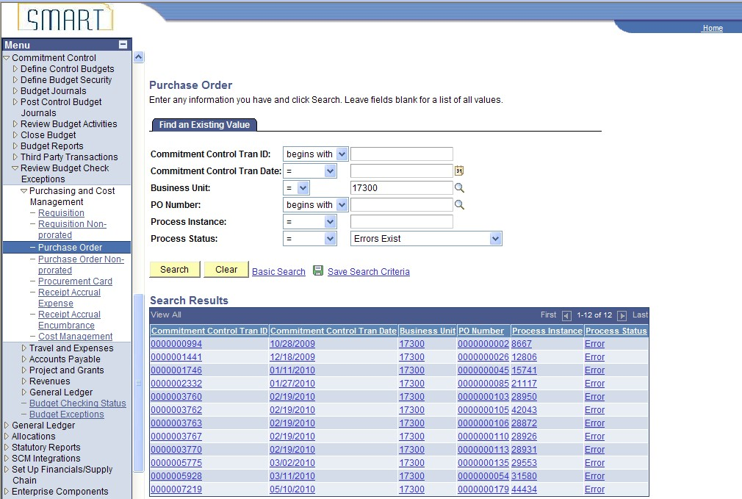
Click anywhere in the line to pull up details (shown in step 4).

- You can also search by specifying the business unit and PO ID instead of searching for all purchase orders in error. Once you have entered the business unit and PO ID, click the Search button.
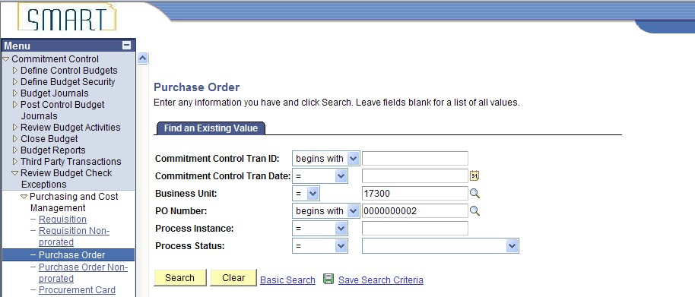

- You will be redirected to the Purchase Order Exceptions details page.
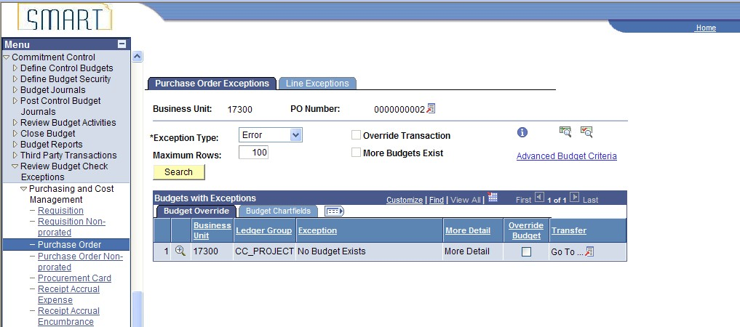

View Budget Check Exceptions for Vouchers

- Navigate to: Commitment Control > Review Budget Check Exceptions > Accounts Payable > Voucher
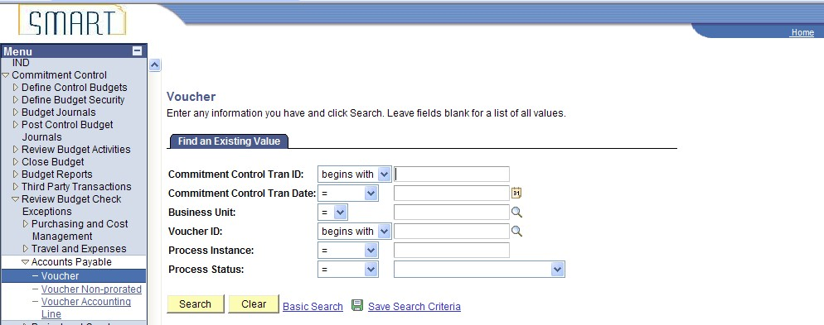

- 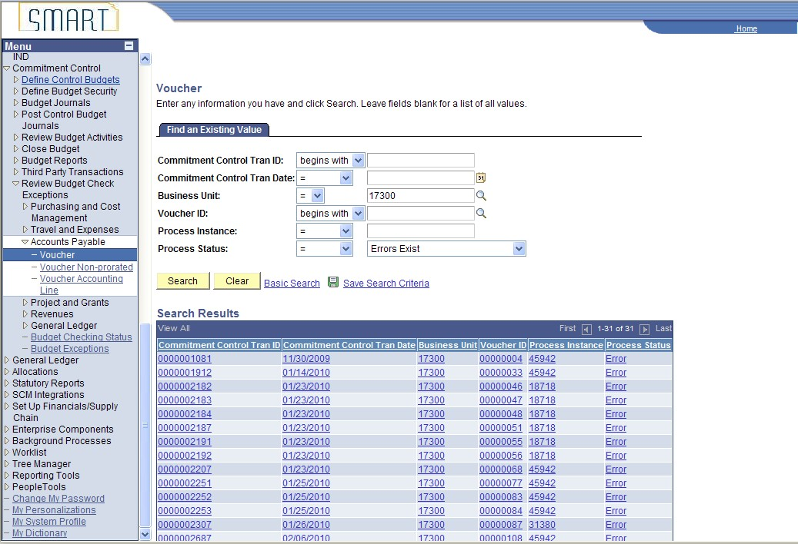Enter your agency’s business unit (i.e. 17300). Select Process Status of Errors Exist from the drop down menu to view all vouchers in budget check error. Once you have entered the business unit and process status, click the Search button. The Search Results will appear under the selection criteria. Click on any of the hyperlinks to pull up the budget check exception details.
Click anywhere in the line to pull up details (shown in step 4).

- You can also search by specifying the business unit and Voucher ID instead of searching for all vouchers in error. Once you have entered the business unit and voucher ID, click the Search button.
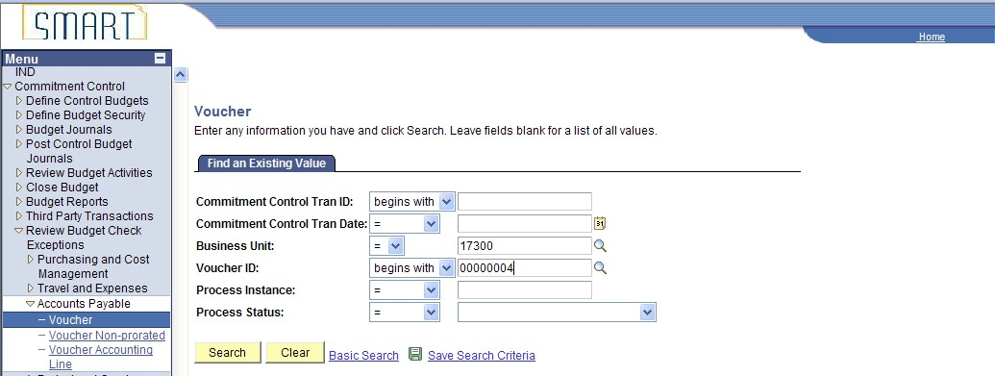

- You will be redirected to the Voucher Exceptions details page.
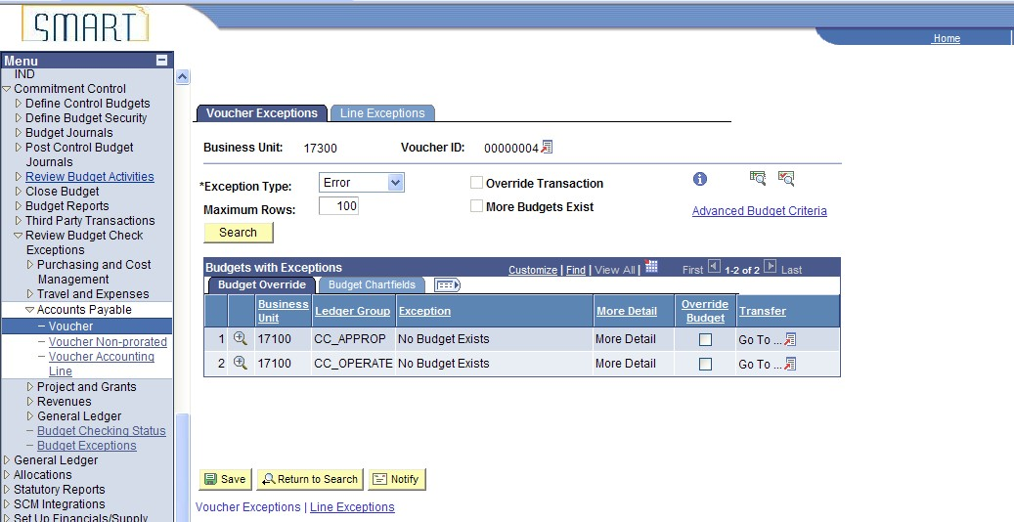

View Budget Check Exceptions for Journals

- Navigate to: Commitment Control > Review Budget Check Exceptions > General Ledger > Journal
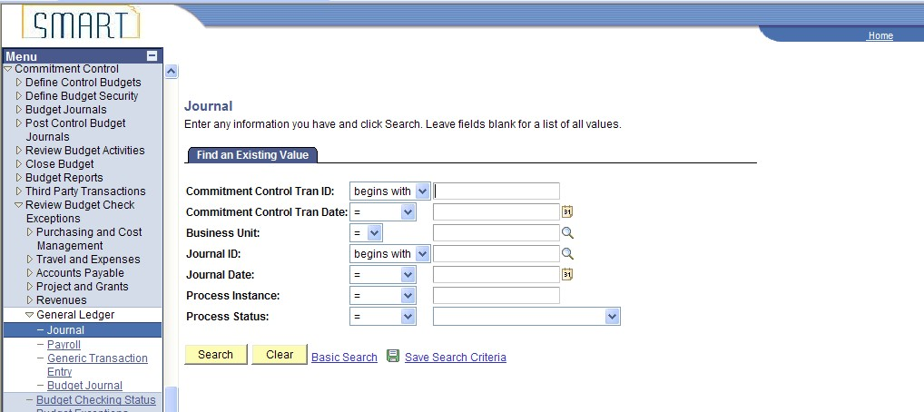

- Enter your agency’s business unit (i.e. 17300). Select Process Status of Errors Exist from the drop down menu to view all journals in budget check error. Once you have entered the business unit and process status, click the Search button. The Search Results will appear under the selection criteria. Click on any of the hyperlinks to pull up the budget check exception details.

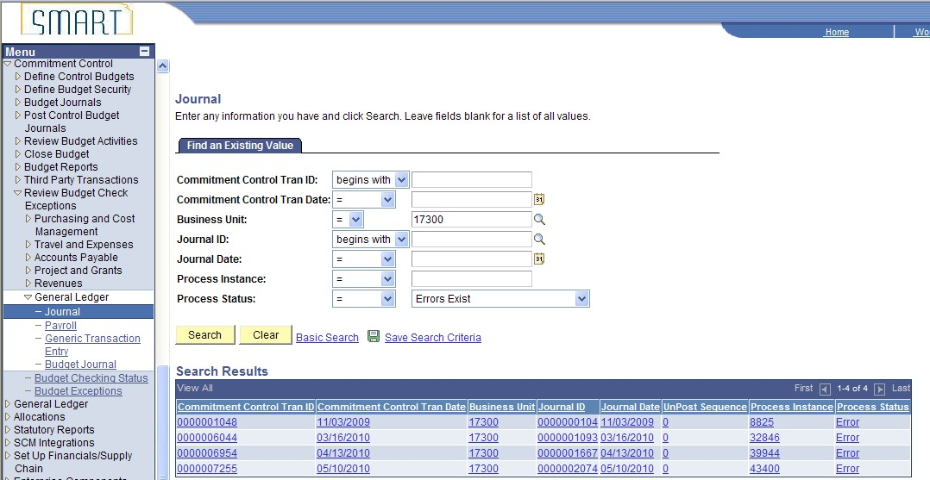

Click anywhere in the line to pull up details (shown in step 4).

- You can also search by specifying the business unit and Journal ID instead of searching for all journals in error. Once you have entered the business unit and Journal ID, click the Search button.
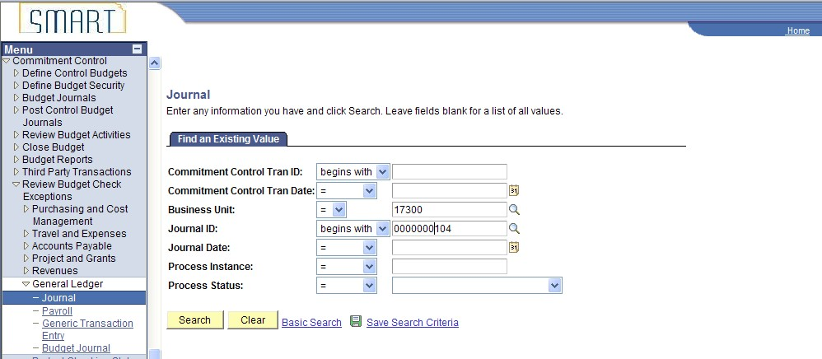

- You will be redirected to the GL Journal Exceptions details page.
