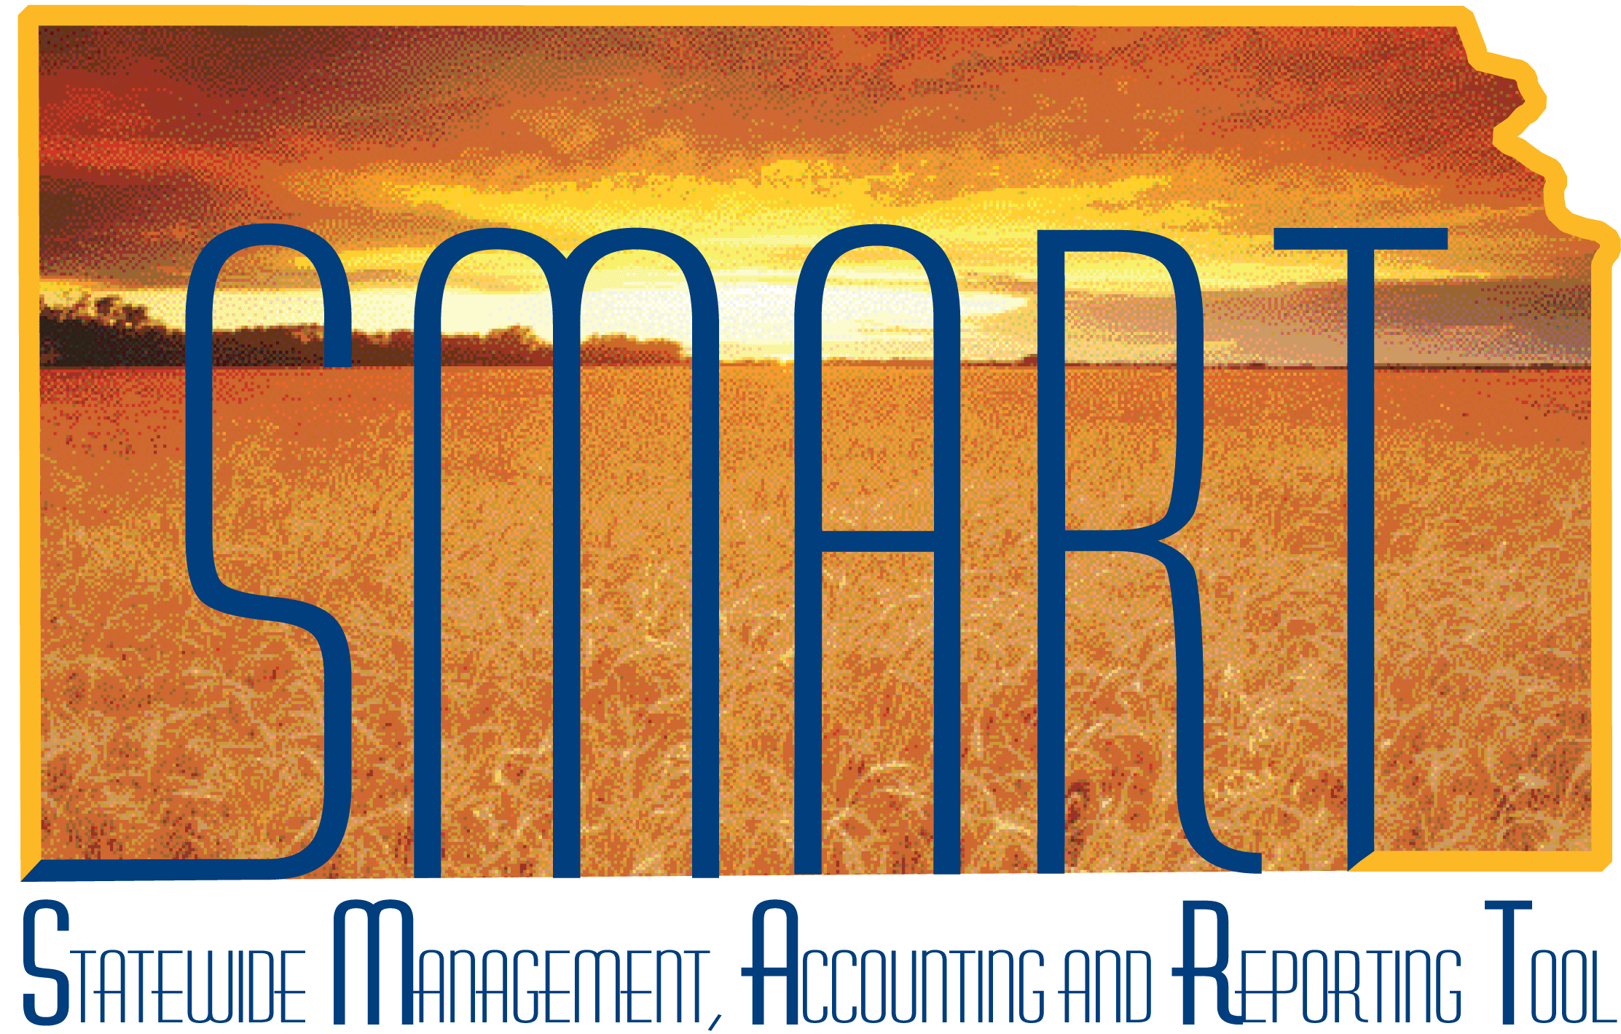
Training Guide –
Processing Budget Journals
State of Kansas

Applicable Roles:

Agency Budget Processor
Agency Budget Approver
TABLE OF CONTENTS
Lesson 4: Processing Budget Journals 3
Objectives 3
Topic 1: Budget Journal Posting 3
Topic 2: View and Correct Budget Journal Errors 5

Lesson 4: Processing Budget Journals

Objectives
Upon completion of this lesson, you will be able to:
- Describe the types of errors that might occur during the budget journal post process
- Review and correct budget journal entry errors

Topic 1: Budget Journal Posting
- The Commitment Control Posting process will post completed budget journals to the control budget ledgers
- Commitment Control ledgers are set up by Central staff in Department of Administration. They are set up by business unit and have the same naming convention for each agency.
- Commitment Control ledgers are made up of ledger groups. For example, the Commitment Control Ledgers for the CC_OPR_DOB Ledger Group are CC_OPD_BUD, CC_OPD_EXP, or CC_OPD_ENC.
- There are two ways to run the budget journal posting process:
- You can initiate it on the Budget Lines page for a single budget journal if the budget needs to be reconciled immediately, or
- You can request a batch process on the Budget Posting Request page. The batch process is considered best practice if you have budget journals with over 200 lines or multiple budget journals to post.
Page name | Navigation
Budget Posting Request | SMART Homepage > General Ledger/KK page > Commitment Contro tile > Budget Journals > Request Posting> Enter or Find the Run Contol ID.

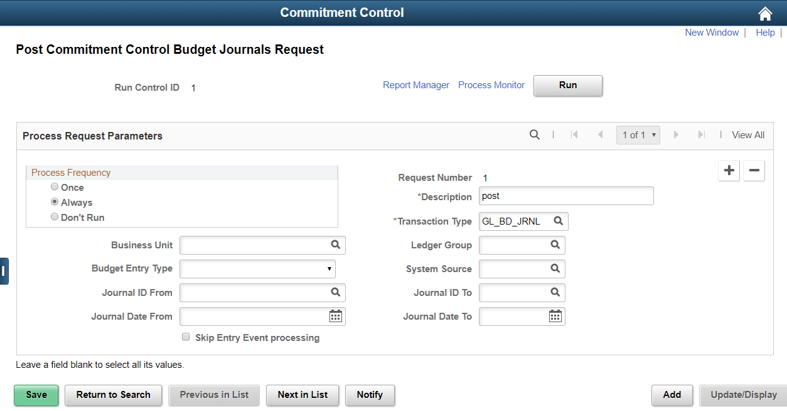
Figure 1. Post commitment Control Budget Journals Request Page
Field | Description
Process Frequency |  | Click on the Always button
Description |  | Enter a description of the journal
Transaction Type |  | GL_BD_JRNL defaults as the transaction type. Do not change it.
Ledger Group |  | Enter the ledger group for the budget journals you intend to post, CC_OPERATE, etc.
Business Unit |  | Your business unit
Ledger Group, Journal ID, and/or Journal Date |  | (optional) Enter to refine the range of budget journals that will be posted.
Skip Entry Processing |  | Leave blank
Table 1. Post Commitment Control Budget Journals Request Page Elements

Topic 2: View and Correct Budget Journal Errors
- If budget journal entries fail edits or receive warnings, you can use the Budget Journal Exceptions pages to view the exceptions and derive more detailed information about the budget journals, journal lines and the associated exceptions
- You can access the original journal or other options and determine the nature of the errors and, before running budget journal posting again, make the necessary corrections
- Potential Errors:
  - Budget is closed
  - Key ChartField values are not at or above a budgetary-level node of the translation tree, if translation is established in the budget definition.
    - For example, a value that is not at tree level based on the agency’s operating budget definition set up will produce an error because it needs to match the agency’s designated budget structure.
    - SMART uses three trees for budget ing purposes – CC_ACCOUNT, CC_DEPT_ID, and CC_PROGRAM.
    - Determine the translation values by reviewing the budget ledger group using the Commitment Control inquiry. Navigation: Commitment Control> Review Budget Activities> Budget Details. Enter the Business Unit and Ledger Group and Search. The results will show you the ChartField values used for the particular Budget Ledger Group.
  - Budget Period is not valid for the budget ledger
  - Budget Ledger not is valid for the business unit
  - Account is an account type that is excluded for the budget
  - Key ChartFields are blank
  - Note: The Budget Errors page on the Budget Journal component will show some errors. However, best practice is to use the Budget Journal Exceptions page because it shows all the errors.
- There is no workflow associated with the budget journal posting process in SMART. The ability to post a budget journal in SMART is determined by role.
- The Budget Approver role can post a budget journal.The Budget Processor role, can enter budget journals but cannot post them. If a Budget Processor attempts to post a budget journal, a security error message will be received.
- Note: Role assignments and role segregation decisions are made at an individual Agency level.
- If the Budget Processor role makes an error while creating a budget journal, the error will not be recognized in SMART until a Budget Approver attempts to post the budget journal in SMART
- The Budget Approver can view a summary of the errors made on the budget journal using the Budget Journal Exception page. It will be up to the agency whether or not the Budget Approver will fix the journal or send it back to Budget Processor for corrections.
Page name | Navigation
Budget Journal Exceptions page | Navigator > Commitment Control>Review Budget Check Exceptions>General Ledger>Budget Journal>Budget Journal Exceptions

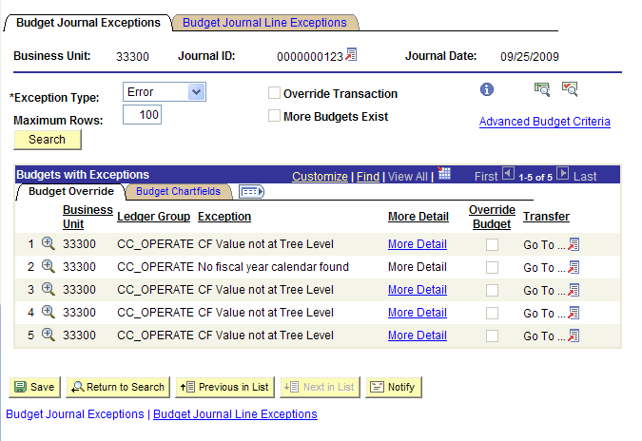
Figure 2. Budget Journal Exceptions Page

Field |  | Description
 | Click this button, that is located next to the journal ID, to access the original budget journal
Exception Type | You can limit information returned for this budget journal to either errors or warnings and when you click the Search button, the system populates the scroll up to the number of rows that you specify in the Maximum Rows field.
Maximum Rows | Enter the maximum number of budget journal lines with exceptions that you want to retrieve to the budgets with exceptions grid at the bottom of the page. The default value is 100.
More Budgets Exist | The system selects this field when the Maximum Rows field value is less than the total number of budget rows retrieved by the system.
 | Click the Budget Check Document button after overriding errors to budget check the budget journal again.
Advanced Budget Criteria | Select this link to access the Refine Inquiry Criteria page where you can change the budget criteria to limit the rows you see.
 | Click to view the Budget Journal Drill Down page for a budget journal row where you can view the line identifiers, source information, and transaction line detail.
Override Budget | If you have the security, you can override errors for individual budget journal rows. Agencies can not override budget errors for centrally maintained budget ledger groups – CC_APPROP, CC_CASH, and CC_CSH_REV
 | Click this button under the Transfer column to access 2 links. One is the Go to Budget Exception link that enables you to go to the Commitment Control Budget Exceptions page. You can also click the link to access the Commitment Control Budget Details page. These pages enable you to access additional pages and inquiries used in managing budgets and transaction exceptions.
Table 2. Budget Journal Exceptions Page Elements
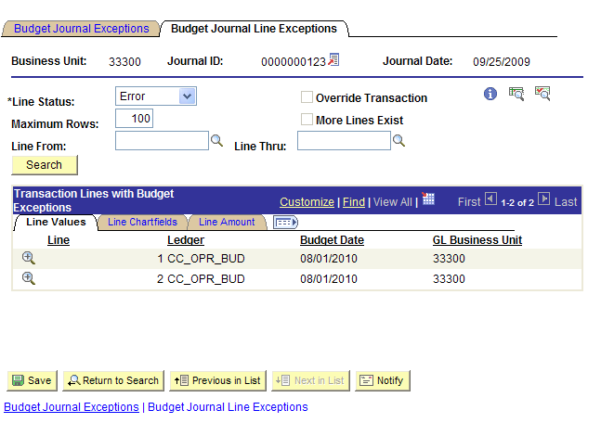
Figure 3. Budget Journal Line Exceptions Page
Field | Description
Line From and Line Thru |  | Enter a consecutive block of line numbers and click the Search button to display those rows within the Maximum Rows constraints.  If the number of rows populating the Transactions Lines with Budget Exceptions grid is less than the number retrieved given you criteria, the system will issue a message that more lines exist and you can either increase the lines or select the OK button on the message to display the block of numbers that you originally selected.
More Lines Exist |  | The system selects this field when the Maximum Rows field value is less than the total number of transaction lines with budget exceptions retrieved by the system.
Table 3. Budget Journal Line Exceptions Page Elements

In this lesson, you learned how to:
- Describe the types of errors that might occur during the budget journal post process,
- Review and correct budget journal entry errors

