Training Guide – Importing Budget Spreadsheet Journals in SMART
State of Kansas

Applicable Roles:

Agency Budget Processor
Agency Budget Approver

TABLE OF CONTENTS
Importing Budget Spreadsheet Journals in SMART 3
Objectives 3
Topic 1: Budget Spreadsheet Journals Overview 3
Topic 2: Budget Spreadsheet Journal File Requirements 4
Topic 3: Creating a Budget Spreadsheet Journal 7
Topic 4: Importing a Budget Spreadsheet Journal 14
Lesson Review 17

Importing Budget Spreadsheet Journals in SMART

Objectives
Upon completion of this lesson, you will be able to:
- Explain the importance of budget spreadsheet journal uploads in SMART
- List the requirements for importing budget spreadsheet journals into SMART
- Demonstrate the steps to successfully import a budget spreadsheet journal

Topic 1: Budget Spreadsheet Journals Overview
- The Budget Spreadsheet Journal workbook enables you to enter budget journals offline using Microsoft Excel and then import the budget journals directly into Commitment Control. It is recommended that each journal contain no more than 250 lines.
- The benefits for using budget spreadsheet journals are:
- Spreadsheets enable rapid data entry, which is useful for keying large journals
- Recurring or repetitive budget journals can be saved and easily updated for changing dates and amounts
- The accounting data necessary to create a budget journal is oftentimes already in an Excel spreadsheet and can easily be copied into the spreadsheet template
- The Budget Spreadsheet Journal functionality is different from the online budget journal. The differences include no dropdown lists for ChartField values and no Chartfield or combination edit validation against the database until the journal has been imported and saved. But, the following edits are performed for the data:
  - Checks for the existence of all of required fields
  - Checks to see if the user supplied journal ID already exist in the database
  - Checks to see if the ledger group is a commitment control ledger group
The following diagram shows the highlights of the Importing a Budget Spreadsheet Journal process.
Figure 1. Importing a Budget Spreadsheet Journal Process

Topic 2: Budget Spreadsheet Journal File Requirements
- The Budget Spreadsheet Journal files can be obtained by logging a Service Desk ticket and requesting the files.

Required Files | Description
BudgetJournalUpload.XLS | This is the budget journal workbook that you use to create and import budget journals. You can rename this file, if you want.
JRNLMCRO.XLA | This is the Visual Basic code library and dialog control
GLLOG.XLT | This is the Message log template
MSXML.DLL | Microsoft delivered XML library file used when importing online
Table 1. Budget Spreadsheet Upload Files
- There are four files used to import budget spreadsheet journals into Commitment Control. The first three files are in the .zip file and should be placed in the same directory anywhere on your workstation. The MSXML.dll file is part of the Microsoft library.
- You can create multiple journal workbooks by saving a clean BudgetJournalUpload.xls file as JRNL2.xls or JRNL3.xls, for example. However, the message log template, GLLOG.txt, and the macro sheet files, JRNLMCRO.xla, must not be changed or renamed.
- In order to import budget spreadsheet journals, Microsoft Excel must be enabled to accept macros. To enable macros, go to Tools>Macro>Security and select Medium or Low on the Security Level tab.

Topic 3: Creating a Budget Spreadsheet Journal
- You must access a new budget journal sheet to begin entering the data for your spreadsheet upload
- You can insert as many budget journal sheets as needed, and each budget journal sheet can contain as many budget journals as necessary

Page Name | Navigation
Budget Spreadsheet Journal Import (BSJI) Control sheet | Open BudgetJournalUpload.xls file at workstation
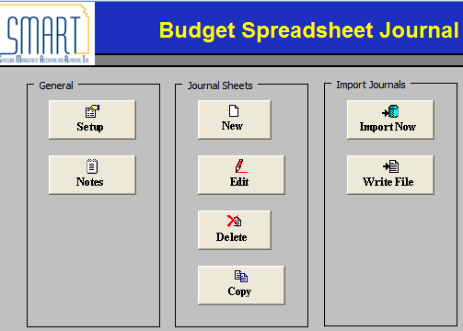
Figure 7. Budget Spreadsheet Journal Import Control Worksheet
Fields | Description
Setup | Click to set up access to the Define Options and Defaults dialog box. The Setup is used to set budget journal header defaults, message logging options, and online import controls. Options set here will default to budget journal sheets and budget journals created within this workbook.
Notes | Click to access another worksheet in the workbook that can be used as a scratch pad. Use the scratch pad for instructions, calculations, notes, and so on.
New | Click to insert a new budget journal sheet. A workbook can contain as many budget journal sheets as needed, and each budget journal sheet can contain as many budget journals as desired.
Edit | Click to edit an existing budget journal worksheet. A list of available spreadsheets will be displayed. Highlight the file you want to edit.
Delete | Click to delete one or more budget journal sheets in the workbook. A list of available spreadsheets will be displayed. Highlight the file(s) you want to delete.
Copy | Click to copy one budget journal sheet to a new journal sheet saved under a new name
Import Now | SMART does not use this functionality
Write File | Click to write and save a selected journal sheet to a file. The spreadsheet will be converted to an HTML formatted file. After saving the file, you must run the batch budget spreadsheet journal import process from SMART to upload the file.
Table 2. Budget Spreadsheet Journal Import Control Sheet Fields
Page Name | Navigation
Define Options and Defaults | BSJI Control Page>Setup button
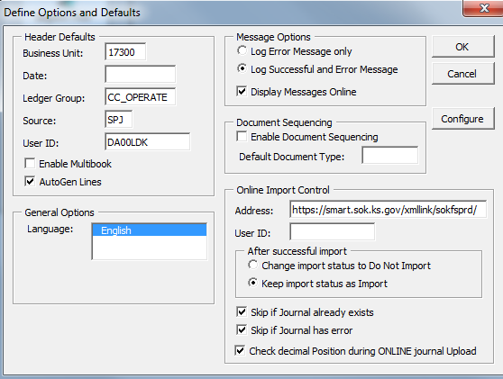
Figure 8. Define Options and Defaults Dialog Box
Fields | Description
Header Defaults section | Fill in your most commonly used budget journal parameters as defaults. The values are case sensitive.
General Options | No changes required.
Message Options section | Choose whether you wish to see success and error messages or error messages only. You can also choose to view error messages online rather than using the text file on your workstation.
Document Sequencing section | Document sequencing is not used in SMART.
Online Import Control section | No changes required.
Table 3. Define Options and Defaults Dialog Box Fields

Page Name | Navigation
New Spreadsheet Journal Sheet | BSJI Control Page>New button
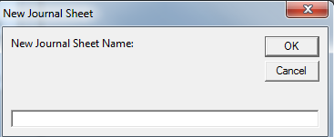
Figure 9. New Journal Sheet Dialog Box

Field | Description
New Journal Sheet Name | Enter a meaningful sheet name then click OK to open the Budget Spreadsheet Journal Worksheet.
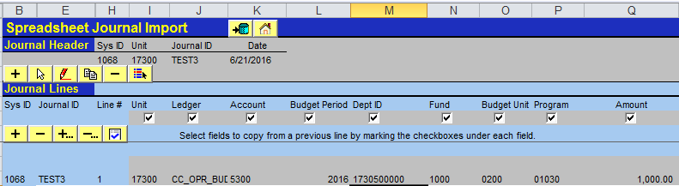
Figure 10. New Budget Spreadsheet Journal Worksheet
Fields | Description
Row 2: Overall Actions Buttons
 | SMART will not use the Import Now button
 | Returns to the Budget Spreadsheet Journal Import Control sheet

Row 5: Budget Journal Header Action Buttons
Create a new Budget Journal Header
Select a Budget Journal Header
Edit a Budget Journal Header
Copy a Budget Journal Header and Lines
Delete a Budget Journal entry
Change the import status of a budget journal
Row 9: Budget Journal Lines Action Buttons
Add a budget journal line in the current selected budget journal header. Note: If you wish to copy values down to new lines, use the check boxes in row 8. If a check box is not selected, the initial value for that field on the succeeding line is blank.
Delete a budget journal line. Position your cursor on the line and click this button.
Add/Copy a block of multiple lines
Delete a block of multiple lines
Check the amount fields to verify that you have entered amounts with the correct number of decimal points. The default number of decimal points is 2. Click the button to check the number of decimal points before you import the journal.
Table 4. New Budget Spreadsheet Journal Worksheet Icons

Page Name | Navigation
New Budget Journal Header | BSJI Control Page>New button>Create Budget Journal Header button
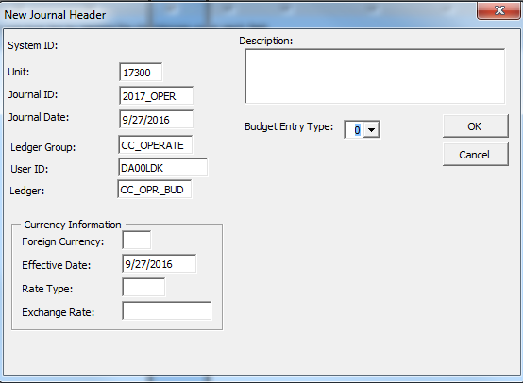
Figure 11. New Budget Journal Header Dialog Box
Fields | Description
Unit | Enter the Business Unit for your agency, which is the three-digit agency number followed by "00". Depending on your security level, you may have access to more than one business unit.
Journal ID | The Journal ID field defaults to NEXT. For Budget Spreadsheet Journals, you must change this to a 10-character value in order for the journal to be imported into SMART.
Journal Date | Enter the Journal Date for the budget journal you are creating.
Ledger Group | Enter the Ledger Group for the budget journal you are creating.
User ID | Enter your SMART User ID into this field.
Ledger | Enter the Ledger for the budget journal you are creating. The Ledger must be associated to the Ledger Group i.e., CC_OPERATE ledger group requires CC_OPR_BUD ledger.
Currency Information section | No changes required.
Description | Enter the Header Description. The description can be 254 characters long.
Budget Entry Type | Identifies the type of budget journal entry. In most cases, choose ‘0’ that indicates this is an Original budget journal.
Click the OK button when the journal header is completed.
Table 5. New Journal Header Dialog Box Fields

Page Name | Navigation
New Budget Journal Lines | BSJI Control Page>New button> Add a journal line or Add journal lines button
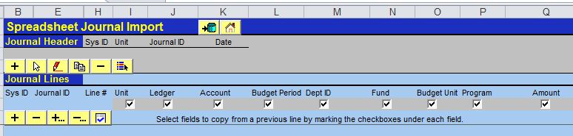
Figure 11. New Budget Journal Line ChartFields
- There are three options when adding Budget Journal lines. For all of the options, save the budget journal spreadsheet before writing and importing the file.
  - Option 1: Enter the funding line ChartFields and Amount in the appropriate columns. If additional lines are needed, click on the button.
  - Option 2: Cut and paste the ChartFields from another spreadsheet. Prepare a spreadsheet and arrange the spreadsheet’s columns in the same order as the columns in the Budget Journal Spreadsheet. Add the number of lines needed using the button. ‘Copy’ the data from the other spreadsheet and ‘Paste as Values’ into the journal spreadsheet. If you have not added enough lines, you will receive an error and will need to add more lines then copy and paste again. If you have added too many lines, delete them using the or buttons.
  - Option 3: Copy a prior journal and change the ChartFields and/or Amounts, as needed. For more information, see description below.
Fields | Description
Unit | Enter the Business Unit for your agency, which is the three-digit agency number followed by "00". Depending on your security level, you may have access to more than one business unit.
Ledger | Enter the budget ledger. The budget ledger must be in the Ledger Group chosen on the Header. If CC_OPERATE is the ledger group use CC_OPR_BUD for the ledger.
ChartFields | Enter the required ChartField values based on your agency’s Budget Definition. Note that the DeptID, Program, and Account Chartfields should be entered at the translation level chosen in the Budget Definition.
Table 6. Budget Journal Line Key Elements

Page Name | Navigation
Copy Budget Journal | BSJI Control Page>New button>Copy Budget Journal Header and Lines button
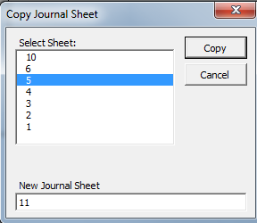
Figure 12. Copy Budget Journal Dialog Box
Fields | Description
Journal listing | Highlight the journal you are copying.
New Journal Sheet | Enter the new Journal Sheet name.

Topic 4: Importing a Budget Spreadsheet Journal
- After you create a file for import, you log into SMART and use the budget spreadsheet journal import batch process to upload the file
- There are two steps to import the journal into SMART.
  - The first step is to “Write File” which converts the Excel spreadsheet file into an HTML format.
  - The second step Imports the HTML file into SMART.
- Budget spreadsheet journal validation is limited and it is not intended to be as broad as the validation provided with online journal entry using the Budget Journal Entry page in Commitment Control. For batch import, error messages are provided in a separate log file and are not part of the message log.
- The following are examples of error and warning messages that might be logged during budget spreadsheet journal import:
  - Logs error if “NEXT” is used. For the Budget Journal spreadsheet, a budget journal ID must be entered into the spreadsheet.
  - Logs budget journal header validation errors
- Logs budget journal line validation errors
- Logs message for skipped budget journal headers
- Logs message for skipped invalid budget journals
- Logs message for ledger groups that are not commitment control ledger groups

Page Name | Navigation
Write Journals to File | BSJI Control Page>Write File button

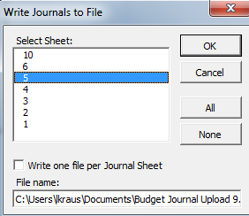
Figure 13. Write Journals to File Dialog Box

Fields | Description
Select Sheet | Select the spreadsheet journal(s) you have created.
Write one file per Budget Journal Sheet check box | This check box defaults to not selected so that one file is generated for all budget journal sheets. You have the option of selecting this checkbox to create one file for each budget journal sheet and an index file.
File Name | Enter a name for the file including the path where you want it saved. Note the file location for the next step. Click on the OK button to process.
Table 6. Write Journals to File Dialog Box Fields

Page Name | Navigation
Budget Journal Spreadsheet Import Request | SMART Homepage > General Ledger/KK page > Commitment Control tile > Budget Journals > Budget Journal Spreadsheet > Budget Journal Spreadsheet Imp
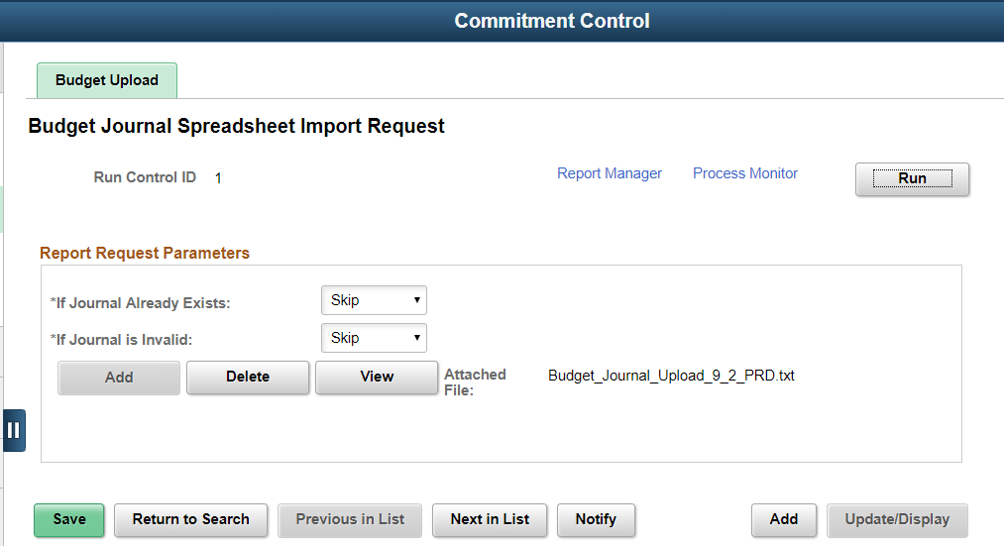
Figure 14. Budget Journal Spreadsheet Import Request Page
Fields | Description
If Journal Already Exists | Select whether to abort, skip, or update if the same budget journal already exists
If Journal is Invalid | Select to abort or skip if the budget journal is invalid
Add | Click to add an attachment. Browse for the file you have written from the budget spreadsheet journal workbook, and then click Upload.
Delete | Click to delete an attachment
View | Click to display the contents of the attached file.
Run | Select Run to process the request.
Process Monitor | Click on the link to see the Process Instance Page to determine when process is complete.
Table 7. Budget Spreadsheet Journal Import Request Page Fields

After the budget journal has been uploaded, then please refer to the Creating a Budget Journal Entry training guide for information concerning editing and posting of the journal.

Lesson Review
In this lesson, you learned how to:
- Explain the importance of budget spreadsheet journal uploads in SMART
- Demonstrate the steps to successfully import a budget spreadsheet journal

