**State of Kansas**

**How to Find a Cash Balance in SMART**

***Statewide Management, Accounting and Reporting Tool***

The purpose of this training document is to explain how to find a cash balance in SMART. Cash balances provide vital information for agency management and fiscal staff throughout a budget period or fiscal year.

Steps for identifying cash balance differences will also be discussed.

## Cash balances in SMART

There are TWO different cash balances in SMART:

General Ledger Cash Balance (GL Cash), and

Commitment Control Cash Control Balance (CC Cash or KK Cash)

**General Ledger Cash Balance (GL Cash):**

* GL Cash is tracked in the 'ACTUALS' Ledger Group (in the General Ledger module of SMART)
* GL Cash is tracked by Fiscal Year and Accounting Period
* GL Cash is the balance in Account code '110100' (Treasurers Common Cash).
* The beginning balances in the General Ledger Cash Account (Account 110100) and the Cash Control Budget Ledgers were the same when the SMART system implemented on July 1, 2010.
* GL Cash is updated when Payment journals or Collected Revenue journals are posted to the General Ledger.
* GL Cash acts as a checkbook tracking all deposits, expenses, and transfers written in the check register.

**A General Ledger Cash Balance can be found in SMART using the following navigations:**

* *Ledger Inquiry* – SMART Homepage > General Ledger/KK page > General Ledger tile> Inquires > Ledger Inquiry
* *Cash Balance Report* – SMART Homepage > General Ledger/KK page > GL & KK Reports tile > GL Reports > Cash Balance Report (KGL00001).

**Commitment Control Cash Control Balance (CC Cash or KK Cash)**

* CC Cash is tracked in the Commitment Control Cash Ledgers (in the Commitment Control module of SMART)
* CC Cash is tracked by Fund or Fund and Budget Unit only
* CC Cash is the sum of the beginning balance (CC_CASH Budget), the total expenditures (CC_CASH Expense), and the total collected revenues (CC_CSH_REV Collected Revenue) from the inception of SMART (07/01/2010) through the current date.
* CC Cash is recorded in the Commitment Control Cash Ledgers when an expenditure (Account code 5xxxxx - ChartField value), collected revenue (Account code 4xxxxx - ChartField value), or transfer (Account code 7xxxxx - ChartField value) has been budget checked in SMART.

**A Commitment Control Cash Control Balance can be found in SMART using the following navigation:**

* *Budget Detail Inquiry* – SMART Homepage> General Ledger/KK page > Commitment Control tile > Review Budget Activities> Budget Details
* *Cash Control Report* *(This report only provides balances by Fund)* – SMART Homepage > General Ledger/KK page > GL & KK Reports tile > Commitment Control Reports> Cash Control Report(KGL00002).

## The Differences Between GL and CC Ledgers

It is important to know and understand GL Cash and CC Cash ***may not be equal***.  To compare cash balances in SMART, you first need to understand when SMART transactions are recorded in each ledger and the impact to each ledger.    
  
In this scenario, the following transactions will be used to illustrate the impact on cash balances in each of the Ledgers:

* $1,000 invoice amount
* $100 billed amount
* $250 direct journal deposit
* $350 contract disbursement

The highlighted values (highlighted in gray in the table) are the transactions that impact GL Cash and CC Cash.

**Please Note:**This example does not discuss Pre-encumbrances (Requisitions) or Encumbrances (Purchase Orders, Travel Authorizations, and GL Encumbrances) because CC Cash is not impacted by Pre-encumbrances or Encumbrances.

|  |  |  |  |  |  |  |  |  |  |  |
| --- | --- | --- | --- | --- | --- | --- | --- | --- | --- | --- |
| Transaction | GL Expenditures (Account 5xxxxx) | GL Payables (Account 2xxxxx) | GL Revenues (Account 4xxxxx) | GL Receivables Unbilled (Account 130110) | GL Receivables Billed (Account 130100) | GL Cash (Account 110100) |  | CC Cash Expenditure | CC Cash Recognized Revenue | CC Cash Collected Revenue |
| Voucher | $1,000 | ($1,000) |  |  |  |  |  | $1,000 |  |  |
| Payment |  | $1,000 |  |  |  | ($1,000) |  |  |  |  |
|  |  |  |  |  |  |  |  |  |  |  |
| Billing |  |  | ($100) |  | $100 |  |  |  | $100 |  |
| Billing Deposit |  |  |  |  | ($100) | $100 |  |  |  | $100 |
|  |  |  |  |  |  |  |  |  |  |  |
| Direct Journal Deposit |  |  | ($250) |  |  | $250 |  |  | $250 | $250 |
|  |  |  |  |  |  |  |  |  |  |  |
| Contract Disbursements | $350 | ($350) | ($350) | $350 |  |  |  | $350 | $350 |  |
| Contract Payments |  | $350 |  |  |  | ($350) |  |  |  |  |
| Contract  Billing |  |  |  | ($350) | $350 |  |  |  |  |  |
| Contract Deposit |  |  |  |  | ($350) | $350 |  |  |  | $350 |

The table above reflects the following:

* Vouchers are recorded in the Commitment Control Cash Ledgers and they impact CC Cash *before* the payment is posted to GL Cash Account (Account code 110100) in the General Ledger
* Billed/Contract Revenue is recorded as 'Recognized Revenue' in the Commitment Control Cash Ledgers, and is posted as 'Revenue' and 'Accounts Receivable' in the General Ledger *at the time of billing*
* Direct Journal Deposits impact the 'Recognized and Collected' Revenue *simultaneously*

**For example**:  The differences between the cash balances may be due to outstanding Accounts Payable transactions, or transactions that have not yet posted to the General Ledger.    
  
***The Comparison of GL Cash and CC Cash***

Agencies may have instances where there appears to be sufficient cash balance in the General Ledger but a voucher, expense report, transfer out, or GL journal will receive a budget check error due to insufficient CC Cash. When this occurs, agencies will need to compare GL Cash and CC Cash to figure out why.

The steps below can assist with finding these differences. The data is compared at the most summarized level and as differences are found, more detail is needed.

**High Level Steps:**

1. Find GL Cash balance(s)
2. Find CC Cash balance(s)
3. Compare GL Cash to CC Cash and identify the differences
4. Identify Payables that are not in the GL Cash balance
5. Identify Transactions “Not Posted” to the General Ledger
6. Calculate the revised differences – balances should now match

**Detailed Steps:**

The following pages contain detailed steps which explain how to compare the cash balances, and how to find the differences between the cash balances.

1. **Find the GL Cash balance**

The **Ledger Inquiry** page is used to view detailed transaction data in the General Ledger.  
  
**Navigation to the Ledger Inquiry page:**  **SMART Homepage > General Ledger/KK tile > General Ledger > Inquiries > Ledger Inquiry > Find an Existing Value** or **Add a New Value**

**Step One**:  Enter the desired search criteria in the Ledger Inquiry Page, and then click the **Search** button.  
  
**In this example: Ledger Criteria** section**:**  Unit = '17300', Ledger = 'ACTUALS', Fiscal Year = '2018', From Period = '1', and To Period = '12'.  The 'Show YTD Balance' checkbox is selected.  
  
**Chartfield Criteria** section:  Fund Code = '2323'.  The 'Sum By' checkboxes are selected for 'Account', 'Fund Code', and 'Budget Unit'.  
  
The **Search** button was clicked after the search criteria was entered.

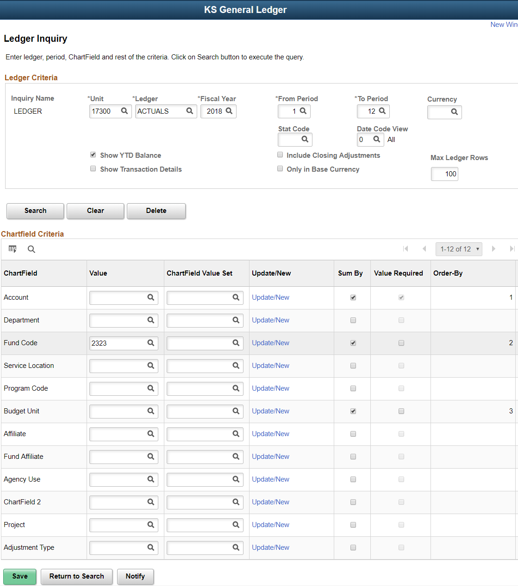

**Step Two:**  View the results of the General **Ledger Inquiry**.  
  
The results of the***Ledger Inquiry*** are displayed in the screenshot below (which shows the **Ledger Amount by Currency** section of the results page).

The **General Ledger Cash Balance** is:

* Found in the most recent accounting **Period** with activity   
  (In this example, refer to the 'Period' column, rows containing Period '**5**')
* Displayed by '**Fund**' and '**Budget Unit**'
* Displayed in the **YTD Period Balance column(s)**

**Note**: The **YTD Period Balance (in Transaction Currency)** column and the **YTD Period Balance (in Base Currency)** column balances should match)

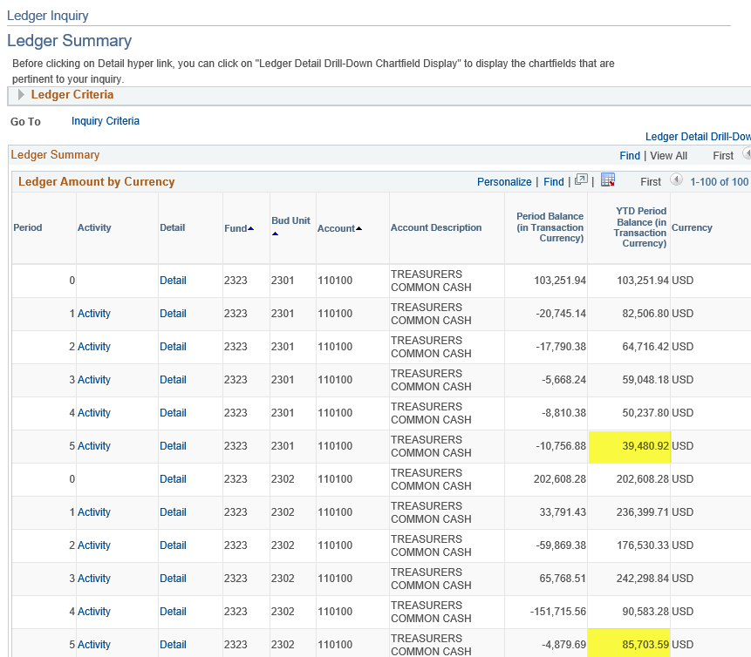

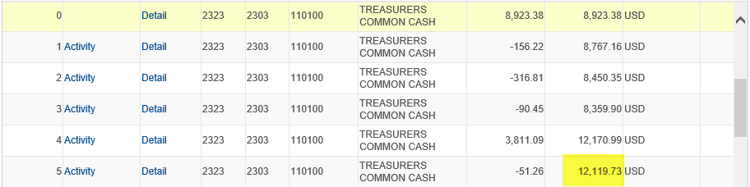

You have now completed your review of the General Ledger Cash Balance.  Next, you need to review the Commitment Control Cash Control Balance.

1. **Find the CC Cash balance**

The **Budget Details** page is used to view detailed transaction data in the **Commitment Control module**  
  
**Navigation to the Budget Details page:** **SMART Homepage > General Ledger/KK page > Commitment Control tile >Review Budget Activities > Budget Details > Find an Existing Value**.

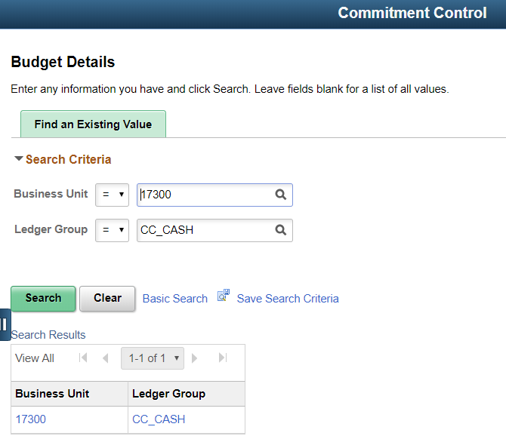

**Step Three:**  Use the Budget Details page to enter the desired search criteria.  
  
**In this example** (shown in the screenshot above): On the Budget Details page, the following **search criteria** were entered:  
  
**Business Unit** = '17300', **Ledger Group** = ‘CC_CASH'

Click the **Search button**.  Clicking the Search button prompts SMART to display the Budget Inquiry Criteria page.

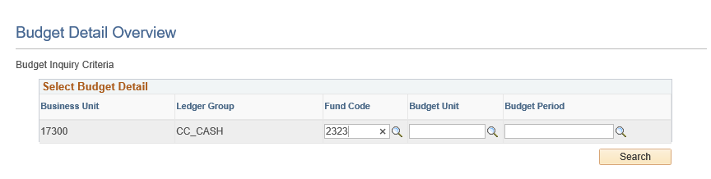

On the Budget Inquiry Criteria page (shown on the screen shot above), the following **search** criteria were entered:

**Fund Code** = ‘2323’  
  
***\*\*\*Do NOT enter a Budget Period - the Cash Budget Ledgers do NOT have a budget calendar. \*\*\****  
  
Click the **Search button**.  Clicking the Search button prompts SMART to display the search results.  
  
**Step Four:**  Now that you have entered the search criteria into the Budget Inquiry Criteria page, and clicked the Search button, SMART displays the **Budget Detail Overview** (shown in screenshot below).  Select the desired search result by clicking on it.

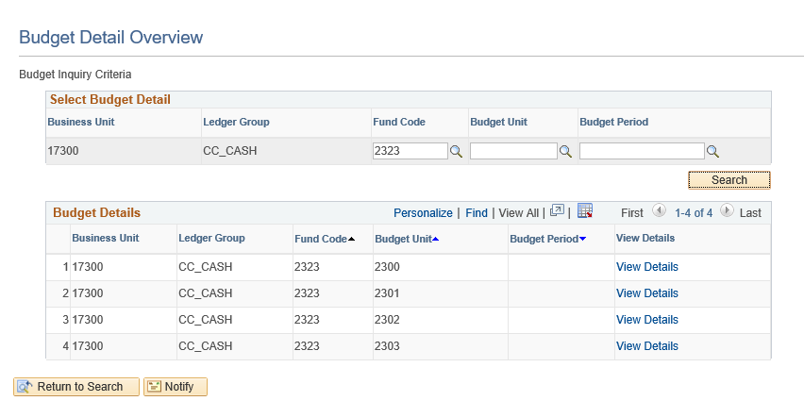

**Step Five:**  Selecting the desired Search Result prompts SMART to open the **Commitment Control Budget Details page**.  Use this page to view the Budget Cash balance details.

In SMART, the **CC Cash balance** is:

* Found on the **Commitment Control Budget Details page**, under the **Available Budget** section.  
  (**Note:**  The 'Without Tolerance' and the 'With Tolerance' amounts should be the same because the State of Kansas is not using the 'Tolerance' functionality in SMART).
* Displayed by '**Fund**' and '**Budget Unit**'
* The sum of the Budget and Associate Revenues less the Expenses:  
    
  ***Budget + Associate Revenues - Expense = CC Cash balance***

**In this example:** Each **'Fund**' and '**Budget Unit**' combination for Fund '**2323**' is displayed (multiple screenshots to follow):

The following screenshots show examples of the **Commitment Control Budget Details page**.

Review the Fund, Budget Unit, Budget, Expense, and Associate Revenue information for each of the Fund and Budget Unit combinations shown below.

Screenshot of the **Commitment Control Budget Details page** for **Fund** '2323' and **Budget Unit** '2300':

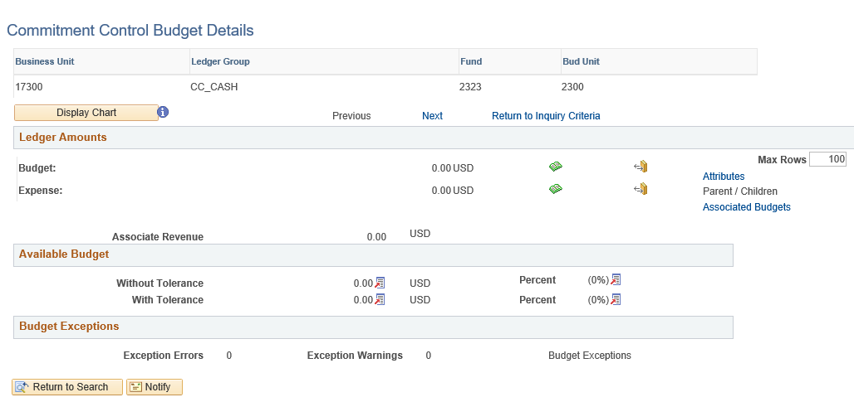

Screenshot of the **Commitment Control Budget Details page** for **Fund** '2323' and **Budget Unit** '2301':

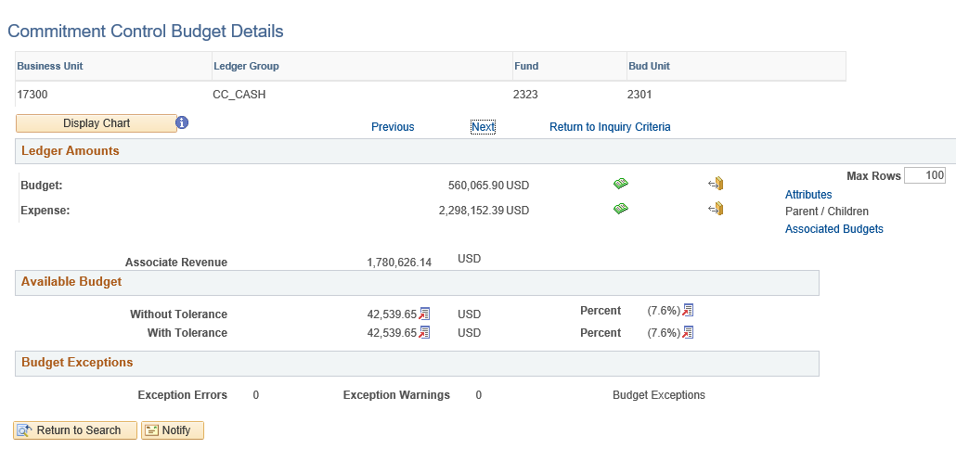

Screenshot of the **Commitment Control Budget Details page** for **Fund** '2323' and **Budget Unit** '2302':

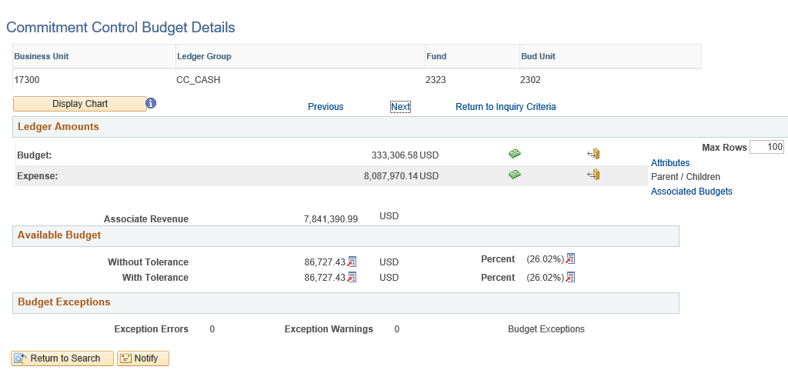

Screenshot of the **Commitment Control Budget Details page** for **Fund** '2323' and **Budget Unit** '2303':

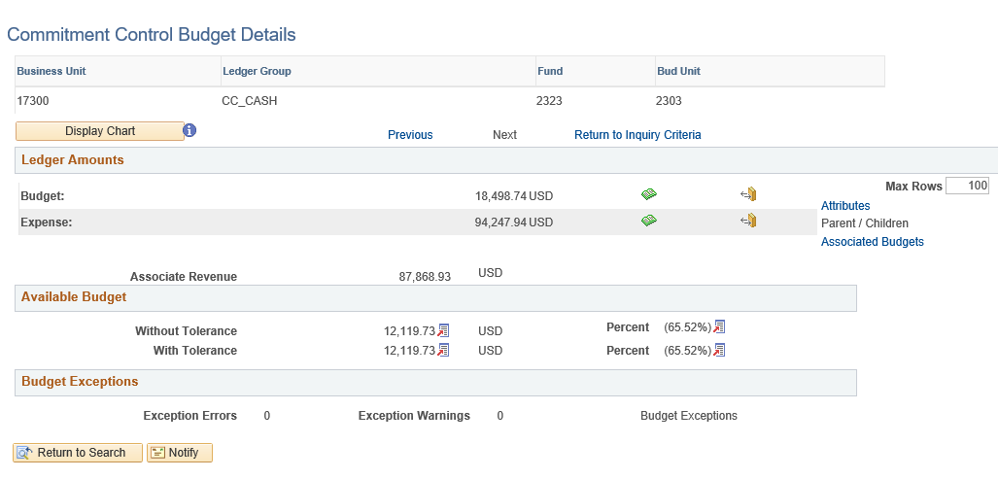

You have now viewed the CC Cash balance information.  Next, you need to compare the GL Cash balance against the CC Cash balance.

1. **Compare the GL Cash balance to the CC Cash balance**

**Step Six:**  Compare the GL Cash balance against the CC Cash balance to identify any differences between the two Cash balances.

The best way to compare the two different Cash balances is to take the information from the two different inquiry pages and create a spreadsheet using the Cash balance amounts.  Using that data, differences can then be identified.  
  
In the following screenshot, the information from the (General) Ledger Inquiry page and from the Commitment Control Budget Details pages (all the different Fund and Budget Unit combinations) has been copied and pasted into a spreadsheet.  The cash balance differences have now been identified and appear in the last column which has been highlighted in yellow:

|  |  |  |  |  |  |
| --- | --- | --- | --- | --- | --- |
| Fund | Budget Unit | GL Account | GL Cash balances | CC Cash balance | Difference |
| 2323 | 2300 | 110100 | - | - | - |
|  |  |  |  |  |  |
| 2323 | 2301 | 110100 | 39,480.92 | 42,539.65 | (3,058.73) |
|  |  |  |  |  |  |
| 2323 | 2302 | 110100 | 85,703.59 | 86,727.43 | (1,023.84) |
|  |  |  |  |  |  |
| 2323 | 2303 | 110100 | 12,119.73 | 12,119.73 | - |

There are several reasons why differences may occur between the two cash balances.  
  
Many of the differences are transactions that are still 'in process' or not “Posted” to the General Ledger.     
  
The steps that follow will provide inquiry pages and queries that can be used to review and identify transactions that are still ‘in process’ which may account for the differences between the cash balances.

1. **Identify Payables that are not in the GL Cash balance**

**Step Seven:**   You can use the **Ledger Inquiry page** to identify all Payables items in SMART that are NOT included in the GL Cash balance.  (Refer to Pages 3 - 5 of this document for instructions on using the Ledger Inquiry page.)

Reminder, the GL Cash balance uses Account code '110100'.  
  
In the screenshot below, the Ledger Inquiry page has been used to identify the Payables items that are NOT included in the GL Cash balance.    
  
Payables accounts in SMART begin with a '2xxxxx' Account code, and include Accounts Payable, Expense Payable, Payroll Deductions (SHaRP), and Payroll Taxes (SHaRP).  
  
**Explanation:**  The Payables items using Account Codes that begin with a '2xxxxx' are still 'in process' in the Payables modules of SMART.  They have not yet progressed to the point of payment in SMART.  Therefore, these Payables items are not yet reflected in the GL Cash balance (Account '110100').    
  
When the payments occur for each of these Payables items, the payments will use the Account code of '110100'.  At that time, the payments will then appear in the GL Cash balance.

| **Period** | **Activity** | **Detail** | **Fund** | **Bud Unit** | **Account** | **Account Description** | **Period Balance (in Transaction Currency)** | **YTD Period Balance (in Transaction Currency)** |
| --- | --- | --- | --- | --- | --- | --- | --- | --- |
| 0 |  | Detail | 2323 | 2301 | 220100 | ACCOUNTS PAYABLE | 0 | 0 |
| 1 | Activity | Detail | 2323 | 2301 | 220100 | ACCOUNTS PAYABLE | 0 | 0 |
| 2 | Activity | Detail | 2323 | 2301 | 220100 | ACCOUNTS PAYABLE | -616.46 | -616.46 |
| 3 | Activity | Detail | 2323 | 2301 | 220100 | ACCOUNTS PAYABLE | 417.71 | -198.75 |
| 4 | Activity | Detail | 2323 | 2301 | 220100 | ACCOUNTS PAYABLE | 198.75 | 0 |
| 5 | Activity | Detail | 2323 | 2301 | 220100 | ACCOUNTS PAYABLE | 0 | 0 |
| 1 | Activity | Detail | 2323 | 2301 | 220110 | ACCRUED EXPENSES PAYABLE | 0 | 0 |
| 2 | Activity | Detail | 2323 | 2301 | 220110 | ACCRUED EXPENSES PAYABLE | 0 | 0 |
| 3 | Activity | Detail | 2323 | 2301 | 220110 | ACCRUED EXPENSES PAYABLE | 0 | 0 |
| 4 | Activity | Detail | 2323 | 2301 | 220110 | ACCRUED EXPENSES PAYABLE | 0 | 0 |
| 5 | Activity | Detail | 2323 | 2301 | 220110 | ACCRUED EXPENSES PAYABLE | 0 | 0 |
| 1 | Activity | Detail | 2323 | 2301 | 220420 | PAYROLL DEDUCTIONS SHARP | 0 | 0 |
| 2 | Activity | Detail | 2323 | 2301 | 220420 | PAYROLL DEDUCTIONS SHARP | 0 | 0 |
| 3 | Activity | Detail | 2323 | 2301 | 220420 | PAYROLL DEDUCTIONS SHARP | 0 | 0 |
| 4 | Activity | Detail | 2323 | 2301 | 220420 | PAYROLL DEDUCTIONS SHARP | 0 | 0 |
| 5 | Activity | Detail | 2323 | 2301 | 220420 | PAYROLL DEDUCTIONS SHARP | 2,202.64 | 2,202.64 |
| 1 | Activity | Detail | 2323 | 2301 | 220430 | PAYROLL GARNISHMENTS SHARP | 0 | 0 |
| 2 | Activity | Detail | 2323 | 2301 | 220430 | PAYROLL GARNISHMENTS SHARP | 0 | 0 |
| 3 | Activity | Detail | 2323 | 2301 | 220430 | PAYROLL GARNISHMENTS SHARP | 0 | 0 |
| 4 | Activity | Detail | 2323 | 2301 | 220430 | PAYROLL GARNISHMENTS SHARP | 0 | 0 |
| 5 | Activity | Detail | 2323 | 2301 | 220430 | PAYROLL GARNISHMENTS SHARP | 140.97 | 140.97 |
| 0 |  | Detail | 2323 | 2301 | 220440 | PAYROLL TAXES SHARP | -372.48 | -372.48 |
| 1 | Activity | Detail | 2323 | 2301 | 220440 | PAYROLL TAXES SHARP | 130.59 | -241.89 |
| 2 | Activity | Detail | 2323 | 2301 | 220440 | PAYROLL TAXES SHARP | 35.18 | -206.71 |
| 3 | Activity | Detail | 2323 | 2301 | 220440 | PAYROLL TAXES SHARP | 79.6 | -127.11 |
| 4 | Activity | Detail | 2323 | 2301 | 220440 | PAYROLL TAXES SHARP | 16.91 | -110.2 |
| 5 | Activity | Detail | 2323 | 2301 | 220440 | PAYROLL TAXES SHARP | 825.32 | 715.12 |
| 0 |  | Detail | 2323 | 2302 | 220100 | ACCOUNTS PAYABLE | 0 | 0 |
| 1 | Activity | Detail | 2323 | 2302 | 220100 | ACCOUNTS PAYABLE | 0 | 0 |
| 2 | Activity | Detail | 2323 | 2302 | 220100 | ACCOUNTS PAYABLE | -649.49 | -649.49 |
| 3 | Activity | Detail | 2323 | 2302 | 220100 | ACCOUNTS PAYABLE | 450.73 | -198.76 |
| 4 | Activity | Detail | 2323 | 2302 | 220100 | ACCOUNTS PAYABLE | 198.76 | 0 |
| 5 | Activity | Detail | 2323 | 2302 | 220100 | ACCOUNTS PAYABLE | 0 | 0 |
| 0 |  | Detail | 2323 | 2303 | 220100 | ACCOUNTS PAYABLE | 0 | 0 |
| 2 | Activity | Detail | 2323 | 2303 | 220100 | ACCOUNTS PAYABLE | -609 | -609 |
| 3 | Activity | Detail | 2323 | 2303 | 220100 | ACCOUNTS PAYABLE | 609 | 0 |
| 4 | Activity | Detail | 2323 | 2303 | 220100 | ACCOUNTS PAYABLE | 0 | 0 |
| 5 | Activity | Detail | 2323 | 2303 | 220100 | ACCOUNTS PAYABLE | 0 | 0 |
| 1 | Activity | Detail | 2323 | 2303 | 220110 | ACCRUED EXPENSES PAYABLE | 0 | 0 |
| 2 | Activity | Detail | 2323 | 2303 | 220110 | ACCRUED EXPENSES PAYABLE | 0 | 0 |
| 3 | Activity | Detail | 2323 | 2303 | 220110 | ACCRUED EXPENSES PAYABLE | 0 | 0 |

**For this example:**  The Differences spreadsheet that was created earlier is now going to be updated with Revised Differences (reflecting the Payables that are not included in the GL Cash balance).  
  
From the screenshot above, we are going to use the three Payables items that are identified with red arrows to revise the Difference amounts.

**Step Eight:**  In the screenshot below, the spreadsheet has now been updated to reflect the **GL Payables balances** and subsequently the **Revised Differences '1'**. These two columns have been highlighted in yellow for easy identification.  
  
**The Revised Differences '1' column is calculated by:**  The sum of the 'Difference' column and the 'GL Payables balances' column.

|  |  |  |  |  |  |  |
| --- | --- | --- | --- | --- | --- | --- |
| Fund | Budget Unit | GL Account | GL Cash balances | CC Cash balance | GL Payables Balance (Accounts 2xxxxx) | Revised Difference 1 (Sum of Difference and Payables) |
| 2323 | 2300 | 110100 | - | - | 0 | - |
|  |  |  |  |  |  |  |
| 2323 | 2301 | 110100 | 39,480.92 | 42,539.65 | 3058.73 | (0.00) |
|  |  |  |  |  |  |  |
| 2323 | 2302 | 110100 | 85,703.59 | 86,727.43 | 0 | (1,023.84) |
|  |  |  |  |  |  |  |
| 2323 | 2303 | 110100 | 12,119.73 | 12,119.73 | 0 | - |

In addition to the outstanding Payables items, there are other transactions that may also affect the Cash balances.  The following pages will show SMART queries that can be run to help identify additional transaction details.  These queries should be run and used when comparing the GL Cash balance against the CC Cash balance.

1. **Identify Transactions Not Posted to the General Ledger**

**Step Nine:**  Run the **'NOT_POSTED' queries** to identify additional SMART transactions that have not yet 'Posted' to the General Ledger.  Use the Query Viewer to access and run the desired queries.

**Navigation:** **Smart Homepage** > **General Ledger/KK page > GL Utilities tile > Query Viewer**. This prompts SMART to open the **Query Viewer page**.    
  
On the Query Viewer page, click on the **'Advanced Search' link.**  
**Query Name field**:  Select **'contains'** from the drop-down list options, and then enter **NOT_POSTED** into the Query Name field.

Click the **Search button** to view the '**Query**'**Search Results**.  The Search Results section displays all queries containing "NOT_POSTED" in the name of the query (shown in the screenshot below):

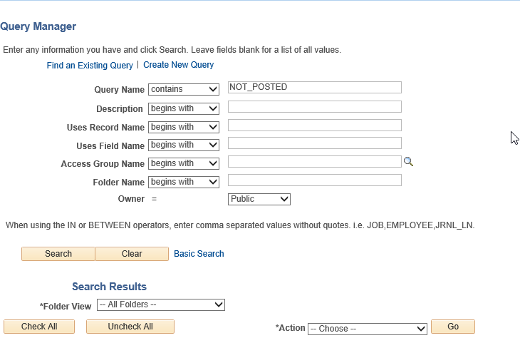

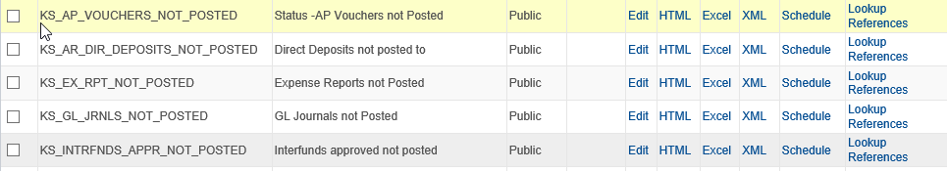

As shown in the screenshot above, there are several 'NOT_POSTED' queries that pertain to different transactions in SMART.    
  
The following pages will show you the 'NOT_POSTED' queries that can be used to identify SMART transactions that have not yet been 'Posted' to the General Ledger.    
  
The results of the 'NOT_POSTED' queries will be used as adjustments to the GL Cash balance amount. The query results will be copied and pasted in to the spreadsheet, to help calculate the revised cash balance amounts.

**Query Viewer Page:**  'NOT_POSTED' Queries

Enter the query criteria, as needed on the query request page.

Below contain the query names that may assist in identifying transactions that have NOT posted to the General Ledger Cash balance.    
  
Each query is shown using a screenshot of the Search Results after the query has been run.  
  
**Note:**  Depending on the transactions available in SMART at the time the query is run, queries may, or may not, display Search Results.  
  
**For this example:**  Please review the search results for each of the queries shown below.

**Query:**  KS_AP_VOUCHERS_NOT_POSTED

**Search Results:**  For this example, the query results need to be downloaded into Excel and filtered by Fund and Budget Unit. The filtered results display no results for Vouchers that have not been Posted - For **Fund** '2323'



**Query:**  KS_EX_RPT_NOT_POSTED

**Search Results:**  For this example, the query results need to be downloaded into Excel and filtered by Fund and Budget Unit. The filtered results display no results for Expense Reports Not Posted - For **Fund** '2323':



**Query:**  KS_GL_JRNLS_NOT_POSTED

**Search Results:**For this example, the query results need to be downloaded into Excel and filtered by Fund and Budget Unit. The filtered results display no results for GL Journals that have not been Posted - For **Fund** '2323':



**Query:**  KS_AR_DIR_DEPOSITS_NOT_POSTED

**Search Results:**For this example, the query results need to be downloaded into Excel and filtered by Fund and Budget Unit. The filtered results display one result for Direct Deposits not posted - For **Fund** '2323':



**Query:**  KS_INTRFNDS_APPR_NOT_POSTED

**Search Results:**  For this example, the query results display all for Interfunds Approved Not Posted. The query will provide the Interfund ID.





After identifying the interfunds not posted, the interfund details inquiry is used to provide the deposit and expenditure fund and budget unit amount for each interfund.

Navigation: **SMART Homepage >**  **Accounts Payable page> Interfunds tile > Interfund Details.** Enter the Interfund ID from the query results.

For this example, enter Interfund Id AA00225877 in the Search Criteria.

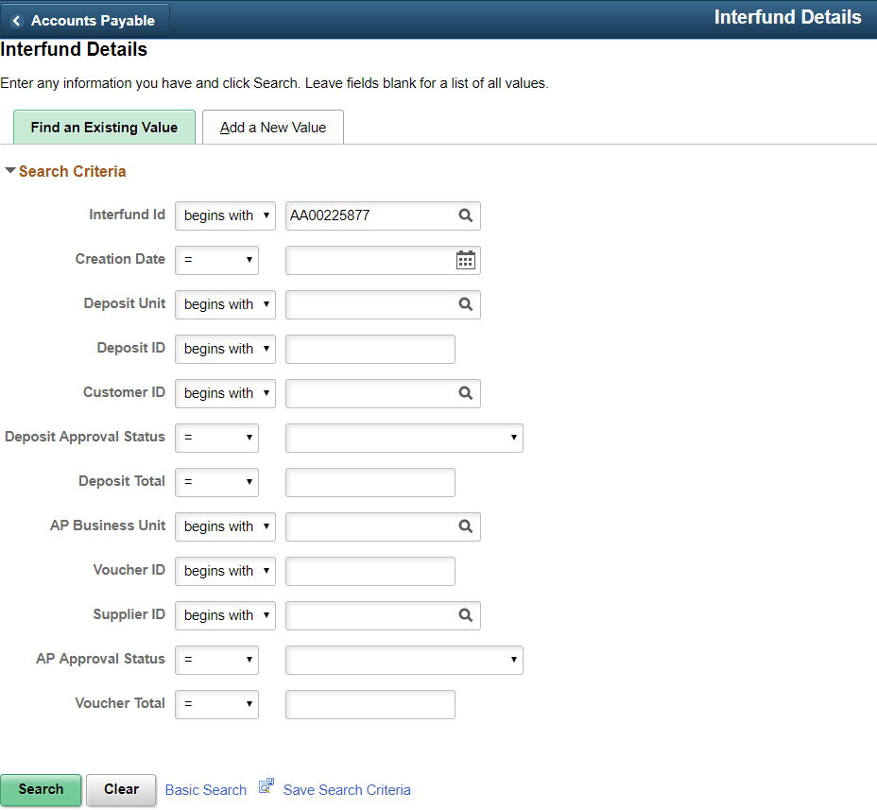

Expand the Interfund Details for the Account Receivable Transactions and the Accounts Payable Transactions. Review the Fund and Budget Unit funding line and note amounts found.

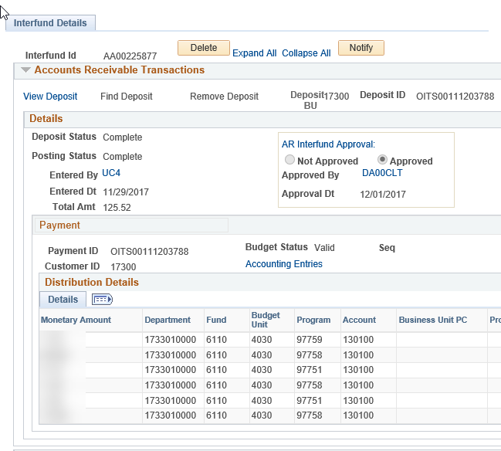

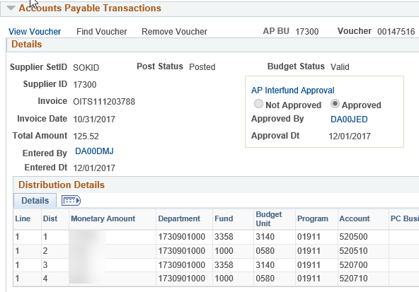

Determine the totals by Fund and Budget Unit. In this example, no amounts were found for Fund 2323 in any of the inter funds identified by the query.

Next, you need to take the search results from each of these queries and inquiries and add them to the Differences spreadsheet.

1. **Calculate the revised Differences – balances should now match**

**Step Ten:** In this step, you need to take the search results from the 'NOT_POSTED' queries and add the search result data to the 'Difference' spreadsheet.  As shown in the screenshot below, the Differences Spreadsheet has had several of the search results from the queries added as new columns in the spreadsheet:

* Expenses Not Posted
* Vouchers Not Posted
* Journals Not Posted
* Interfunds Approved Not Posted
* Direct Journals Not Posted

Finally, the last column named '**Revised Difference 2**' was added (highlighted in yellow, in the screenshot below).    
  
The 'Revised Difference 2' column amounts are calculated by taking the amounts from the 'Revised Difference 1' column and then subtracting the 'Not Posted' transaction amounts in the 'NOT_POSTED' columns.  
  
The 'Revised Difference 2' column reflects the final totals for the differences between the General Ledger Cash balance and the Budget (Commitment Control) Cash balance.  Please notice the balances for each of the Fund and Budget Unit combinations now total a zero-dollar amount, and show the General Ledger Cash Balance (GL) and the Commitment Control (Budget - CC) Cash Control Balance match (because they each have a zero-dollar balance).

If there are still differences, see the “*Identifying differences between GL Cash Balance and the Commitment Control Cash Control Balance” steps below.*

|  |  |  |  |  |  |  |  |  |  |
| --- | --- | --- | --- | --- | --- | --- | --- | --- | --- |
| Fund | Budget Unit | GL Account | Revised Difference 1 (Sum of Difference and Payables) | Expenses not posted | Vouchers not posted | Journals not posted | Interfunds approved not posted | Direct Deposits not posted | Revised Difference 2 (Sum of Difference 1 and "Not Posted" transactions) |
| 2323 | 2300 | 110100 | - | 0 | 0 | 0 | 0 |  | - |
|  |  |  |  |  |  |  |  |  |  |
| 2323 | 2301 | 110100 | - | 0 | 0 | 0 | 0 |  | - |
|  |  |  |  |  |  |  |  |  |  |
| 2323 | 2302 | 110100 | (1,023.84) | 0 | 0 | 0 | 0 | (1,023.84) | - |
|  |  |  |  |  |  |  |  |  |  |
| 2323 | 2303 | 110100 | - | 0 | 0 | 0 | 0 |  | - |

***Identifying the differences between GL Cash balance and the CC Cash Control balance***

The following steps can assist you in identifying these differences. As mentioned above, the data was compared at the most summarized level. Now since balance differences are not reconciled, more detail is needed.

The following steps will assist you in identifying these differences. Detailed instructions will follow.

**High Level Steps:**

1. Determine which fund balances do not match using *“The Comparison of the GL Cash and Commitment Control Cash Control balances”* steps above.
2. Run detailed GL and KK queries for the fund(s) where the KK and GL balances do not match.
3. Create pivot tables to summarize the query results by Account code
4. Compare the two pivot tables to determine which Account codes do not match.
5. Revise the pivot tables to summarize the query results by Account, Fiscal Year, and Accounting Period ONLY for the Fund, Budget Unit and Accounts that have differences.
6. Compare the revised pivot tables to determine which Fiscal Year and Accounting Period the differences occurred.
7. Run the **Budget Overview Inquiry** and drill to the accounting period with the difference to find the transaction creating the difference.
8. Review the transactions and determine what corrections are needed.

**Detailed Steps:**

1. **Determine which fund balances do not match.**

**Step 1:** After determining which fund(s) have differences, using “*The Comparison of the GL Cash and Commitment Control Cash Control balances”* steps above, additionalqueries will be run to compare detail from both GL and Commitment Control.

1. **Run detailed GL and KK queries**

**Step 2:**  Run the General Ledger query

**Navigation to the Query Viewer page:** From the **SMART Homepage**, click **'General Ledger/KK page**' then click '**GL Utilities tile**', then click '**Query Viewer**'. This prompts SMART to open the **Query Viewer page**.

On the **Query Viewer** page in the Search by box enter KS_GL_EXPS_REVS_XFERS and click Search. On the query page, enter the ‘Business Unit’ and the ‘Fund’ with the difference. Use Excel for the output.

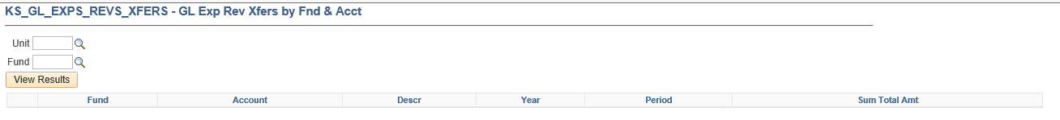

The results are from the General Ledger ACTUALS ledger by Fund, Account, Fiscal Year and Accounting Period. The query will provide you with expenditures, revenues and transfers. Below is an example of the query results:



**Step 3:**  Run the Commitment Control query.

**Navigation to the Query Viewer page:** From the **SMART Homepage**, click **'General Ledger/KK page**' then click '**GL Utilities tile**', then click '**Query Viewer**'. This prompts SMART to open the **Query Viewer page**.

On the **Query Viewer** page in the Search by box enter KS_KK_ EXPS_REVS_XFERS and click **Search**. On the query page, enter the ‘Business Unit’ and the ‘Fund’ with the difference. Use Excel for the output.

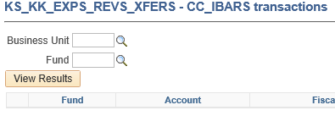

The results are from the Commitment Control IBARS expenditure and revenue ledgers by Fund, Account, Fiscal Year and Accounting Period. Below is an example of the query results:



1. **Create pivot tables to summarize the query results by Account code**

**Step 4:**  Create a pivot table to summarize the KS_GL_EXPS_REVS_XFERS results by Fund, Account, Descr, and Posted Total Amount. The GL pivot table example is shown below. If you are unfamiliar with pivot tables here is a short tutorial: <http://www.ehow.com/video_4986263_make-pivot-table-excel-2007.html> .

The following outlines the steps to create a pivot table:

* 1. **To insert a pivot table for the GL results**, highlight the range on the query results, click “Insert”, click “PivotTable”. Confirm the range and choose “New Worksheet”. The pivot table will be on a new tab preceding the query results sheet.

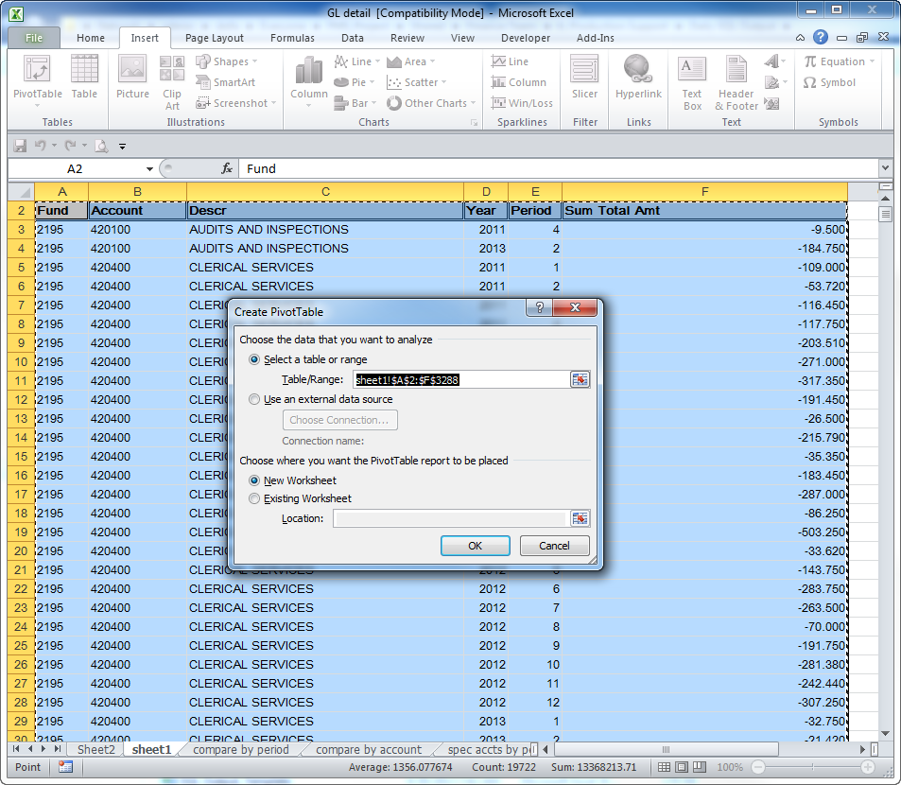

U**se the PivotTable Field list** to choose fields to add to report: In the GL pivot table, on the field list, choose Fund, Account, Descr, Sum Total Amount.

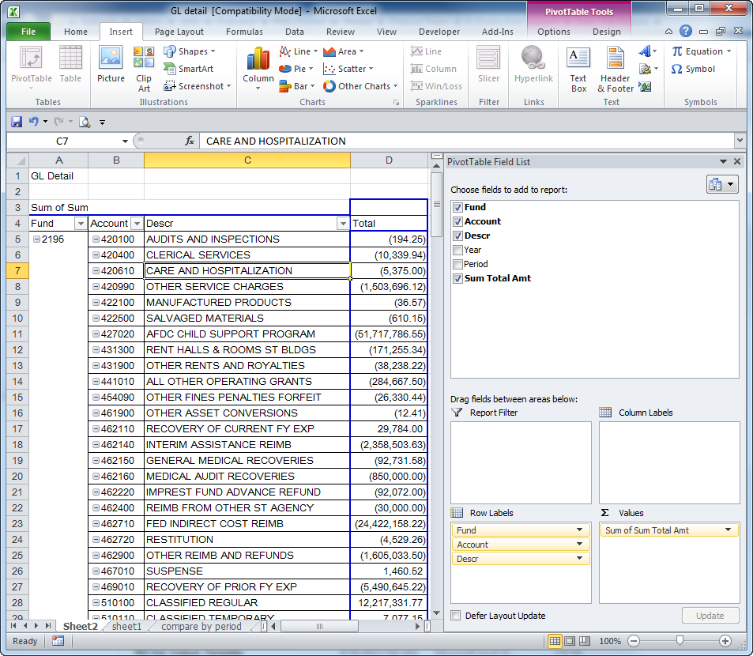

***b. Remove Pivot table Subtotals:*** Choose Pivot Table Tools, Design, Subtotals. In Subtotals, choose *“Do Not Show Subtotals”*

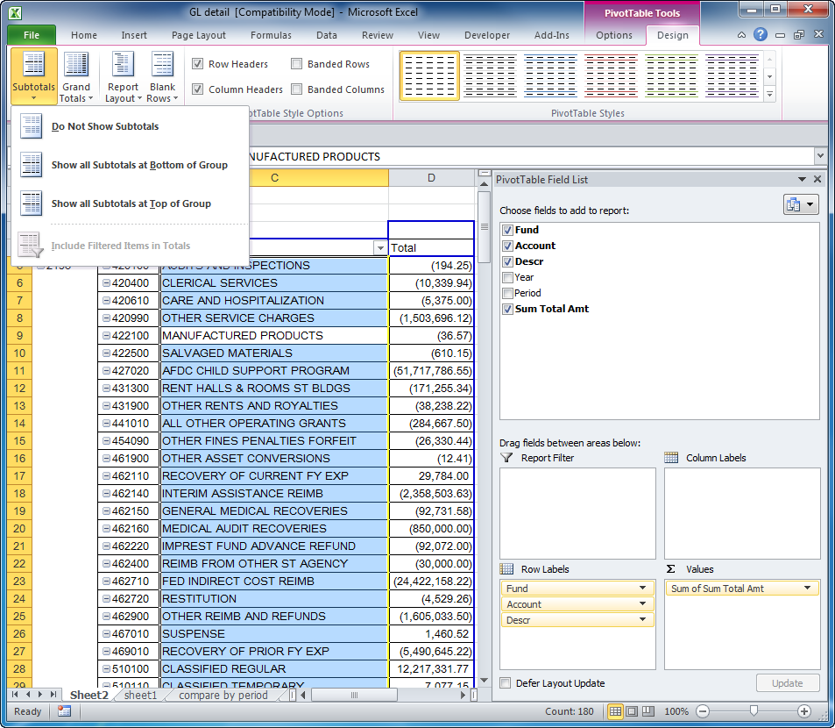

1. ***Change Pivot table Report layout:*** Choose Pivot Table Tools, Design, Report Layout

In Report Layout. Choose “Show in tabular form” and “Repeat all item labels”.

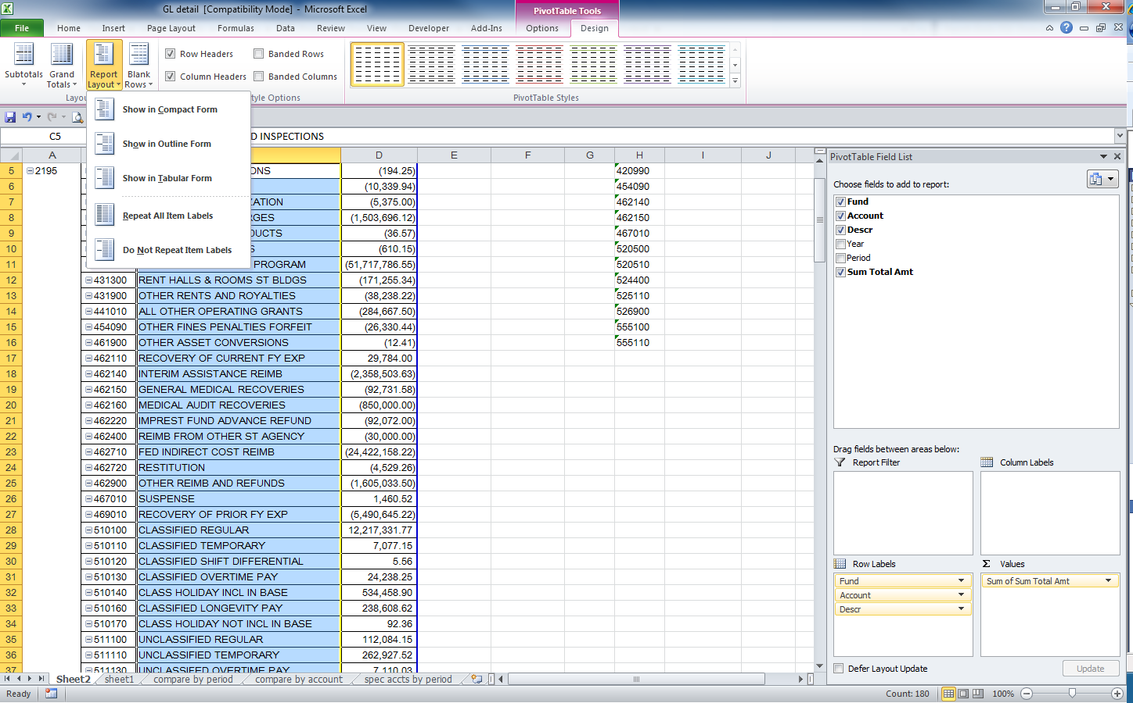

* 1. **Save the file.**

**Step 5:** Create a pivot table to summarize the KS_KK_EXPS_REVS_XFERS results by Fund Code, Account, and Sum Posted Total Amount. Change the Subtotals and Report Layout as shown above. The KK pivot table example is shown below.

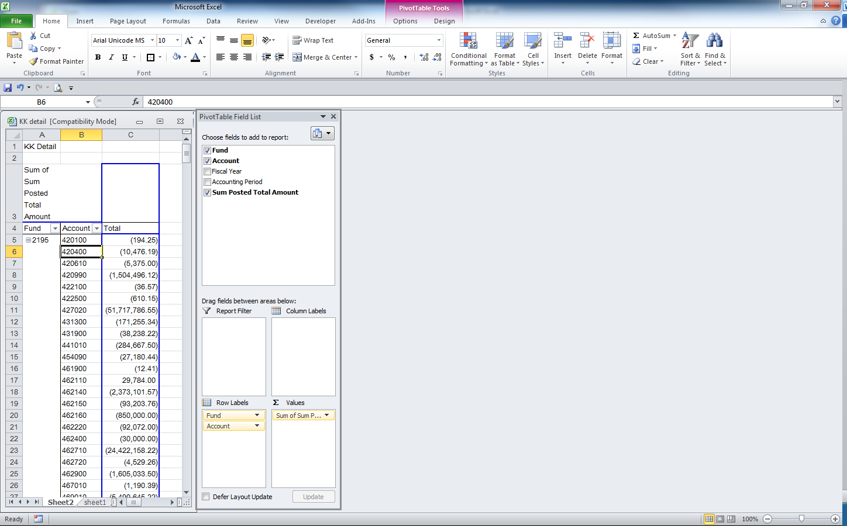

1. **Compare the two pivot tables**

**Step 6: Compare the two pivot tables to determine which Account codes do not match.** Copy and paste (as values) the GL pivot table and the KK pivot table side by side into one spreadsheet. Line up the totals by Account. The Excel function =*VLOOKUP* can also be used to compare the pivot tables.

Calculate the differences and determine which Account balances do not match.

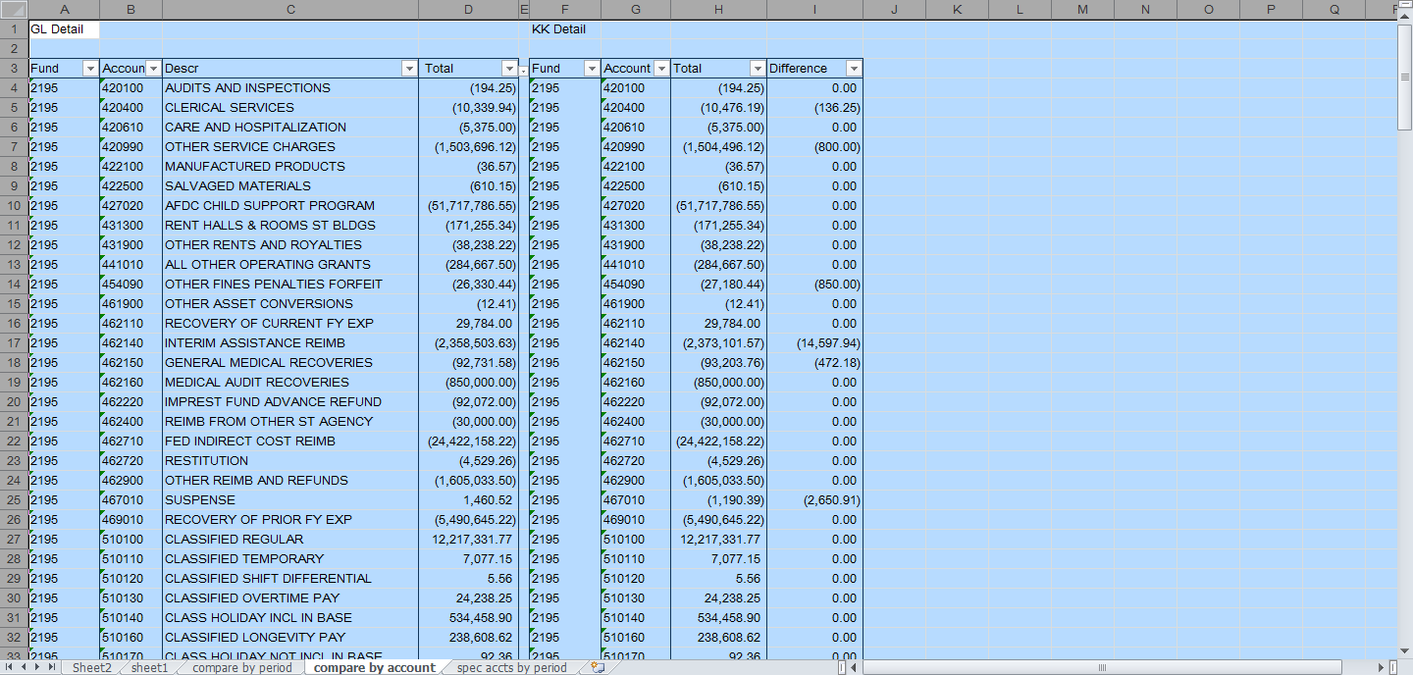

1. **Revise the pivot tables**

**Step 7:** **Revise the GL pivot table to summarize the query results by Account, Fiscal Year, and Accounting Period**. Filter the Account column by unclicking Select All, then clicking on the Accounts with differences from Step 5. Change the GL Pivot Table Field List to include Fund Account, Descr, Fiscal Year, Accounting Period and Total Amount.

**Step 8: Revise the KK pivot tables to summarize the query results by Account, Fiscal Year, and Accounting Period**. Filter the Account column by unclicking Select All, then clicking on the Accounts with differences from Step 5. Change the KK Pivot Table Field List to include Fund, Account, Fiscal Year, Accounting Period and Total Amount.

1. **Compare the revised pivot tables.**

**Step 9:** Copy and paste the pivot tables from Steps 7 and 8 into one spreadsheet, side by side. Line up the totals by Account, Fiscal Year, and Accounting Period. Again, the Excel function =*VLOOKUP* can also be used to compare the pivot tables.

Calculate the differences. In the example below, Account 420400 has a difference of $136.25 in Period 12, Fiscal Year 2011.



1. **Find the Transaction creating the difference.**

**Step 10:** Run the **Budget Overview Inquiry** to find the transaction which created the difference.

* 1. Navigate to: SMART Homepage > General Ledger/KK page > Commitment Control tile> Review Budget Activities> Budgets Overview.

1. Enter the search parameters. The following parameters are for the example shown above:
   1. **Business Unit:** 62900
   2. **Ledger Group**: CC_IBARS_R (Use CC_IBARS_R ledger group to find revenue transactions and CC_IBARS_E ledger group to find expenditure transactions)
   3. **Type of Calendar**: Detail Accounting Period (this will show the results by fiscal year rather than budget period)
      * **From Year:** 2011, **From Period**: 12 (the accounting period with the difference)
      * **To Year:** 2011, **To Period:** 12 (the accounting period with the difference)
      * **Account:** 420400
      * **Fund:** 2195.
2. Click on Search

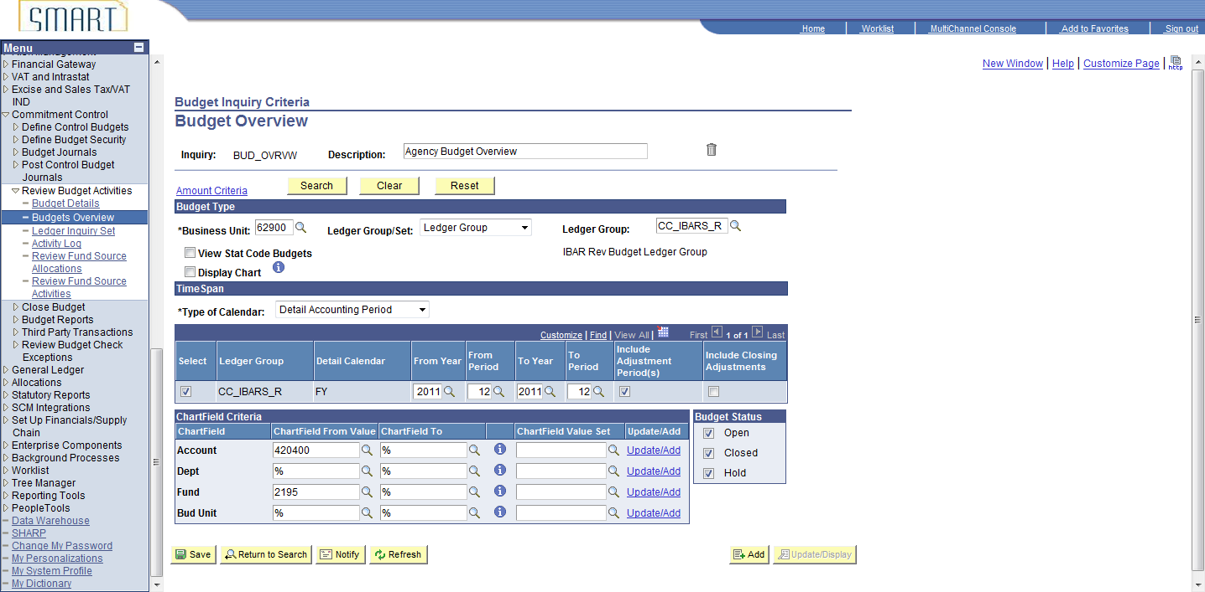

**Step 11: Budget Overview Results.** Drill to the Activity Log by clicking on the Collected Revenue Amount link.

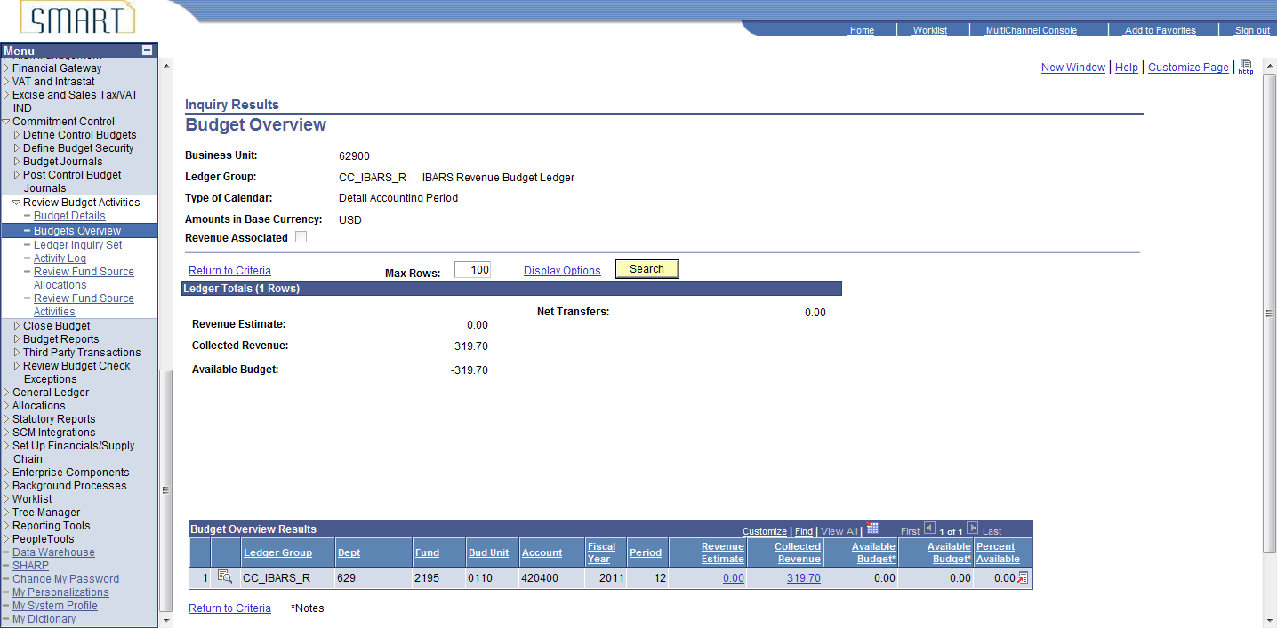

1. **Review the Detailed Transactions.**

**Step 12:** Review the transactions and determine what corrections are needed. Click on magnifying glass icon next to the Journal ID 0000125322. This journal was picked because it equals the difference amount.

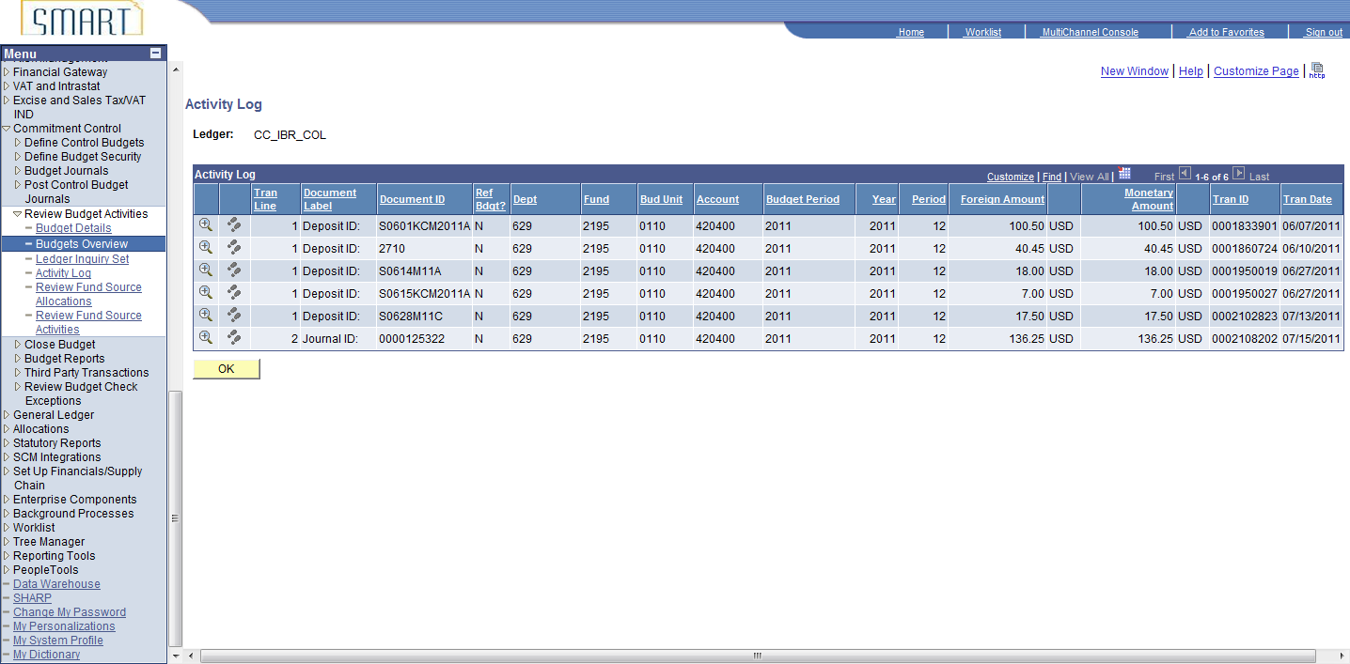

**Step 13:** Review the **General Ledger Journal Line Drill Down.** Click on the icon next to the **Journal ID** to drill to the GL journal.

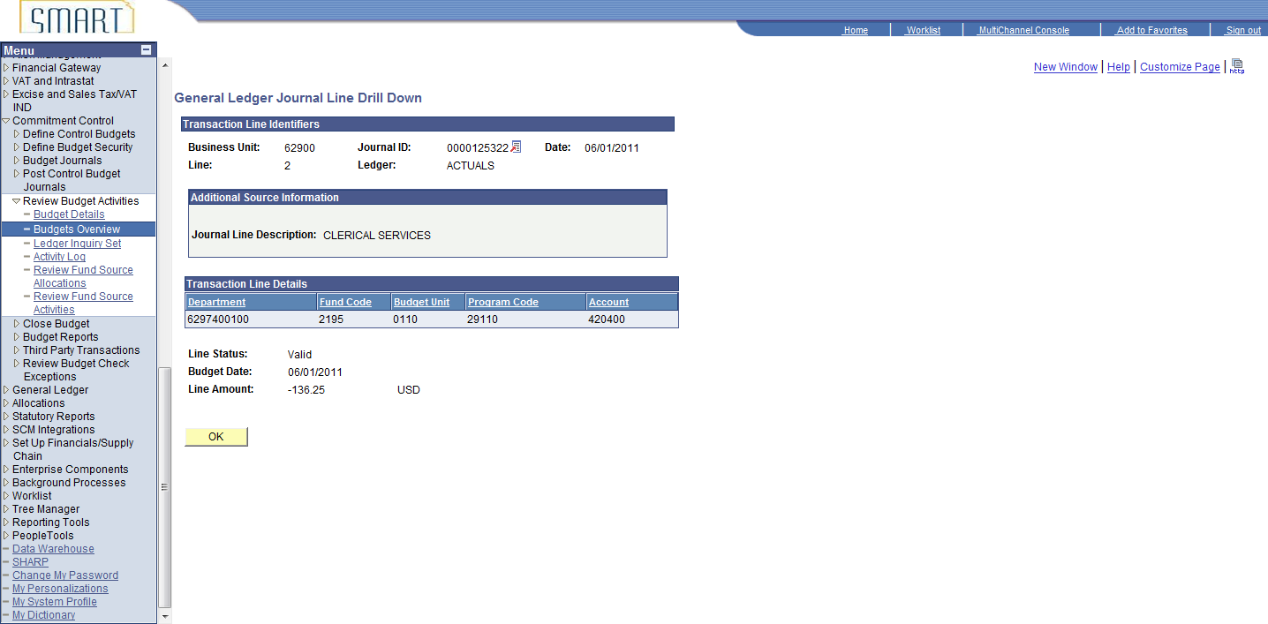

**Step 14:** Review the GL Journal Header**.**

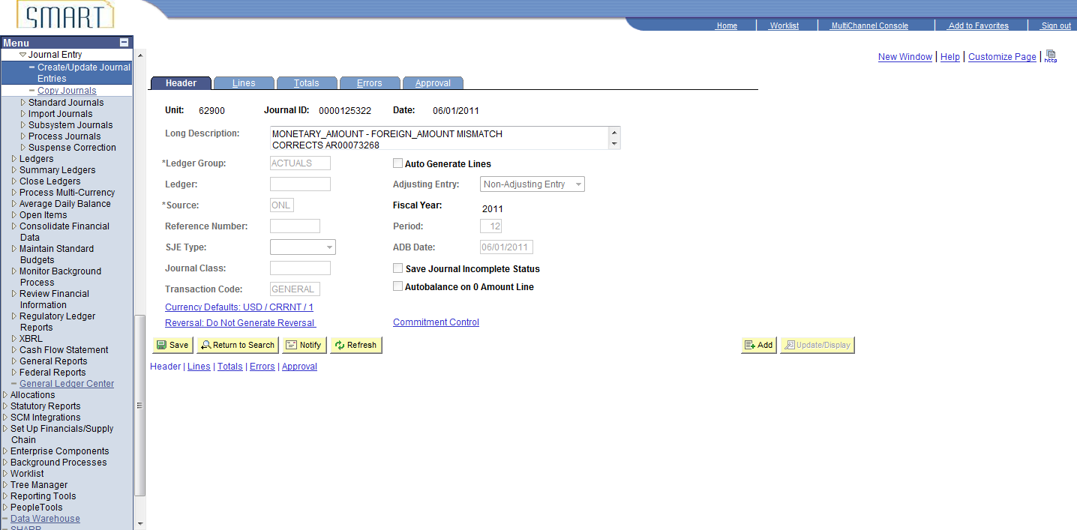

**Step: 15:** Review GL Journal Lines

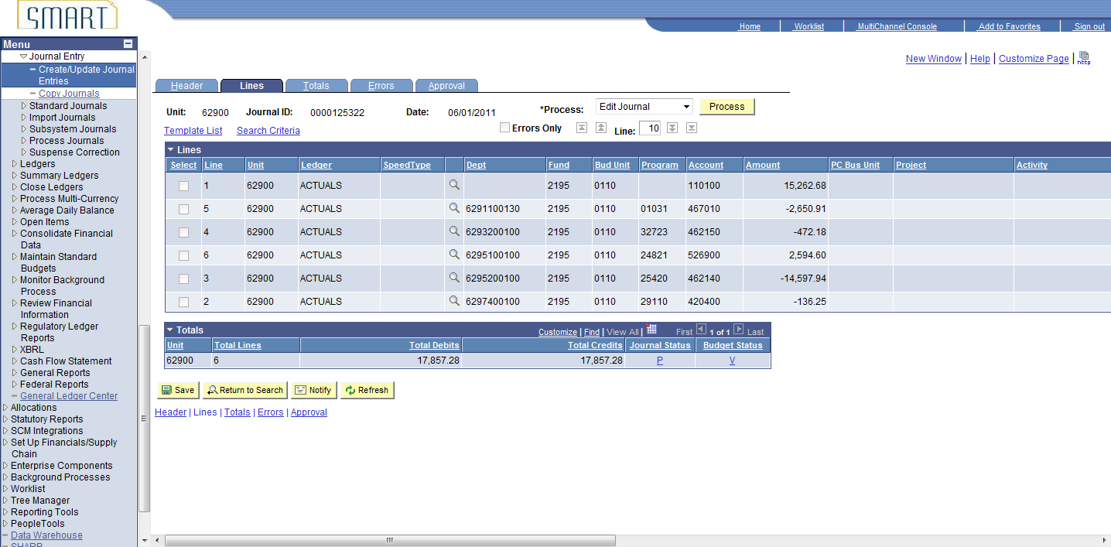

**Conclusion:** After researching this journal, it was determined Journal ID AR00073268 is not recorded in the KK collected revenue ledger due to the commitment control amount type being marked Actuals and Recognize rather than Actuals, Recognize and Collect.

**8. Causes for Differences between GL Cash and CC Cash Control balances**

There can be many reasons there are differences between the cash balances in the General Ledger and Commitment Control. Below are some additional reasons differences occur.

1. The Account code used in KK was changed before it was posted to the GL so the amounts by Account code do not agree. This type of error does not impact overall spending authority.
2. The transaction can be budget checked in one accounting period/fiscal year and posted to GL in a different fiscal year. Overall the Fund and Account match.
3. The travel accounts can have differences every accounting period. The approval process creates a time lag between budget checking and posting in the GL. This can cause the accounting periods to not match.