Training Guide –
Creating a Budget Journal Entry
State of Kansas

Applicable Roles:

Agency Budget Processor
Agency Budget Approver

TABLE OF CONTENTS
Topic 1: Understanding Budget Journal and Budget Transfer Types 3
Topic 2: Creating a New Budget Journal Entry 4
Topic 3: Budget Transfers 13
Topic 4: Copy a Budget Journal 17

Topic 1: Understanding Budget Journal and Budget Transfer Types
- You can manually enter budget journals or transfers to establish or change the budgeted amount for a control budget—whether it is an expenditure budget definition or a revenue budget definition. The way your budget journal/transfer entries are processed depends on the rules set up for the budget definition in the Budget Definitions and Budget Attributes components. This was provided when your agency defined the budgets they wanted in SMART.
- You enter budget amounts and adjustments using budget journals. Enter budget journals in the Enter Budget Journals component.
- You enter transfer amounts using budget transfers. Budget transfers are used primarily in the appropriation budget for reappropriations, lapses, and transfers within an agency. Enter budget transfers in the Enter Budget Transfer component.
- To report on budget journal entry activity, each budget journal header row and each budget ledger row carries one of the following budget entry types:
  - Original – This indicates an original budget journal entry. This type is used to record adopted or approved budgets.
  - Adjustment –This indicates an adjustment to an original budget and includes Supplementals, Lapses to No Limit Funds and Budget Transfers to a different Business Unit in the Appropriation Budget.
- To report on budget transfer entry activity, each budget transfer header row and each budget ledger row carries one of the following budget entry types:
  - Transfer Original – This indicates Budget Transfers within the same Business Unit and lapses to Appropriated Funds.
  - Transfer Adjustment – This indicates a Reappropriation between budget periods in the Appropriation Budget.
- Only Central Staff can enter appropriation budget journals and budget transfers.
- Storing budget entry types, fiscal year and the accounting period for a budget journal in the budget ledger, enables the reporting of budget activity by agencies and for the Division of Budget.
- Budget entry types also enable the proper segregation of budget amounts for GASB reporting.

Topic 2: Creating a New Budget Journal Entry
The budget journal entry pages are used to enter new budgets, adjust a budget, perform budget transfers, or adjust budget transfers.
- Budget Journal Original refers to the initial budget entered into SMART.
- Budget Journal Adjustments happen when budgets need to be increased or decreased or funds need transferred between agencies.
- Budget adjustments are used in the CC_APPROP budget but can be used in the other budget ledgers.
Procedure:
- Navigate to the Enter Budget Journals page:
Page name | Navigation
Enter Budget Journals | SMART Homepage > General Ledger/KK page> Commitment Control tile>Budget Journals>Enter Budget Journals

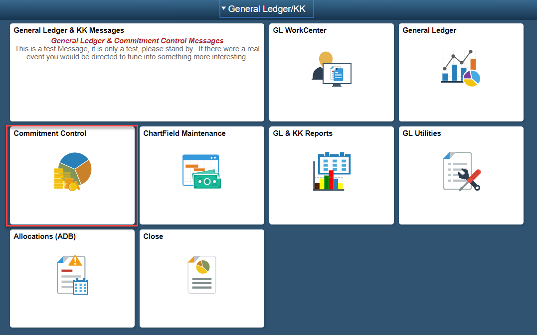
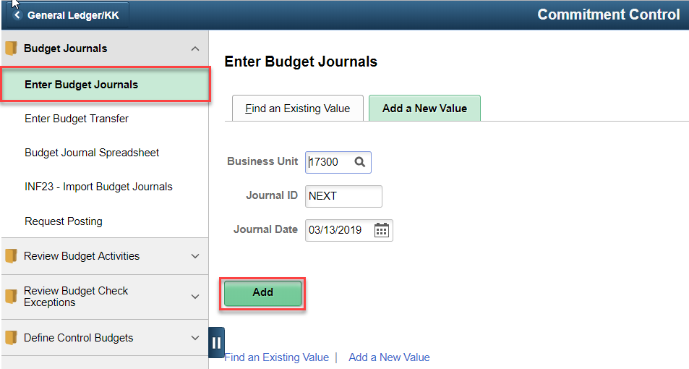

Figure 1. Navigation to Enter Budget Journals

- On the Enter Budget Journals page, click on Add a New Value tab. Enter the required information. Click the Add button:
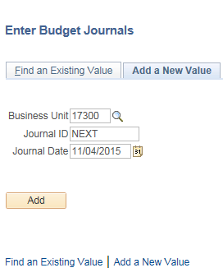
Figure 2. Enter Budget Journals Page

Field | Description
Business Unit | Agency Business Unit
Journal ID | Use ‘NEXT’ to auto number the journal or enter a 10 digit journal ID.
Journal Date | Use the current date.
Table 1. Enter Budget Journals Elements

- Enter the required information into the Budget Header tab. When the header is complete, click on the Budget Lines tab.
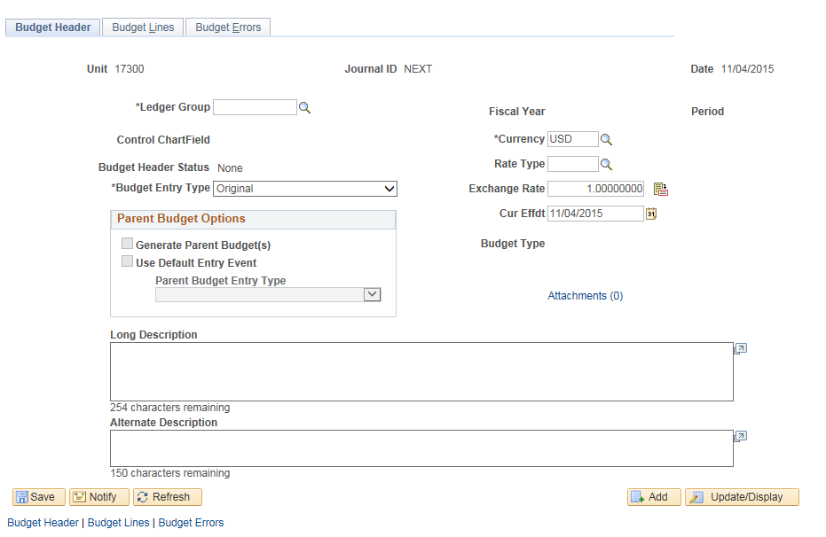
Figure 3. Budget Header Page

Field | Description
Ledger Group | When adding a new journal, a lookup is available to select the ledger group for the budget ledger where this entry will be recorded
Budget Entry Type | Use the lookup to select the entry type for this journal, as described in Topic 1.
Long Description | Enter a meaningful description. This description can assist you when searching for a journal.
Table 2. Budget Header Page Elements

- Enter the required information on the Budget Lines tab.
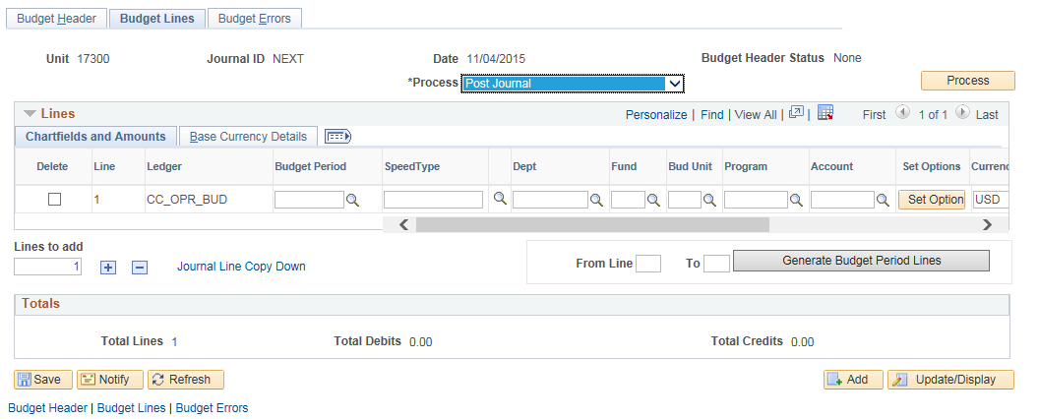
Figure 4. Budget Lines Page

Field | Description
Budget Period | A budget period represents a time segment that the system uses to divide budgets. Most budgets are established on the State Fiscal year basis but you may have elected to use a monthly revenue estimate budget.
ChartFields | The ChartFields shown are required and determined by the Budget Definition set-up. The DeptID, Program, and Account ChartFields must be entered at the translation level defined in the Budget Definition.
Description | Enter information to assist users when viewing the journal. Examples include Statutory citation, Governor’s Budget recommendations, allotments, etc.
Lines to Copy | Number of lines you want to copy
Journal Line Copy Down link | Select the fields you want to copy to the next journal entry line on the Budget Lines page. See Figure 4 below.
Table 3. Budget Lines Page Elements

- Use the Journal Line Copy Down link to select the fields you want to copy to the next journal entry line on the Budget Lines page. Click OK after selecting fields.
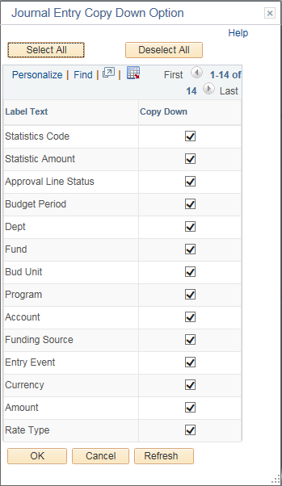
Figure 5. Journal Entry Copy Down Option Page

- After entering/copying all the journal lines, save the journal and choose Edit ChartFields options in the Process box. When editing is complete, choose the Post Journal option in the Process box to post the journal Commitment Control ledger. The Budget Header Status will change to Posted. If there is an error, click on the Budget Errors tab.
Figure 4. Budget Lines Page

Process | Select one of the following processing options and initiate the process by clicking the Process button:  - Budget PreCheck – Runs budget check on the budget journal to determine if funds are available. The budget precheck does not post the budget transactions to the budget ledgers.  - Copy Journal – Copies the budget journal, which can be saved, and changes made.  - Delete Journal – Deletes budget journals that have not posted.  - Edit ChartFields – Edits to determine if the budget journal passes ChartField validation and combination editing rules prior to posting  - Post Journal – Process edits the journal and, if the journal is valid, posts it. This process must be run by the Budget Approver role  - Refresh Journal – Refreshes the data on the page with data from the database. You lose unsaved changes if you do a refresh.
Table 4. Process Drop down menu

- Use the Budget Errors tab to view and drill down to the budget journal line items found to be in error by the system. This page shows ChartField combination edit errors only.
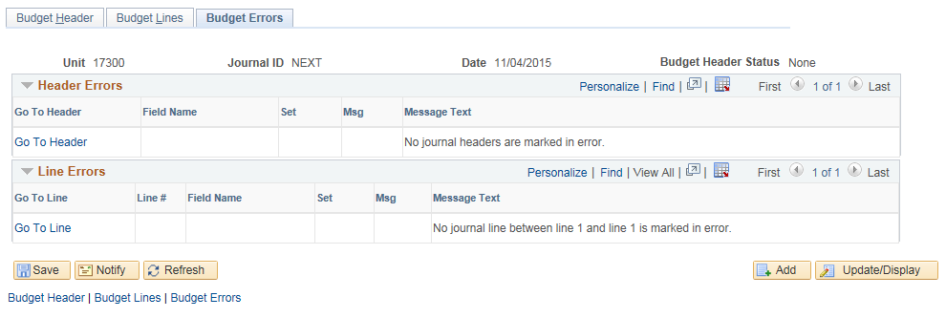
Figure 5. Budget Errors Page

Field | Description
Go To Header and Go To Line | Click the Go To Header link in the Header Errors scroll area to open the Budget Header page, where you can correct budget header journal errors.  Click the Go To Line link in the Line Errors scroll area to open the Budget Lines page and correct errors.
Field Name | Displays the ChartField in error
Set | Displays the message set that contains the error message
Table 4. Budget Errors Page Elements

- The Budget Header Status link, located on the Budget Lines tab, leads to exceptions pages to show budget checking and posting errors.
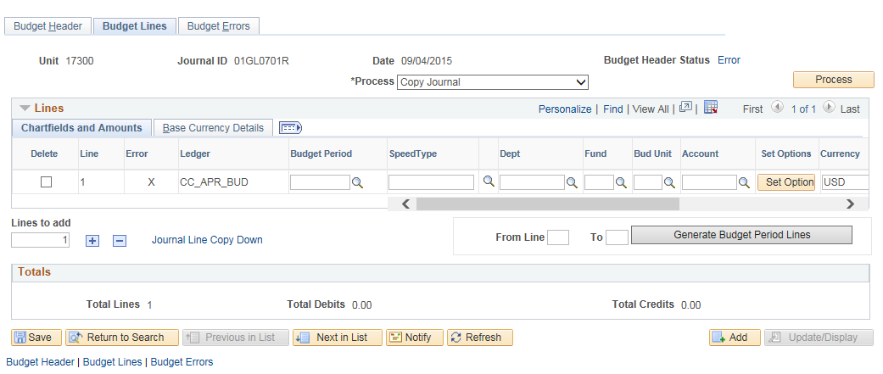
Figure 6. Budget Journal Lines page

- The Budget Journal Exceptions tab will show specific error detail.
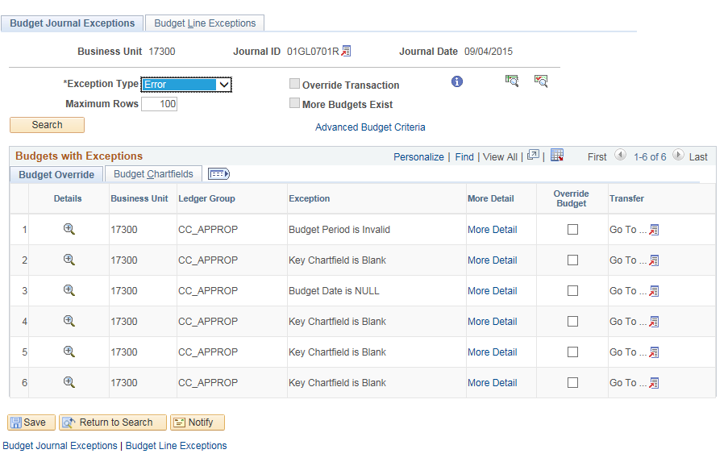

Figure 7. Budget Journal Exceptions page

- The Budget Line Exception tab will show the journal lines that have errors.

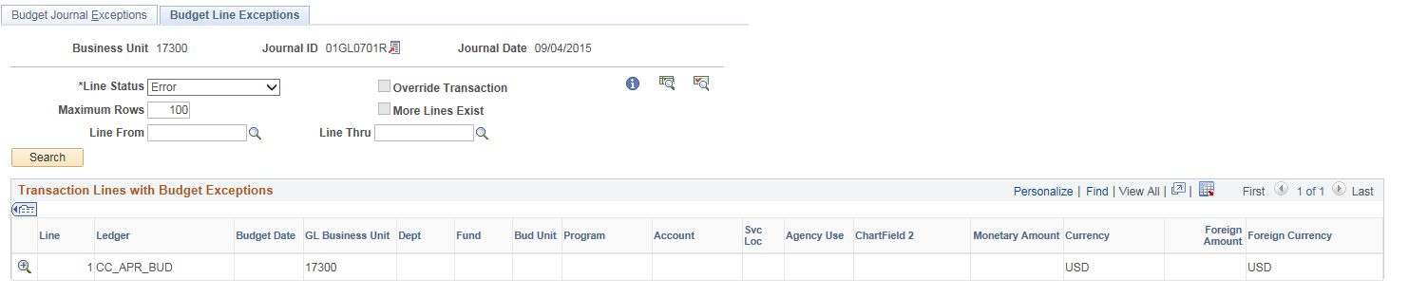

Figure 8. Budget Journal Line Exceptions

Topic 3: Budget Transfers
- The Enter Budget Transfer component uses the similar pages as the Enter Budget Journals component. You process and post transfers just as you do regular budget entries, with the following exception:
  - The Budget Header tab in the Enter Budget Transfer component has different budget entry type options, namely, Transfer Original and Transfer Adjustment.
- Central Staff enter appropriation budget journals and Transfers
- You can transfer amounts only between budgets within a single Commitment Control ledger group and business unit combination. For instance, transfer budget for Business Unit 17300, CC_APPROP ledger group.
- If the control option for a budget is control, then a transfer cannot reduce the budget amount below previously committed amounts. For instance, if the control budget is currently $100 and you want to transfer $150 there will be a budget check error.
- If the control option is track with budget, then a transfer that reduces the budget amount below total commitment amounts can pass budget checking.

Procedure:
- Navigate to the Enter Budget Transfers Page:
Page name | Navigation
Enter Budget Journals | SMART Homepage > General Ledger/KK page> Commitment Control tile>Budget Journals>Enter Budget Transfer
Table 5. Navigation to Enter Budget Transfers page

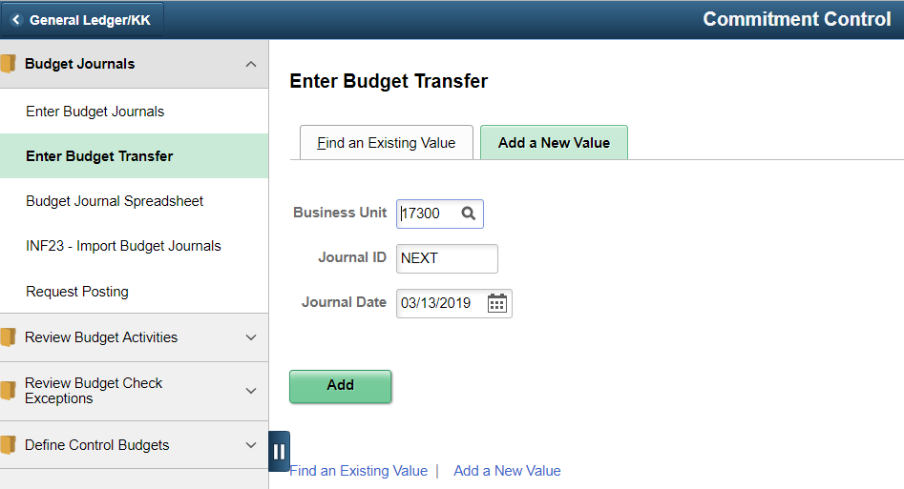
Figure 9. Navigation to Enter Budget Transfer page
- On the Enter Budget Transfers page, click on Add a New Value tab. Enter the required information. Click the Add button:
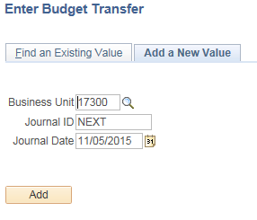
Figure 10. Enter Budget Transfer Page

Field | Description
Business Unit | Agency Business Unit
Journal ID | Use ‘NEXT’ to auto number the journal or enter a 10 digit journal ID.
Journal Date | Use the current date.
Table 6. Enter Budget Transfer Elements

- Enter the required information into the Budget Header page. The Transfer Adjustment is used for Reappropriations and Transfer Original is for Lapses and Transfers within the agency.
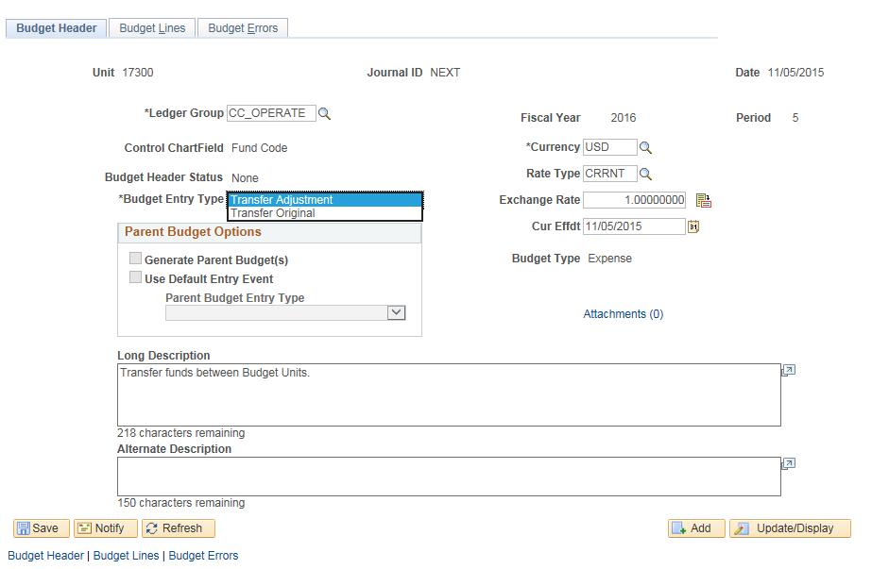
Figure 11. Budget Header Page

Field | Description
Ledger Group | When adding a new journal, a lookup is available to select the ledger group for the budget ledger where this entry will be recorded
Budget Entry Type | Use the lookup to select the entry type for this journal, as described in Topic 1.
Long Description | Enter a meaningful description. This description can assist you when searching for a journal.
Table 7. Budget Header Page Elements

- After the Header is complete, use the Enter Budget Journals steps 4 through 10 to complete the Budget Transfer.

Topic 4: Copy a Budget Journal
- In SMART, you can open an existing budget journal using the commitment control Budget Journal Entry page and copy it to a new budget journal entry online. Budget Journals can be copied if they are in the following statuses: posted, unposted, edited, edit required, and error.
- Copying a budget journal saves time as you can use an existing budget journal as the basis for a new journal entry.
- After you successfully finish copying the budget journal, you refresh Commitment Control Journal Entry page to load the SMART page with the newly copied budget journal. Most of the data in the new budget journal comes from the source budget journal.
- There are two ways to copy a budget journal: the Budget Journal Copy page and directly from the Budget Lines page. The best practice for SMART is to copy a budget from the Budget Lines page.
- To copy a journal from the Budget Lines page, select Copy Journal in the Process dropdown list.
- After completing the Copy Journal process, you will have a copy of the original budget journal. The budget lines are the same. However, SMART will automatically assign a new Journal ID. From here, you will be able to make your changes.
Procedure:
- On the Enter Budget Journals page, click on Find an Existing Value tab. Clear the current values and enter the criteria for the budget journal you want to copy Click the Search button:
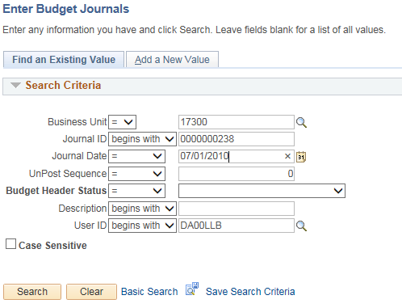
Figure 12. Enter Budget Journals Page

Field | Description
Business Unit | Agency Business Unit
Journal ID | Enter the Journal ID or partial Journal ID
Journal Date | Enter the journal date, if known.
Table 8. Enter Budget Journals Elements

- Click on the Budget Lines tab. The Copy Journal option should show in the Process box. Click on the Process button.
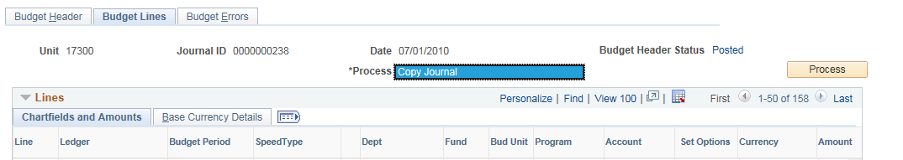
Figure 13. Budget Lines Page

Process | Select Copy processing options and initiate the process by clicking the Process button:  - Copy Journal – Copies the budget journal that can be saved and changes made.
Table 9. Budget Lines Process Element

- On the Budget Journal Copy page, review/enter the New Journal ID, New Journal Date, and Budget Entry Type. Click on the OK button

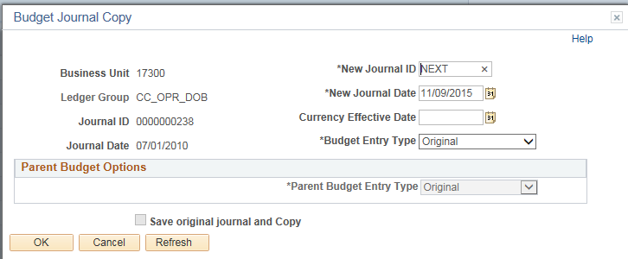
Figure 14. Budget Journal Copy Page

Journal ID | Use ‘NEXT’ to auto number the journal or enter a 10 digit journal ID.
Journal Date | Use the current date.
Budget Entry Type | Use the lookup to select the entry type for this journal, as described in Topic 1.
Table 10. Budget Journal Copy Components

- A Message reminding you to save the copied journal will display. Click the OK button.

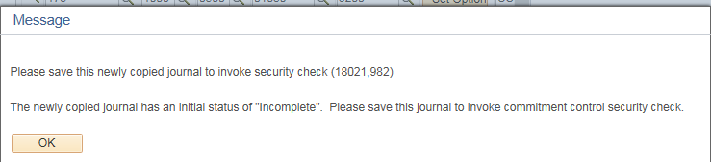
Figure 15. Message Page

- Save the budget journal, then make changes to the journal as needed.

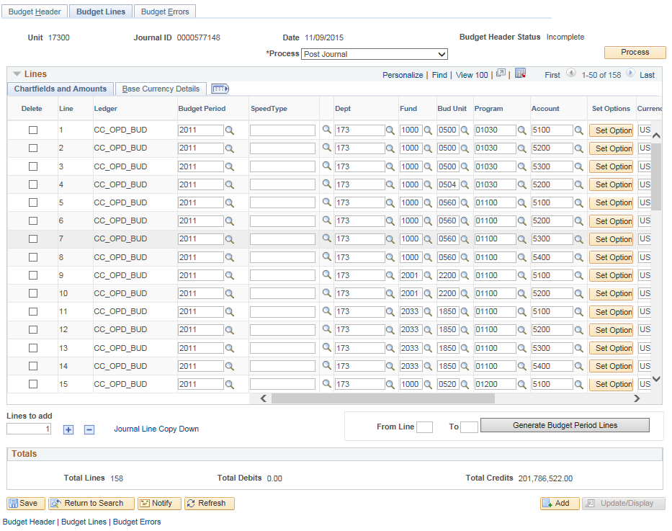
Figure 14. Budget Journal Lines Page

