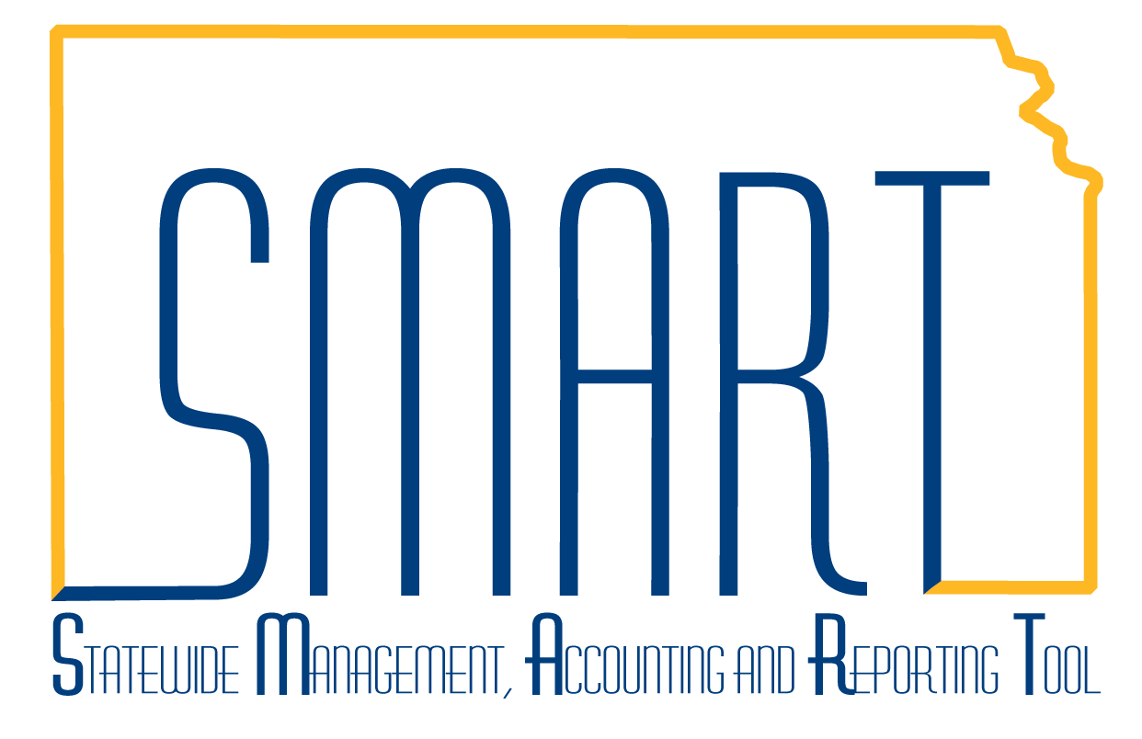
State of Kansas
Budget Status Report
Statewide Management, Accounting and Reporting Tool

Date Created: | 01/11/2013
Version: | 3.0
Last Updated: | 03/20/2019
Purpose: | To describe how to create a Budget Status Report in SMART.
Description: | The Budget Status Report (GLS8020) displays all Commitment Control ledger amounts (budget, pre-encumbrance, encumbrance, expense, collected revenue, or recognized revenue – where applicable) and the available balance for the budgets you select.
SMART Security Access role: | KS GL Viewer
How to create a Budget Status Report: | - Navigation: From the SMART Homepage, click the ‘General Ledger/KK page > GL & KK Reports tile > Commitment Control Reports > Budget Status Report (GLS8020)’.  - Click the “Add a New Value” tab.  - Enter a ‘Run Control ID’.  - Click the “Add” button.  This opens the Commitment Control Budget Status Report page (refer to screenshot on following page):  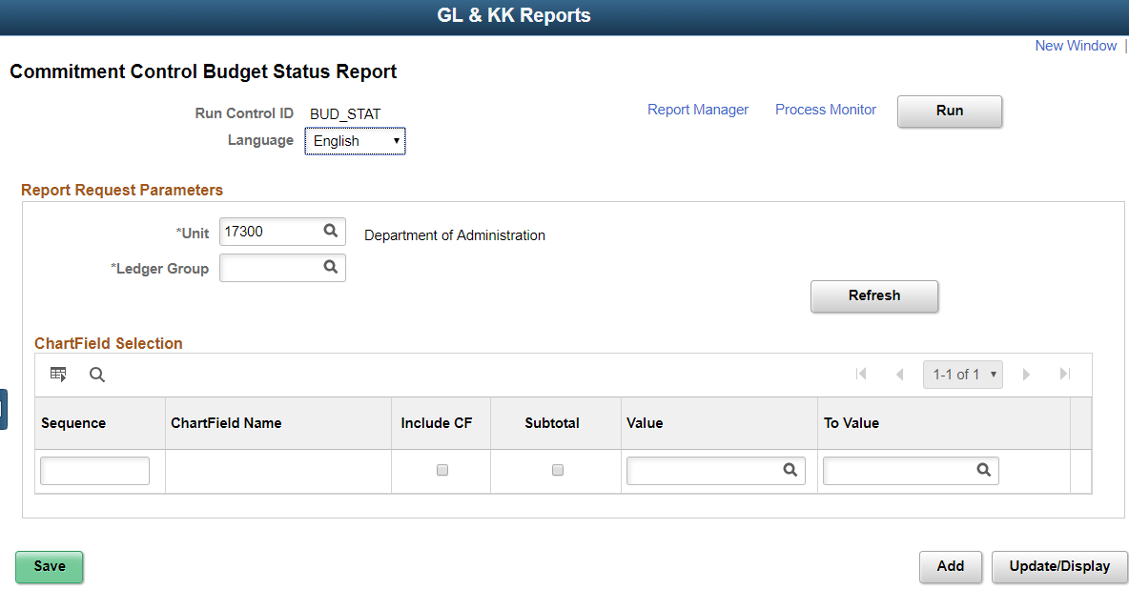  In the Report Request Parameters section of the ‘Commitment Control Budget Status Report’ page:  - Enter the ‘Business Unit’.  - Enter the ‘Ledger Group’ to report against.  - Click the “Refresh” button to activate the Chartfield Selection section.  Once the Chartfield Selection section has been activated, the user can select additional report parameters to customize their report (as shown in the following screenshot):  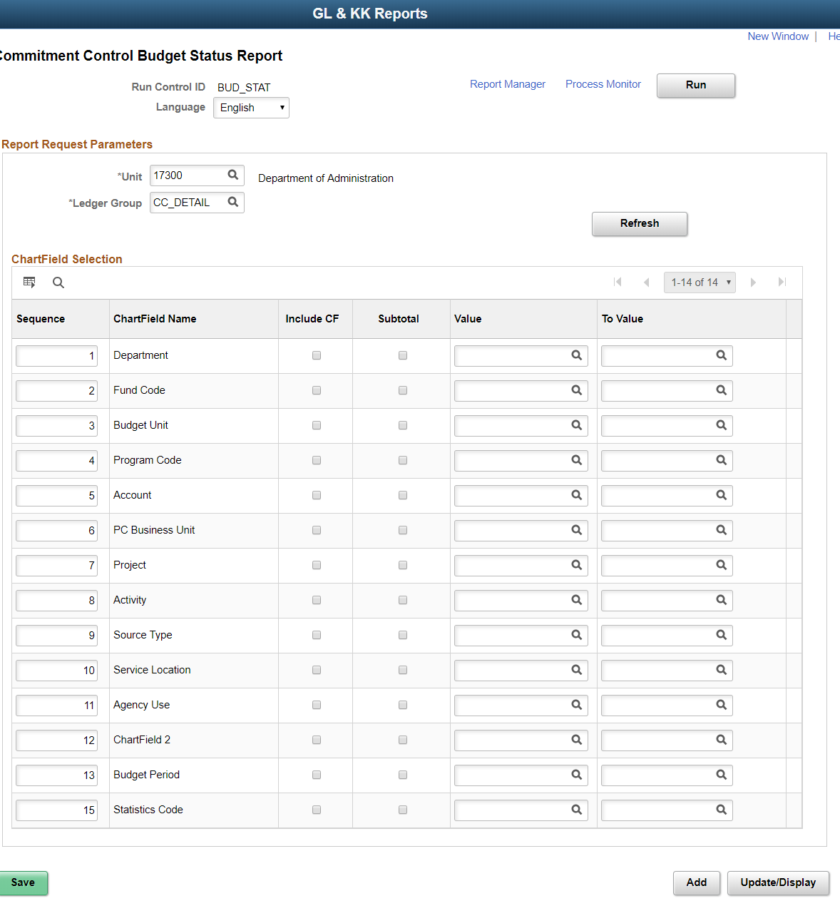  Budget Status Report – Report Request Parameters  Field Description Examples  Unit: Enter the desired business unit into this field. 17300, 03900  Ledger Group: Enter the desired ledger group into this field. CC_APPROP  Sequence: Enter a numbering sequence to determine the sequence (or order), of the ChartFields in the report. There must not be any gaps in the sequence. Please refer to the NOTES section at the end of this document for an example. 1, 2, 3,…  Include CF: Select the ‘Include CF’ checkbox(es) to have SMART include the Chartfield(s) in the Budget Status Report. Different combinations of Chartfields may be selected to develop different snapshots and views of the same budgets. If a ChartField is NOT part of the budget structure for a specific Ledger for an Agency, it can NOT be selected to be included in the report. Hint: Double-check the budget structure for your Agency’s budget before creating the Budget Status Report, to verify which ChartFields are available for you to select from. N/A  Subtotal: Select the ‘Subtotal’ checkbox(es) to instruct SMART to report budget balances either in detail, or, summarized by the selected Chartfield(s). This is a useful tool for providing budget status overview reports. Please refer to the NOTES section at the end of this document for an example. N/A  Value: / To Value: Use the ‘Value’ field and the ‘To Value’ fields to restrict or include the desired ChartFields for the Budget Status Report The use of these fields instructs SMART to report results only for a given value or range of values for the particular Chartfield(s). Please refer to the “NOTES” section at the end of this document for additional information. (Example for The Account ChartField) = 510000-519999  - Optional step: Once you have selected all desired Budget Status Report parameters, click the “Save” button to save the ‘Run Control ID’. Saving the Run Control ID allows the end user to access and use the same Run Control ID and report parameters again.  - Click the “Run” button to access the ‘Process Scheduler Request’ page. The report format can be changed on this page. If a spreadsheet format is desired, change the Format to ‘CSV’, otherwise leave the Format ‘PDF’. Click the “OK” button to start the process, which creates the Budget Status Report.  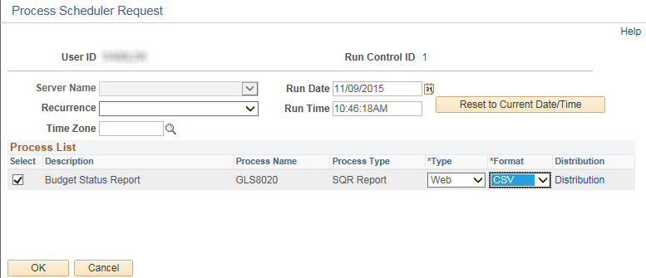  - On the Commitment Control Budget Status Report page, click on the ‘Process Monitor’ to go to the Process List page.  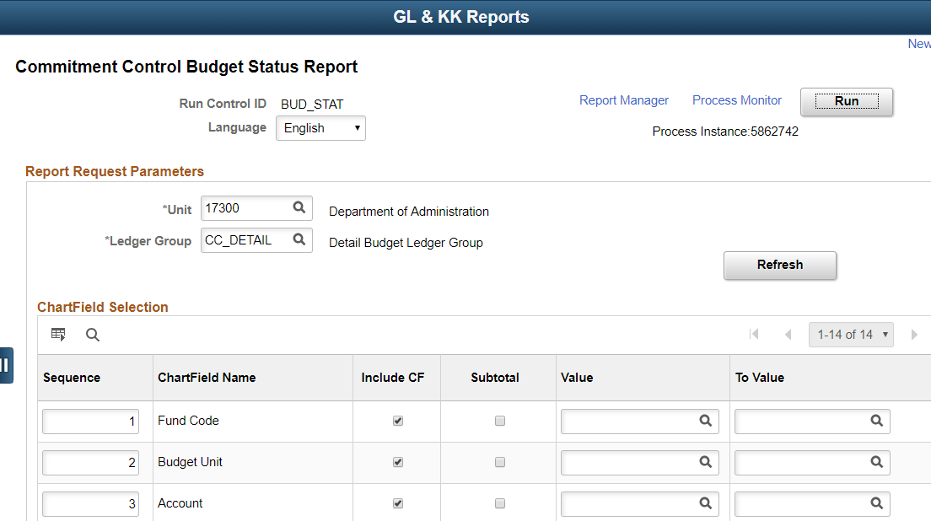  - Click on the Refresh button until the Run Status=’Success’ and the Distribution Status=’Posted’. Click on the “Details” link.  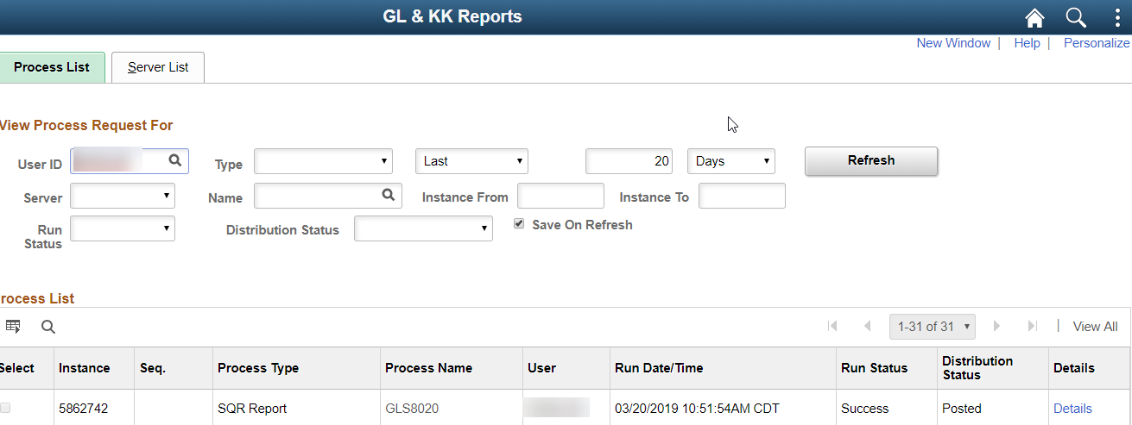  - On the Process Detail page click on the ‘View Log/Trace’ link to open the report.  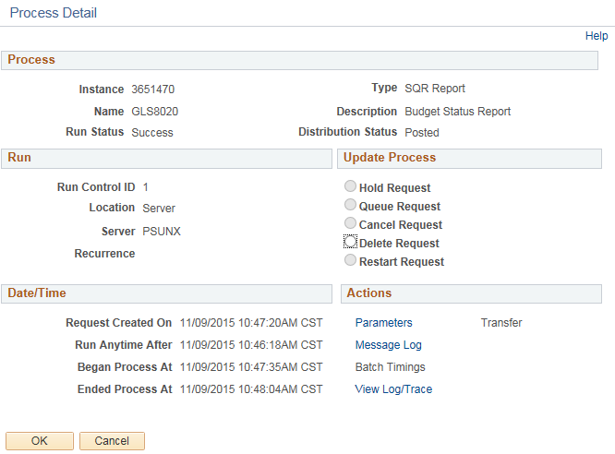  - For the .PDF format, click on the File with the .PDF file extension to open the report.  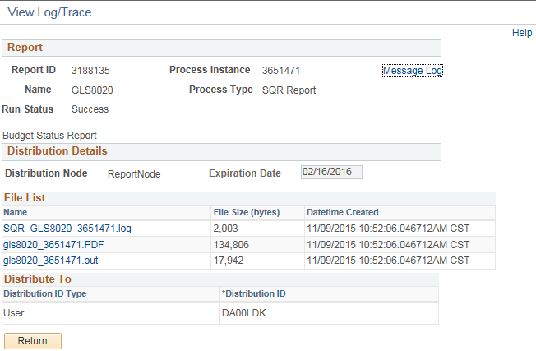  - View .PDF report  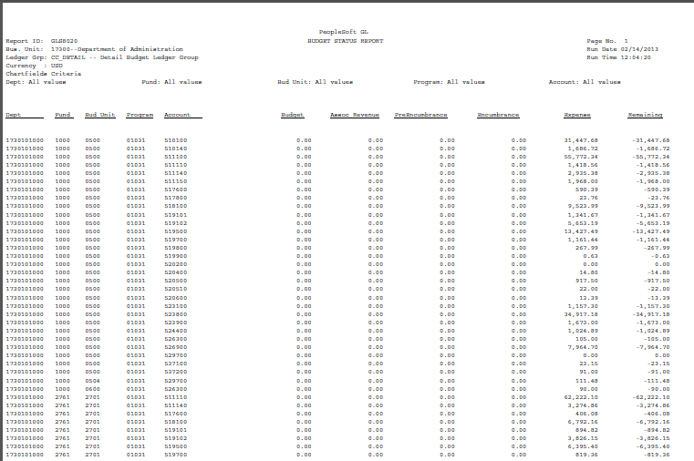  - For the CSV format, click on the File with the .CSV file extension to open the report.  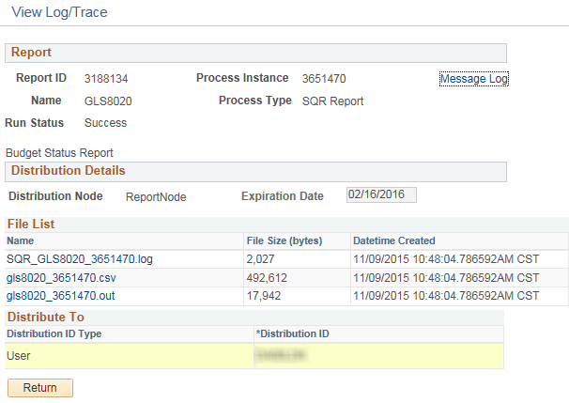  - A file download screen will appear, click on the Open button. The report will open in Excel.  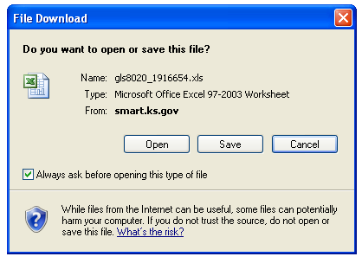  - View .CSV report. Formatting may be required.  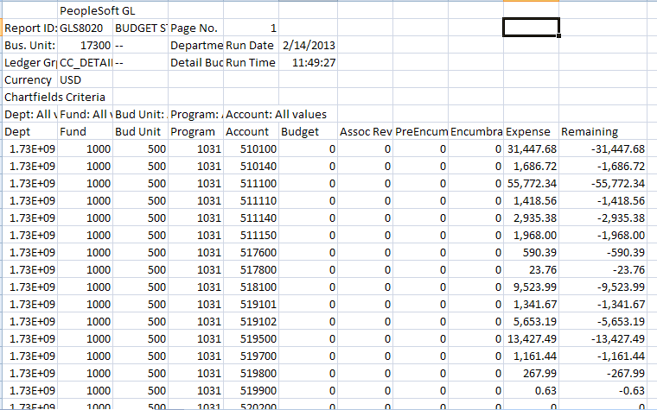

Commitment Control Budgets and Available ChartFields: | The table (on the following page) details the Commitment Control budgets used by the Agencies of the State of Kansas.  Please note that NOT all Commitment Control ledgers are available to ALL State Agencies.  For example: The ‘CC_PROJECT’ Ledger Group is used only by those State Agencies who are using the Projects and Grants modules to track their Agency’s Project budgeting.  If your Agency is NOT using the Projects and Grants modules in SMART, you will not be able to use the ‘CC_PROJECT’ Ledger Group.  Commitment Control Budgets in SMART  Ledger Group Description Available ChartFields  CC_APPROP Appropriation Ledger Department = Level 2 (Agency Level), Account = 50 (Expenditures), Budget Unit, Fund Code  CC_CASH Cash Control Ledger Budget Unit (for Type 2 funds only), Fund Code  CC_CSH_REV Cash Control Revenue Ledger Budget Unit (for Type 2 funds only), Fund Code  CC_IBARS_E DOB IBARS Expense Ledger Account = Detail Values, Budget Unit, Department=Detail Values, Fund Code, Program = Level 2 (DoB Program Level)  CC_IBARS_R DOB IBARS Revenue Ledger Account, Budget Unit, Department, Fund Code  CC_OPR_DOB Operating Default Ledger Account=Level 4 (Category Level), Budget Unit, Department=Level 2 (Agency Level) , Fund Code, Program = Level 2 (DoB Program Level)  CC_REV_DOB Revenue Estimating Default Ledger Account, Department = Level 2 (3 digit agency number), Budget Unit, Fund Code  Optional Budget Structures (Chartfields and translations will vary):  Ledger Group Description Available ChartFields  CC_PROJECT Project Optional Ledger Activity, Department, Fund Code, PC Business Unit, Program, Project, Service Location, Source  CC_PRJ_PRT Project Parent Ledger Activity, PC Business Unit, Project  CC_DETAIL Detail Budget Ledger Account, Activity, Agency Use, Budget Unit, Department, Fund Code, PC Business Unit, Program, Project, Service Location, Source
NOTES: | - At least ONE (1) Chartfield must be selected from the Chartfield Selection section to be included in the report. If no Chartfield is selected, the Budget Status Report will NOT contain any data.  - When using the ChartField Selection section, all selected Subtotal checkbox(es) must be in sequence - there must NOT be any gaps in the sequence.  For example: To report the ‘Subtotals’ for a range of ‘Account’ ChartField values within a given ‘Budget Unit’, the end user MUST:  - Enter the desired ‘Budget Unit’ in the Value field  - Enter the ‘Budget Unit’ Sequence as ‘1’  - Enter the desired ‘Account’ range in the ‘Value’ and the ‘Value To’ fields  - Enter the ‘Account’ Sequence as ‘2’  - Select the Subtotal checkboxes for the ‘Budget Unit’ and for the ‘Account’  This produces a Budget Status report with Subtotals for the specified Accounts in the Budget Unit.  - Not all “Available ChartFields” are available for the “Optional” Ledger Groups. For example: Agency A uses the ‘Service Location’ ChartField on their operating optional budget, while Agency B does not.  Hint: Check the Agency’s specific budget structure to understand exactly which ChartFields are available.  - For the ‘CC_CASH’ and ‘CC_CSH_REV’ Ledger groups, the Budget Status Report will need to be run twice:  - First: For Type 1 funds (Include only the ‘Fund’ code)  - Second: For Type 2 funds (include BOTH the ‘Fund’ code and the ‘Budget Unit’).  - When running the report for Type 2 funds (‘Fund’ and ‘Budget Unit’), the Budget Status Report returns data for Type 1 funds, however it does NOT include ‘Associated Revenue’ amounts for those funds.  - As a result, the Available Budget Balance calculation is NOT correct for the Type 1 funds when BOTH the ‘Fund’ and the ‘Budget Unit’ ChartFields are selected.

