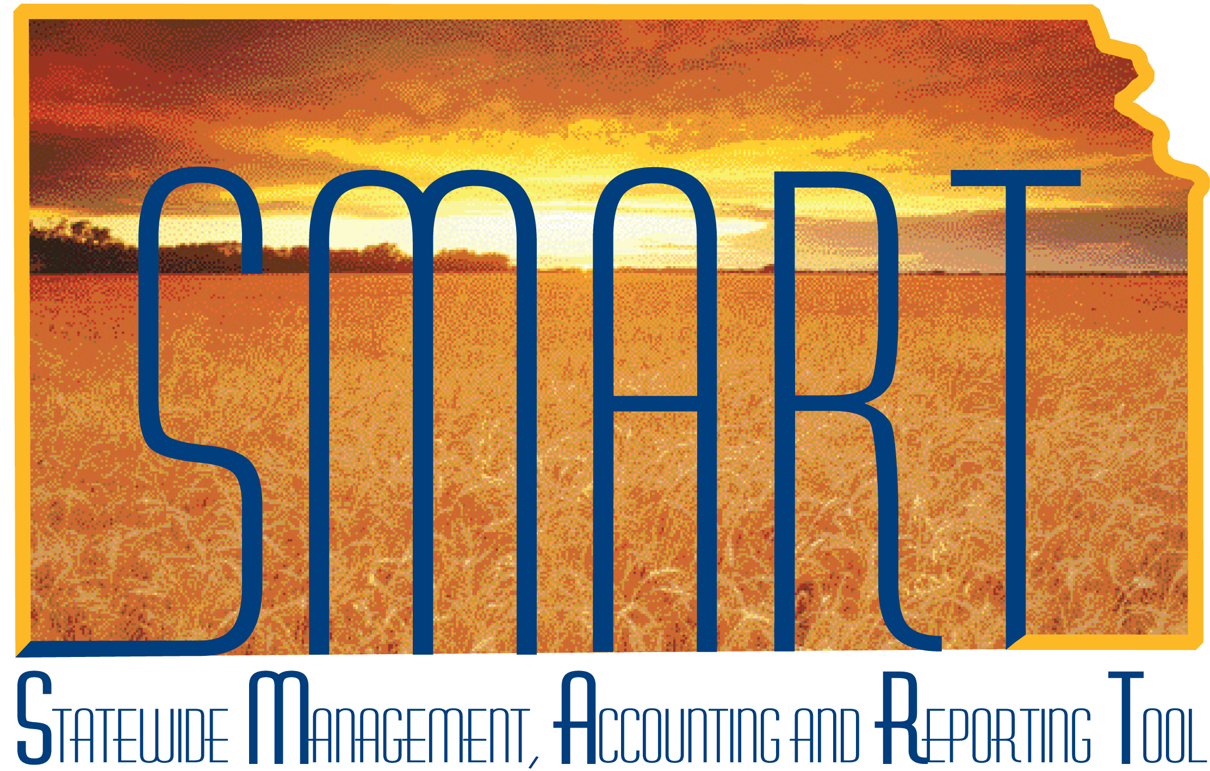
Training Guide –
Budget Journal Entry Overview
State of Kansas

Applicable Roles:

Agency Budget Processor
Agency Budget Approver

TABLE OF CONTENTS
Topic 1: Key Terms and Concepts 3
Topic 2: End-to-End Budget Journal Process 4
Topic 3: Budget Journal Roles 6
Topic 4: SMART Budget Ledgers 7

Topic 1: Key Terms and Concepts
- Budget Header –The SMART fields that contain information for a specific budget journal such as date, ledger and journal type.
- Budget Lines – Lines used to enter the transaction information that make up a budget journal
- Budget Journal – A transaction that establishes or updates budget amounts in SMART.
- Budget Transfer – The process of moving a budget from one line item to another in a budget journal. A budget transfer must total $0.
- Commitment Control – The process of budgetary accounting which enables the tracking or controlling of expenses against budgets and revenues against estimates
- Budget Ledger – A ledger that defines the type of budget and the type of transactions recorded in a SMART budget ledger.
- Expense Budget – A structure of budget (such as Appropriation) that records Budget, Expenses, and Encumbrances.
- Revenue Budget – A structure of budget that records Estimated, Recognized and Collected Revenues.
- Control – Strictly control transactions against budgeted amounts. Error exceptions are logged when transactions exceed the budgeted amount.
- Tracking with Budget – Track transaction amounts against a budget, but do not issue error exceptions unless there is no corresponding budget row. A transaction will pass budget checking if the budget funding row exists, even for a zero amount, but issue warnings when transactions exceed the budgeted amount.
- Track without Budget -- Track transactions even if there is no budget setup. If a budget row does exist, warnings will be logged when transactions exceed the budgeted amount. If no budget row exists, no warning is issued.

Topic 2: End-to-End Budget Journal Process
The following three diagrams represent the End-to-End Budget Journal process.

Figure 1. End-to-End Budget Journal Process

Topic 3: Budget Journal Roles
The State of Kansas will use several roles to process budget journals. A user can only have one of these roles. If both roles are chosen, SMART will defer to the most restrictive role (the Agency Budget Processor). The roles needed to process and approve budget journals are:
Role | Description
Agency Budget Processor | This role is responsible for maintaining agency budgets after they interface from the IBARS system and entering new agency budget journals that did not interface from IBARS into the system.
Agency Budget Approver | This role is responsible for approving, posting, and deleting agency-level budget journals.
Table 1. Budget Journal Roles

Topic 4: SMART Budget Ledgers
The following are general assumptions about the SMART Budget Ledger process and the differences/similarities in agency and central responsibility.

- Kansas has a centrally maintained Appropriation Budget Ledger group (CC_APPROP). The Department of Administration controls the official Appropriation Budget Ledger for the State.
- The Cash Budget ledgers (CC_CASH and CC_CSH_REV) are used for cash control. The Cash Budgets are centrally maintained.
- Agency Operating Budget Ledgers (CC_OPERATE) can be set up so agencies can control their budget information.
- Budget Journal security determines who can enter a budget and who can post a budget. Security can be configured by specific budget ledger. For example, Appropriation budgets can be posted centrally and operating budgets can be posted at the agency level.
- The Detail Budget Ledger Group (CC_DETAIL) does not have a budget ledger so Agencies cannot enter/post budget journals to the Detail Budget Ledger group. This ledger group stores the expenditures and encumbrances at the detailed Chartfield level and is only available for inquiries.
- No formal systematic workflow process exists for approving and posting budget journals. The budget approver posts journals as his/her approval.
- The process of building the budget and the legislative process does not take place in SMART. The final, legislative approved, budget is recorded in IBARS and interfaced into SMART.
- Reports on budget vs. actuals out of SMART are available for the appropriation ledger as well as operating budgets.
The following are the different types of State of Kansas budget ledgers and how/why they are used:
- Appropriation Budget
  - The Appropriation Budget is the spending authority granted by the legislature at the Agency, Fund, and Budget Unit level. The Appropriation Budget is centrally maintained.
  - Transactions that exceed spending authority will fail when budget checked against the Appropriation Budget. Transactions cannot be processed and recorded until they pass budget check.
- Operating Budget
  - There are two different Operating Budgets in SMART for agency use.
  - The DOB Operating Budget (Ledger Group CC_OPR_DOB) is the approved budget reflected in IBARS. This budget is loaded into SMART via an interface with IBARS.
  - The Agency Operating Budget (Ledger Group CC_OPERATE) is available to agencies if they elect to define the operating budget in additional detail. This budget is entered by the agency
  - Operating Budgets are managed at the Department, Fund, Budget Unit, and Program level.
  - Agencies can enter and adjust operating budgets by entering budget journals.

- Project Budget
  - The Project Budget is the budget established by the agency and associated with a specific project. Establishing a Project Budget is optional.
  - Project budget structures include three options:
    - Dept. ID, PC Business Unit & Project/Activity
    - Dept. ID, PC Business Unit, Project/Activity, and Service Location
    - Dept. ID, PC Business Unit, Project/Activity, and Fund

- Cash Control Budget
  - The Cash Control Budget stores information about the agency’s budgetary cash balance. Cash Control Budget is a separate ledger from the General Ledger actual expenses and revenues and the Commitment Control appropriation budget.
  - The Cash Control Budget maintains detail on cash balances in order to facilitate budget checking and ensure that there is cash available to cover outlays.
  - The information in the Cash Control Budget is not truly a budget –it is a reflection of cash balances. However, it is structured like a budget in SMART so that financial transactions can be “budget-checked” against cash balances.
  - Expenditure, Revenue and Transfer transactions are budget checked against the Cash Control Budget.

- Revenue Estimate Budget
  - The Revenue Estimate Budgets store information about the agency’s estimated, recognized, and collected revenue.
  - The DOB Revenue Estimate Budget (Ledger Group CC_REV_DOB) is the budget reflected in IBARS. This budget is loaded into SMART via an interface with IBARS at the beginning of each fiscal year. This budget is not updated unless the agency enters budget journals to adjust the budget throughout the year.
  - The Agency Revenue Estimate Budget (Ledger Group CC_REV) is available to agencies if they elect to further define the revenue estimate budget in additional detail. This budget is entered by the agency.
  - Revenue Estimate Budgets are managed at the Fund and Budget Unit ChartField level.

- IBARS Budgets
- The IBARS Budget Ledgers (Ledger Groups CC_IBARS_E and CC_IBARS_R) record the expenditure, encumbrance and collected revenue transactions (budget ACTUALS) loaded annually into IBARS.
- By storing budget entry types and the fiscal year with the accounting period for a journal in the budget ledger, enables the reporting of budget activity directly from the budget ledger. Budget entry types also enable the proper segregation of budget amounts for GASB reporting.
- The General Ledger ACTUALS ledger stores consolidated financial transactions for actual expenses, revenues and cash balances (non-budgetary transactions). Actuals Ledger is a separate ledger from the Budget Ledgers.

