State of Kansas
Delete an Interfund Voucher
Statewide Management, Accounting and Reporting Tool

Date Created: |  | 2/16/2018
Version: |  | 2.0
Security: |  | - Role Security: Only those individuals with the following roles will have access to delete an interfund or interfund voucher:  - Agency AP Processor (KAP_Agy_AP_Processor)  - Agency AP Maintainer (KAP_Agy_AP_Maintainer)  - Agency AP Interfund Processor (KAP_Interfund_Processor)  - *Agency AP Interfund Approver (KAP_Interfund_Approver)  - BU Security: Business Unit Security is applied. Agencies will only have access to the interfunds and vouchers associated to their agency business unit.  *If the Interfund was not approved or does not need to be deleted, you do not need the Agency AP Interfund Approver role.
Information
- To delete an interfund voucher it must first be removed from the interfund. The interfund can be deleted during this process, as well. The interfund cannot be deleted if there is a deposit associated with it.
- The voucher can be removed and deleted if there is a deposit associated with the interfund as long as both sides of the interfund are not approved. Once both sides of the interfund are approved, neither side can be edited.
Navigation |  | Accounts Payable > Inferfund Details
1. | Remove the Voucher from the Interfund  - Click the ‘Remove Voucher’ hyperlink.  If the Accounts Payable side of the interfund is approved, unapprove it and save before removing the voucher.  - Click ‘Yes’ on the pop up message stating that this action will unlink the transaction from the interfund. | 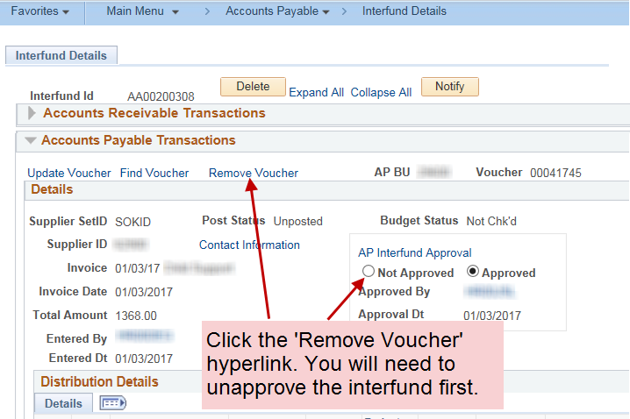  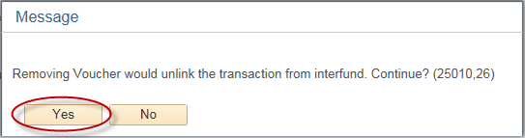
 | If there is no deposit associated with the interfund, proceed by deleting the interfund itself. Otherwise, proceed to step 2.  - Click the ‘Delete’ button at the top of the Interfund. This should only be done if there is no deposit associated with the interfund.  - Click ‘Yes’ on the pop up message asking if you really want to delete the interfund record. Then click the ‘Save’ button.  To check that the interfund has been deleted, navigate back to the interfund search page and search for the Interfund ID. It should not come up in the search after it has been successfully deleted. | 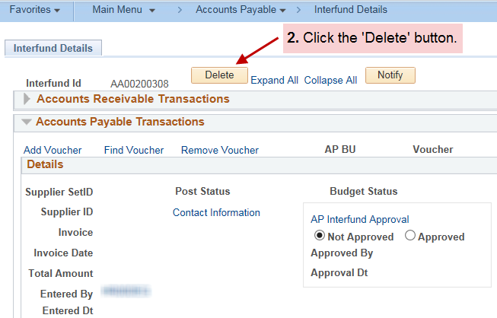  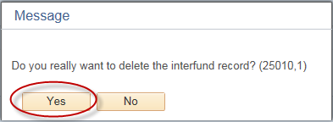
Navigation |  | Accounts Payable > Vouchers > Add/Update > Regular Entry
2. | Delete the Voucher  - Navigate to the voucher removed from the interfund by proceeding to the Accounts Payable module.  - Confirm the voucher is eligible to be deleted by going through the checklist to the right. | Interfund Vouchers Eligible to be Deleted Checklist:  - The voucher must not be attached to an Interfund. Follow the instructions in Step 1, above, to remove the voucher from the interfund.  Note: An Initiating Interfund voucher (the origin is ‘I’) will automatically generate a new interfund to attach itself too when the Hourly Batch Processes run during the day. If, when the voucher is searched for in Accounts Payable, a message states that it is in the interfund module, it may have re-generated an interfund to attach itself to. Please remove it from its new interfund in order to proceed with deleting the voucher.  - The voucher must not be matched. If needed, unmatch the voucher using the Match Workbench.  - The finalize PO check box must not be checked on any distribution line in the voucher. If needed, uncheck the finalize PO box on the distribution line(s).

Navigation |  | Accounts Payable > Vouchers > Add/Update > Delete Voucher
 | - Look up the voucher in the Voucher Delete search using the various search options.  If the voucher does not show up in the search results, it is likely not eligible to be deleted. Review the checklist above.  The Delete Voucher page can also be navigated to directly from the voucher using the Add/Update dropdown menu.  - Select the appropriate voucher and click the ‘Delete’ button.  - A popup message will appear to confirm the voucher will be deleted. Click the ‘OK’ button to delete the voucher.  A deleted voucher will no longer appear when you search for it in Accounts Payable. | 