Table of Contents
WorkCenters 1
Understanding WorkCenters 1
Workcenter - My Work 13
Workcenter - Links pagelet 17
Workcenter - Reports/Processes pagelet 32
Workcenter - Queries pagelet 49

WorkCenters
WorkCenters are role-based central navigational components that are designed to help users of a module organize and streamline their workload. It provides a single place to perform a broad range of tasks without leaving the WorkCenter, such as journal functions with exception alerts, monthly closing activities, or reconciliation and reporting, resulting in improved efficiency, productivity, and effectiveness. The WorkCenter is configurable by organization and by function. Each module has its own WorkCenter.
The WorkCenters have been configured for general agency use. The Links, Queries, and Reports and Processes pagelets can be personalized by individual users. The My WorkCenter can NOT be personalized so there is consistency between agencies and modules.
The following pagelets are delivered with the General Ledger WorkCenter and discussed in this section. Each pagelet has a separate UPK which provides additional detail.
- My Work Pagelet
- Links Pagelet
- Queries Pagelet
- Reports and Processes Pagelet

Understanding WorkCenters
The "Understanding WorkCenters" UPK uses the General Ledger WorkCenter as the example for this UPK. Each module's WorkCenter is organized and can be personalized using the same processes shown in this UPK.
Procedure

Step | Action
WorkCenters are designed for users who spend many hours using PeopleSoft applications. A WorkCenter can be designed for an individual or for many users to share.

Some of the benefits of WorkCenters are to:
- provide a central area for you to access key components within Financial and Supply Chain applications.
- enable you to access various pages and keep multiple windows open while doing your daily work.
- reduce navigation time and let you accomplish your daily tasks in an efficient manner.

Use the General Ledger WorkCenter page to focus on your daily tasks that are specific to your work.

WorkCenter security follows user roles, permissions lists, and user ID setup.

On the right side of the WorkCenter page is the transaction area.

This area can display various items such as a welcome statement and application pages.

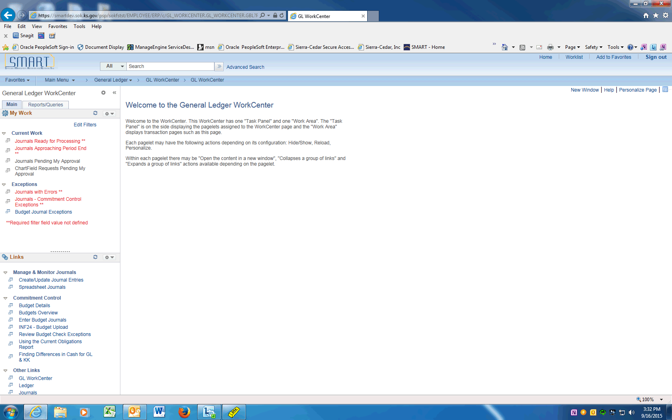

Step | Action
You can minimize and personalize the navigational pagelets on the left.

Click the Pagelet Settings dropdown menu.

If you would like to see more of the Links pagelet, you can minimize the My Work pagelet.

Click the Minimize link.

 | Notice that the My Work pagelet is now collapsed and you can view the Links pagelet more easily. You can click the Pagelet Settings button again to expand the My Work pagelet.
 | The Links pagelet makes it possible for you to access your most commonly-used pages with full functionality without ever leaving your WorkCenter.
Expand the My Work pagelet again.

Click the Pagelet Settings button.

 | Click the Expand link.

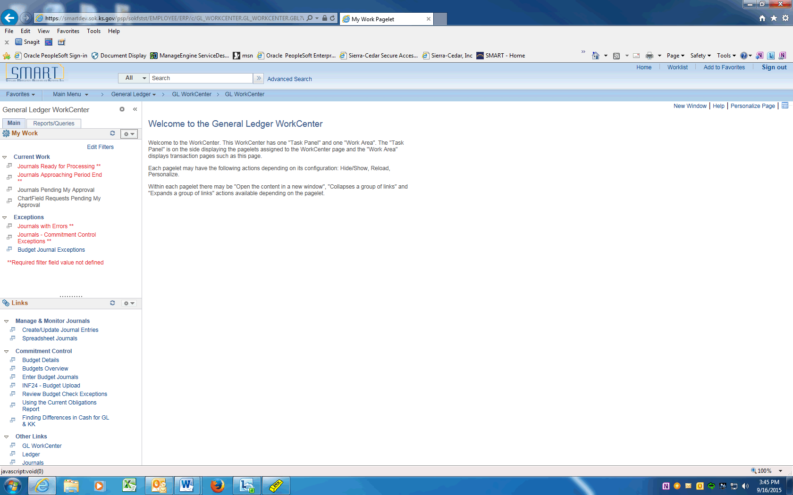

Step | Action
 | In each WorkCenter, the Main tab displays a My Work pagelet and the Links pagelet.
The My Work pagelet can include links to events and notification alerts, prioritized items needing immediate attention, and worklist tasks for workflow approval.

The pagelet is standardized for all agencies and will not be personalized.
 | Each pagelet can include group headings. Group headings are used to place similar pages and links into logical groupings, and are expandable and collapsible.
The Links pagelet can include additional links to pages and other areas of interest including links that are external to your organization.

You can personalize (from the list enabled by your system administrator) which links appear on your WorkCenter.

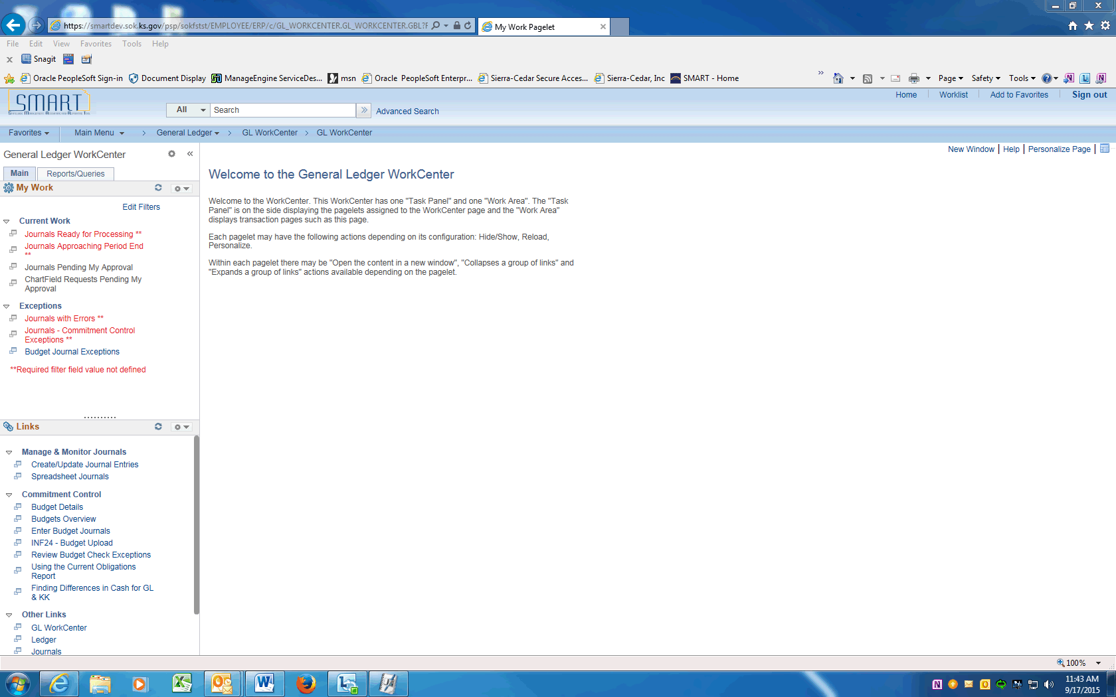

Step | Action
 | There are additional navigational tools for the pagelets that appear when your cursor hovers in the area: one is a right-hand vertical scroll area. You can left-click the scroll once it appears, hold down the cursor and drag the scroll bar up or down.

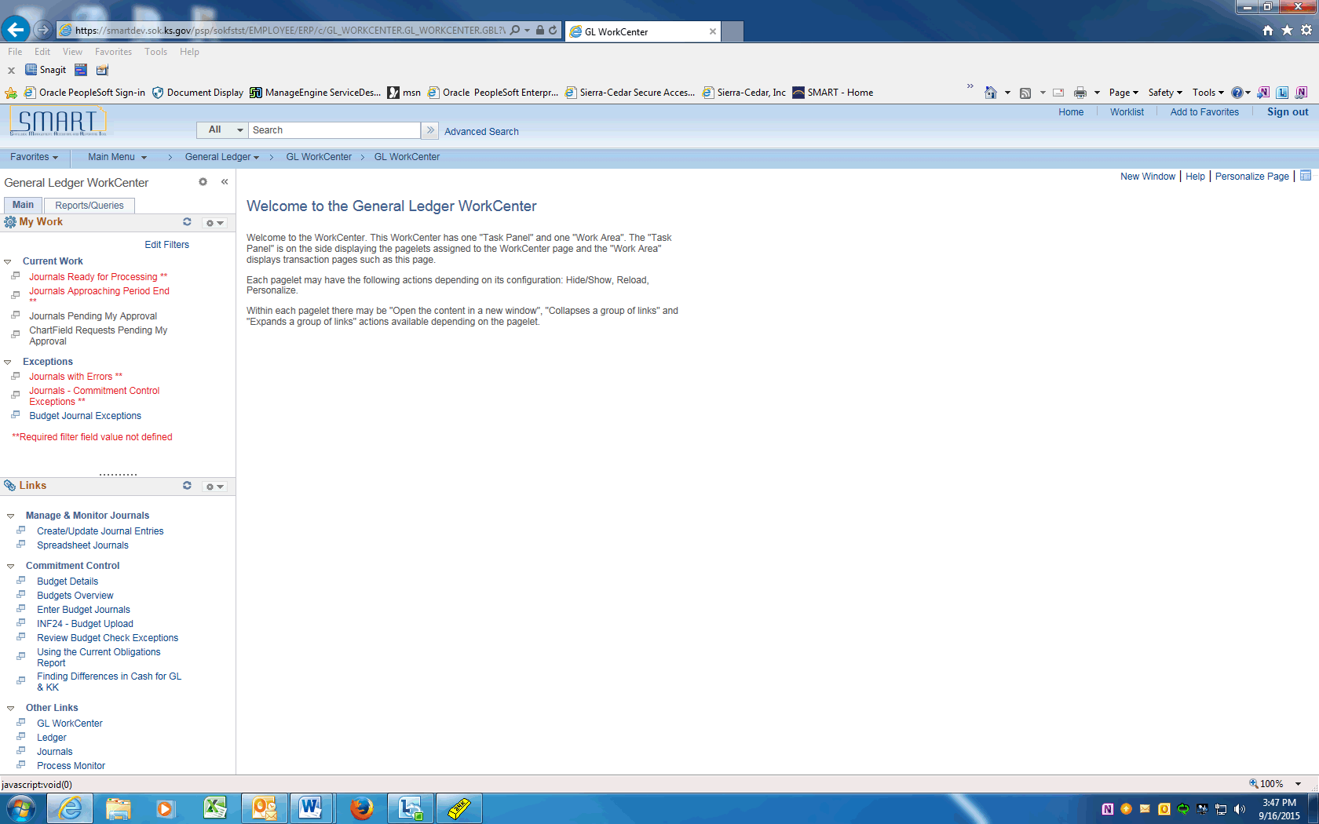

Step | Action
 | You can also resize each WorkCenter pagelet. Just hover over the dotted line in each pagelet until the cursor turns into a double-sided arrow, left-click and hold down, drag and drop up or down to resize the pagelet.

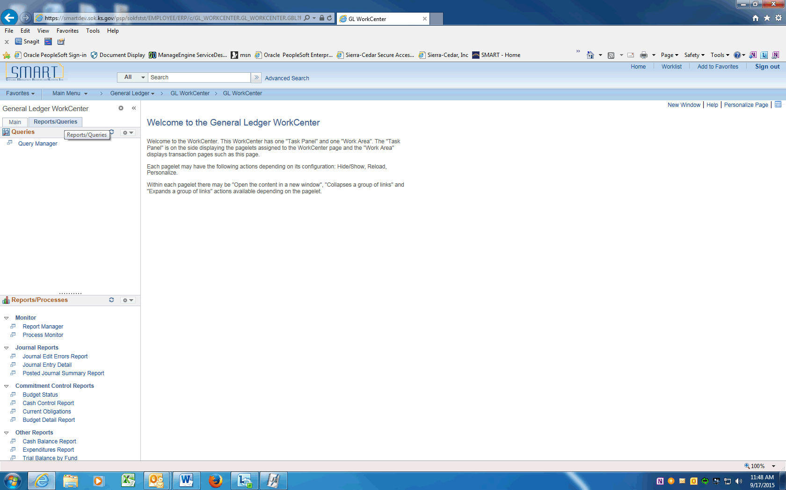

Step | Action
Next, access the Reports and Queries pagelets.

Use the Reports/Queries pagelets to store and run frequently accessed queries, reports, and processes. You can run an ad hoc query, report, or process when you need to.
The Queries pagelet can include links to Query Manager, public queries, private queries, and pivot grids.

You can personalize which links (from the list enabled by your system administrator) appear on your WorkCenter.

The Reports/Processes pagelet can include access to reports and processes that are frequently used.

These links take you directly to the Run Control page for the report or process.

You can personalize which links (from the list enabled by your system administrator) appear on your WorkCenter.

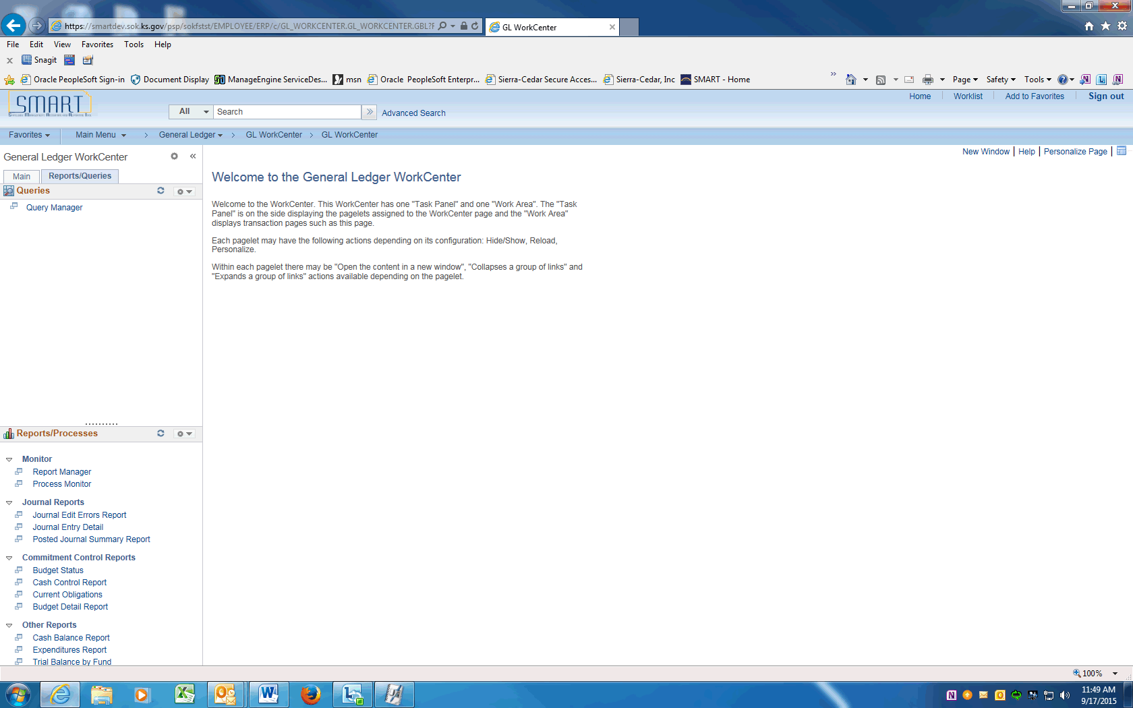

Step | Action
Now let's look at some additional configuration and personalization options that allow you to tailor your pagelets to fit your needs.

Click the Main tab.
Within the My Work pagelet, use the Edit Filters link to modify criteria for alerts.

Some links can be subject to filter criteria that limit the amount of data available.

Click the Edit Filters link.

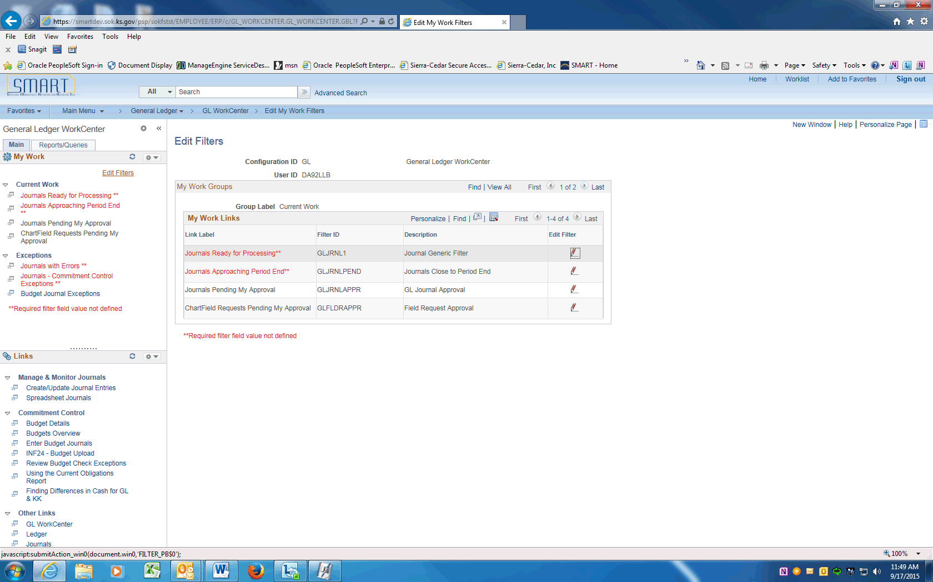

Step | Action
Use the Edit Filters page to adjust filters for items that appear in the My Work pagelet.

The filters used to select the data for each link in the My Work pagelet can be changed.

Use the Configure Filter Values page to adjust specific values that are used to select the data displayed in the transaction area.

This enables you to change the filters and limit the result set of the data.

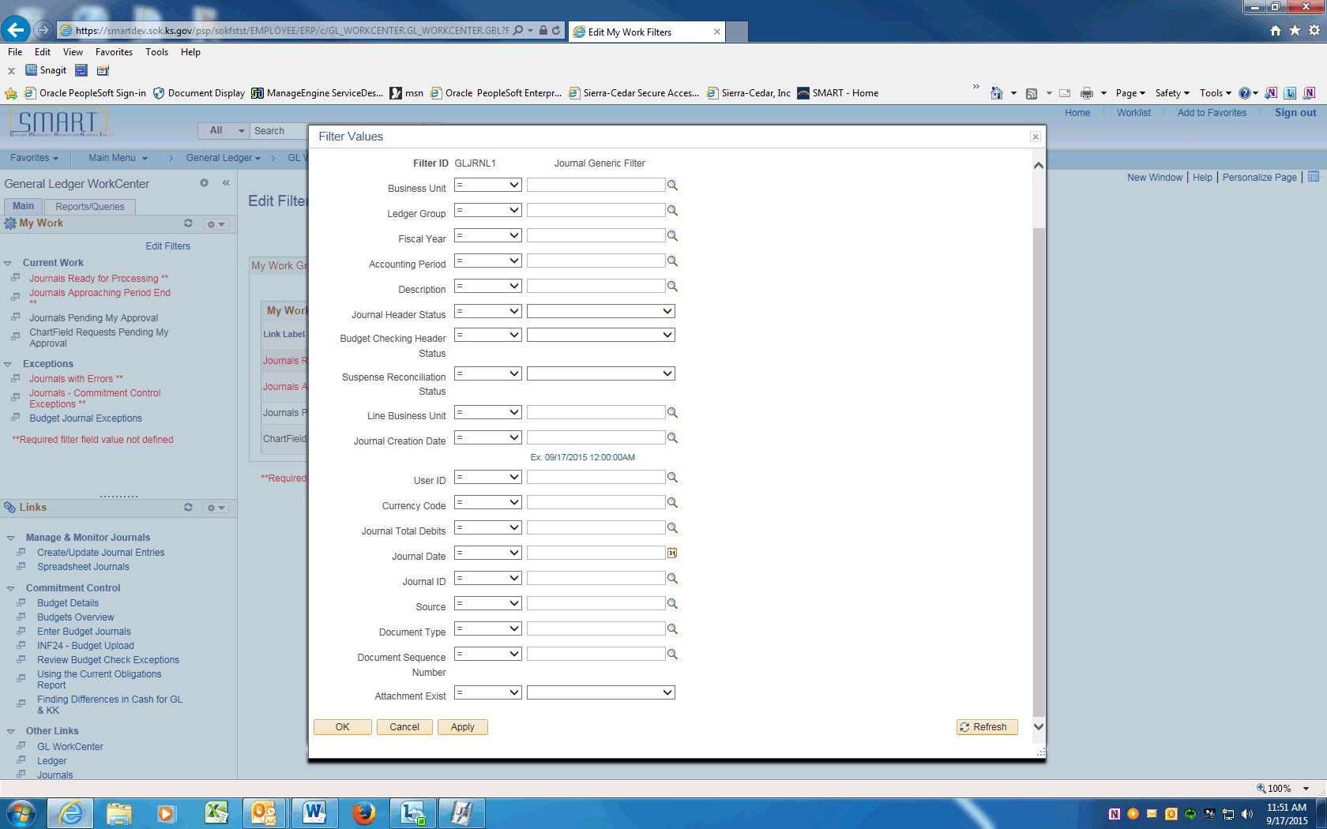

Step | Action
 | When you are finished making filter changes, click the OK or Apply button.

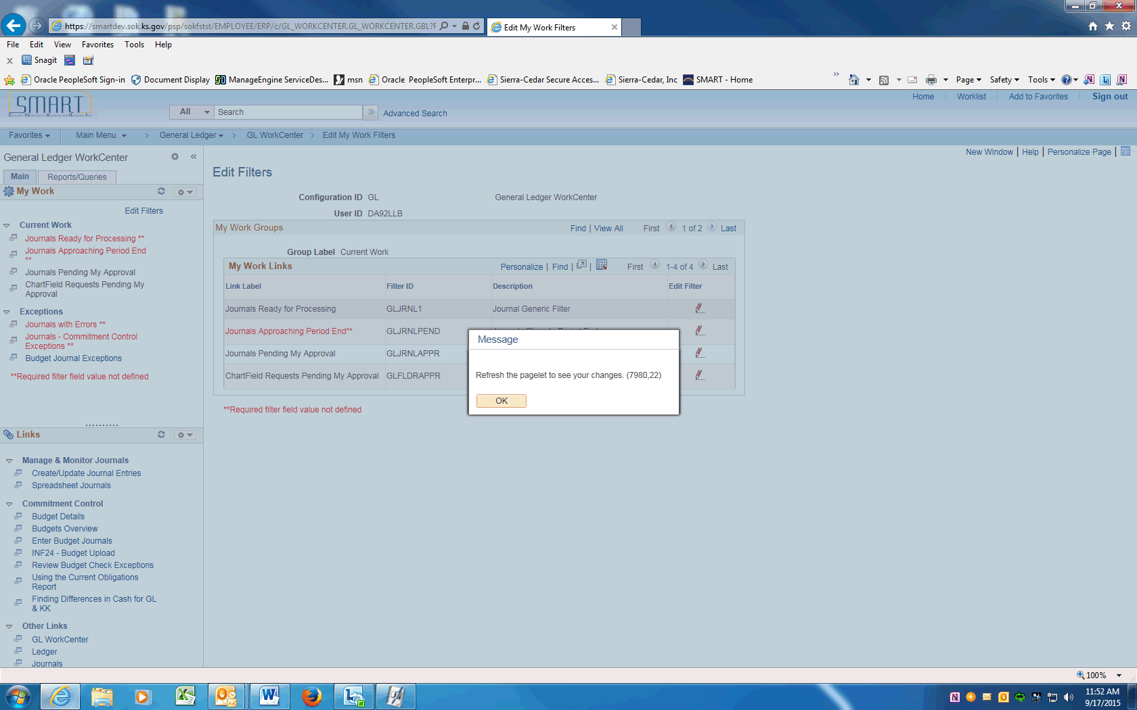

Step | Action
The system instructs you to refresh (or reload) the WorkCenter page to view any changes.

Click the OK button.

 | Click the Reload icon to reload the data after you've made changes
 | Use the New Window icon to open the transaction information in a new window.
Your selection in the pagelet area drives what you see in the transaction area.

Note that the count number displays how many transactions will appear.

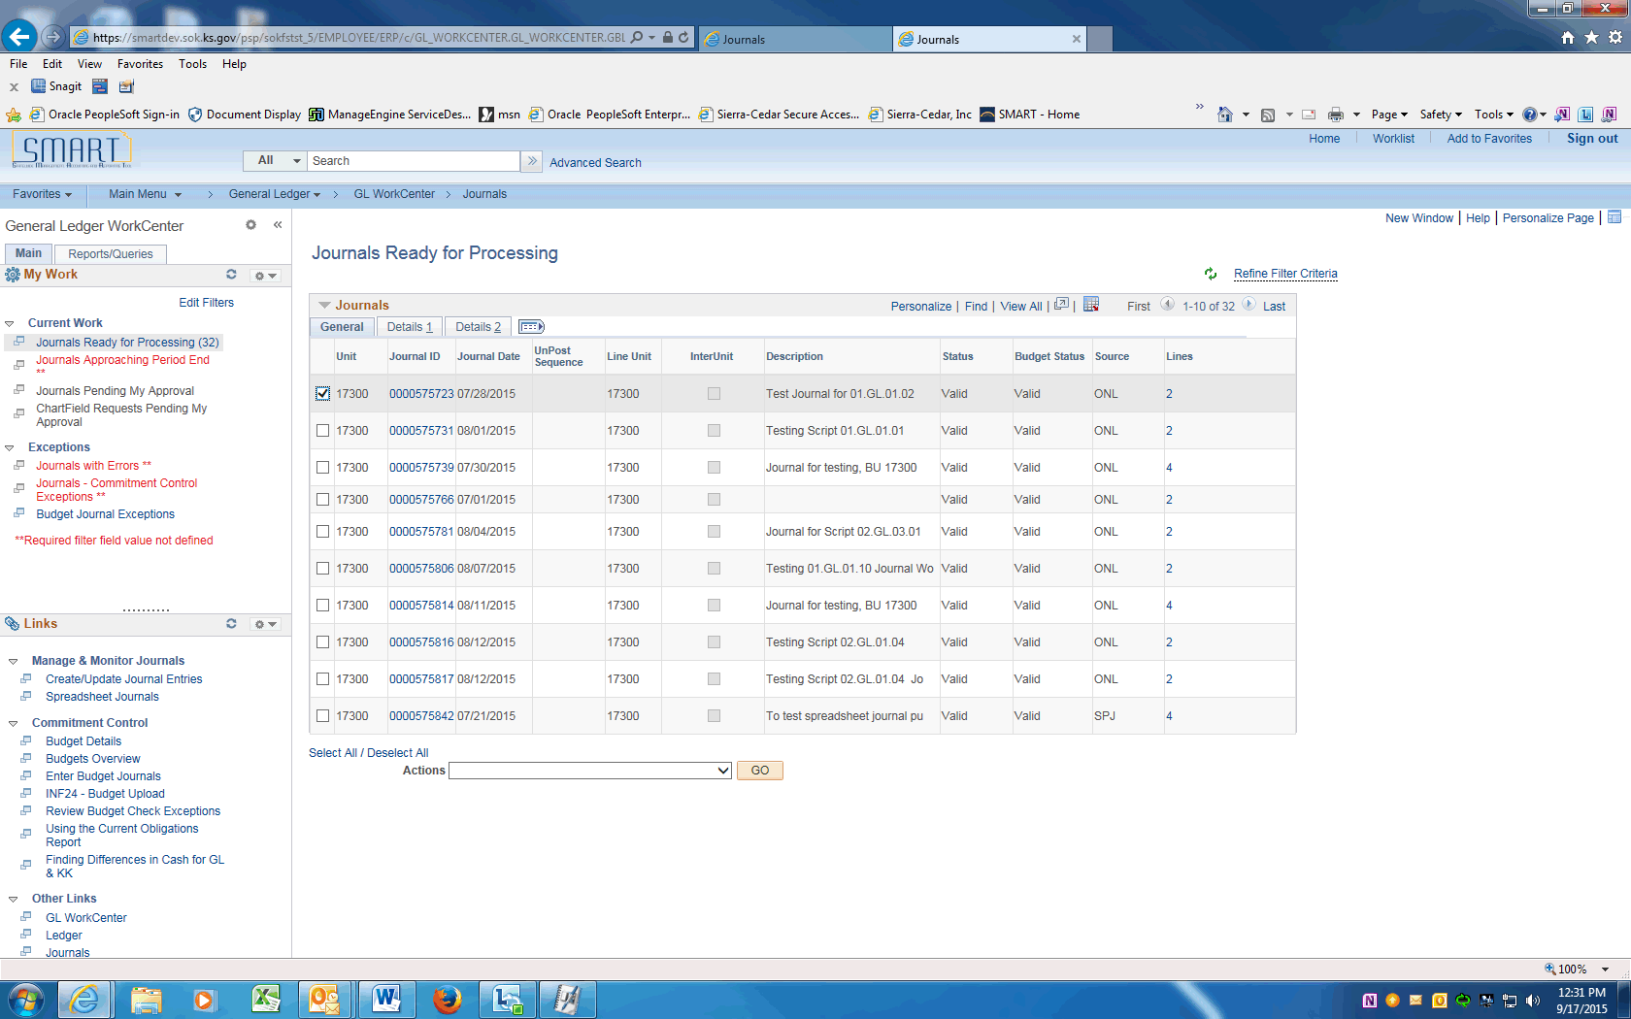

Step | Action
Use the transaction area to view data that is specific to the pagelet selection and the filter criteria defined in the Configure Filter Values page.

This area enables you to see transaction information, perform needed actions, and drill into additional details for the transaction.

Each transaction area can have a different look for each option selected in the pagelet area.

Blue text indicates a link that will take you to specific transaction pages.

Select the box before the Journal ID item.

An Actions list box enables you to take various actions on selected transactions.

These are the various actions that you can take for selected transactions.

To perform an action on the transactions selected in the grid, select the action in this list box.

Click the Post Journals list item.

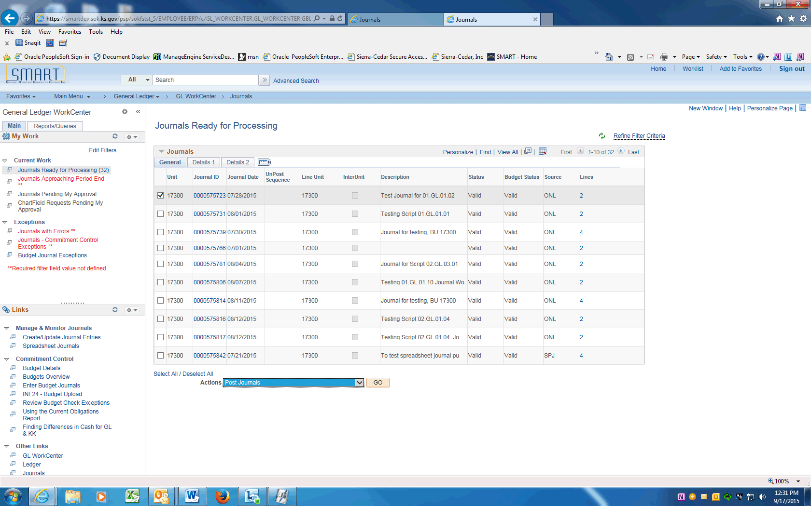

Step | Action
 | Click the GO button to perform the chosen action.
 | End of Procedure.

Workcenter - My Work
The My Work pagelet within the WorkCenter includes:
- Links to tasks that you perform most often such as entering a transaction, transactions needing approvals, etc.
- Exceptions and alerts for items that require your attention and potentially some type of action.
Links that are set up for the My Work pagelet are subject to agency and role based security which may limit the amount of data that is available to a user.
Procedure

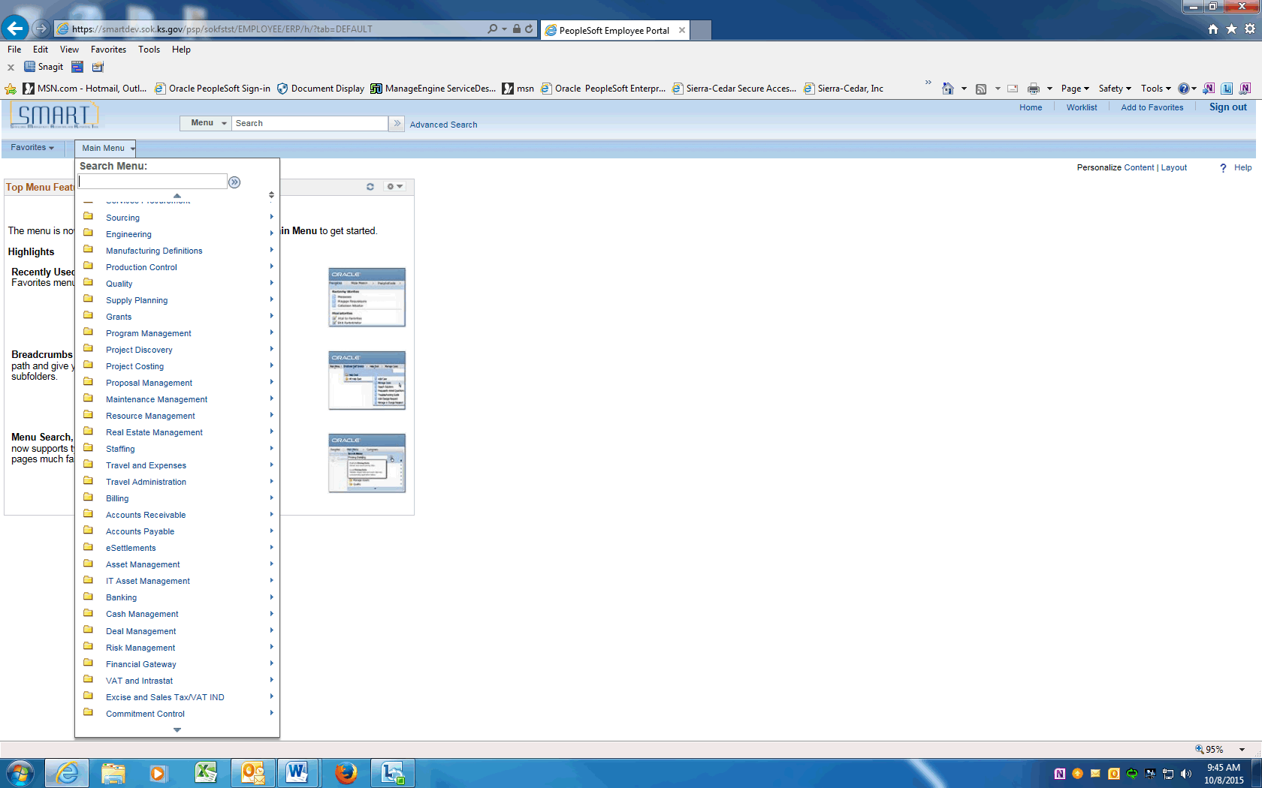

Step | Action
Begin by navigating to the General Ledger WorkCenter.
Click the Scroll Down arrow.

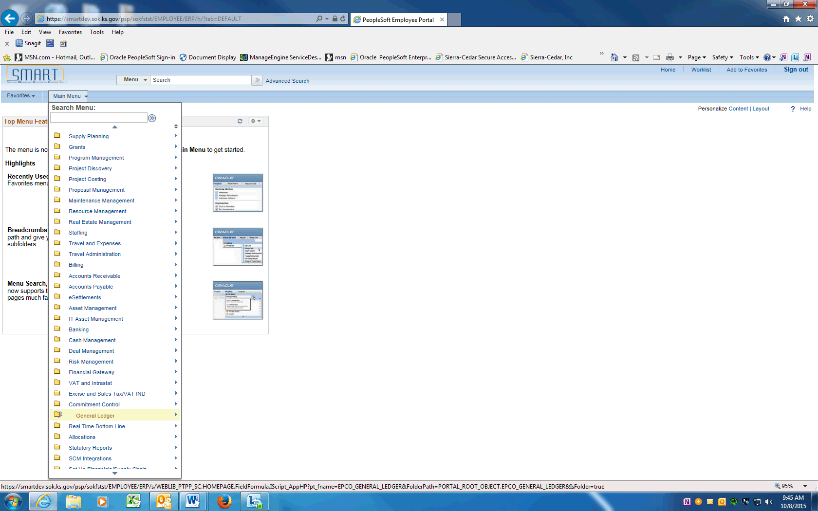

Step | Action
 | Click the General Ledger menu.

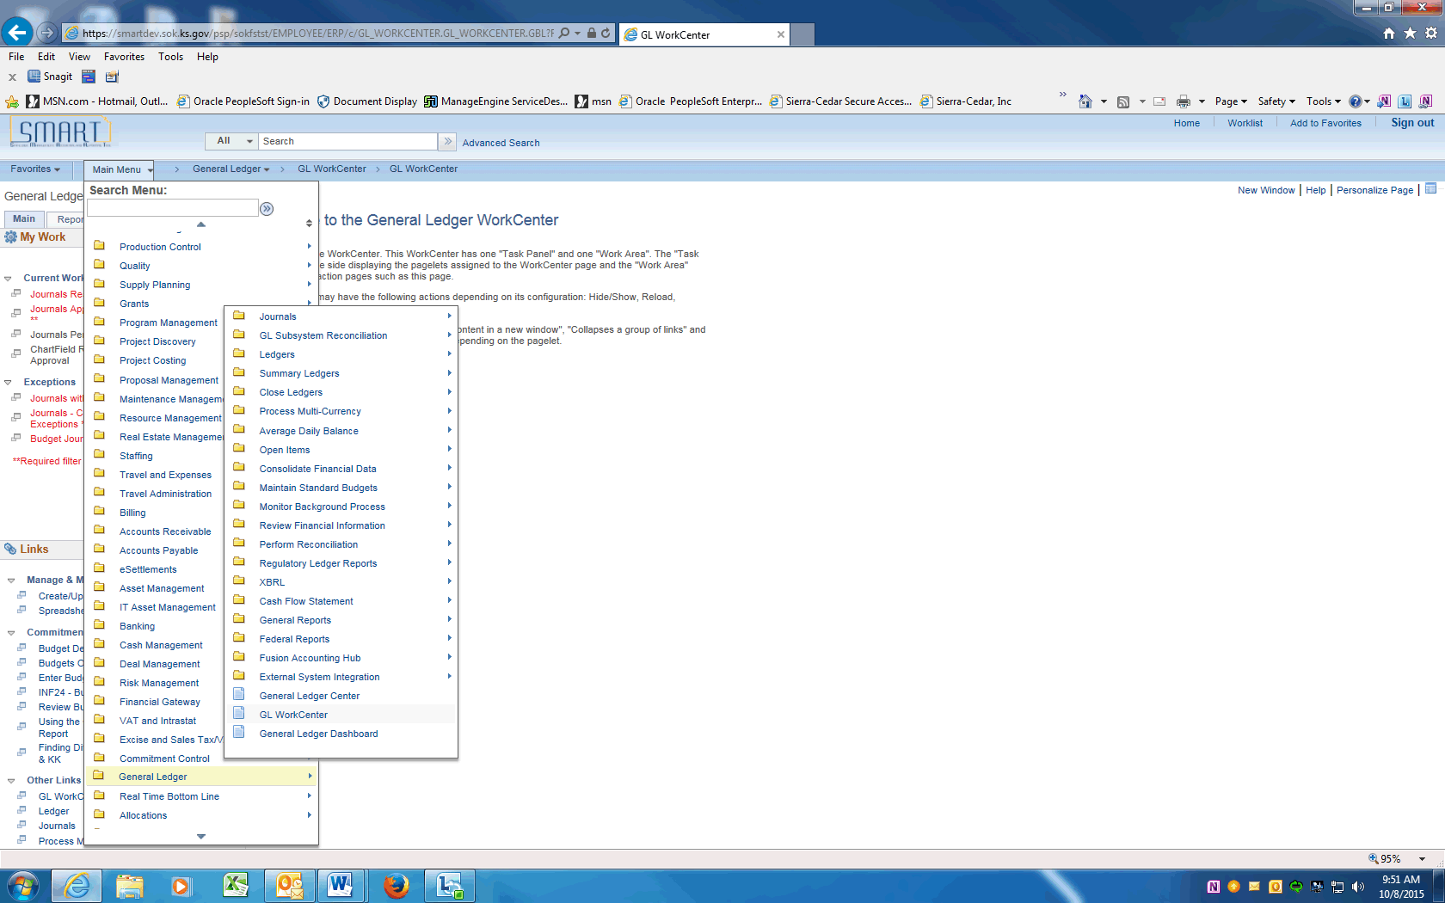

Step | Action
 | Click the General Ledger WorkCenter.
 | Use the General Ledger WorkCenter page to access work items, links, queries, reports, and processes that are specific to your position.
 | The My Work pagelet is set up with two groups.
 | The first group label is Current Work. These alerts include items that require further processing, such as journals pending approval or incomplete journals.
 | The second group label is Exceptions. These alerts show the journals with the various types of errors that require attention.

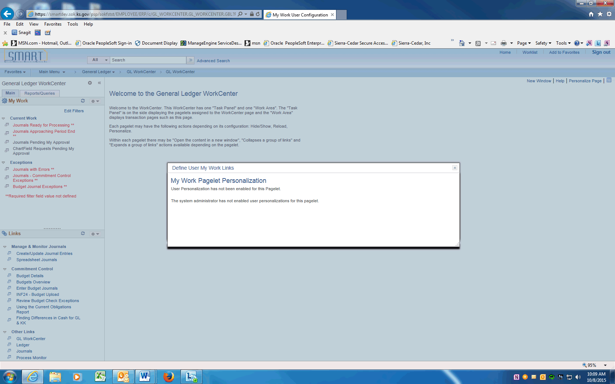

Step | Action
The other pagelets in the WorkCenters -- Links, Reports and Processes and Queries -- can be Personalized with page, report, and query links.

Note that Personalization is not available for the My Work Pagelet. The standard set-up provides consistency across all agencies and modules.
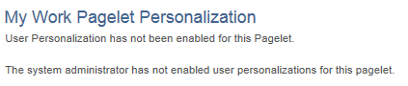
You have successfully reviewed the My Work pagelet.

End of Procedure.

Workcenter - Links pagelet
The Links pagelet within a WorkCenter includes links to your most commonly-used pages or other areas of interest to module users. A system administrator maintains the list of links that are available to users, as well as related security. You can then personalize the links that you want to access from your WorkCenter. Commonly-used external links, such as training materials, can also be added to this section.
In this topic, we explore the Links pagelet within the WorkCenter, its functionality and personalizations.
Procedure

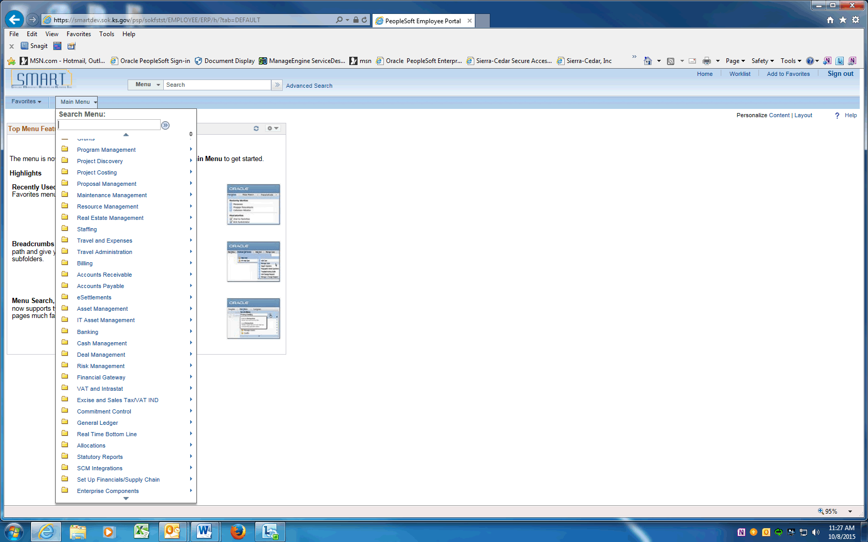

Step | Action
 | Begin by navigating to the General Ledger WorkCenter. Scroll down the drop down menu.

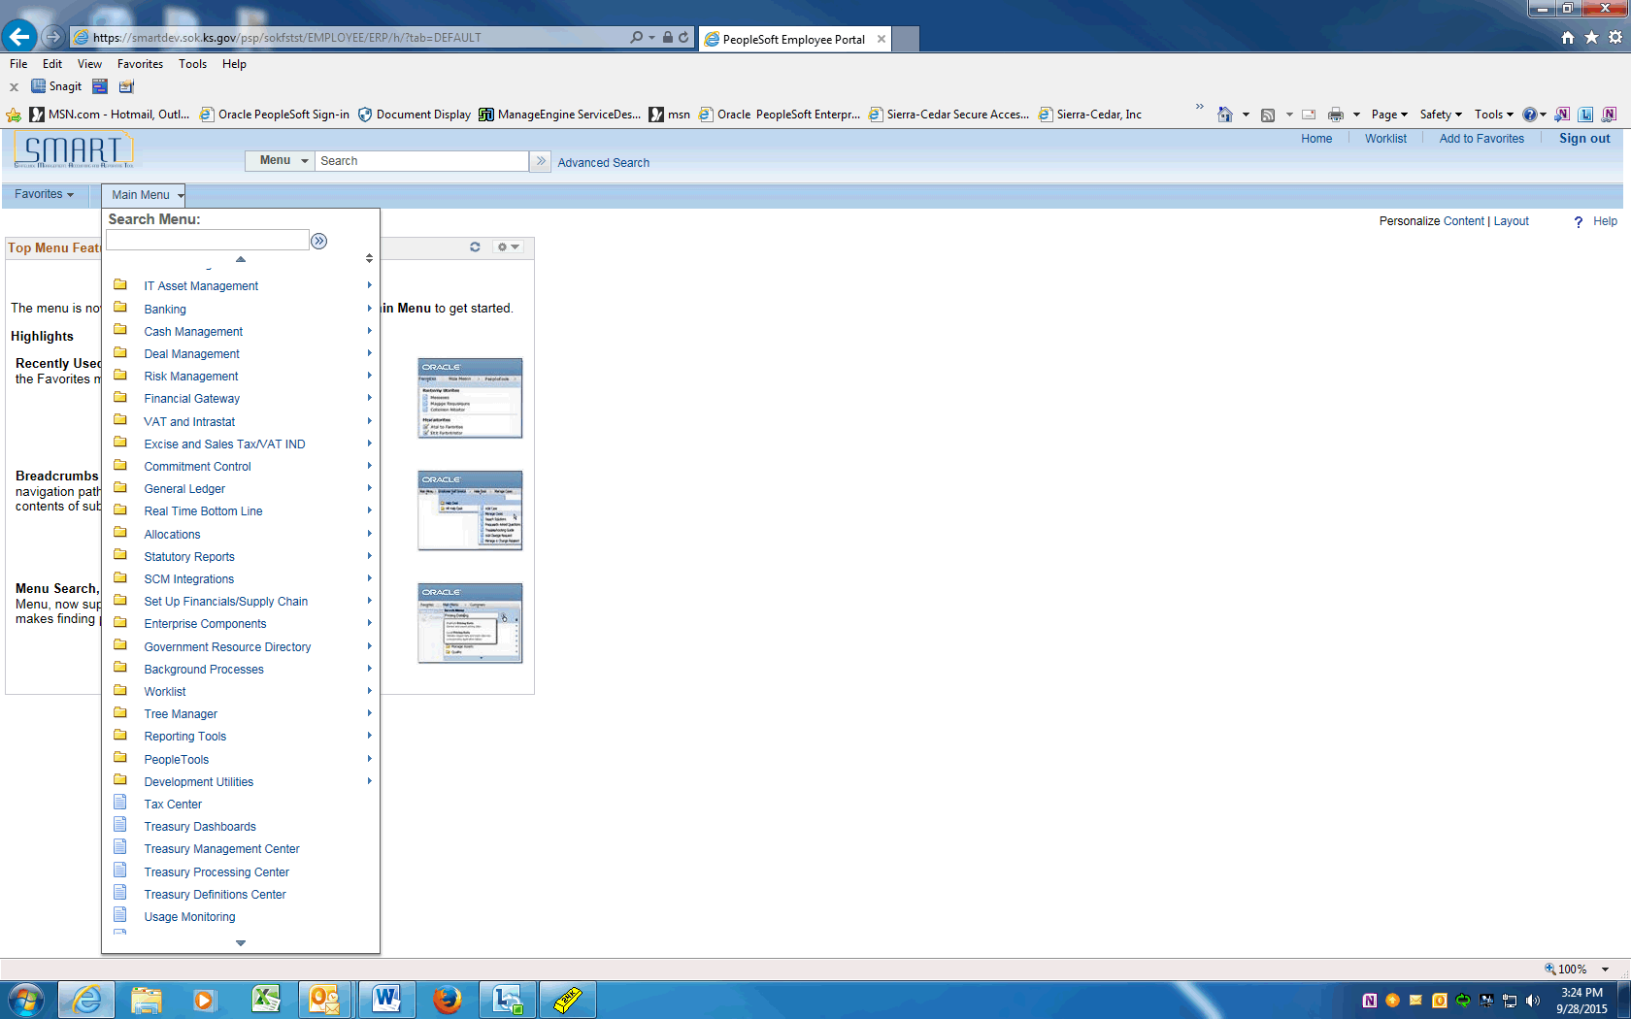

Step | Action
 | Click the General Ledger menu.
 | Click the GL WorkCenter menu.

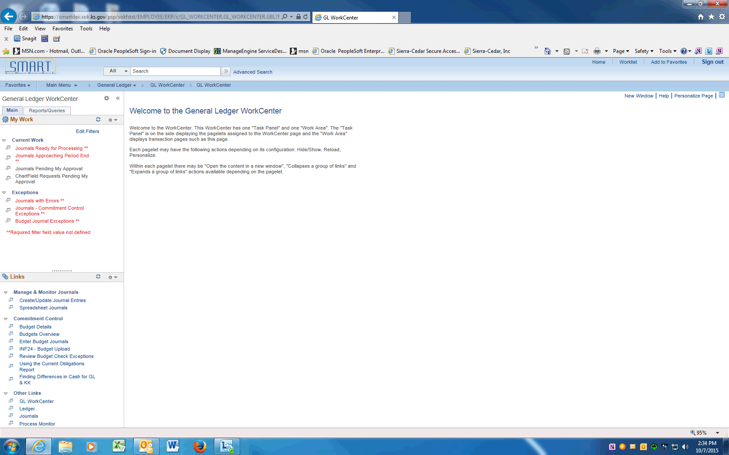

Step | Action
 | Use the General Ledger WorkCenter page to access work items, links, queries, reports, and processes that are specific to your position.
 | Click on the My Work pagelet settings.

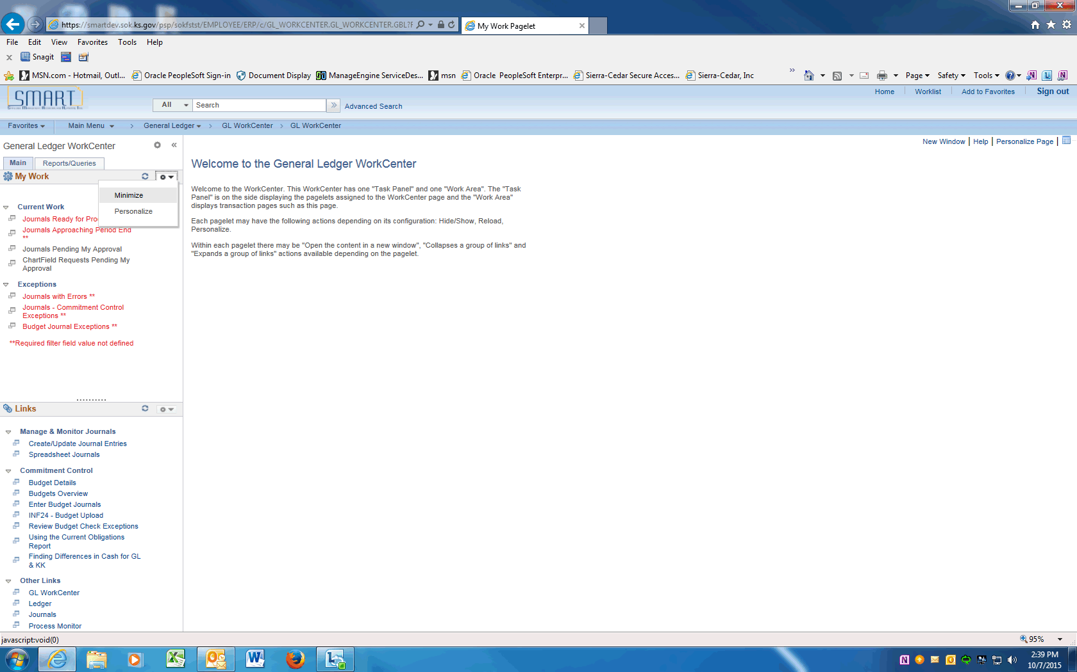

Step | Action
 | Click on Minimize to hide the Current Work items.

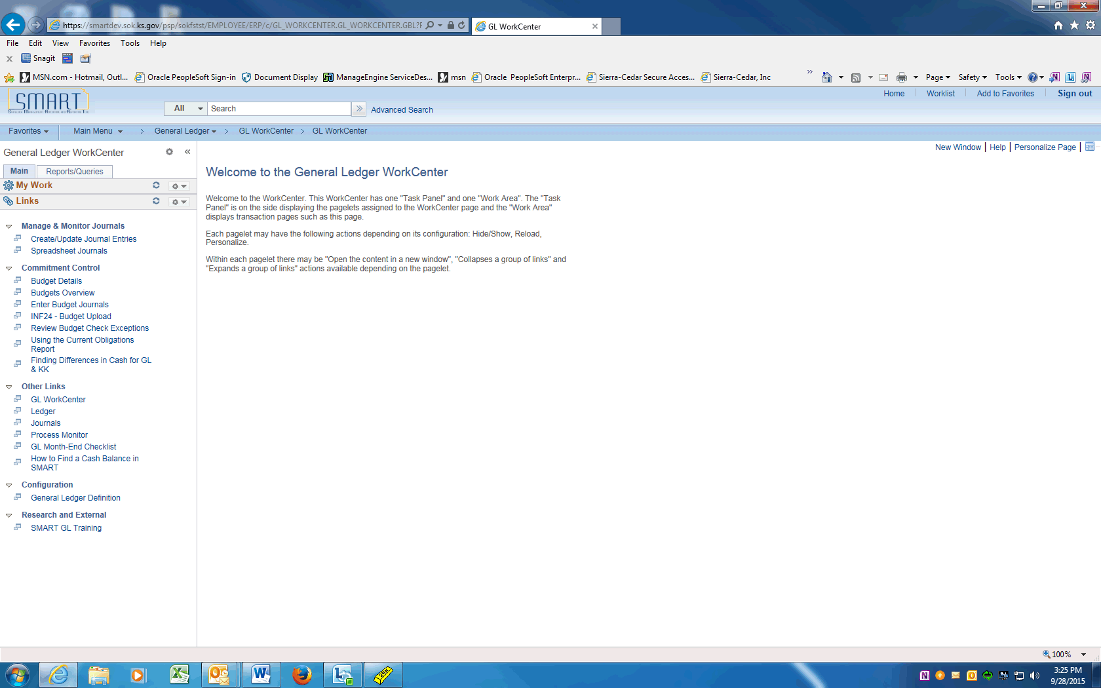

Step | Action
The Links pagelet of the General Ledger WorkCenter includes additional links to components that you commonly access.

The System administrator has configured a list of links that are available for this pagelet and has enabled end users to personalize their display options, as well as define group labels and links.

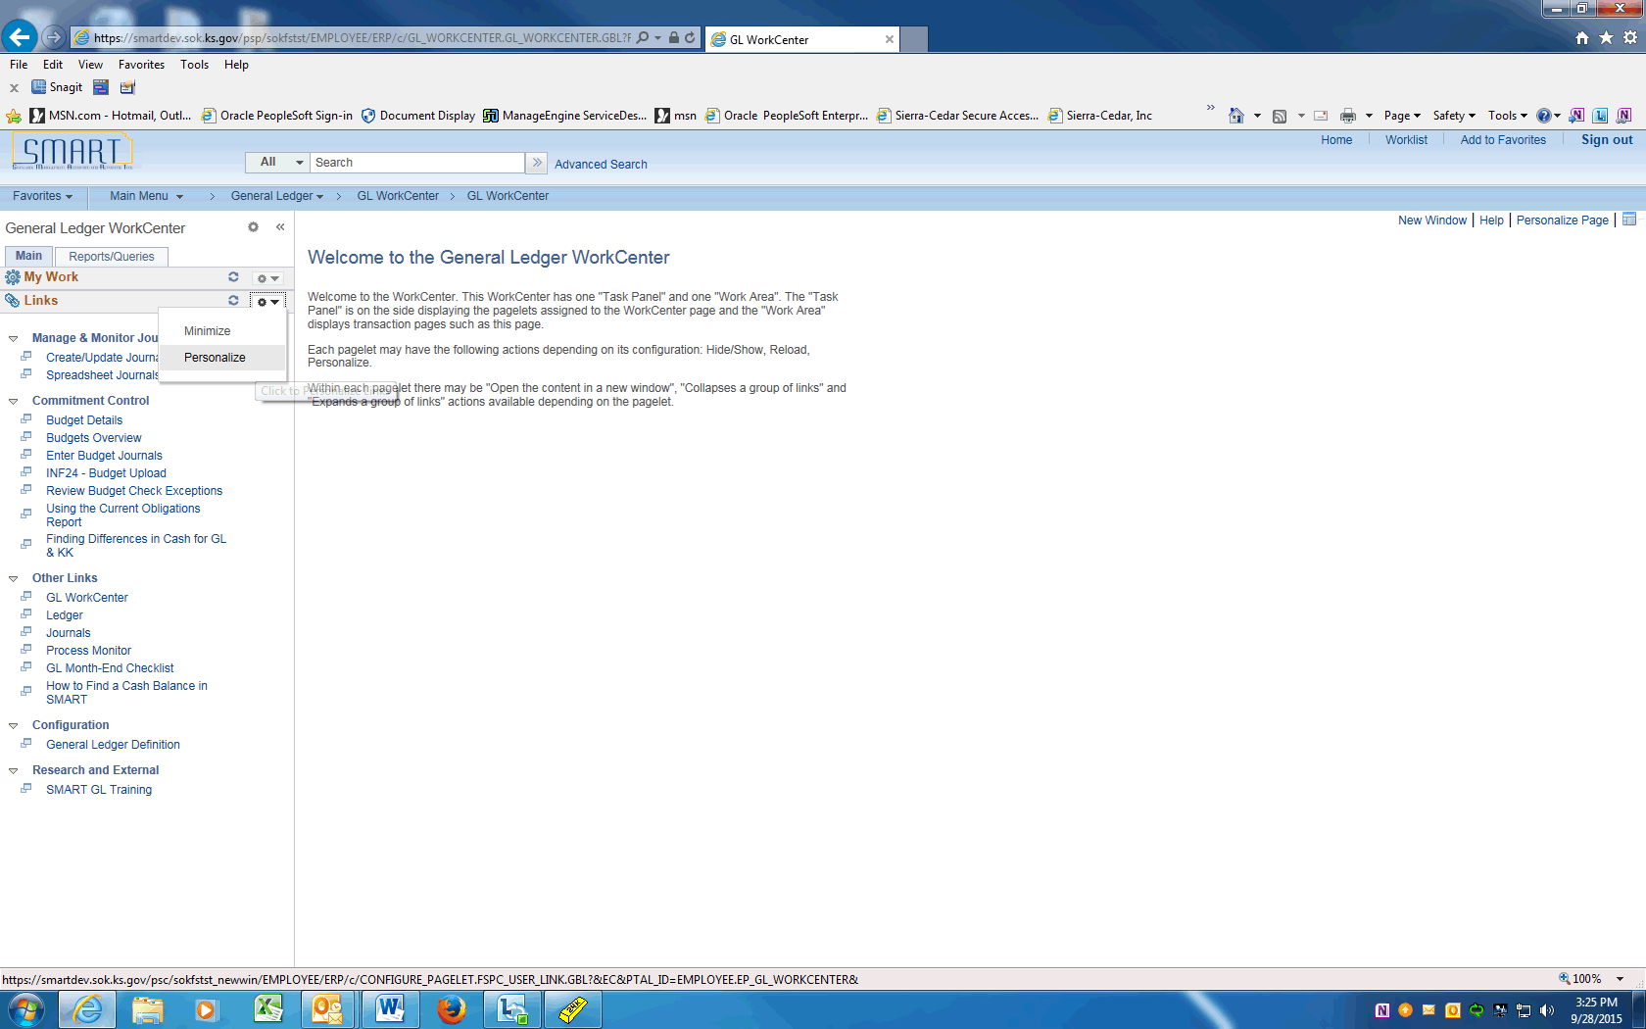

Step | Action
 | To begin personalizing the Links pagelet, click on the Links pagelet settings and choose Personalize.

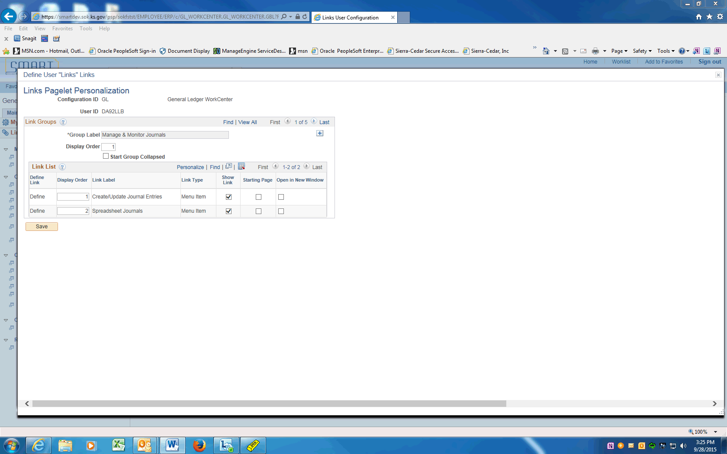

Step | Action
Use the Links Pagelet Personalization page to structure your Links pagelet as you want to see it.

The Group Label fields created by the system administrator are non-editable.

The Display Order field is an open field. This means that you can change the order the groups are displayed.

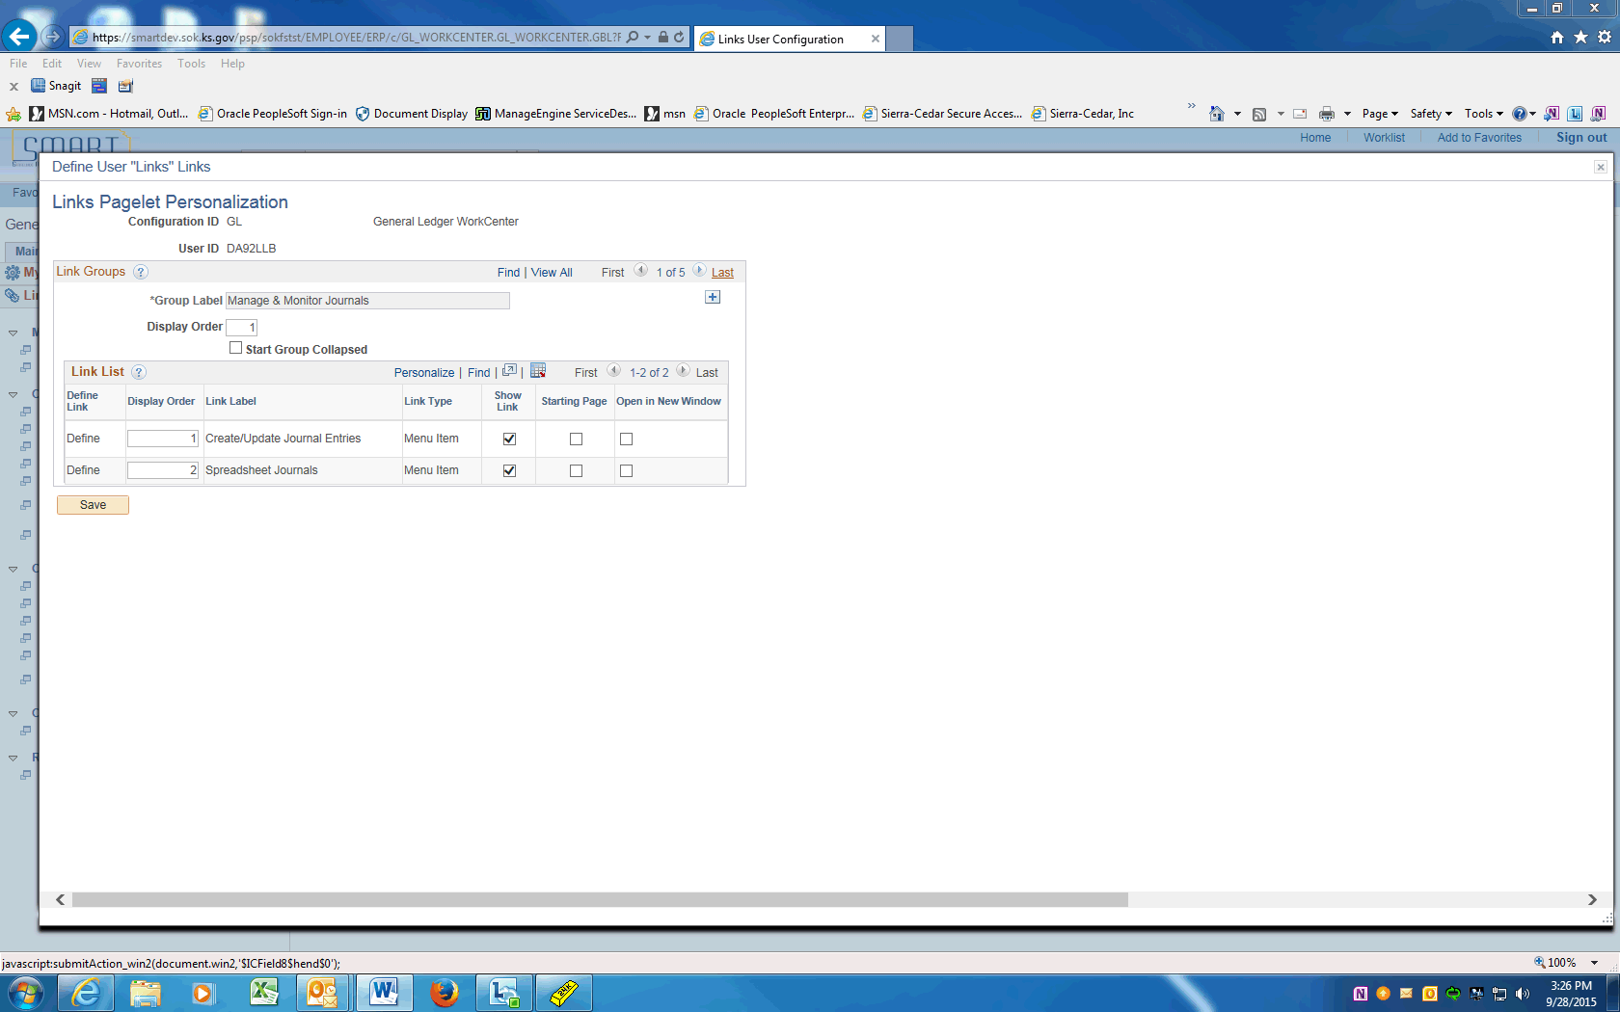

Step | Action
 | You are going to add some personal links so that you can quickly access menu items and other links from the Links pagelet. Click the Last link.

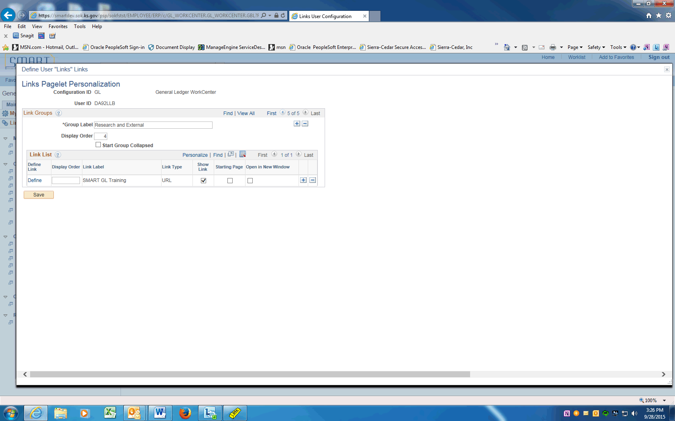

Step | Action
 | Click the Add a new row button.

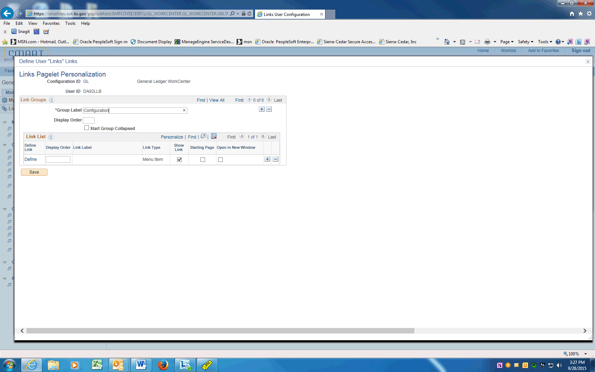

Step | Action
Click in the Group Label field.
Enter the desired information into the Group Label field. Enter "Configuration".
Click in the Display Order field.

Enter the desired information into the Display Order field. Enter "3".

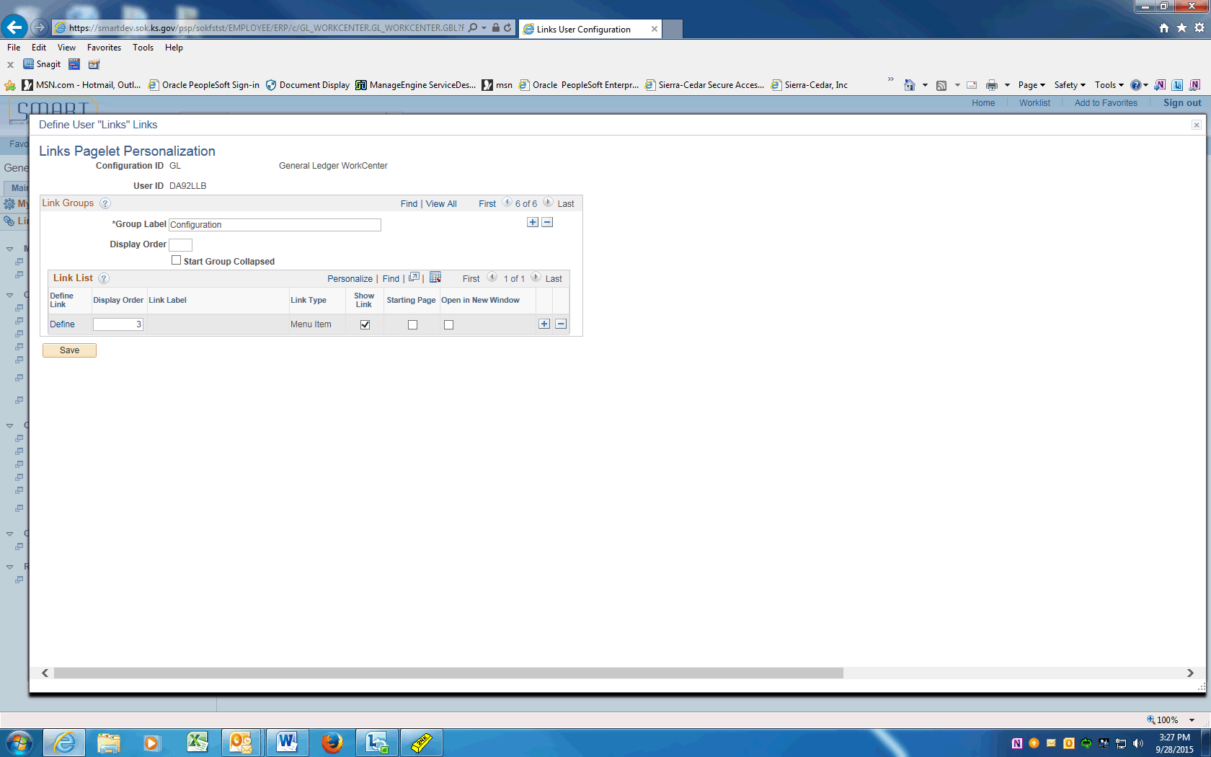

Step | Action
 | Use the Start Group Collapsed option for links that are not frequently used. When you select this option, the group appears collapsed when you initially access the WorkCenter.

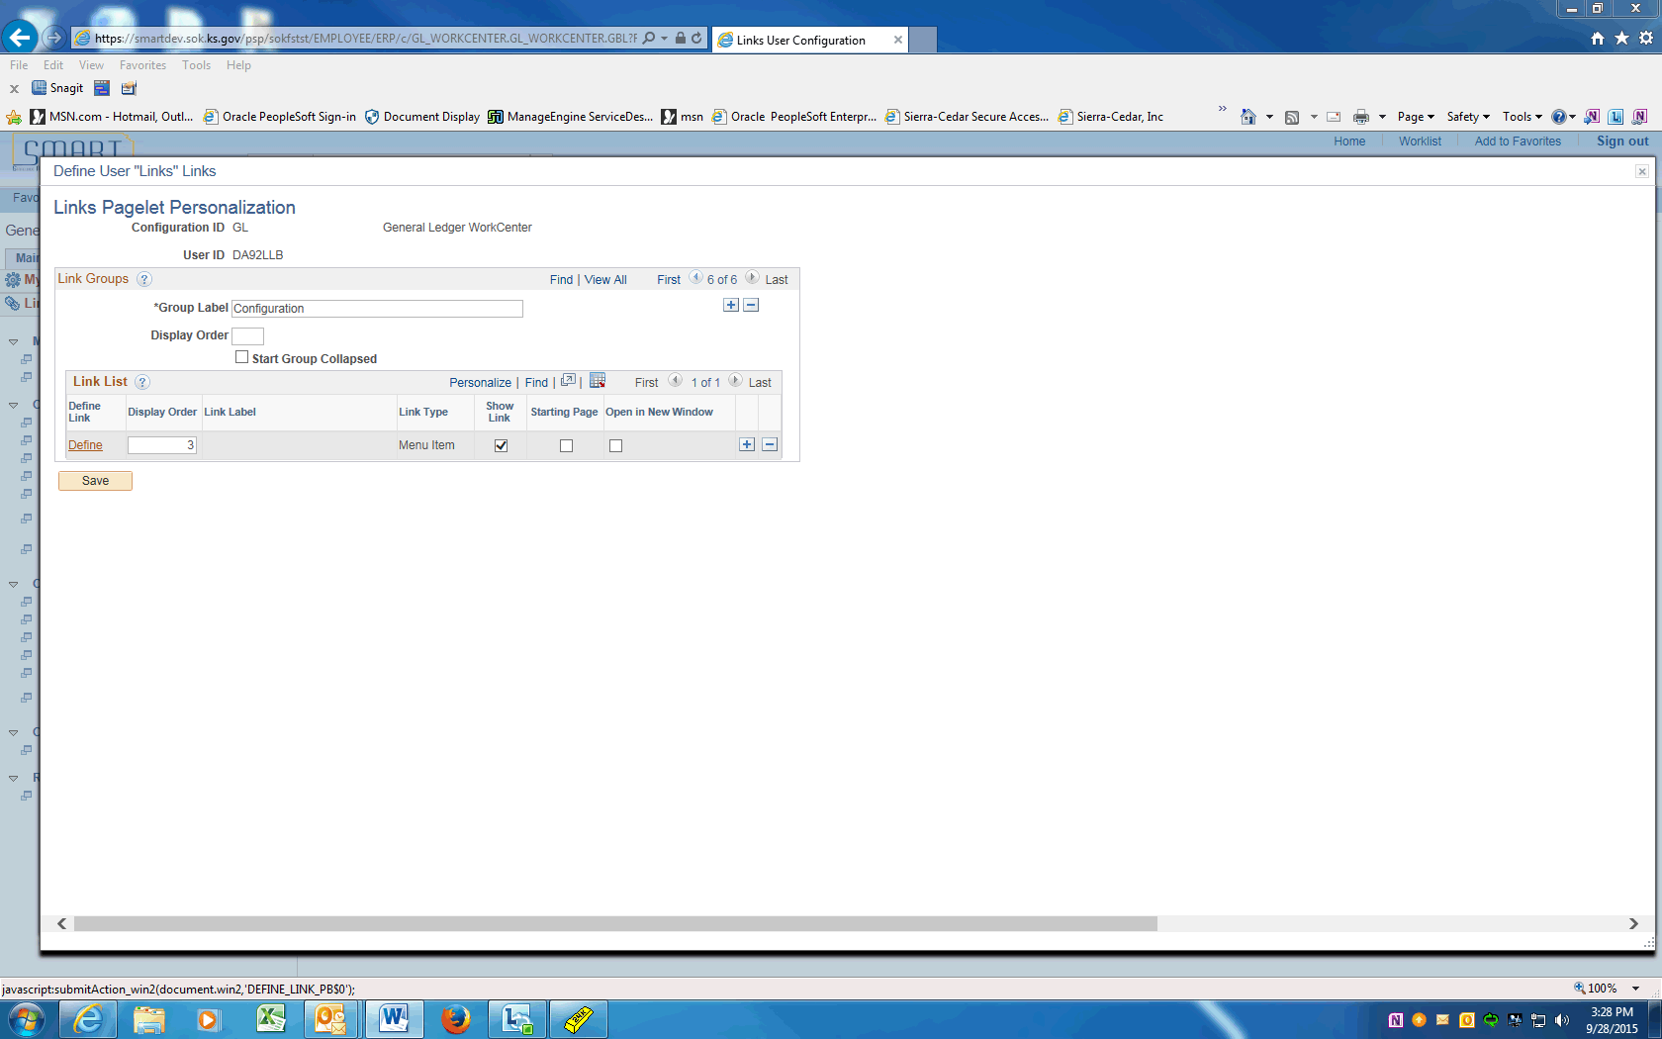

Step | Action
Use the Define Link column to access the Define Link page.

Click the Define link.

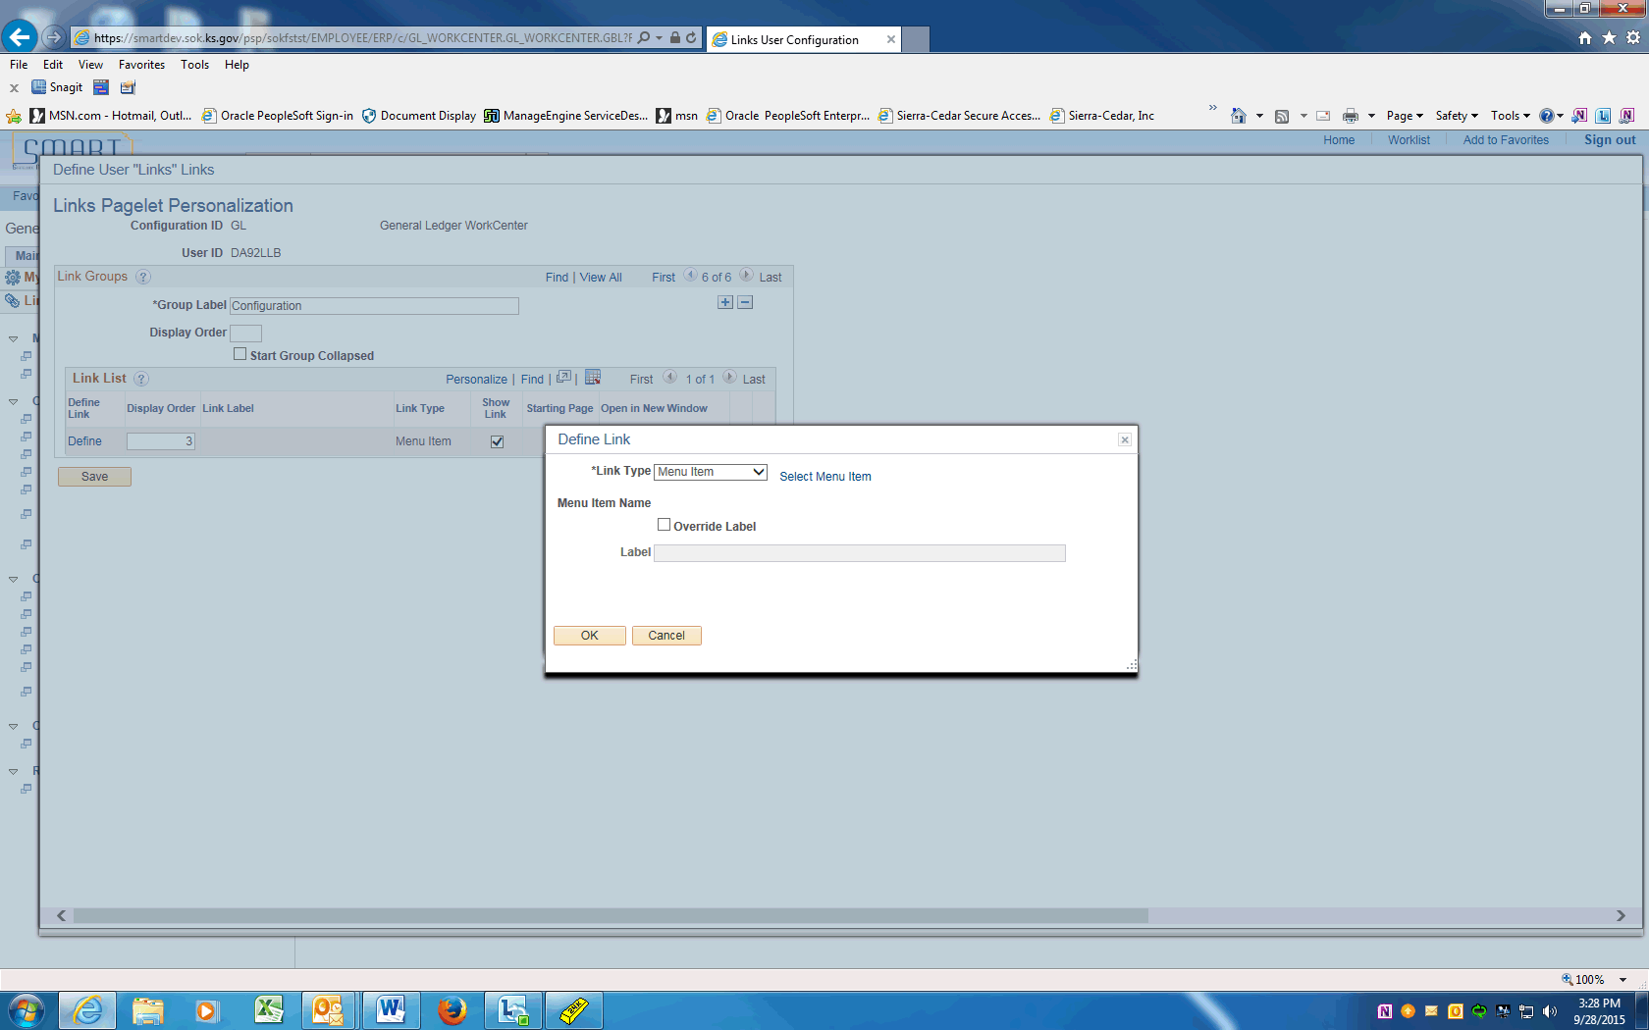

Step | Action
Use the Define Link page to determine the link type and link label.

Click the Link Type list.
 | Use the Link Type drop down list box to select the type of link. Options include: Menu Item and URL.
Use the Select Menu Item link to access the PeopleSoft menu structure.

Click the Select Menu Item link.

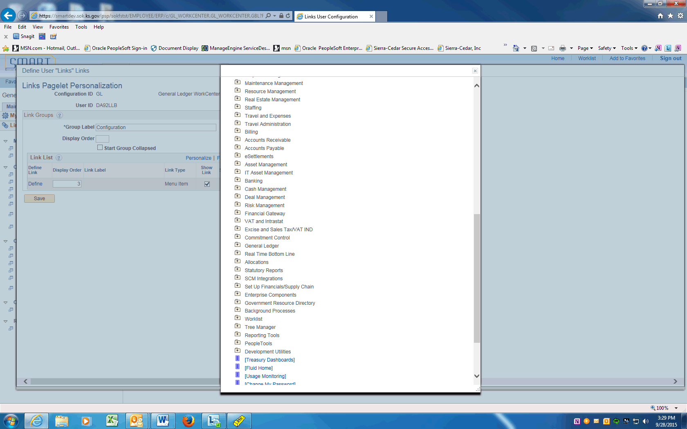

Step | Action
 | Click the vertical scrollbar.

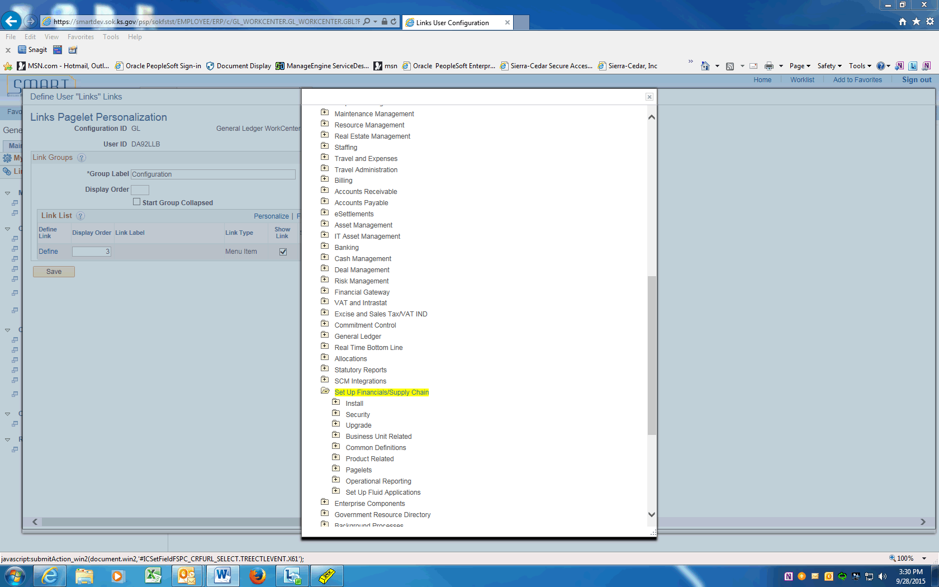

Step | Action
 | Click the Set Up Financials/Supply Chain button.
 | Click the Business Unit Related button.

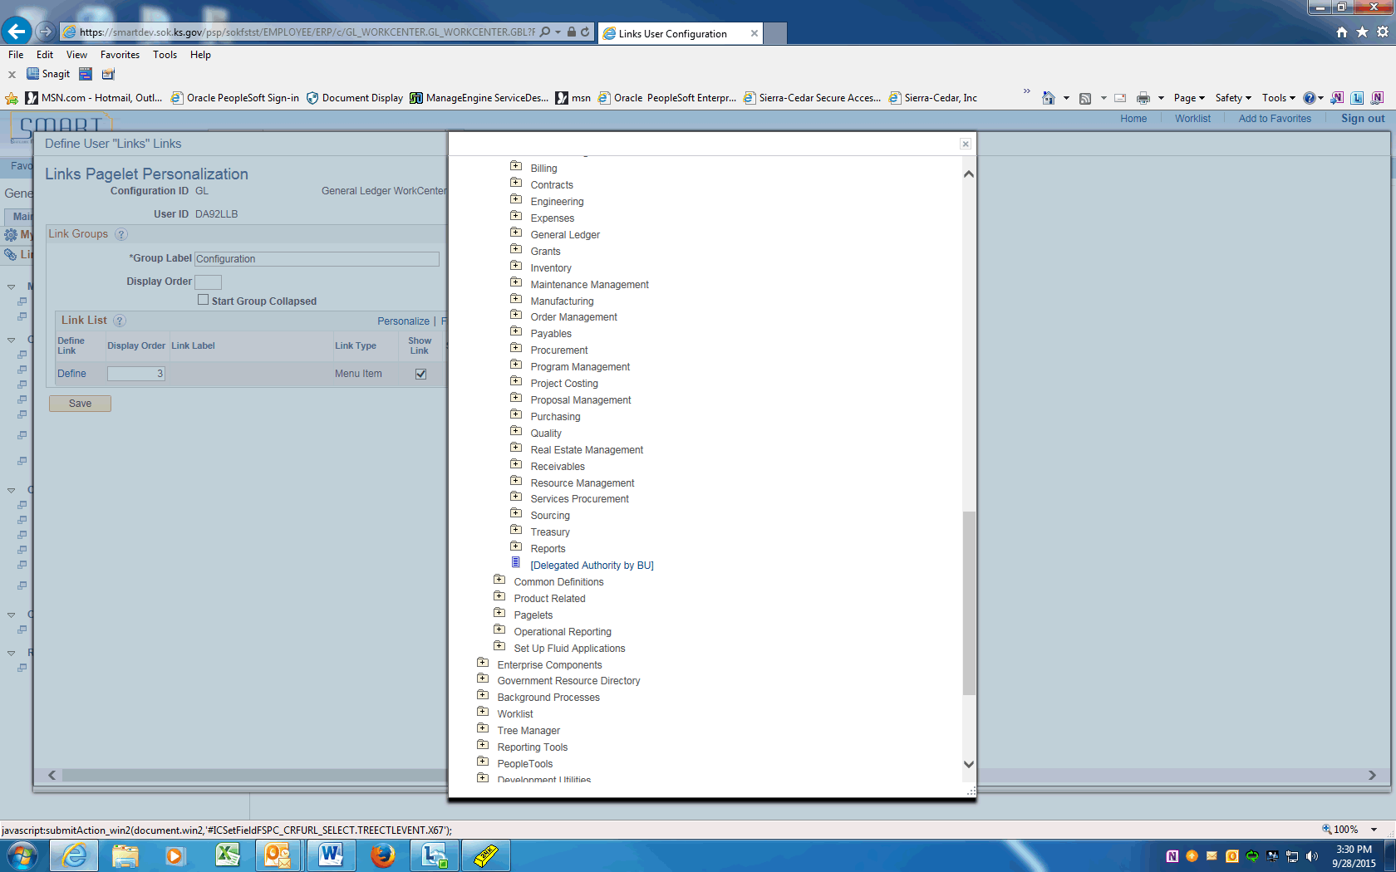

Step | Action
 | Click the General Ledger button.
 | Click the [General Ledger Definition] link.

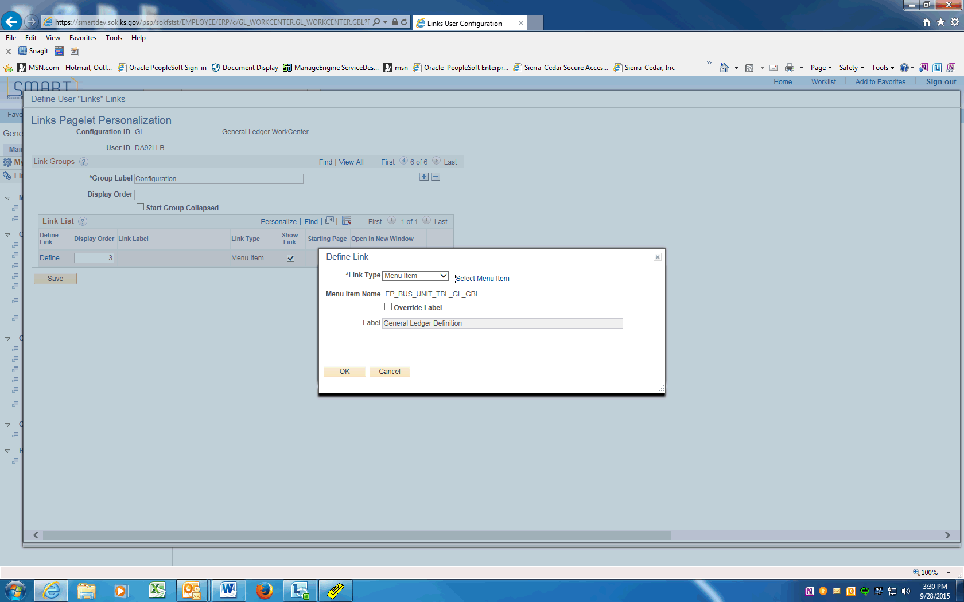

Step | Action
 | You can accept the default label for the link or you can select the Override Label check box. This selection enables you to enter a new label in the Label field

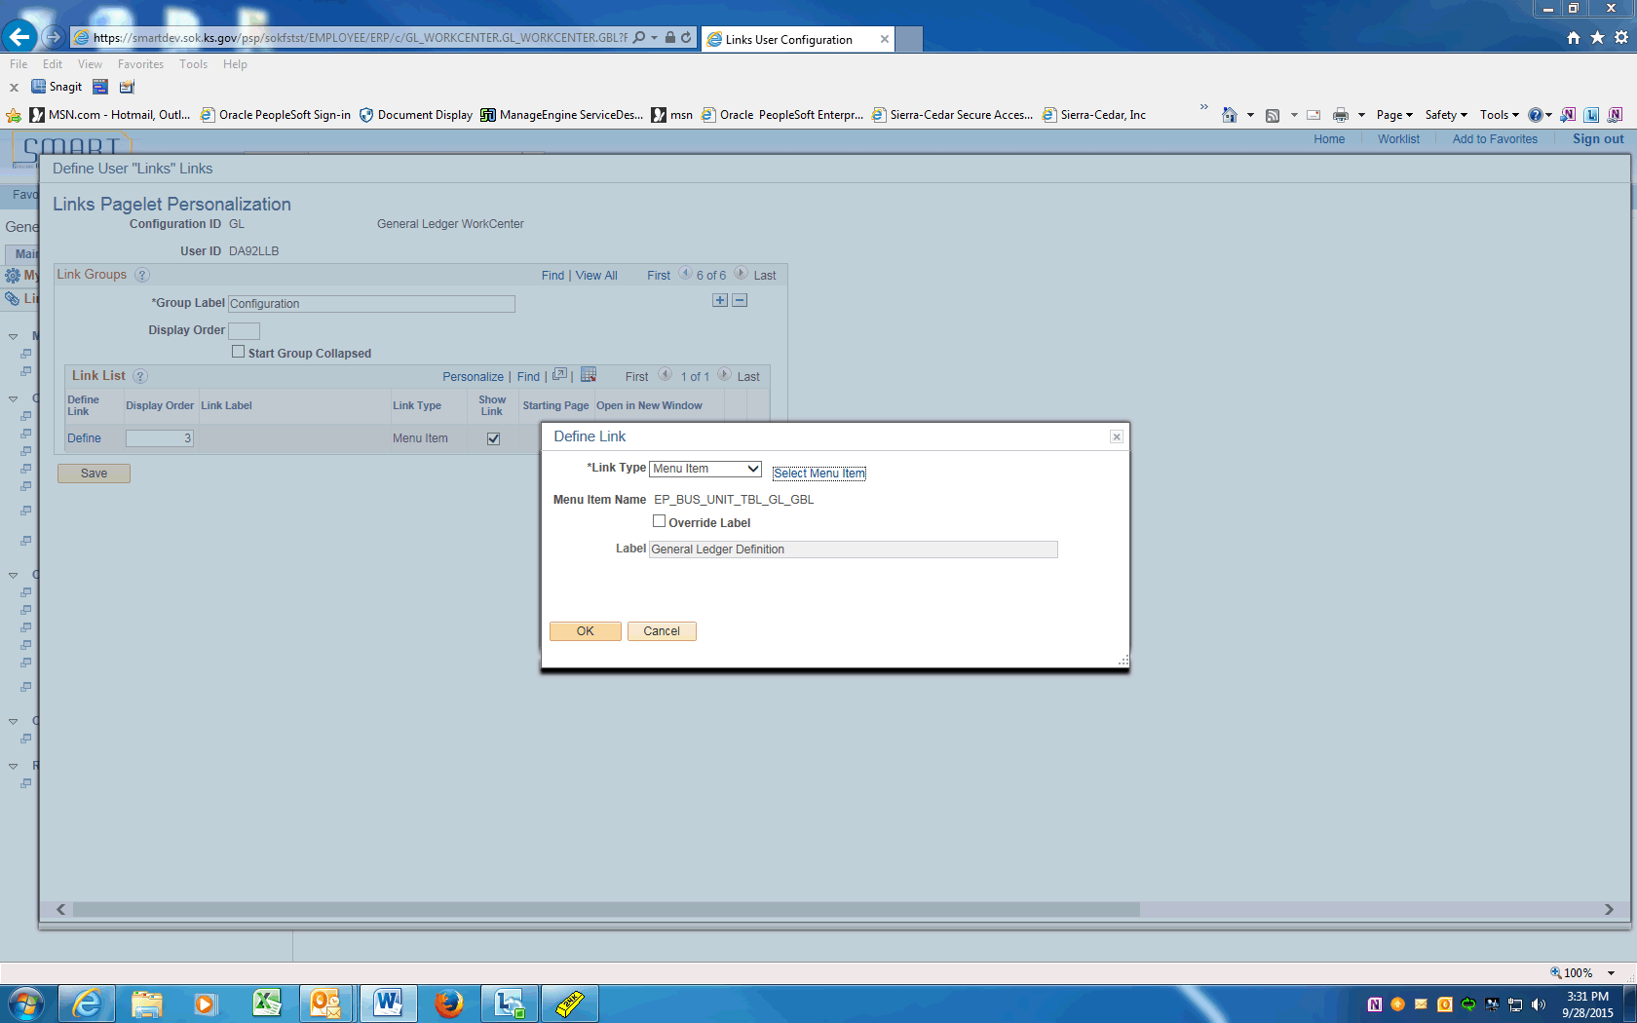

Step | Action
 | Click the OK button.
 | Notice that the General Ledger Definition link label appears. You could change the label if you wanted to override this label. Just click the Define link , select to override the label and supply a more meaningful label if needed.
Next, you will add another Group Label for research and external links.

Click the Add a new row button.

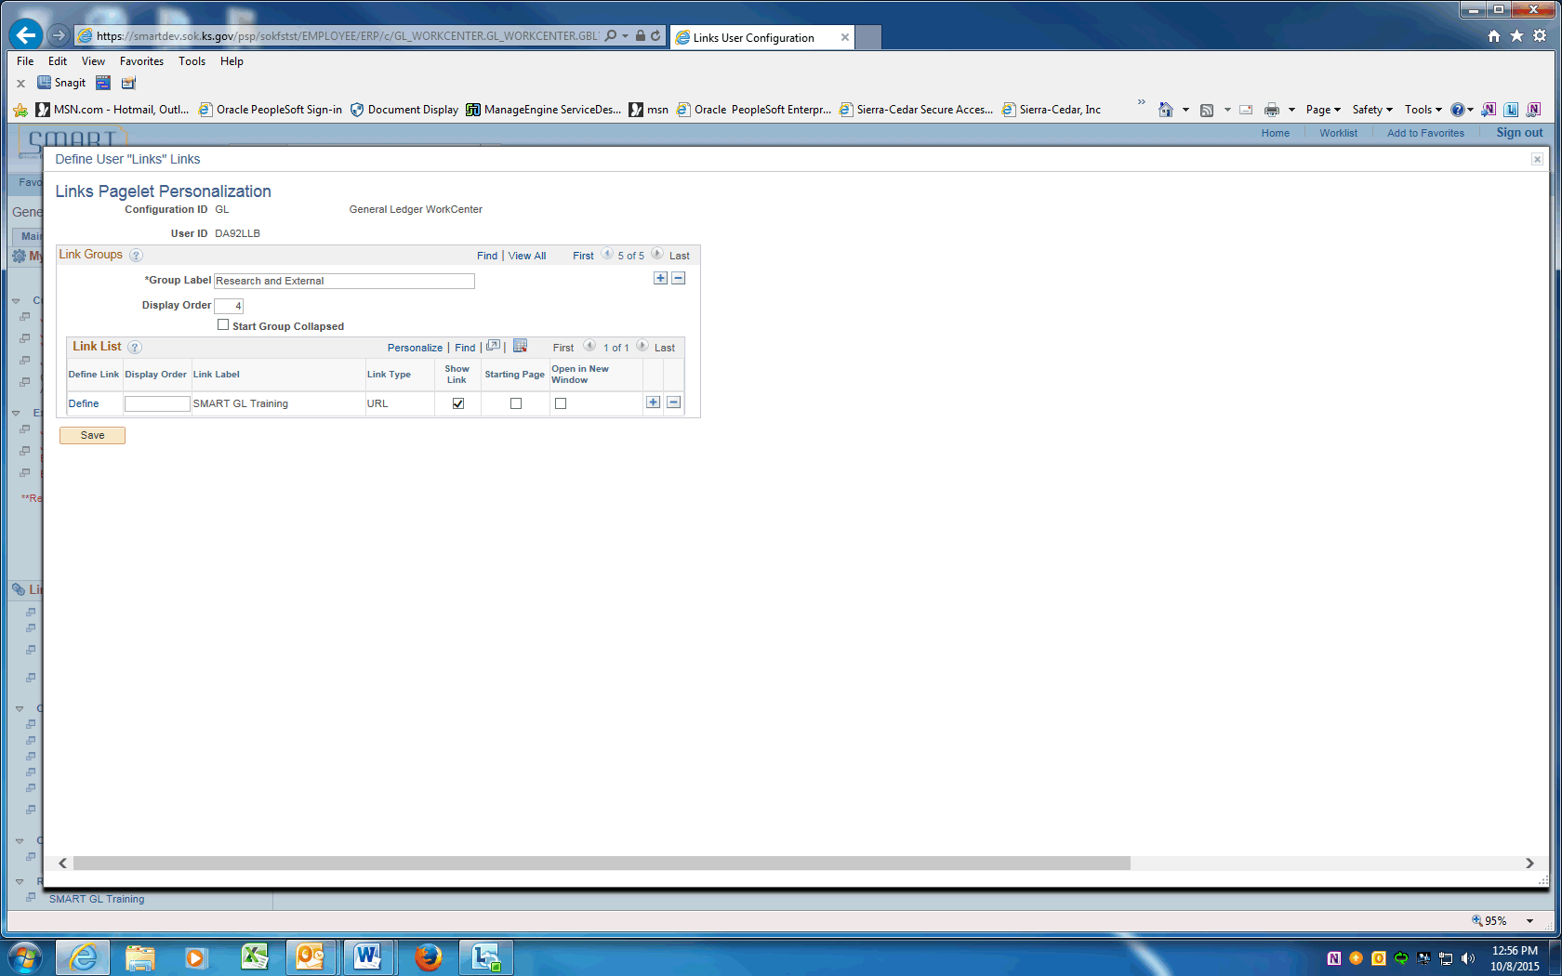

Step | Action
 | Enter the desired information into the Group Label field. Enter "Research and External".
 | Click in the Display Order field.

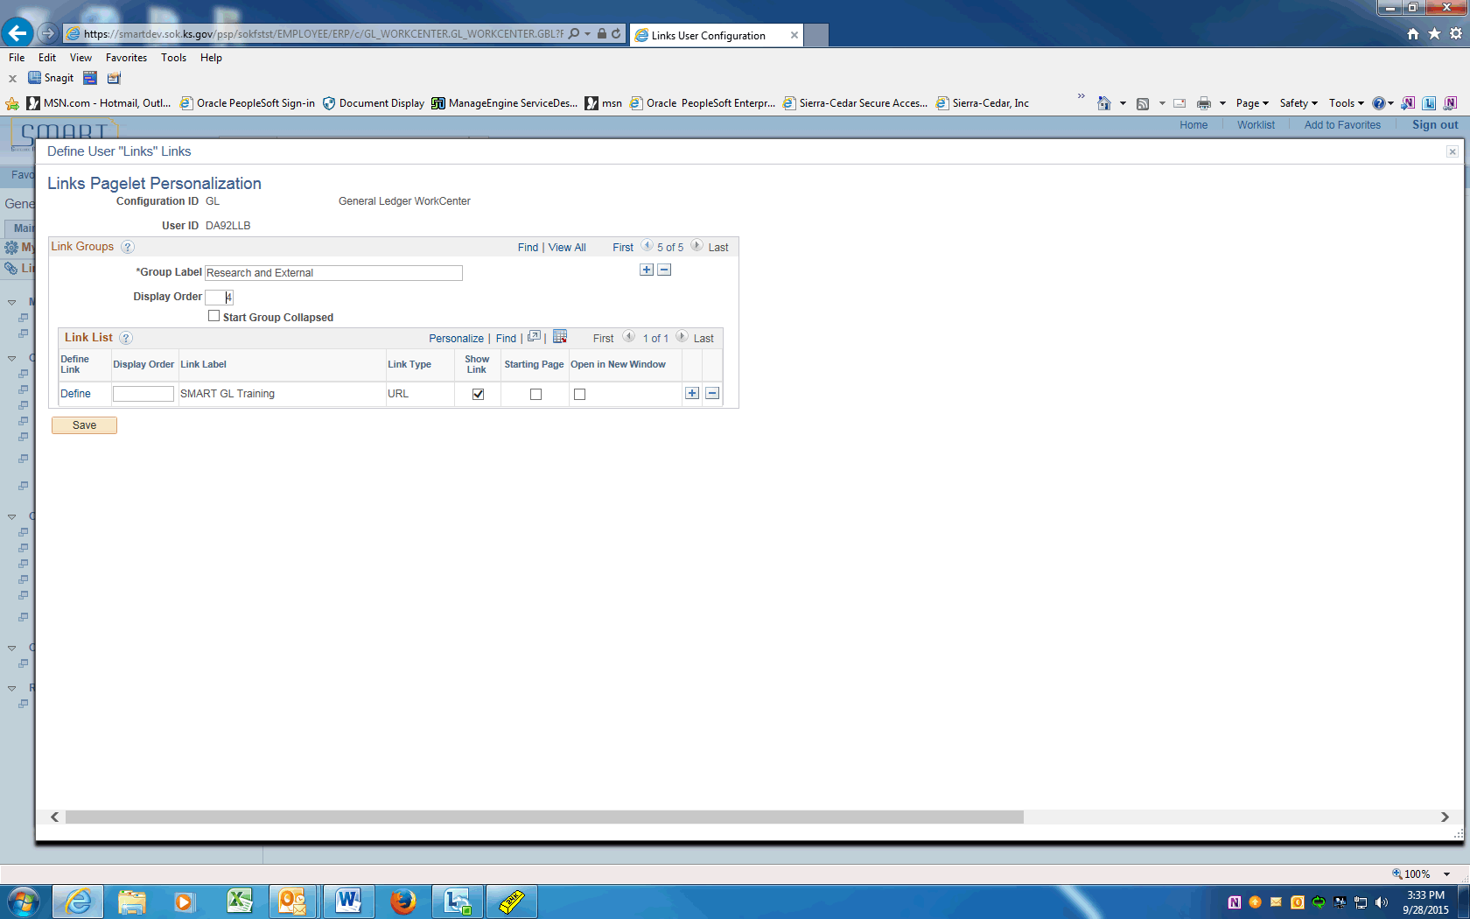

Step | Action
 | Enter the desired information into the Display Order field. Enter "4".

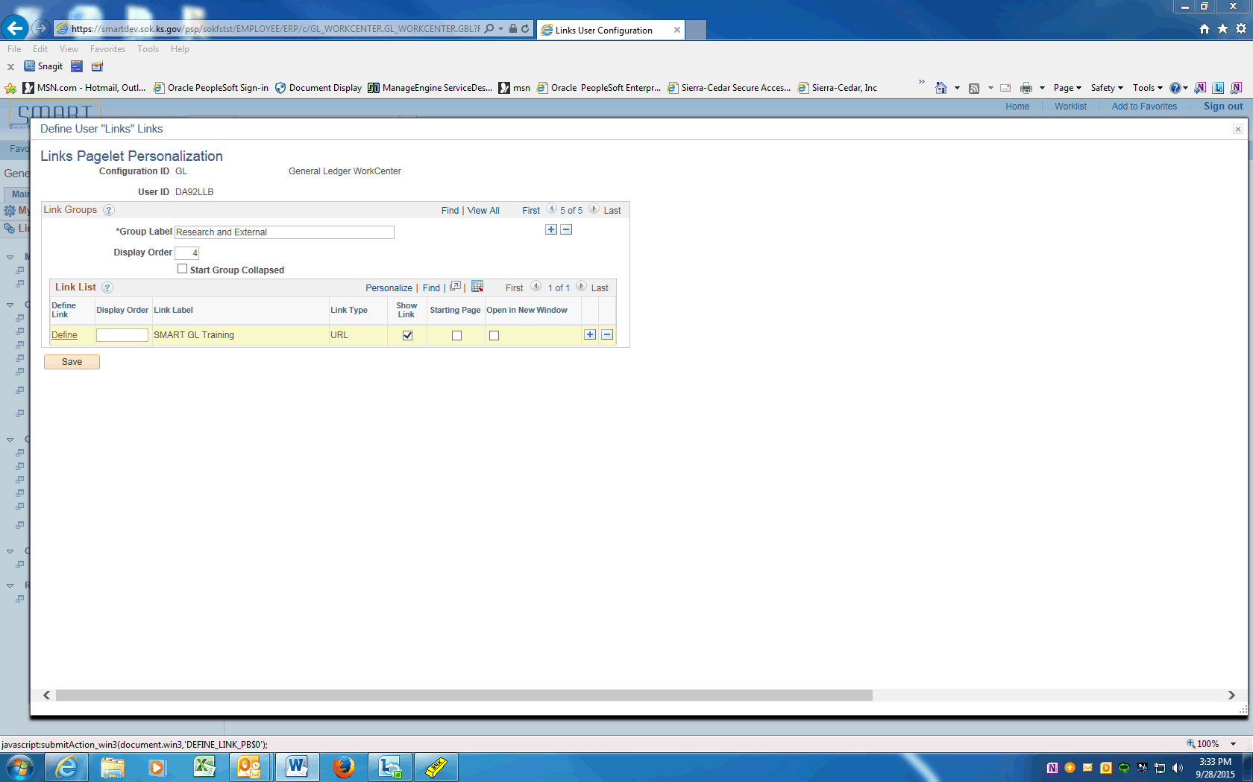

Step | Action
 | Click the Define link.

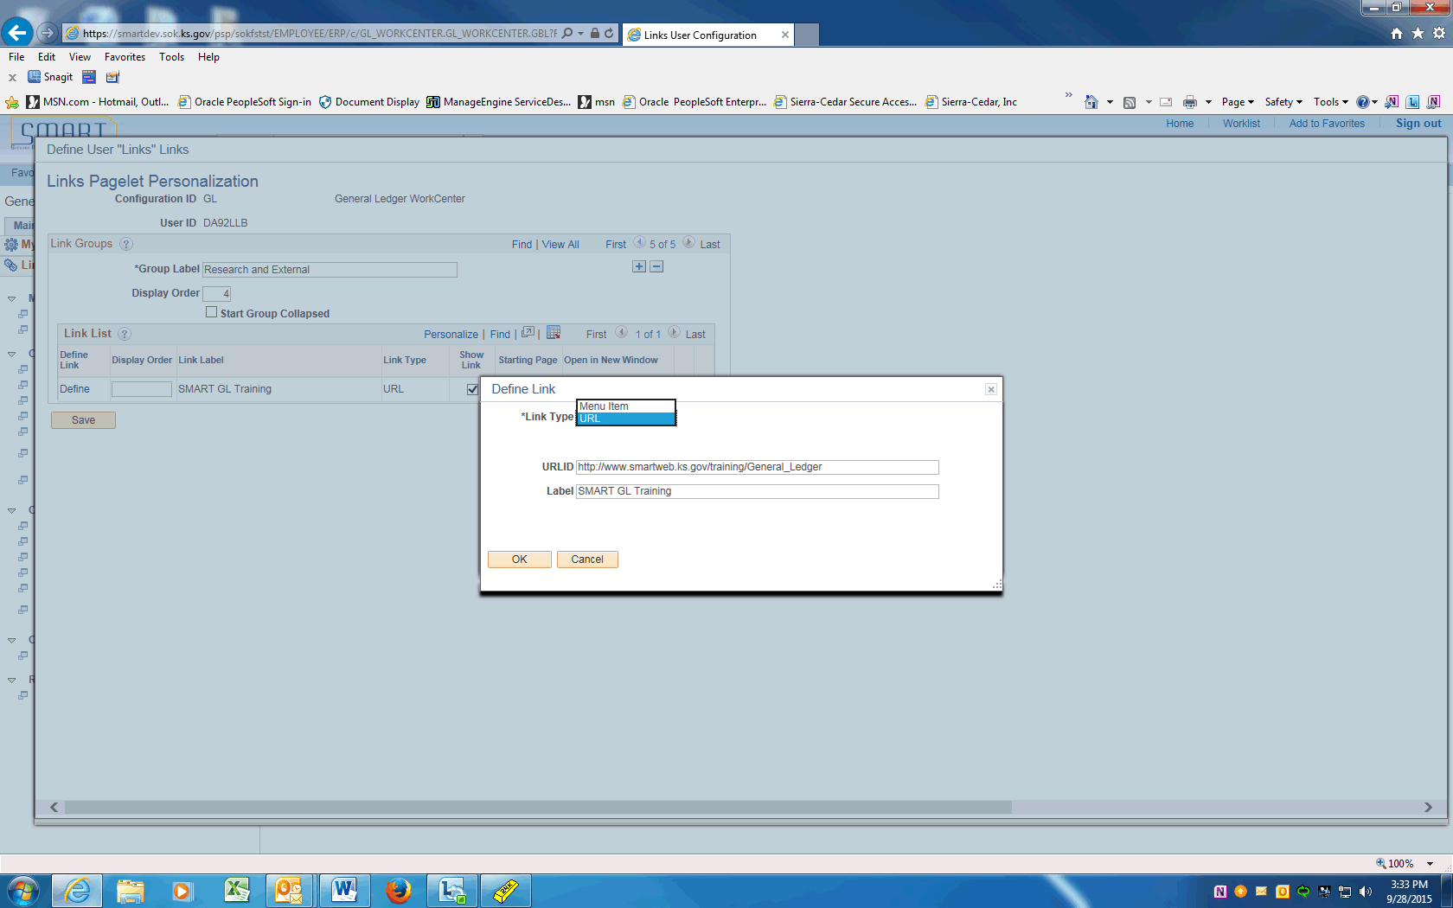

Step | Action
The link type is going to be a URL.

Click the Link Type list.
Click in the URLID field. Enter or copy/paste the desired URL.
Click in the Label field.

Enter the desired information into the Label field. Enter SMART GL Training
 | Click the OK button.
 | Click the Save button.
 | Click the Close link to return to the General Ledger WorkCenter pagelet.
Click the Reload the Links link.

Once you have reloaded the Links pagelet, your new Groups appear in the Links pagelet.

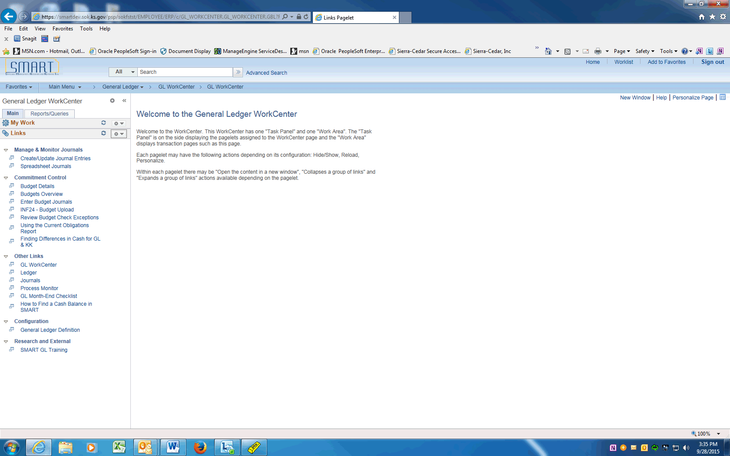

Step | Action
Your Links pagelet becomes a powerful collection of your most commonly-accessed links, saving you a great deal of navigation and processing time.

Click the General Ledger Definition link.

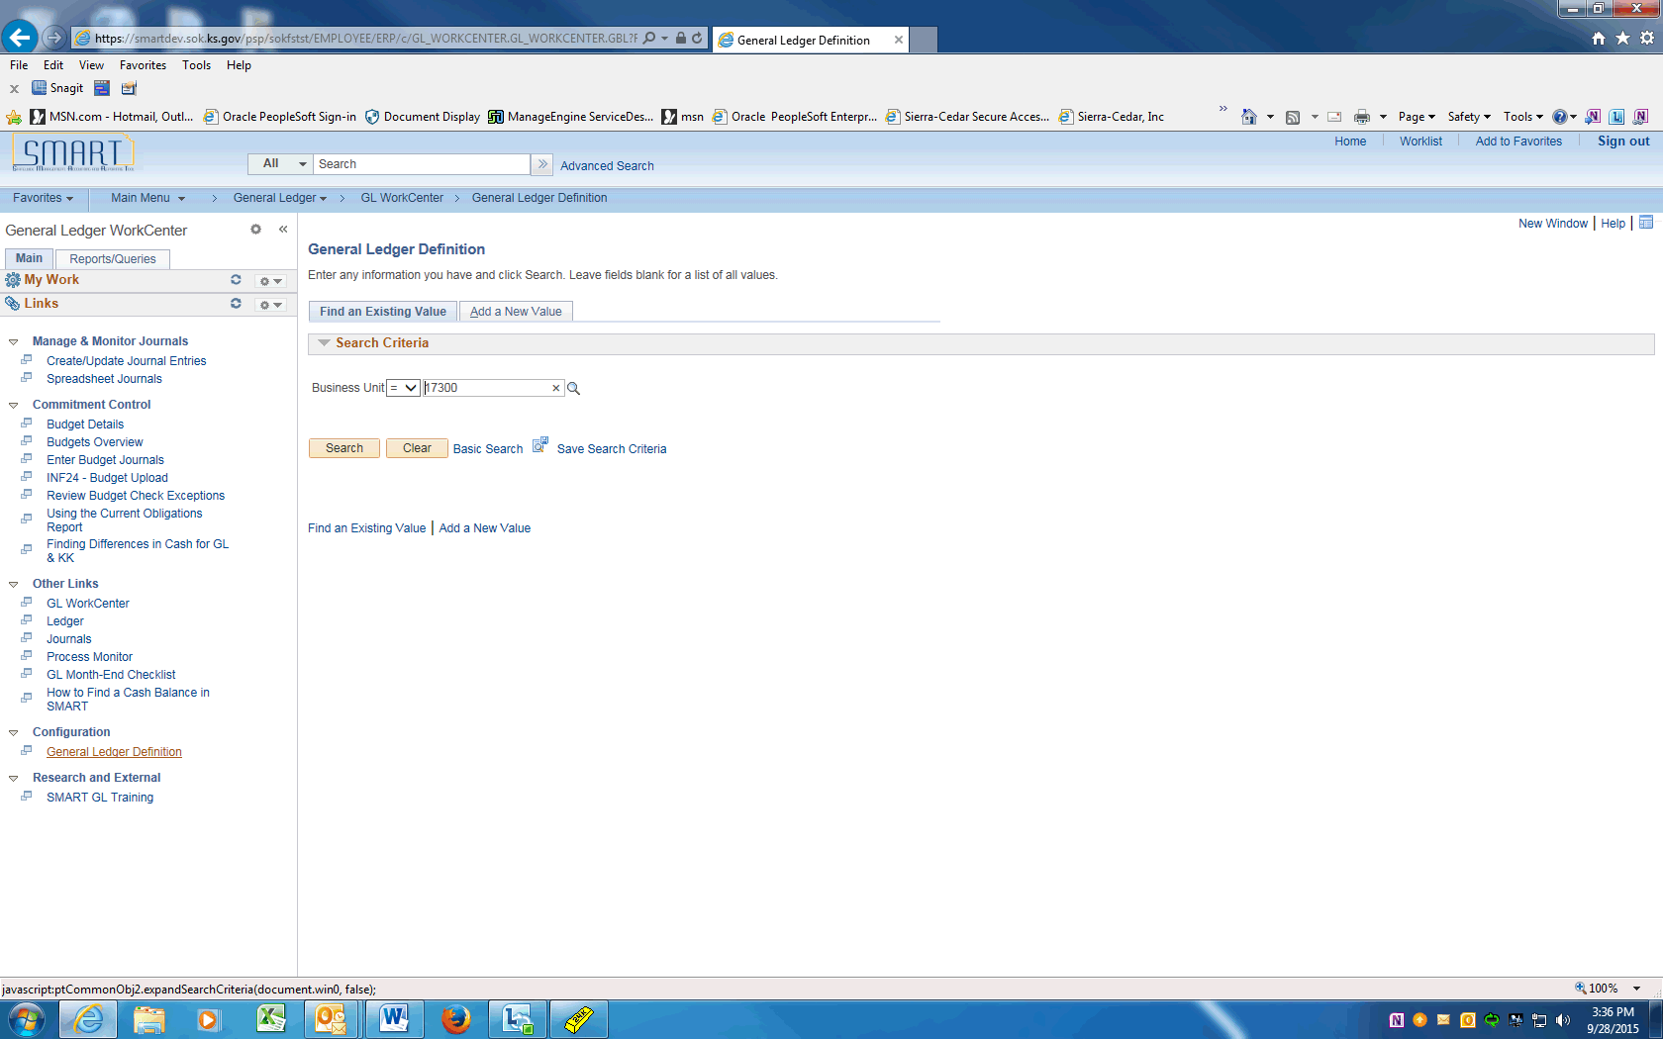

Step | Action
 | The system takes you directly to the General Ledger Definition page where you can view your business unit set-up from the WorkCenter.
Click in the Business Unit field.

Enter the desired information into the Business Unit field. Enter "17300".

Click the Search button.
 | Notice that you have full functionality from your WorkCenter page to access other pages, reports, inquiries and so on.
You have successfully personalized the Links pagelet.

End of Procedure.

Workcenter - Reports/Processes pagelet
The Reports and Processes pagelet within the WorkCenter includes links to reports and processes that you commonly use. The links take you to the run control page for reports, processes, and the Reporting Console. The system administrator can enable users to configure this pagelet to their own specifications.
In this topic, we explore some of the functionality within the Reports and Processes pagelet of the WorkCenter.
Procedure

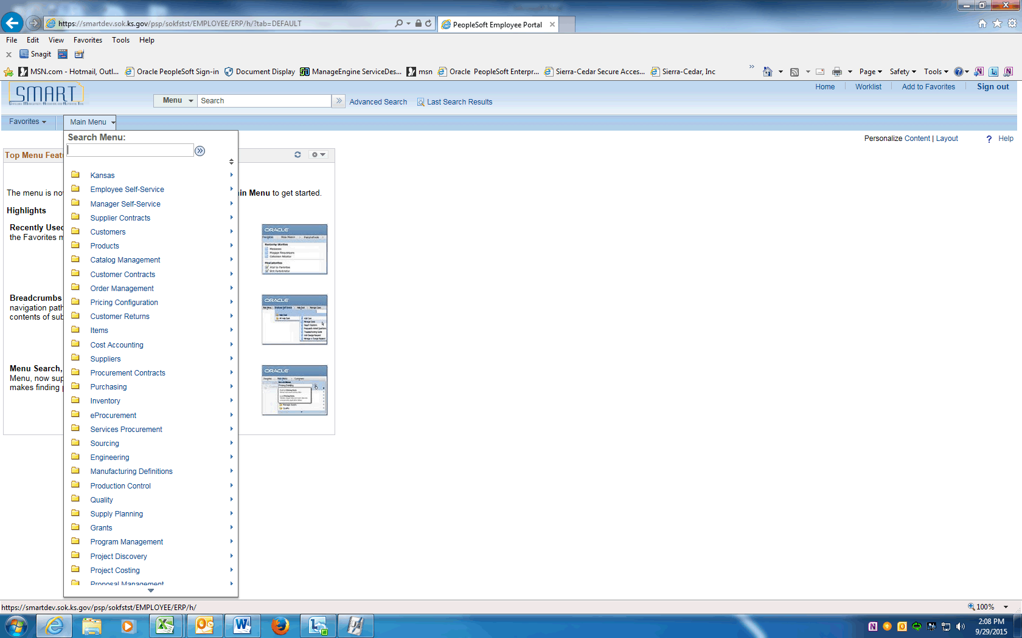

Step | Action
Begin by navigating to the General Ledger WorkCenter.

Point to the Scroll Down button.
 | Click the General Ledger menu.
 | Click the GL WorkCenter menu.

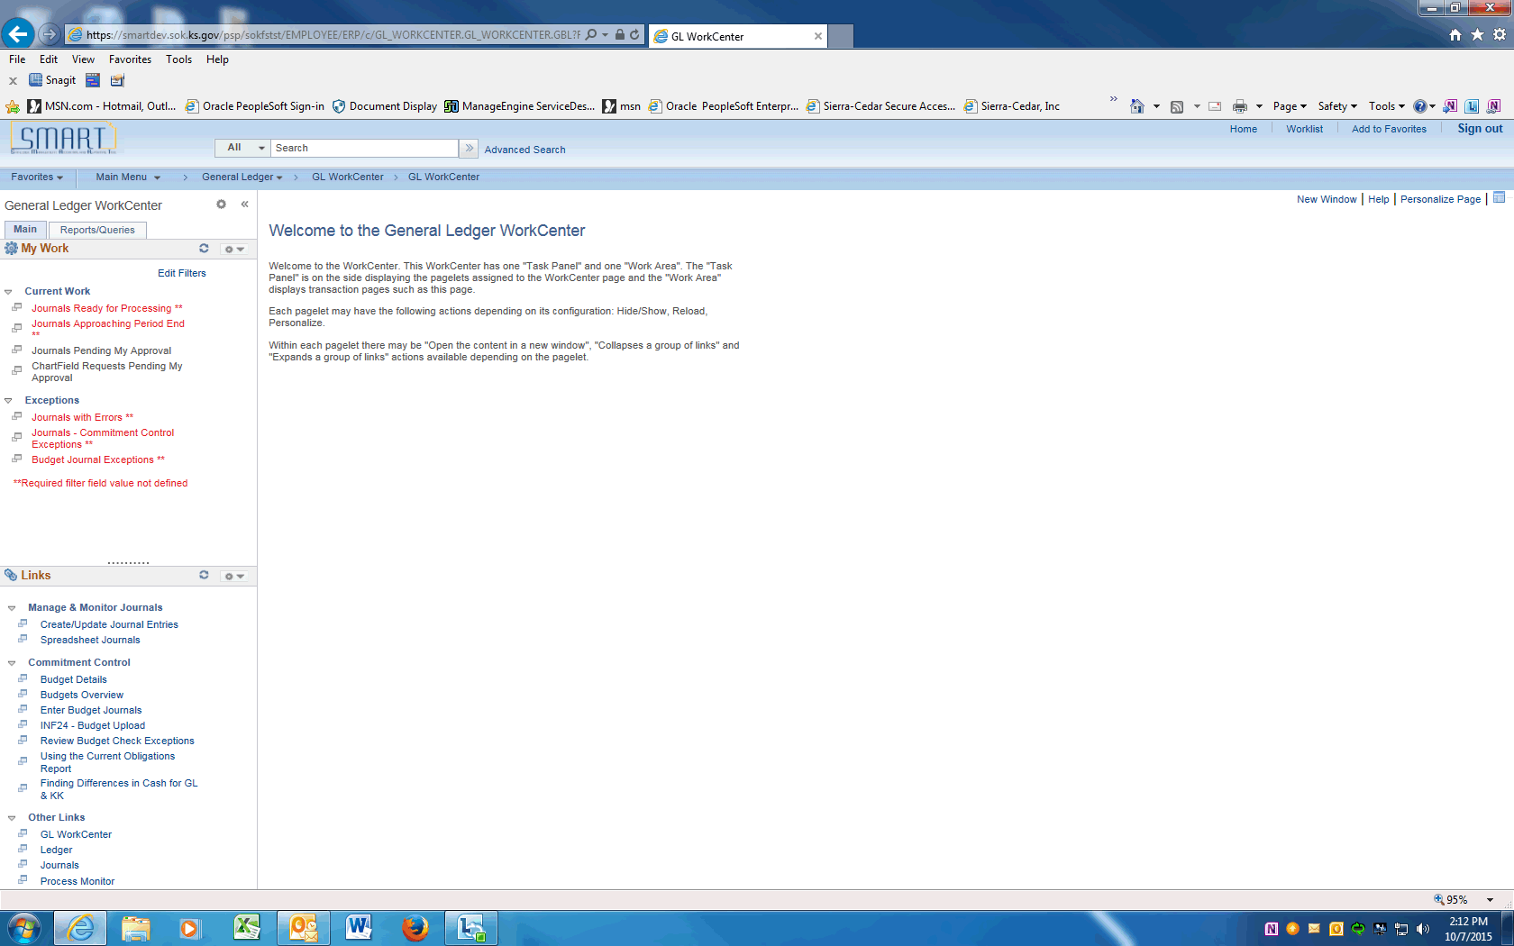

Step | Action
 | Use the General Ledger WorkCenter page to access work items, links, queries, reports, and processes that are specific to your position.
If you run reports and processes often, you will want to personalize the Reports/Processes pagelet of the General Ledger WorkCenter.
Click the Reports/Queries tab.
Minimize the Queries pagelet.

Click the Queries Pagelet Settings button.
 | Click the Minimize menu.

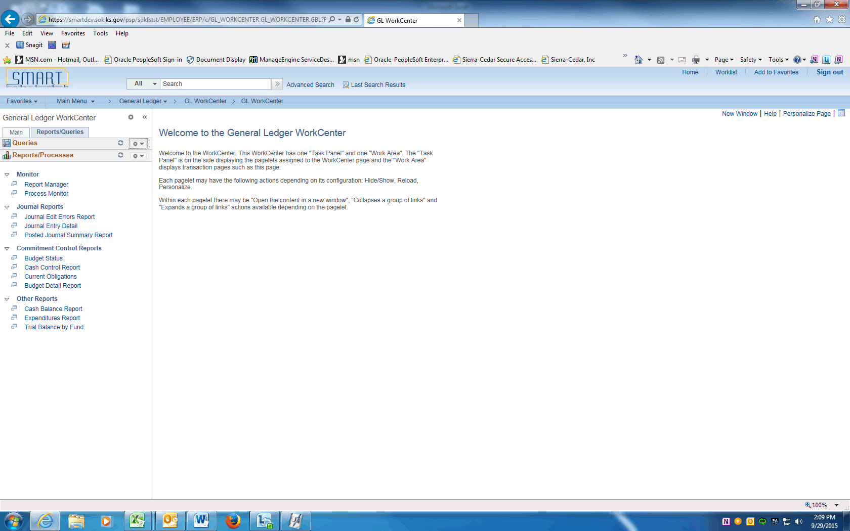

Step | Action
Access the personalization page for Reports and Processes.

Click the Pagelet Settings button.

 | Click the Personalize link.
Use the Reports/Processes Pagelet Personalization page to structure your Reports/ Processes pagelet to meet your needs.

Your system administrator has created a few group labels for you. You would like to add one more for Personal Reports and Processes.
 | Click the Last link.
 | Click the Add a new row (+) button.

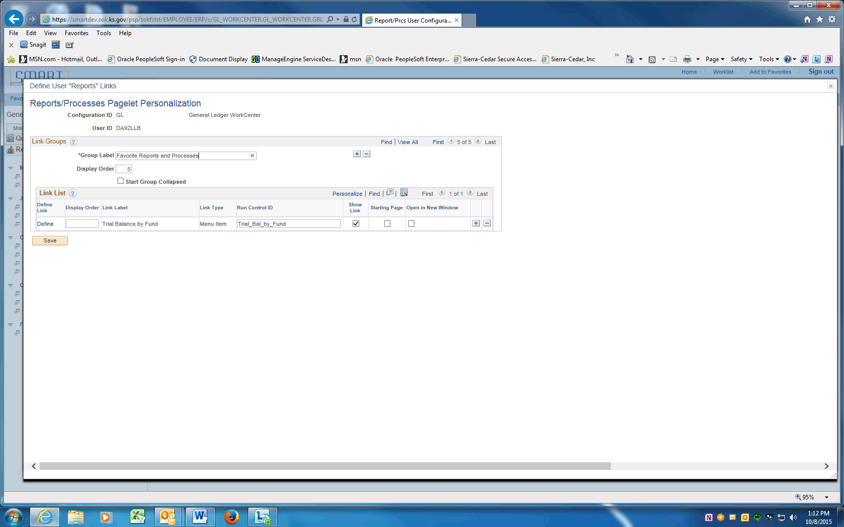

Step | Action
 | Enter the desired information into the Group Label field. Enter "Favorite Reports and Processes".

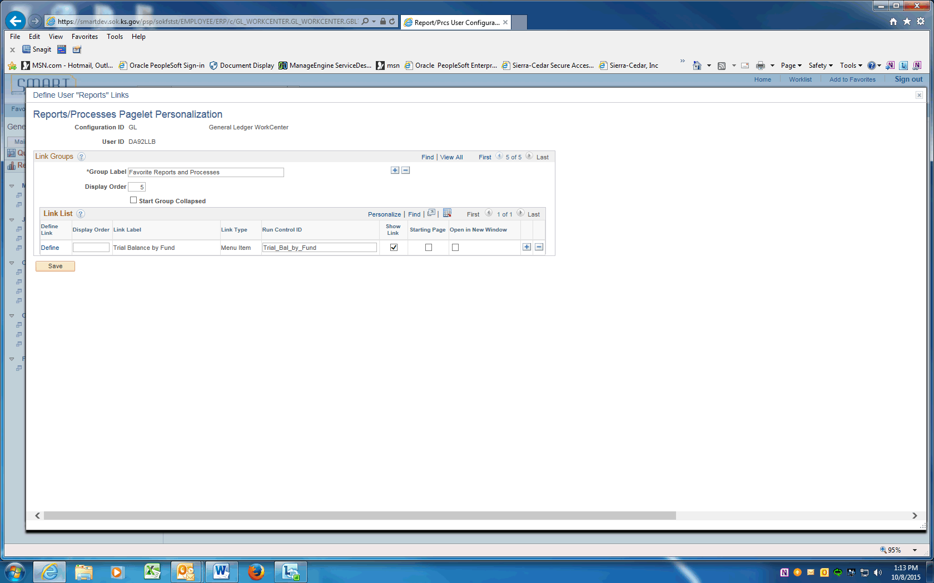

Step | Action
Click in the Display Order field.
Enter the desired information into the field. Enter "5".

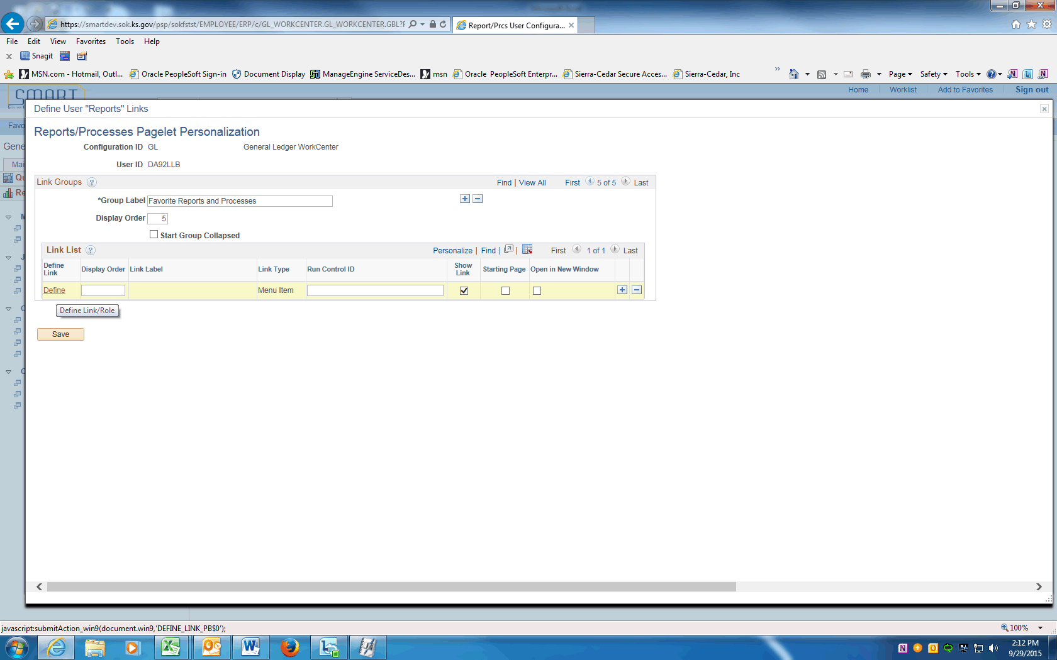

Step | Action
Click the Define link.

Use the Define Link page to determine the type of link and link information for the pagelet.
 | Click the Link Type list.

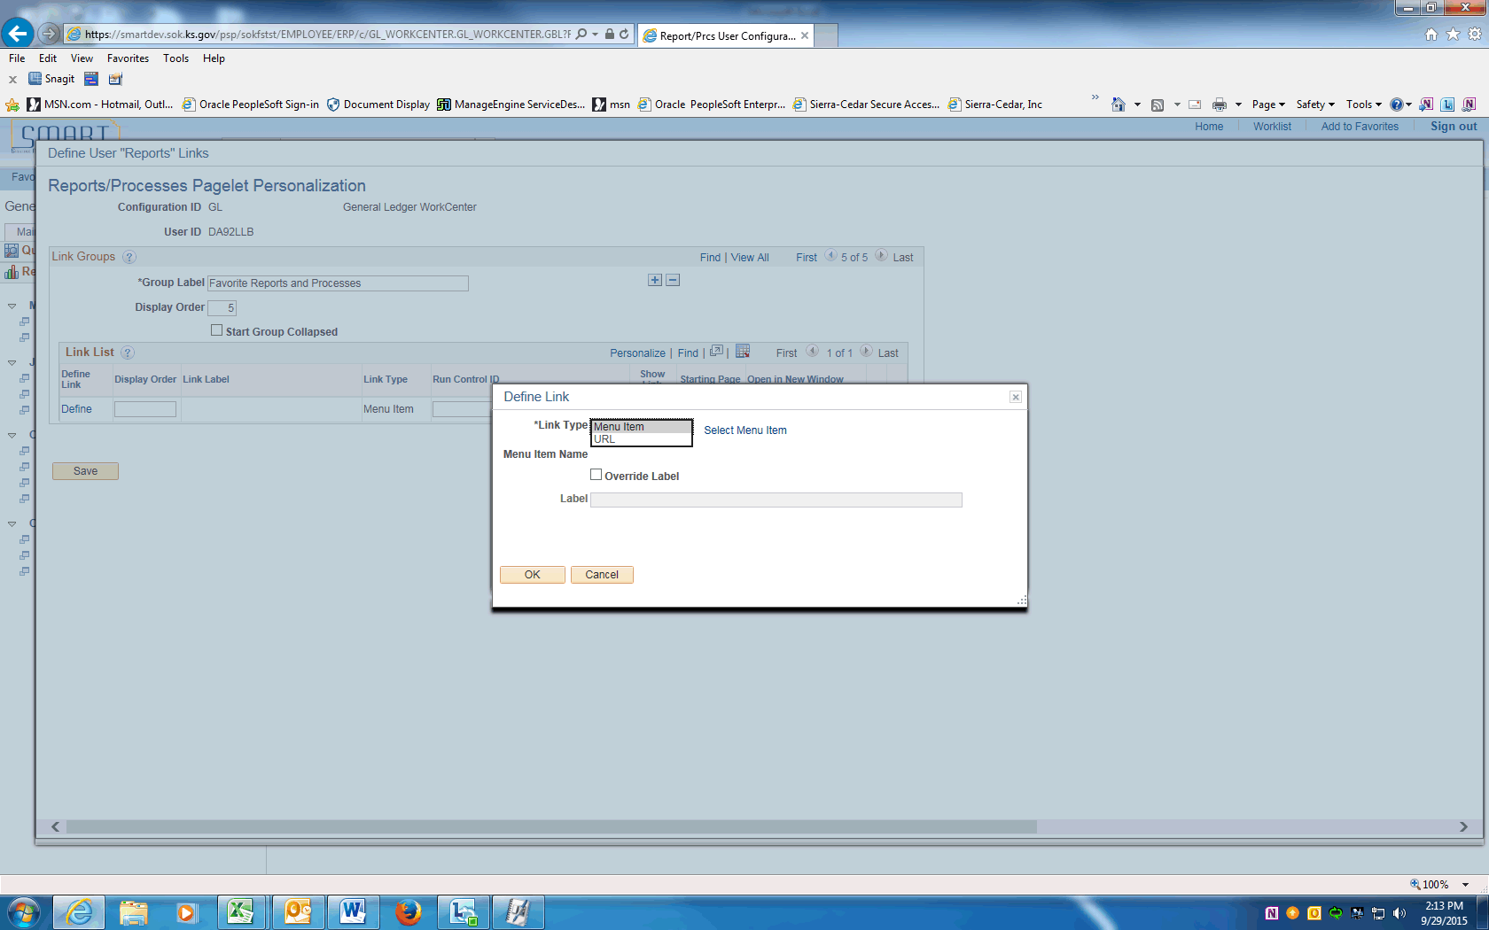

Step | Action
The Link Type can be Menu Item or URL.

Click Menu Item.
 | Click the Select Menu Item link.

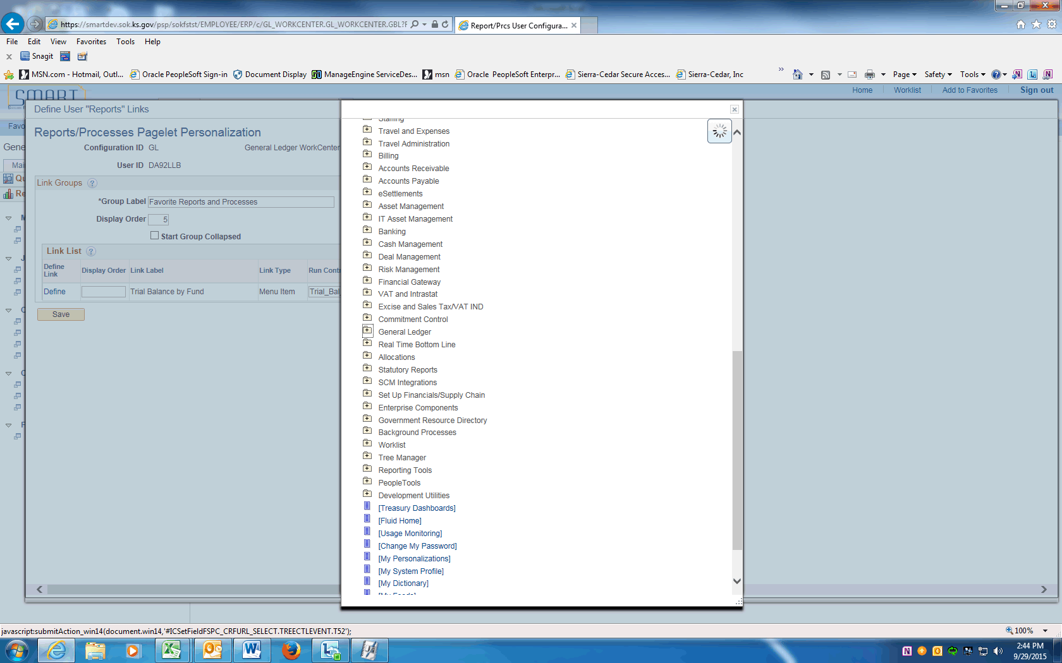

Step | Action
 | Scroll down and click the General Ledger button.
 | Click the General Reports menu.

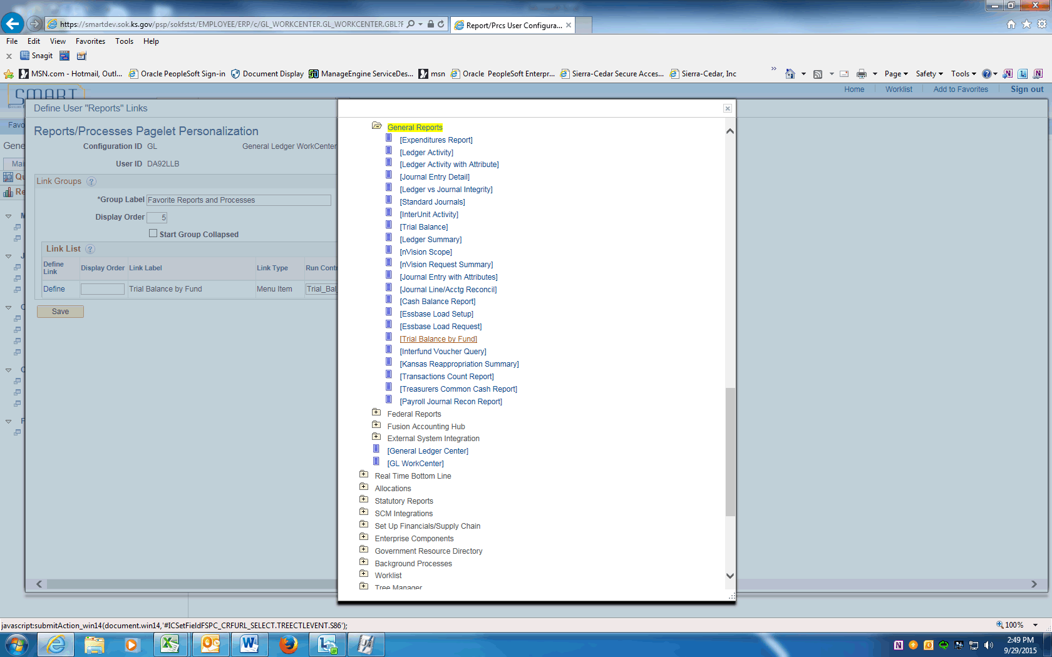

Step | Action
 | Click the [Trial Balance by Fund] tree item.

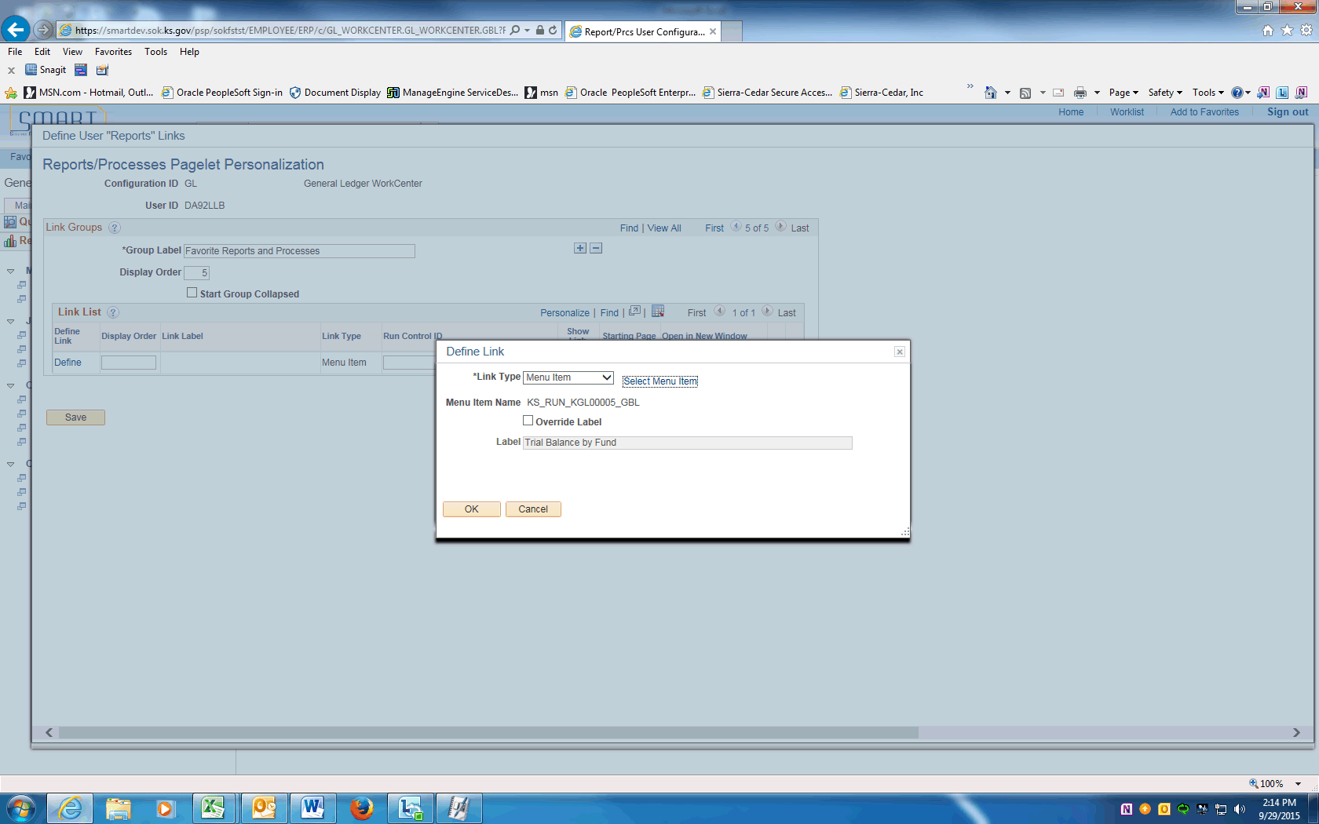

Step | Action
 | Click the OK button.
 | Click the Save button.

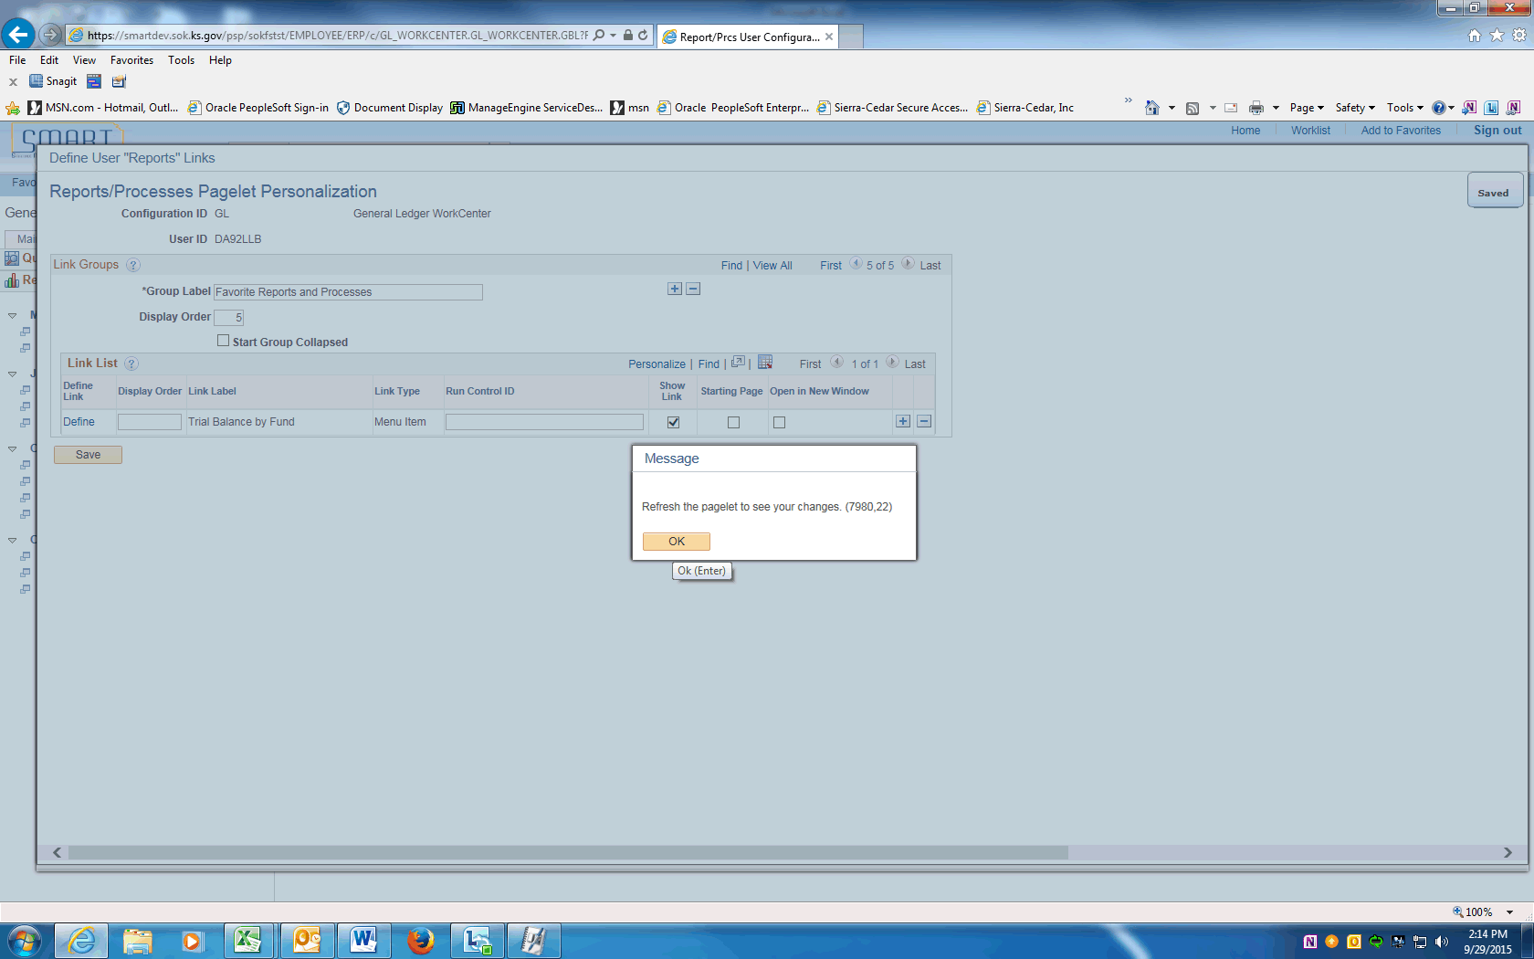

Step | Action
A message will be displayed reminding you to refresh the pagelet to see your changes.

Click the OK button.
 | Click the Close link.
Click to Reload the Reports/Processes link.

The Favorite Reports and Processes group label appears with the link that you added.

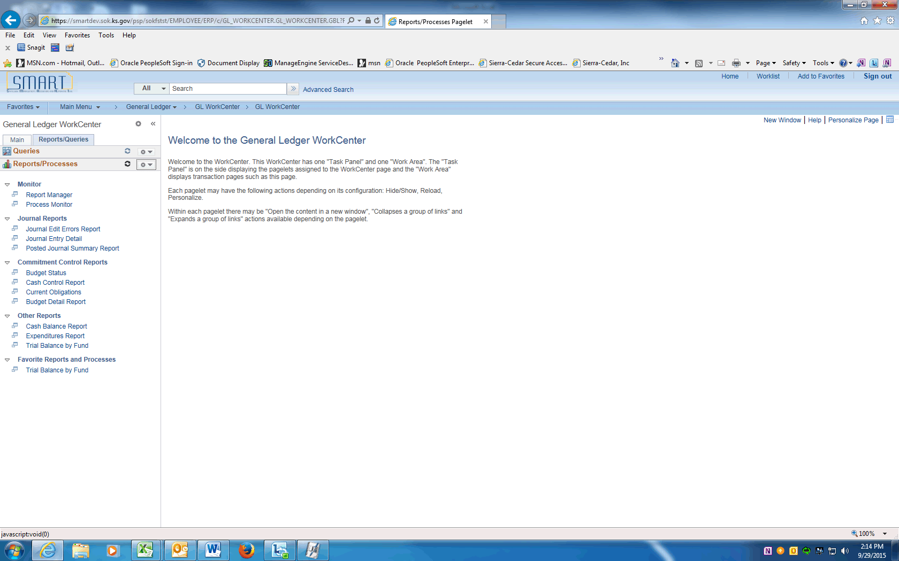

Step | Action
 | Click the Trial Balance by Fund link.

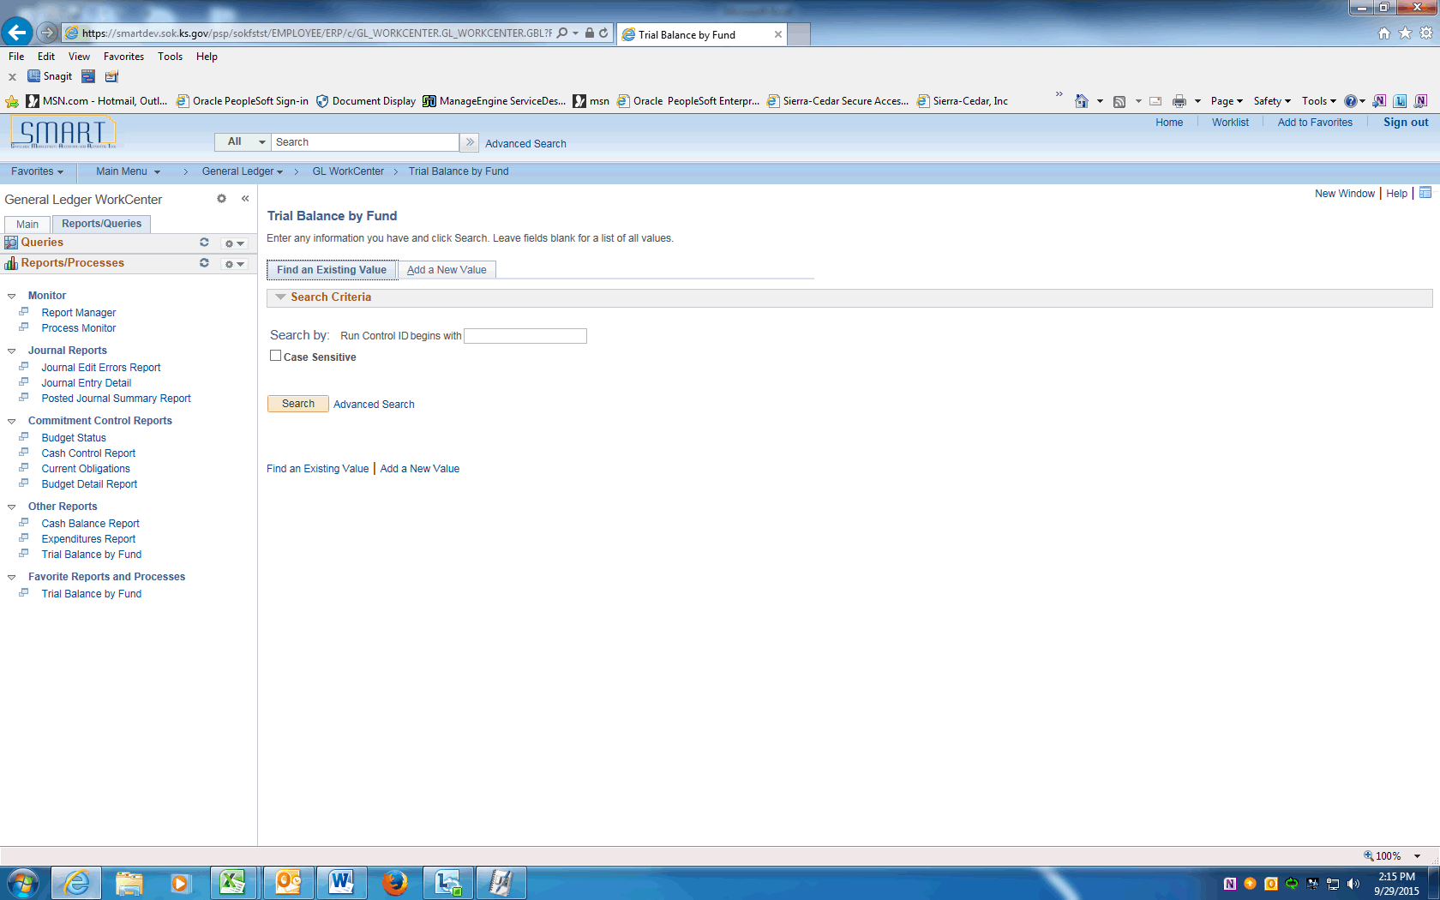

Step | Action
 | The system automatically takes you to the Trial Balance by Fund run control search page.

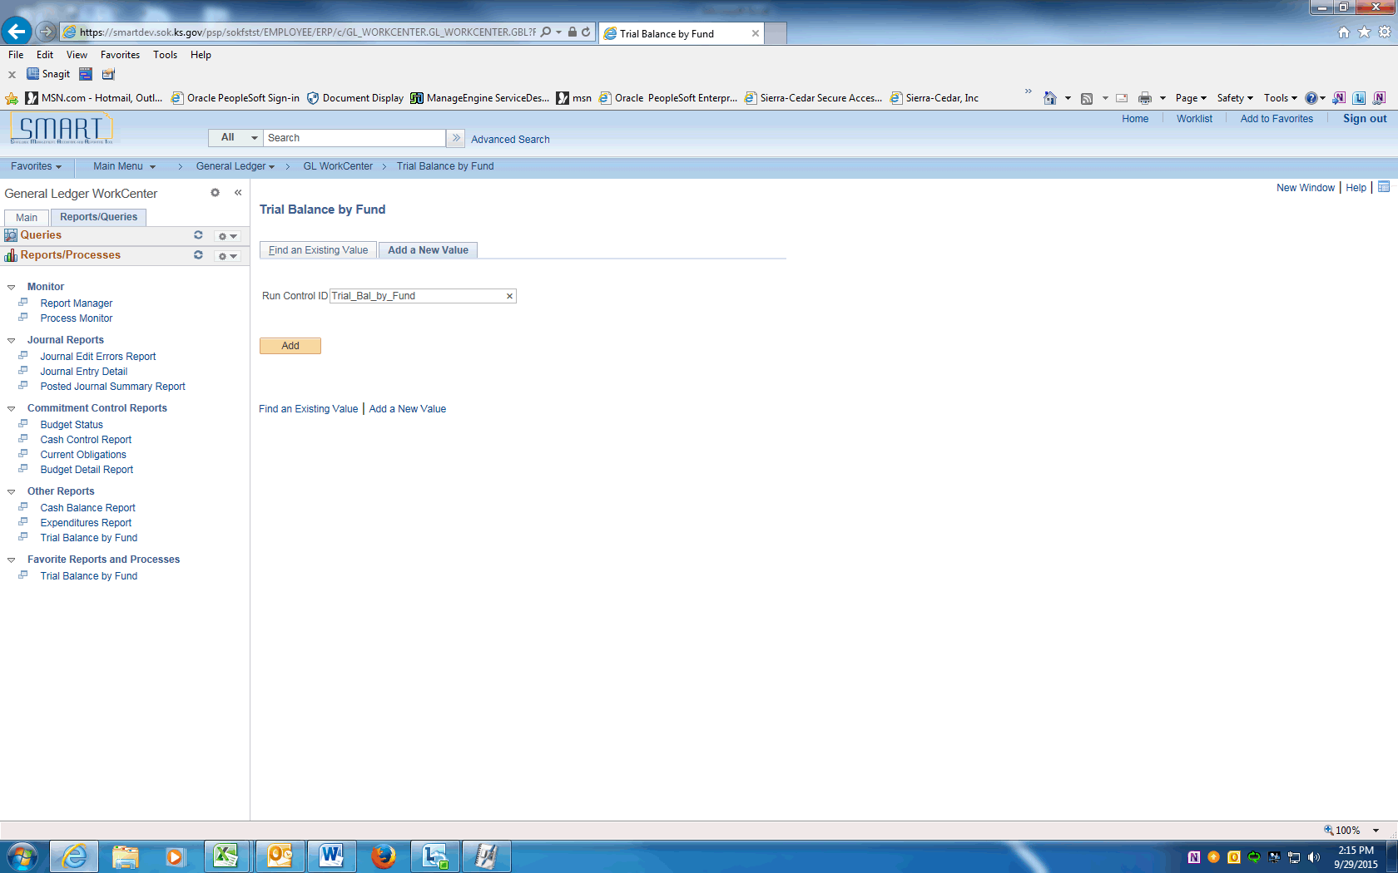

Step | Action
Click on Add a New Value and enter the desired information into the Run Control ID field. Enter "Trial_Bal_by_Fund".

Click Add.

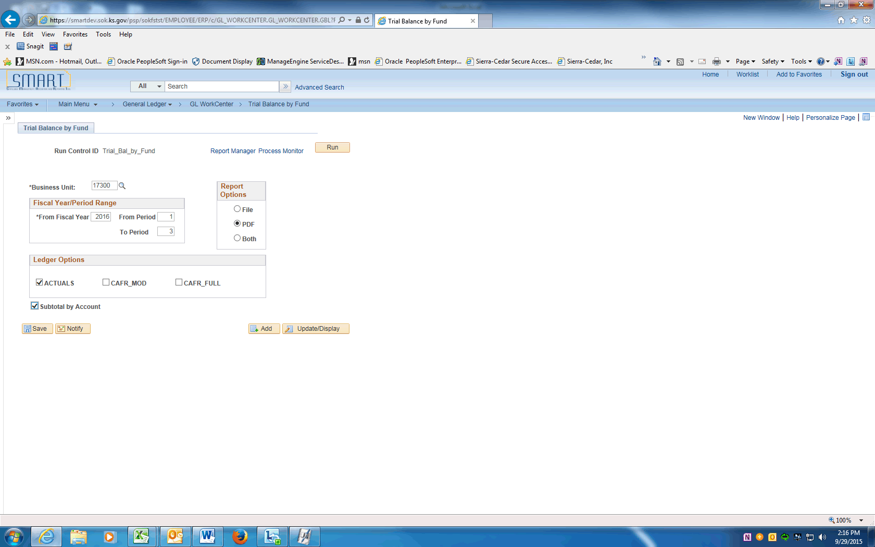

Step | Action
You can change any option on the run control page.

Click the Save button.
 | Click the Run button.

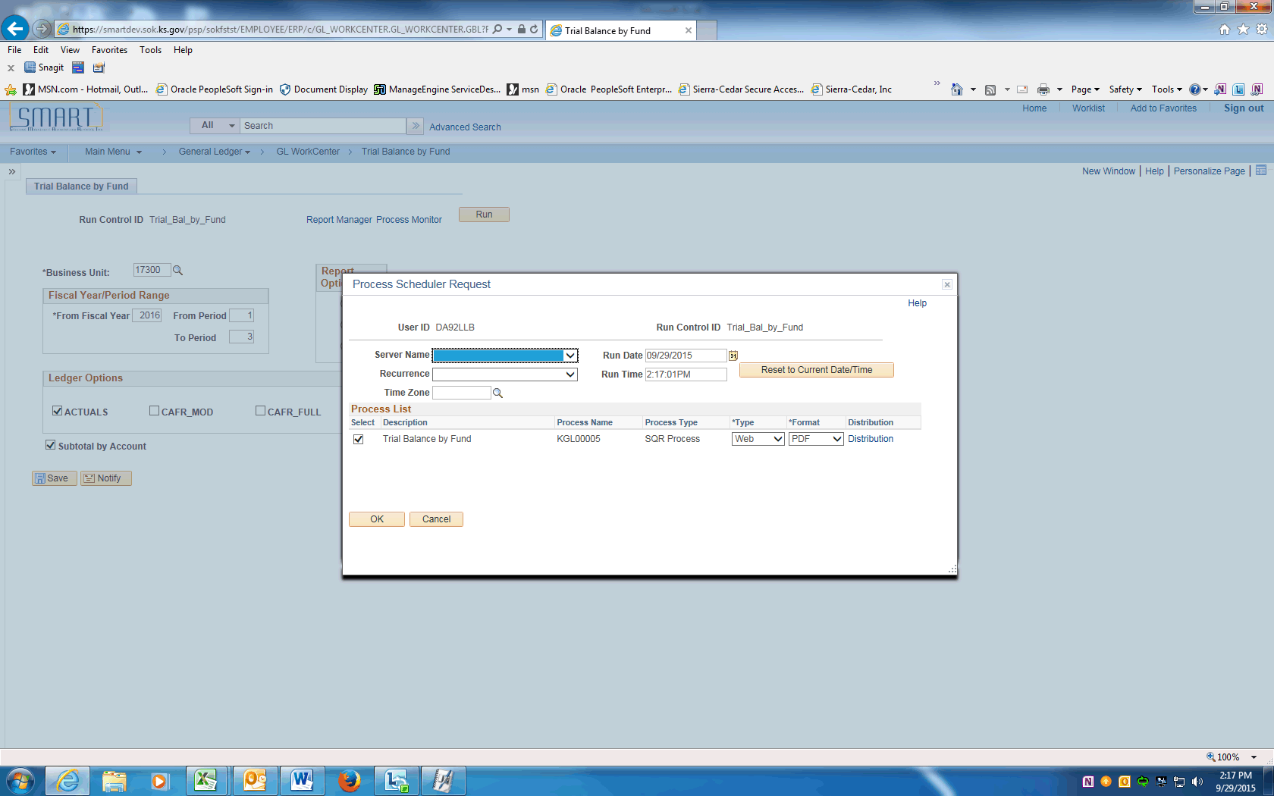

Step | Action
 | On the Process Scheduler Request page, click OK.

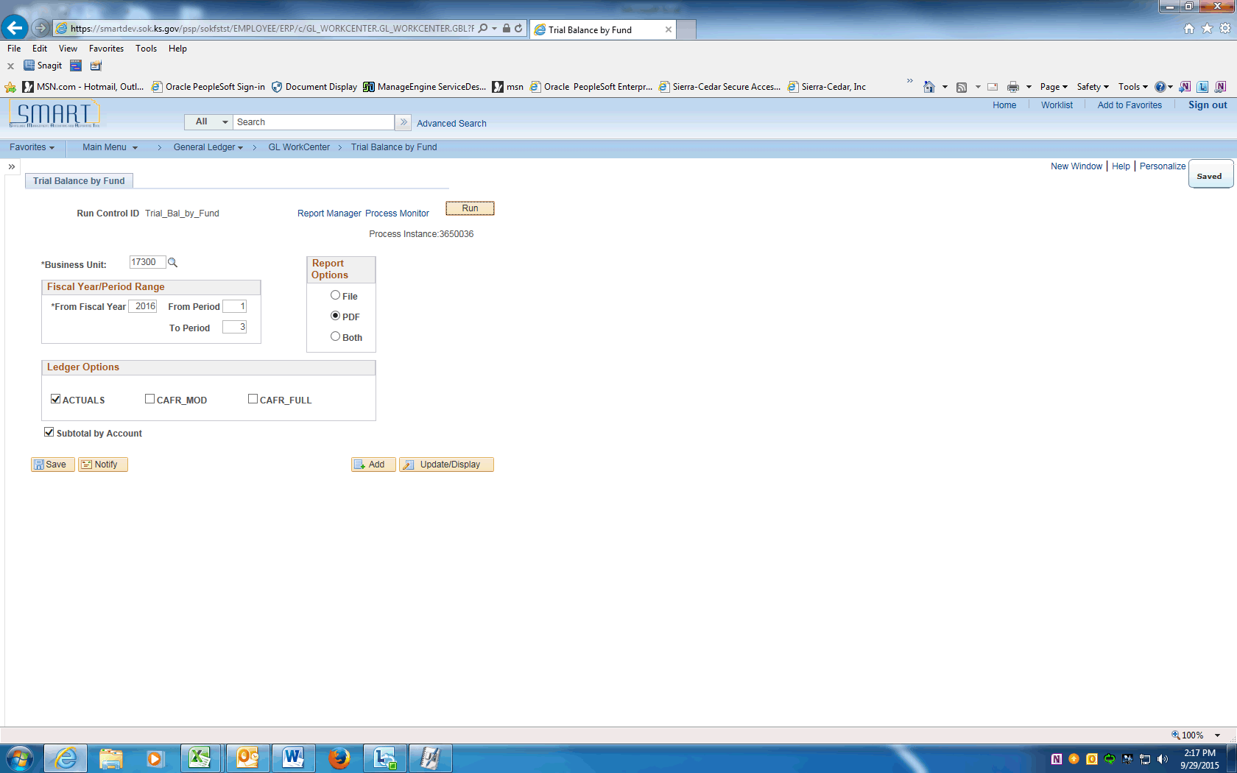

Step | Action
 | To check the status of the process, click on the Process Monitor link.
Refresh the page until the Run Status is Success and the Distribution Status is Posted.
Click the object.
 | Click on Go back to the Trial Balance by Fund link to return to the run control page.
 | Click on the Report Manager link.

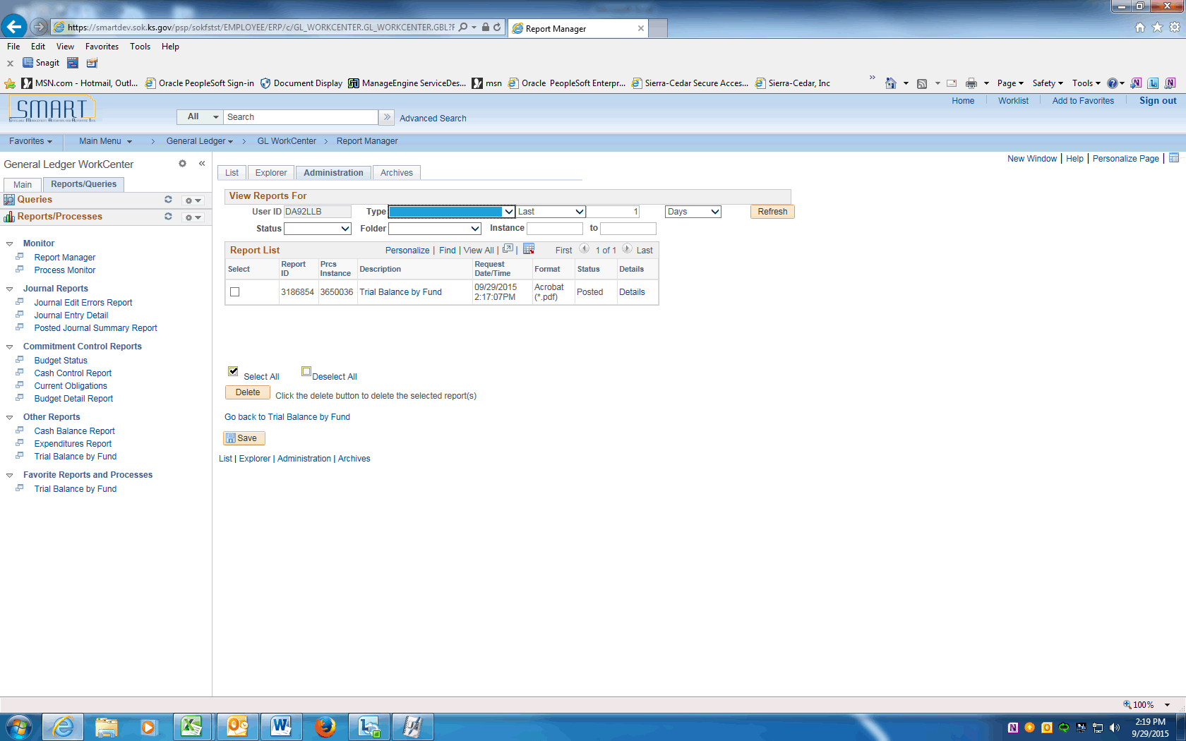

Step | Action
 | In the Report Manager, click the Administration tab.
 | Click the Trial Balance by Fund link to open the report.

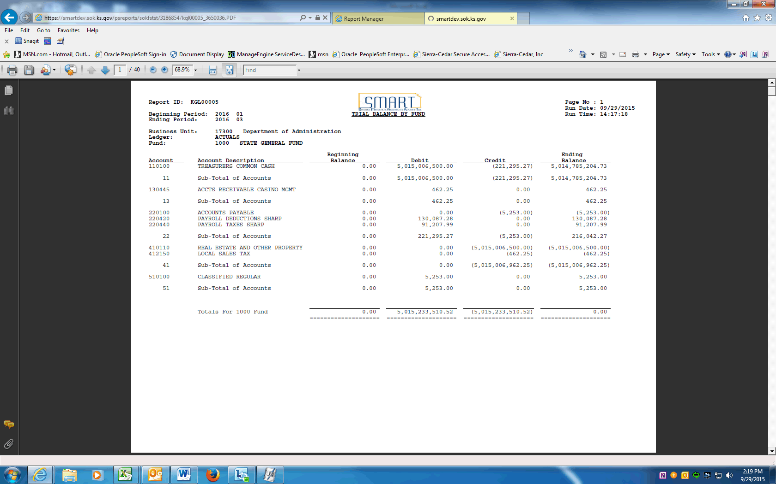

Step | Action
 | Review your report.

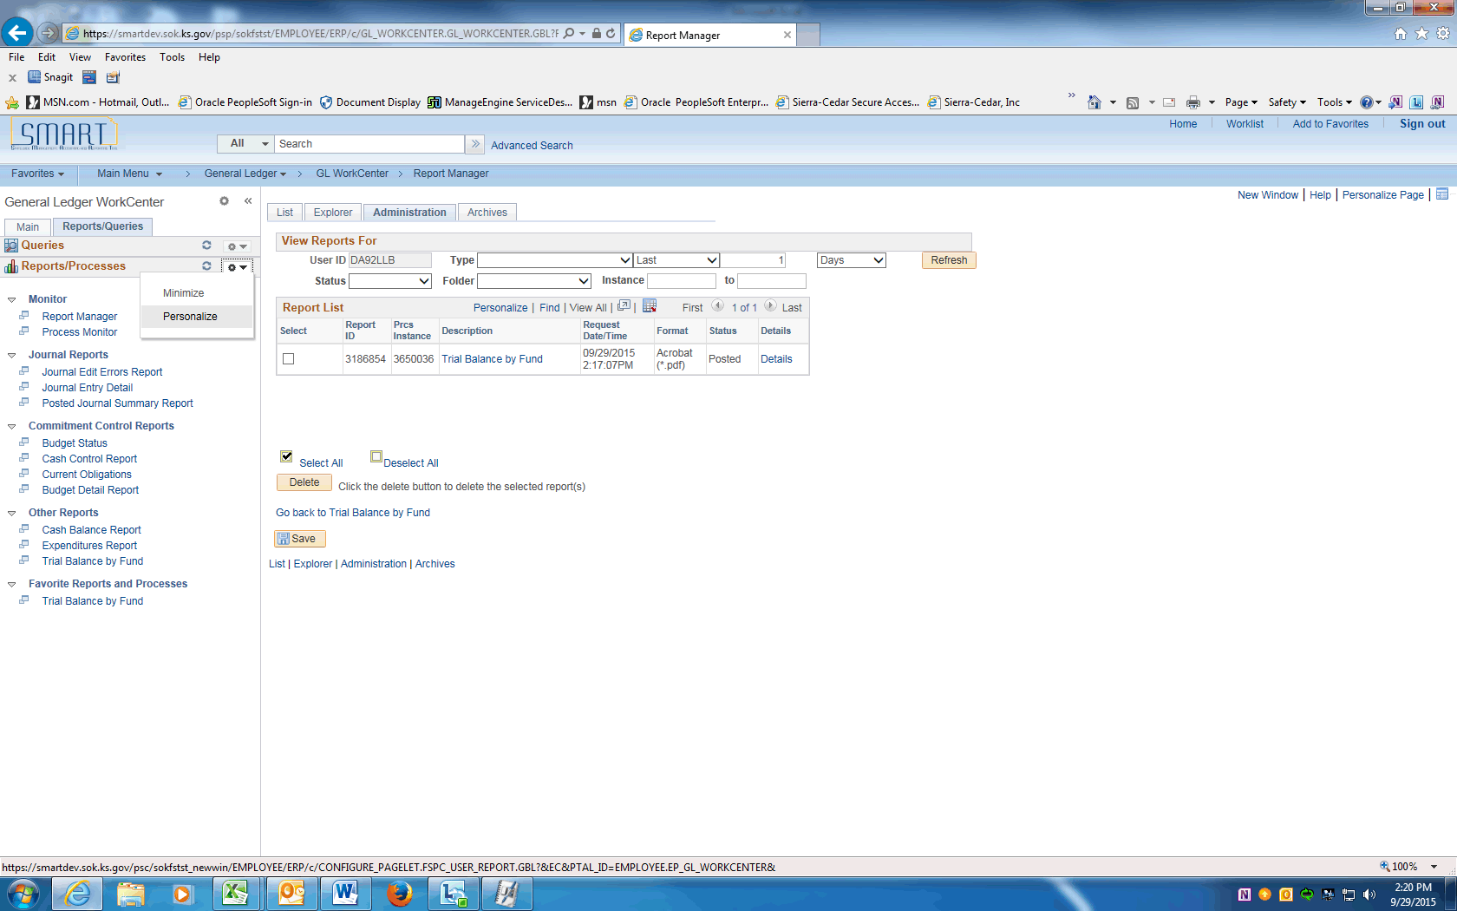

Step | Action
Now, you want the Trial Balance by Fund Report link to automatically select your run control ID.

Click the Pagelet Settings button and choose Personalize.

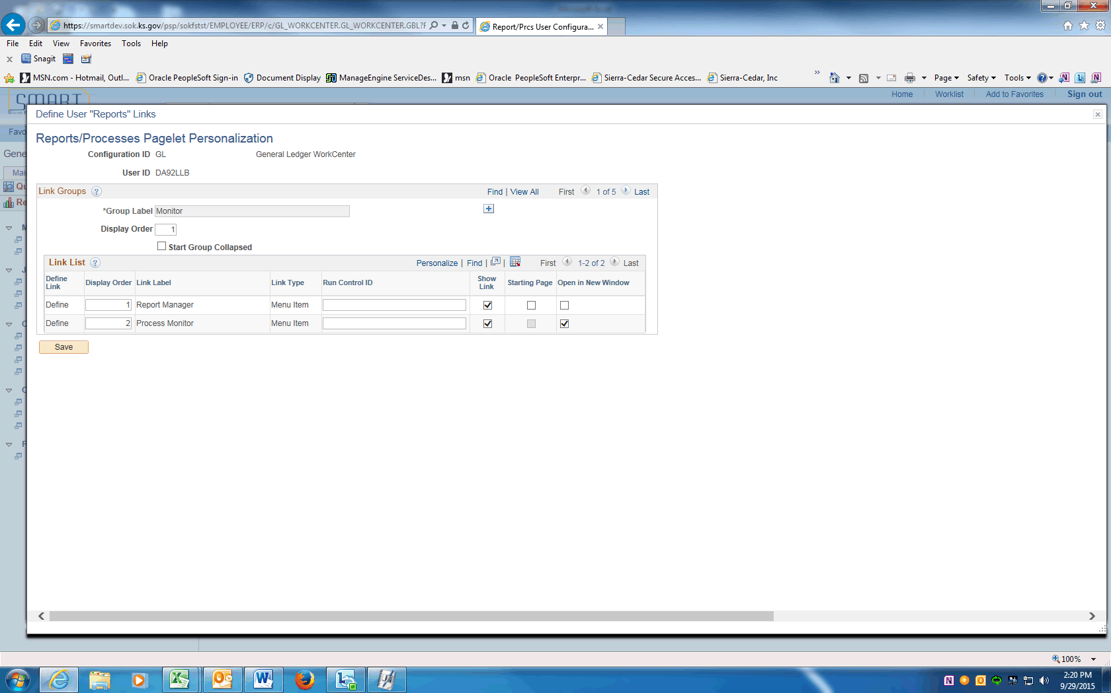

Step | Action
 | Click the Last link to view the last Group.

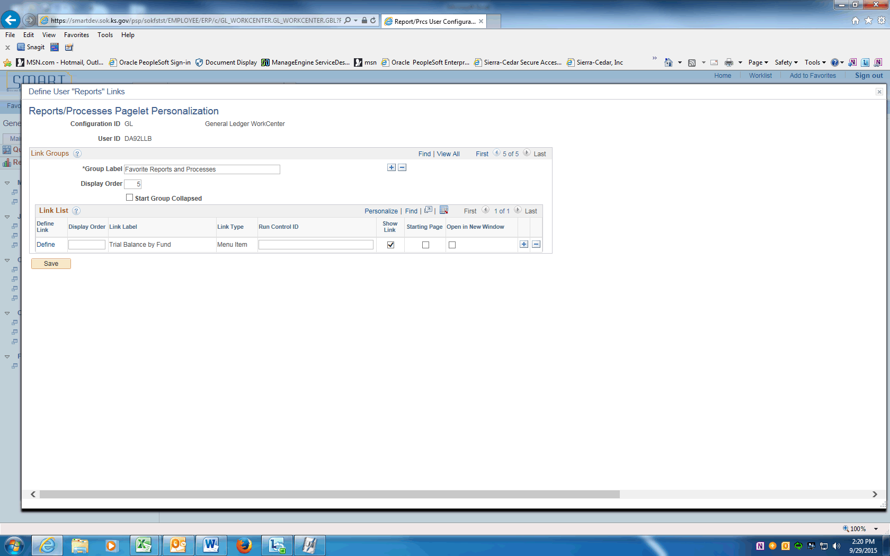

Step | Action
 | On the Favorite Reports and Processes Link List, enter the Run Control ID into the field provided. Enter "Trial_Bal_by_Fund".

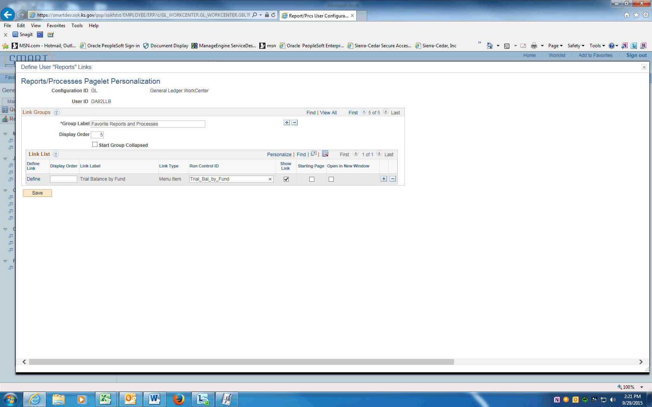

Step | Action
 | Click the Save button.
 | A message reminding you to Refresh the pagelet to see you changes will be displayed. Click the OK button.

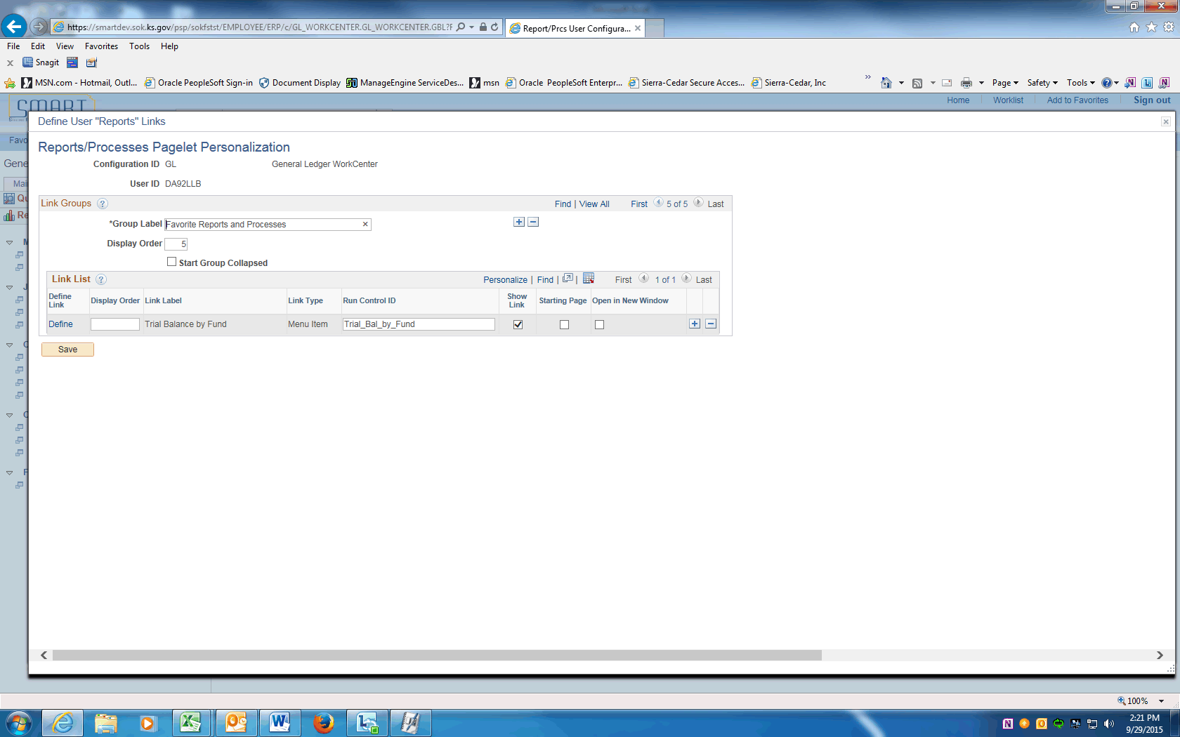

Step | Action
 | Scroll to the upper right corner of the screen. Click the Close link.

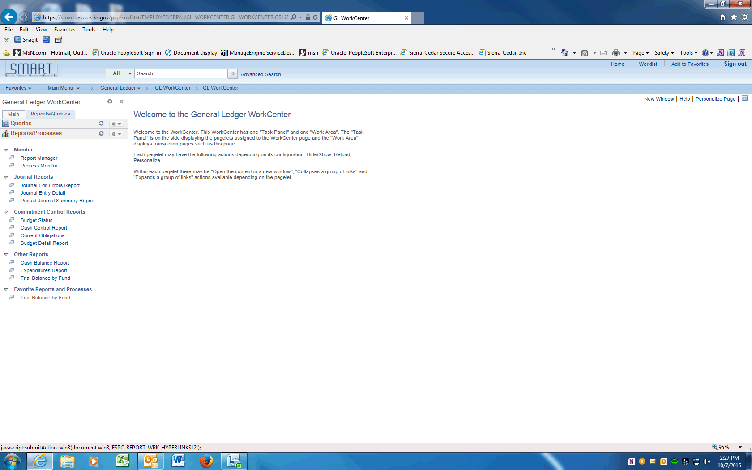

Step | Action
 | Click the Reload button to update the Trial Balance by Fund link.
After reloading the pagelet, try clicking the run control link again for the Trial Balance by Fund report.

This time, the system takes you directly to the Run Control ID that you added to the Personalization page. The options that you saved for this run control ID are displayed. Now you can schedule or run this process.
You have completed personalizing the Reports/Processes pagelet.
End of Procedure.

Workcenter - Queries pagelet
In this topic, we explore some of features and functionality of the Queries pagelet within the WorkCenter.
Procedure

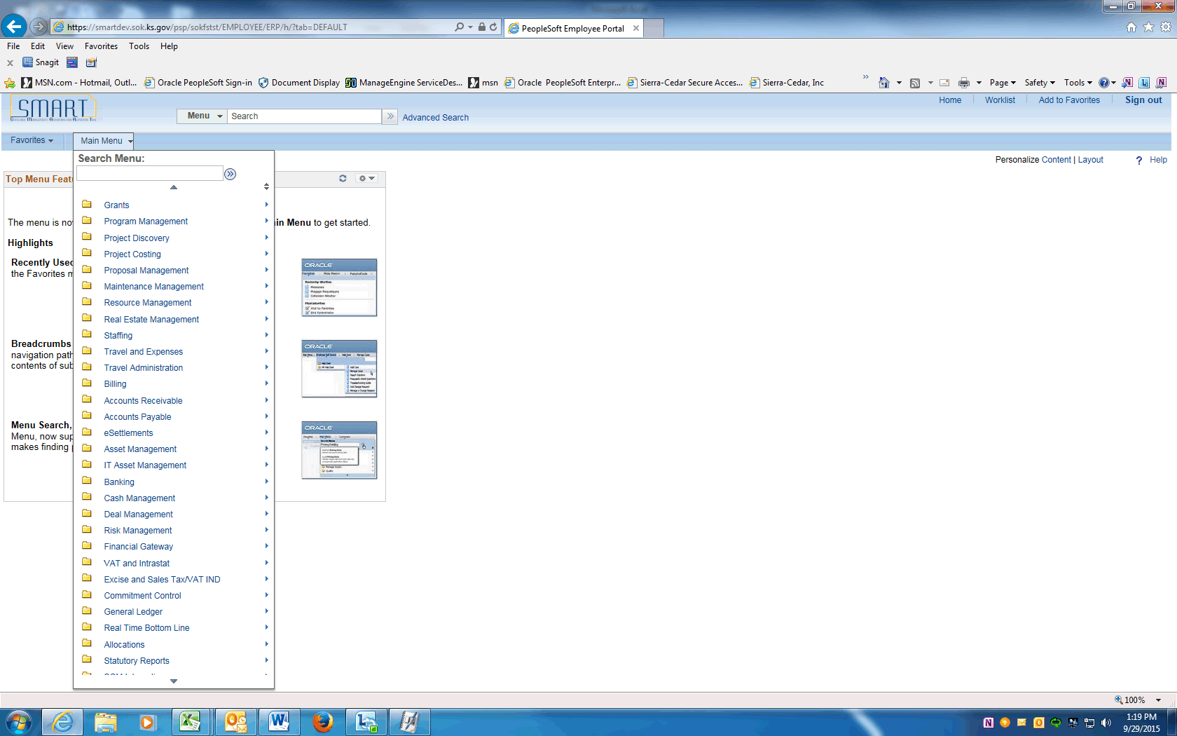

Step | Action
 | Begin by navigating to the General Ledger WorkCenter.
 | Click the General Ledger menu.
 | Click the GL WorkCenter menu.

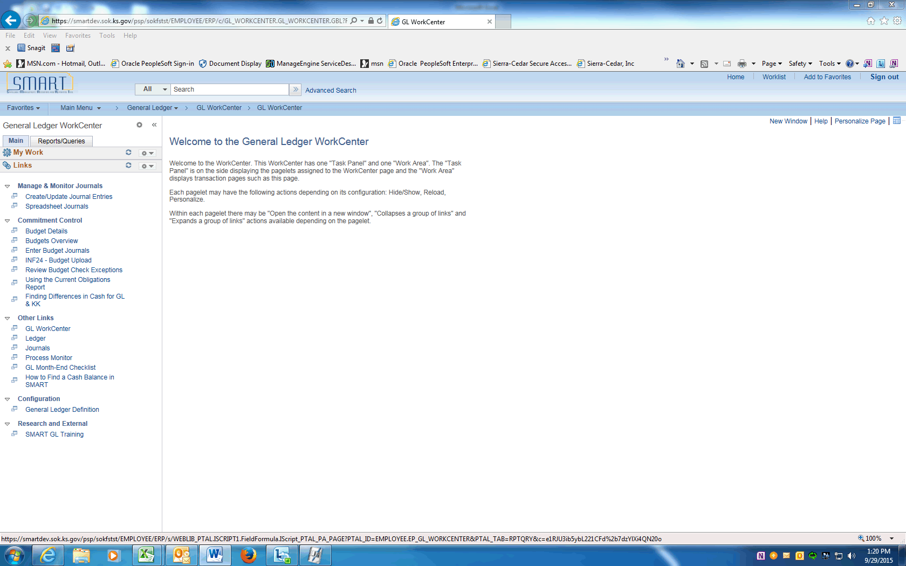

Step | Action
 | Use the General Ledger WorkCenter page to access work items, links, queries, reports, and processes that are specific to your position.

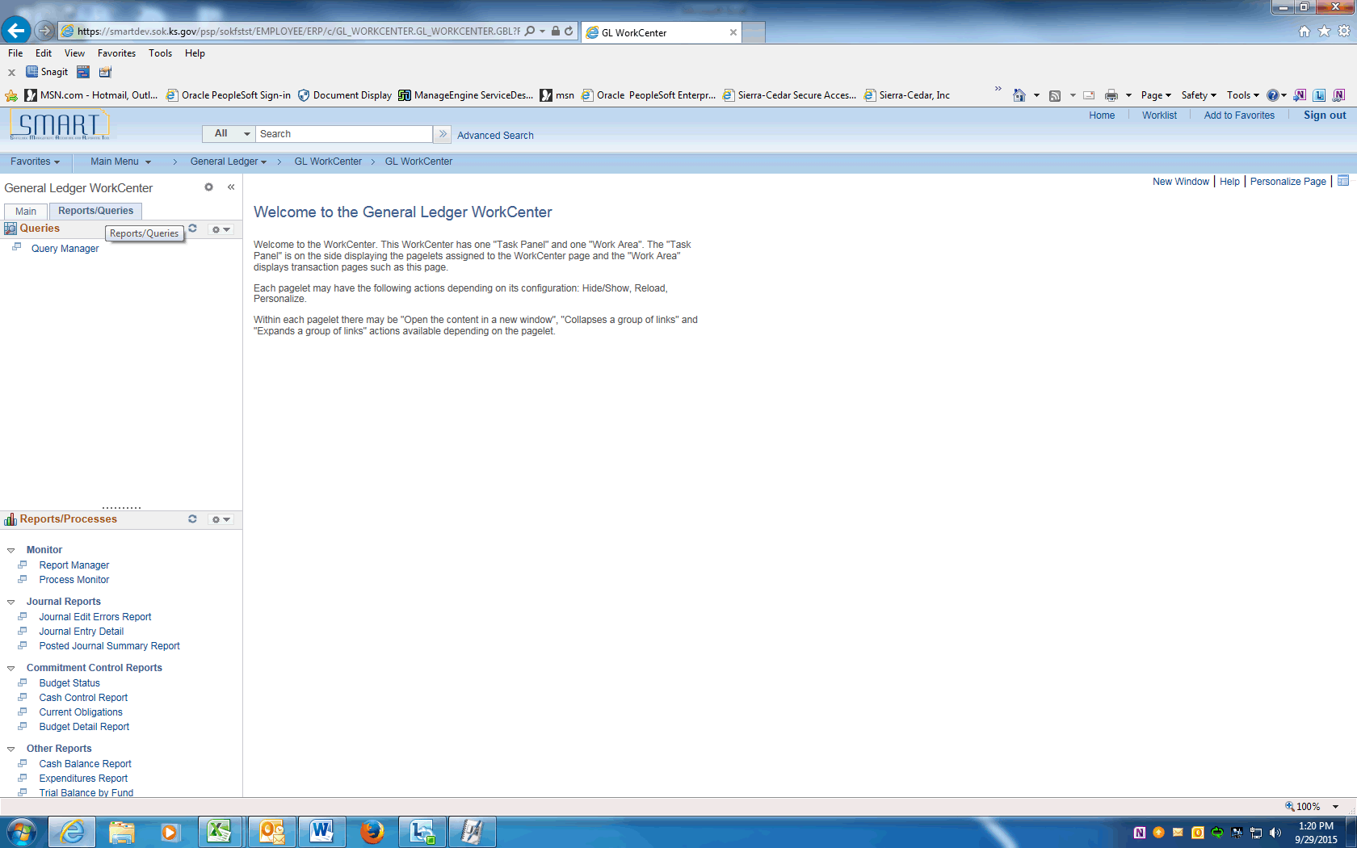

Step | Action
We will use the Reports/Queries tab to run reports/queries and personalize the Queries pagelet.

Click the Reports/Queries link.

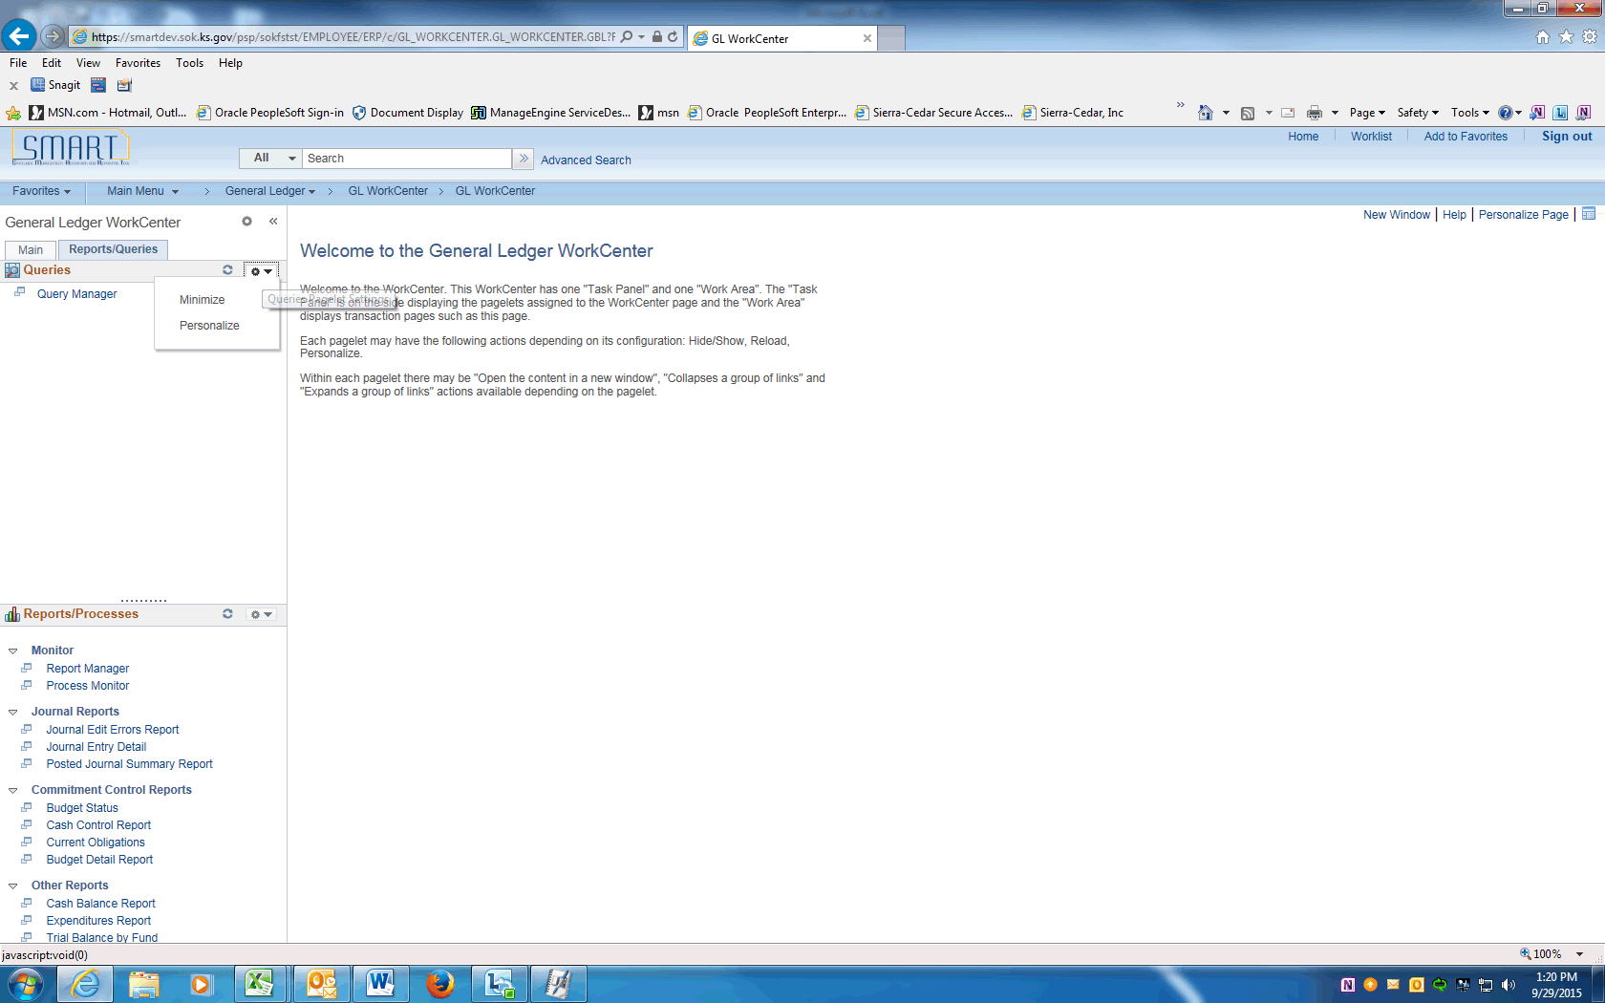

Step | Action
 | Click the Pagelet Settings button

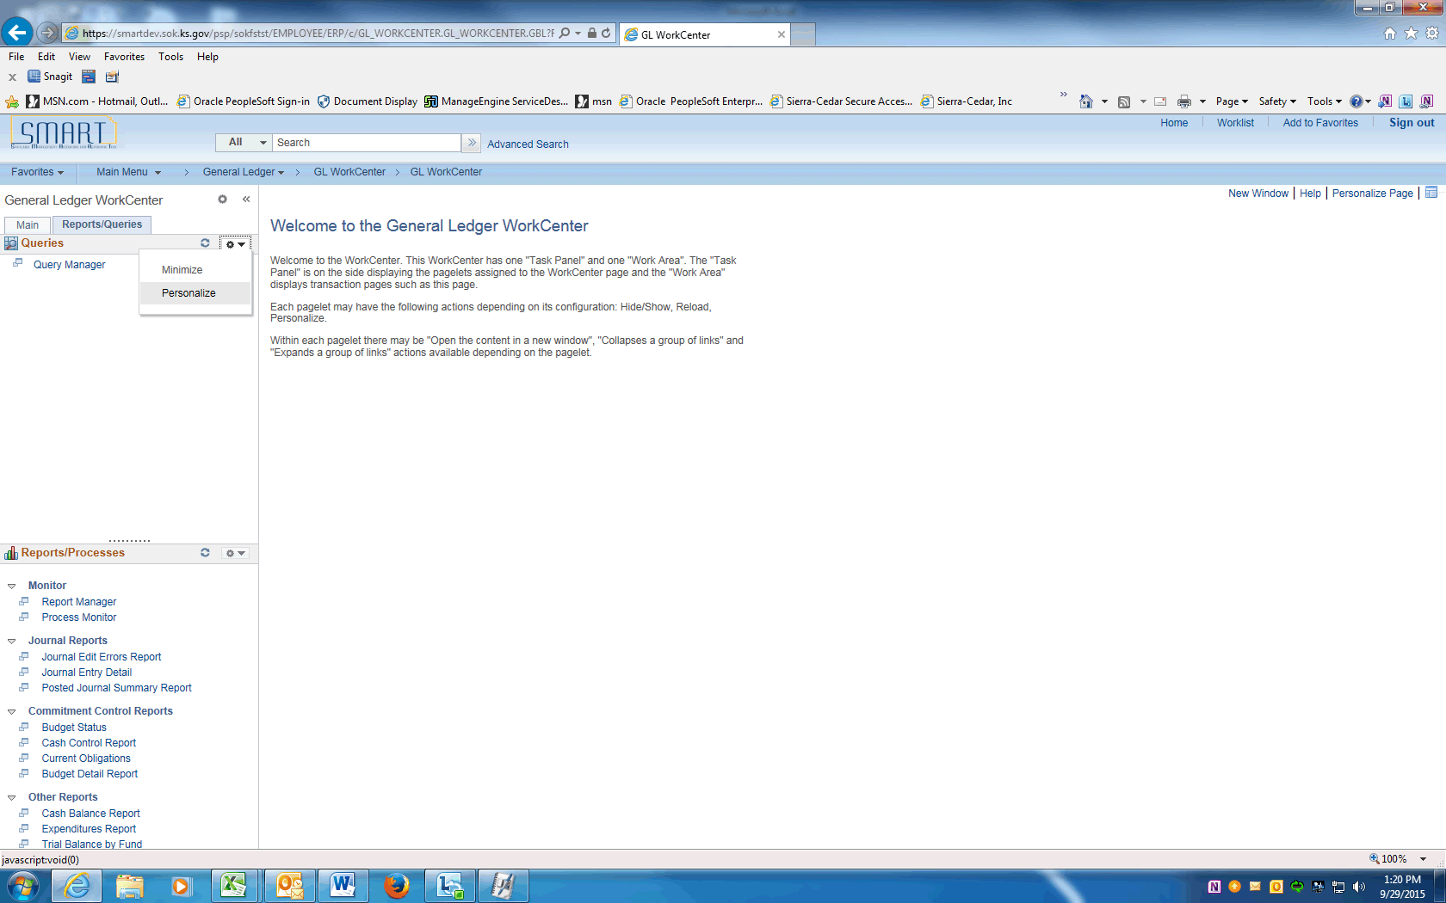

Step | Action
 | Click the Personalize link.

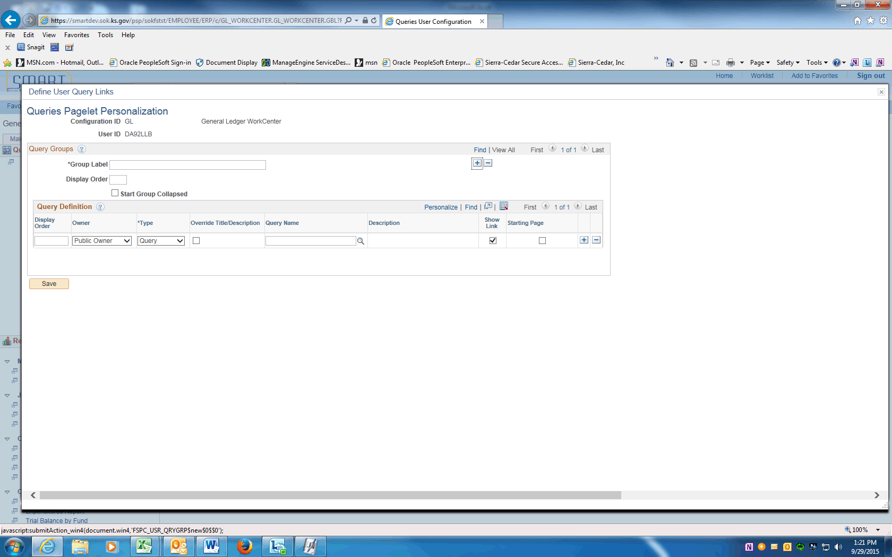

Step | Action
Use the Queries Pagelet Personalization page to structure your Queries pagelet as you want to see it.

If you share a WorkCenter with other users, you may want to consult those users to make sure they agree to the changes.

You would like to add your own group label for queries and pivot grids that you frequently use.

Click the Add a new row (+) button.

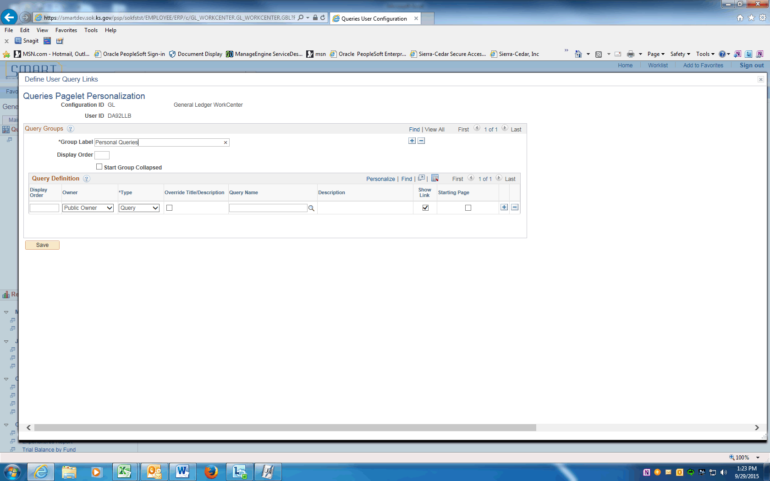

Step | Action
 | Enter the desired information into the Group Label field. Enter "Personal Queries".

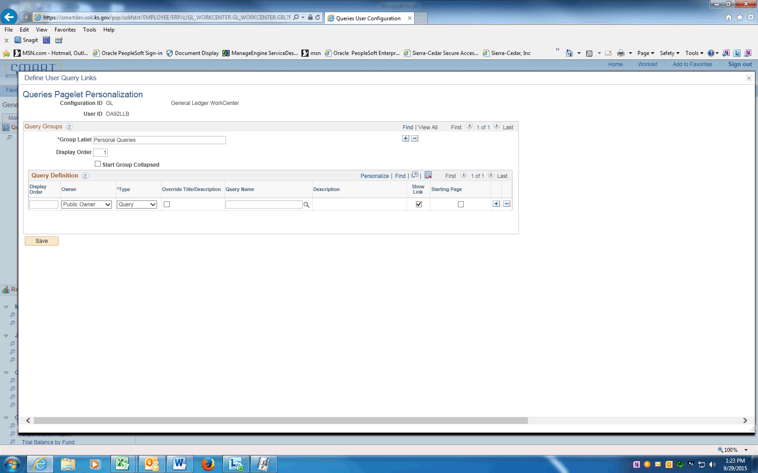

Step | Action
Click in the Display Order field.

Enter the desired information into the Display Order field. Enter "1".
Use the Owner column to determine if the owner is Public or Private.

If adding a link to a public query, then select Public Owner.
If adding a link to a private query, then select Private Owner.

Click the Owner list.

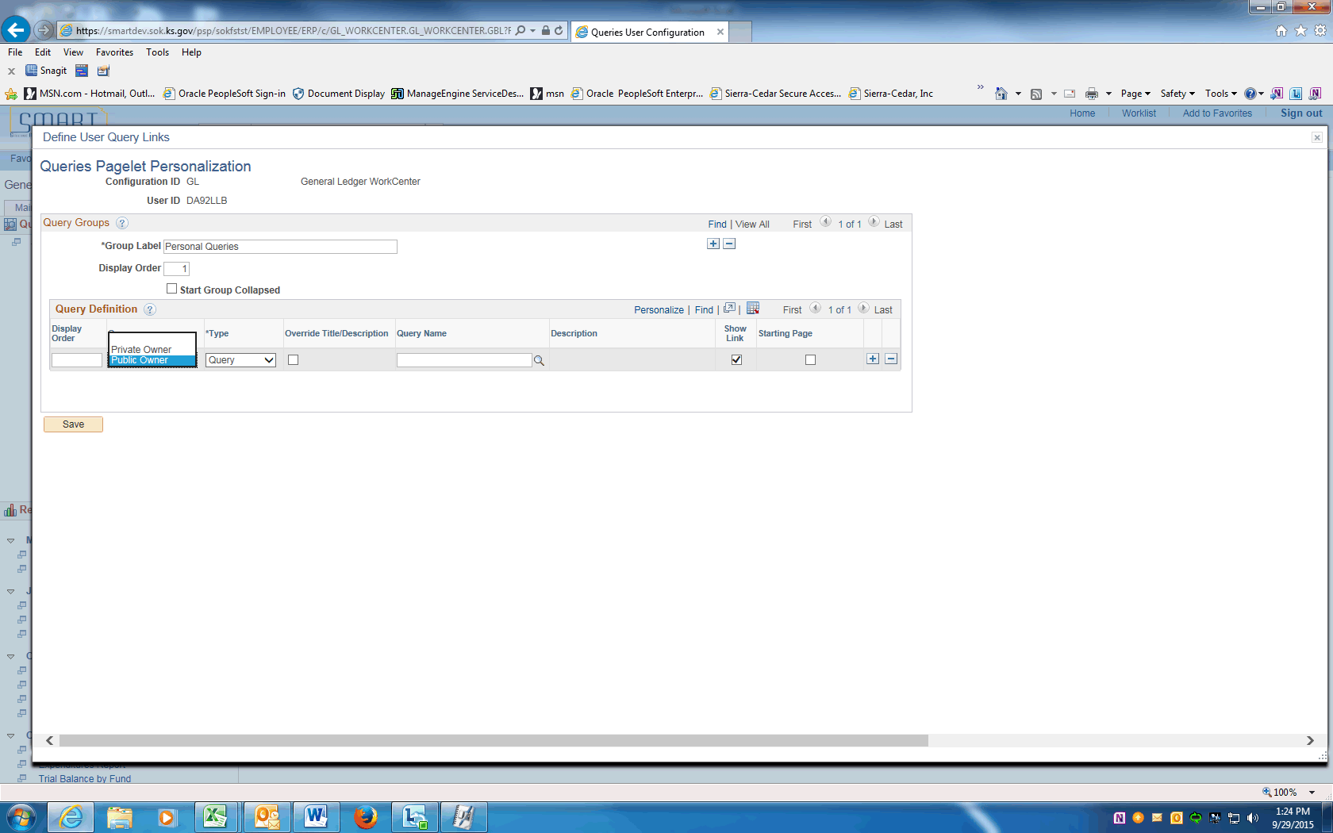

Step | Action
 | Click the Public Owner list item.

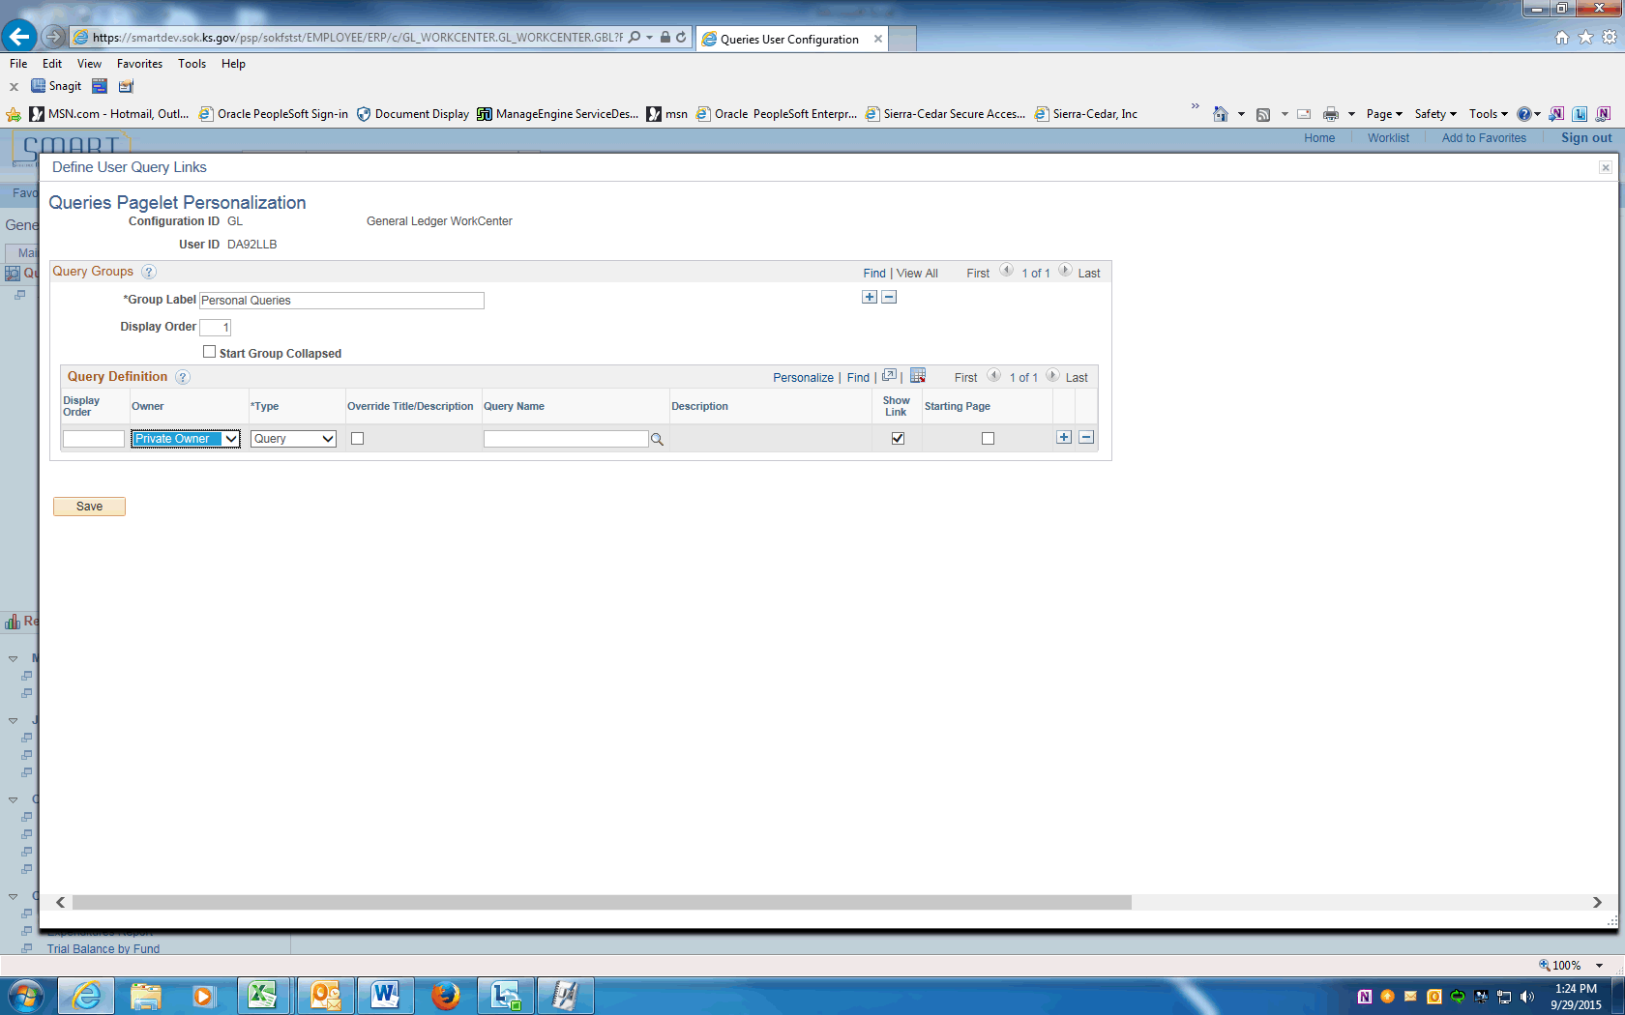

Step | Action
Use the Type field to designate the link as a Pivot Grid or a Query.

You want to select a query.

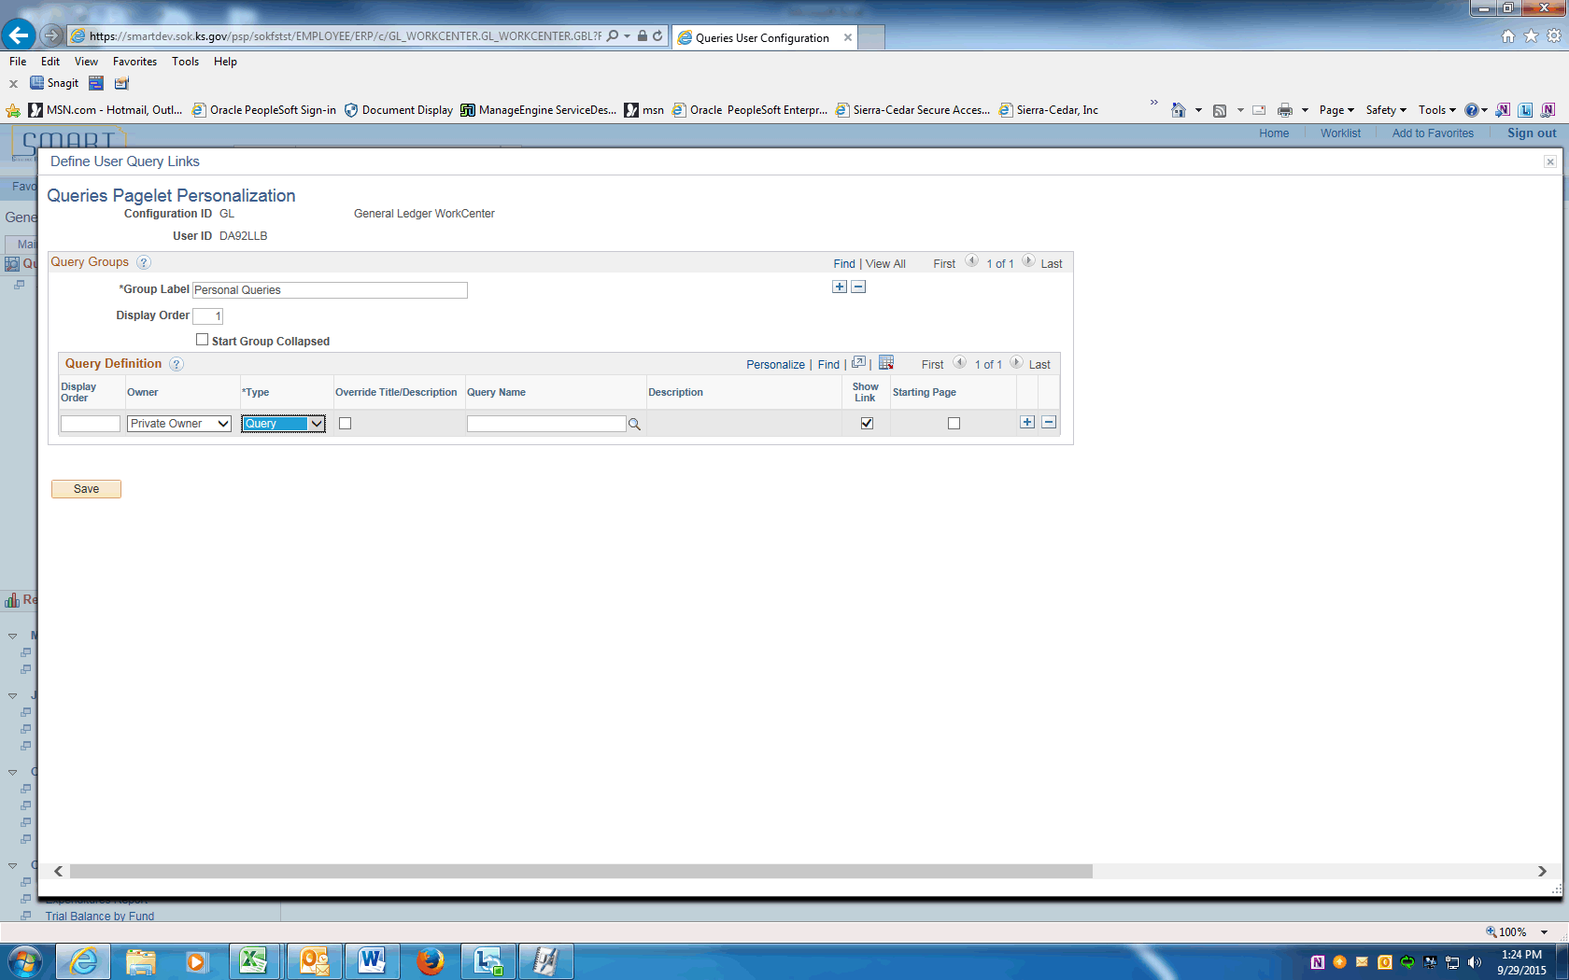

Step | Action
 | Use the Query Name field to select the query
You must know the name of the query so you can type or paste it in the field directly.

Enter the desired information into the Query Name field. Enter "KS_KK_BP15_IBARS_ACTUALS".

 | Click the Save button.

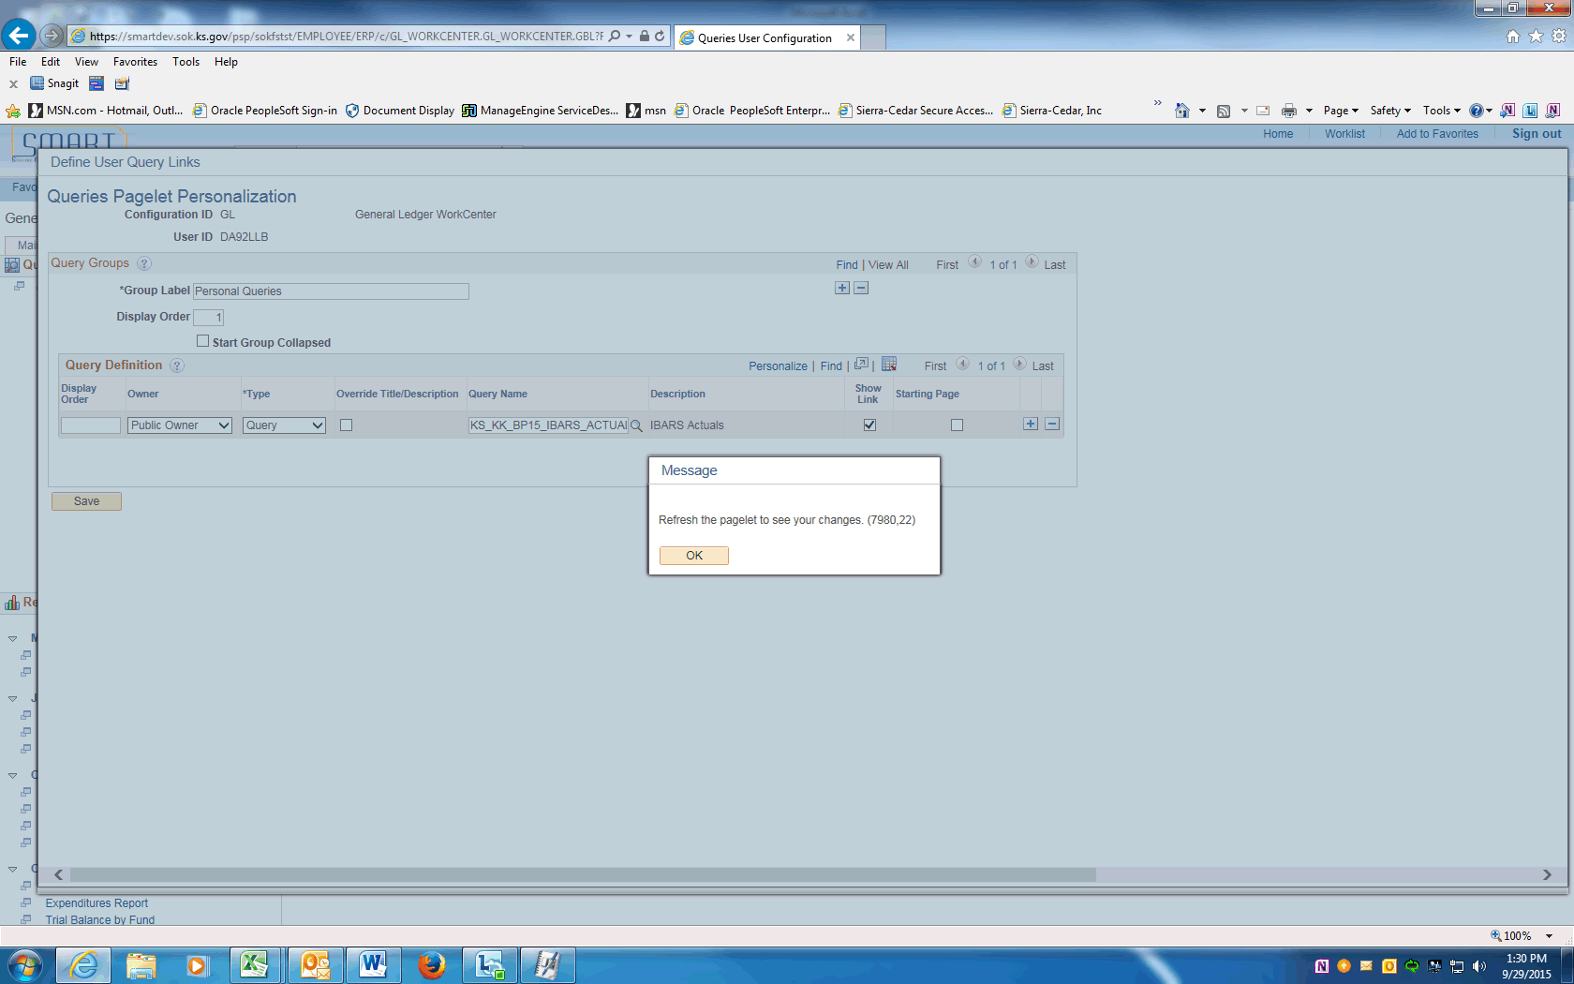

Step | Action
A message will be displayed reminding you to refresh the pagelet to see your changes.

Click the OK button.
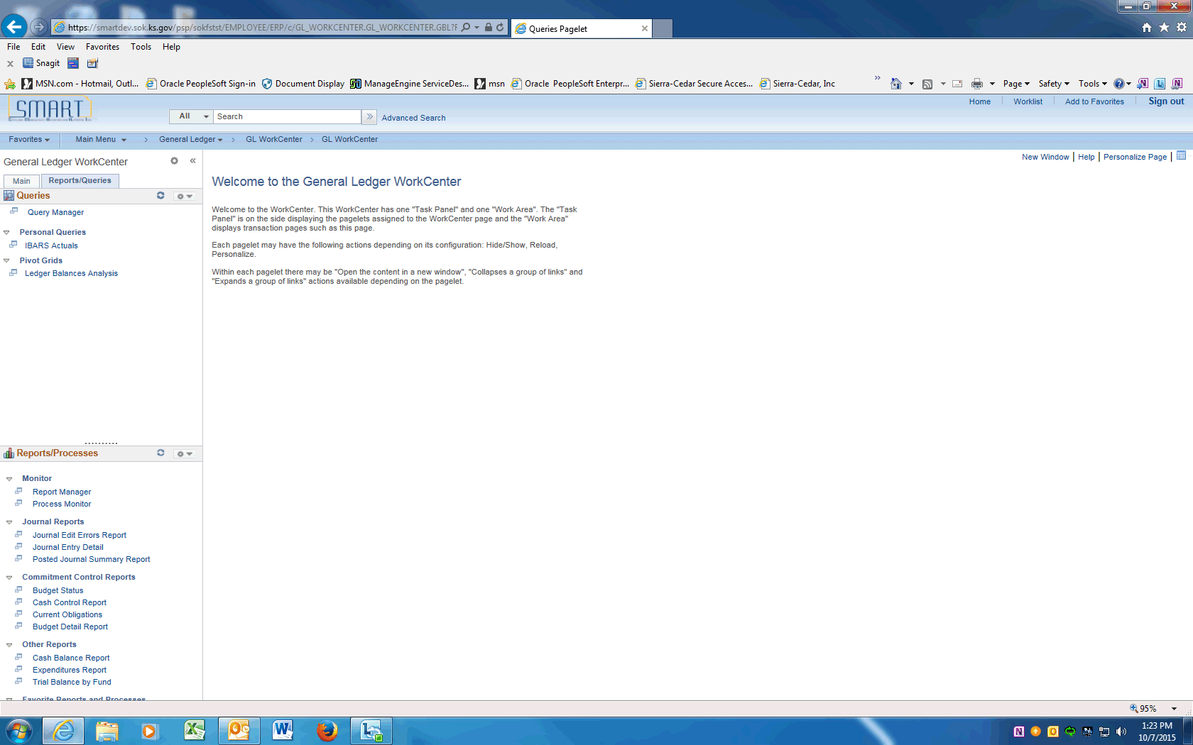

Step | Action
 | After you click the Reload button, the queries and pivot grids that you added appear on the Queries pagelet.

Step | Action
 | Under Personal Queries, click the IBARS Actuals link.
The system takes you directly to the query page where you can enter prompt criteria (if your query includes prompts) and click the View Results button.

If your query does not include prompts, the system loads the result set to the WorkCenter transaction pane using the existing query criteria.

You have successfully personalized the Queries pagelet.
End of Procedure.

