State of Kansas
Using the KS_GL_ACTUALS_DETAIL_PD Query
Statewide Management, Accounting and Reporting Tool

Date Created: | 4/8/2013
Version: | 2.0
Last Updated Date: | 03/21/2019
Purpose of the Query: | This query provides all General Ledger activity including journals, Accounts Payable, Accounts Receivable, Payments, and Travel & Expenses.  The use of the ‘%’ (wildcard functionality in SMART) allows for the inclusion of all criteria within the Search criteria section. For example: All budget units within a fund, or, all account codes.  The query results include: Journal ID, Date, Document ID/Source, Accounting Date, Fiscal Year, Invoice Number, PO/TA Number, Payment ID, Vendor Number/Employee ID, Name, Budget Date, Bus Unit, Dept, Fund, Bud Unit,, Program, Account, Description, Sum Amount, Project, Activity, AN Type, Source Type, Category, Subcategory, Agency Use, ChartField2, Service Location, Description, and Contract ID.
Query parameters: | - Although you MUST enter the Business Unit to return results, the remaining parameters allow for the selection of specific criteria such as Dept ID, Fund, Bud Unit, Program, and Account.  - The use of the ‘%’ wildcard in fields allows the query to expand the results. If only the Bus Unit and Fiscal Year are entered the query results will be ‘YEC’ entries. (Year End Close – the YEC prefix is used on journals that are part of year-end clean up.)  - The Fiscal Year and Accounting Periods must be entered for other query results.  - When ‘Excel’ is selected for the query results, the result data may be manipulated and compared to the Expenditure Reports, Cash Balance Reports, and Trial Balance Reports.  - Note: When using the Grants and/or Customer Contract modules, deposits are NOT reflected. (This is because these deposits are entered under the ‘100000’ codes. The ‘KS_GL_ACTUALS_DETAIL2_PD’ Query provides this detail).
Prompt Values: | Required Prompt Values:  - Business Unit  - Dept ID, Fund, Bud Unit, Program, and Account fields must have an entered value, or must use a ‘%’  - The Fiscal Year must be entered  - ‘From Accounting Period’ and ‘To Accounting Period’ must be entered to return more than just the YEC entries.
Result Sorts: | Query results are presented (sorted) in this order:  - Journal ID  - Fund  - Bud Unit
Security: | - Role Security: Only those individuals with the following security access role will receive results from this query:  - GL Viewer.
1. | Navigation:  From the SMART Homepage, click on ‘General Ledger/KK page’, then click on ‘GL Utilities tile’, then click on ‘Query Viewer’.  On the ‘Query Viewer’ page:  *Search By field: Select the option of ‘Query Name’.  Begins with field: Enter the name of the query. In this case, enter: ‘KS_GL_ACTUALS_DETAIL_PD’.  Click the “Search” button. | 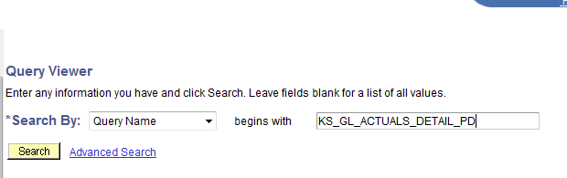
2. | On the Query Viewer page, in the Search Results section:  Select the “Excel” link. | 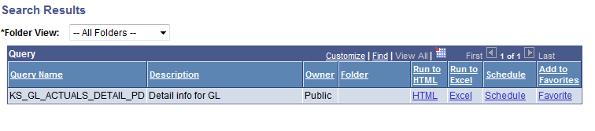
3. | The specific query page opens in a new window.  Enter the desired prompt values:  Bus Unit: Enter your agency’s Business Unit number.  Dept ID, Fund, Bud Unit, Program, and Account: The use of a ‘%’ wildcard in these field retrieves all values for that field.  To limit the query results, manually enter the specific values in the fields.  For example: Fund or Program.  From Accounting Period, To Accounting Period, and Fiscal Year: Enter specific values to limit the query results to specific periods.  Note: Leaving the From and To Accounting Periods blank (empty), but entering the Fiscal Year will return ‘YEC’ data. (Year End Close)  After you have entered your desired search criteria, click the “View Results” button. | Note: For those fields containing a ‘(%)’ after the field name:  The ‘(%)’ after the field name indicates that this field can NOT be left blank (empty). A data value or a “%’ wildcard MUST be entered in these fields. If any of these fields are left blank, and the ‘View Results’ button is clicked, then SMART will display the following message:  ‘No matching values were found.’  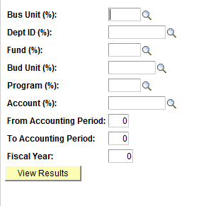
4. | A message window appears.  Click the “Open” button.  The query results are displayed in Excel in a new window.
NOTE: |  | If desired, you can also select the “HTML” link on the Query Viewer page. This will display the query results online directly in SMART. You can then select the “Excel” link from that page to export the query results in to an Excel worksheet.

