
State of Kansas
Using the KGL00012 Expenditure Report
Statewide Management, Accounting and Reporting Tool

Date Created: |  | 4/02/2013
Version: |  | 3.0
Last Updated Date: |  | 03/21/2019
Purpose of the Report: |  | This report is designed to give a summary of monthly and year to date expenditures by Fund, Budget Unit, Program, and Account code that have posted to the General Ledger.  This is a key monthly balancing tool.
Report parameters: |  | - The report results are the expenditures posted to the General Ledger during the month and fiscal year.  - Note: Budget periods are NOT separated out in this report, therefore prior year encumbrance payments appear the report results.  If desired, you will need to manually remove the prior year encumbrance payments from the report results in order to report only the current budget period expenses.
Report Prompt Values: |  | Required Prompt Values:  - Business Unit  - Fiscal Year  - Accounting Period  - Desired level of detail for Account, Fund, and Budget Unit report results
Report Result Sorts: |  | The report results are sorted by the following values:  - Business Unit ID  - Fund  - Budget Unit  - Program  - Account Code
Security Access: |  | - Role Security: Only those individuals with the following security access role will receive results from this report:  - GL Viewer  - BU Security: Business Unit security is applied. Agencies will have access only to those expenditures associated to their agency’s Business Unit(s).
1. | Navigation:  From the SMART Homepage, click on General Ledger/KK page> GL & KK Reports tile> GL Reports > Expenditures Report (KGL00012). | 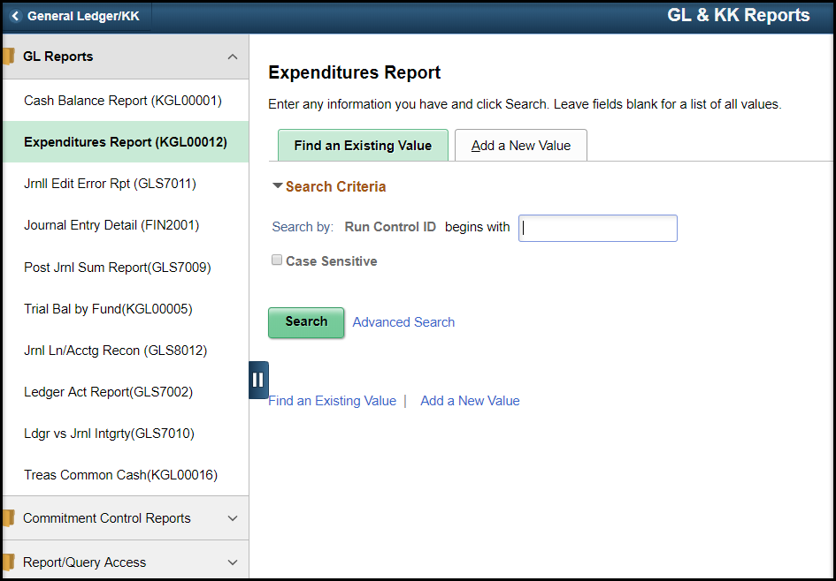
 | On the Expenditures Report page, click the ‘Find an Existing Value’ tab:  Run Control ID begins with field: Enter the name of the (previously established) Run Control ID you wish to use.  Click the Search button.  If you have NOT used this report in the past, use the ‘Add a New Value’ tab. Enter a new Run Control ID  Click the Add button. | 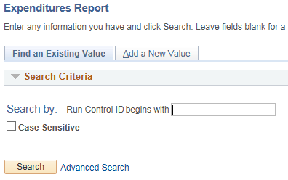  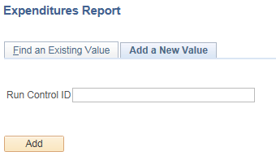
2. | On the Expenditures Rpt page:  Business Unit: Enter the agency’s Business Unit number.  Fiscal Year: Enter the desired Fiscal Year.  Accounting Period: Enter the desired Accounting Period (to get the month for the report).  *Account: Use the drop-down list to select the report results based on the features/detail available in the list.  *Fund: Use the drop-down list to select the report results based on the features/detail available in the list.  *Budget Unit: Use the drop-down list to select the report results based on the features/detail available in the list. | 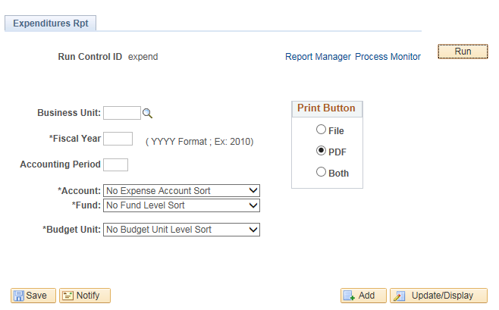
Print Button Menu:
Select the desired print method:

File: Provides the report results in a .DAT format, which can then be copied into ‘Excel’ and delimited.

PDF: Provides the report results in a printable format (.PDF file).

 | Click Save then click the Run button.
3. | Clicking the “Run” button opens the Process Scheduler Request page.  On the Process Scheduler Request page:  *Type: Select the desired file type.  *Format: Select the desired file output.  Click the OK button. Clicking the OK button submits the report (process) to SMART (for the report results to be generated). | 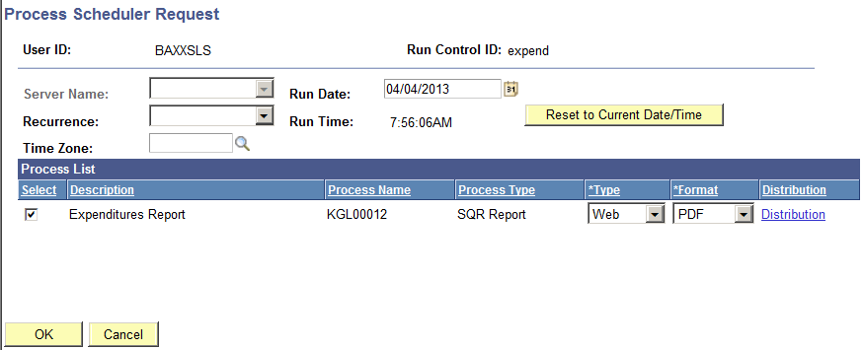
4. | On the Expenditures Rpt page.  Click the Process Monitor link.
5. | On the Process List page:  Click the Refresh button to refresh the process data.  If the ‘Run Status’ is “Success”, then the report results have been successfully generated.  If the ‘Run Status’ is NOT “Success” you may need to refresh the process results.  To view the report results, click the Details link. | 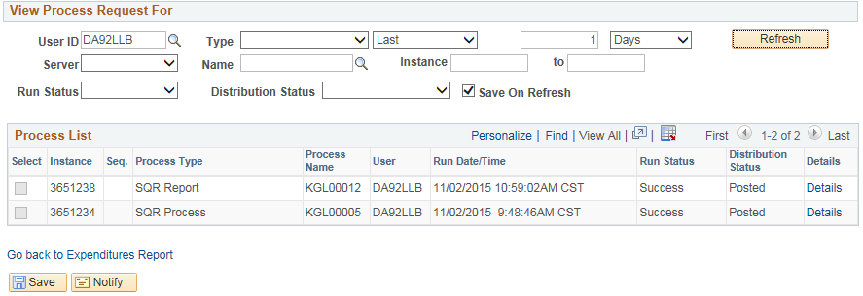
6. | On the Process Detail page:  To view the report results, click the View Log/Trace link. | 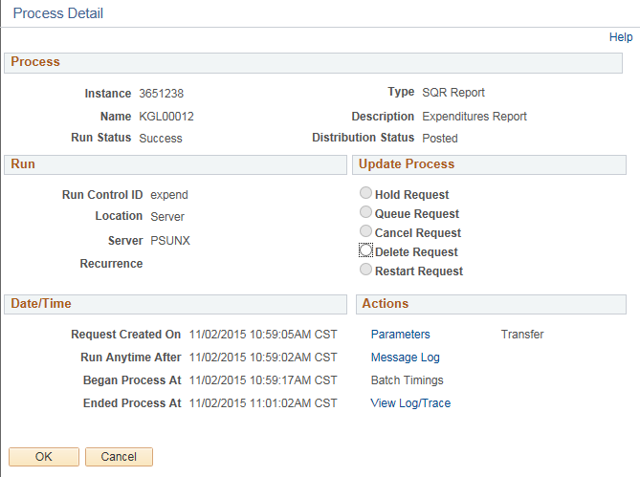
7. | On the the View Log/Trace page.  In the File List section: Click the Name link for the desired file output type.  Generating ‘report results’ prompts SMART to generate multiple file outputs, which are visible in the File List section. (For example: ‘.PDF’ file: This is the report results Format that you requested on the Process Scheduler Request page). | 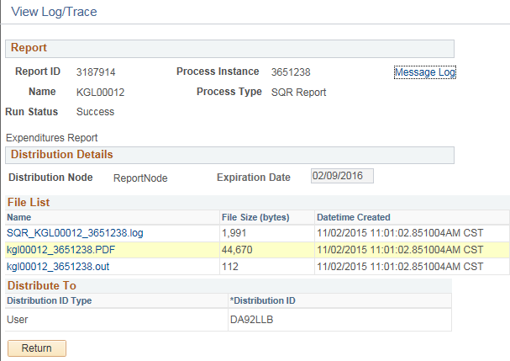

8. | Clicking the file Name link, opens the file in the specified ‘reports results’ Format. | Use the KGL00012 Expenditure Report results as a summary of expenditures by Fund, Budget Unit, Program, and Account code for your agency, depending on the report parameters chosen.  When the report results appear, you may then save or print the file.  

